DT-600-2-00001 UPPER
PB1000102-02 HYDRAULIC PRESSURE GENERATING SYSTEM PD1000101-01 SWING SYSTEM
PE1000095-01 ELEVATING SYSTEM PF1000088-02 WINCH SYSTEM PG1000096-01 TELESCOPING SYSTEM PH1000095-00 SAFETY DEVICES PK1000103-01 FRAME
PL1000099-00 CONTROL DEVICES PN1000096-01 ELECTRIC EQUIPMENT PO1000123-00 INDICATION PLATES PP2000002-02 AUGER SYSTEM PY1000244-06 OPTIONS
ASSEMBLY
000000

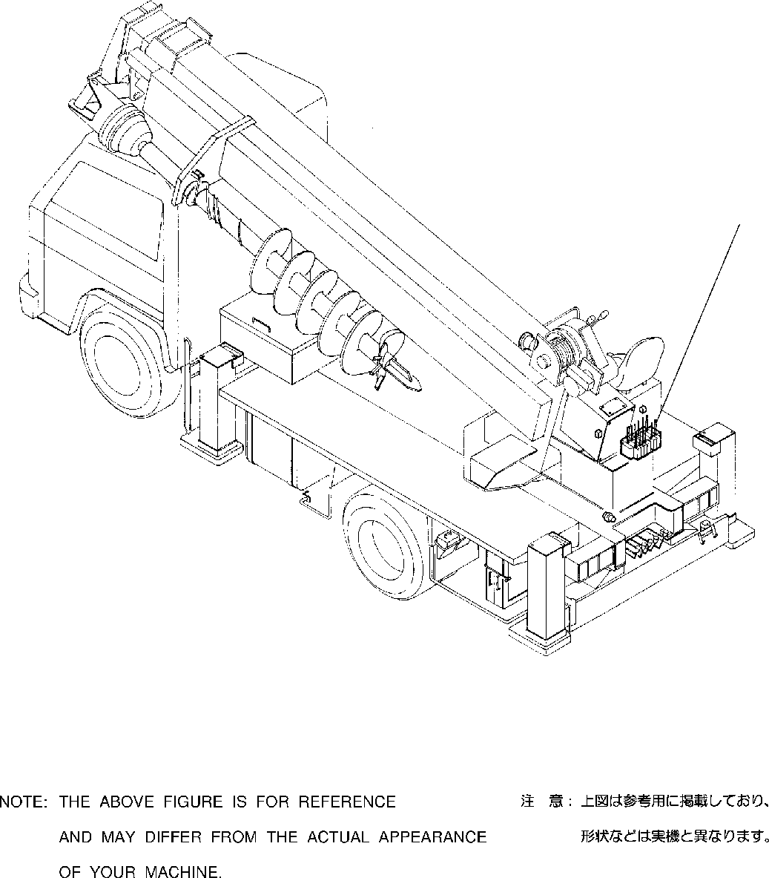
DT-600-2-00001 UPPER
PB1000102-02 HYDRAULIC PRESSURE GENERATING SYSTEM
1

DT-600-2-00001 UPPER
000001
Pos No.

Parts No
Parts Name
Qty
Unit
Technical Data
Serial No (Start)
Serial No (End)
Remar

1

(***********)
PIPING,HYDRAULIC UPPER
1

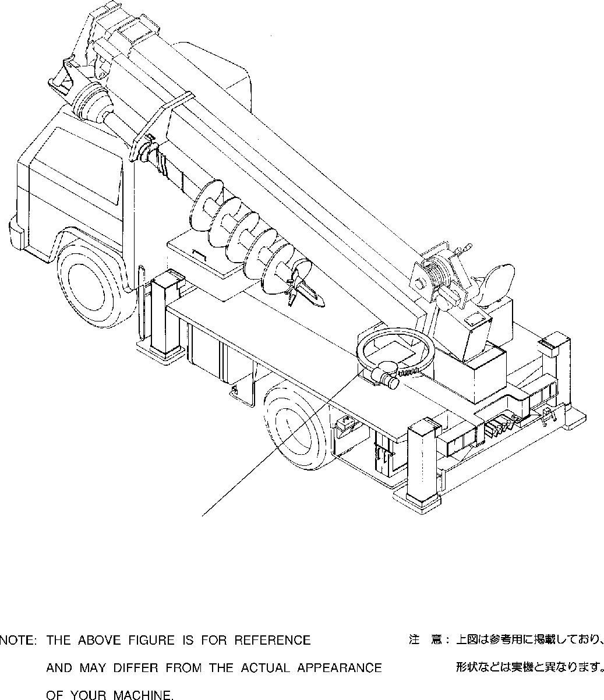
DT-600-2-00001 UPPER PD1000101-01 SWING SYSTEM
1

DT-600-2-00001 UPPER
000002
Pos No.

Parts No
Parts Name
Qty
Unit
Technical Data
Serial No (Start)
Serial No (End)
Remarks

1

(***********) (***********)
REDUCER,SWING SPEED REDUCER,SWING SPEED
1
1

275194
275193

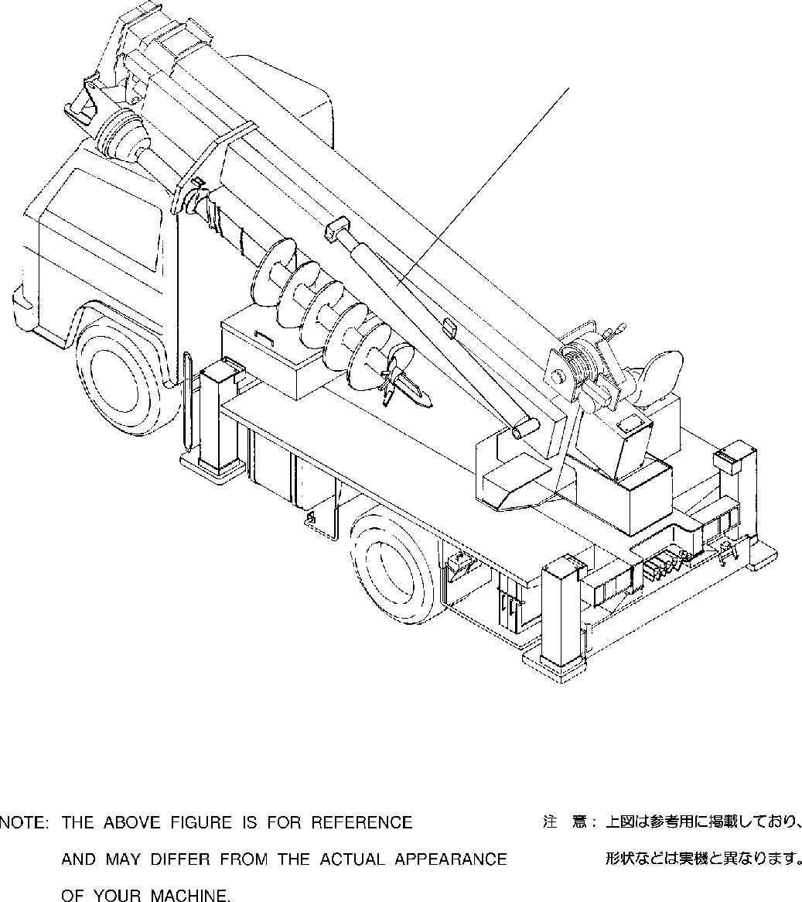
DT-600-2-00001 UPPER
PE1000095-01 ELEVATING SYSTEM
1

DT-600-2-00001 UPPER
000003
Pos No.

Parts No
Parts Name
Qty
Unit
Technical Data
Serial No (Start)
Serial No (End)
Remarks
1

(***********)
CYLINDER,ELEVATING
1

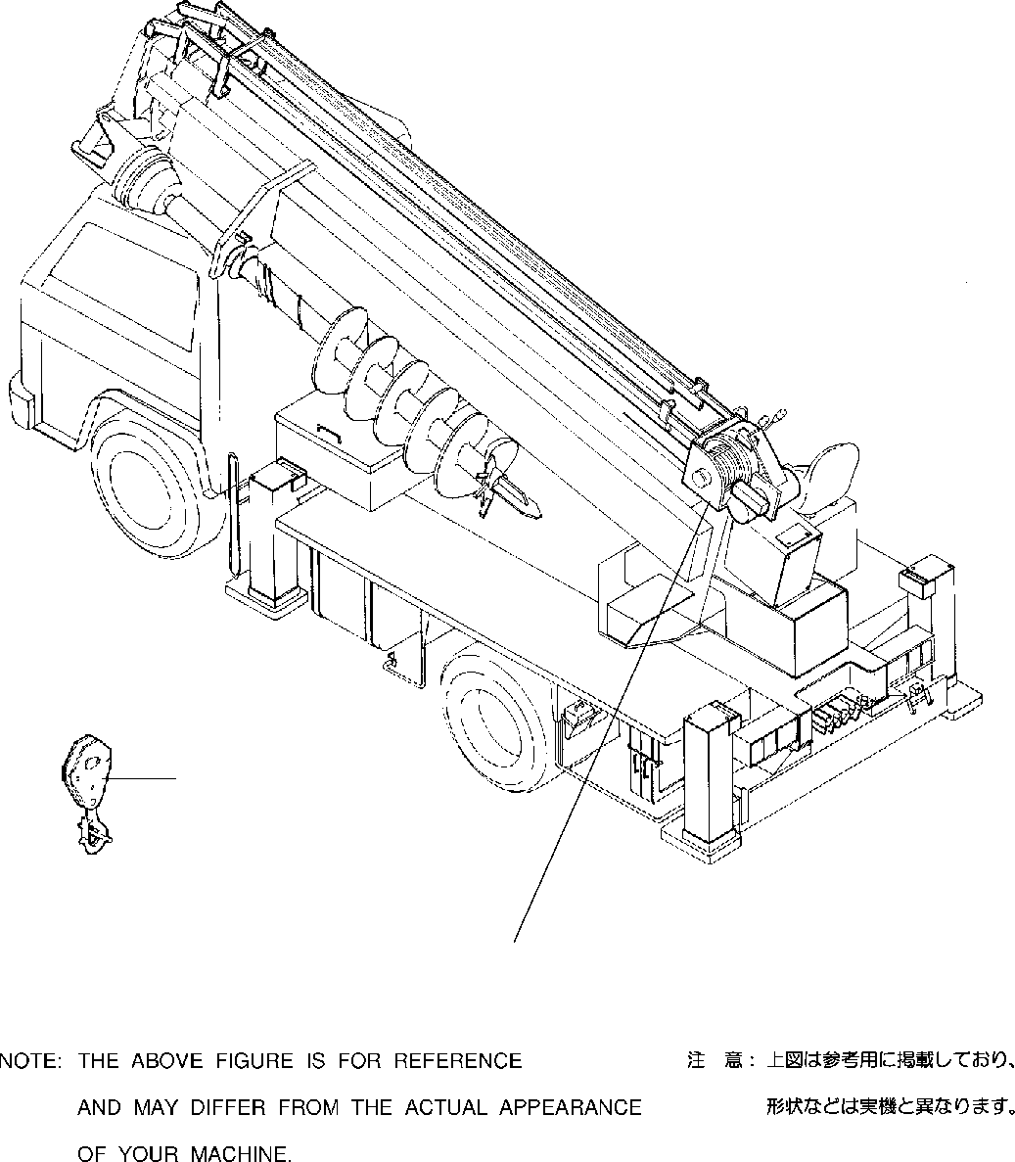
DT-600-2-00001 UPPER PF1000088-02 WINCH SYSTEM
1
2

DT-600-2-00001 UPPER
000004
Pos No.

Parts No
Parts Name
Qty
Unit
Technical Data
Serial No (Start)
Serial No (End)
Remarks
Page 00002
00002
00002
00003
1

2

(***********) 32290040000
(***********) (***********)
HOOK HOOK HOOK
MOUNT,WINCH
1
1
1
1

275088
275213

275087
275212

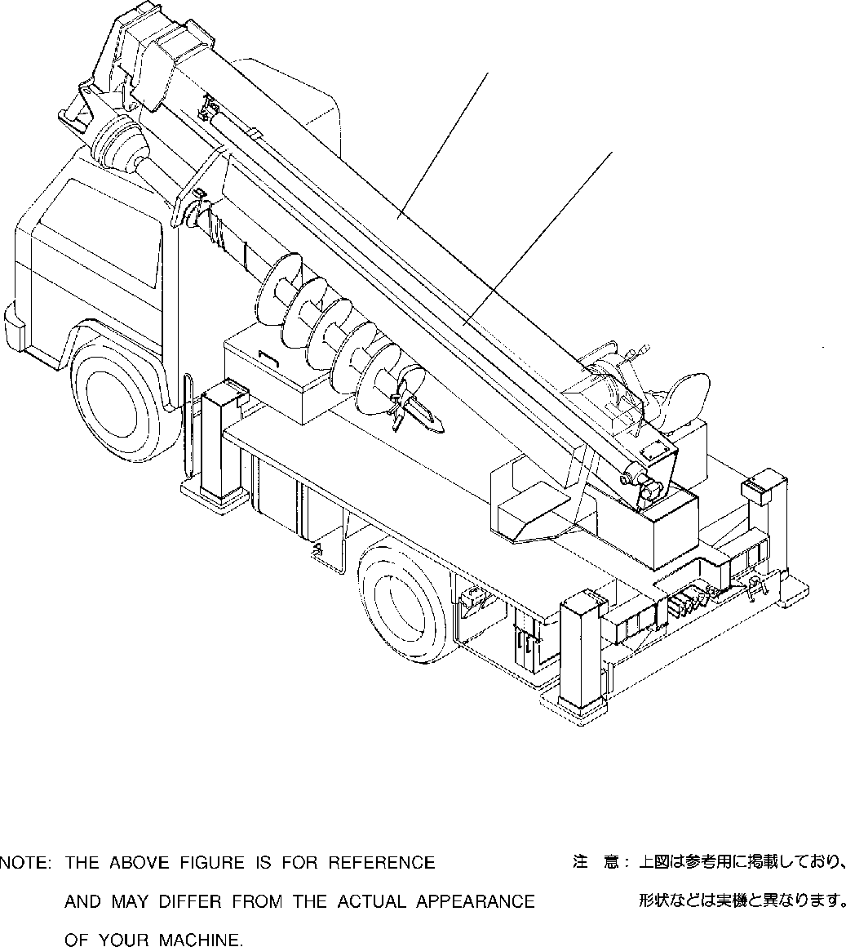
DT-600-2-00001 UPPER
PG1000096-01 TELESCOPING SYSTEM
1
2

DT-600-2-00001 UPPER
000005
Pos No.

Parts No
Parts Name
Qty
Unit
Technical Data
Serial No (Start)
Serial No (End)
R

1

2

(***********) (***********) (***********)
BOOM BOOM
CYLINDER ASSY,TELESCOPING
1
1
1

275213

275212

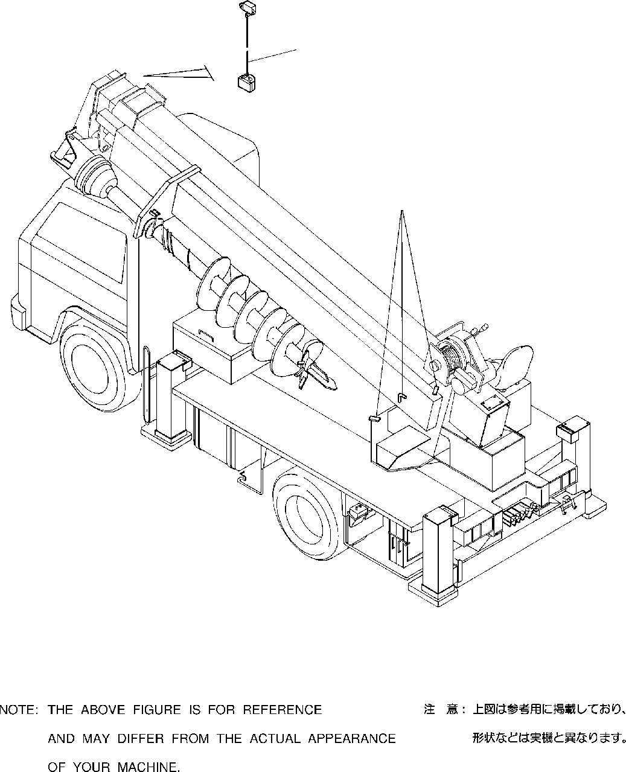
DT-600-2-00001 UPPER PH1000095-00 SAFETY DEVICES
1
2

DT-600-2-00001 UPPER
000006
Pos No.

Parts No
Parts Name
Qty
Unit
Technical Data
Serial No (Start)
Serial No (End)
R

1

2

(***********) (***********) (***********) (***********)
DETECTOR,OVER WINDING INDICATOR ASSY,OVERWIND DETECTOR,OVER FRONT AREA DETECTOR,OVER FRONT AREA
1
1
1
1

275054

275194
275053

275193

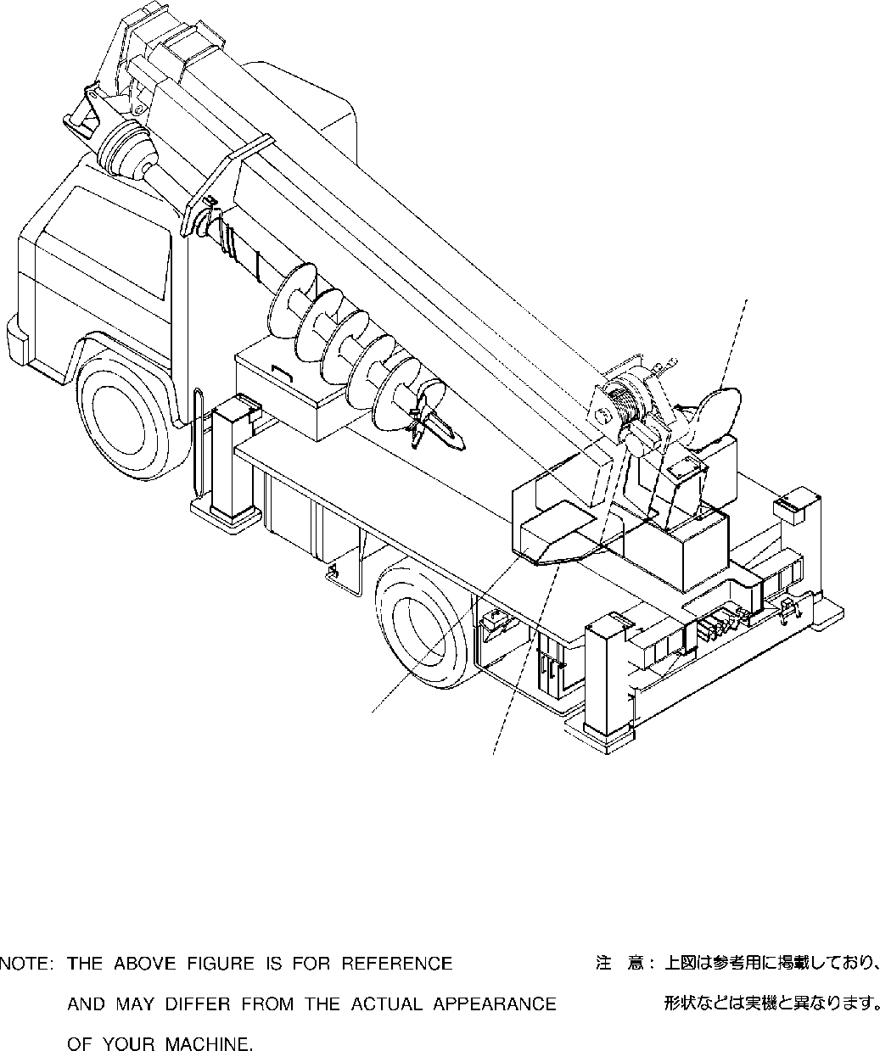
DT-600-2-00001 UPPER PK1000103-01 FRAME
2
3
1

DT-600-2-00001 UPPER
000007
Pos No.

Parts No
Parts Name
Qty
Unit
Technical Data
Serial No (Start)
Serial No (End)
Remarks
1

2
3

(***********) (***********) (***********) (***********)
SWING FRAME SWING FRAME SWING TABLE
COVER,SWING FRAME
1
1
1
1

275194

275193

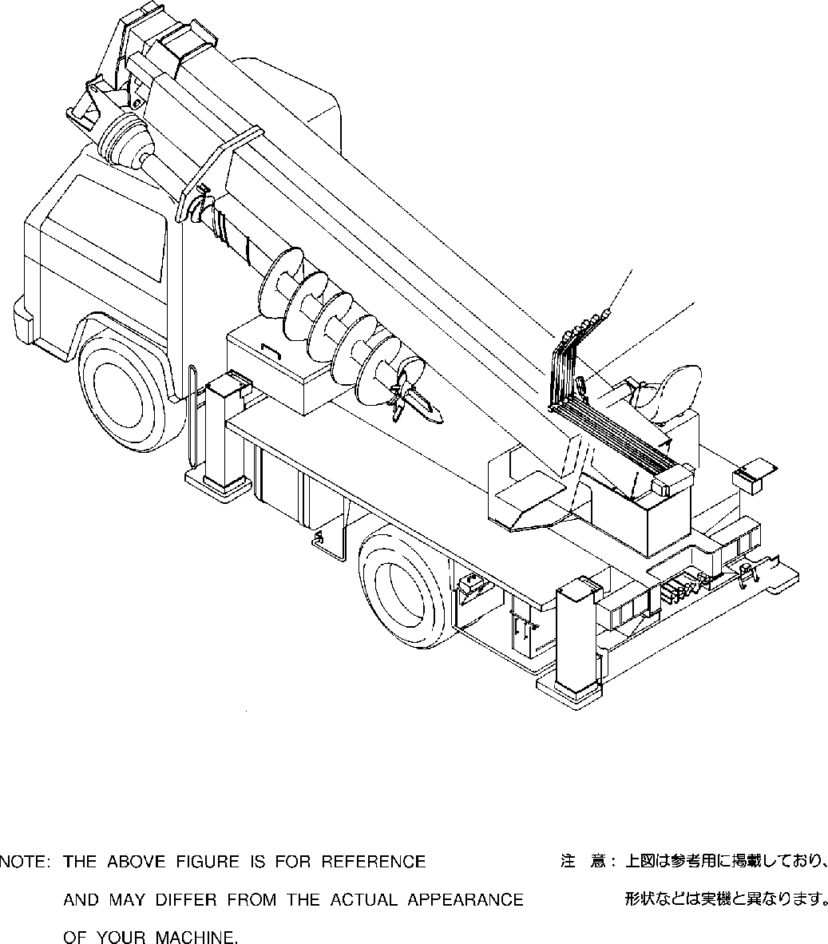
DT-600-2-00001 UPPER PL1000099-00 CONTROL DEVICES
1
2

DT-600-2-00001 UPPER
000008
Pos No.

Parts No
Parts Name
Qty
Unit
Technical Data
Serial No (Start)
Serial No (

1
2

(***********) (***********)
OPERATION SYSTEM, CONTROL VALVE OPERATION SYSTEM, ACCELERATOR
1
1

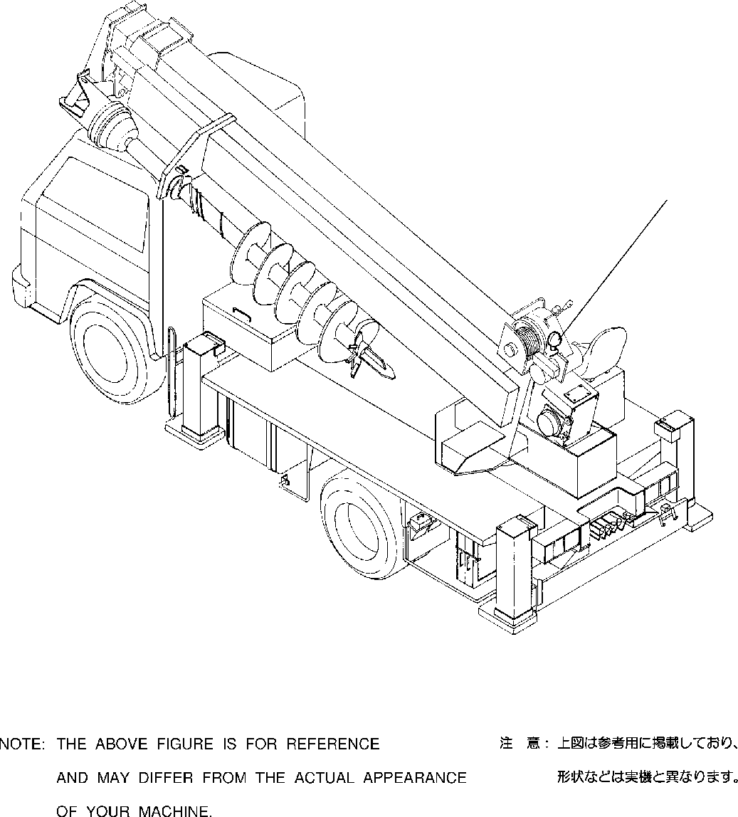
DT-600-2-00001 UPPER
PN1000096-01 ELECTRIC EQUIPMENT
1

DT-600-2-00001 UPPER
000009
Pos No.

Parts No
Parts Name
Qty
Unit
Technical Data
Serial No (Start)
Serial No (End)
Rema

1

(***********)
ELECTRICAL ACCESSORIES
1

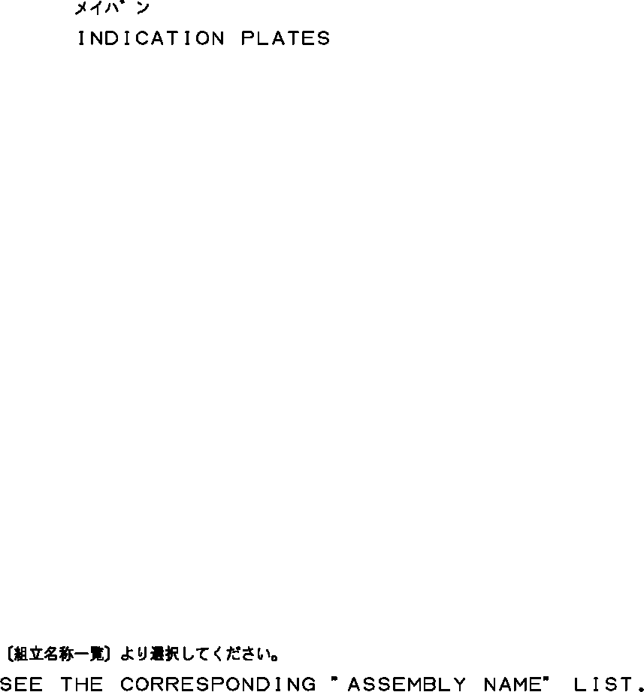
DT-600-2-00001 UPPER
PO1000123-00 INDICATION PLATES

DT-600-2-00001 UPPER
000010
Pos No.

Parts No
Parts Name
Qty
Unit
Technical Data
Serial No (Start)
Serial No (End)
Remarks

1
2

(***********) (***********)
PLATE,INDICATION PLATE ASSY,NAME (OIL)
1
1

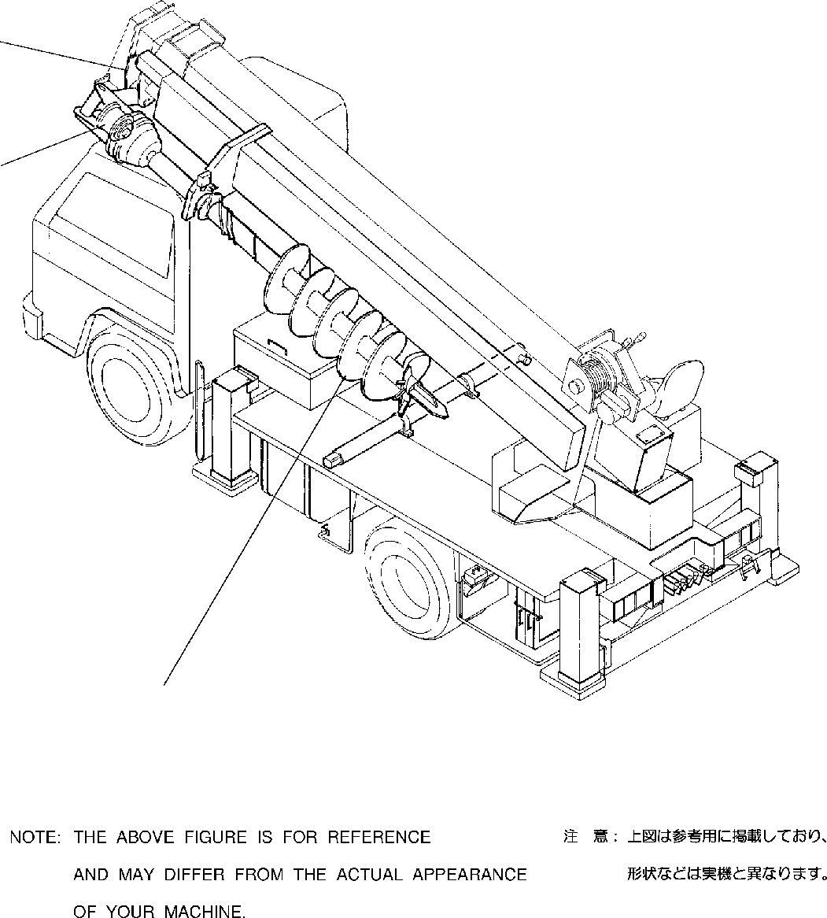
DT-600-2-00001 UPPER PP2000002-02 AUGER SYSTEM
3
2
1

DT-600-2-00001 UPPER
000011
Pos No.

Parts No
Parts Name
Qty
Unit
Technical Data
Serial No (Start)
Serial No (End)
Remarks
Pa 00
00
00
00
00
00
00
00
00
00
00
00
00
1

2

3

(***********) (***********) (***********) (***********) (***********) (***********) (***********) (***********) (***********) (***********) (***********) (***********) (***********)
AUGER (450,P) AUGER (300.PENGO) AUGER (250.PENGO) AUGER (350.PENGO) AUGER (400.PENGO) AUGER (200)
AUGER (300)
AUGER (450)
AUGER (450) MOUNT,AUGER MOUNT,AUGER MOUNT,AUGER PIPING,AUGER
1
1
1
1
1
1
1
1
1
1
1
1
1

275203
275203
275203
275203
275203
275687
275697
275700

275203
275213

275696
275696
275696
275696
275696
275696

275699

275202
275212

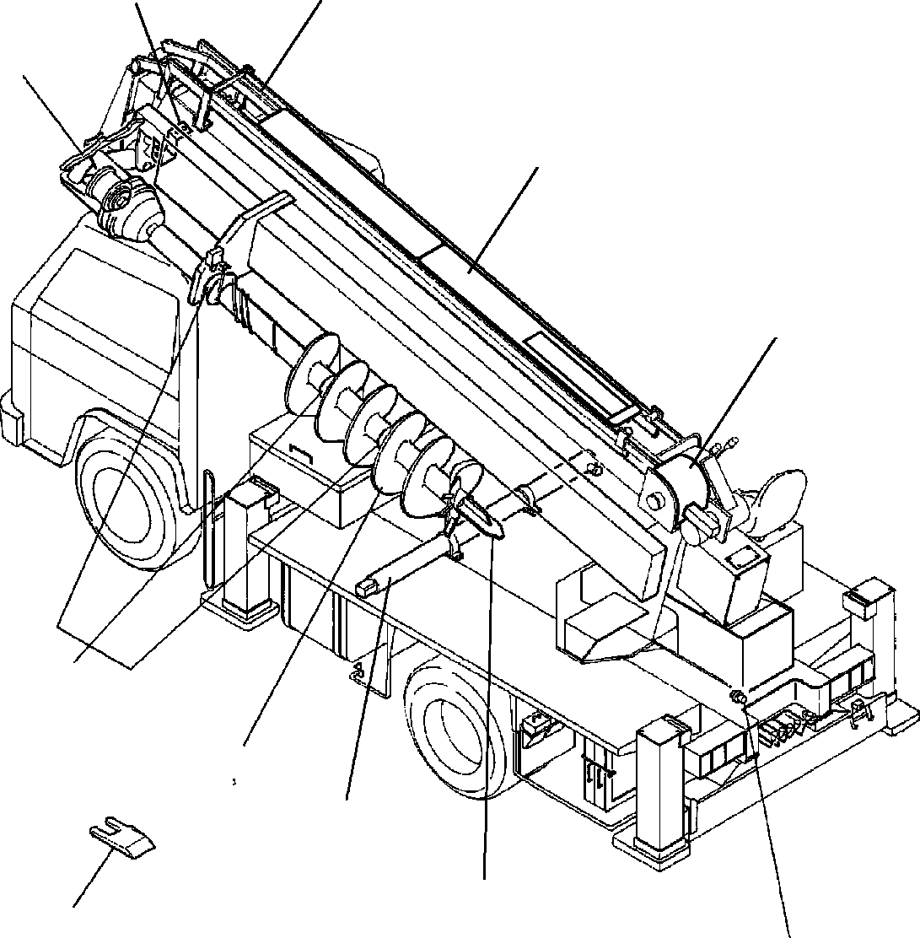
DT-600-2-00001 UPPER PY1000244-06 OPTIONS
8
13
6
10
9
21
1 2
3
4
5
7

DT-600-2-00001 UPPER
000012
Pos No.

Parts No
Parts Name
Qty
Unit
Technical Data
Serial No (Start)
Seria

1

2

3

4

5

6
7
8

9
10
13
21

(***********) (***********) (***********) (***********) (***********) 32471060000
(***********) (***********) (***********) (***********) (***********) (***********) 32490020100
(***********) (***********) (***********) (***********) (***********) (***********) (***********) (***********) (***********) 32470650000
(***********) (***********) (***********) (***********) (***********) (***********) (***********) (***********) (***********) (***********) (***********) (***********) (***********) (***********) (***********) (***********)
AUGER (300.PENGO) AUGER (600.OPTION) AUGER (400.R6,OPTION) AUGER (250.PENGO) AUGER (450,OPTION)
AUGER (650.S-TYPE,OPTION) AUGER (200)
AUGER (400.PENGO) AUGER (350.PENGO)
DRILL,AUGER (OPTION.450 R6) DRILL,AUGER (OPTION.450 R4) DRILL,AUGER (OPTION.450 R7) DRILL,AUGER (450 S) DRILL,AUGER (OPTION) DRILL,AUGER (OPTION.200 R2) DRILL,AUGER (OPTION) DRILL,AUGER (OPTION.450 R7) DRILL,AUGER (OPTION) SHAFT,AUGER (1.7M,OPTION) SHAFT,AUGER (2M,OPTION) HEAD,AUGER (450.D) HEAD,AUGER (R4/OPTION) HEAD,AUGER (450.DW) (OPTION) HEAD,AUGER (PENGO,450.PH) HEAD,AUGER (450.F/OPTION) HEAD,AUGER (550.R6/OPTION) HEAD,AUGER (400.R6) HEAD,AUGER (300.R4)
TOOTH (PENGO.PH/OPTION) TOOTH (PENGO,STD.P)/OPTION) SUPPORT,POLE
VALVE,MANUAL CONTROL (RELIEF VALVE) GUARD,WIRE (OPTION)
GUARD,WIRE (OPTION) GUARD,WIRE (OPTION) COVER (WINCH)
COVER (WIRE GUARD:2 PCS) GUARD ASSY
MOUNT (MARK)
1
1
1
1
1
1
1
1
1
1
1
1
1
1
1
1
1
1
1
1
1
1
1
1
1
1
1
1
1
1
1
1
1
1
1
1
1
1
1

275417

DT-600-2-00001 UPPER
PB1320073-01 VALVE,MANUAL CONTROL
PB1320168-00 VALVE,MANUAL CONTROL (RELIEF VALVE) PB1400045-02 PIPING,HYDRAULIC UPPER
PC5680001-00 COUPLING (AUGER/SHAFT) PD1010016-00 REDUCER,SWING SPEED PD1010084-00 REDUCER,SWING SPEED PD1010149-00 REDUCER,SWING SPEED PE1010041-03 CYLINDER,ELEVATING PF1010020-00 WINCH
PF1050040-01 HOOK PF1050042-00 HOOK PF1050042-00 HOOK PF1050059-00 HOOK
PF1050101-00 HOOK (SHEAVE 1 PC) PF1050201-01 HOOK
PF1070005-00 ROPE,WIRE PF1070005-00 ROPE,WIRE PF1400040-01 MOUNT,WINCH
PF1420001-00 GUARD,WIRE (OPTION) PF1420007-00 GUARD,WIRE (OPTION) PF1420008-00 GUARD,WIRE (OPTION) PG1010090-02 BOOM
PG1010383-05 BOOM
PG1050042-05 CYLINDER ASSY,TELESCOPING PG5200002-01 GUARD ASSY
PH1060036-02 DETECTOR,OVER WINDING PH1100006-00 DETECTOR,OVER FRONT AREA PH1100039-00 DETECTOR,OVER FRONT AREA PI1010011-01 MOTOR,HYDRAULIC (SWING) PI1010145-00 MOTOR,HYDRAULIC
PI1060001-00 CYLINDER,BRAKE PI1100006-01 VALVE,RELIEF PI1100008-01 VALVE,RELIEF PI1120034-01 VALVE,SOLENOID PI1140010-00 VALVE,CHECK
PI1250035-00 VALVE,COUNTERBALANCE PI1250063-00 VALVE,COUNTERBALANCE PI1250105-01 VALVE,COUNTERBALANCE PI1440007-00 METER,LOAD
PI5070003-00 INDICATOR ASSY,OVERWIND PK1100046-00 SWING FRAME
PK1100191-01 SWING FRAME PK1120052-03 SWING TABLE PK1200137-00 COVER,SWING FRAME PK1330253-00 COVER (WINCH)
PK1330414-00 COVER (WIRE GUARD:2 PCS) PL1010079-02 OPERATION SYSTEM, CONTROL VALVE PL1030067-02 OPERATION SYSTEM, ACCELERATOR PN1010184-03 ELECTRICAL ACCESSORIES PN1350070-02 REEL,CORD
PO1010166-02 PLATE,INDICATION PO1012579-01 PLATE ASSY,NAME (OIL) PP2010000-02 AUGER
PP2010002-02 AUGER (450,OPTION) PP2010009-03 AUGER (250.PENGO) PP2010010-01 AUGER (650.S-TYPE,OPTION) PP2010011-03 AUGER (300.PENGO) PP2010012-02 AUGER (400.PENGO) PP2010013-02 AUGER (350.PENGO) PP2010014-01 AUGER (200)
PP2010015-01 AUGER (600.OPTION) PP2010016-03 AUGER (450,P) PP2010017-00 AUGER
PP2010020-01 AUGER (400.R6,OPTION) PP2010027-02 AUGER (450)
PP2010030-00 AUGER (300)
PP2010031-00 AUGER (450) PP2020000-00 DRILL,AUGER (OPTION) PP2020001-00 DRILL,AUGER (OPTION)
PP2020005-02 DRILL,AUGER (OPTION.450 R6)
000013

DT-600-2-00001 UPPER
PP2020006-01 DRILL,AUGER (OPTION.450 R4) PP2020007-01 DRILL,AUGER (OPTION.200 R2) PP2020008-02 DRILL,AUGER (OPTION.450 R7) PP2020008-02 DRILL,AUGER (OPTION.450 R7) PP2020009-00 DRILL,AUGER (450 S) PP2020011-00 DRILL,AUGER (OPTION) PP2030000-01 DRIVING UNIT,AUGER PP2030002-02 DRIVING UNIT,AUGER PP2050002-01 MOUNT,AUGER
PP2050012-06 MOUNT,AUGER PP2050013-00 MOUNT,AUGER PP2050014-00 MOUNT,AUGER PP2050015-01 MOUNT,AUGER PP2100002-09 PIPING,AUGER PP2100009-00 PIPING,AUGER PP2100010-05 PIPING,AUGER
PP2150008-02 SHAFT,AUGER (2M,OPTION) PP2150012-02 SHAFT,AUGER (1.7M,OPTION) PP2170000-00 HEAD,AUGER (450.DW) (OPTION) PP2170001-02 HEAD,AUGER (PENGO,450.PH) PP2170002-01 HEAD,AUGER (450.D)
PP2170003-01 HEAD,AUGER (450.F/OPTION) PP2170004-02 HEAD,AUGER (550.R6/OPTION) PP2170005-02 HEAD,AUGER (R4/OPTION) PP2170006-01 HEAD,AUGER (400.R6) PP2170008-01 HEAD,AUGER (300.R4) PP2180000-01 TOOTH (PENGO.PH/OPTION) PP2180001-01 TOOTH (PENGO,STD.P)/OPTION) PS5040008-00 SCREW ASSY
PV5180003-00 VALVE ASSY,SELECTOR (MANUAL CONT.) PX1940020-00 MOUNT (MARK)
PX1940248-01 BOLT ASSY PY1040002-00 SUPPORT,POLE
000013

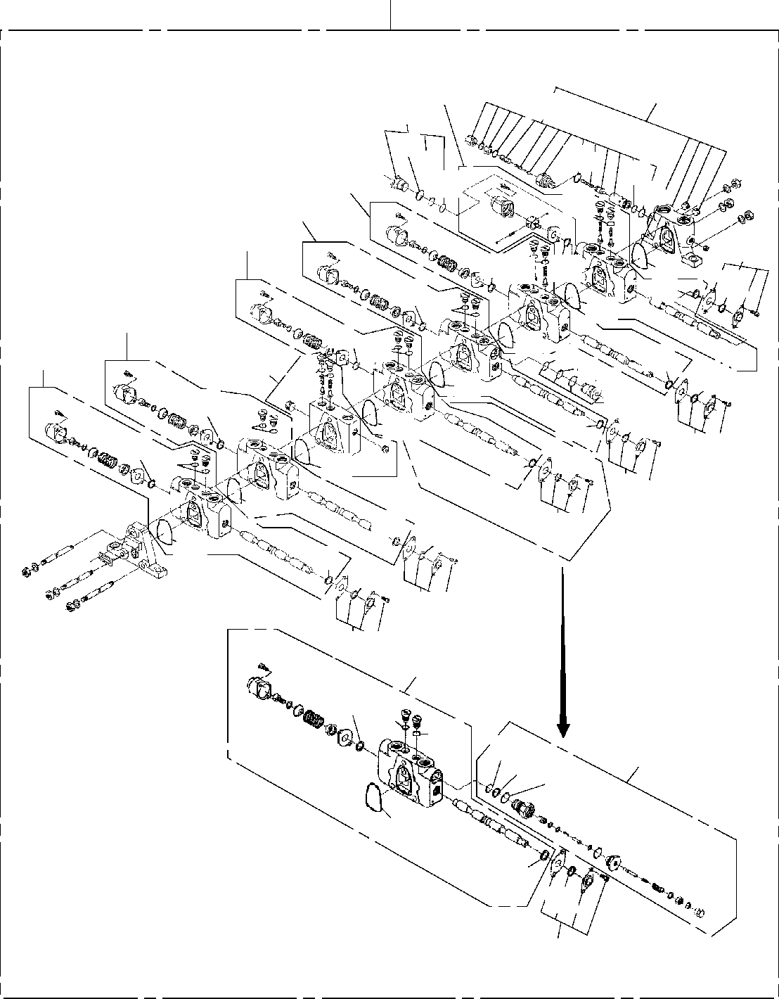
DT-600-2-00001 UPPER
PB1320073-01 VALVE,MANUAL CONTROL
200
101
102
116
43
121
43
22
44
45
48
47
103
104
105
109
13
1522
21
15
15
1522
21
107
15
21
22
108
4544
15
106
13
43
21
22
116
13
15
22
21
15
13
15
109
22
21
15
109
21
15
13
109
109
13
21
15
109
104
15 22
22
45
110
4443
21
15
13
109

DT-600-2-00001 UPPER
000014
Pos No.

Parts No
Parts Name
Qty
Unit
Technical Data
Serial No (Start)
Serial No (End

275087

275087

275087

275087

275087

3
13
15

21

22

43

44

45

47
48
101
102
103
104

105
106
107
108
109
110
116
121
200

36631065100
36631065110
36631065120
36631065120
36631065120
91001205500
91001205500
91001205500
91002801200
91002801200
91002801200
91001102100
91001102100
36631065130
36631065130
36631065140
36631065140
91001101600
91412001600
36631065010
36632045010
36631065030
36632285010
36632285010
36632045020
36631065060
36631065070
36631065150
36631065160
36631065090
36632285020
36631065080
36632280000
COVER,END SCRAPER RING,SEAL RING,SEAL RING,SEAL O-RING
O-RING O-RING O-RING O-RING O-RING O-RING O-RING
RING,BACKUP RING,BACKUP O-RING
O-RING O-RING
RING,BACKUP COVER ASSY (INLET)
VALVE,CONTROL (ATTACHMENT) VALVE,CONTROL (SWING) VALVE,CONTROL (ELEVATING) VALVE,CONTROL (ELEVATING) VALVE,CONTROL (TELESCOPE) VALVE,CHECK
VALVE,CONTROL (WINCH) VALVE,CONTROL (AUGER) CASE ASSY (SEAL) VALVE,RELIEF (175KG/CM2) PLUG ASSY
VALVE,RELIEF VALVE,MANUAL CONTROL
1
6
4
8
4
6
2
2
4
10
4
3
1
2
1
2
1
1
1
1
1
1
1
2
1
1
1
1
6
1
2
1
1

1A G55
1A G55
1A G55
1B P12
1B P12
1B P12
1A P21
1A P21

1A P16

275088

275088

275088

275088

275088

275088

275088

275088

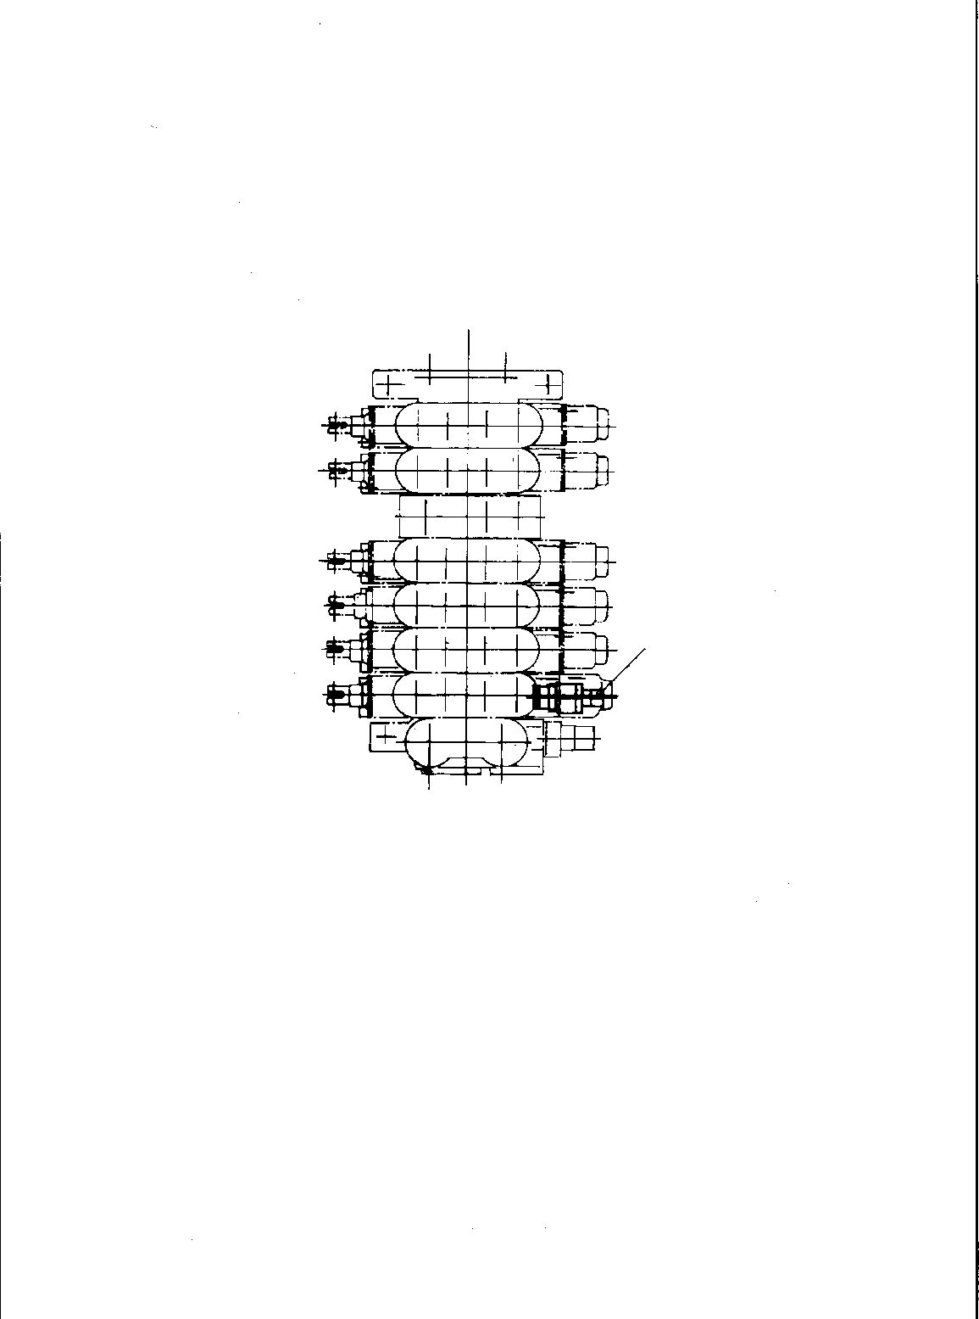
DT-600-2-00001 UPPER
PB1320168-00 VALVE,MANUAL CONTROL (RELIEF VALVE)
1

DT-600-2-00001 UPPER
000015
Pos No.

Parts No
Parts Name
Qty
Unit
Technical Data
Serial No (Start)
Serial No (End)
Remarks
Pages 00004
1

36601760000
VALVE,RELIEF
1

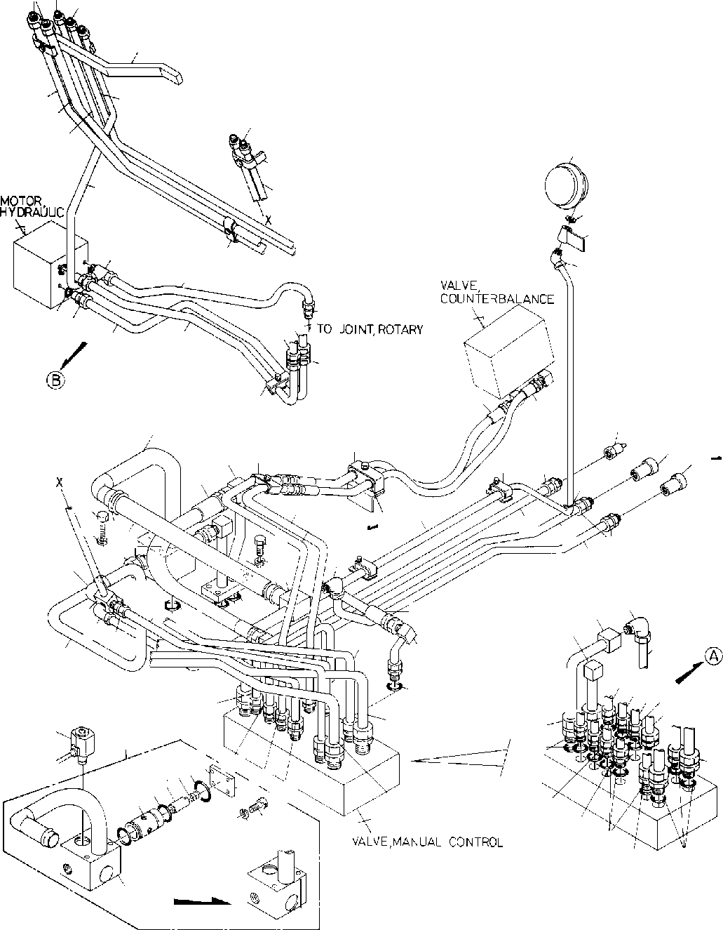
DT-600-2-00001 UPPER
PB1400045-02 PIPING,HYDRAULIC UPPER
2
41
1
40
53
52
58
59
1
66
47
50
42
68
67
48
4
39
6
16
4443
11
10
3
5
45
21
62
22
18
23
38
17 17
63
29
71
64 16
32
69
25
13
12
20
70
19
26 2827
7
81
34
15
31
16
14
26
9
33
34
51
33
30
35
46
4849
24
37
50
14
36
56
55
8
1511
132
59
19
52
60
61
92
23
95969798
10
54
12
939493
58
53
1
10099
57
55
56
55
91
91

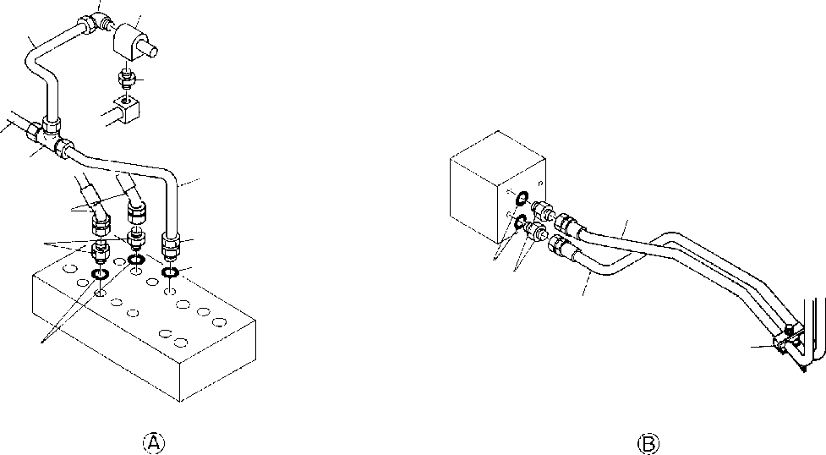
DT-600-2-00001 UPPER
PB1400045-02 PIPING,HYDRAULIC UPPER
34
72
74
73
33
77
75
76
3
3
57
55
8078
4443
3
7962
55

DT-600-2-00001 UPPER
000016
Pos No.

Parts No
Parts Name
Qty
Unit
Technical Data
Serial No (Start)
Serial No (End)
Rema

1
2
3

4
5
6
7
8
9
10
11
12
13
14
15
16
17
18
19
20
21

22

23
24
25
26
27
28
29
30
31
32

33
34

35

36
37
38
39
40
41
42
43

44
45
46
47
48
49
50
51
52
53
54
55
56
57

58
59
60

37000900110
37000910110
81408000160
37002428710
80305050100
81408000160
81408000160
80302010240
81408000241
80303030240
81408000160
81408000160
81408000160
81408000160
81408000160
81408000160
80302010160
80456010610
80456020610
81408000160
81408000130
37002417340
37002426570
37002417730
37002426580
32340188010
91001203500
90101510090
90302041001
37002502940
91801300480
32340180020
91002902500
90101510040
37002409350
37002425610
32340180030
80303030160
80303030160
80303030160
37002415480
37002404910
32340100050
32340180040
37000708060
37000708050
32340180050
37000900130
81408000160
80302090161
80400160129
91002801400
80301010100
32340180060
37000708040
80303030100
80302010200
81408000160
81408000210
81408000290
81408000290
80302090271
91002801800
80302090201
80302090151
80302090151
81408000160
81408000160
80302090281
JOINT JOINT PIPE,STEEL HOSE FITTING,TEE PIPE,STEEL PIPE,STEEL FITTING PIPE,STEEL
FITTING,ELBOW PIPE,STEEL PIPE,STEEL PIPE,STEEL PIPE,STEEL PIPE,STEEL PIPE,STEEL FITTING
JOINT,SELF SEALING JOINT,SELF SEALING PIPE,STEEL PIPE,STEEL
HOSE HOSE HOSE HOSE
VALVE ASSY O-RING BOLT
WASHER,SPRING HOSE
CLIP JOINT O-RING BOLT HOSE HOSE JOINT
FITTING,ELBOW FITTING,ELBOW FITTING,ELBOW HOSE
HOSE JOINT JOINT
CLAMP ASSY CLAMP ASSY CLAMP ASSY JOINT PIPE,STEEL FITTING JOINT
O-RING FITTING JOINT CLAMP ASSY
FITTING,ELBOW FITTING PIPE,STEEL PIPE,STEEL PIPE,STEEL PIPE,STEEL FITTING
O-RING FITTING FITTING FITTING PIPE,STEEL PIPE,STEEL FITTING
4
2
1
2
1
1
1
1
1
1
1
1
1
1
1
1
4
2
1
2
2
1
1
1
1
1
1
2
6
1
4
1
2
4
1
1
1
1
2
1
1
1
1
1
1
1
1
2
1
2
2
2
2
1
1
2
1
1
1
2
2
2
13
2
9
7
2
2
2

M

M M

M

M M M M M M

M M

M

M M M M

M M

12X1.4T L=1450 KTK12-030N 12X1.4T
12X1.4T

18X1.9T

12X1.4T
12X1.4T
12X1.4T
12X1.4T
12X1.4T
12X1.4T KCT12-030N

12X1.4T
10X1.8T L=750 L=750 L=825 L=825

1A G35 M10X90 10 L=450 D=43-48

1B G25 M10X40 L=530 L=530

KLN12-030N KLN12-030N KLN12-030N L=600 L=600

12X1.4T KCO12-030N

1B P14 KUA12-000N

KLN10-020N KCT15-040N 12X1.4T
15X2.0T
22X2.5T
22X2.5T KCO22-040N 1B P18 KCO15-040N KCO12-040N KCO12-040N 12X1.4T
12X1.4T KCO22-060N

275088

275041

275041

275034

275066
275088

275034

275088

275088

275087

275087

275087
275087

275040

275040

275033

275065
275087

275033

275087

275087

275087

275065

DT-600-2-00001 UPPER
000016
Pos No.

Parts No
Parts Name
Qty
Unit
Technical Data
Serial No (Start)
Serial No (End)
Rema

61
62

63
64
66
67
68
69
70
72
73
74
75
76
77
78
80
81
91
92
93
94
95
96
97
98
99
100

91002802400
37000708030
37000711090
37000714040
37000703420
37000700100
36681030000
32340180070
14115209000
91810130240
37000300740
36601080000
80306030040
81408000160
80305010100
81408000160
81408000160
80400160130
91810130250
37000300740
32340182000
36641460000
91001102600
32340182010
32340182020
59155306000
91001103600
32340182030
90131508025
90302040801
O-RING CLAMP ASSY CLAMP ASSY CLAMP ASSY CLAMP ASSY CLAMP ASSY METER,LOAD JOINT PACKING FASTENER SLEEVE VALVE,RELIEF JOINT,NIPPLE PIPE,STEEL FITTING,TEE PIPE,STEEL PIPE,STEEL JOINT FASTENER SLEEVE JOINT
VALVE,SOLENOID O-RING
SLEEVE VALVE SPRING O-RING COVER
BOLT,HEXAGON SOCKET WASHER,SPRING
2
1
1
1
1
2
1
1
3
1
1
1
1
1
1
1
1
2
2
1
1
1
2
1
1
1
1
1
4
4

1B P24

18X2
18X2

18-12

3/8
12X1.4T KTA12-000N 12X1.4T
12X1.4T S,G1/2-G3/8

18-12

1A P26

1A P36

M8X25 8

275088
275382

275066
275066
275066
275066
275066
275066
275088
275088
275294

275087
275381

275040
275087
275087
275087
275087
275087

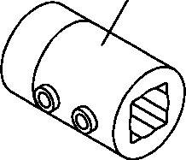
DT-600-2-00001 UPPER
PC5680001-00 COUPLING (AUGER/SHAFT)
1

DT-600-2-00001 UPPER
Rem
000017
Pos No.

Parts No
Parts Name
Qty
Unit
Technical Data
Serial No (Start)
Serial No (End)

1

32490520020
COUPLING (AUGER/SHAFT)
1

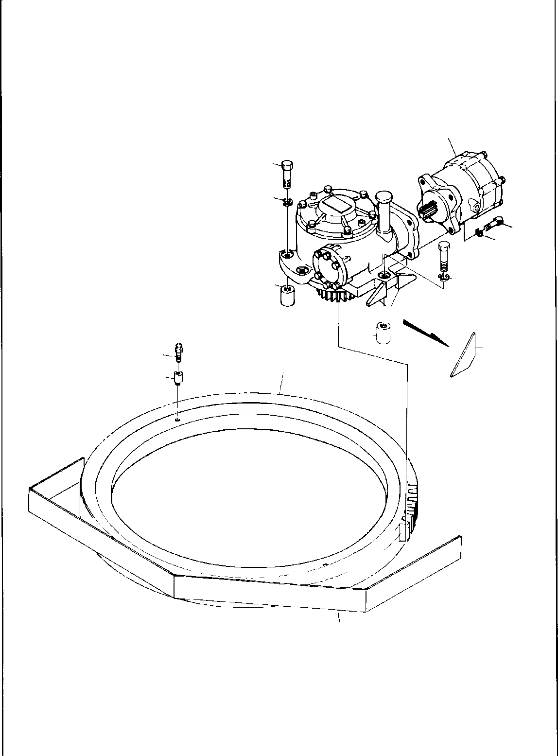
DT-600-2-00001 UPPER
PD1010016-00 REDUCER,SWING SPEED
1
4
5
2
9
3
4
5
7
6
7
6
11
12
8
10

DT-600-2-00001 UPPER
000018
Pos No.

Parts No
Parts Name
Qty
Unit
Technical Data
Serial No (Start)
Serial No (End)
Re

1
2
3
4
5
6

7
8
9
10
11
12

36660510000
90131512030
90302041201
90101514055
90302041401
32300000010
32300050030
32300050010
37002301350
36080250000
32300050020
82456101000
37000912420
MOTOR,HYDRAULIC (SWING) BOLT,HEXAGON SOCKET WASHER,SPRING
BOLT WASHER,SPRING PLATE
PLATE BOSS
BEARING,SWING REDUCER,SWING SPEED COVER
NIPPLE,GREASE JOINT
1
4
4
5
5
2
2
5
1
1
1
2
2

M12X30 12 M14X55 14

A-PT1/8

275023

275022

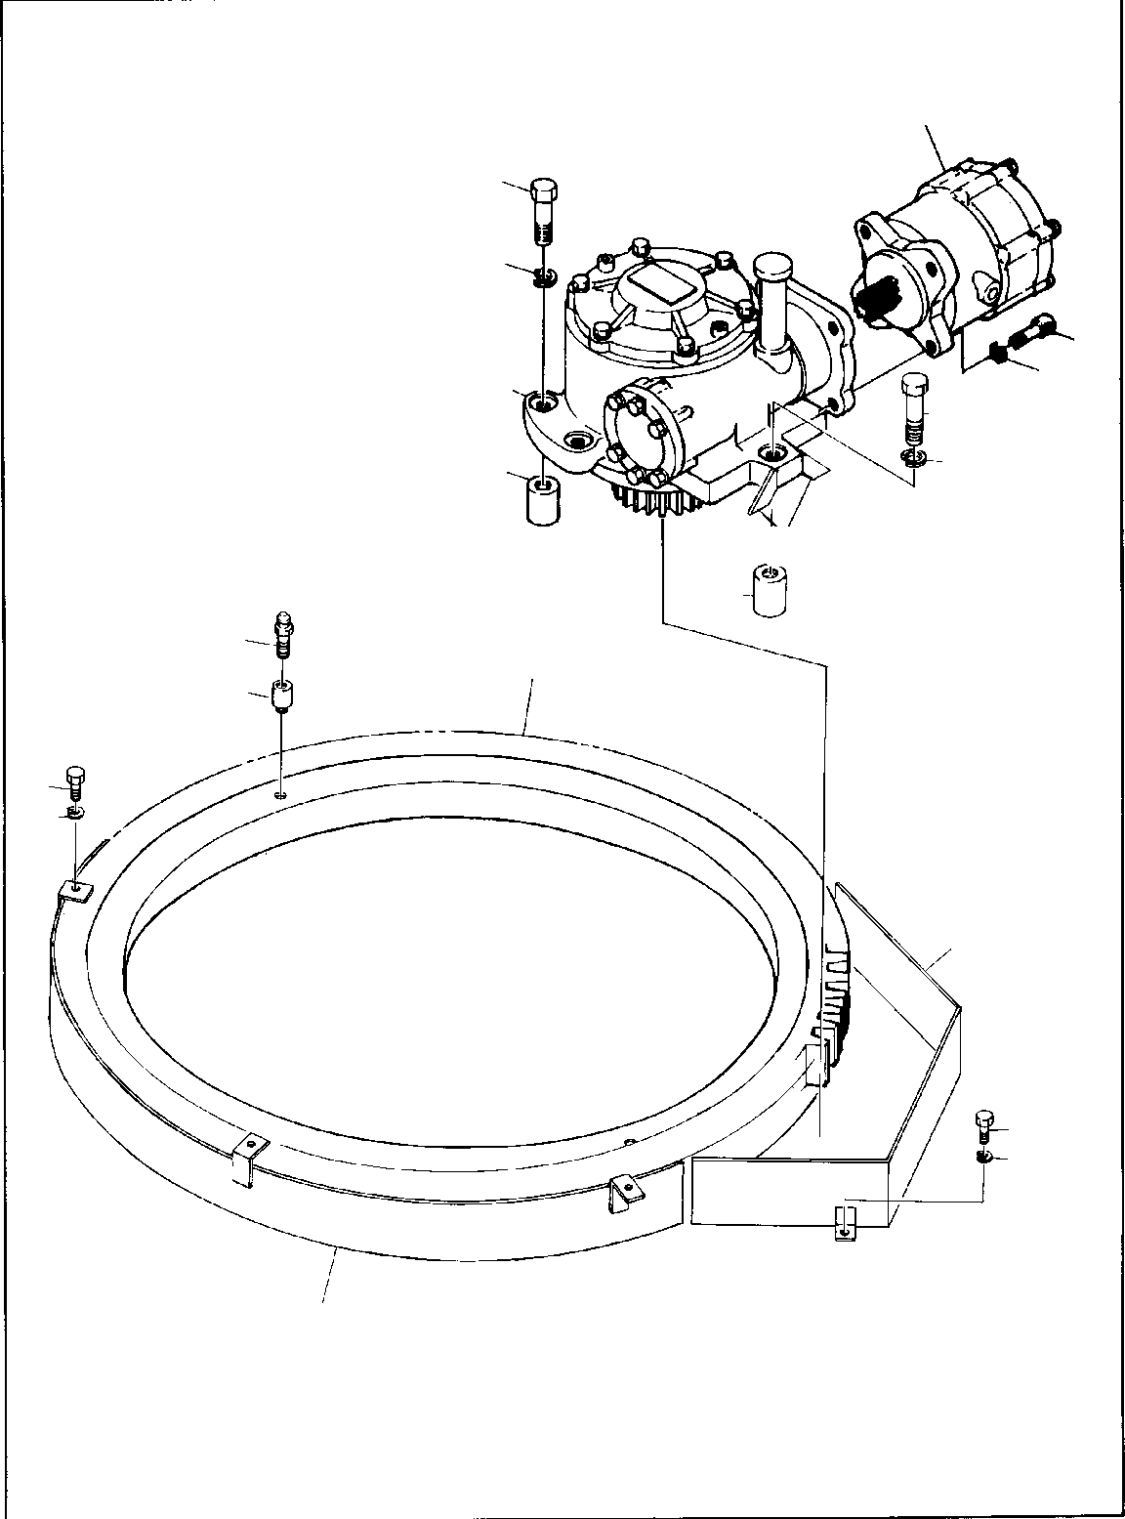
DT-600-2-00001 UPPER
PD1010084-00 REDUCER,SWING SPEED
1
4
5
2
9
3
4
5
7
6
7
11
12
8
15
14
10
15
14
16

DT-600-2-00001 UPPER
000019
Pos No.

Parts No
Parts Name
Qty
Unit
Technical Data
Serial No (Start)
Serial No (End)
Re

1
2
3
4
5
6
7
8
9
10
11
12
15
16

36660510000
90131512030
90302041201
90101514055
90302041401
32300050030
32300050010
37002302630
36080250000
32300190010
82456101000
37000912420
90302041001
32300190030
MOTOR,HYDRAULIC (SWING) BOLT,HEXAGON SOCKET WASHER,SPRING
BOLT WASHER,SPRING PLATE
BOSS BEARING,SWING
REDUCER,SWING SPEED COVER
NIPPLE,GREASE JOINT WASHER,SPRING COVER
1
4
4
5
5
2
5
1
1
1
2
2
5
1

M12X30 12 M14X55 14

A-PT1/8 10

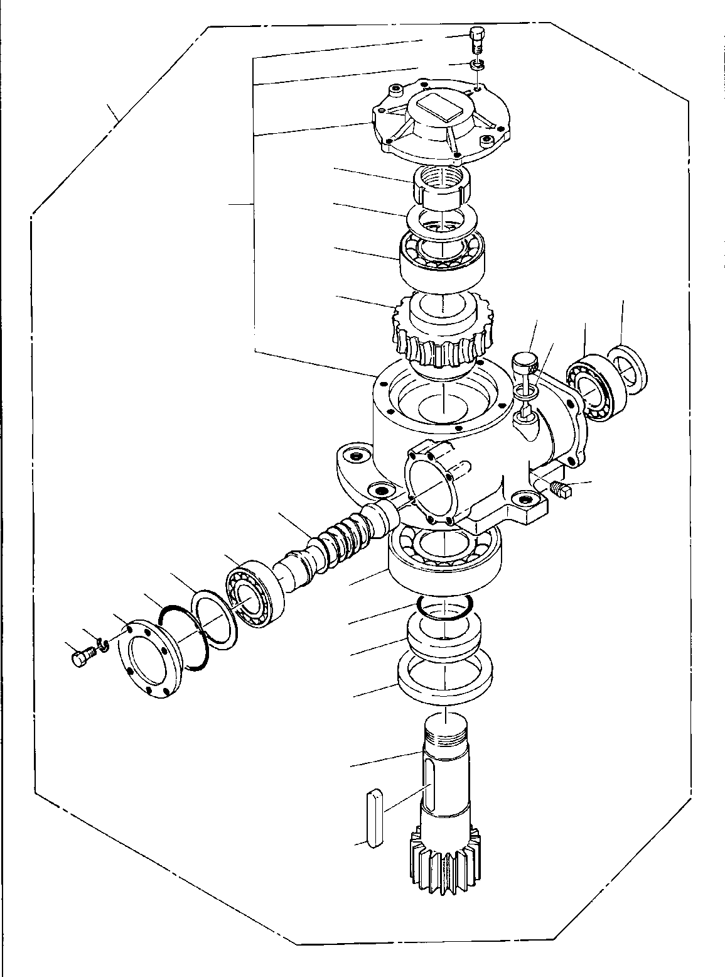
DT-600-2-00001 UPPER
PD1010149-00 REDUCER,SWING SPEED
31
32
100
34
33
51
29
45
27
48
49
42
44
43
41
42
40
39
38
25
23
22
37
32
31
24
21
28

DT-600-2-00001 UPPER
000020
Pos No.

Parts No
Parts Name
Qty
Unit
Technical Data
Serial No (Start)
Serial No (End)
Remar

21
22
23
24
25
27
28
29
31
32
33
34
37
38
39
40
41
42
43
44
45
48
49
51
100

36080205010
36080095020
91001207000
91216105001
80515006314
36080095040
36080095050
36080095130
90101510025
90302041001
80562100120
80561100120
12643302100
91001208500
12643302120
12643302130
12643302140
36080095120
36080095090
80205000200
36080095110
36080095072
36080235080
36080095150
36080250000
GEAR RING,SEAL O-RING SEAL,OIL
BEARING,BALL WHEEL,WORM KEY BEARING,BALL BOLT WASHER,SPRING WASHER,PLAIN NUT
RETAINER O-RING SHIM (T=0.1) SHIM (T=0.2) SHIM (T=0.3)
BEARING,ROLLER WORM
PLUG SEAL,OIL GAUGE,OIL WASHER,SEAL CASE ASSY
REDUCER,SWING SPEED
1
1
1
1
1
1
1
1
6
6
1
1
1
1
N N N 2
1
1
1
1
1
1
1

1A G70

M10X25 10 AW12 AN12

1A G85

PT1/4

M16

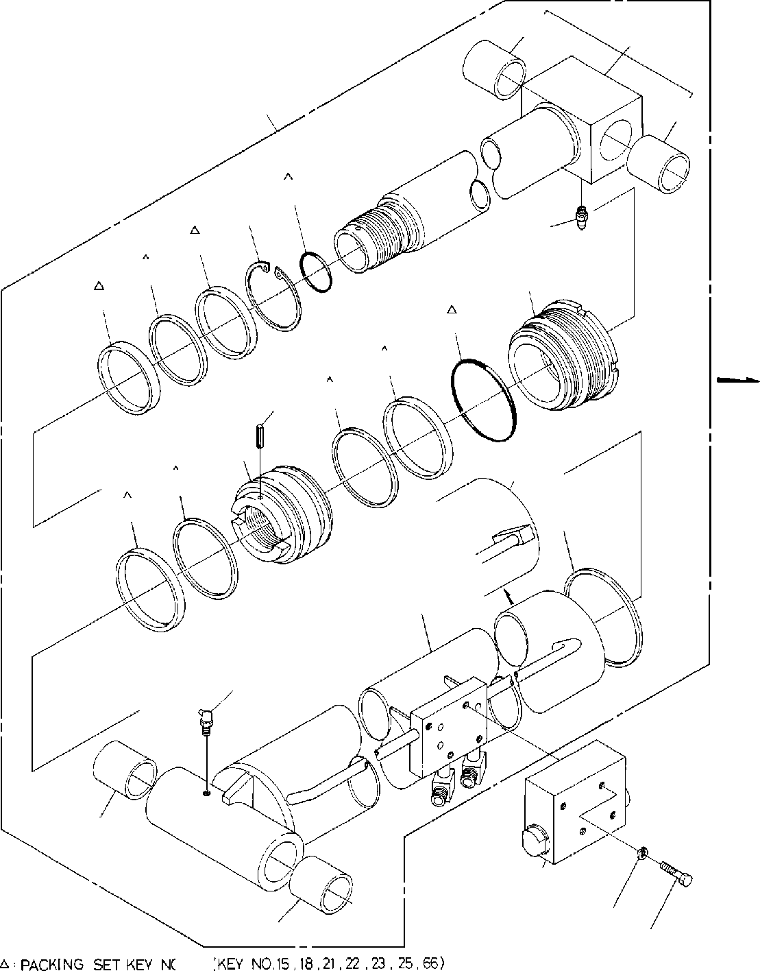
DT-600-2-00001 UPPER
PE1010041-03 CYLINDER,ELEVATING
11
69
1
11
18
26
27
25
23
20
22
21
15
66
14
17
12
66
15
24
12
13
11
2
3
11
4
100

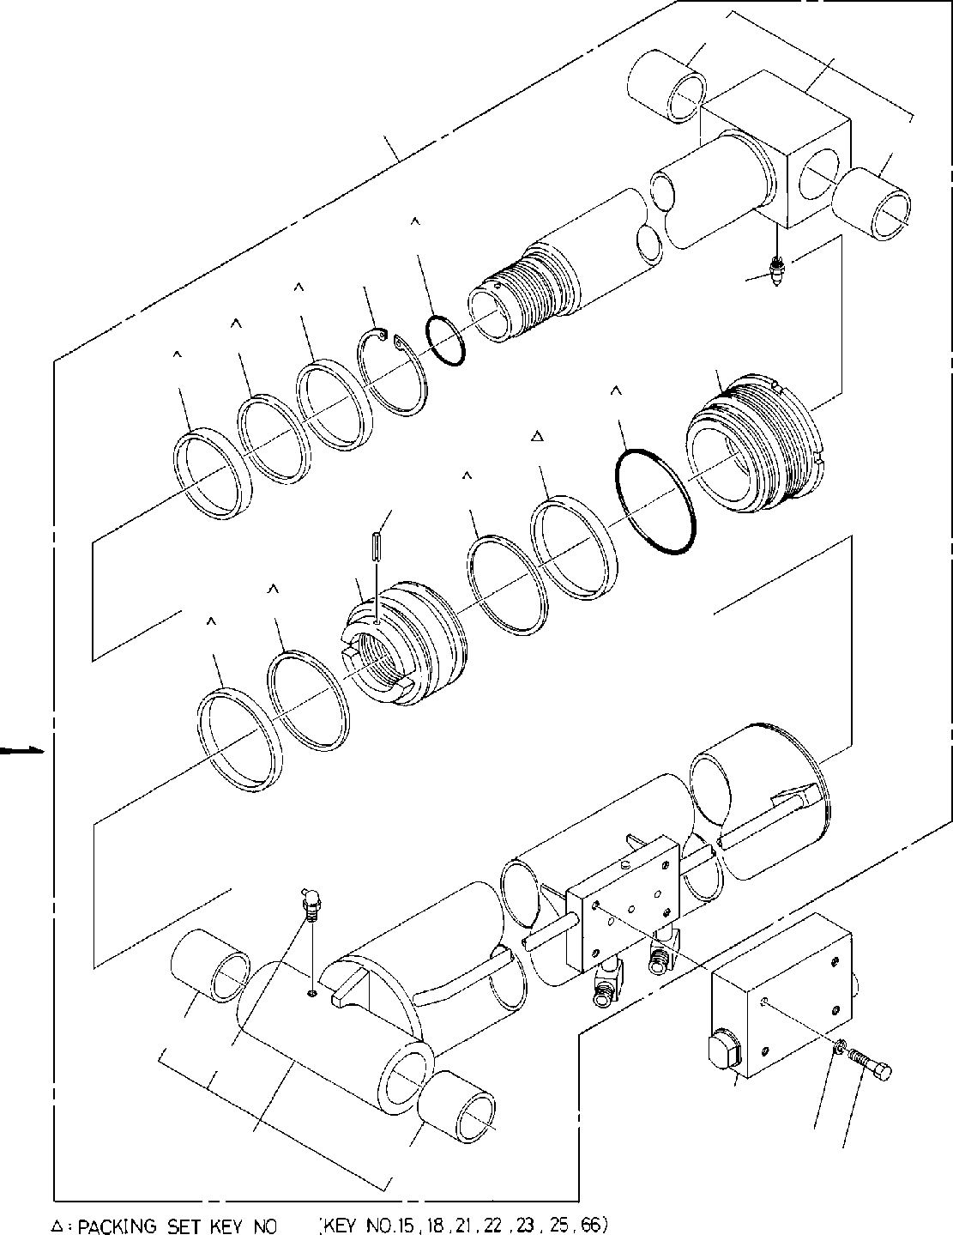
DT-600-2-00001 UPPER
PE1010041-03 CYLINDER,ELEVATING
11
69
1
11
18
26
27
25
23
20
22
21
15
66
14
17
66
15
11
13
2
3
62
11
4
100

DT-600-2-00001 UPPER
000021
Pos No.

Parts No
Parts Name
Qty
Unit
Technical Data
Serial No (Start)
Serial No (End)
Rem

1

2

3

4
11

12

13
14
15
17
18
20
21
22
23
24
25
26
27
62
66
69

100

36021670000
36023440000
36601030000
36603110000
90101208065
90101208070
90302040801
37000401400
37000401400
37000401400
37000403660
36021670010
36021670011
82458102000
80720105025
91684011500
36021670020
91002906000
36021670040
91002911000
91694008001
91410208001
36021670050
91660008000
80622000800
82456101000
36023449510
91411210001
36023719520
36021670030
36023449900
CYLINDER ASSY CYLINDER ASSY,DERRICK VALVE,COUNTERBALANCE VALVE,COUNTERBALANCE BOLT
BOLT WASHER,SPRING BEARING,PLAIN BEARING,PLAIN BEARING,PLAIN BEARING,PLAIN CYLINDER CYLINDER NIPPLE,GREASE PIN,SPRING PACKING PISTON
O-RING COVER,ROD O-RING PACKING RING,BACKUP WASHER SEAL,DUST
RING,RITAINING NIPPLE,GREASE CYLINDER ASSY RING,BACKUP ROD
ROD ASSY PACKING SET
1
1
1
1
4
4
4
2
2
2
4
1
1
1
1
2
1
1
1
1
1
1
1
1
1
1
1
2
1
1
1

M8X65 M8X70 8

B-PT1/8 5X25

1B G60

1B G110

SP80
A-PT1/8

100X160

275136

275136

275136

275136
275482

275104

275136

275482

275135

275135

275135

275481
275135
275481

275103
275135

275135

275481

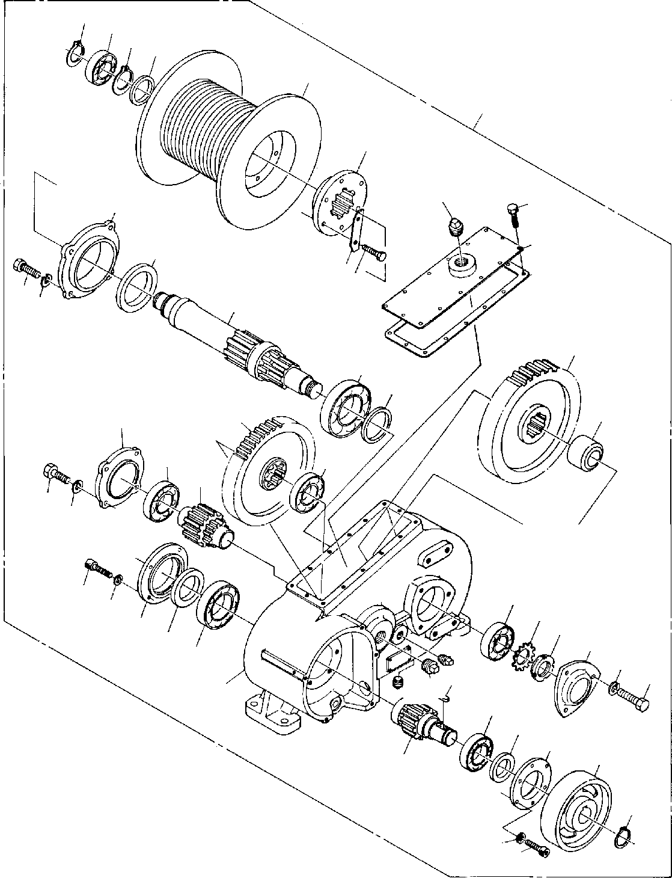
DT-600-2-00001 UPPER PF1010020-00 WINCH
9
43
4241
40
50
39
15
35
14
12
13
36
3837
28
24
29
20
21
22
11
30
34
17
17
19
2829
27
26
3
4
25
33 31
23
16
32
29
28
1618 8
1
10
6
5
2
7
9
4
3

DT-600-2-00001 UPPER
000022
Pos No.

Parts No
Parts Name
Qty
Unit
Technical Data
Serial No (Start)
Serial No (End)
Rema

1

2
3

4

5
6
7
8
9
10
11
12
13
14
15
16
17
18
19
20
21
22

23
24

25
26
27
28
29
30
31
32
33

34
35
36
37
38
39
40
41
42
43
46
50

36070945010
36070945011
36070565020
90131706018
90131706018
90302040601
90302040601
36070565030
91216040003
36070565040
36070565050
80601110350
80500006009
36070565060
36070945020
36070565080
36070565090
36070565100
80205000300
80500006208
80205000600
36070565110
36070565120
80500006212
36070305090
36070305091
36070565130
36070565140
36070565141
80561100070
80562100070
80500006207
90102210025
90302041001
36070565150
91216055002
80500006011
36070305020
36071435020
36070305040
36070305140
91216070002
90102512035
36070565160
36070565170
36070565180
36070565190
80601110450
80516006307
80303080080
36070940000
CASE,GEAR CASE,GEAR WHEEL,BRAKE
BOLT,HEXAGON SOCKET BOLT,HEXAGON SOCKET WASHER,SPRING WASHER,SPRING RETAINER (C)
SEAL,OIL GEAR,SPUR KEY RING,RITAINING BEARING,BALL GEAR,SPUR COVER PACKING
BOLT PLUG PLUG
BEARING,BALL PLUG GEAR,SPUR GEAR,SPUR BEARING,BALL SPACER SPACER RETAINER (B) DRUM,SHAFT DRUM,SHAFT NUT WASHER,PLAIN BEARING,BALL BOLT WASHER,SPRING SPACER (A) SEAL,OIL BEARING,BALL RETAINER (F) RETAINER (F) RETAINER (D) RETAINER (A) SEAL,OIL
BOLT PLATE
BOSS (DRUM) DRUM SPACER (B)
RING,RITAINING BEARING,BALL ELBOW
WINCH
1
1
1
10
12
10
12
1
1
1
1
2
1
1
1
1
14
1
2
2
1
1
1
1
1
1
1
1
1
1
1
1
11
11
1
1
1
1
1
1
1
1
6
3
1
1
1
1
1
1
1

M6X18 M6X18 6
6

S35

M6X12 PT3/4 PT3/8

PT3/4

AN07 AW07

M10X25 10

M12X35

S45

275099

275099

275099

275038

275038

275099

275017

275098

275098

275098

275037

275037

275098

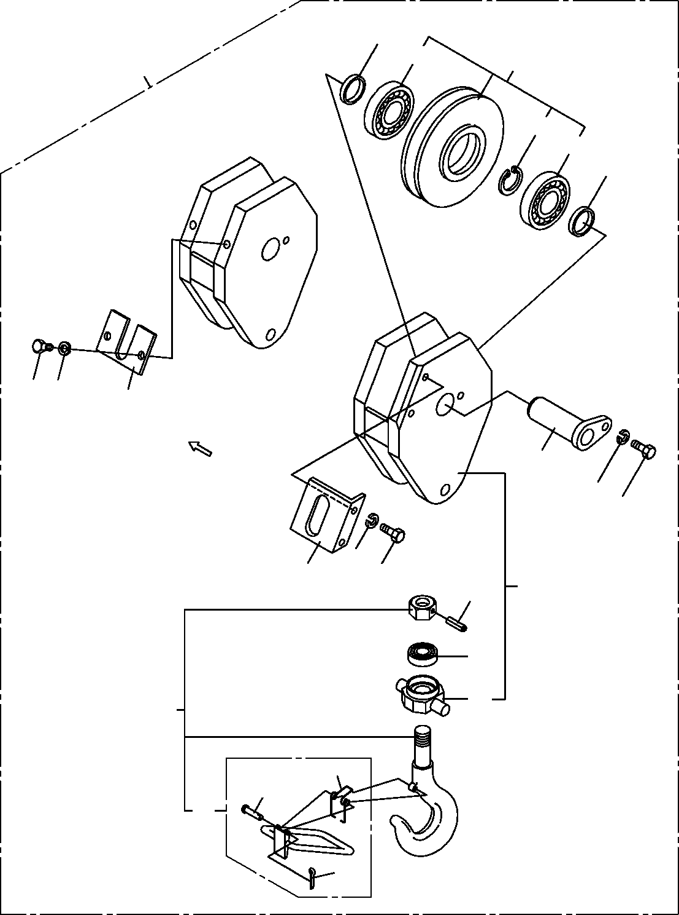
DT-600-2-00001 UPPER PF1050040-01 HOOK
2
23
4
30
22
23
2
16
17
6
3
8
7
8
6
7
1
9
14
25
20
12
10
13
11

DT-600-2-00001 UPPER
000023
Pos No.

Parts No
Parts Name
Qty
Unit
Technical Data
Serial No (Start)
Serial No (End)
Remarks
Pa

1
2
3
4
6
7
8
9
10
11
12
13
14
20
22
23
25
30

36091200010
37000303080
37000115430
37001003050
36091200020
90101210020
90302041001
80720105040
37000105180
80136316012
37001400020
36091209510
80500051205
36091209520
80602110800
80515006208
36091202000
36091200000
BODY SPACER PIN
SHEAVE ASSY SUPPORT BOLT
WASHER,SPRING PIN,SPRING
PIN PIN,SPLIT SPRING
STOPPER ASSY BEARING,BALL HOOK ASSY RING,RITAINING BEARING,BALL TRUNNION HOOK
1
2
1
1
1
3
3
1
1
1
1
1
1
1
1
2
1
1

L=7.5

M10X20 10
5X40

1.6X12

R80

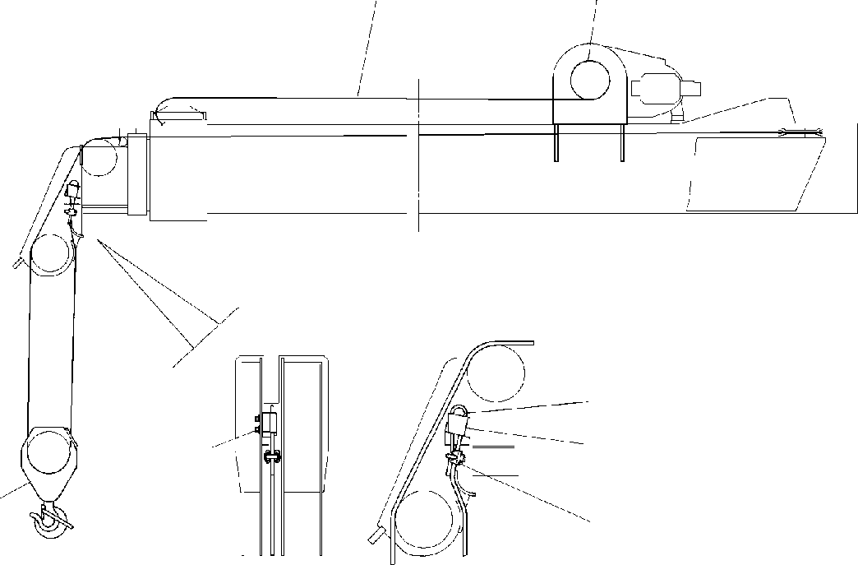
DT-600-2-00001 UPPER PF1050042-00 HOOK
2
1
7
6
459
3
8

DT-600-2-00001 UPPER
000024
Pos No.

Parts No
Parts Name
Qty
Unit
Technical Data
Serial No (Start)
Serial No (End)
Rema

1
2
3
4
5
6
7
8
9

13643002000
37001801490
36091200000
90131512028
90302041201
32290040010
14117602001
83151411000
90303071201
WEDGE ROPE,WIRE HOOK
BOLT,HEXAGON SOCKET WASHER,SPRING SOCKET
WEDGE CLIP
WASHER,PLAIN
1
1
1
2
2
1
1
1
2

M12X28 12

12

DT-600-2-00001 UPPER PF1050042-00 HOOK
2
1
7
6
459
3
8

DT-600-2-00001 UPPER
000025
Pos No.

Parts No
Parts Name
Qty
Unit
Technical Data
Serial No (Start)
Serial No (End)
Rema

1
2
3
4
5
6
7
8
9

13643002000
37001801700
36091840000
90131512028
90302041201
32290040010
14117602001
83151411000
90303071201
WEDGE ROPE,WIRE HOOK
BOLT,HEXAGON SOCKET WASHER,SPRING SOCKET
WEDGE CLIP
WASHER,PLAIN
1
1
1
2
2
1
1
1
2

M12X28 12

12

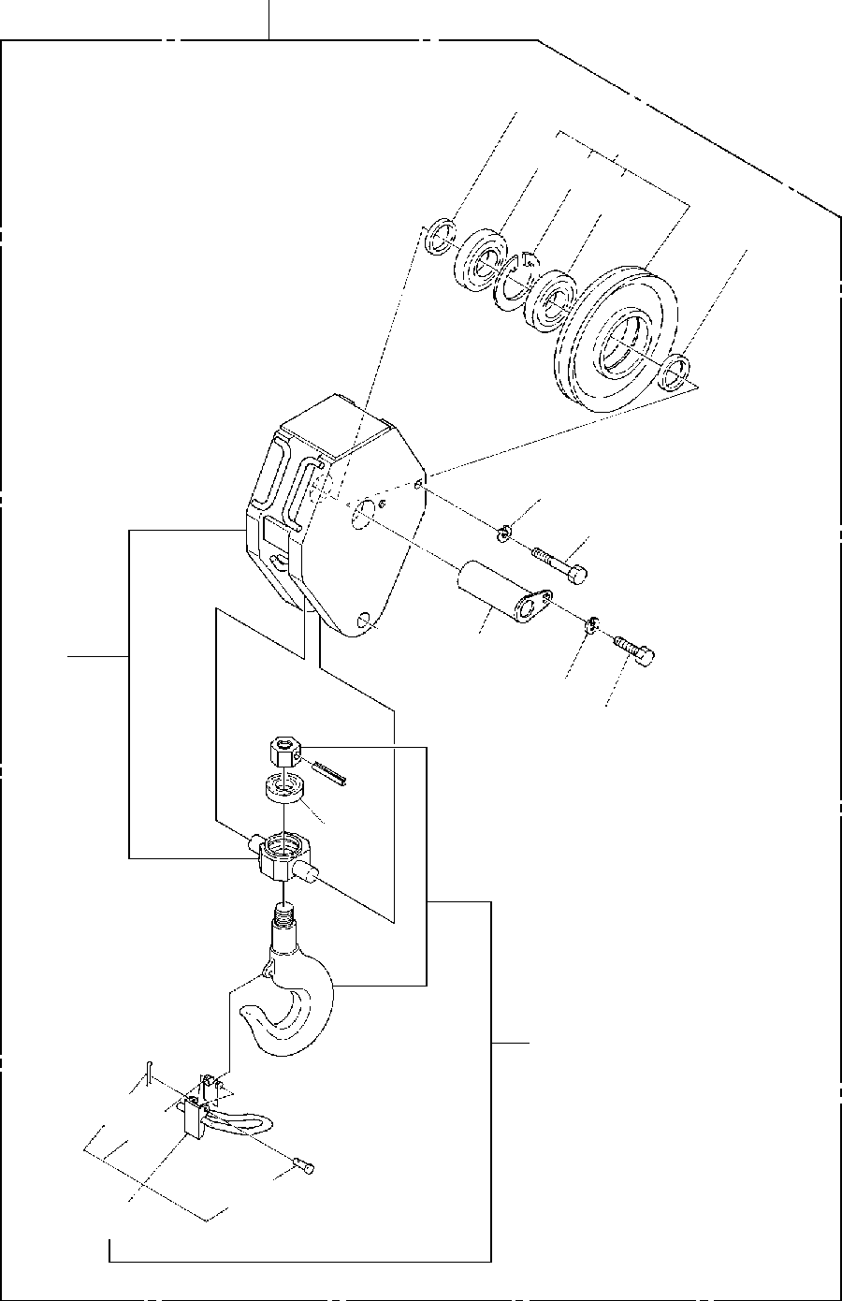
DT-600-2-00001 UPPER PF1050059-00 HOOK
40
2
4
33
32
33
2
16
6
3
1
8
7
9
14
30
1112
10
13

DT-600-2-00001 UPPER
000026
Pos No.

Parts No
Parts Name
Qty
Unit
Technical Data
Serial No (Start)
Serial No (End)
Remarks
Pa

1
2
3
4
6
7
8
9
10
11
12
13
14
16
30
32
33
40

36091840010
37000303080
37000115430
37001003050
90101208100
90101210020
90302041001
80720105040
37000105180
80136316012
37001400020
36091849510
80500051205
90302040801
36091849520
80602110800
80515006208
36091840000
BODY SPACER PIN
SHEAVE ASSY BOLT
BOLT WASHER,SPRING PIN,SPRING
PIN PIN,SPLIT SPRING
STOPPER ASSY BEARING,BALL WASHER,SPRING HOOK ASSY RING,RITAINING BEARING,BALL HOOK
1
2
1
1
1
1
1
1
1
1
1
1
1
1
1
1
2
1

L=7.5

M8X100 M10X20 10
5X40

1.6X12

8

R80

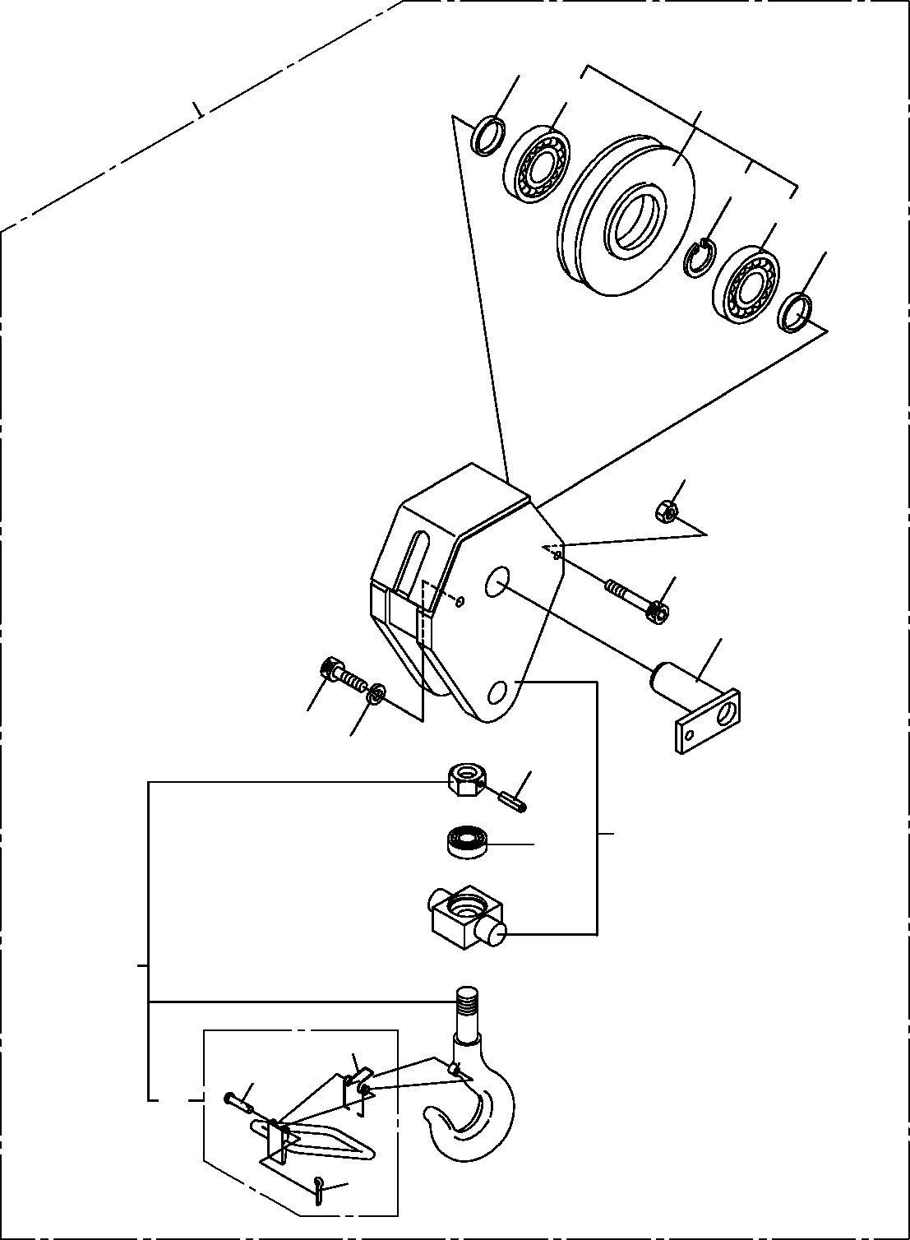
DT-600-2-00001 UPPER
PF1050101-00 HOOK (SHEAVE 1 PC)
2
50
43
4
42
43
2
16
15
3
10
11
5
1
7
30
14
12
31
13

DT-600-2-00001 UPPER
000027
Pos No.

Parts No
Parts Name
Qty
Unit
Technical Data
Serial No (Start)
Serial No (End)
Rema

1
2
3
4
5

7
10

11
12
13
14
15

16
30
31
42
43
50

36092390010
37000303080
36092390020
37001003050
80720105040
80720105045
80500051205
90131510035
90172110035
90302041001
37000105180
80136316012
37001400020
90131508085
90172108085
90201200800
36091209520
36091209510
80602110800
80515006208
36092390000
BODY SPACER PIN
SHEAVE ASSY PIN,SPRING PIN,SPRING BEARING,BALL
BOLT,HEXAGON SOCKET BOLT,HEXAGON SOCKET WASHER,SPRING
PIN PIN,SPLIT SPRING
BOLT,HEXAGON SOCKET BOLT,HEXAGON SOCKET NUT
HOOK ASSY STOPPER ASSY RING,RITAINING BEARING,BALL HOOK (SHEAVE 1 PC)
1
2
1
1
1
1
1
1
1
1
1
1
1
1
1
1
1
1
1
2
1

L=7.5

5X40
5X45

M10X35 M10X35 10

1.6X12

M8X85 M8X85 M8

R80

275291

275832

275832

275290

275831

275831

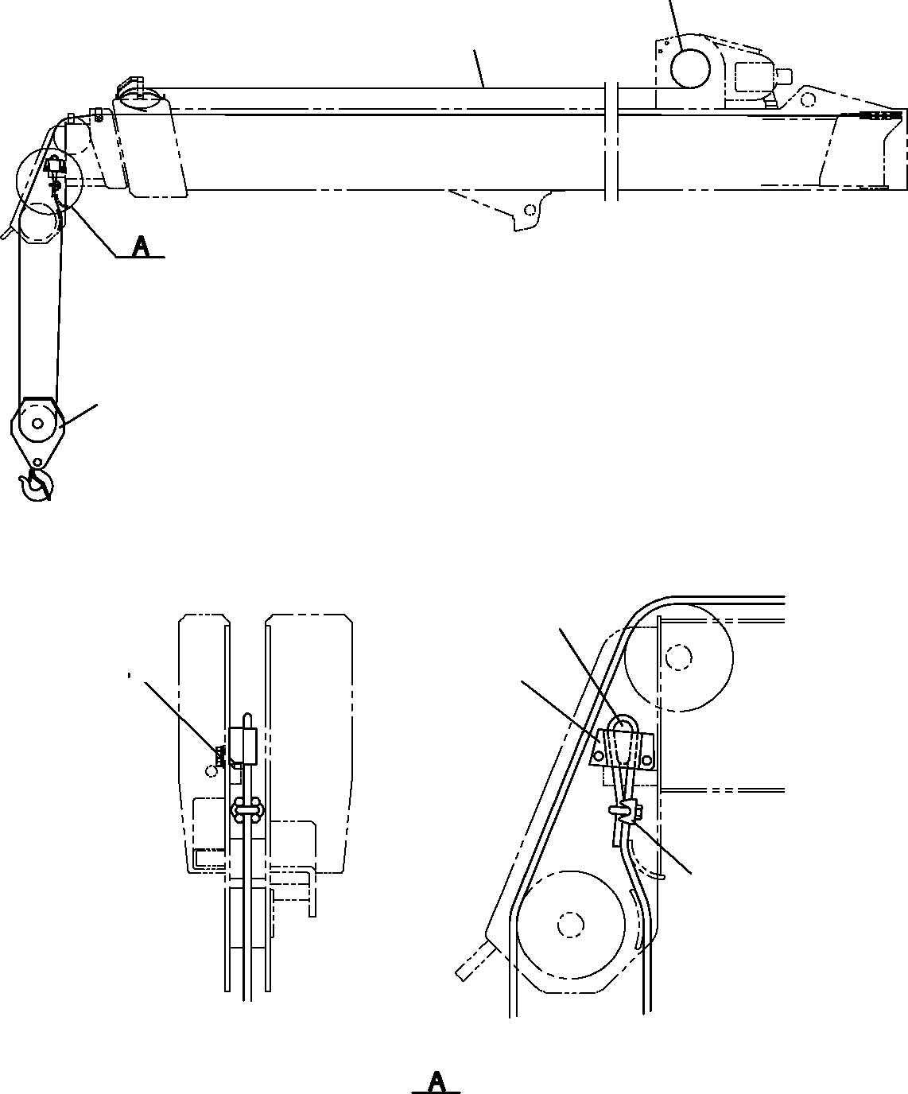
DT-600-2-00001 UPPER PF1050201-01 HOOK
1
2
3
5
7
8 9
4
6

DT-600-2-00001 UPPER
000028
Pos No.

Parts No
Parts Name
Qty
Unit
Technical Data
Serial No (Start)
Serial No (End)
Remarks
1
2
3
4
5
6
7
8
9

13643002000
37001801700
36092390000
32290260010
14117602001
83151411000
90101512030
90302041201
90303071201
WEDGE ROPE,WIRE
HOOK (SHEAVE 1 PC) SOCKET
WEDGE CLIP BOLT
WASHER,SPRING WASHER,PLAIN
1
1
1
1
1
1
2
2
2

M12X30 12
12

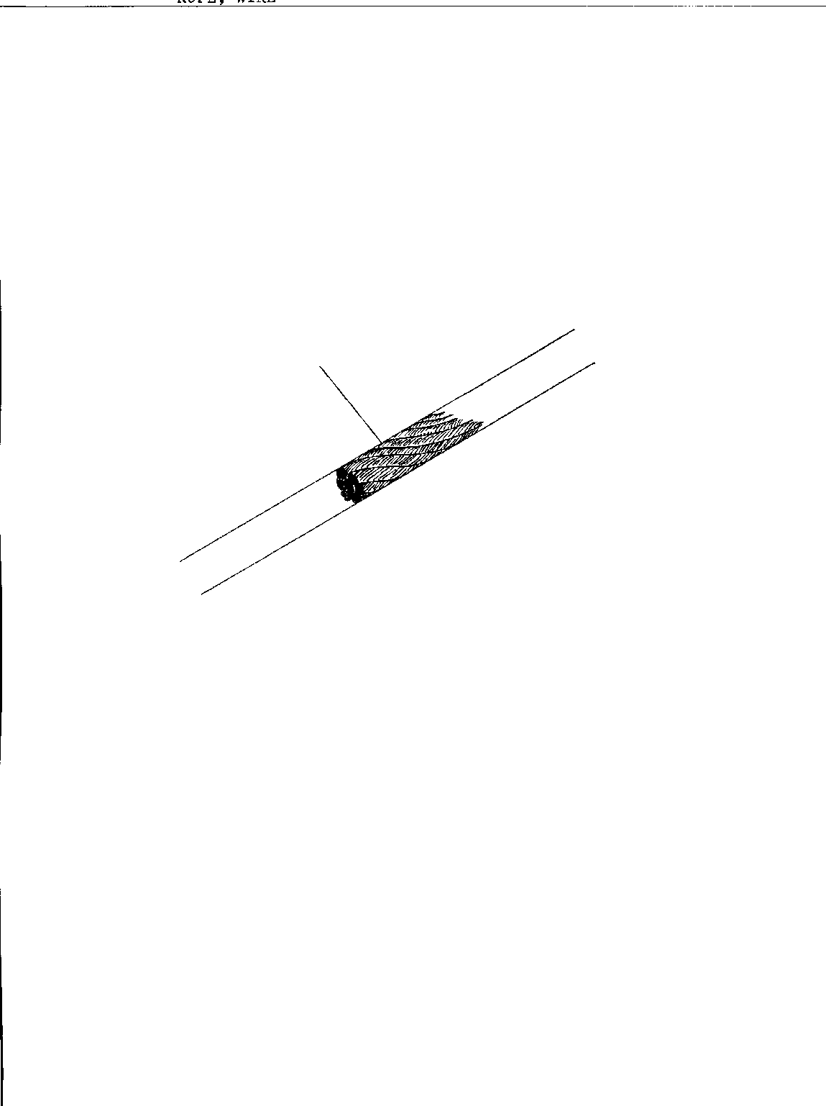
DT-600-2-00001 UPPER PF1070005-00 ROPE,WIRE
1

DT-600-2-00001 UPPER
000029
Pos No.

Parts No
Parts Name
Qty
Unit
Technical Data
Serial No (Start)
Serial No (End)
Remarks
Pages
1

37001801490
ROPE,WIRE
1

DT-600-2-00001 UPPER PF1070005-00 ROPE,WIRE
1

DT-600-2-00001 UPPER
000030
Pos No.

Parts No
Parts Name
Qty
Unit
Technical Data
Serial No (Start)
Serial No (End)
Remarks
Pages
1

37001801700
37001801700
ROPE,WIRE ROPE,WIRE
1
1

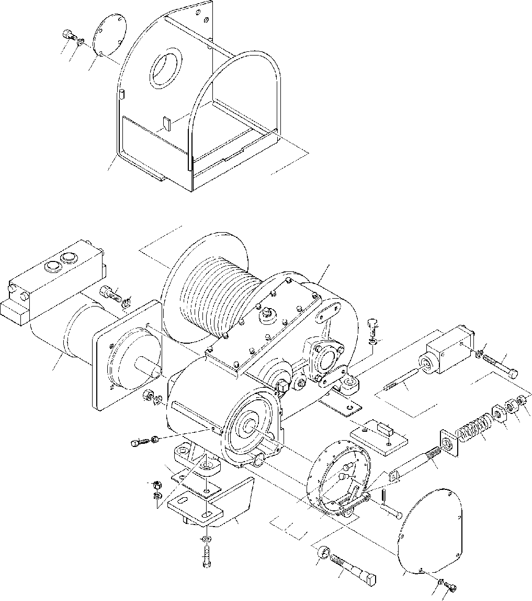
DT-600-2-00001 UPPER PF1400040-01 MOUNT,WINCH
3031
32
71
1
33
10
26
10
24
23
25
29
22
27
3637
28
72
2021
5
27
4
19
18
16
17
9
10
15
14
5657
55
12
11
8
13
35
34
3
7 6

DT-600-2-00001 UPPER
000031
Pos No.

Parts No
Parts Name
Qty
Unit
Technical Data
Serial No (Start)
Serial No (End)
Rema

1
3
4
5
6
7
8
9
10
11
12
13
14
15
16
17
18
19
20
21
22
23
24
25
26
27
28
29
30
31
32
33
34
35
36
37
55
56
57
71
72

36070940000
32310030030
90102206035
90201200600
90131506012
90302040601
90101512050
90201401200
90302041201
90303071201
32310040020
32310030020
37000115190
80720103020
32310010040
32310010100
37001200450
32310010030
90203252000
90203201200
32310010020
90101510070
90302041001
36060500000
90101512035
32310030050
37000507550
36660820000
90101208012
90302040801
32310030010
90101512040
37001501460
37000302160
90201201400
90302041401
32310034050
32310034060
32310034070
32310042010
32310032010
WINCH COVER BOLT NUT
BOLT,HEXAGON SOCKET WASHER,SPRING
BOLT NUT
WASHER,SPRING WASHER,PLAIN SUPPORT
BAND PIN
PIN,SPRING SUPPORT ROD SPRING SUPPORT NUT
NUT ROD BOLT
WASHER,SPRING CYLINDER,BRAKE BOLT
PLATE PLATE
MOTOR,HYDRAULIC BOLT WASHER,SPRING COVER
BOLT BOLT SPACER NUT
WASHER,SPRING LINING
RIVET RIVET SUPPORT PLATE
1
1
3
3
5
5
2
2
6
2
1
1
1
1
1
1
1
1
1
1
1
2
2
1
2
2
1
1
4
4
1
2
1
1
1
1
4
20
4
1
1

M6X35 M6 M6X12 6 M12X50 M12
12
12

3X20

M12

M10X70 10

M12X35

M8X12 8

M12X40

M14 14

3.9X9
3.9X11

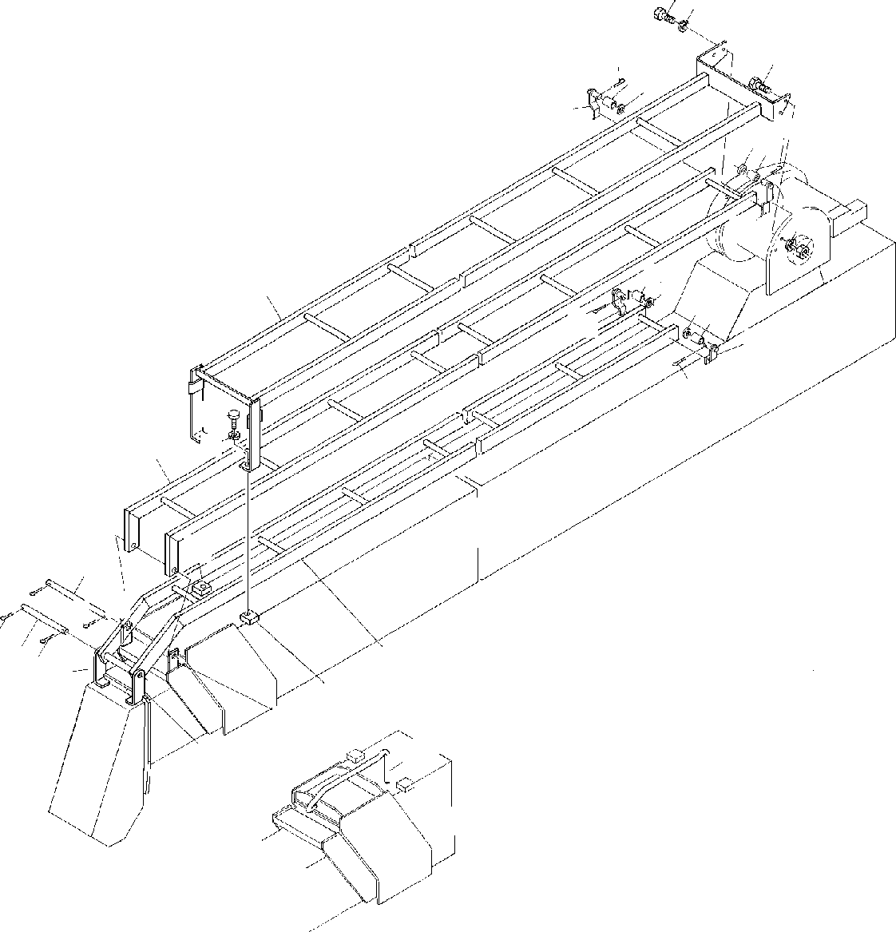
DT-600-2-00001 UPPER
PF1420001-00 GUARD,WIRE (OPTION)
1718
17
16
1415
12
15 16
14
1819
12
1415
1
1514
1613
13
16
20
21
2
10
6
7
5
7
7
8 7
3
9
10
5
11
4

DT-600-2-00001 UPPER
000032
Pos No.

Parts No
Parts Name
Qty
Unit
Technical Data
Serial No (Start)
Serial No (End)
Remarks
Pa

1
2
3
4
5
6
7
8
9
10
11
12
13
14
15
16
17
18
19
20
21

32470180010
32470180020
32470180030
32470180040
37000530000
37000127820
80136350032
37000127160
32470180050
32470122010
32470120080
32470120090
32470120100
37001103020
37000524650
80136340020
90101210025
90302041001
90201201000
90101212022
90302041201
GUARD GUARD GUARD SUPPORT PLATE PIN PIN,SPLIT PIN SUPPORT PLATE GUARD SUPPORT SUPPORT ROLLER PLATE PIN,SPLIT BOLT
WASHER,SPRING NUT
BOLT WASHER,SPRING
1
1
1
1
2
1
4
1
1
2
1
2
2
4
4
4
4
4
2
2
2

5X32

T=2.3 TO 2.5 4X20 M10X25
10
M10 M12X22 12

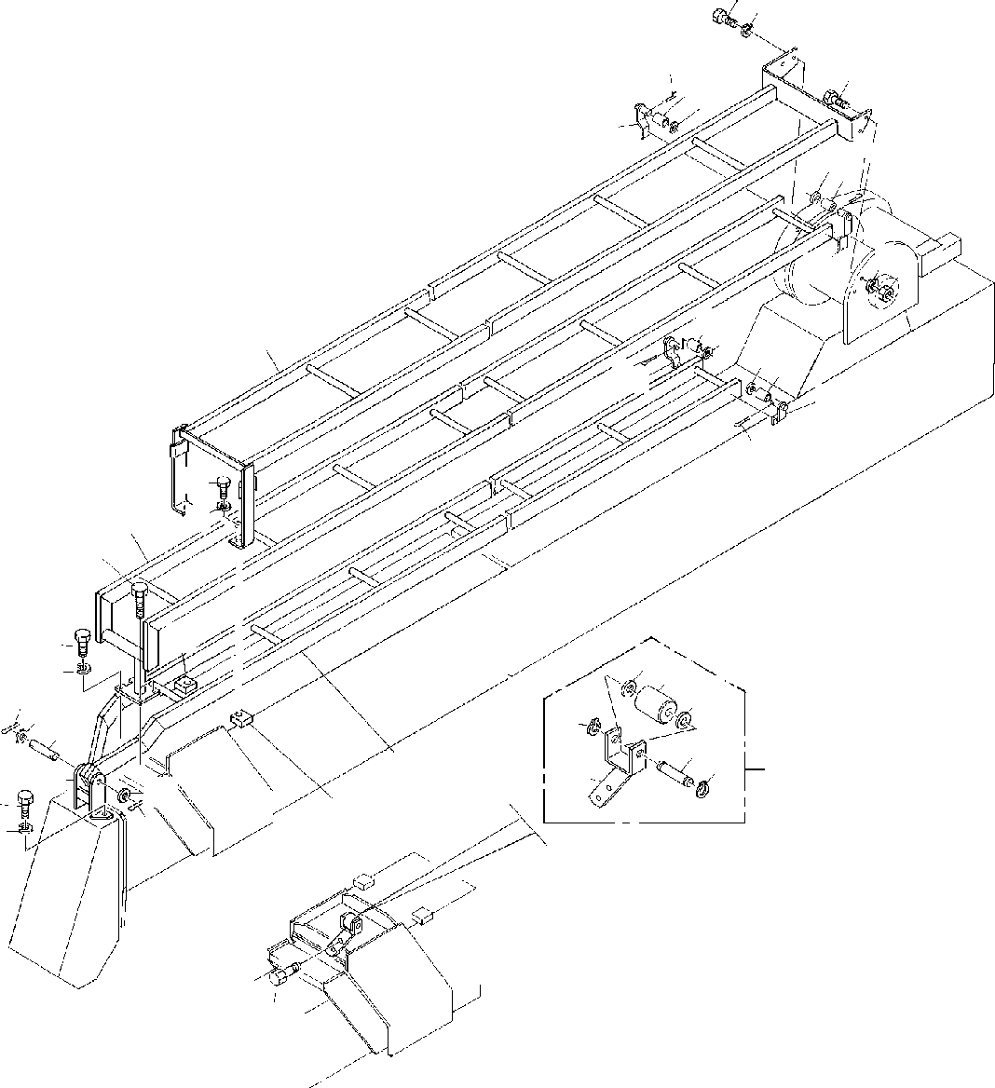
DT-600-2-00001 UPPER
PF1420007-00 GUARD,WIRE (OPTION)
1718
16
1415
17
12
16
1514
1819
12
1415
1
1514
1613
13
16
20
21
2
5
10
17
18
32
31
32
722
4
34
8
33
34
11
3
35
22
7
17
18
10
9

DT-600-2-00001 UPPER
000033
Pos No.

Parts No
Parts Name
Qty
Unit
Technical Data
Serial No (Start)
Serial No (End)
Remarks
Pa

1
2
3
4
5
7
8
9
10
11
12
13
14
15
16
17
18
19
20
21
31
32
33
34
35

32470180010
32471370020
32471370030
32471330020
90101210040
80136350032
37000126070
90101508030
32470122010
32470450050
32470120090
32470120100
37001103020
37000524650
80136340020
90101210025
90302041001
90201201000
90101212022
90302041201
37001104840
90303071401
37000136210
80601110150
32470452000
GUARD GUARD GUARD SUPPORT BOLT PIN,SPLIT PIN
BOLT PLATE
ROLLER ASSY SUPPORT SUPPORT ROLLER PLATE PIN,SPLIT BOLT
WASHER,SPRING NUT
BOLT WASHER,SPRING ROLLER WASHER,PLAIN PIN RING,RITAINING SUPPORT
1
1
1
1
2
2
1
2
2
1
2
2
4
4
4
8
8
2
2
2
1
2
1
2
1

M10X40 5X32

M8X30

T=2.3 TO 2.5 4X20 M10X25
10
M10 M12X22 12

14

15

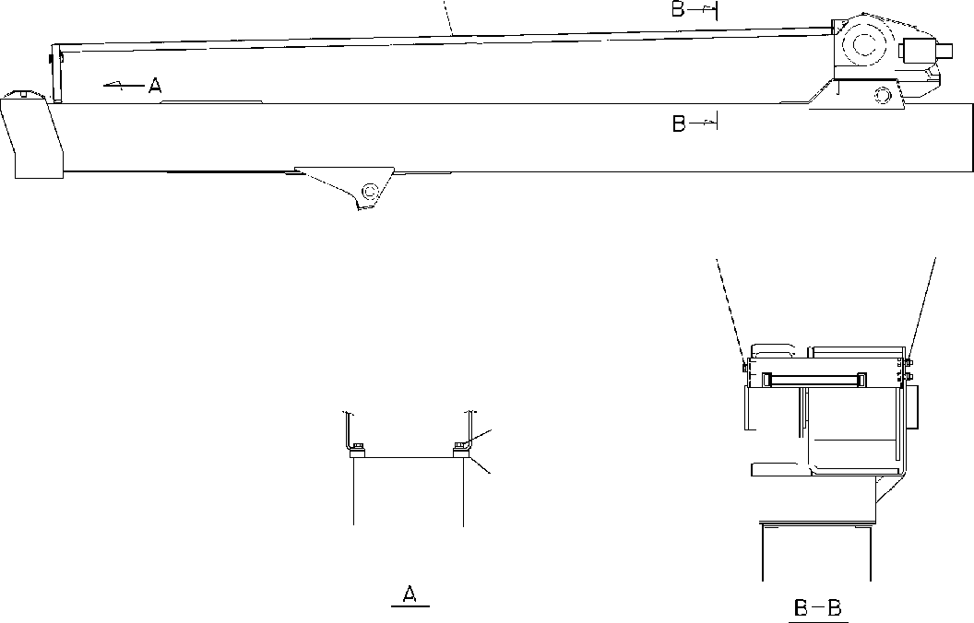
DT-600-2-00001 UPPER
PF1420008-00 GUARD,WIRE (OPTION)
1
1718
171819
4 3
2

DT-600-2-00001 UPPER
000034
Pos No.

Parts No
Parts Name
Qty
Unit
Technical Data
Serial No (Start)
Serial No (End)
Remarks
Pa

1
2
3
4
17
18
19

32470180010
32470122010
90101212022
90302041201
90101210025
90302041001
90201201000
GUARD PLATE BOLT
WASHER,SPRING BOLT WASHER,SPRING NUT
1
2
2
2
4
4
2

M12X22 12 M10X25 10
M10

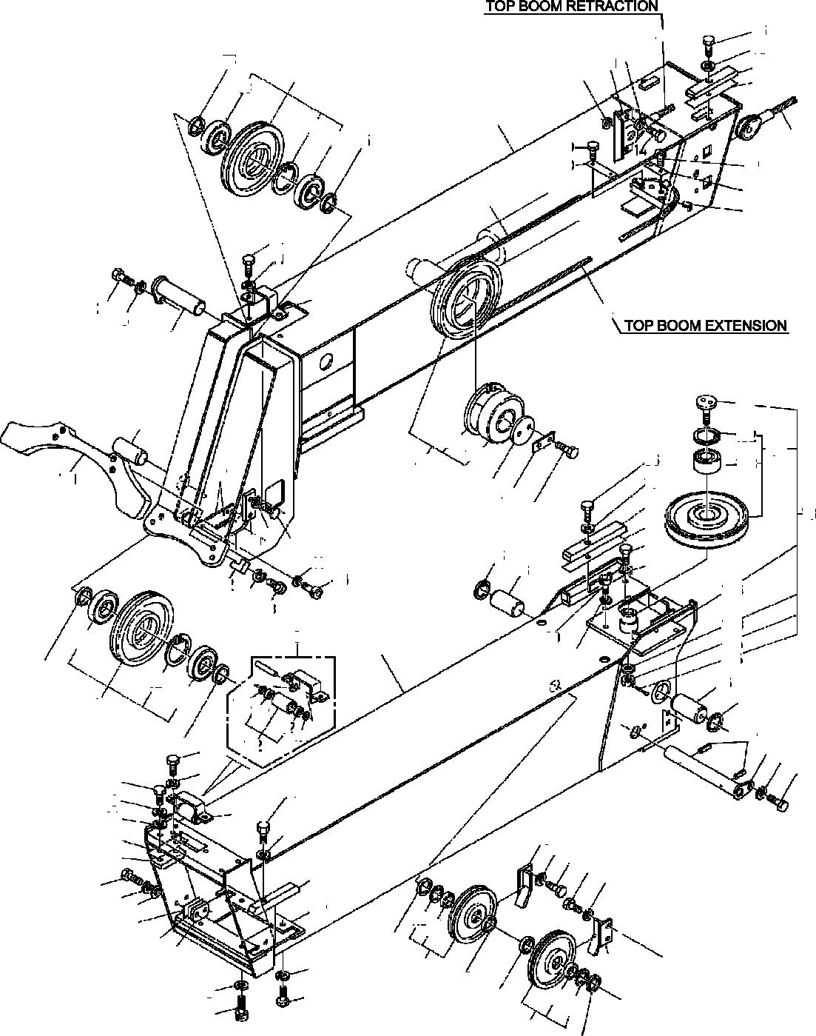
DT-600-2-00001 UPPER PG1010090-02 BOOM
36
15
55
56
45
11
25
53
52
4
93
1
92
45
93
25
49
50
49
12
51
44
14
11
24
22
44
8
26
181
10
192
122
182
123
36
15
46
193
87
151
47
48
58
59
74
8
22
73
11
80
14
75
11
76
88
152
186
154
153
183
184
185
76
75
9
93
89
2
8
27
92
93
4
171
202
202
79
171
27
172
13
22
8
8
7
31
8
34
30
29
36
9
15
70
11 14
14
11
35
81
11
15
18
20
112
113
78
17
16
71
77
8
78
8
21
22
78
113
112
77
78

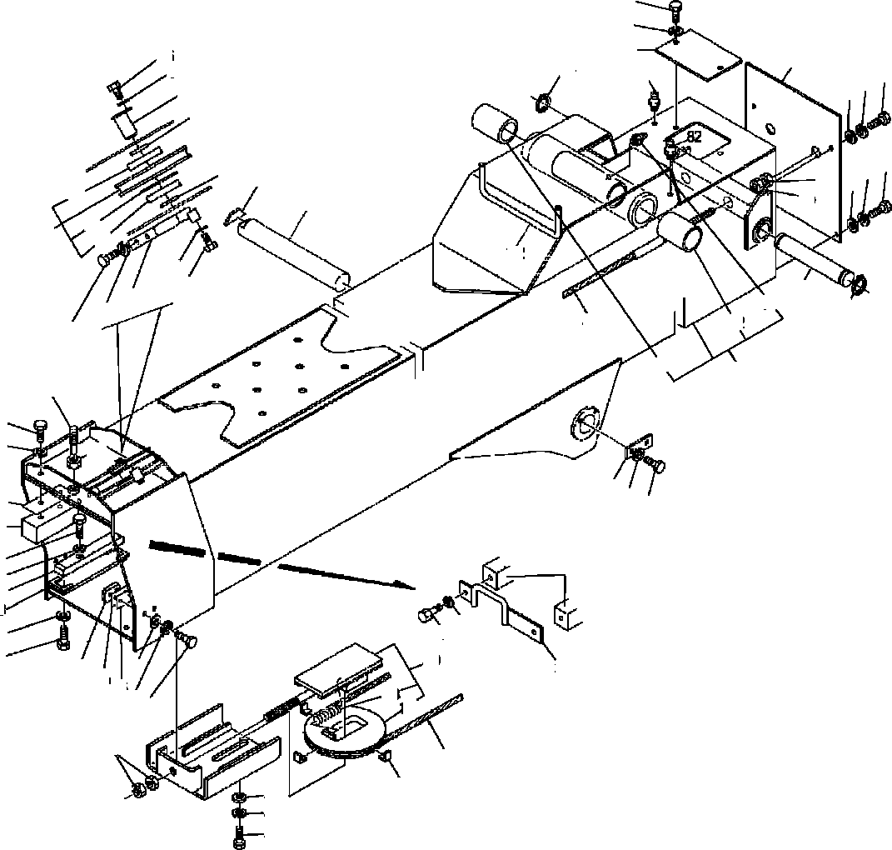
DT-600-2-00001 UPPER PG1010090-02 BOOM
61
11
60
82
86
8
67
64
14
1511
6
5
11 14
5
63
66
15
93
54
69
92
93
4
142
11
14
65
19
57
64
11
44
62
14
62
3
37
22
8
72
68
8
33
32
22
36
15
38
23
32
8
7
8
7
40
15
83
37
84
85
133
132
1114
39
45
28
43
42
41

DT-600-2-00001 UPPER
000035
Pos No.

Parts No
Parts Name
Qty
Unit
Technical Data
Serial No (Start)
Serial No (End)
Rema

1
2
3
4
5
6
7

8

9
10
11

12
13
14
15
16

17

18

19
20
21
22
23
24
25
26
27
28
29
30
31
32

33
34
35
36
37

38
39
40
41
42
43
44
45
46
47
48
49
50
51
52
53
54
55
56
57
58
59
60
61

32200090010
32200090020
32200099510
37001003470
37000303950
37000126160
90101210016
90101210016
90302041001
90302041001
32200090040
37000128790
90302040801
90302040801
37000529980
37000126140
90101508016
90303070801
37002000660
37002000660
31200090700
31200090700
31200090750
31200090750
32200080040
32200080050
90131510022
90101210022
32200080060
32200090050
37000303960
37000126180
37000304020
36010780050
37000529820
37000529800
90101210035
37000529810
32200140060
37000529790
90303071001
37002002290
90101506012
32200080080
32200140070
37002003150
90201201600
32200080090
90101212020
90302041201
90303071201
37001912150
37001902410
37001003880
37000527870
37000527860
90101510030
37000529990
32200080100
90303072001
32200090060
90203251800
37002002300
37000512150
82456101000
37002002270
37000512120
32200090070
90101208010
BOOM,TOP BOOM,2ND BOOM,BASE SHEAVE ASSY SPACER
PIN BOLT BOLT
WASHER,SPRING WASHER,SPRING ROLLER ASSY PIN WASHER,SPRING WASHER,SPRING PLATE
PIN BOLT
WASHER,PLAIN PLATE,SLIDE PLATE,SLIDE SHIM
SHIM SHIM SHIM GUARD RETAINER
BOLT,HEXAGON SOCKET BOLT
RETAINER GUARD SPACER PIN SPACER PLATE
PLATE,SLIDE PLATE
BOLT PLATE,SLIDE PLATE,SLIDE PLATE WASHER,PLAIN PLATE,SLIDE BOLT
BOLT COVER PLATE,SLIDE NUT
SHEAVE ASSY BOLT WASHER,SPRING WASHER,PLAIN ROPE,WIRE (TESAC) ROPE,WIRE SHEAVE ASSY PLATE
PLATE BOLT PLATE SUPPORT
WASHER,PLAIN PIN
NUT PLATE,SLIDE PLATE NIPPLE,GREASE PLATE,SLIDE PLATE
PLATE BOLT
1
1
1
3
2
1
9
11
33
35
1
1
29
33
1
1
23
28
4
2
4
2
4
2
1
1
2
15
2
1
2
1
2
3
2
2
4
2
2
2
4
2
8
1
1
2
2
1
1
1
1
1
1
2
2
2
4
1
1
2
2
2
2
4
1
2
4
1
2

L=3.5

M10X16 M10X16 10
10

8
8

M8X16 8

T=1 T=1 T=0.5 T=0.5

M10X22 M10X22

L=13.5 L=6

T=1.0 M10X35

T=1.0 10

M6X12

M16

M12X20 12
12

8

M10X30 T=1.6

20

T=1.0
A-PT1/8 T=1.0
M8X10

275088

275088

275032

275028

275028

275028

275088

275088

275087

275087

275031

275027

275027

275027

275087

275087

DT-600-2-00001 UPPER
000035
Pos No.

Parts No
Parts Name
Qty
Unit
Technical Data
Serial No (Start)
Serial No (End)
Rema

62
63
64
65
66
67
68
69
70
71
72
73
74
75
76
77
78
79
80
81
82
83
84
85
86
87
88

89
92
93
112
113
122
123
132
133
142
151
152
153
154
171
172
181
182
183
184
185
186
192
193
202

37000400950
90201251800
80601110350
37000111690
32200090120
32200090080
37000507400
37000127720
32200090090
32200090100
90201201400
32200090130
90191510025
80602110400
37000127780
37001003700
37000303980
80720105040
37000531030
90101508020
82458202000
37002003440
32200080180
32200080190
90101210014
32200120120
90131508016
90180208016
90131510025
80602110720
80515006207
80602110620
80516006206
80602111100
80516006310
32200082030
37001200550
32440050020
32470200010
32470200020
90101514040
90302041401
37000303970
37001103540
32200082080
37001004440
90303071201
90236201201
80136332025
32200092050
80604110720
80520314910
80516006001
BEARING,PLAIN NUT RING,RITAINING PIN
PLATE PLATE PLATE PIN GUARD GUARD NUT
SHEAVE ASSY BOLT RING,RITAINING PIN
SHEAVE ASSY SPACER PIN,SPRING PLATE
BOLT NIPPLE,GREASE PLATE,SLIDE SHIM
SHIM BOLT PLATE
BOLT,HEXAGON SOCKET BOLT,BUTTON BOLT,HEXAGON SOCKET RING,RITAINING BEARING,BALL RING,RITAINING BEARING,BALL RING,RETAINING BEARING,BALL
SHEAVE SPRING SUPPORT SUPPORT PLATE BOLT
WASHER,SPRING SPACER
ROLLER ASSY BOLT
SHEAVE ASSY WASHER,PLAIN NUT,CASTLE PIN,SPLIT SUPPORT RING,RETAINING BEARING,ROLLER BEARING,BALL
2
2
2
1
1
1
1
1
1
1
1
1
2
2
2
2
4
2
1
4
4
2
2
2
1
2
4
4
4
3
6
2
2
2
2
1
1
1
1
2
4
4
2
1
1
1
1
1
1
1
1
1
2

M18 S35

M14

M10X25 R40

L=7 5X40

M8X20
B-TYPE PT1/8

T=1 T=0.5 M10X14

M8X16 M8X16 M10X25 R72

R62 110

M14X40 14 L=2.5

12
M12 3.2X25

275028
275028
275028

275032
275032
275082

275087

275081

275055

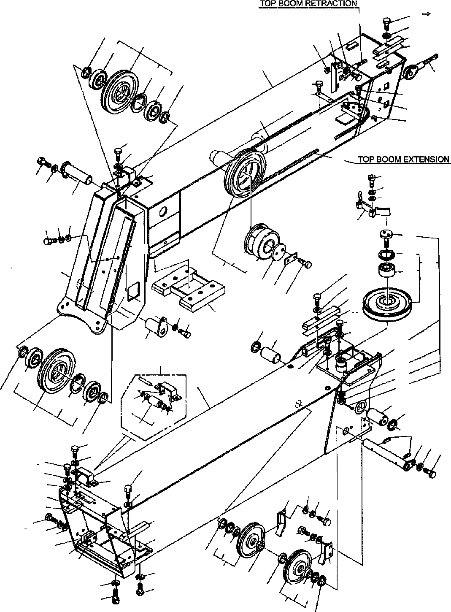
DT-600-2-00001 UPPER PG1010383-05 BOOM
93
36
15
55
56
45
53 11
25
103
52
4
1
102
103
45
25
49
50
14
49
12
51
44
14
11
44
24
92
8
34
22
8
26
11 15
91
27
141
80
162
163
132
142
133
36
15
58
59
74
8
46
47
48
22
73
8
87
86
75
76
6
146
9
143
144
145
76
75
89 8
103
2
5
102
111
172
103
4
172111
112
79
5
13 8
22
8
7
31
8
34
30
29
36
9
15
15 11
70
14
35
81
15
11
20
15
18
14
152
153
11
78
17
16
71
77
8
22
78
8
21
78
153
152
77
78

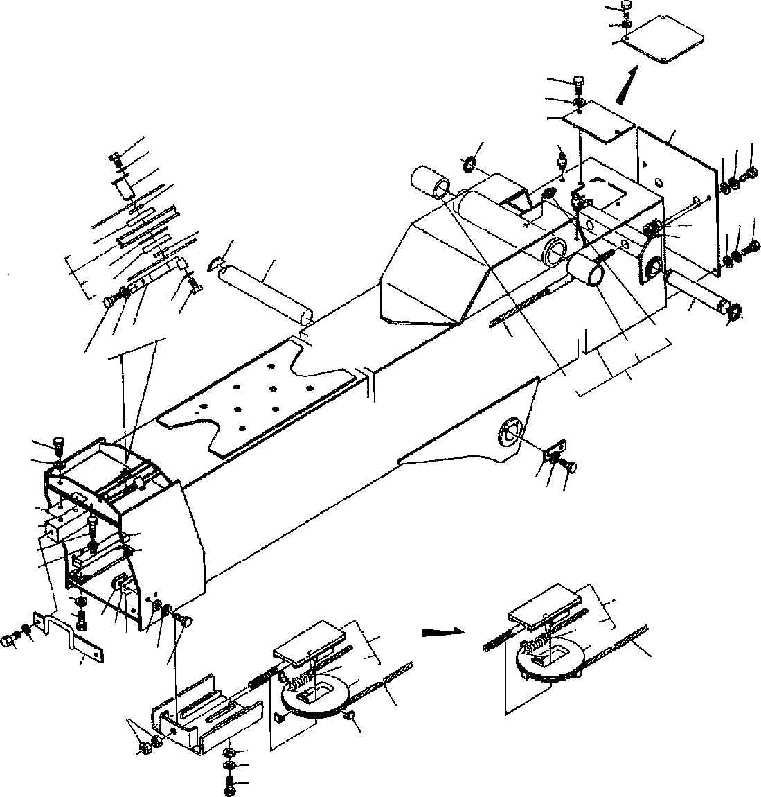
DT-600-2-00001 UPPER PG1010383-05 BOOM
61
11
60
61
11
60
82
67
86
8
64
1114
15
6
5
82
11 14
63
54
5
15
66
103
69
102
103
4
11
14
65
19
57
64
11
44
62
14
62
3
22
8
68 8
22
33
32
36
15
38
23
8
7
110
83
123
182
84
40
85 15
11
14
8
7
123
45
37
122
39
45
28
43
42
41

DT-600-2-00001 UPPER
000036
Pos No.

Parts No
Parts Name
Qty
Unit
Technical Data
Serial No (Start)
Serial No (End)
Rema

1
2
3
4
5
6
7
8
9
11
12
13
14

15

16
17
18
19
20
21

22
23
24
25
26
27
28
29

30
31

32
33

34
35
36

37
38
39
40
41
42
43
44

45

46
47
48
49

50
51
52
53
54
55
56
57

32200090200
32200090020
32200099510
37001003470
37000303950
37000126160
90101210016
90302041001
32200090040
90302040801
37000529980
37000126140
90101508016
90171108016
90303070801
90303070801
37002000660
31200090700
31200090750
32200080040
32200080050
90131510022
90172110022
90101210022
32200080060
32200090050
37000303960
37000126180
90101208012
36010780050
37000529820
37000572300
37000529800
90101210035
90101210032
90171110032
32200140060
37000529790
37000529790
90303071001
37002002290
90101506012
90171106012
90171106012
32200140070
37002003150
90201201600
32200080090
90101212020
90302041201
90303071201
37001912150
37001910780
37001902410
37001920870
37001920860
37001003880
37000527870
37000527860
90101510030
90171110030
37000529990
32200080100
90303072001
32200090060
90203251800
37002002300
37000512150
82456101000
BOOM,TOP BOOM,2ND BOOM,BASE SHEAVE ASSY SPACER
PIN BOLT
WASHER,SPRING ROLLER ASSY WASHER,SPRING PLATE
PIN BOLT BOLT
WASHER,PLAIN WASHER,PLAIN PLATE,SLIDE SHIM
SHIM GUARD RETAINER
BOLT,HEXAGON SOCKET BOLT,HEXAGON SOCKET BOLT
RETAINER GUARD SPACER PIN
BOLT PLATE
PLATE,SLIDE PLATE,SLIDE PLATE
BOLT BOLT BOLT
PLATE,SLIDE PLATE PLATE
WASHER,PLAIN PLATE,SLIDE BOLT
BOLT BOLT COVER
PLATE,SLIDE NUT
SHEAVE ASSY BOLT WASHER,SPRING WASHER,PLAIN ROPE,WIRE (TESAC)
ROPE,WIRE (KOKOKU) ROPE,WIRE ROPE,WIRE (TESAC) ROPE,WIRE (KOKOKU) SHEAVE ASSY
PLATE PLATE BOLT BOLT PLATE SUPPORT
WASHER,PLAIN PIN
NUT PLATE,SLIDE PLATE NIPPLE,GREASE
1
1
1
3
4
2
11
38
1
33
1
1
22
22
30
34
2
2
2
1
1
2
2
15
2
1
2
1
2
3
2
2
2
4
4
4
2
2
8
6
2
8
8
6
1
2
2
1
1
1
1
1
1
1
1
1
2
2
2
4
4
1
1
2
2
2
2
4
1

L=3.5

M10X16 10

8

M8X16 M8X16 8
8

T=1 T=0.5

M10X22 M10X22 M10X22

L=13.5 M8X12

T=1.0 M10X35 M10X32 M10X32

T=1.0 T=1.0 10

M6X12 M6X12 M6X12

M16

M12X20 12
12

8

M10X30 M10X30 T=1.6

20

T=1.0
A-PT1/8

275213

275213

275301

275301

275301

275449

275449
275557

275301
275213

275301
275763

275343

275557
275557

275301

275300

275300

275300

275778
275448

275448
275556

275300

275300
275762

275778

275556

275300

DT-600-2-00001 UPPER
000036
Pos No.

Parts No
Parts Name
Qty
Unit
Technical Data
Serial No (Start)
Serial No (End)
Rema

58
59
60
61
62
63
64
65
66
67
68
69
70

71

73
74

75
76
77
78
79
80
81

82
83
84
85
86
87
89

91
92

93
102
103
110
111
112
122
123
132
133
141
142
143
144
145
146
152
153
162
163
172
182

37002002270
37000512120
32200080120
90101208010
37000400950
90201251800
80601110350
37000111690
32200090120
32200090080
37000507400
37000127720
32200090090
32200090140
32200090100
32200090150
32200090130
90191510025
90171110025
80602110400
37000127780
37001003700
37000303980
80720105040
32200310050
90101508020
90171108020
90171108018
82458202000
37002003440
32200080180
32200080190
90101210014
32200238110
90131510025
90172110025
32200080240
90131510040
90172110040
90171106016
80602110720
80515006207
32200080091
37000303970
37001103540
32200082030
37001200550
80602111100
80516006310
32200082080
37001004440
90303071201
90236201201
80136332025
32200092050
80602110620
80516006206
80604110720
80520314910
80516006001
32200082031
PLATE,SLIDE PLATE COVER BOLT
BEARING,PLAIN NUT RING,RITAINING PIN
PLATE PLATE PLATE PIN GUARD GUARD GUARD GUARD
SHEAVE ASSY BOLT
BOLT RING,RITAINING PIN
SHEAVE ASSY SPACER PIN,SPRING PLATE
BOLT BOLT BOLT
NIPPLE,GREASE PLATE,SLIDE SHIM
SHIM BOLT
SUPPORT ASSY BOLT,HEXAGON SOCKET BOLT,HEXAGON SOCKET GUARD
BOLT,HEXAGON SOCKET BOLT,HEXAGON SOCKET BOLT
RING,RITAINING BEARING,BALL SHEAVE ASSY SPACER ROLLER ASSY SHEAVE SPRING
RING,RETAINING BEARING,BALL BOLT
SHEAVE ASSY WASHER,PLAIN NUT,CASTLE PIN,SPLIT SUPPORT RING,RITAINING BEARING,BALL RING,RETAINING BEARING,ROLLER BEARING,BALL SHEAVE
2
4
1
4
2
2
2
1
1
1
1
1
1
1
1
1
1
2
2
2
2
2
4
2
1
4
4
4
4
2
2
2
2
1
4
4
1
2
2
2
3
6
1
2
1
1
1
2
2
1
1
1
1
1
1
2
2
1
1
2
1

T=1.0 M8X10
M18 S35

M10X25 M10X25 R40

L=7 5X40

M8X20 M8X20 M8X18
B-TYPE PT1/8

T=1 T=0.5 M10X14

M10X25 M10X25

M10X40 M10X40 M6X16 R72

L=2.5

110

12
M12 3.2X25

R62

275213
275213

275557

275557

275301

275301
275635

275301
275213
275213
275301
275763

275779

275779

275556

275556

275300

275300
275634

275300

275300

275778

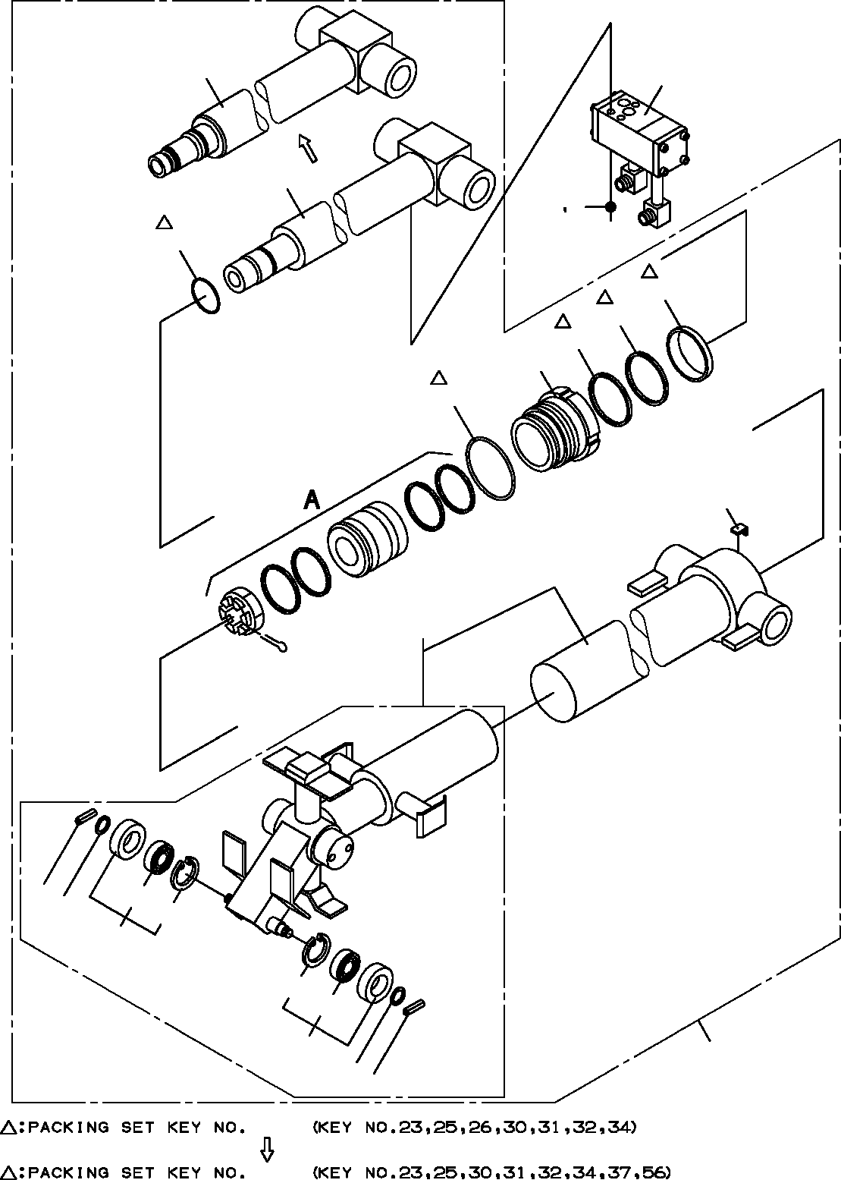
DT-600-2-00001 UPPER
PG1050042-05 CYLINDER ASSY,TELESCOPING
58
3
28
4 5
23
34
32
31
29
30
33
60
14
13
41
42
12
42
41
12
40
13
14
100
101

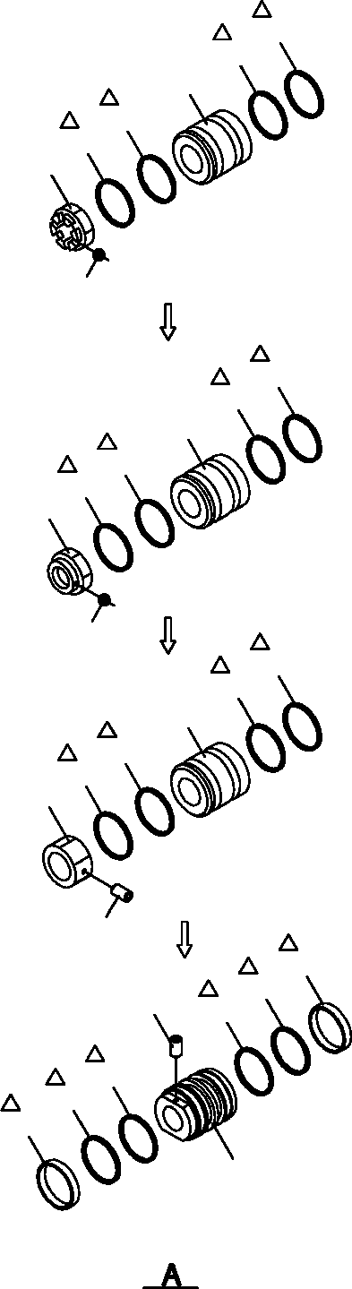
DT-600-2-00001 UPPER
PG1050042-05 CYLINDER ASSY,TELESCOPING
25
26
24
26
25
22
21
25
26
24
26
25
52
51
25
26
24
26
25
36
35
37
25
55
56
56
25
37
54

DT-600-2-00001 UPPER
000037
Pos No.

Parts No
Parts Name
Qty
Unit
Technical Data
Serial No (Start)
Serial No (End)
3
4
5
12
13
14
21
22
23
24
25
26
28
29
30
31
32
33
34
35
36
37
40
41
42
51
52
54
55
56
58
60
100
101

36601770000
90131508065
90302040801
37001102380
90303071201
80720103018
80136363071
37001600000
91002803600
36011840010
91684008001
91411206502
36011840030
36011840040
91002907500
91694106500
91410206503
36011840050
91660006501
90190000010
37001602590
91302208000
32210058010
80516006002
80602110320
80136363065
37001601100
36011840070
90730008140
91431206502
36011840100
36011849520
36011849900
36011849901
VALVE,COUNTERBALANCE BOLT,HEXAGON SOCKET WASHER,SPRING
ROLLER ASSY WASHER,PLAIN PIN,SPRING PIN,SPLIT NUT,CASTLE
O-RING PISTON PACKING RING,BACKUP ROD COVER,ROD O-RING PACKING RING,BACKUP PLATE SEAL,DUST SCREW,SET NUT
BEARING,PLAIN
CYLINDER ASSY,TELESCOPING BEARING,BALL RING,RITAINING
PIN,SPLIT NUT PISTON SCREW,SET
RING,BACKUP ROD
CYLINDER ASSY PACKING SET PACKING SET
1
3
3
2
2
2
1
1
1
1
2
2
1
1
1
1
1
1
1
1
1
2
1
2
2
1
1
1
1
2
1
1
1
1

M8X65 8

12
3X18
6.3X71 M36 1B P36

1B G75

M8X10

R32 6.3X65 M36X2

M8X14

65X80
65X80

275404
275404
275725

275088
275088
275725
275725
275725
275725

275725

275087
275087

275724

275724
275724

275724
275724

275403
275403

275724

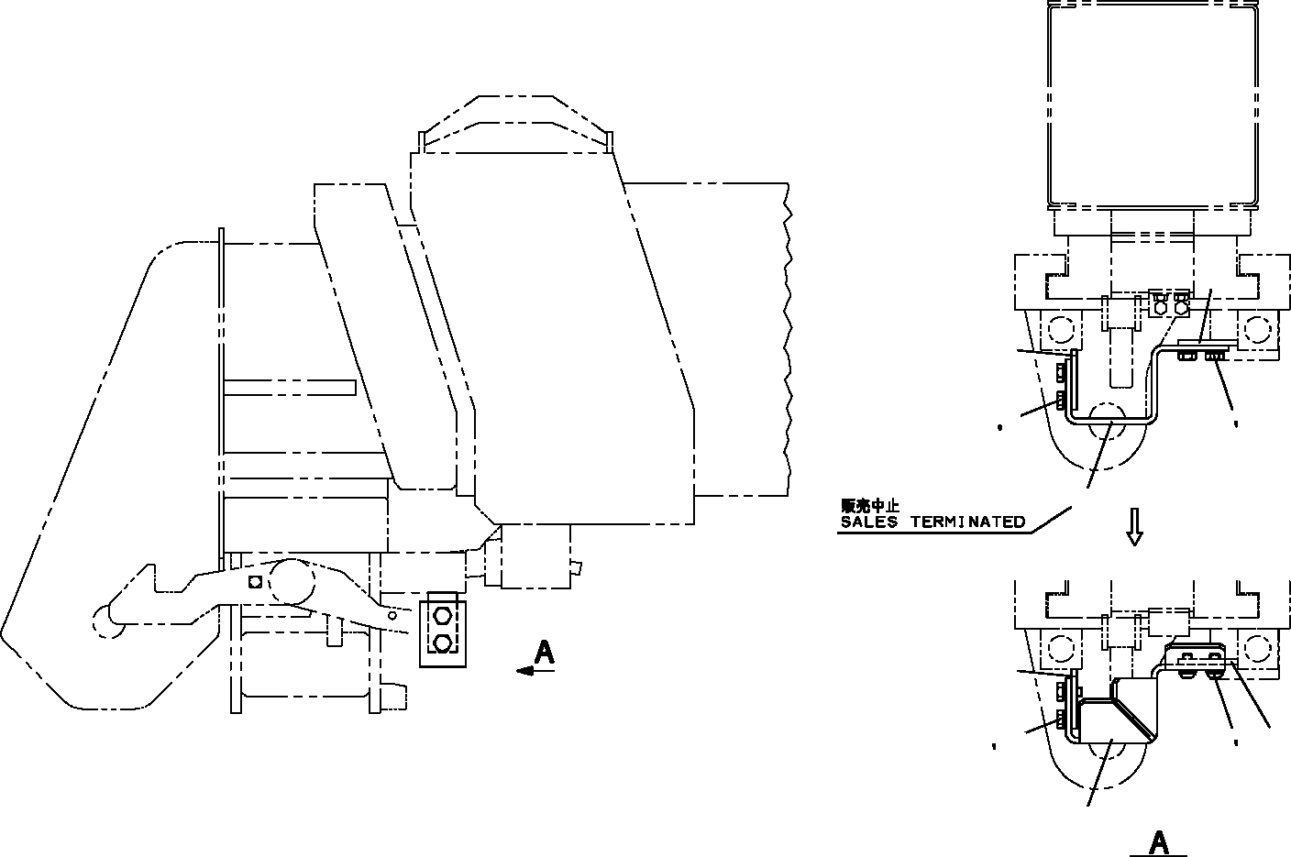
DT-600-2-00001 UPPER PG5200002-01 GUARD ASSY
3
3
1 2
1 2
4
3
2 5 3
2
11
14

DT-600-2-00001 UPPER
000038
Pos No.

Parts No
Parts Name
Qty
Unit
Technical Data
Serial No (Start)
Serial No (End)
Remarks
Pa

1
2
3
4
5
11
14

90101210020
90302041001
32472870100
32472870200
90180210020
90101210020
32472870201
BOLT WASHER,SPRING PLATE
SUPPORT BOLT,BUTTON BOLT SUPPORT
4
4
2
1
2
2
1

M10X20 10

M10X20 M10X20

275442
275442
275442

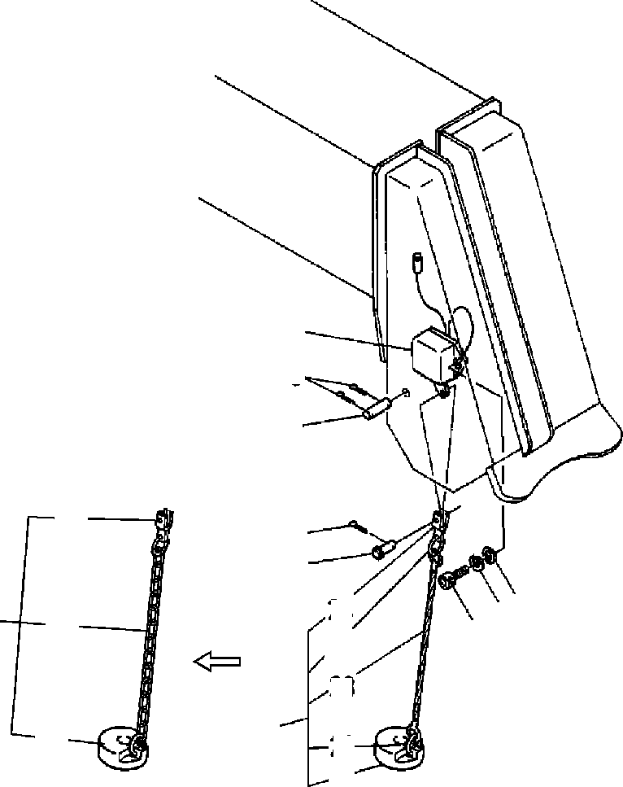
DT-600-2-00001 UPPER
PH1060036-02 DETECTOR,OVER WINDING
7
5
4
24
9
8
3 2
24
22
23
10
33
1
10
21
22
21

DT-600-2-00001 UPPER
000039
Pos No.

Parts No
Parts Name
Qty
Unit
Technical Data
Serial No (Start)
Serial No (End)
Rema

1
2
3
4
5
7
8
9

10
21
22
23
24

90131506016
90303070601
90302040601
37000128780
80136340018
31370000010
37000120180
90000000090
80136332014
32370070010
32370072010
14128208000
37001902460
32370020060
BOLT,HEXAGON SOCKET WASHER,PLAIN WASHER,SPRING
PIN PIN,SPLIT SWITCH PIN
RING PIN,SPLIT WEIGHT ASSY WEIGHT
RING ROPE,WIRE END
2
2
2
1
2
1
1
1
1
1
1
2
1
1

M6X16 6
6

4X18

3.2X14

275031

275030

275702
275300

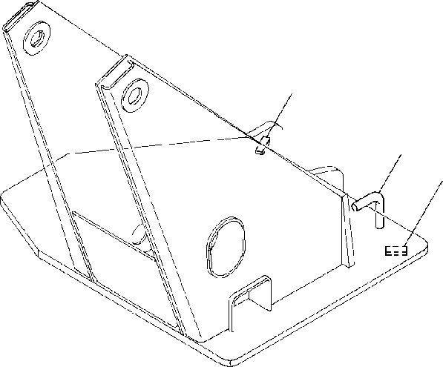
DT-600-2-00001 UPPER
PH1100006-00 DETECTOR,OVER FRONT AREA
1
2
1

DT-600-2-00001 UPPER
000040
Pos No.

Parts No
Parts Name
Qty
Unit
Technical Data
Serial No (Start)
Serial No (End)
Remarks
Pages
1
2

37000530330
32950030010
PLATE BAR
2
1

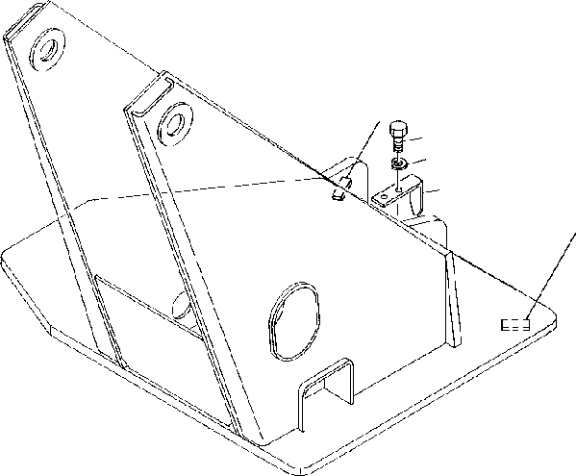
DT-600-2-00001 UPPER
PH1100039-00 DETECTOR,OVER FRONT AREA
1
3
4
2
1

DT-600-2-00001 UPPER
000041
Pos No.

Parts No
Parts Name
Qty
Unit
Technical Data
Serial No (Start)
Serial No (End)
Remarks
Pa

1
2
3
4

37000530330
32950070010
90101210016
90302041001
PLATE INDICATOR BOLT
WASHER,SPRING
2
1
2
2

M10X16 10

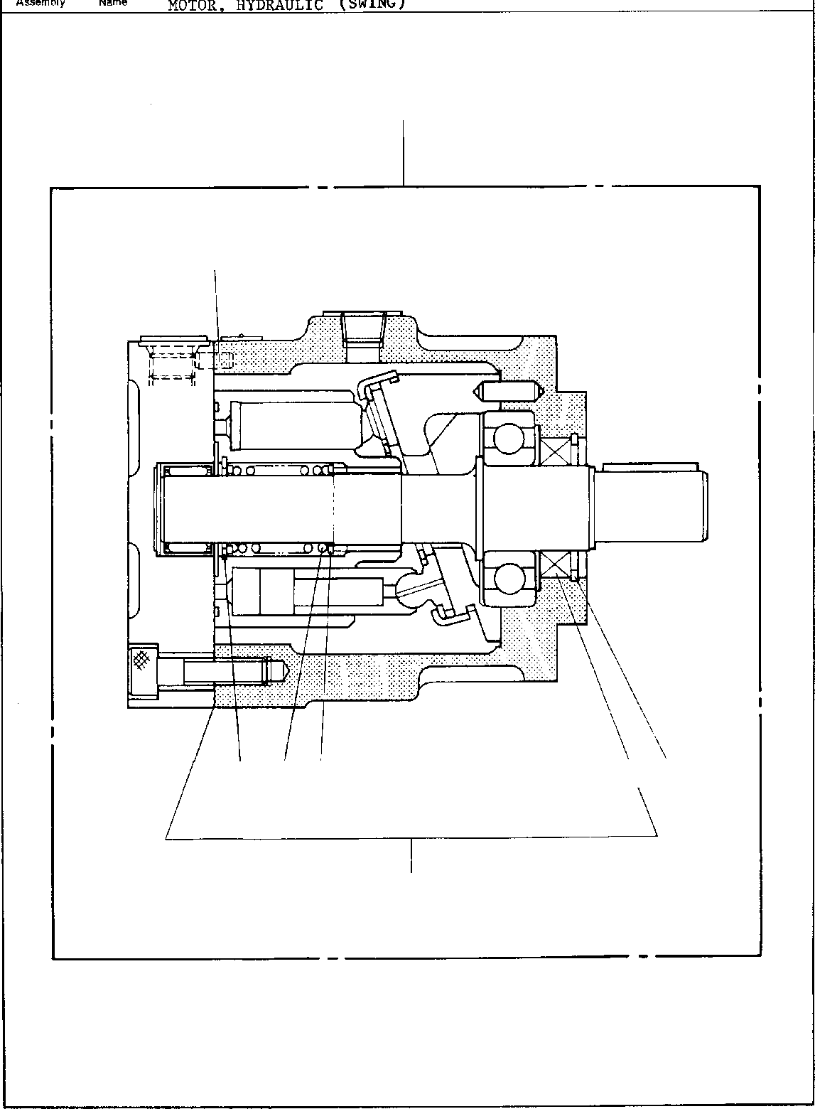
DT-600-2-00001 UPPER
PI1010011-01 MOTOR,HYDRAULIC (SWING)
50
14
17
15
16
10
9
30

DT-600-2-00001 UPPER
000042
Pos No.

Parts No
Parts Name
Qty
Unit
Technical Data
Serial No (Start)
Serial No (End)
Re

9
10
14
15
16
17
30
50

36660515010
36660515020
80730060012
36660515030
36660515040
36660515050
36660515060
36660510000
WASHER SPRING PIN
RING,RETAINING RING,RETAINING SEAL,OIL
SEAL KIT (REPAIR KIT) MOTOR,HYDRAULIC (SWING)
2
1
2
1
1
1
1
1

6X12

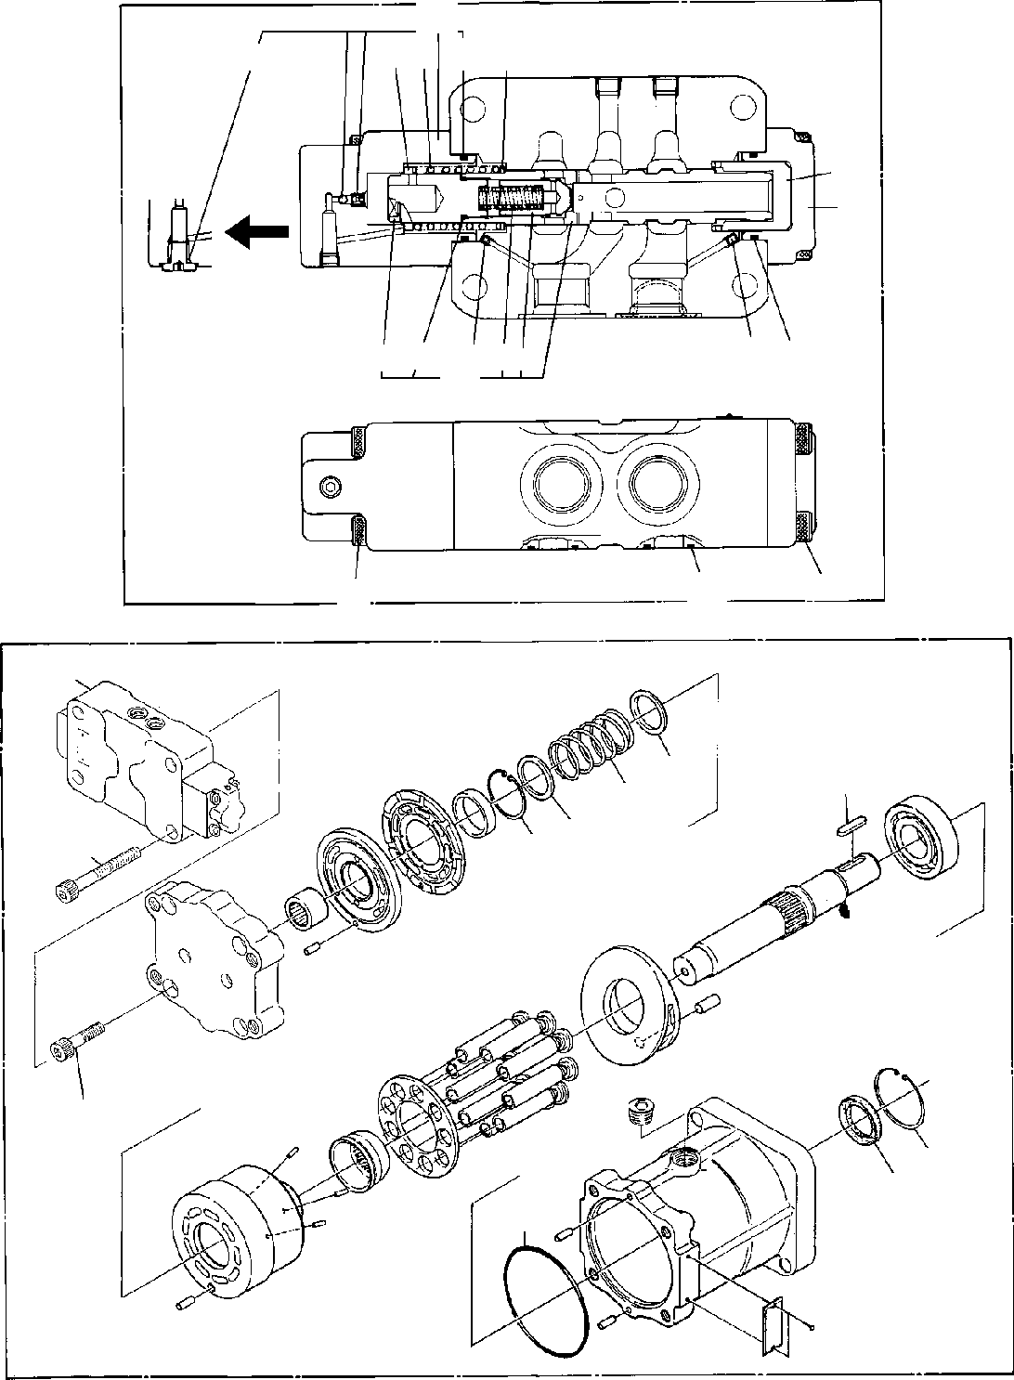
DT-600-2-00001 UPPER
PI1010145-00 MOTOR,HYDRAULIC
35
46
4543 53
44
76
48
47
58 53
64 65 57 63
42
54
50
49
100
35
12
32
18
19 13
36
31
20
29
23

DT-600-2-00001 UPPER
000043
Pos No.

Parts No
Parts Name
Qty
Unit
Technical Data
Serial No (Start)
Serial No (End)
Rem

12
13
18
19
20
23
29
31
32
35
36
42
43

44
45

46

47
48
49
50
53
54
57
58
63
64
65
76
100

36660825010
36660825020
36660825030
36660825040
36660825050
91001211500
36660825060
90131712040
36660825070
36660825080
90131712070
36660825090
36660825120
36660825190
36660825130
36660825140
36660825200
36660825150
36660825210
36660825160
36600755030
90131710060
90131710030
91002904000
91002802200
36660825170
36660825180
36660825100
36660825110
91002801800
91002800800
36660820000
GUIDE,SPRING GUIDE,SPRING SPRING RING,RETAINING RING,RETAINING O-RING SEAL,OIL
BOLT,HEXAGON SOCKET KEY VALVE,COUNTERBALANCE BOLT,HEXAGON SOCKET PLUNGER ASSY
SPRING SPRING SEAT,SPRING SEAT,SPRING SEAT,SPRING CAP ASSY CAP ASSY CAP
CAP
BOLT,HEXAGON SOCKET BOLT,HEXAGON SOCKET O-RING
O-RING ORIFICE ORIFICE <0.6. SPRING PLUG
O-RING O-RING
MOTOR,HYDRAULIC
1
1
1
1
1
1
1
4
1
1
4
1
1
1
1
1
1
1
1
1
1
4
4
2
2
1
1
1
1
1
1
1

1A G115 M12X40

M12X70

M10X60 M10X30 1B G40
1B P22
1.2

1B P18
1B P8

275041

275041

275387

275387

275040

275040

275386

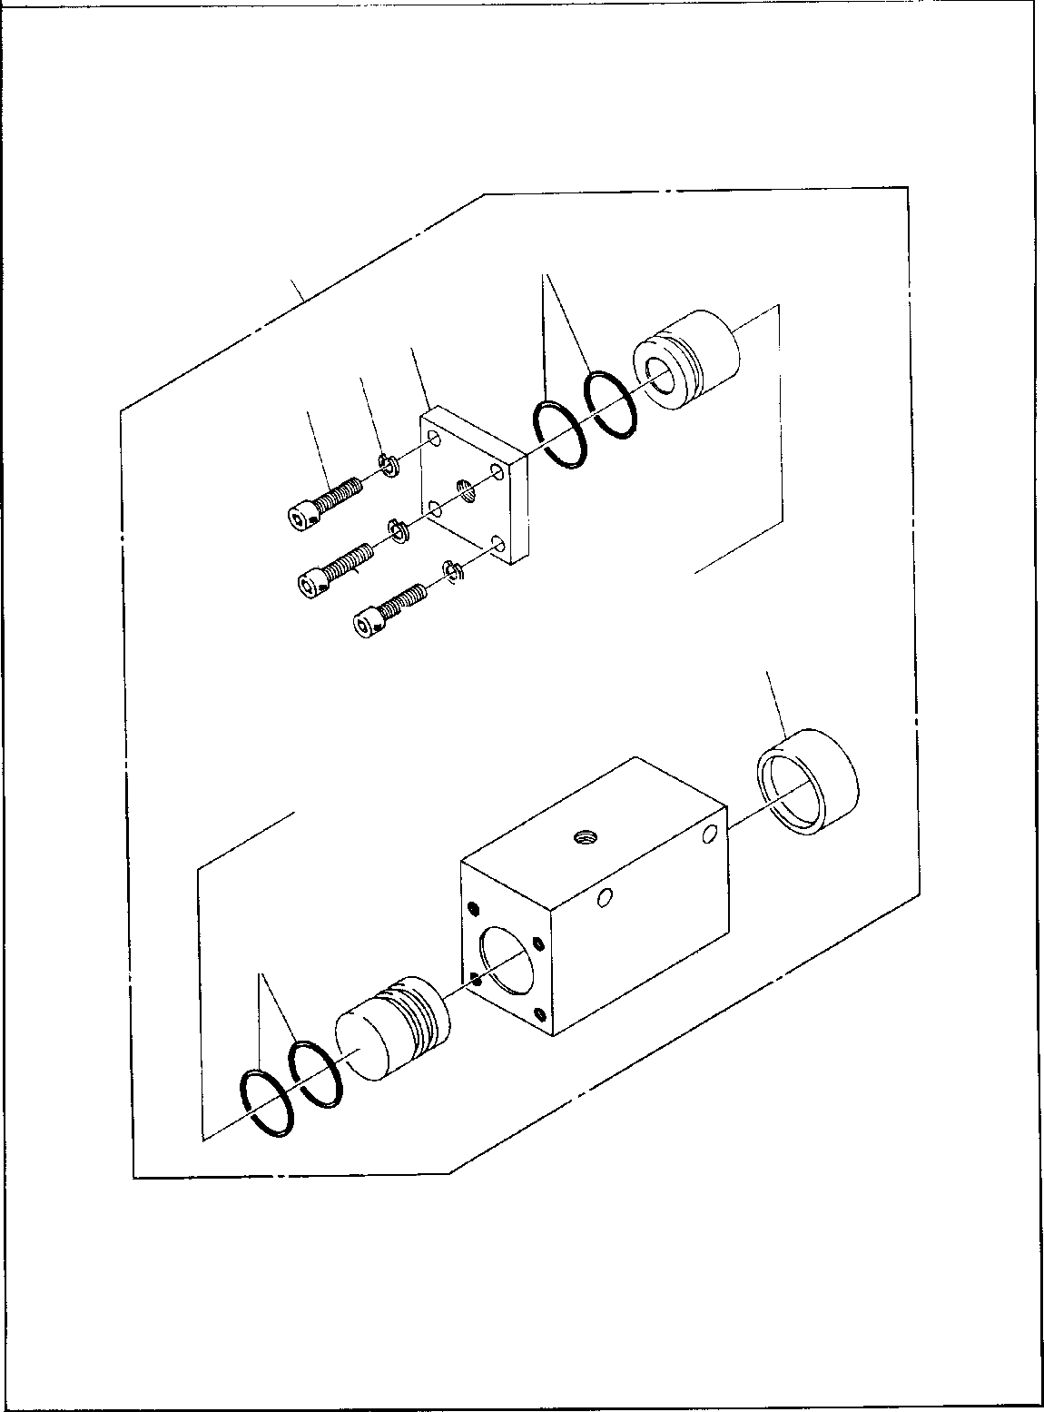
DT-600-2-00001 UPPER PI1060001-00 CYLINDER,BRAKE
4
10
5
6
7
6
7
6
7
8
4

DT-600-2-00001 UPPER
000044
Pos No.

Parts No
Parts Name
Qty
Unit
Technical Data
Serial No (Start)
Serial No (End)
Rema

4
5
6
7
8
10

91002803000
36060505010
90302040801
90131508025
36060505020
36060500000
O-RING COVER
WASHER,SPRING BOLT,HEXAGON SOCKET BOOT
CYLINDER,BRAKE
4
1
4
4
1
1

1B P30

8
M8X25

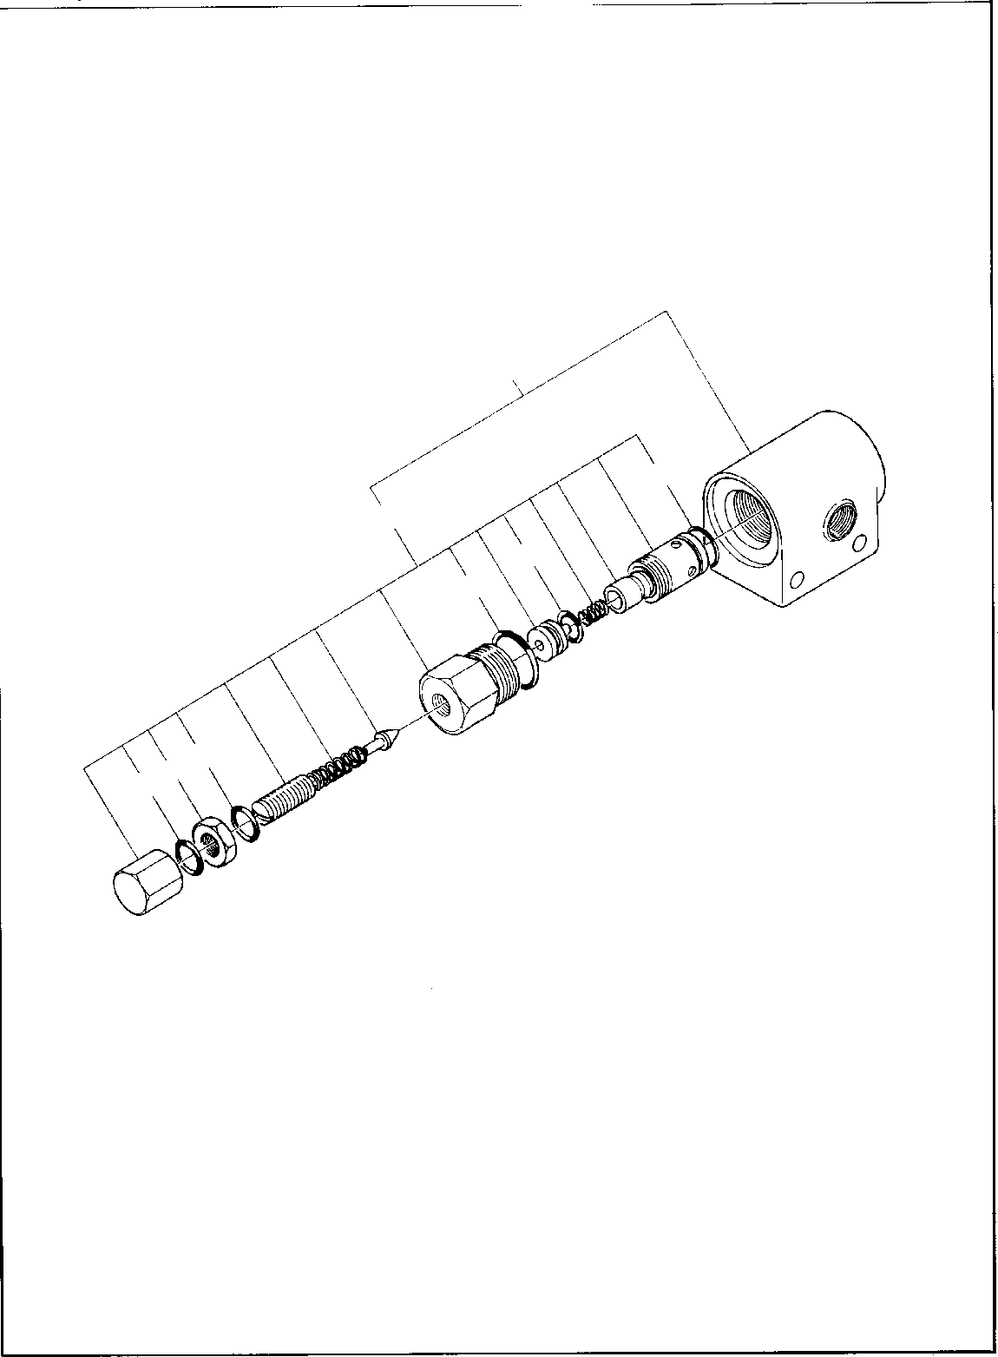
DT-600-2-00001 UPPER PI1100006-01 VALVE,RELIEF
30
4
20
6
5
14
14

DT-600-2-00001 UPPER
000045
Pos No.

Parts No
Parts Name
Qty
Unit
Technical Data
Serial No (Start)
Serial No (End)
Remarks
Pages

4
5
6
14
20
30

91000501500
91002802200
91002801001
91001001600
58355102000
36601080000
O-RING O-RING O-RING O-RING
VALVE,RELIEF VALVE,RELIEF
1
1
1
2
1
1

AS568-015 1B P22
1B P10A
1A S16

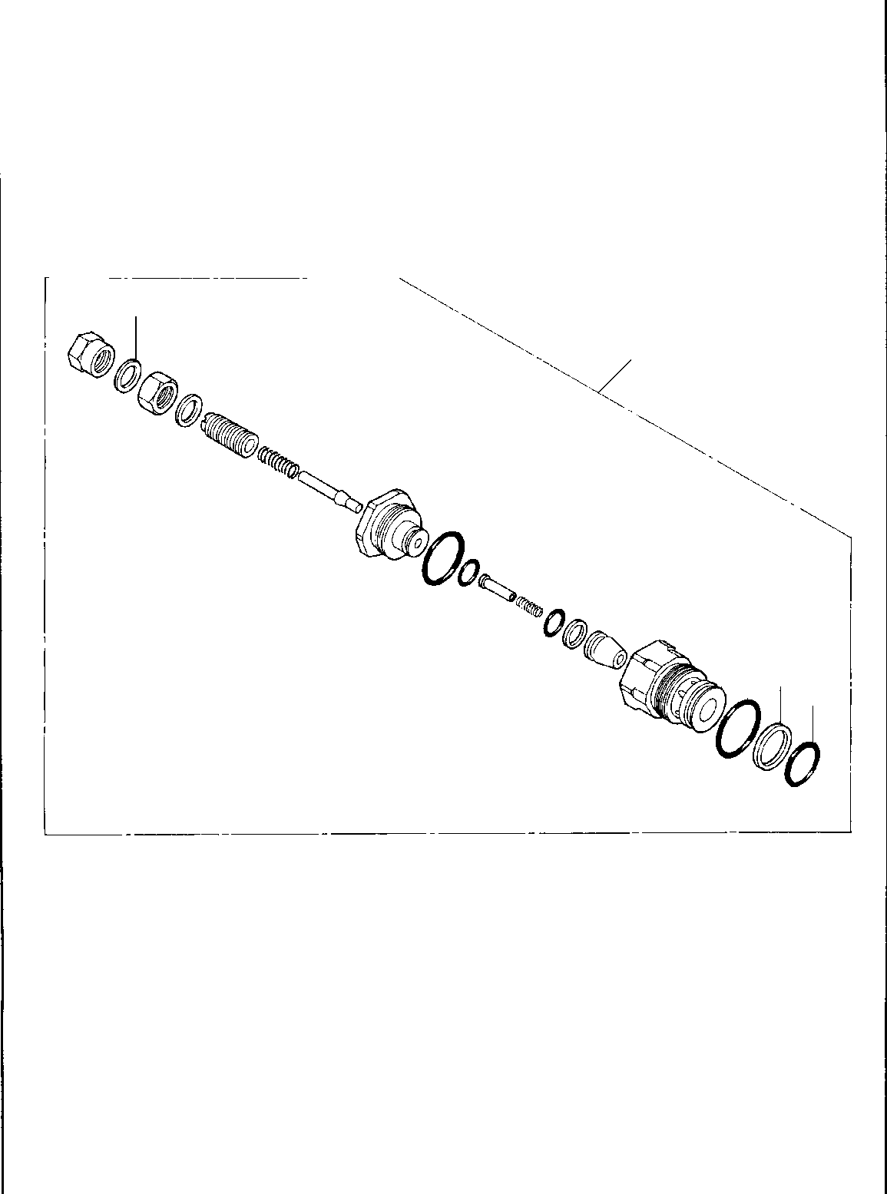
DT-600-2-00001 UPPER PI1100008-01 VALVE,RELIEF
14
14
20
9
2
1

DT-600-2-00001 UPPER
000046
Pos No.

Parts No
Parts Name
Qty
Unit
Technical Data
Serial No (Start)
Serial No (End)
Remarks
Pages

1
2
9
14
20

36631065140
36631065130
91001102100
36601765010
36601760000
O-RING RING,BACKUP O-RING GASKET VALVE,RELIEF
1
1
1
1
1

1A P21

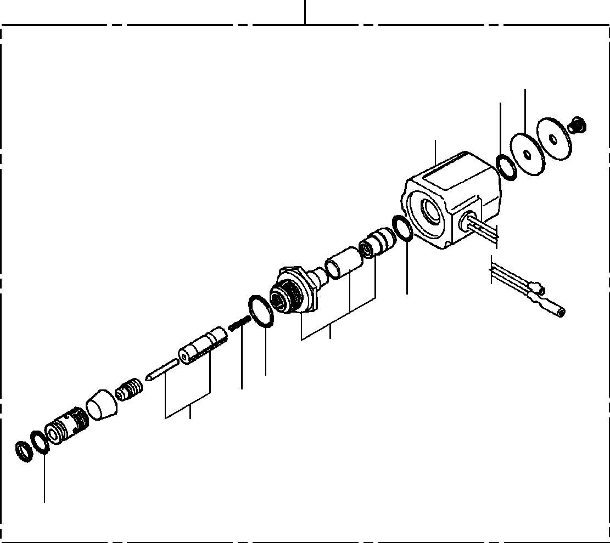
DT-600-2-00001 UPPER PI1120034-01 VALVE,SOLENOID
30
14
12
13
12
22
8
7
21
2

DT-600-2-00001 UPPER
000047
Pos No.

Parts No
Parts Name
Qty
Unit
Technical Data
Serial No (Start)
Serial No (End)
Remarks
Pa

2
7
8
12
13
14
21
22
30

36641465020
36641465040
36641465050
91001101120
36641465060
36641465070
36641465080
36641465090
36641460000
O-RING SPRING O-RING O-RING
SOLENOID PLATE PLUNGER ASSY BODY ASSY
VALVE,SOLENOID
1
1
1
2
1
1
1
1
1

1A P11.2

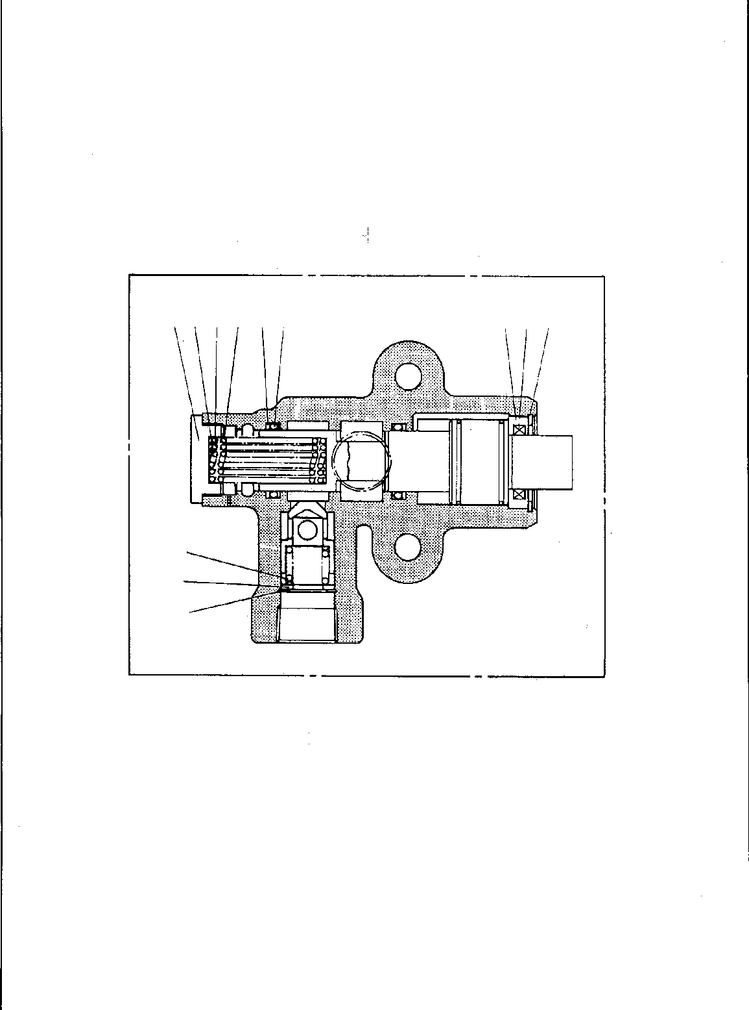
DT-600-2-00001 UPPER PI1140010-00 VALVE,CHECK
50
4 1615 81112
6 9 14
10
7
13

DT-600-2-00001 UPPER
000048
Pos No.

Parts No
Parts Name
Qty
Unit
Technical Data
Serial No (Start)
Serial No (End)
Remarks
Page

4
6
7
8
9
10
11
12
13
14
15
16
50

36620715010
36620715020
36620715030
36620715040
36620715050
36620715060
91411002500
91001102500
80602110220
80602110380
36620715070
36620715080
36620710000
CAP COVER SEAT SPRING (A) SEAL,DUST SPRING
RING,BACKUP O-RING RING,RITAINING RING,RITAINING SPRING (C) SPRING (D) VALVE,CHECK
1
1
1
1
1
1
2
2
1
1
1
1
1

P25
1A P25 R22 R38

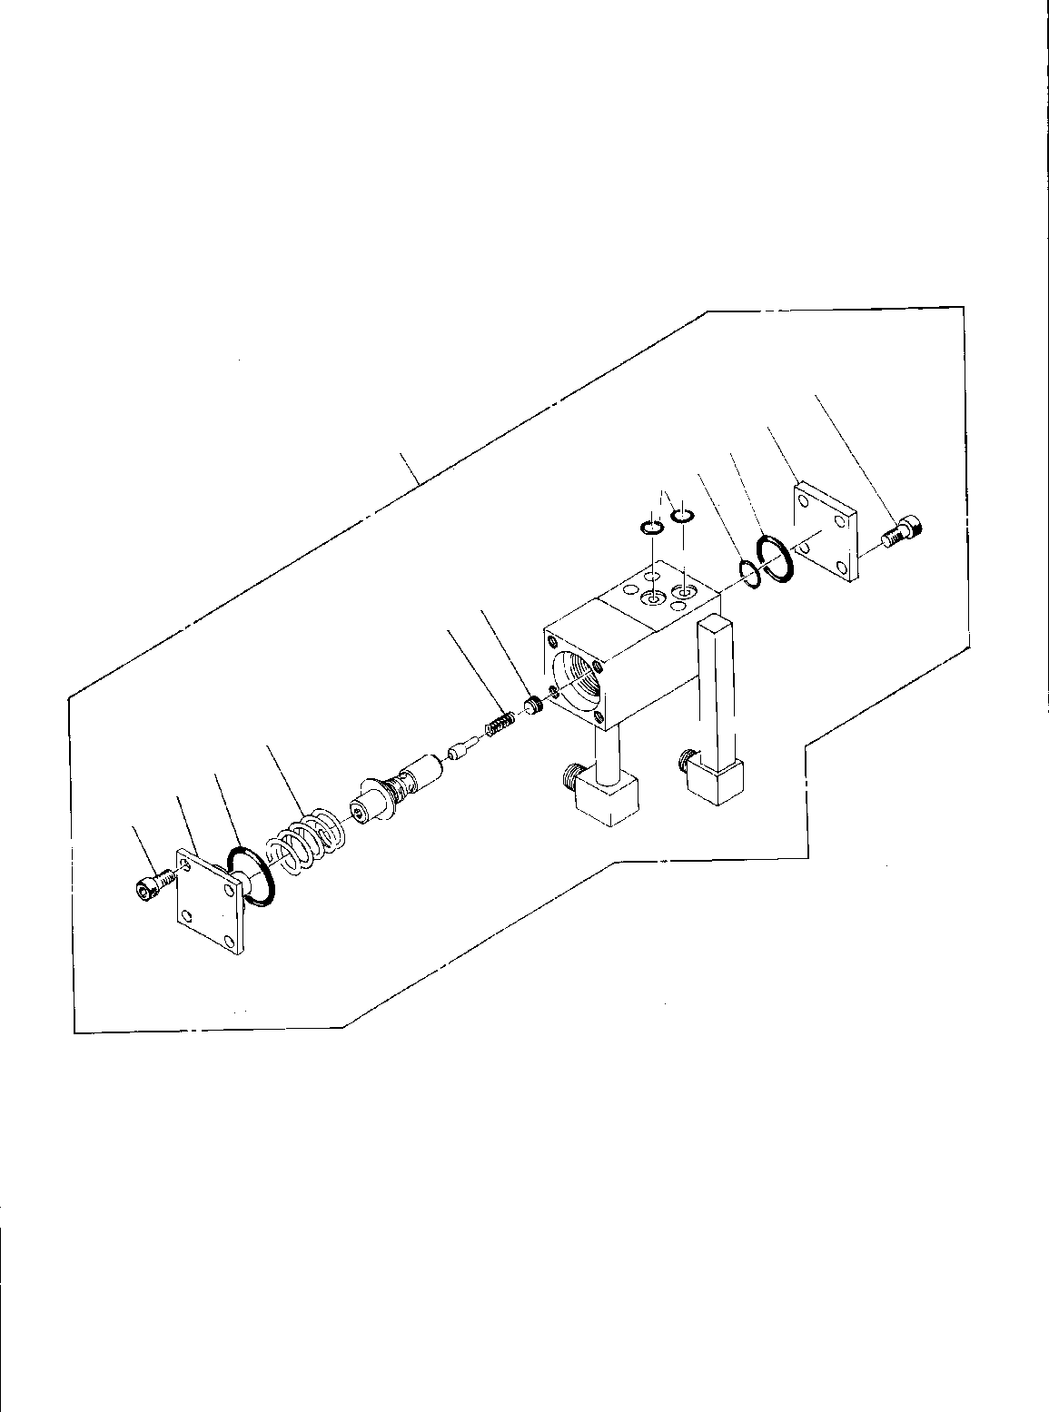
DT-600-2-00001 UPPER
PI1250035-00 VALVE,COUNTERBALANCE
1
12
10
8
20
13
9 11
4
3
2
1

DT-600-2-00001 UPPER
000049
Pos No.

Parts No
Parts Name
Qty
Unit
Technical Data
Serial No (Start)
Serial No (End)
Rem

1
2
3
4
8
9
10
11
12
13
20

90131708018
36600160010
91002803800
36600070020
91002801600
36600070070
91002802800
80316030020
36600870030
91002801500
36601770000
BOLT,HEXAGON SOCKET COVER
O-RING SPRING O-RING SPRING O-RING PLUG COVER O-RING
VALVE,COUNTERBALANCE
8
1
1
1
1
1
1
1
1
2
1

M8X18 1B P38
1B P16

1B P28 PT1/8

1B P15

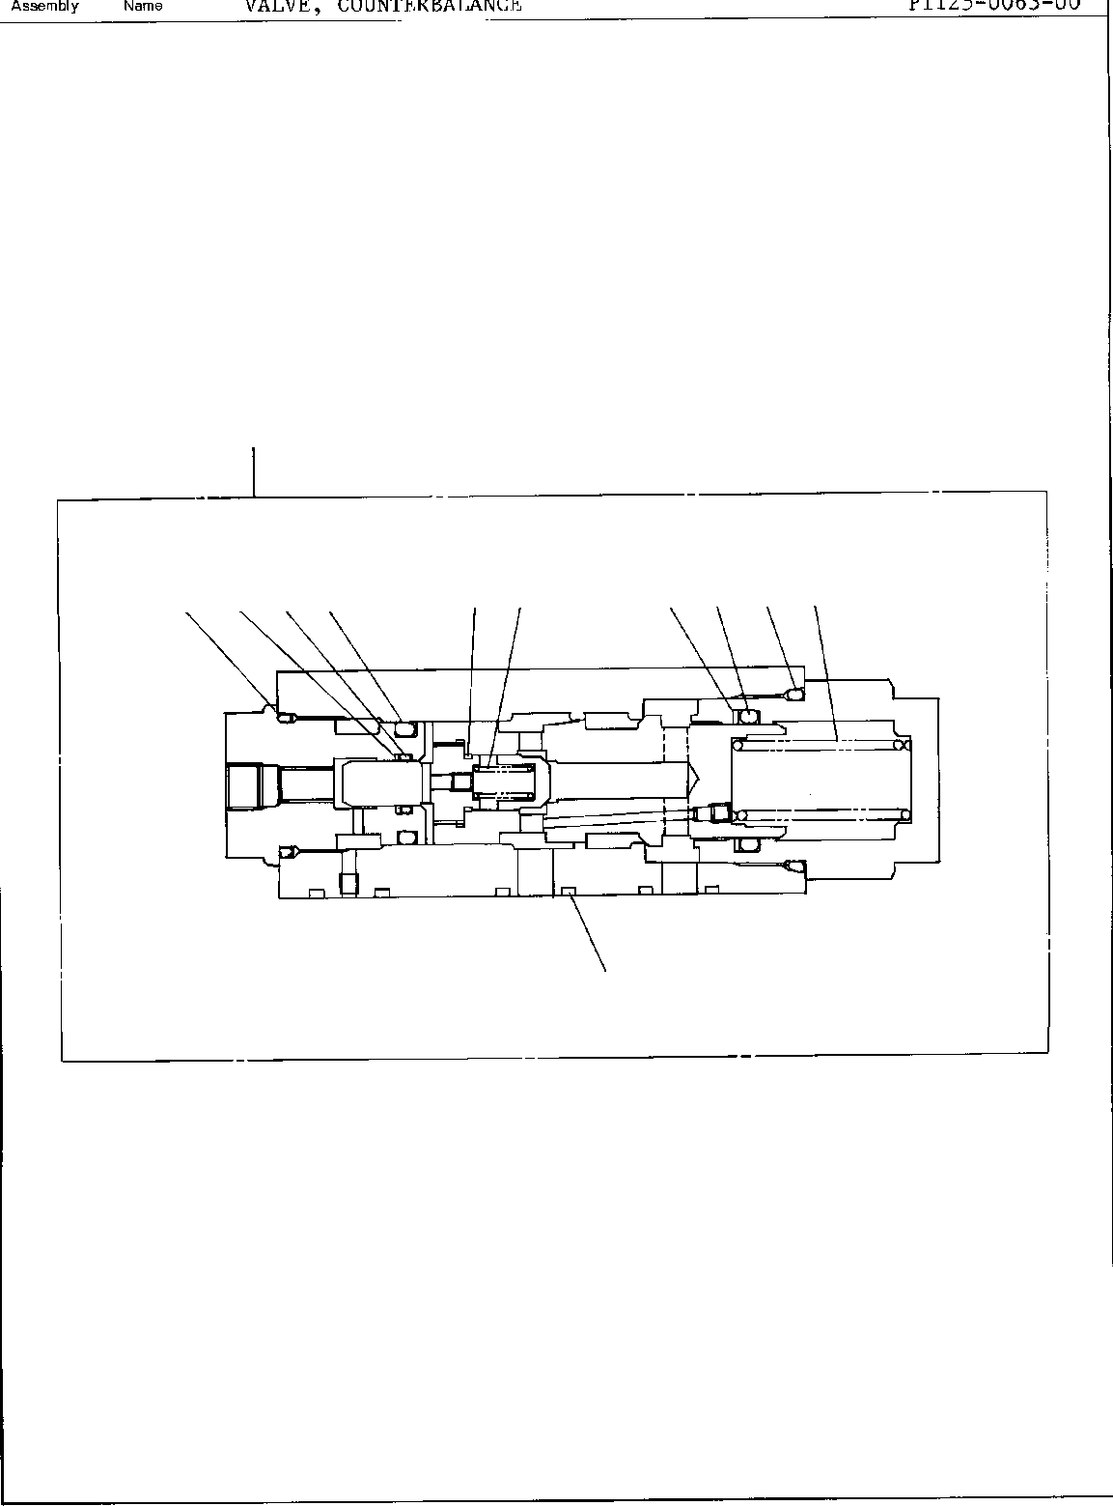
DT-600-2-00001 UPPER
PI1250063-00 VALVE,COUNTERBALANCE
50
15 14 13 11
10 7
18 21 20 19
3

DT-600-2-00001 UPPER
000050
Pos No.

Parts No
Parts Name
Qty
Unit
Technical Data
Serial No (Start)
Serial No (End)
Rem

3
7
10
11
13
14
15
18
19
20
21
50

91002801400
36601665020
91001001600
36601665030
91002803400
36601665050
91410002500
91002802600
91001301600
91002801000
91410001000
36603110000
O-RING SPRING O-RING SPRING O-RING O-RING
RING,BACKUP O-RING
O-RING O-RING
RING,BACKUP VALVE,COUNTERBALANCE
3
1
1
1
1
1
1
1
1
1
1
1

1B P14

1A S16

1B P34 P25 P25
1B P26 WP16 1B P10 P10

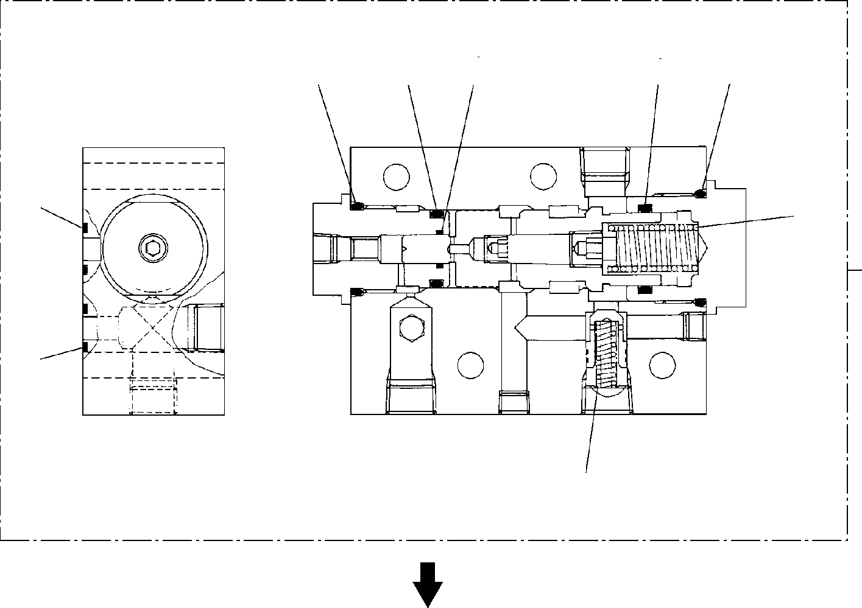
DT-600-2-00001 UPPER
PI1250105-01 VALVE,COUNTERBALANCE
21
11
20
8
13
12
9
18
6
50
18
15

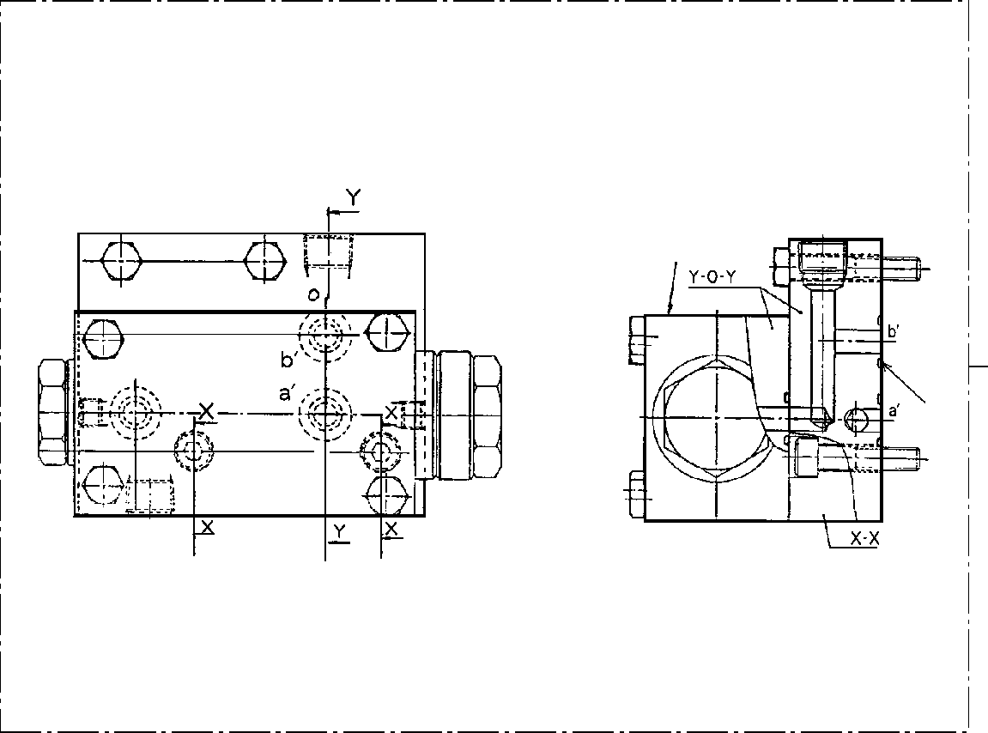
DT-600-2-00001 UPPER
PI1250105-01 VALVE,COUNTERBALANCE
34
50
18

DT-600-2-00001 UPPER
000051
Pos No.

Parts No
Parts Name
Qty
Unit
Technical Data
Serial No (Start)
Serial No (End)
Rem

6
8
9
11
12
13
15
18
20
21
50

36601665010
91002802500
91002803400
91002801000
91001301600
91002802800
36601035070
91002801400
91410002500
91410001000
36601030000
SPRING (A) O-RING
O-RING O-RING O-RING O-RING
SPRING (B) O-RING
RING,BACKUP RING,BACKUP VALVE,COUNTERBALANCE
1
1
1
1
1
1
1
3
1
1
1

1B P25
1B P34
1B P10 WP16 1B P28

1B P14 P25 P10

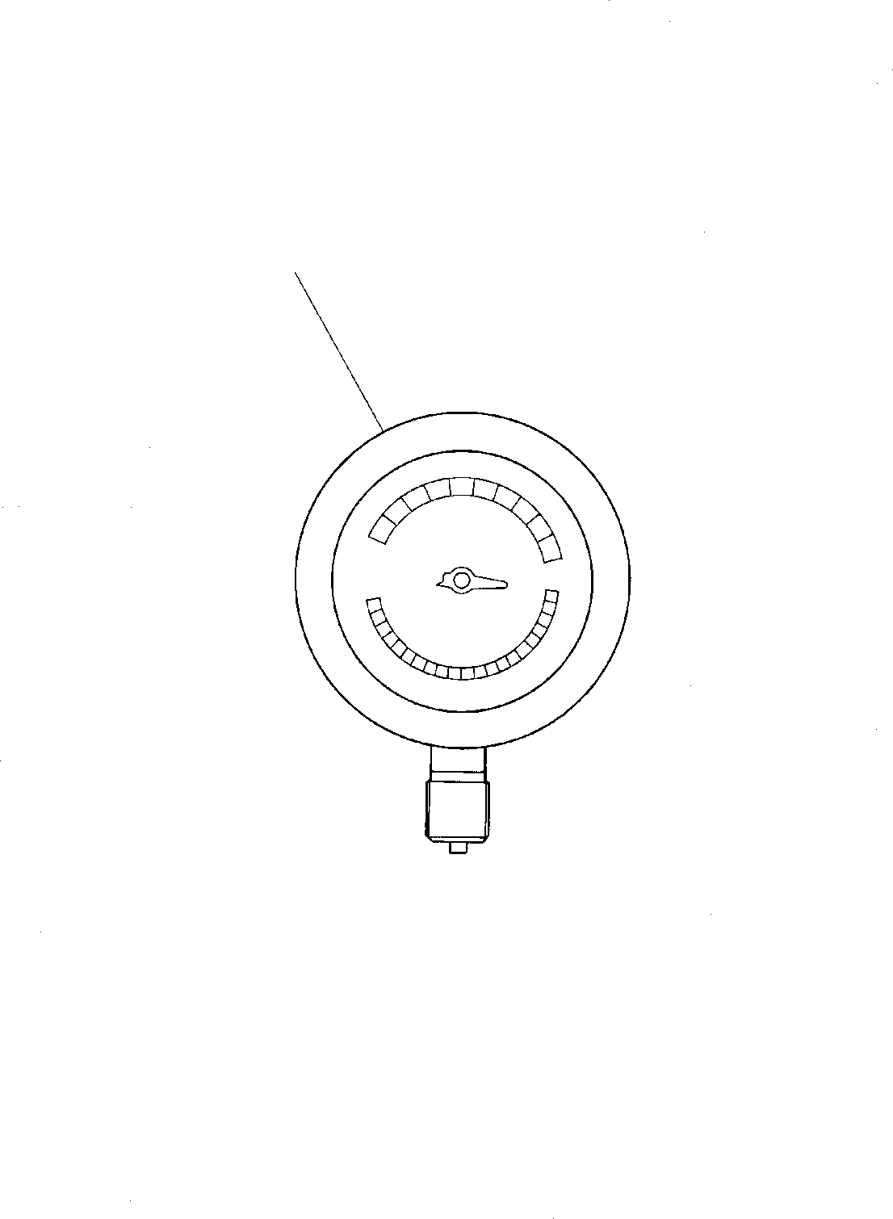
DT-600-2-00001 UPPER PI1440007-00 METER,LOAD
1

DT-600-2-00001 UPPER
000052
Pos No.

Parts No
Parts Name
Qty
Unit
Technical Data
Serial No (Start)
Serial No (End)
Remarks
Pages
1

36681030000
METER,LOAD
1

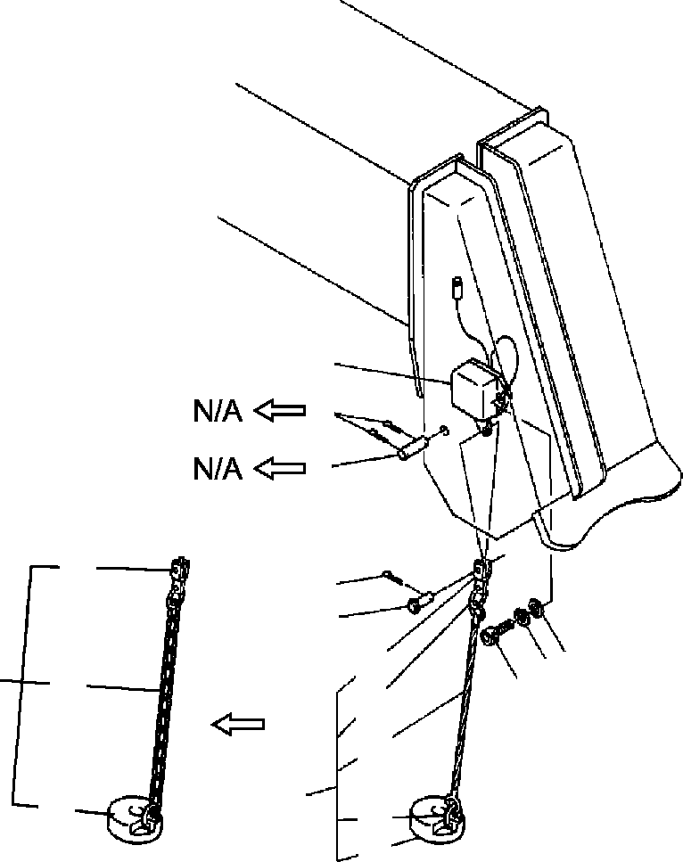
DT-600-2-00001 UPPER
PI5070003-00 INDICATOR ASSY,OVERWIND
7
5
4
24
9
8
32
24
22
23
10
33
1
10
21
22
21

DT-600-2-00001 UPPER
000053
Pos No.

Parts No
Parts Name
Qty
Unit
Technical Data
Serial No (Start)
Serial No (End)

See a

1
2
3
4
5
7
8
9
10

21

22
23

24
33

*

90131506016
90303070601
90302040601
37000128780
80136340018
32370081000
37000120180
90000000090
32370070010
32370080100
32370072010
31371923000
14128208000
37001902460
37001905070
32370020060
32472090200
32370080200
BOLT,HEXAGON SOCKET WASHER,PLAIN WASHER,SPRING
PIN PIN,SPLIT
SWITCH ASSY PIN
RING
WEIGHT ASSY WEIGHT ASSY WEIGHT WEIGHT
RING ROPE,WIRE ROPE,WIRE END
CHAIN ASSY CHAIN ASSY
2
2
2
1
2
1
1
1
1
1
1
1
2
1
1
1
1
1

M6X16 6
6

4X18

3X0.375M

275712

275712

275301

275703
275712

275713
275713

275711

275711

275702
275300
275702

275711

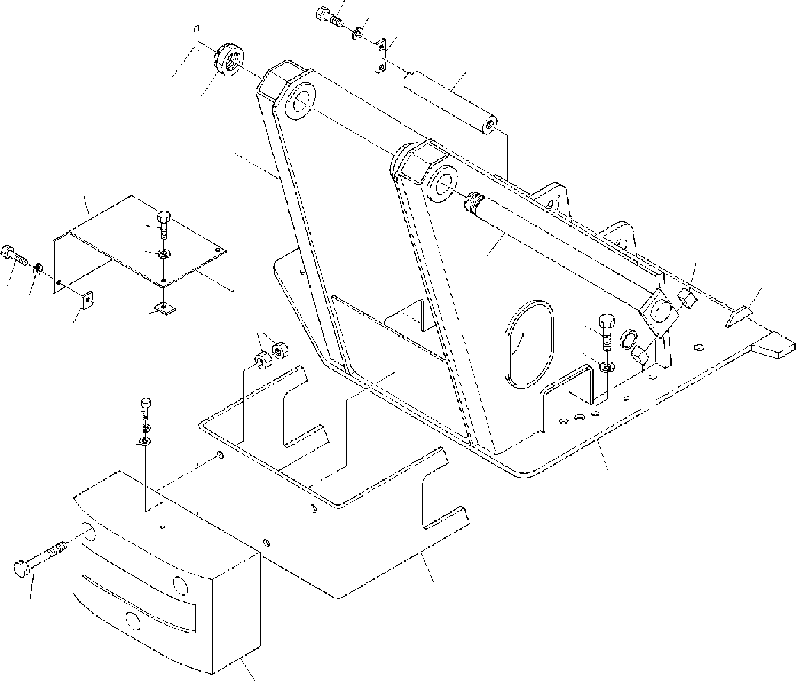
DT-600-2-00001 UPPER PK1100046-00 SWING FRAME
6
7
5
8
3
2
21
23
24
15
1
16
2324
22
11
12
10
22
15
6
7
17
4
14
9
13

DT-600-2-00001 UPPER
000054
Pos No.

Parts No
Parts Name
Qty
Unit
Technical Data
Serial No (Start)
Serial No (End)
Remarks
Pa

1
2
3
4
5
6
7
8
9

10
11
12

13

14

15
16
17
21
22
23
24

37000127630
37001600330
80136380071
32230070010
37000507400
90101210022
90302041001
37000114710
90101216140
90101216160
90201201600
37001501320
90302041601
90303501601
32230070020
32230070040
32230070030
32230070050
37000525160
32230010020
90303071001
32270040010
37000508890
90101208012
90302040801
PIN NUT,CASTLE PIN,SPLIT
TABLE,SLEWING PLATE
BOLT WASHER,SPRING PIN
BOLT BOLT NUT BOLT
WASHER,SPRING WASHER,PLAIN WEIGHT
WEIGHT SUPPORT SUPPORT BAR PLATE
WASHER,PLAIN COVER
PLATE BOLT
WASHER,SPRING
1
1
1
1
1
3
3
1
3
3
6
26
26
26
1
1
1
1
2
1
1
1
4
4
4

8X71

M10X22 10

M16X140 M16X160 M16 M16X60 16
16

10

M8X12 8

275134

275122

275134

275134

275133

275121

275133

275133

275133

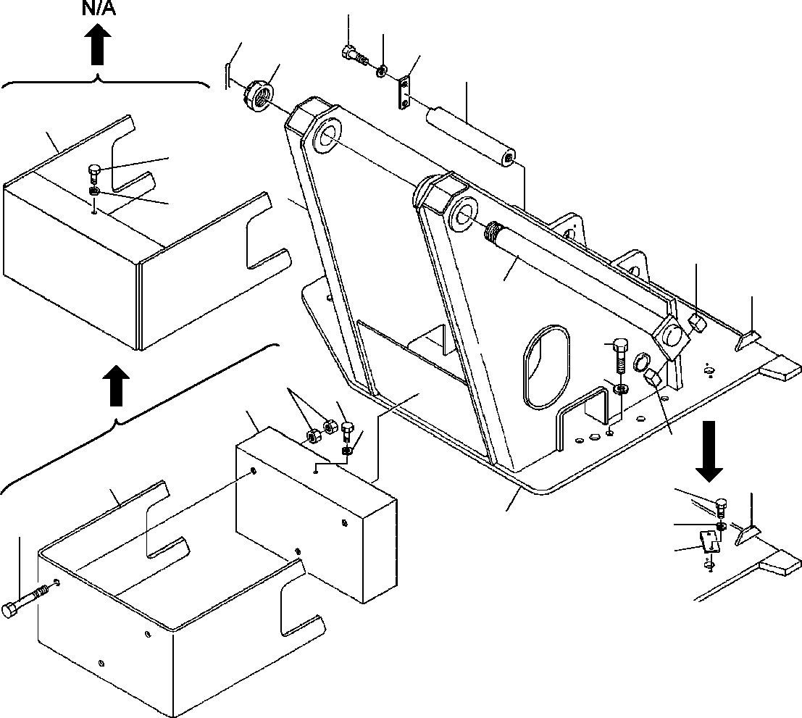
DT-600-2-00001 UPPER PK1100191-01 SWING FRAME
6
7
3
5
2
8
34
6
7
15
16
1
11
12
10
6
13
7
15
14
16
18
7
17
9
4

DT-600-2-00001 UPPER
000055
Pos No.

Parts No
Parts Name
Qty
Unit
Technical Data
Serial No (Start)
Serial No (End)
Remarks
Pa

1
2
3
4
5
6

7

8
9
10
11
12
13
14
15
16
17
18
34

37000152000
37001600330
80136380071
32230328010
37000507400
90101210022
90101210022
90302041001
90302041001
90302041001
37000152950
90101216160
90201201600
37001505940
90303501805
32230070040
32230070050
37000525160
32230010020
37000518610
90101210016
32230070060
PIN NUT,CASTLE PIN,SPLIT
TABLE,SLEWING PLATE
BOLT BOLT
WASHER,SPRING WASHER,SPRING WASHER,SPRING PIN
BOLT NUT BOLT
WASHER,PLAIN WEIGHT SUPPORT
BAR PLATE PLATE BOLT SUPPORT
1
1
1
1
1
3
2
3
5
4
1
3
6
29
29
1
1
2
1
1
2
1

8X71

M10X22 M10X22 10
10
10

M16X160 M16 M18X60 18

M10X16

275309

275236
275309

275236
275236
275213

275308

275235
275308

275212
275212

275212
275212

275308

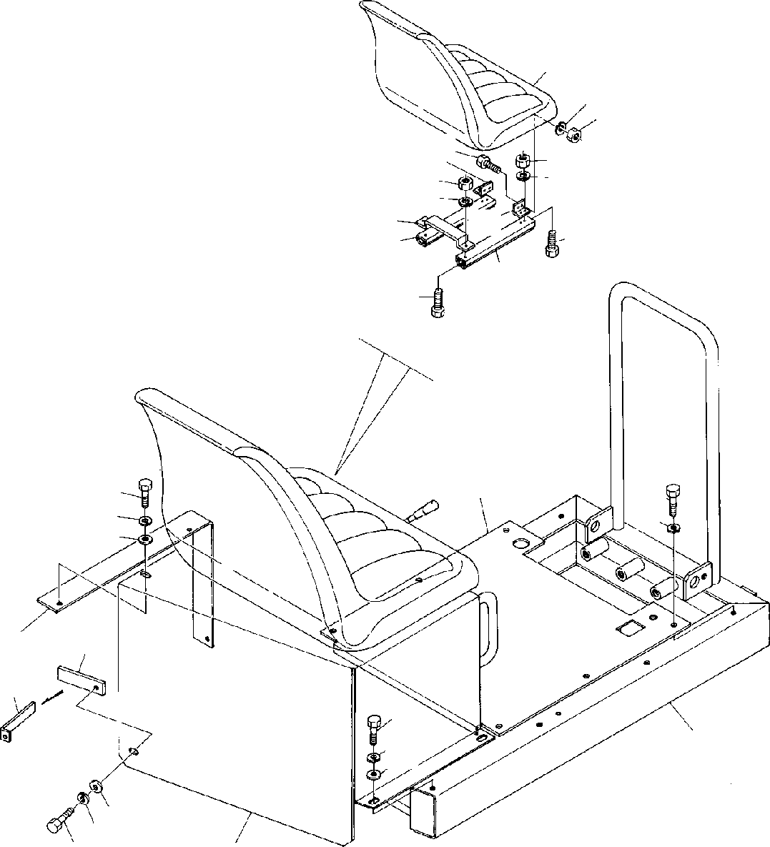
DT-600-2-00001 UPPER PK1120052-03 SWING TABLE
21
28
27
26
27
28
29
27
28
25
24
22
26
23
26
6
1
2
8
1
2
3
9
9
1
2
8
7
8
2
1
4

DT-600-2-00001 UPPER
000056
Pos No.

Parts No
Parts Name
Qty
Unit
Technical Data
Serial No (Start)
Serial No (End)
Rema

1
2
3
4

6
7
8
9

21
22
23
24
25
26

27
28
29

90101208016
90302040801
32250050010
32250050020
32250050050
32250050030
32250050040
90303070801
37000521820
32250050100
32250041100
32250043010
32250041300
32250041200
32250043020
90131508018
90131508016
90201200800
90302040801
32250043030
BOLT WASHER,SPRING SUPPORT COVER
COVER COVER FRAME
WASHER,PLAIN PLATE SUPPORT SEAT SUPPORT ADJUSTER ADJUSTER SUPPORT
BOLT,HEXAGON SOCKET BOLT,HEXAGON SOCKET NUT
WASHER,SPRING SUPPORT
12
12
1
1
1
1
1
6
1
1
1
1
1
1
1
10
10
10
10
1

M8X16 8

8

M8X18 M8X16 M8
8

275090

275309

275274

275089

275308

275273

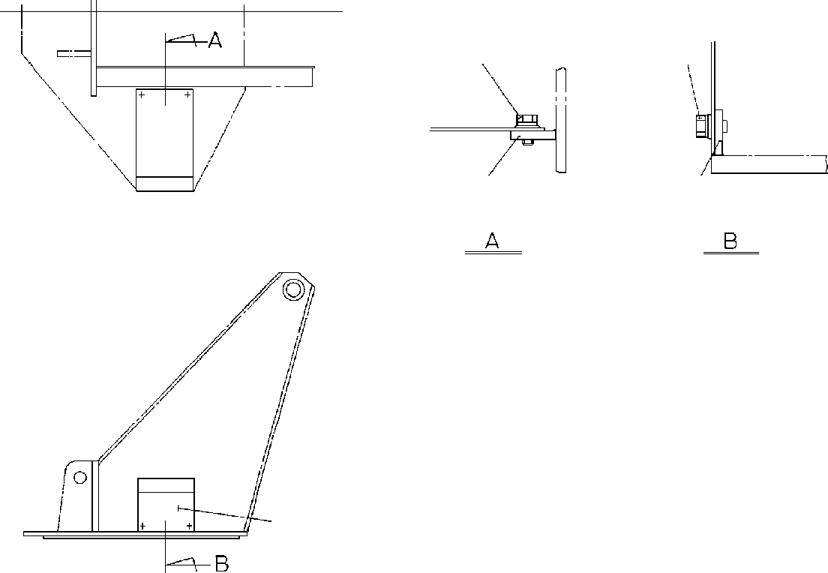
DT-600-2-00001 UPPER
PK1200137-00 COVER,SWING FRAME
3 4
3 4
2
2
1

DT-600-2-00001 UPPER
000057
Pos No.

Parts No
Parts Name
Qty
Unit
Technical Data
Serial No (Start)
Serial No (End)
Remarks
Pa

1
2
3
4

32270040010
37000508890
90101208012
90302040801
COVER PLATE BOLT
WASHER,SPRING
1
4
4
4

M8X12 8

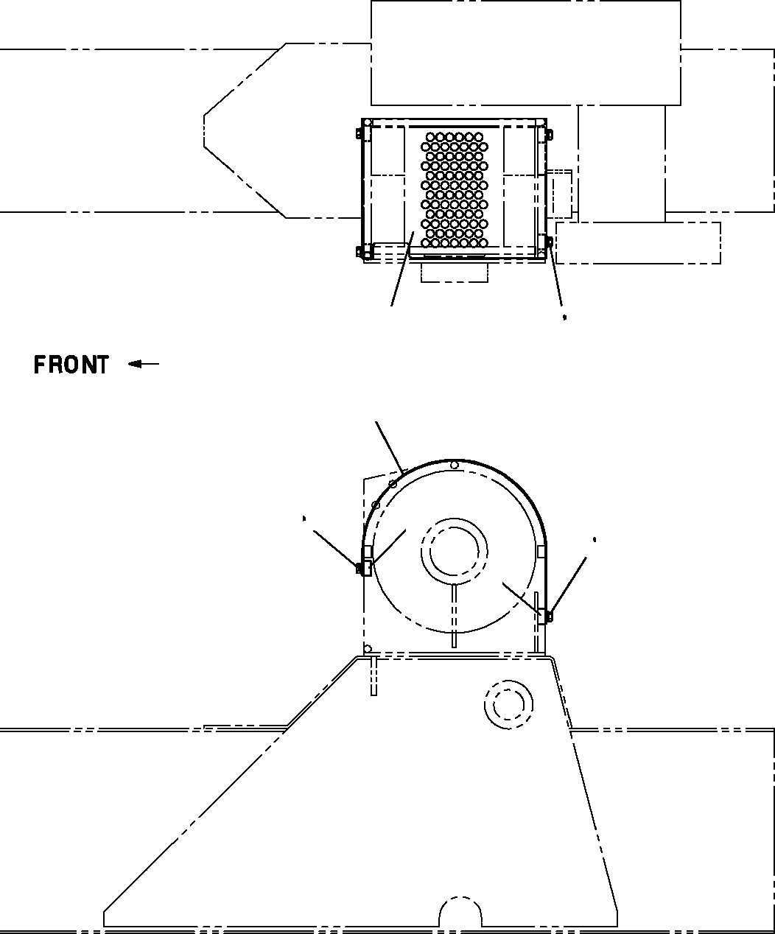
DT-600-2-00001 UPPER PK1330253-00 COVER (WINCH)
1
3 4
5
1
3 4
5
2
3 4
5
2

DT-600-2-00001 UPPER
000058
Pos No.

Parts No
Parts Name
Qty
Unit
Technical Data
Serial No (Start)
Serial No (End)
Remarks
Pa

1

2
3
4
5

32472600100
32472602000
37000541030
90101208012
90302040801
90303070801
COVER COVER PLATE BOLT
WASHER,SPRING WASHER,PLAIN
1
1
4
4
4
4

M8X12 8
8

275454

275453

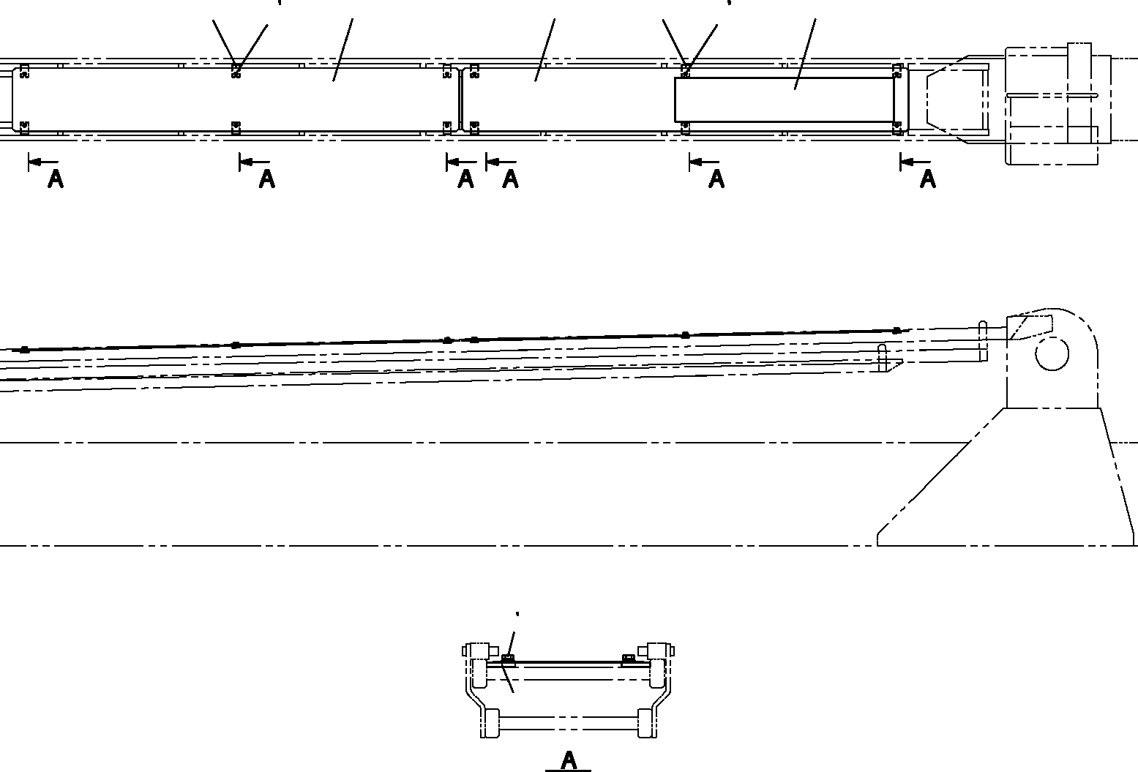
DT-600-2-00001 UPPER
PK1330414-00 COVER (WIRE GUARD:2 PCS)
2 3
4
2 3
4
6
1
1
6
5
2 3
4
6

DT-600-2-00001 UPPER
000059
Pos No.

Parts No
Parts Name
Qty
Unit
Technical Data
Serial No (Start)
Serial No (End)
Remarks
Pa

1
2
3
4
5
6

32472830100
90101208014
90302040801
90303070801
32472830200
37000555360
COVER BOLT
WASHER,SPRING WASHER,PLAIN PLATE,NAME PLATE
2
12
12
12
1
12

M8X14 8
8

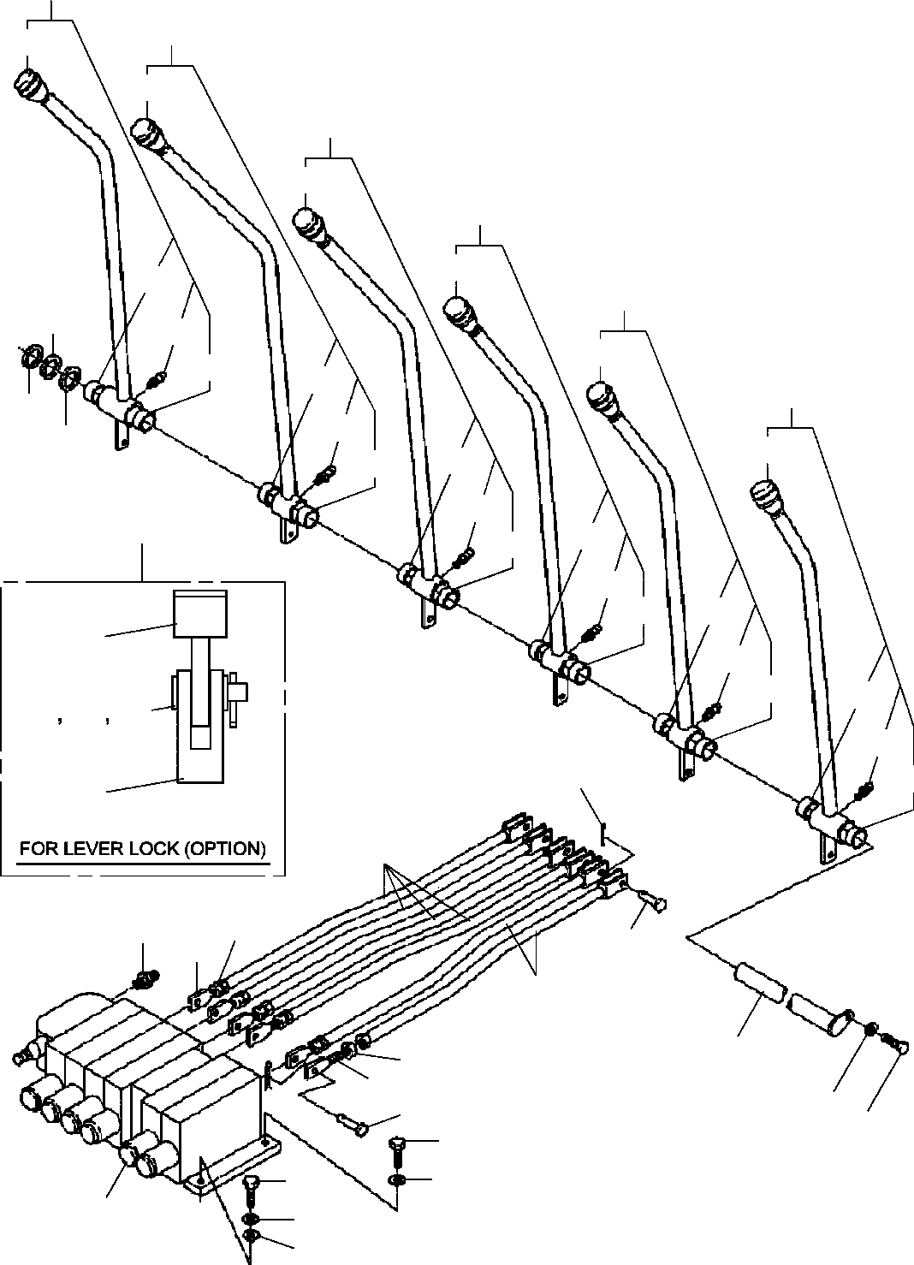
DT-600-2-00001 UPPER
PL1010079-02 OPERATION SYSTEM, CONTROL VALVE
20
19
31
31
18
31
17
31
36
16
14
33
31
36
36
15
14
33
14
31
36
36
33
101
36
36
33
36
36
51
33
36
36
52
53
54
33
10
36
55
7
6
21
8
5
7
12
6
5
3
8
13
2
3
2
3
4
1

DT-600-2-00001 UPPER
000060
Pos No.

Parts No
Parts Name
Qty
Unit
Technical Data
Serial No (Start)
Serial 27573

27508

27508

27569

1

2
3
4
5
6
7
8

10
12

13
14
15
16
17
18
19
20
21
31

33

36
51
53
54
55
101

36632280000
36638740000
90101210030
90302041001
90303071001
31320020071
90203200800
32320060010
37000120030
37000129200
80136320010
37000115680
37000135360
90101210018
37000518780
32320060020
32320060030
32320060040
32320060050
32320060060
32320060070
80456950401
31320020010
31320020020
82456106000
82456106000
82455106000
80804022010
33320001200
90303070601
80136320014
33320001210
33320001040
VALVE,MANUAL CONTROL
VALVE ASSY,SELECTOR (MANUAL CONT.) BOLT
WASHER,SPRING WASHER,PLAIN ADJUSTER
NUT ROD PIN PIN
PIN,SPLIT PIN
PIN BOLT PLATE
LEVER ASSY LEVER ASSY LEVER ASSY LEVER ASSY LEVER ASSY LEVER ASSY
JOINT,SELF SEALING (COUPLER) KNOB (BLACK)
KNOB (RED) NIPPLE,GREASE NIPPLE,GREASE NIPPLE,GREASE BEARING,PLAIN LEVER WASHER,PLAIN PIN,SPLIT SUPPORT LEVER ASSY
1
1
4
5
1
6
6
6
12
12
12
1
1
1
3
1
1
1
1
1
1
1
5
1
1
5
5
12
1
1
1
1
1

M10X30 10
10

M8

2X10

M10X18

1/4-28UNF
1/4-28UNF A-M6F FE

6
2X14

275731

275082

275082

275397

275700

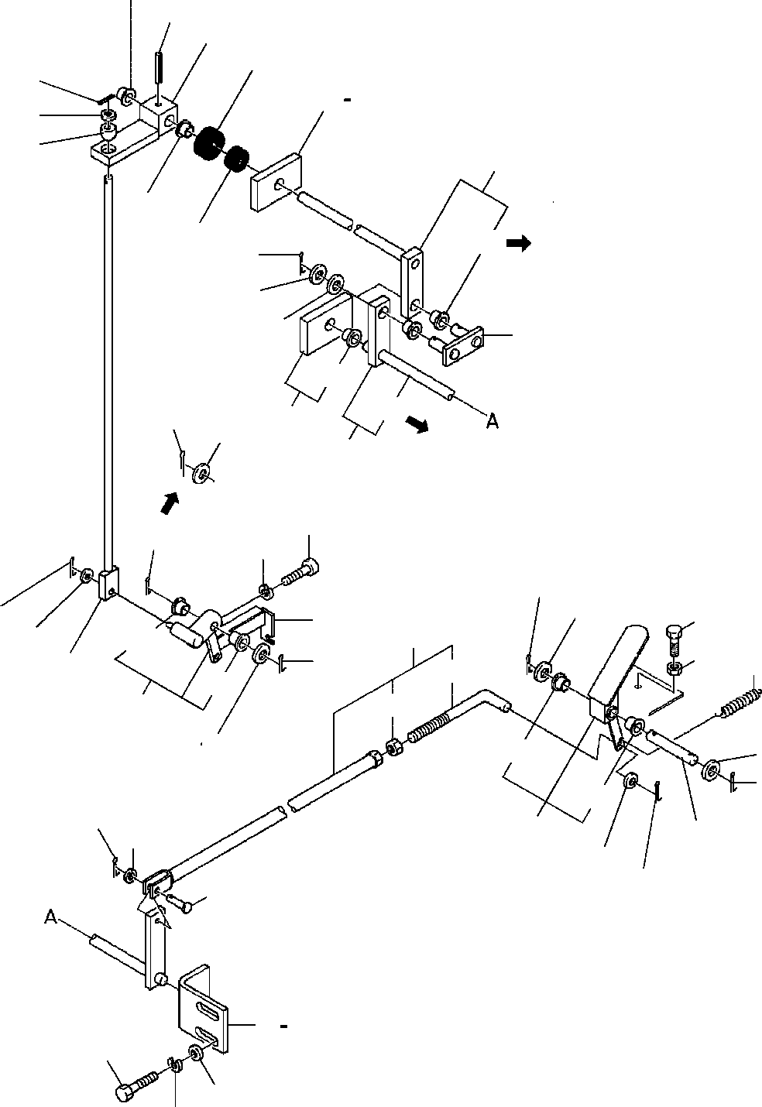
DT-600-2-00001 UPPER
PL1030067-02 OPERATION SYSTEM, ACCELERATOR
21
23
22
25
11
10
9
27
52
24
21
26
52
62
15
14
34
28
52
52
15
29
14
62
1
32
15
33
15
14
8
31
16
6
10
52
17
15
19
20
41
52
42
30
14
52
14
15
52
8
12
7
13
7
8
18
2
52
3
5
4

DT-600-2-00001 UPPER
000061
Pos No.

Parts No
Parts Name
Qty
Unit
Technical Data
Serial No (Start)
Serial No (End)
Remarks
Pa

1
2
3
4
5
6
7
8
9
10
11
12
13
14

15
16
17
18
19
20

21
22
23
24
25
26
27
28
29
30
31

32
33
34
41
42
52

62

32330050010
32330022010
90101210020
90302041001
90303071001
32330030020
90303070801
80136320016
32330020120
90303070601
80720102012
32330050020
37000104920
90303071201
90303071201
80136332025
90102210035
90203201000
37000105730
16314010000
32330030030
32330050060
37000400510
32330020110
80720104032
32330050030
82400000075
82400000215
32330020070
32330050040
32330050050
32330030050
32330030060
32330050070
90101208015
90302040801
42823500200
32330022130
90201200800
37000400510
37000400510
80824001208
LEVER SUPPORT BOLT
WASHER,SPRING WASHER,PLAIN ROD ASSY WASHER,PLAIN PIN,SPLIT
END WASHER,PLAIN PIN,SPRING PEDAL
PIN WASHER,PLAIN WASHER,PLAIN PIN,SPLIT BOLT
NUT PIN SPRING ROD ROD
BEARING,PLAIN LEVER PIN,SPRING SHAFT GROMMET GROMMET SUPPORT
ROD SUPPORT LEVER SUPPORT SUPPORT BOLT
WASHER,SPRING PLATE
ROD NUT
BEARING,PLAIN BEARING,PLAIN BEARING,PLAIN
1
1
2
2
2
1
2
3
1
2
1
1
1
5
6
5
1
1
1
1
1
1
2
1
1
1
1
1
1
1
1
1
1
1
2
2
2
1
1
7
2
2

M10X20 10
10

8
2X16

6
2X12

12
12
3.2X25 M10X35 M10

4X32

M8X15 8

M8

275018

275018

275018

275830

275474

275017

275017

275017

275473

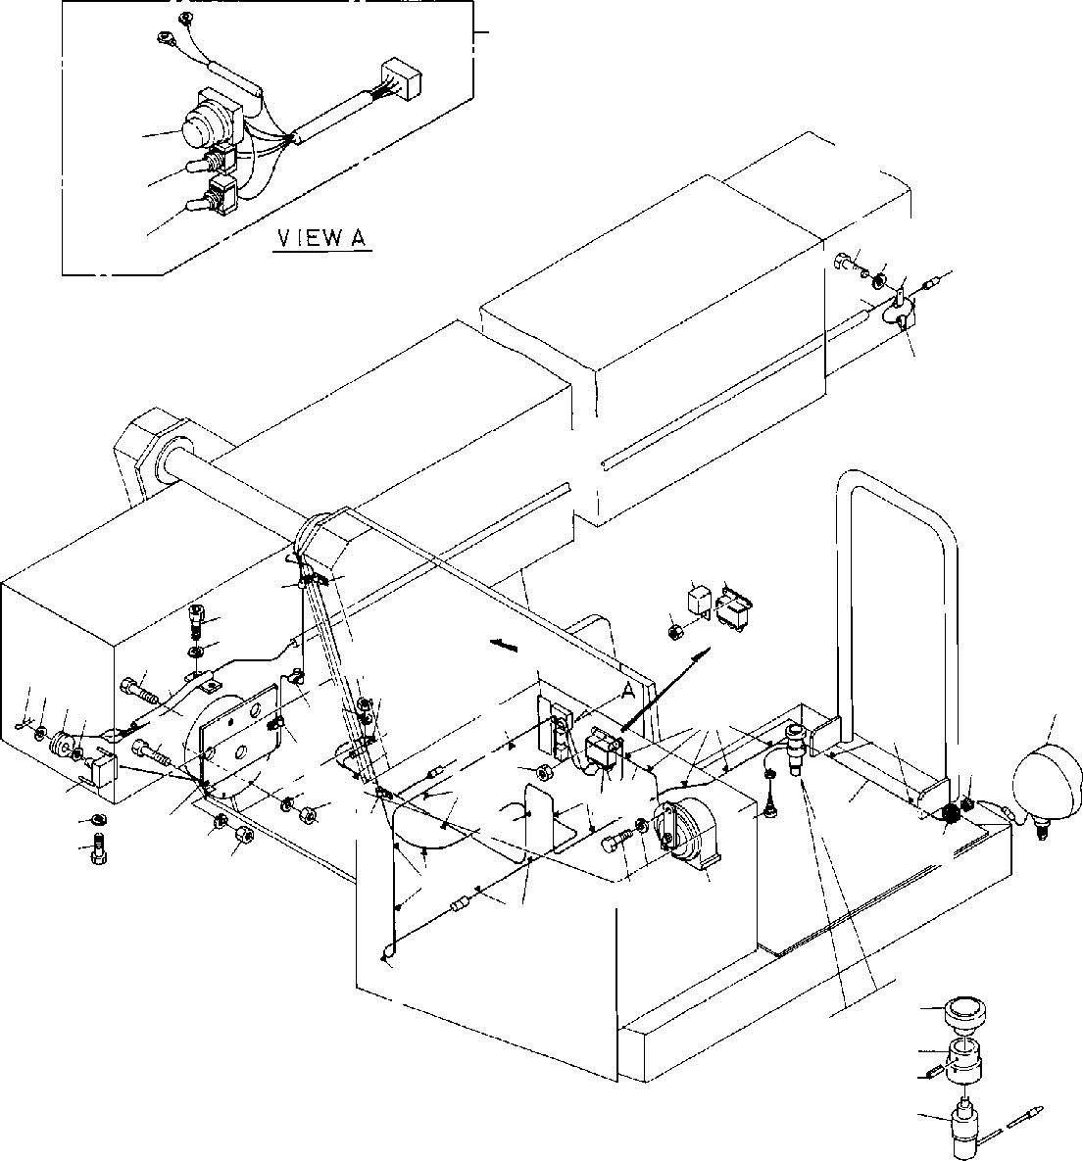
DT-600-2-00001 UPPER
PN1010184-03 ELECTRICAL ACCESSORIES
25
4647
4344
4445
121314
9

121314
31
24
23
22
22
17
1
32
12
16
26
15
24
3 4 5
18
18
13
22
1140
4
18
18
18
28
20
24
21
1324
22
18
18
7
6
1
2
23
19
18
27
29
13
24
10
2 1
18
8
18
18
51
52
53
54

DT-600-2-00001 UPPER
000062
Pos No.

Parts No
Parts Name
Qty
Unit
Technical Data
Serial No (Start)
Serial No (

275202

275053

275375

275053

275053

275053

275426

1
2
3
4
5
6
7
8

9
10
11
12
13

14
15
16
17
18
19

20
21
22
23
24

25

26
27
28
29
31

32
40
43
44
45
46
47
51
52
53
54

90302040801
90101208016
80136332020
90303071201
37001102460
32430080010
32430080020
82100000001
82100002600
32430030010
82400000216
82100001354
90101206012
90302040601
90302040601
82100002052
32430080030
32430080040
90131508012
82100001173
32430080050
32430100020
91810130240
31370250010
37000705910
82100000734
90201200600
90201200600
32430080060
32430100030
90101206016
32430030030
82100002002
90441340060
59481504000
82100002851
32430080030
82100000044
82100000897
82100000665
82100000895
82100001658
82100001694
42430130410
42430130450
80720103025
82100000081
WASHER,SPRING BOLT
PIN,SPLIT WASHER,PLAIN ROLLER SUPPORT HARNESS HORN
HORN (HIGH PITCH) HARNESS GROMMET
LAMP BOLT
WASHER,SPRING WASHER,SPRING CLAMP PLATE,NAME SUPPORT
BOLT,HEXAGON SOCKET <M8X12. CLAMP ASSY
HARNESS HARNESS FASTENER REEL,CORD CLAMP ASSY RELAY
NUT NUT
SWITCH ASSY
SWITCH ASSY (WITH HARNESS,3 SW) BOLT
PLATE CLAMP
SCREW,TAPPING RELAY
RELAY PLATE,NAME
BULB,LAMP (24V 60/60W> SWITCH,TOGGLE
CAP (BLACK) SWITCH,TOGGLE SWITCH,PUSH
COVER (RUBBER/BLACK) ROD
SUPPORT PIN,SPRING SWITCH,LIMIT
5
3
1
2
1
1
1
1
1
1
1
1
2
5
6
1
1
1
2
20
1
1
1
1
4
1
5
6
1
1
3
1
1
1
1
1
1
1
1
2
1
1
1
1
1
1
1

8
M8X16 3.2X20
12

L=450

L=5100 C30NG79-H 24V 60W M6X12
6
6

L=65

D=8

M6 M6

M6X16

WR6 M4X6

3X25

275203

275054

275054

275054

275054

275054
275427
275376

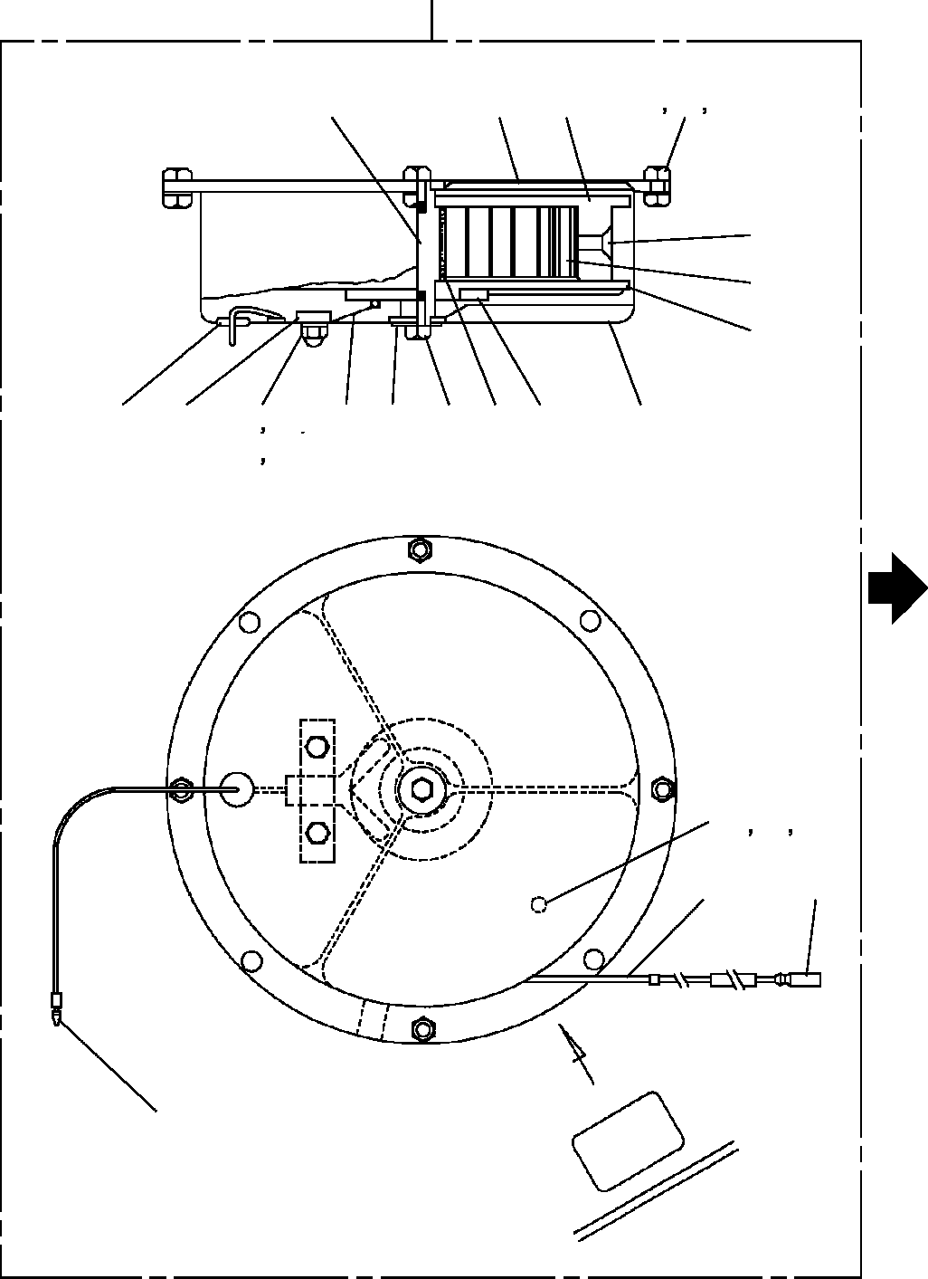
DT-600-2-00001 UPPER PN1350070-02 REEL,CORD
500
8
1
3
24
25
26
6
7
4
19
11
13
12
14
9
17
18
5
15
2
10
21
22
23
16
30
27

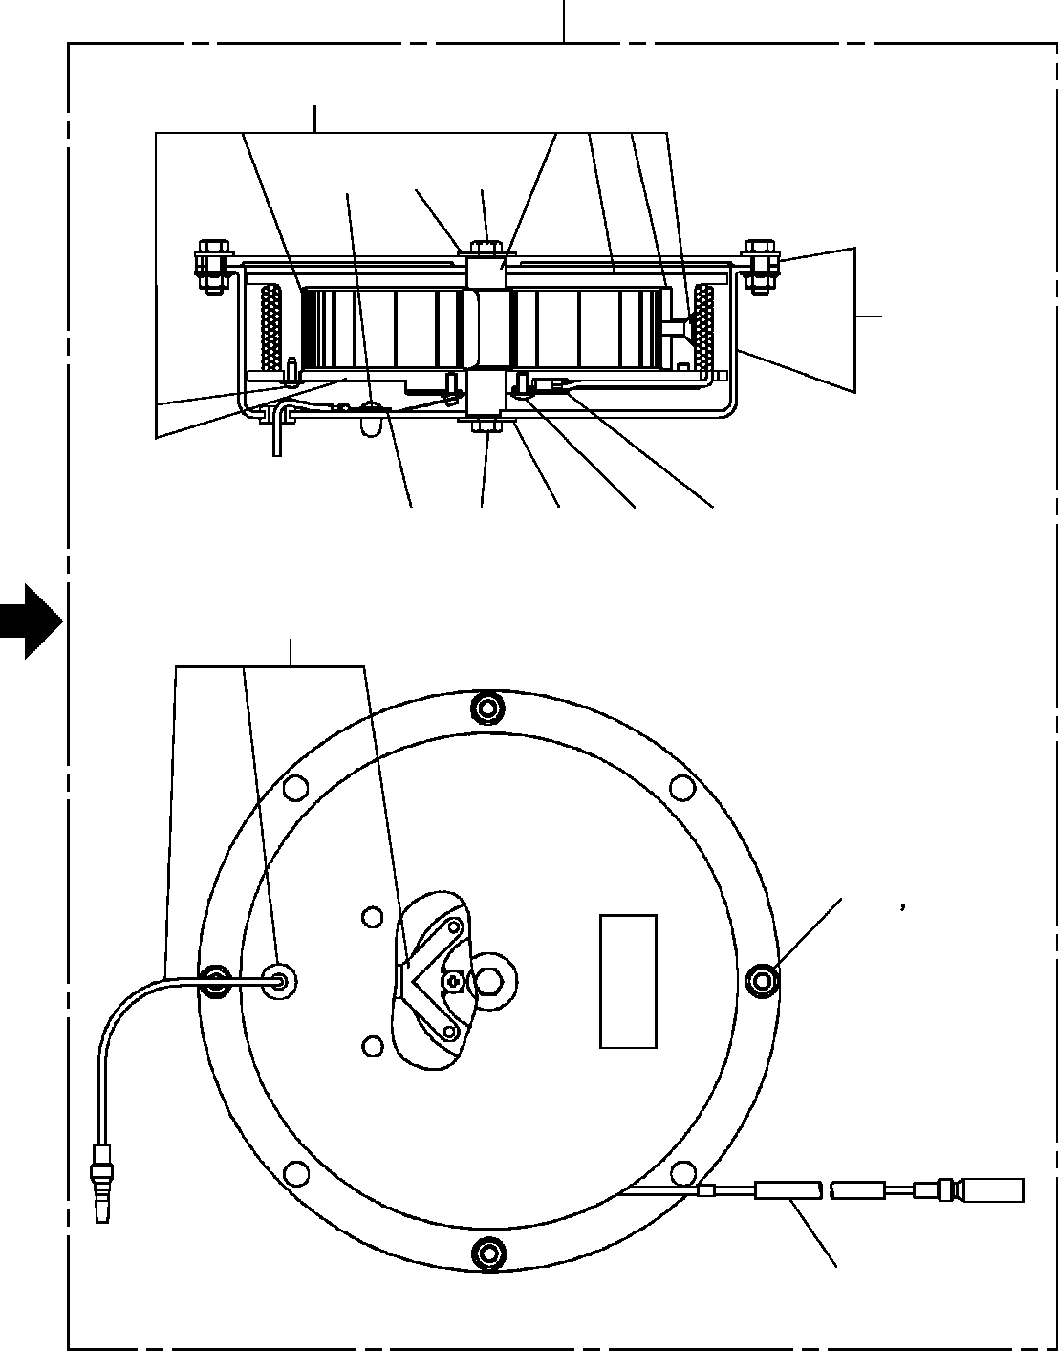
DT-600-2-00001 UPPER PN1350070-02 REEL,CORD
500
152
111
114
115
151
110
115
114
111
112
153
119 120
113

DT-600-2-00001 UPPER
000063
Pos No.

Parts No
Parts Name
Qty
Unit
Technical Data
Serial No (Start)
Serial No (End)
Remarks
P

1
2
3
4
5
6
7
8
9
10
11
12
13
14
15
16
17
18
19
21
22
23
24
25
26
27
30
110
111
112
113
114
115
119
120
151
152
153
500

31370255010
31370255020
31370255030
31370255040
31370255050
80175105012
31370255060
31370255070
31370255080
31370255090
80175104012
90240200400
90303100401
90302040401
31370255100
82100000080
31370255110
90102205008
31370255120
90441230010
90302040301
90303100301
90102205012
90201200500
90303100501
82100000192
82100000191
31370257510
31370257520
31370257530
31370257540
31370257550
90102205008
31370257560
31370257570
31370257580
31370257590
31370257600
31370250010
PLATE CASE DRUM
PLATE (DRUM) SPRING SCREW,MACHINE NUT
SHAFT BRUSH PLATE
SCREW,MACHINE NUT,CAP WASHER,PLAIN WASHER,SPRING RING,SLIP
CORD (1-LINE) WASHER BOLT GROMMET
SCREW,MACHINE WASHER,SPRING WASHER,PLAIN BOLT
NUT WASHER,PLAIN TERMINAL TERMINAL PLATE SCREW,MACHINE RING,SLIP
CORD ASSY (MAIN) WASHER
BOLT
BOLT (WITH W) NUT
CASE ASSY SPRING ASSY CORD ASSY (SUB) REEL,CORD
1
1
1
1
1
1
1
1
1
1
2
2
2
2
1
9
2
2
1
4
4
4
4
4
8
1
1
1
4
1
1
2
2
4
4
1
1
1
1

M

M5X12

M4X12 M4
4
4

M5X8

M3X10 3
3
M5X12 M5
5

M3X6 L=8.6M
M5X8 M5X12

275442
275442
275442
275442
275442
275442
275442
275442
275442
275442
275442

275441
275441
275441
275441
275441
275441
275441
275441
275441
275441
275441
275441
275441
275441
275441
275441
275441
275441
275441
275441
275441
275441
275441
275441
275441
275441
275441

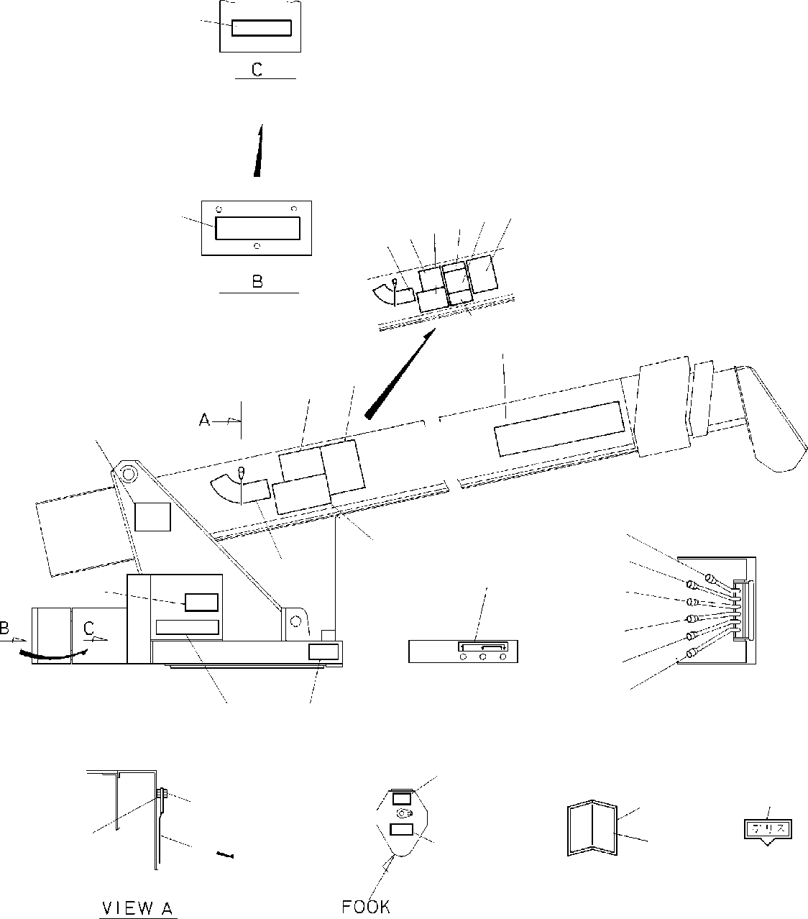
DT-600-2-00001 UPPER PO1010166-02 PLATE,INDICATION
26
8 28 9 291110
26
30 2
10
9
7
16
17
18
19
20
21
11
8
15
27
1
1314
3
25
5
6
23
22
24
4
31

DT-600-2-00001 UPPER
000064
Pos No.

Parts No
Parts Name
Qty
Unit
Technical Data
Serial No (Start)
Serial No (End)
Re

1
2

3

4
5
6
7
8
9
10
11

14
15
16
17
18
19
20
21
22
23

24

25
26
28

29
30
31

32390140010
12647115000
37002209510
13117014000
37002200180
32390140070
18617081000
32390140020
32390140030
32390050060
32390140040
32390140050
32390050100
32390140080
80147310420
32390050110
32390050120
37002203620
37002202000
37002202010
42390010050
37002203630
90201201000
90101210016
90101210018
11627023001
31391150120
12117140000
37002209550
32940720020
32390140090
32940720050
32940720030
31390040010
PLATE,NAME (DT-600) PLATE,NAME (TADANO) PLATE,NAME (TADANO) PLATE,NAME (2.9TON) PLATE,NAME (2.9TON) PLATE,NAME (11.66M-370KG) CASE
PLATE,NAME PLATE,NAME PLATE,NAME PLATE,NAME PLATE,NAME PLATE,CAUTION PLATE,NAME RIVET PLATE,NAME PLATE,NAME PLATE,NAME PLATE,NAME PLATE,NAME PLATE,NAME PLATE,NAME NUT
BOLT BOLT INDICATOR INDICATOR
PLATE,NAME (GREASE) PLATE,NAME (TADANO) PLATE,CAUTION PLATE,CAUTION PLATE,CAUTION PLATE,CAUTION INDICATOR
2
2
2
2
2
1
1
1
1
1
1
1
1
1
4
1
1
1
1
1
1
1
1
1
1
1
1
12
1
1
1
1
1
1

3.2X6

M10 M10X16 M10X18

275134

275397

275331

275228

275225

275134
275331
275376
275331
275331
275331

275133

275396

275330

275227

275224
275330

275375

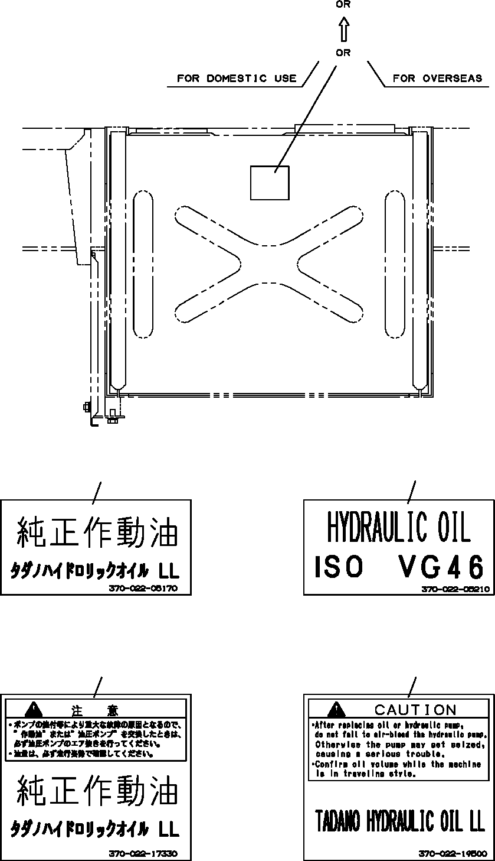
DT-600-2-00001 UPPER
PO1012579-01 PLATE ASSY,NAME (OIL)
11
12
1
2
1
2
11
12

DT-600-2-00001 UPPER
000065
Pos No.

Parts No
Parts Name
Qty
Unit
Technical Data
Serial No (Start)
Serial N 275429
275429

1
2
11
12

37002205170
37002205210
37002217330
37002219500
PLATE,NAME (HYDRAULIC OIL LL) PLATE,NAME (OIL ISO VG46 ,EXP) PLATE,CAUTION (TADANO HYDRAULIC) PLATE,CAUTION (OIL/FOR EXP.)
1
1
1
1

275430
275430

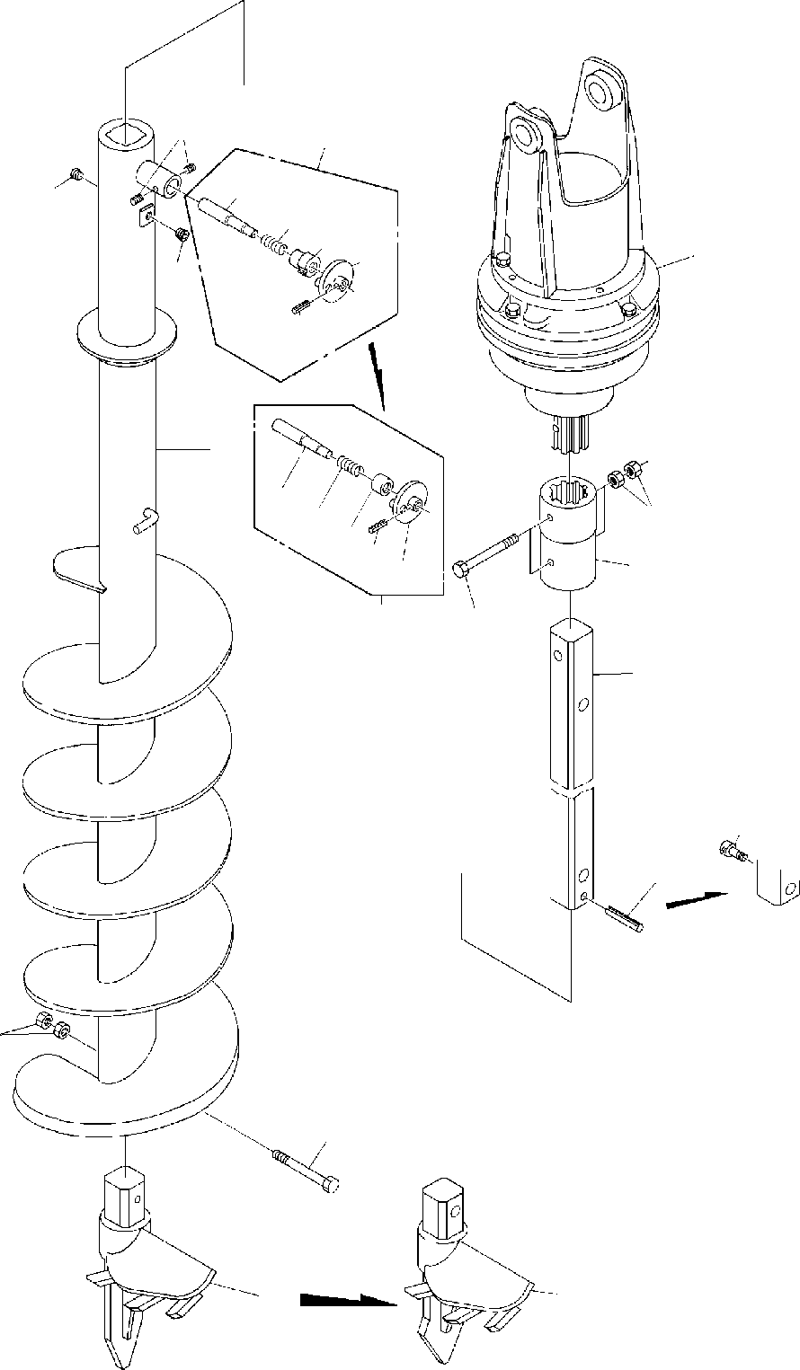
DT-600-2-00001 UPPER PP2010000-02 AUGER
6
3
21
4
22
23
24
1
4
25
7
21 22
11
2
2325
24
3
12
5
13
5
9
11
12
8
8

DT-600-2-00001 UPPER
000066
Pos No.

Parts No
Parts Name
Qty
Unit
Technical Data
Serial No (Start)
Serial No (End)
Rema

1
2
3

4
5

6
7
8

9
11
12
13
21
22
23

24
25

36340050000
32490020010
32490020060
32490020070
80316030060
32490020030
32490020110
90710006080
32490020040
32490020051
32490020100
80720110080
90201401800
90101718140
90131510020
32490022030
37001200470
32490022040
32490022060
32490022050
80720105018
DRIVING UNIT,AUGER COUPLING
PIN ASSY PIN ASSY PLUG SHAFT SHAFT SCREW,SET SCREW DRILL
DRILL,AUGER (450 S) PIN,SPRING
NUT BOLT
BOLT,HEXAGON SOCKET PIN
SPRING GUIDE GUIDE GRIP PIN,SPRING
1
1
1
1
2
1
1
2
1
1
1
1
6
3
1
1
1
1
1
1
1

PT3/8

M6X8 450

M18 M18X140 M10X20

5X18

275023

275094

275023

275094

275023

275022

275093

275022

275093

275022

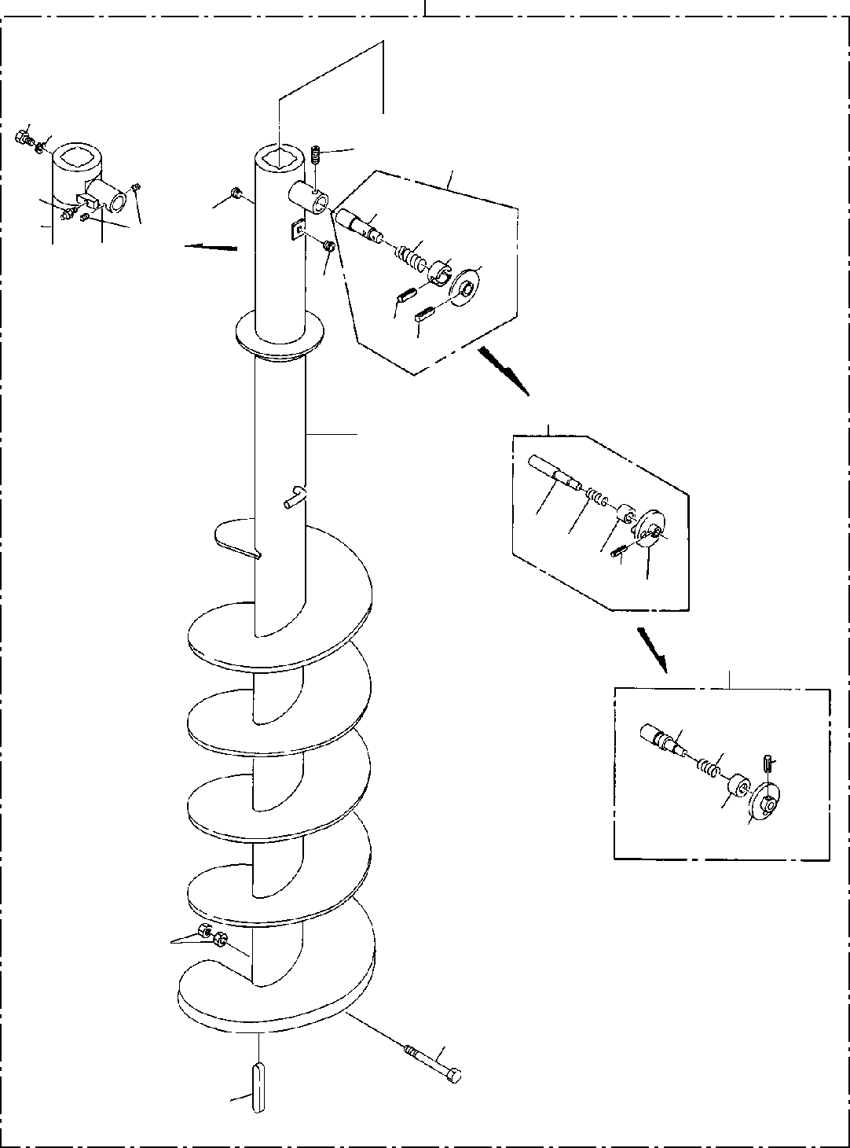
DT-600-2-00001 UPPER
PP2010002-02 AUGER (450,OPTION)
100
9 10
6
3
8
7
21
4
2223
6
25
4
24
26
3
5
3122
3326
34
3
41
42
24
4344
2
1
7

DT-600-2-00001 UPPER
000067
Pos No.

Parts No
Parts Name
Qty
Unit
Technical Data
Serial No (Start)
Serial No (End)
Remarks
Pa

1
2
3

4
5

6

7
8
9
10
21
22
23
24

25
26
31
33
34
41
42
43
44
100

90101916150
90201401600
32490020020
32490020070
32490023000
80316030060
32470220010
32470220030
90710006080
90710006080
32470220020
82456106000
37001504060
90302041801
37000115560
37001200470
32490022010
80720105028
80720105028
32490022020
80720105018
32490022030
32490022060
32490022050
32490023010
37001200720
32490253510
32490253520
32470220000
BOLT NUT
PIN ASSY PIN ASSY PIN ASSY PLUG SCREW SCREW SCREW,SET SCREW,SET KEY
NIPPLE,GREASE BOLT WASHER,SPRING PIN
SPRING GUIDE PIN,SPRING PIN,SPRING GRIP PIN,SPRING PIN
GUIDE GRIP PIN SPRING GUIDE GRIP
AUGER (450)
1
2
1
1
1
2
1
1
1
2
2
1
1
1
1
1
1
1
1
1
1
1
1
1
1
1
1
1
1

M16X150 M16

PT3/8

M6X8 M6X8

1/4-28UNF

18

5X28
5X28

5X18

275028
275094

275094

275028

275094
275094
275094

275094

275028
275028
275028
275094
275094
275094
275094

275027
275093

275093
275093

275027

275027
275093
275027
275027

275027
275093
275093
275093
275093

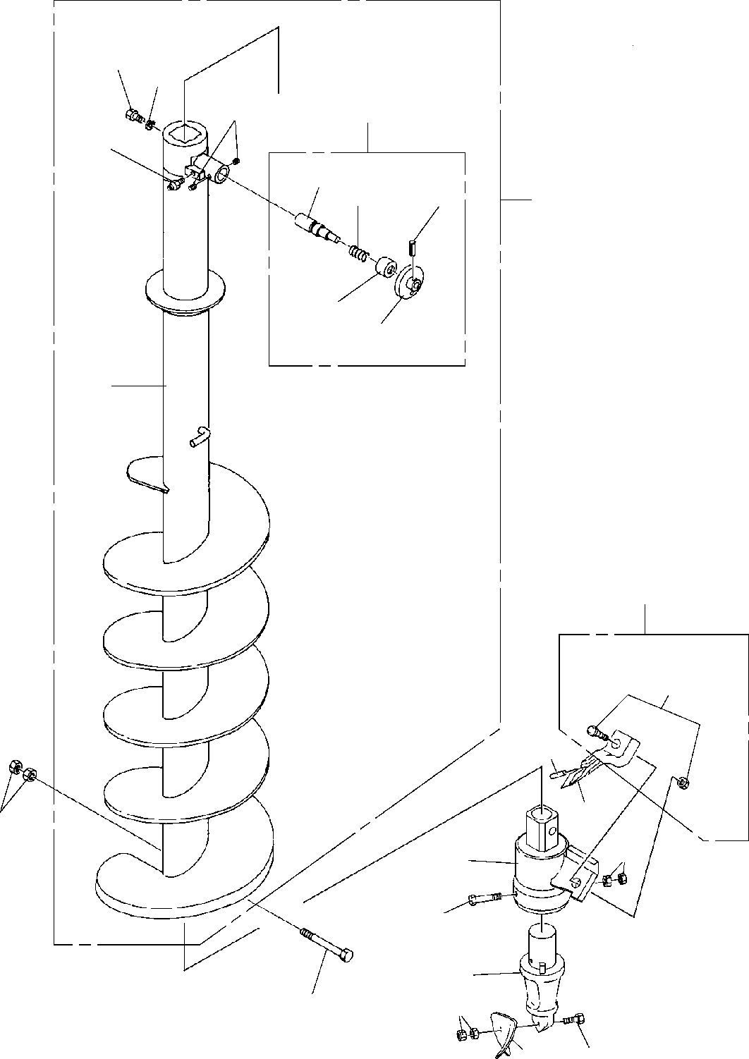
DT-600-2-00001 UPPER
PP2010009-03 AUGER (250.PENGO)
1
2
4
3
5
21
22
25
100
23
24
8
32
51
42
41
7
36
31
35
33
39
6
34
38

DT-600-2-00001 UPPER
000068
Pos No.

Parts No
Parts Name
Qty
Unit
Technical Data
Serial No (Start)
Serial No (End)
Rema

1

2

3

4

5

6

7

8

21

22

23

24

25

31

32

33

34

35

36

38

39

41

42

51

100

37001504060
37001504060
90302041801
90302041801
32490023000
32490023000
90710006080
90710006080
82456106000
82456106000
90101918140
90101918140
90201401800
90201401800
32471020010
32471020010
32490023010
32490023010
37001200720
37001200720
32490253510
32490253510
32490253520
32490253520
80720105028
80720105028
32471012000
32471012000
32471012100
32471012100
32470720300
32470720300
32470720400
32470720400
90101512150
90101512150
90201401200
90201401200
90101510050
90101510050
90203401000
90203401000
32470720600
32470720600
32470720500
32470720500
32470720200
32470720200
32471028010
32471028010
BOLT BOLT
WASHER,SPRING WASHER,SPRING PIN ASSY
PIN ASSY SCREW,SET SCREW,SET NIPPLE,GREASE NIPPLE,GREASE BOLT
BOLT NUT NUT SCREW SCREW PIN
PIN SPRING SPRING GUIDE GUIDE GRIP GRIP
PIN,SPRING PIN,SPRING SUPPORT SUPPORT HOLDER HOLDER ADAPTER ADAPTER
BIT,PILOT (PENGO.FH205) BIT,PILOT (PENGO.FH205) BOLT
BOLT NUT NUT BOLT BOLT NUT NUT
TOOTH (PENGO.1652) TOOTH (PENGO.1652) CUSHION
CUSHION BOLT ASSY BOLT ASSY SCREW ASSY SCREW ASSY
1
1
1
1
1
1
2
2
1
1
1
1
2
2
1
1
1
1
1
1
1
1
1
1
1
1
1
1
1
1
1
1
1
1
1
1
2
2
1
1
2
2
1
1
1
1
1
1
1
1

18
18

M6X8 M6X8
1/4-28UNF
1/4-28UNF M18X140 M18X140 M18
M18

5X28
5X28

M12X150 M12X150 M12
M12 M10X50 M10X50 M10 M10

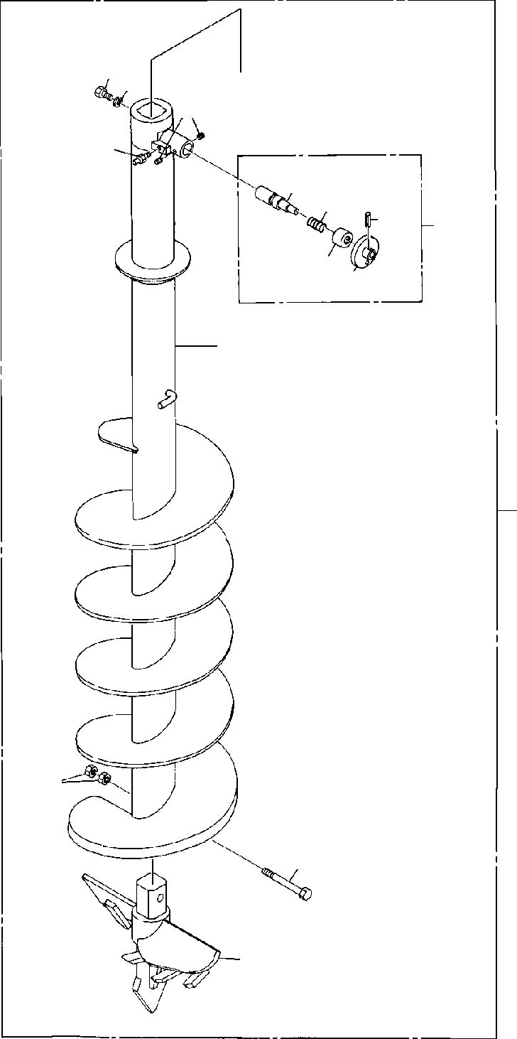
DT-600-2-00001 UPPER
PP2010010-01 AUGER (650.S-TYPE,OPTION)
1 2
4
5
21
22
25
3
2324
8
100
7
6
9

DT-600-2-00001 UPPER
000069
Pos No.

Parts No
Parts Name
Qty
Unit
Technical Data
Serial No (Start)
Serial No (End)
Re

1
2
3
4
5
6
7
8
9
21
22
23
24
25
100

37001504060
90302041801
32490023000
90710006080
82456106000
90101918140
90201401800
32471060010
32471060020
32490023010
37001200720
32490253510
32490253520
80720105028
32471060000
BOLT WASHER,SPRING PIN ASSY SCREW,SET NIPPLE,GREASE BOLT
NUT SCREW
HEAD,AUGER PIN
SPRING GUIDE GRIP PIN,SPRING
AUGER (650.S-TYPE,OPTION)
1
1
1
2
1
1
2
1
1
1
1
1
1
1
1

18

M6X8
1/4-28UNF M18X140 M18

5X28

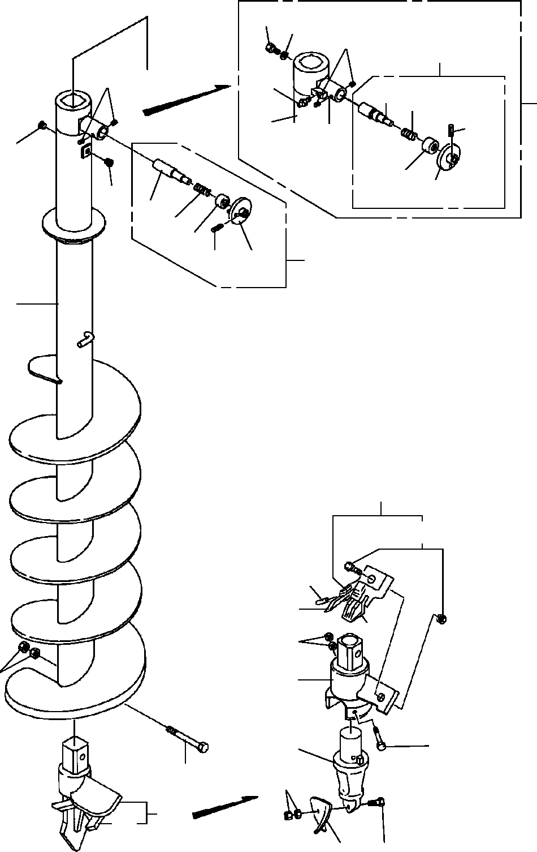
DT-600-2-00001 UPPER
PP2010011-03 AUGER (300.PENGO)
12 13
6
3
6
14
7
31 32
100
35
4
33 34
4
21
22
23
3
25
24
7
52
71
62
60
56
51
61
11
55
53
59
10
8
45
54
58

DT-600-2-00001 UPPER
000070
Pos No.

Parts No
Parts Name
Qty
Unit
Technical Data
Serial No (Start)
Serial No (End)
Remarks
Pa

3

4
6

7

8

10

11

12

13

14

21
22
23
24
25
31

32

33

34

35

45

100

32490020070
32490023000
32490023000
80316030060
90710006080
90710006080
32470350010
32470350020
32470350020
32470340020
32470340020
90101918140
90101918140
90201401800
90201401800
37001504060
37001504060
90302041801
90302041801
82456106000
82456106000
32490022030
37001200470
32490022060
32490022050
80720105018
32490023010
32490023010
37001200720
37001200720
32490253510
32490253510
32490253520
32490253520
80720105028
80720105028
32470590000
32470590000
32470358010
32470358010
PIN ASSY PIN ASSY PIN ASSY PLUG SCREW,SET SCREW,SET SCREW SCREW SCREW DRILL DRILL
BOLT BOLT NUT NUT BOLT BOLT
WASHER,SPRING WASHER,SPRING NIPPLE,GREASE NIPPLE,GREASE PIN
SPRING GUIDE GRIP PIN,SPRING PIN
PIN SPRING SPRING GUIDE GUIDE GRIP GRIP
PIN,SPRING PIN,SPRING BIT,CUTTER BIT,CUTTER SCREW ASSY SCREW ASSY
1
1
1
2
2
2
1
1
1
1
1
1
1
2
2
1
1
1
1
1
1
1
1
1
1
1
1
1
1
1
1
1
1
1
1
1
2
2
1
1

PT3/8 M6X8 M6X8

300
300
M18X140 M18X140 M18
M18

18
18
1/4-28UNF
1/4-28UNF

5X18

5X28
5X28

275094
275094

275094
275094

275094
275094

275094
275094
275094
275094
275094
275094

275094
275094
275094
275094
275094
275094
275094
275094
275094
275094

275094
275094
275093

275093

275093

275093
275093
275093
275093
275093

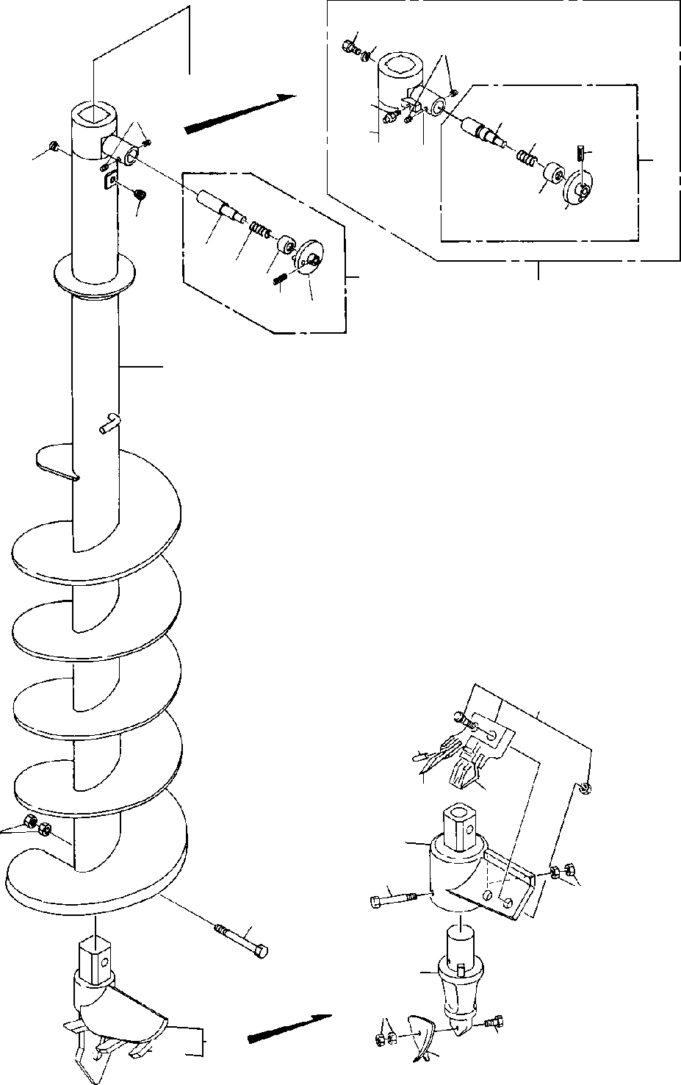
DT-600-2-00001 UPPER
PP2010012-02 AUGER (400.PENGO)
1213
6
14
7
6
31
32
35
3
4
33
34
4
21
2223
2524
3
100
7
52
62
60
61
11
51
55
56
10
53
59
8
58
45
54

DT-600-2-00001 UPPER
000071
Pos No.

Parts No
Parts Name
Qty
Unit
Technical Data
Serial No (Start)
Serial No (End)
Remarks
Pa

3

4
6

7

8

10

11

12

13

14

21
22
23
24
25
31

32

33

34

35

45

100

32490020070
32490023000
32490023000
80316030060
90710006080
90710006080
32470360010
32470360020
32470360020
32470260020
32470260020
90101918140
90101918140
90201401800
90201401800
37001504060
37001504060
90302041801
90302041801
82456106000
82456106000
32490022030
37001200470
32490022060
32490022050
80720105018
32490023010
32490023010
37001200720
37001200720
32490253510
32490253510
32490253520
32490253520
80720105028
80720105028
32470590000
32470590000
32470368010
32470368010
PIN ASSY PIN ASSY PIN ASSY PLUG SCREW,SET SCREW,SET SCREW SCREW SCREW DRILL DRILL
BOLT BOLT NUT NUT BOLT BOLT
WASHER,SPRING WASHER,SPRING NIPPLE,GREASE NIPPLE,GREASE PIN
SPRING GUIDE GRIP PIN,SPRING PIN
PIN SPRING SPRING GUIDE GUIDE GRIP GRIP
PIN,SPRING PIN,SPRING BIT,CUTTER BIT,CUTTER SCREW ASSY SCREW ASSY
1
1
1
2
2
2
1
1
1
1
1
1
1
2
2
1
1
1
1
1
1
1
1
1
1
1
1
1
1
1
1
1
1
1
1
1
3
3
1
1

PT3/8 M6X8 M6X8

400
400
M18X140 M18X140 M18
M18

18
18
1/4-28UNF
1/4-28UNF

5X18

5X28
5X28

275097
275097

275097
275097

275097
275097

275097
275097
275097
275097
275097
275097

275097
275097
275097
275097
275097
275097
275097
275097
275097
275097

275097
275097
275096

275096

275096

275096
275096
275096
275096
275096

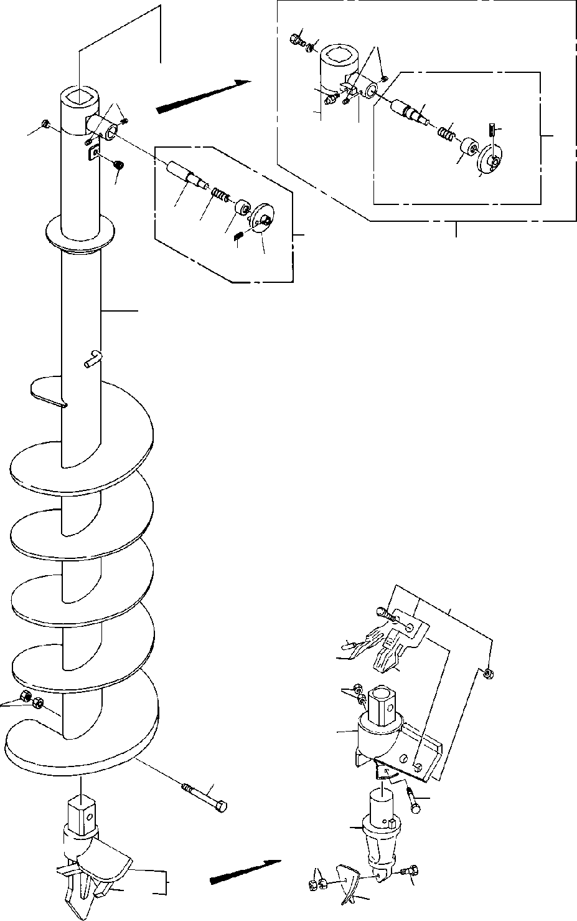
DT-600-2-00001 UPPER
PP2010013-02 AUGER (350.PENGO)
1213
6
14
7
6
31
32
35
3
4
33
34
4
21
2223
3
100
2524
7
52
62
60
56
51
61
11
10
55
53
59
8
45
58
54

DT-600-2-00001 UPPER
000072
Pos No.

Parts No
Parts Name
Qty
Unit
Technical Data
Serial No (Start)
Serial No (End)
Remarks
Pa

3

4
6

7

8

10

11

12

13

14

21
22
23
24
25
31

32

33

34

35

45

100

32490020070
32490023000
32490023000
80316030060
90710006100
90710006080
90710006080
32470390010
32470390020
32470390020
32470400020
32470400020
90101918140
90101918140
90201401800
90201401800
37001504060
37001504060
90302041801
90302041801
82456106000
82456106000
32490022030
37001200470
32490022060
32490022050
80720105018
32490023010
32490023010
37001200720
37001200720
32490253510
32490253510
32490253520
32490253520
80720105028
80720105028
32470590000
32470590000
32470398010
32470398010
PIN ASSY PIN ASSY PIN ASSY PLUG SCREW,SET SCREW,SET SCREW,SET SCREW SCREW SCREW DRILL DRILL
BOLT BOLT NUT NUT BOLT BOLT
WASHER,SPRING WASHER,SPRING NIPPLE,GREASE NIPPLE,GREASE PIN
SPRING GUIDE GRIP PIN,SPRING PIN
PIN SPRING SPRING GUIDE GUIDE GRIP GRIP
PIN,SPRING PIN,SPRING BIT,CUTTER BIT,CUTTER SCREW ASSY SCREW ASSY
1
1
1
2
2
1
1
1
1
1
1
1
1
1
2
2
1
1
1
1
1
1
1
1
1
1
1
1
1
1
1
1
1
1
1
1
1
2
2
1
1

PT3/8 M6X10 M6X8 M6X8

350
350
M18X140 M18X140 M18
M18

18
18
1/4-28UNF
1/4-28UNF

5X18

5X28
5X28

275094
275094

275094
275094

275094
275094

275094
275094
275094
275094
275094
275094

275094
275094
275094
275094
275094
275094
275094
275094
275094
275094

275094
275094
275093

275093
275093

275093

275093
275093
275093
275093
275093

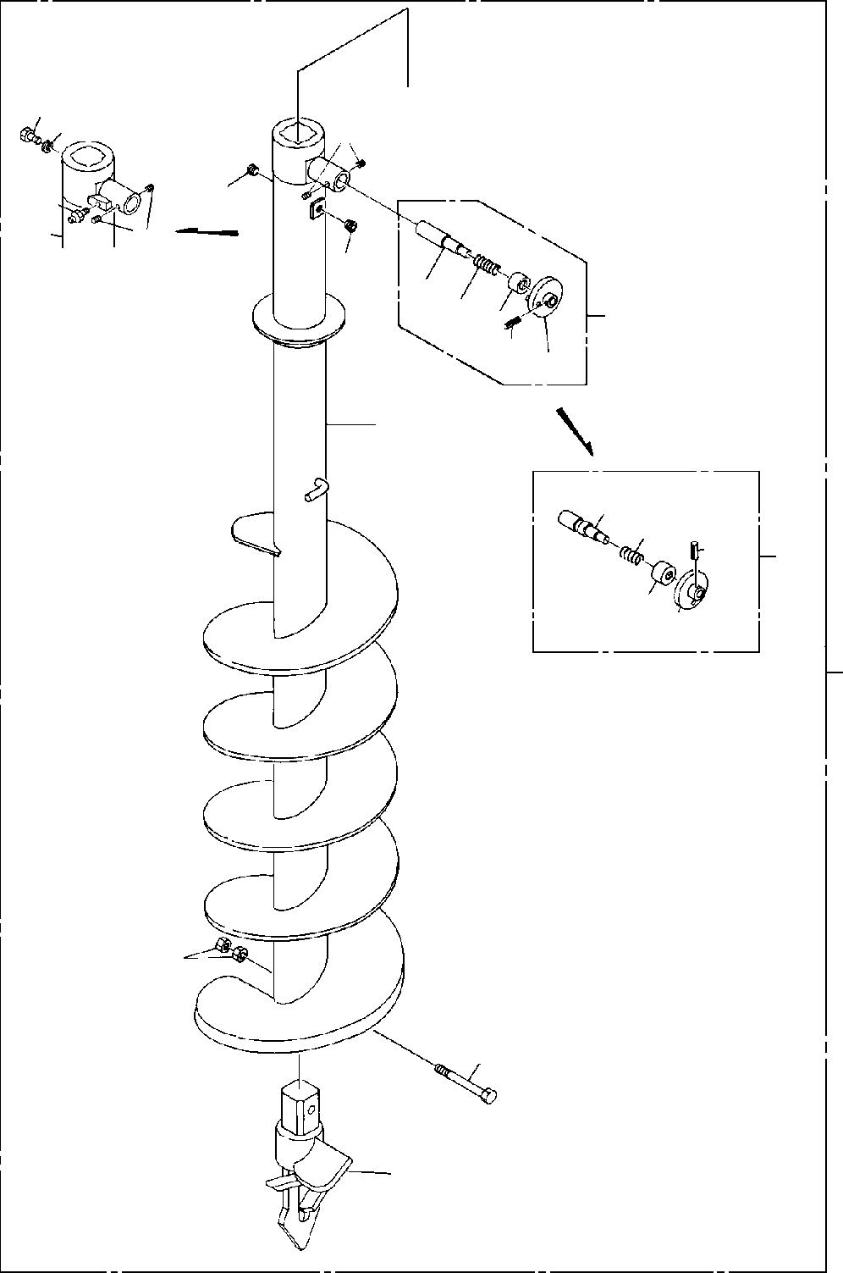
DT-600-2-00001 UPPER PP2010014-01 AUGER (200)
1213
6
14
7
4
6
4
2122 23
25 24
3
7
31
32
35
3
3334
100
11
10
8

DT-600-2-00001 UPPER
000073
Pos No.

Parts No
Parts Name
Qty
Unit
Technical Data
Serial No (Start)
Serial No (End)
Remarks
Pa

3

4
6

7

8

10

11

12

13

14

21
22
23
24
25
31

32

33

34

35

100

32490020070
32490023000
32490023000
80316030060
90710006100
90710006080
90710006080
32470430010
32470430030
32470430030
32470430020
32470430020
90171118160
90101918140
90101918140
90201401800
90201401800
37001504060
37001504060
90302041801
90302041801
82456106000
82456106000
32490022030
37001200470
32490022060
32490022050
80720105018
32490023010
32490023010
37001200720
37001200720
32490253510
32490253510
32490253520
32490253520
80720105028
80720105028
32470430000
32470430000
PIN ASSY PIN ASSY PIN ASSY PLUG SCREW,SET SCREW,SET SCREW,SET SCREW SCREW SCREW DRILL DRILL
BOLT BOLT BOLT NUT NUT BOLT BOLT
WASHER,SPRING WASHER,SPRING NIPPLE,GREASE NIPPLE,GREASE PIN
SPRING GUIDE GRIP PIN,SPRING PIN
PIN SPRING SPRING GUIDE GUIDE GRIP GRIP
PIN,SPRING PIN,SPRING AUGER (200)
AUGER (200)
1
1
1
2
2
2
2
1
1
1
1
1
1
1
1
2
2
1
1
1
1
1
1
1
1
1
1
1
1
1
1
1
1
1
1
1
1
1
1
1

PT3/8 M6X10 M6X8 M6X8

M18X160 M18X140 M18X140 M18
M18

18
18
1/4-28UNF
1/4-28UNF

5X18

5X28
5X28

275094
275094

275094
275094

275094
275094

275094
275094

275094
275094
275094
275094
275094
275094

275094
275094
275094
275094
275094
275094
275094
275094
275094
275094

275093

275093
275093

275093

275093

275093
275093
275093
275093
275093

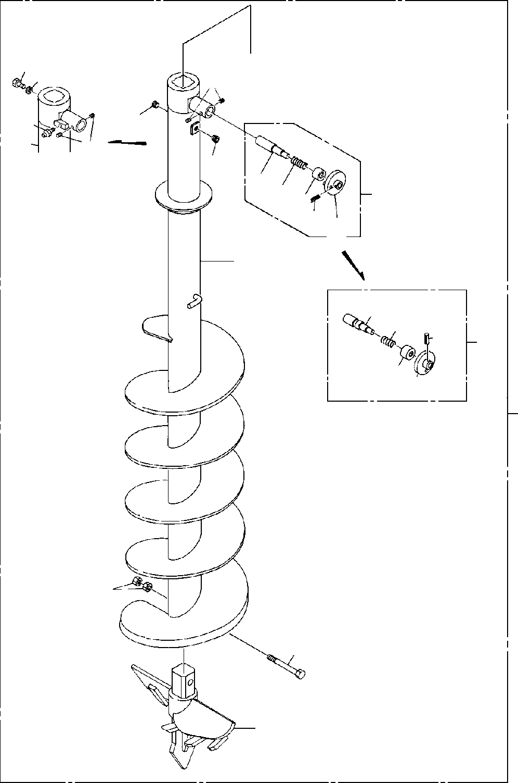
DT-600-2-00001 UPPER
PP2010015-01 AUGER (600.OPTION)
1213
6
14
7
4
6
4
2122
3
23
25 24
7
31
32
35
3
3334
100
11
10
8

DT-600-2-00001 UPPER
000074
Pos No.

Parts No
Parts Name
Qty
Unit
Technical Data
Serial No (Start)
Serial No (End)
Remarks
3

4
6
7

8
10
11
12
13
14
21
22
23
24
25
31
32
33
34
35
100

32490020070
32490023000
80316030060
90710006080
32470540010
32470540030
32470540020
90101918140
90201401800
37001504060
90302041801
82456106000
32490022030
37001200470
32490022060
32490022050
80720105018
32490023010
37001200720
32490253510
32490253520
80720105028
32470540000
PIN ASSY PIN ASSY PLUG SCREW,SET SCREW SCREW DRILL
BOLT NUT BOLT
WASHER,SPRING NIPPLE,GREASE PIN
SPRING GUIDE GRIP PIN,SPRING PIN
SPRING GUIDE GRIP PIN,SPRING
AUGER (600.OPTION)
1
1
2
2
1
1
1
1
2
1
1
1
1
1
1
1
1
1
1
1
1
1
1

PT3/8 M6X8

M18X140 M18

18
1/4-28UNF

5X18

5X28

275094

275094

275094
275094
275094

275094
275094
275094
275094
275094

275093

275093

275093

275093
275093
275093
275093
275093

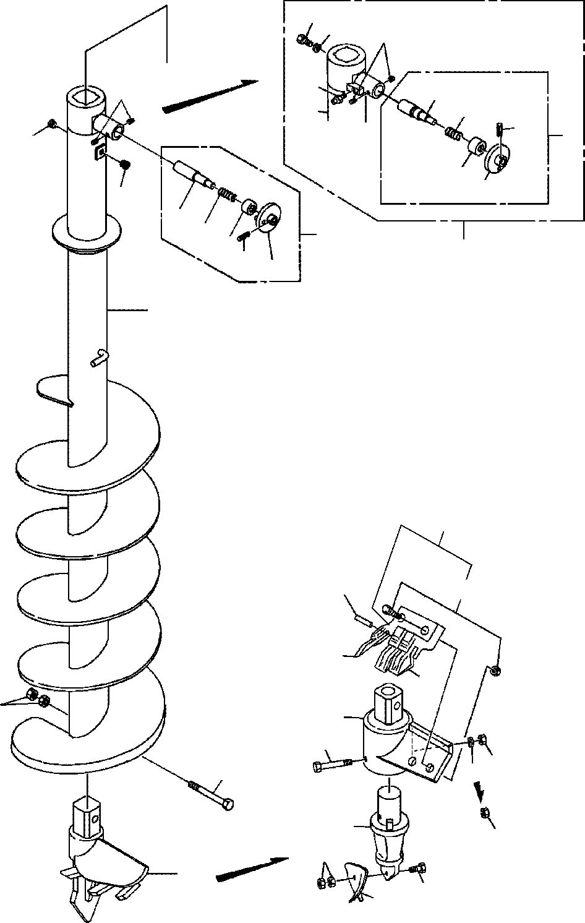
DT-600-2-00001 UPPER PP2010016-03 AUGER (450,P)
12
13
6
14
7
6
31
32
35
3
4
33
34
4
21
22
3
23
100
25
24
7
42
52
61
50
51
11
41
45
47 46
10
43
46
49
8
48
44

DT-600-2-00001 UPPER
000075
Pos No.

Parts No
Parts Name
Qty
Unit
Technical Data
Serial No (Start)
Serial No (End)
Re

3

4
6
7

8
10
11
12
13
14
21
22
23
24
25
31
32
33
34
35
41
42
43
44
45

46

47
48
49
50
51
52
61
100

32490023000
32490020070
80316030060
90710006080
32490020040
32490022000
32490020100
90101918140
90201401800
37001504060
90302041801
82456106000
32490022030
37001200470
32490022060
32490022050
80720105018
32490023010
37001200720
32490253510
32490253520
80720105028
32470720010
32470720100
32470720300
32470720400
90101512140
90101512150
90201401200
90201401200
90302041201
90101510050
90203401000
32470720700
32470720600
32470720500
32470720200
32490028030
PIN ASSY PIN ASSY PLUG SCREW,SET SCREW SCREW
DRILL,AUGER (450 S) BOLT
NUT BOLT
WASHER,SPRING NIPPLE,GREASE PIN
SPRING GUIDE GRIP PIN,SPRING PIN
SPRING GUIDE GRIP PIN,SPRING SUPPORT
HOLDER (WITH BOLT&NUT) ADAPTER
BIT,PILOT (PENGO.FH205) BOLT
BOLT NUT NUT
WASHER,SPRING BOLT
NUT
TOOTH (PENGO.1650) TOOTH (PENGO.1652) CUSHION
BOLT ASSY SCREW ASSY
1
1
2
2
1
1
1
1
2
1
1
1
1
1
1
1
1
1
1
1
1
1
1
1
1
1
1
1
1
2
1
1
2
2
1
3
2
1

PT3/8 M6X8

M18X140 M18

18
1/4-28UNF

5X18

5X28

M12X150 M12
M12 12
M10X50 M10

275094
275094
275094
275094
275094
275434
275094
275434
275094
275094
275094
275094
275094
275094
275094

275093
275093

275093

275093

275093
275093
275093
275093
275093

275433

275433

275433

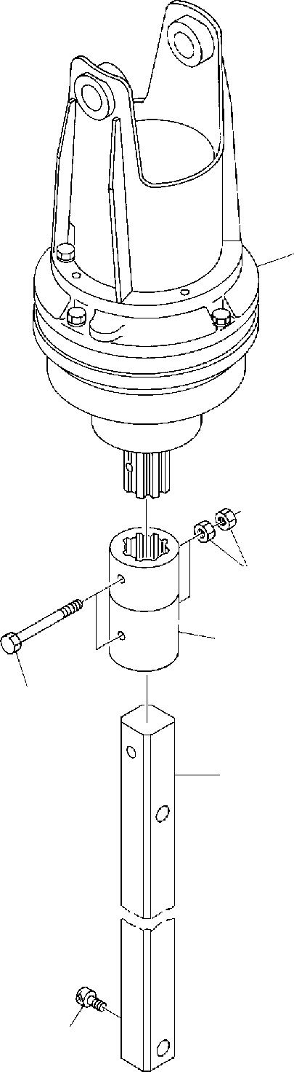
DT-600-2-00001 UPPER PP2010017-00 AUGER
1
7
2
6
3
5

DT-600-2-00001 UPPER
Rem
000076
Pos No.

Parts No
Parts Name
Qty
Unit
Technical Data
Serial No (Start)
Serial No (End)

1
2

3

5
6

7

36340260000
32490520010
32490025000
32490520020
32490020110
32490023500
90131510020
90101718140
90171118160
90201401800
DRIVING UNIT,AUGER COUPLING COUPLING (LONG)
COUPLING (AUGER/SHAFT) SHAFT
SHAFT
BOLT,HEXAGON SOCKET BOLT
BOLT NUT
1
1
1
1
1
1
1
2
2
4

M10X20 M18X140 M18X160 M18

275251

275251

275250

275250

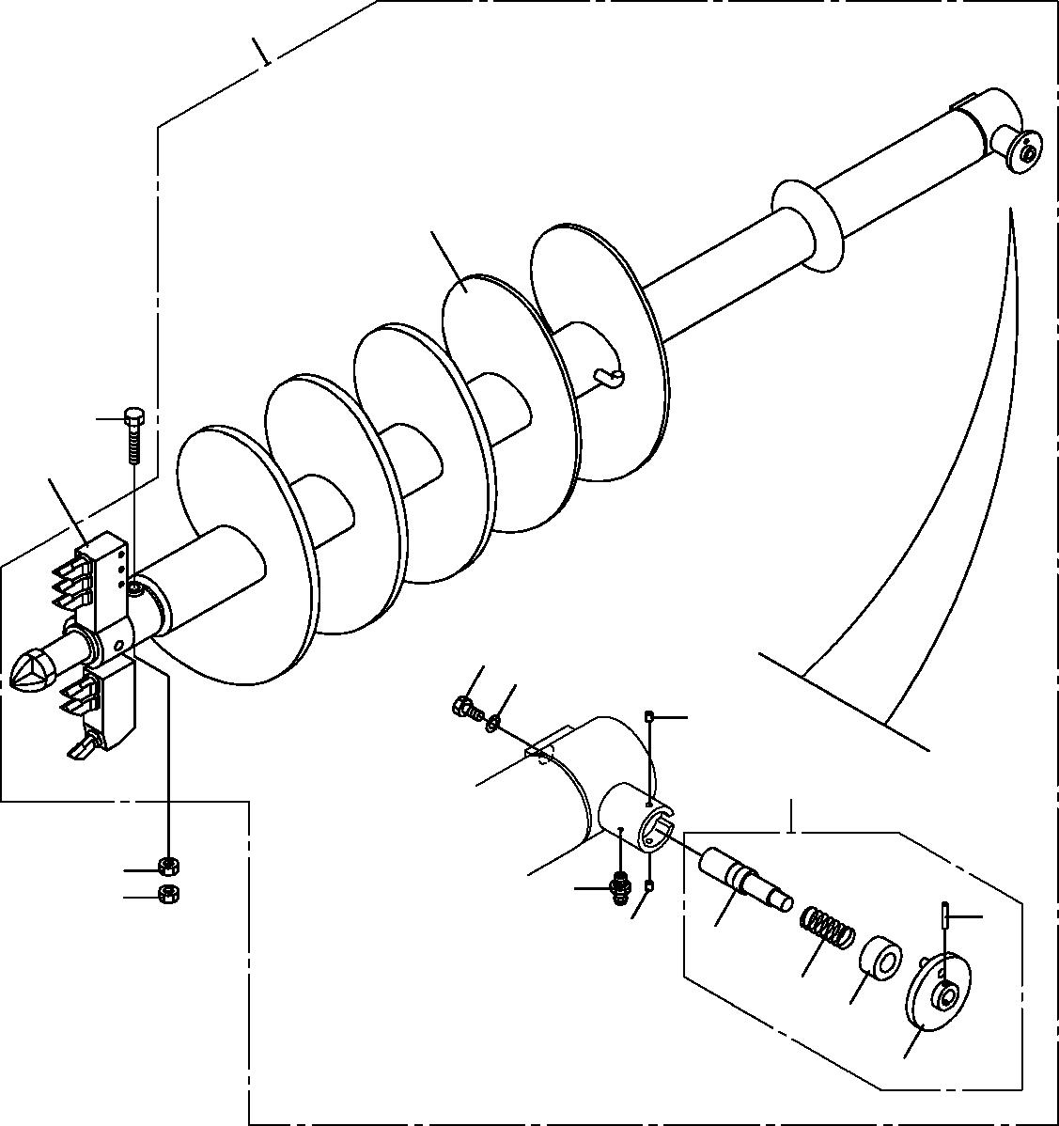
DT-600-2-00001 UPPER
PP2010020-01 AUGER (400.R6,OPTION)
100
4
5
9
1
2
7
3
6
6
8
25
7
21
22
23
24

DT-600-2-00001 UPPER
000077
Pos No.

Parts No
Parts Name
Qty
Unit
Technical Data
Serial No (Start)
Serial No (End)
Remarks

1
2
3
4
5
6
7
8
9
21
22
23
24
25
100

37001504060
90302041801
32490023000
32470360020
90101918140
90201401800
90710006080
82456106000
(***********) 32490023010
37001200720
32490253510
32490253520
80720105028
32470368010
BOLT WASHER,SPRING PIN ASSY SCREW
BOLT NUT
SCREW,SET NIPPLE,GREASE HEAD,AUGER (400.R6) PIN
SPRING GUIDE GRIP PIN,SPRING
SCREW ASSY
1
1
1
1
1
2
2
1
1
1
1
1
1
1
1

18

M18X140 M18 M6X8
1/4-28UNF

5X28

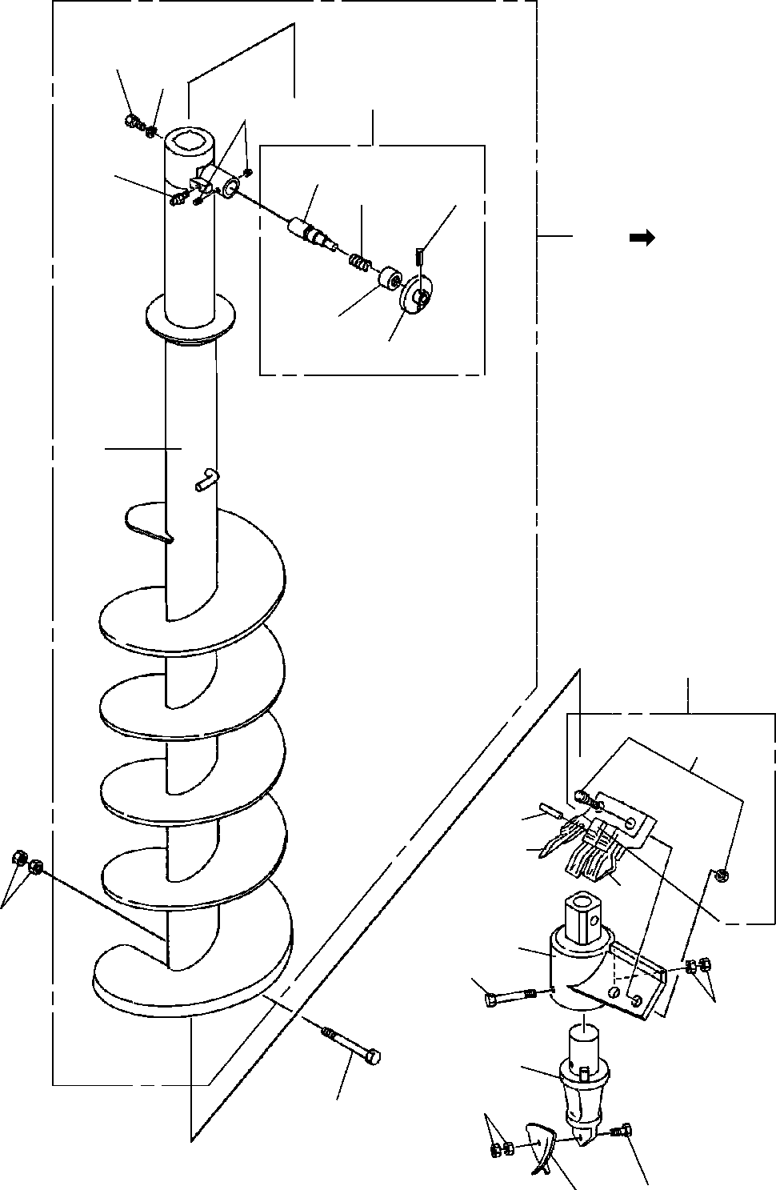
DT-600-2-00001 UPPER PP2010027-02 AUGER (450)
12
13
3
6
31
14
32
35
100
101
33
34
7
42
61
52
50
51
11
41
45
46
43
49
10
44
48

DT-600-2-00001 UPPER
000078
Pos No.

Parts No
Parts Name
Qty
Unit
Technical Data
Serial No (Start)
Serial No (End)
Re

10
11
41
42
43
44
45
46
48
49
50
51
52
61
101

90101918140
90201401800
32470720010
32470720100
32470720300
32470720400
90101512150
90201401200
90101510050
90203401000
32470720700
32470720600
32470720500
32470720200
32490028031
BOLT NUT SUPPORT
HOLDER (WITH BOLT&NUT) ADAPTER
BIT,PILOT (PENGO.FH205) BOLT
NUT BOLT NUT
TOOTH (PENGO.1650) TOOTH (PENGO.1652) CUSHION
BOLT ASSY SCREW ASSY
1
2
1
1
1
1
1
2
1
2
2
1
3
2
1

M18X140 M18

M12X150 M12 M10X50 M10

275434
275434
275094
275094

275697

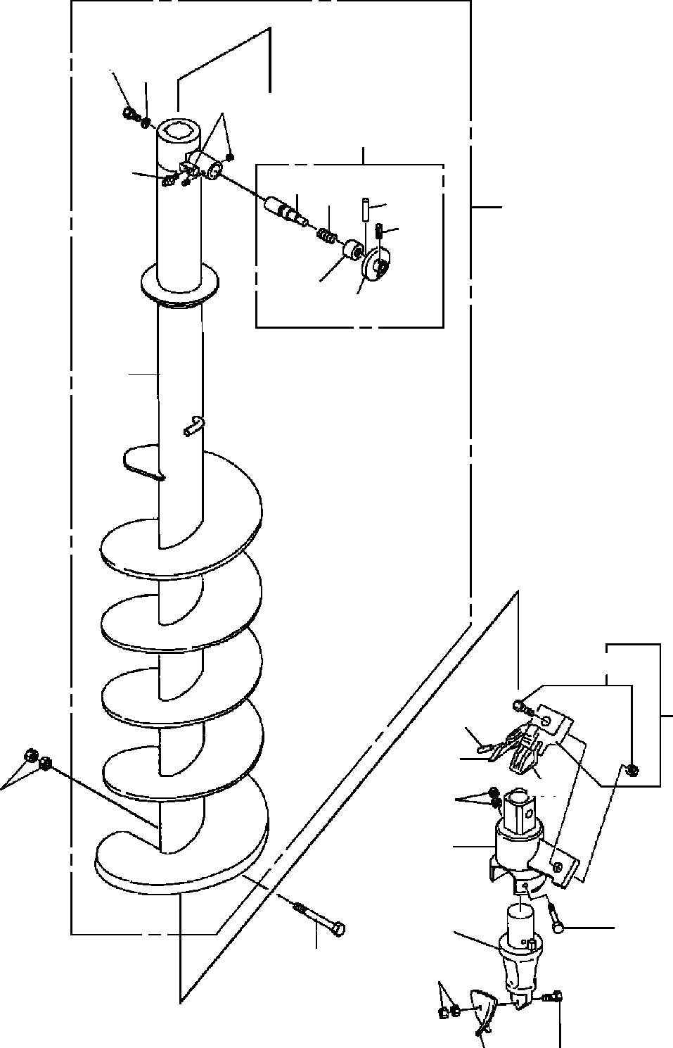
DT-600-2-00001 UPPER PP2010030-00 AUGER (300)
4
5
53
51
52
61
62
64
66
100
63
65
2
41
32
22
30
31
7
26
21
23
25
6
29
24
28

DT-600-2-00001 UPPER
000079
Pos No.

Parts No
Parts Name
Qty
Unit
Technical Data
Serial No (Start)
Serial No (End)
Rema

2
4
5
6
7
21
22
23
24
25
26
28
29
30
31
32
41
51
52
53
61
62
63
64
65
66
100

32470350021
37001504060
90302041801
90171118140
90201401800
32470342000
32470342100
32470720300
32470720400
90101512150
90201401200
90101510050
90203401000
32470720700
32470720600
32470720500
32470720200
32490026000
82455106000
90710006080
32490026100
37001200720
32490253510
80720106045
32490251200
80720105028
32470358030
SCREW BOLT
WASHER,SPRING BOLT
NUT SUPPORT HOLDER ADAPTER
BIT,PILOT (PENGO.FH205) BOLT
NUT BOLT NUT
TOOTH (PENGO.1650) TOOTH (PENGO.1652) CUSHION
BOLT ASSY PIN ASSY
NIPPLE,GREASE SCREW,SET
PIN SPRING GUIDE
PIN,SPRING GRIP PIN,SPRING SCREW ASSY
1
1
1
1
2
1
1
1
1
1
2
1
2
1
1
2
1
1
1
2
1
1
1
1
1
1
1

18
M18X140 M18

M12X150 M12 M10X50 M10

A-M6F FE M6X8

5X28

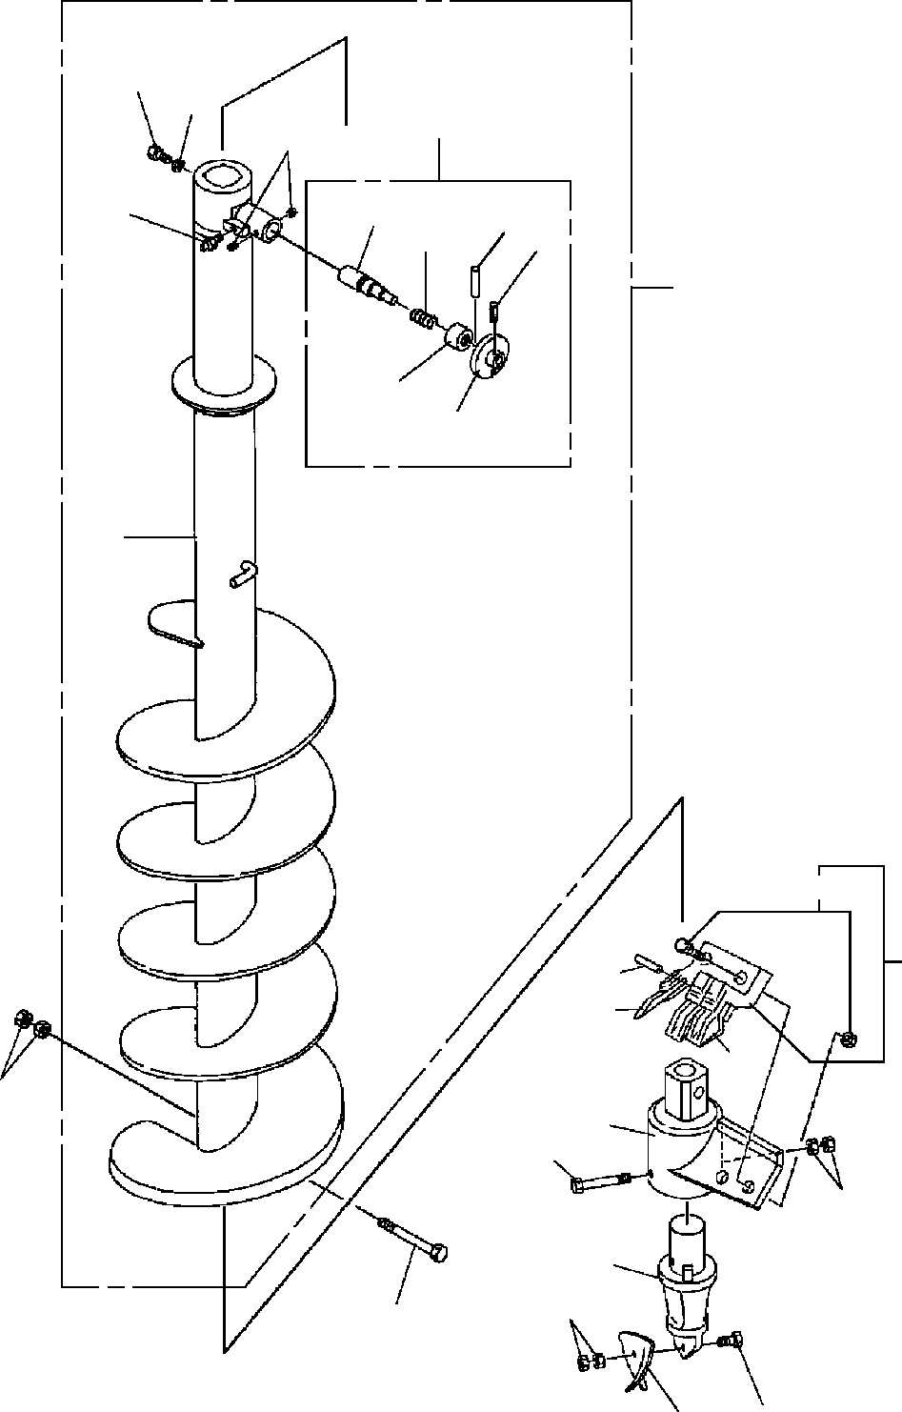
DT-600-2-00001 UPPER PP2010031-00 AUGER (450)
4
5
51
53
52
61
64
66
62
100
63
65
2
41
22
32
30
31
7
21
25
26
23
29
6
28
24

DT-600-2-00001 UPPER
000080
Pos No.

Parts No
Parts Name
Qty
Unit
Technical Data
Serial No (Start)
Serial No (End)
Re

2
4
5
6
7
21
22
23
24
25
26
28
29
30
31
32
41
51
52
53
61
62
63
64
65
66
100

32490022002
37001504060
90302041801
90171118140
90201401800
32470720010
32470720100
32470720300
32470720400
90101512150
90201401200
90101510050
90203401000
32470720700
32470720600
32470720500
32470720200
32490026000
82455106000
90710006080
32490026100
37001200720
32490253510
80720106045
32490251200
80720105028
32490708020
SCREW BOLT
WASHER,SPRING BOLT
NUT SUPPORT
HOLDER (WITH BOLT&NUT) ADAPTER
BIT,PILOT (PENGO.FH205) BOLT
NUT BOLT NUT
TOOTH (PENGO.1650) TOOTH (PENGO.1652) CUSHION
BOLT ASSY PIN ASSY
NIPPLE,GREASE SCREW,SET
PIN SPRING GUIDE
PIN,SPRING GRIP PIN,SPRING SCREW ASSY
1
1
1
1
2
1
1
1
1
1
2
1
2
2
1
3
2
1
1
2
1
1
1
1
1
1
1

18
M18X140 M18

M12X150 M12 M10X50 M10

A-M6F FE M6X8

5X28

275434
275434
275094
275094

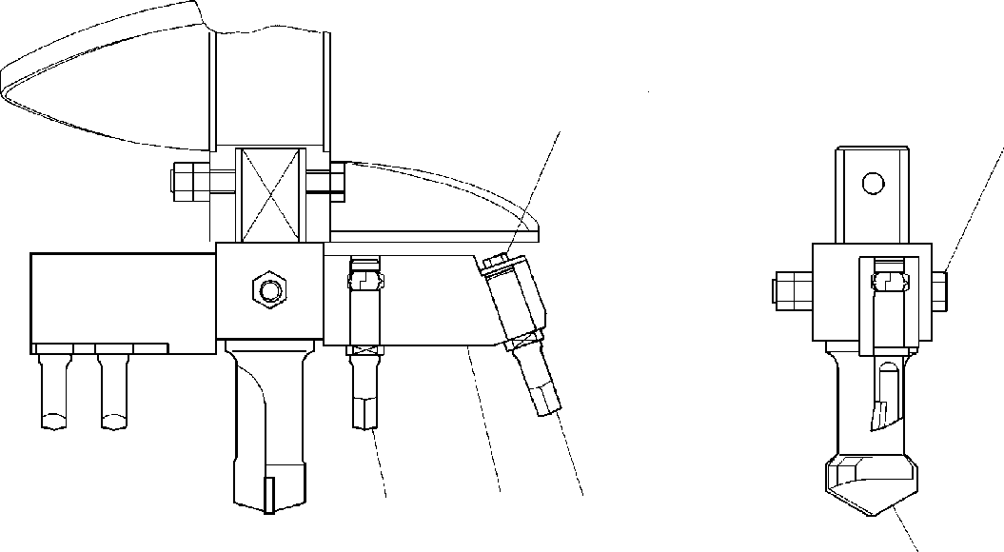
DT-600-2-00001 UPPER
PP2020000-00 DRILL,AUGER (OPTION)
129
45
7
8
3
6

DT-600-2-00001 UPPER
000081
Pos No.

Parts No
Parts Name
Qty
Unit
Technical Data
Serial No (Start)
Serial No (End)
Remarks
Pa

1
2
3
4
5
6
7
8
9

90171110020
37000517380
32470090040
37001502750
90201401800
32470090030
32470090020
32470090010
90302041001
BOLT PLATE BIT,CUTTER BOLT
NUT BIT,CENTER BIT,CUTTER SUPPORT
WASHER,SPRING
1
1
1
1
2
1
3
1
1

M10X20 T=2.3 TO 3.2

M18X132 M18

10

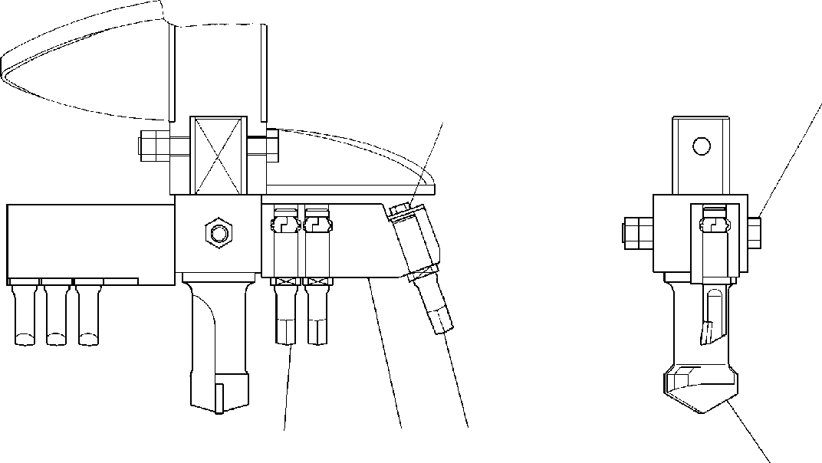
DT-600-2-00001 UPPER
PP2020001-00 DRILL,AUGER (OPTION)
45
129
8
3
7
6

DT-600-2-00001 UPPER
000082
Pos No.

Parts No
Parts Name
Qty
Unit
Technical Data
Serial No (Start)
Serial No (End)
Remarks
Pa

1
2
3
4
5
6
7
8
9

90171110020
37000517380
32470090040
37001502750
90201401800
32470090030
32470090020
32470100010
90302041001
BOLT PLATE BIT,CUTTER BOLT
NUT BIT,CENTER BIT,CUTTER SUPPORT
WASHER,SPRING
1
1
1
1
2
1
5
1
1

M10X20 T=2.3 TO 3.2

M18X132 M18

10

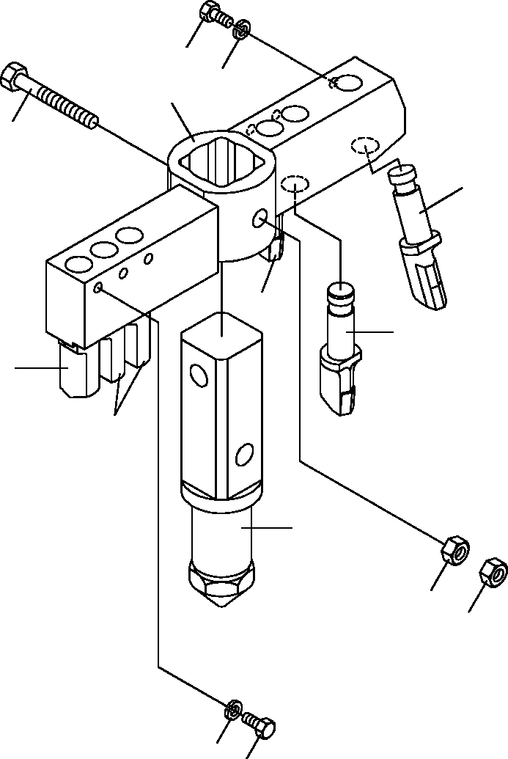
DT-600-2-00001 UPPER
PP2020005-02 DRILL,AUGER (OPTION.450 R6)
1
9
8
4
3
7
7
7
7
6
5
5
9
1

DT-600-2-00001 UPPER
000083
Pos No.

Parts No
Parts Name
Qty
Unit
Technical Data
Serial No (Start)
Serial No (End)
Remarks
Pa

1
3
4
5
6
7
8
9

90171110018
32470560040
37001502750
90201401800
32470560020
32470560010
32470560030
90302041001
BOLT BIT,CUTTER BOLT
NUT BIT,CENTER BIT,CUTTER SUPPORT
WASHER,SPRING
6
1
1
2
1
5
1
6

M10X18

M18X132 M18

10

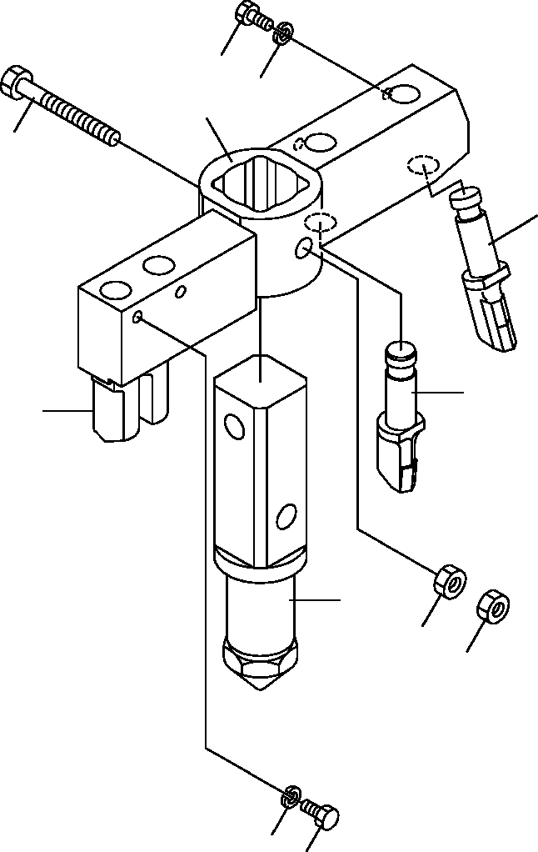
DT-600-2-00001 UPPER
PP2020006-01 DRILL,AUGER (OPTION.450 R4)
1
9
8
4
3
7
7
6
5
5
9
1

DT-600-2-00001 UPPER
000084
Pos No.

Parts No
Parts Name
Qty
Unit
Technical Data
Serial No (Start)
Serial No (End)
Remarks
Pa

1
3
4
5
6
7
8
9

90171110018
32470560040
37001502750
90201401800
32470560020
32470560010
32470570010
90302041001
BOLT BIT,CUTTER BOLT
NUT BIT,CENTER BIT,CUTTER SUPPORT
WASHER,SPRING
4
1
1
2
1
3
1
4

M10X18

M18X132 M18

10

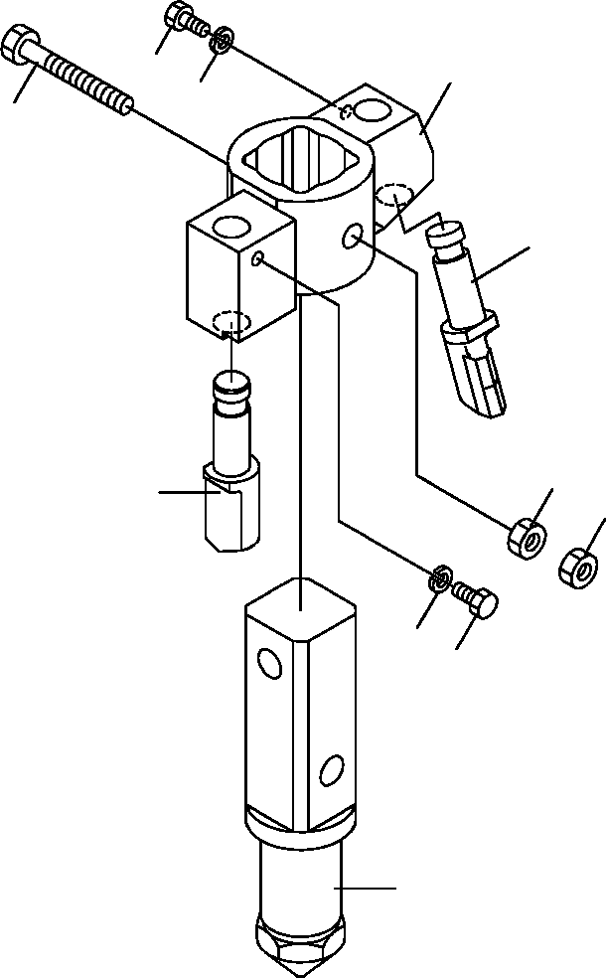
DT-600-2-00001 UPPER
PP2020007-01 DRILL,AUGER (OPTION.200 R2)
1
8
9
4
3
5
7
5
9
1
6

DT-600-2-00001 UPPER
000085
Pos No.

Parts No
Parts Name
Qty
Unit
Technical Data
Serial No (Start)
Serial No (End)
Remarks
Pa

1
3
4
5
6
7
8
9

90171110018
32470560040
37001502750
90201401800
32470560020
32470560010
32470580010
90302041001
BOLT BIT,CUTTER BOLT
NUT BIT,CENTER BIT,CUTTER SUPPORT
WASHER,SPRING
2
1
1
2
1
1
1
2

M10X18

M18X132 M18

10

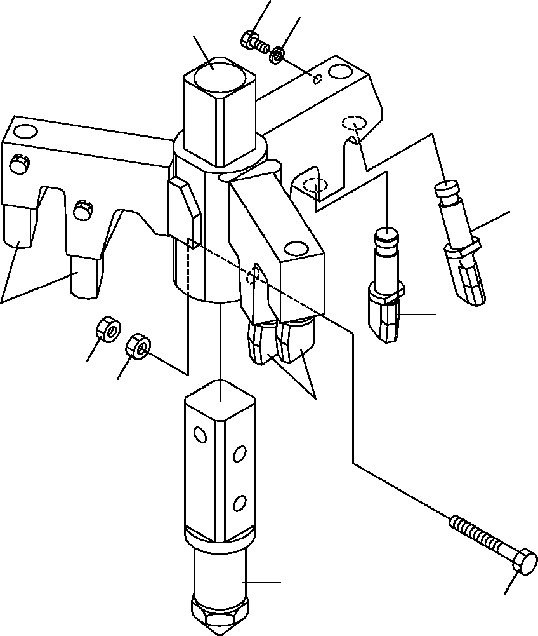
DT-600-2-00001 UPPER
PP2020008-02 DRILL,AUGER (OPTION.450 R7)
6
7
1
2
2
2
5
5
2
3
4

DT-600-2-00001 UPPER
000086
Pos No.

Parts No
Parts Name
Qty
Unit
Technical Data
Serial No (Start)
Serial No (End)
Remarks
Pa

1
2
3
4
5
6
7

32470660010
32470560040
32470660020
90171118160
90201401800
90171110018
90302041001
SUPPORT BIT,CUTTER BIT,CENTER BOLT
NUT BOLT
WASHER,SPRING
1
7
1
1
2
7
7

M18X160 M18 M10X18 10

DT-600-2-00001 UPPER
PP2020008-02 DRILL,AUGER (OPTION.450 R7)
6
7
1
2
2
2
5
5
2
3
4

DT-600-2-00001 UPPER
000087
Pos No.

Parts No
Parts Name
Qty
Unit
Technical Data
Serial No (Start)
Serial No (End)
Remarks
Pa

1
2
3
4
5
6
7

32470661000
32470560040
32471170010
90101918140
90201401800
90171110018
90302041001
SUPPORT BIT,CUTTER BIT,CENTER BOLT
NUT BOLT
WASHER,SPRING
1
7
1
1
2
7
7

M18X140 M18 M10X18 10

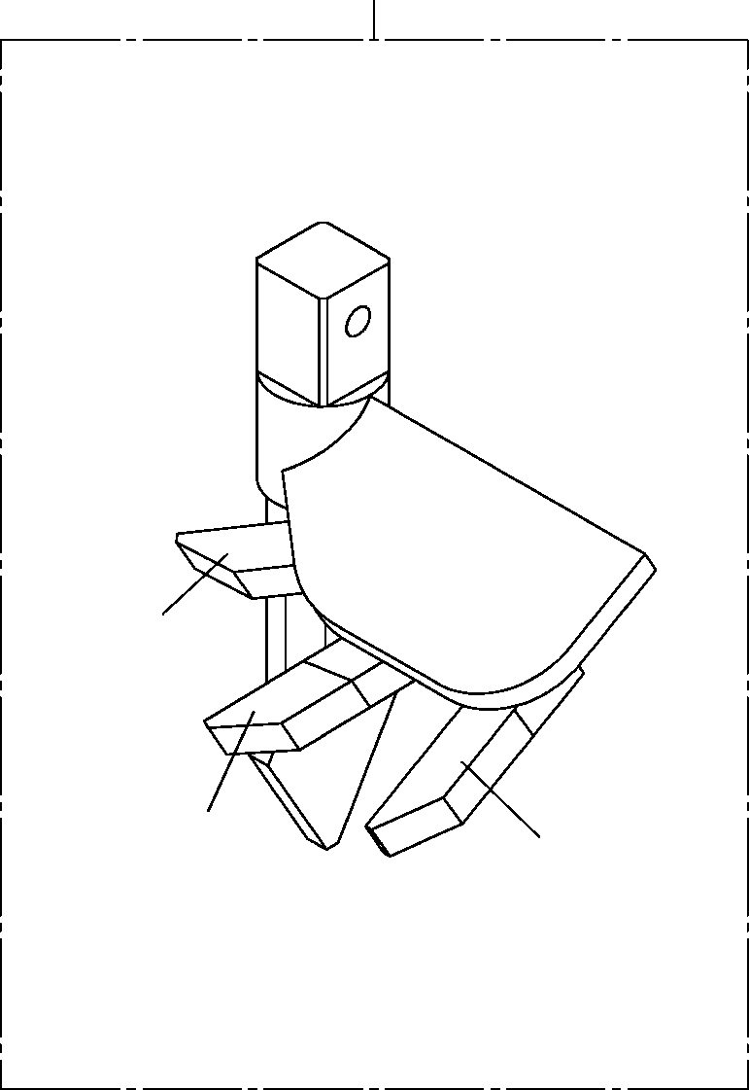
DT-600-2-00001 UPPER
PP2020009-00 DRILL,AUGER (450 S)
20
5
5
5

DT-600-2-00001 UPPER
000088
Pos No.

Parts No
Parts Name
Qty
Unit
Technical Data
Serial No (Start)
Serial No (End)
Remarks
5

20

32470590000
32470590000
32490020100
32490020100
BIT,CUTTER BIT,CUTTER DRILL,AUGER (450 S)
DRILL,AUGER (450 S)
3
3
1
1

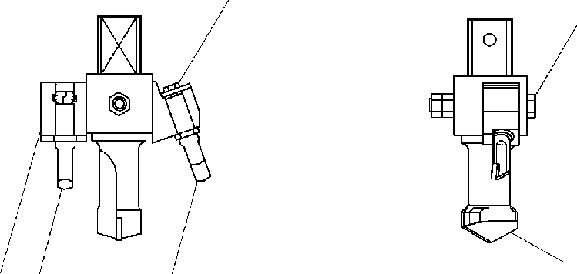
DT-600-2-00001 UPPER
PP2020011-00 DRILL,AUGER (OPTION)
12 9
4 5
6
8
7
3

DT-600-2-00001 UPPER
000089
Pos No.

Parts No
Parts Name
Qty
Unit
Technical Data
Serial No (Start)
Serial No (End)
Remarks
Pa

1
2
3
4
5
6
7
8
9

90171110020
37000517380
32470090040
37001502750
90201401800
32470090030
32470090020
32470490010
90302041001
BOLT PLATE BIT,CUTTER BOLT
NUT BIT,CENTER BIT,CUTTER SUPPORT
WASHER,SPRING
1
1
1
1
2
1
1
1
1

M10X20 T=2.3 TO 3.2

M18X132 M18

10

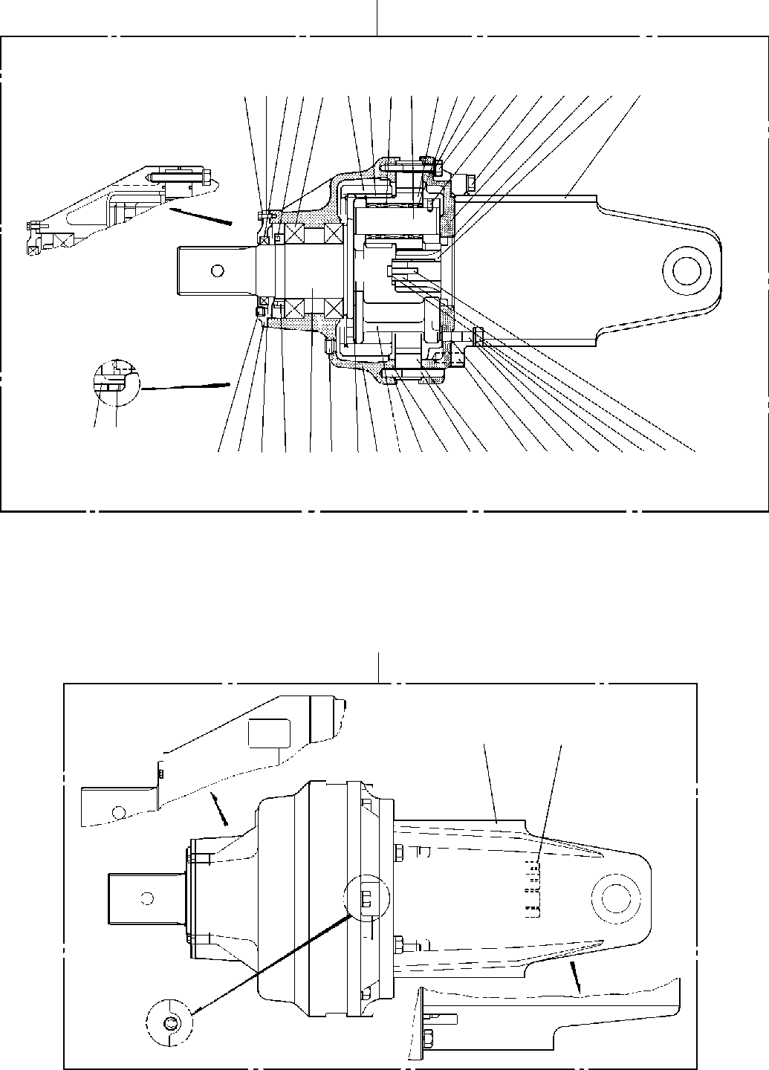
DT-600-2-00001 UPPER
PP2030000-01 DRIVING UNIT,AUGER
100
29309 7 4 51516141317623182721322425
3122
1110 3 8 2224011220333119 2836342635383739
120
100
110

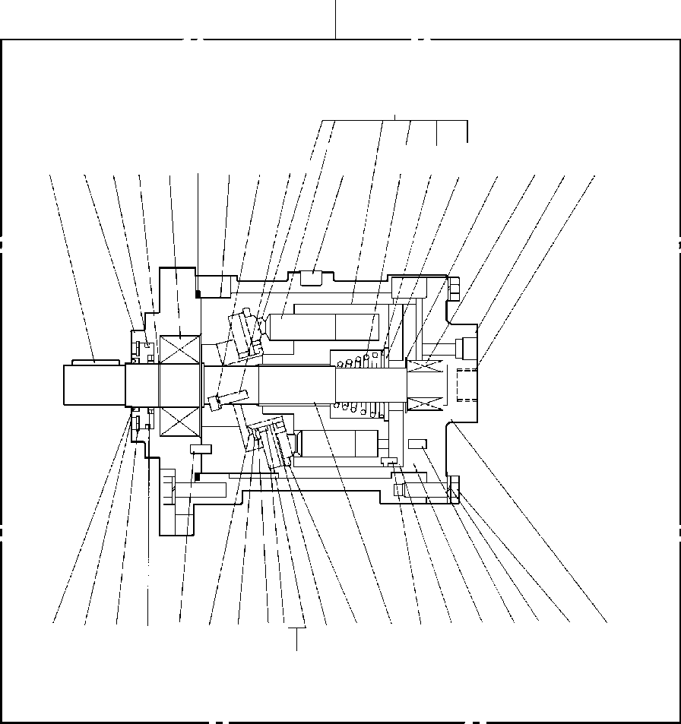
DT-600-2-00001 UPPER
PP2030000-01 DRIVING UNIT,AUGER
110
55
838584 65 627574
694447434256452949
64
51544173726061585963
6848704671665052
53

DT-600-2-00001 UPPER
000090
Pos No.

Parts No
Parts Name
Qty
Unit
Technical Data
Serial No (Start)
Serial No (End)
Re

1

2

3
4
5
6
7

8

9
10

11
12
13
14
15
17
18

19
20
21
22
23
24
25
26
27
28
29
30
31
32
33
34
35
36
37
38
39
40
41
42
43
44
45
46
47
48
49
50
51
52
53
54
55
56
58
59
60
61
62
63
64
65

36340055031
36340136010
36340055040
36340136020
91001214000
36340055050
36340055060
90302041201
36340055070
36340136030
36340055080
36340136040
36660005020
36340055431
36340136050
36340055090
36340055100
36340055110
36340055120
36340055130
36340055150
36340055160
36340175080
36340055171
36340055180
36340055191
36340055200
90101512075
36340055210
36340055221
90302041401
90101514045
36340055230
90302040601
90101506020
36340055240
91001210000
36340055250
36340055260
90201201400
91001101400
36340055271
36340055280
90101508040
36340055290
36340055300
36340055310
80601110300
36340055320
36340055330
36340055340
36340055350
36340055360
90131506020
13115101180
13115101050
13115101150
13115195050
13115101060
36340055370
91001212000
90302041001
90191010035
13615101190
80720106014
36340055380
36340055390
80316030060
13615101290
HOUSING (GEAR) HOUSING (GEAR) SHAFT (R) SHAFT (R)
O-RING BEARING GEAR (R2)
WASHER,SPRING NUT
NUT (AN16) SCREW,SET WASHER SEAL,OIL
COVER (OIL SEAL) COVER (OIL SEAL) PLUG
SPIDER GEAR (P) PIN,KING
BEARING,THRUST BEARING,NEEDLE SCREW,SET SCREW,SET GEAR (R1)
PIN COVER,END PLUG
BOLT GEAR (S1) SUPPORT
WASHER,SPRING BOLT
PIN WASHER,SPRING BOLT
PIN
O-RING O-RING
BOLT,STUD NUT
O-RING WASHER WASHER,TOOTH BOLT RING,RETAINING SHAFT
BEARING RING,RITAINING FLANGE
PLATE (CAM) SEAL,OIL
O-RING
COVER (OIL SEAL) BOLT,HEXAGON SOCKET PLATE,THRUST RETAINER
BEARING PLATE,THRUST HOLDER,PLUNGER BARREL,CYLINDER O-RING WASHER,SPRING BOLT
PLATE (VALVE) PIN,SPRING BEARING
COVER (BOTTOM) PLUG RING,RETAINING
1
1
1
1
1
2
1
6
1
1
1
1
1
1
1
2
1
3
3
6
12
3
3
1
4
1
1
6
1
1
8
4
4
6
4
4
1
2
4
4
4
1
1
1
3
1
1
2
1
1
1
1
1
2
1
1
1
1
1
1
2
16
16
1
1
1
1
1
1

1A G140

12

M8X10

PT1/4

M8X12 M8X16

13X30

PT1/2 M12X75

14
M14X45 14X40
6
M6X20 13X60
1A G100

M14 1A P14

M8X40

S30

M6X20

1A G120
10
M10X35 6X14

PT3/8

275099

275099

275099

275099

275099

275099

275098

275098

275098

275098

275098

275098

DT-600-2-00001 UPPER
000090
Pos No.

Parts No
Parts Name
Qty
Unit
Technical Data
Serial No (Start)
Serial No (End)
Re

66
68
69
70
71
72
73
83
84
85
100

110
120

80601110500
36340055400
36340055410
80602110600
80720110020
36340055420
80730060014
13115101070
80602110450
13615101100
36340055011
36340136000
36340055020
36340050000
RING,RITAINING SEAL,OIL
KEY RING,RITAINING PIN,SPRING
PLATE (CYLINDER BARREL) PIN
SPRING (CENTER) RING,RITAINING SEAT,SPRING REDUCER ASSY REDUCER ASSY MOTOR ASSY DRIVING UNIT,AUGER
1
1
1
1
1
1
2
1
1
1
1
1
1
1

S50

R60 10X20

6X14 R45

275099

275098

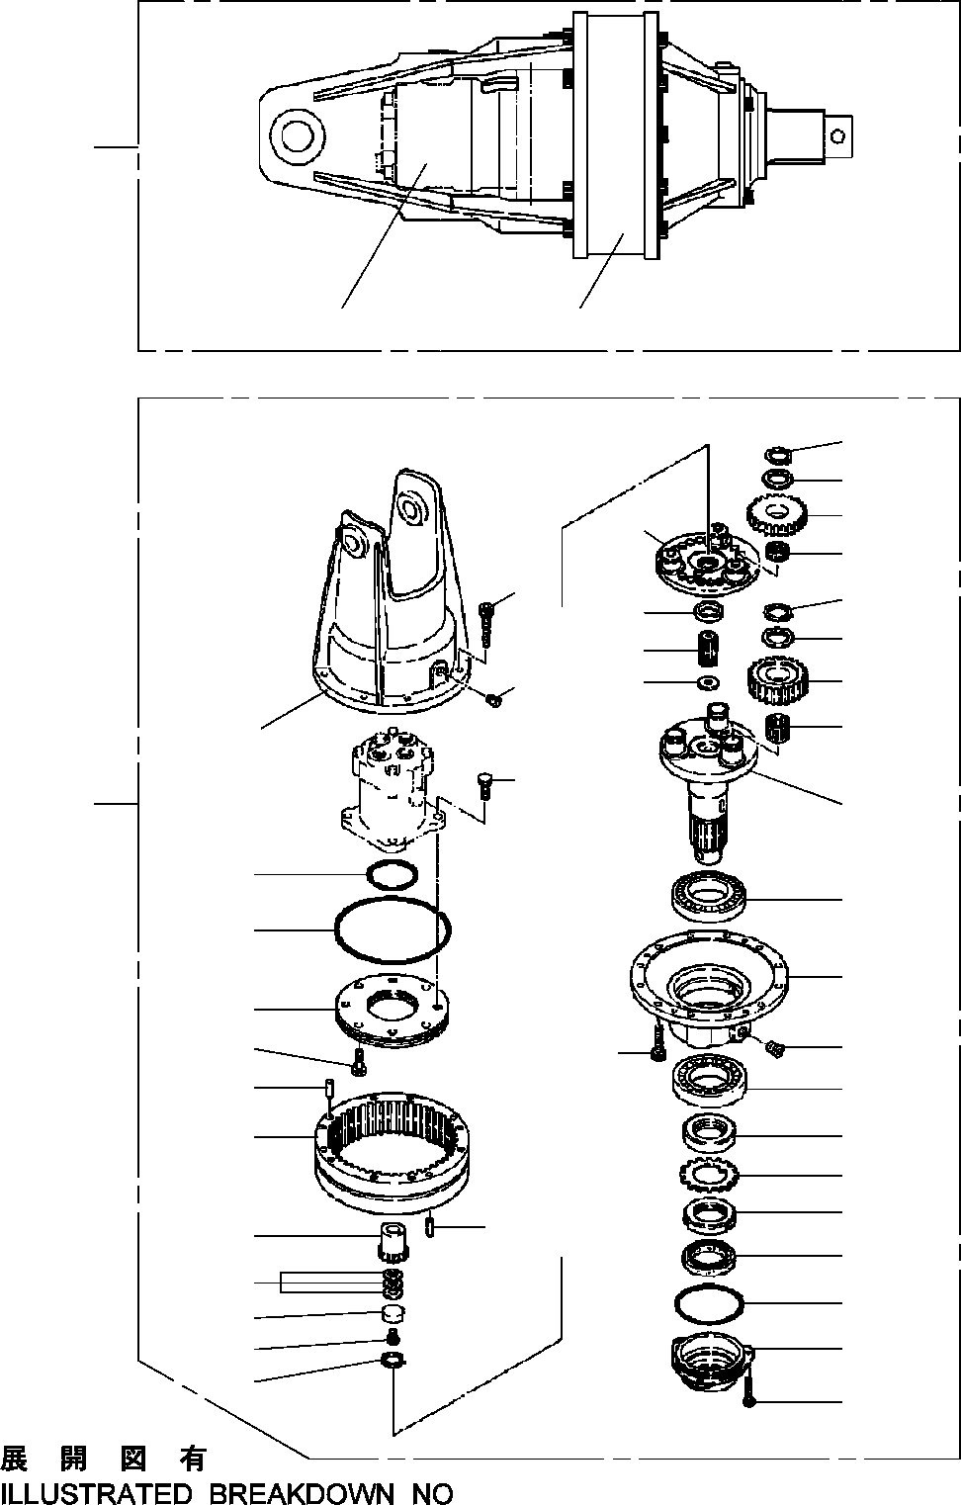
DT-600-2-00001 UPPER
PP2030002-02 DRIVING UNIT,AUGER
100
2
1
25
24
28
27
25
24
23
22
26
48
35
34
33
18
49
45
1
21
44
17
43
20
42
45
41
32
18
17
15
16
15
14
13
12
19
31
40
39
38
37
36
11
2

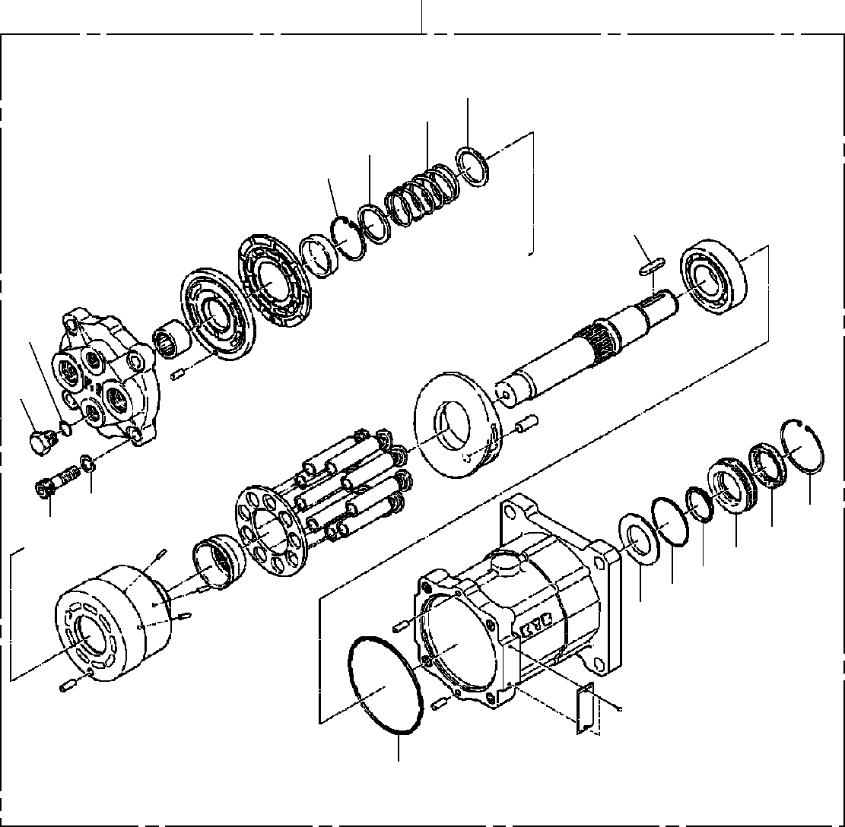
DT-600-2-00001 UPPER
PP2030002-02 DRIVING UNIT,AUGER
2
52
58
53
59
75
61
70
72
60
71
69
51
65
62
57
63

DT-600-2-00001 UPPER
000091
Pos No.

Parts No
Parts Name
Qty
Unit
Technical Data
Serial No (Start)
Serial No (End)
Rema

1
2
11
12
13
14
15
16
17
18
19
20
21
22
23
24
25
26
27
28
31
32
33
34
35
36
37
38
39
40
41
42
43
44
45
48
49
51
52
53
57
58
59
60
61
62
63
65
69
70
71
72
75
100

36340200000
36661930000
90131510025
36340205010
36340205020
36340205030
36340205040
36340205050
36340205060
80316030080
90131512030
36340205080
36340205090
36340205100
36340205110
36340205120
80601110400
36340205130
36340205140
36340205150
80730100026
36340205160
36340205170
36340205180
36340205190
80601110340
90131508020
36340205200
36340205210
36340205220
36340205230
36340205240
36340205250
36340205260
90101514040
90131514040
36340205280
36661315010
36660825010
36660825020
36661315020
36660825030
36660825040
36661315030
91002801400
91001205500
91001211500
36661315040
36661315050
36661315060
90131712040
90302041201
36661315070
36340260000
REDUCER ASSY MOTOR,HYDRAULIC BOLT,HEXAGON SOCKET CARRIER
O-RING SEAL,OIL NUT,LOCK WASHER (LOCK)
BEARING,ROLLER PLUG
BOLT,HEXAGON SOCKET HOUSING
CARRIER ASSY (N2) BEARING,NEEDLE GEAR,PLANETARY RETAINER (THRUST) RING,RITAINING CARRIER ASSY (N1) BEARING,NEEDLE GEAR,PLANETARY PIN
GEAR,RING RETAINER (THRUST) GEAR,SUN (N2) RETAINER (THRUST) RING,RITAINING
BOLT,HEXAGON SOCKET RETAINER
SHIM SET GEAR,SUN (N1) PIN (KNOCK) PLATE (RETAINER) O-RING
O-RING BOLT
BOLT,HEXAGON SOCKET SUPPORT
CASE (OIL SEAL) GUIDE,SPRING GUIDE,SPRING PLATE
SPRING RING,RETAINING RING,RETAINING O-RING
O-RING O-RING
SEAL,CAP SEAL,OIL PLUG
BOLT,HEXAGON SOCKET WASHER,SPRING
KEY
DRIVING UNIT,AUGER
1
1
3
1
1
1
2
1
2
2
12
1
1
3
3
6
6
1
3
3
2
1
1
1
1
1
1
1
1
1
4
1
1
1
8
8
1
1
1
1
1
1
1
1
1
1
1
1
1
1
4
4
1
1

M10X25

PT1/2 M12X30

S40

10X26

S34 M8X20

M14X40 M14X40

1B P14
1A G55
1A G115

M12X40 12

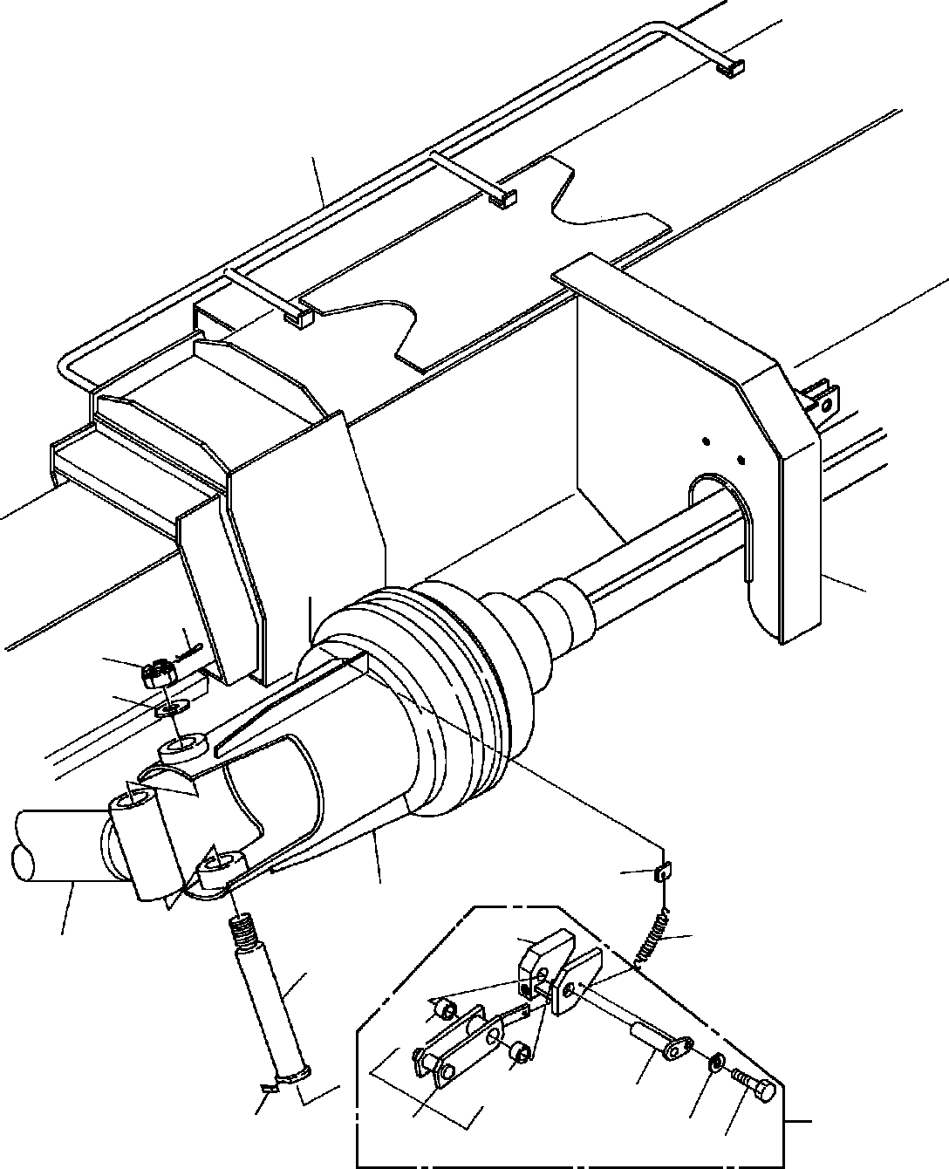
DT-600-2-00001 UPPER PP2050002-01 MOUNT,AUGER
1
4
14
13
12
30
2
29
102
22
15
132
132
103
28
16
101
48
104

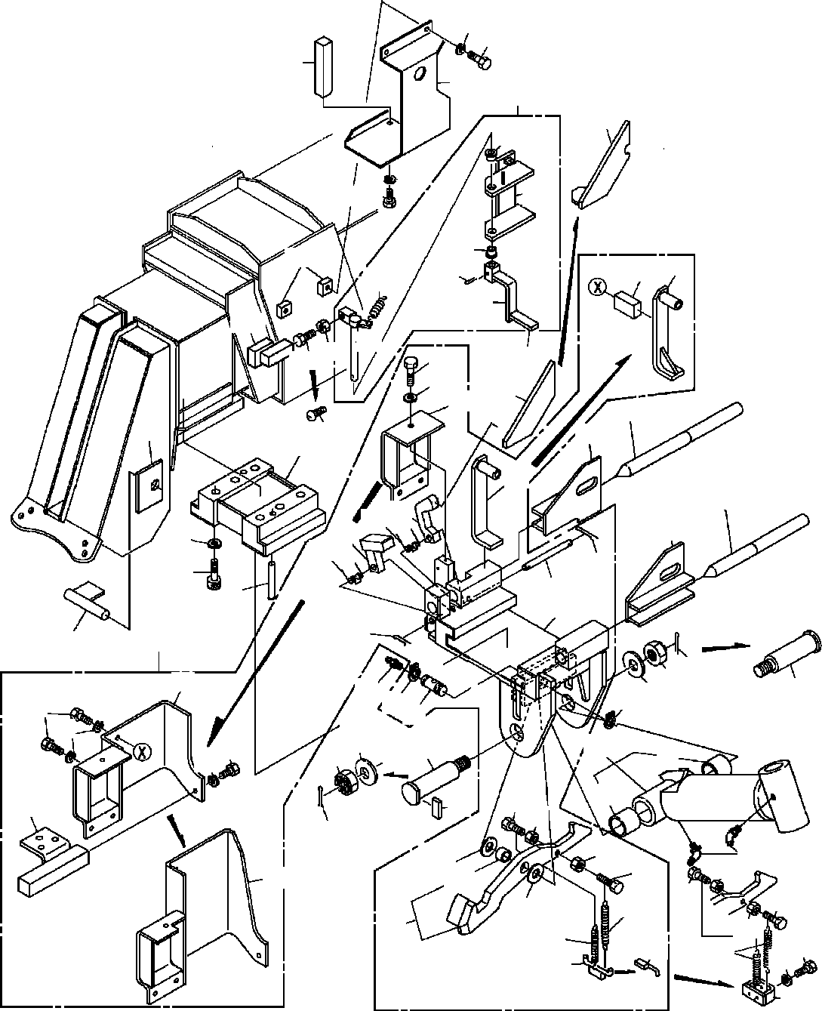
DT-600-2-00001 UPPER PP2050002-01 MOUNT,AUGER
48
149
144
143
141
162
42
48
149
164
162
165
166
146
74
81
29
145
163
14745
142
42
77
78
73
27
24
147
43
38
74
25
70 72
26
40
71
70
76
39
75
61
41
76
36
21
35
34
73
37
31
79 33
79
77
63
31
48
34 33
22
4877
91
91
68
32
80
67
35
67
45 23
65
68
82
124
44
44
65
46
62
45
46
69
69
47
46
48
49

DT-600-2-00001 UPPER
000092
Pos No.

Parts No
Parts Name
Qty
Unit
Technical Data
Serial No (Start)
Serial No (En

275124

275124

275124

275017

275017

275017

275017
275017
275103

275017

275103

1
2
4
12
13
14
15
16
21
22
23
24
25
26
27
28
29

30
31
33
34
35
36
37
38
39

40

41

42
43
44
45

46
47
48

49
61
62
63
65
70

71
72
73

74
75
76
77

79
80

81
82
91
101
102
103
104
124

(***********) (***********) (***********) 37000524100
90236202400
80136350045
37000126040
37000527800
32490110010
32490110020
82458202000
32490110030
32490110040
32490110050
32490110060
32490110070
53620233000
53620233000
37000504620
37000128360
37000524100
90236202401
80136350045
32490110080
82456201000
32490110090
90131516075
90133916075
90302041601
90303501601
80747130090
80737160090
32490110130
32490110110
90101508020
90201200800
90201200800
19114411000
90101508040
90302040801
90302040801
90302040801
32490110120
32490112000
32490119510
37000126120
37000524640
37001400150
37001400150
32490112020
32490112030
32490112040
32490112400
32490112050
37000126050
80136332020
90171108016
90171108016
80601110220
32490112410
32490262030
32490112420
32490262000
37000401810
32490112100
32490112110
37000119920
90101208012
80804022015
PIPING,AUGER AUGER MOUNT,AUGER PLATE NUT,CASTLE PIN,SPLIT
PIN BAR
SUPPORT ASSY SUPPORT NIPPLE,GREASE COVER SUPPORT SUPPORT SUPPORT STOPPER ASSY SPRING
SPRING PLATE PIN PLATE
NUT,CASTLE PIN,SPLIT STOPPER NIPPLE,GREASE SUPPORT
BOLT,HEXAGON SOCKET <M16X75. BOLT,HEXAGON SOCKET WASHER,SPRING
WASHER,PLAIN PIN
PIN CAM
SUPPORT BOLT NUT
NUT SPRING BOLT
WASHER,SPRING WASHER,SPRING WASHER,SPRING STOPPER SUPPORT STOPPER ASSY PIN
PLATE SPRING SPRING STOPPER STOPPER COVER COVER SUPPORT PIN PIN,SPLIT BOLT BOLT
RING,RITAINING SUPPORT SUPPORT SUPPORT COVER BEARING,PLAIN STOPPER SUPPORT
PIN BOLT
BEARING,PLAIN
1
1
1
1
1
1
1
1
1
1
2
1
1
1
1
1
1
1
1
1
1
1
1
1
1
1
6
6
6
6
2
2
1
1
2
2
1
2
2
3
4
9
1
1
1
1
2
2
1
1
1
1
1
1
1
2
4
6
2
1
1
1
1
4
1
1
1
1
1

T=6 M24 5X45

B-TYPE PT1/8

T=6 M24 5X45

A-TYPE PT1/8

M16X75 16
16
13X90
16X90

M8X20 M8
M8

M8X40 8
8
8

3.2X20 M8X16 M8X16 S22

M8X12

275018

275125

275125

275125

275018

275018

275018

275018

275018

275018
275104
275018
275104

DT-600-2-00001 UPPER
000092
Pos No.

Parts No
Parts Name
Qty
Unit
Technical Data
Serial No (Start)
Serial No (En

275031

132
141
142
143
144
145
146
147

149
162
163
164
165
166

80804020010
32490112300
37000532930
32490112310
32490112320
32490112330
37000502190
90101208030
80182308035
90101208014
37000401050
32490113000
32490113010
80720104028
32490113020
BEARING,PLAIN STOPPER ASSY PLATE
COVER SUPPORT SUPPORT PLATE BOLT
SCREW,MACHINE BOLT BEARING,PLAIN SHAFT
SUPPORT PIN,SPRING LEVER
2
1
1
1
1
1
2
1
1
3
2
1
1
1
1

M8X30 M8X35 M8X14

4X28

275018
275018
275018
275018
275018
275018
275018
275032
275018
275018
275018
275018
275018
275018

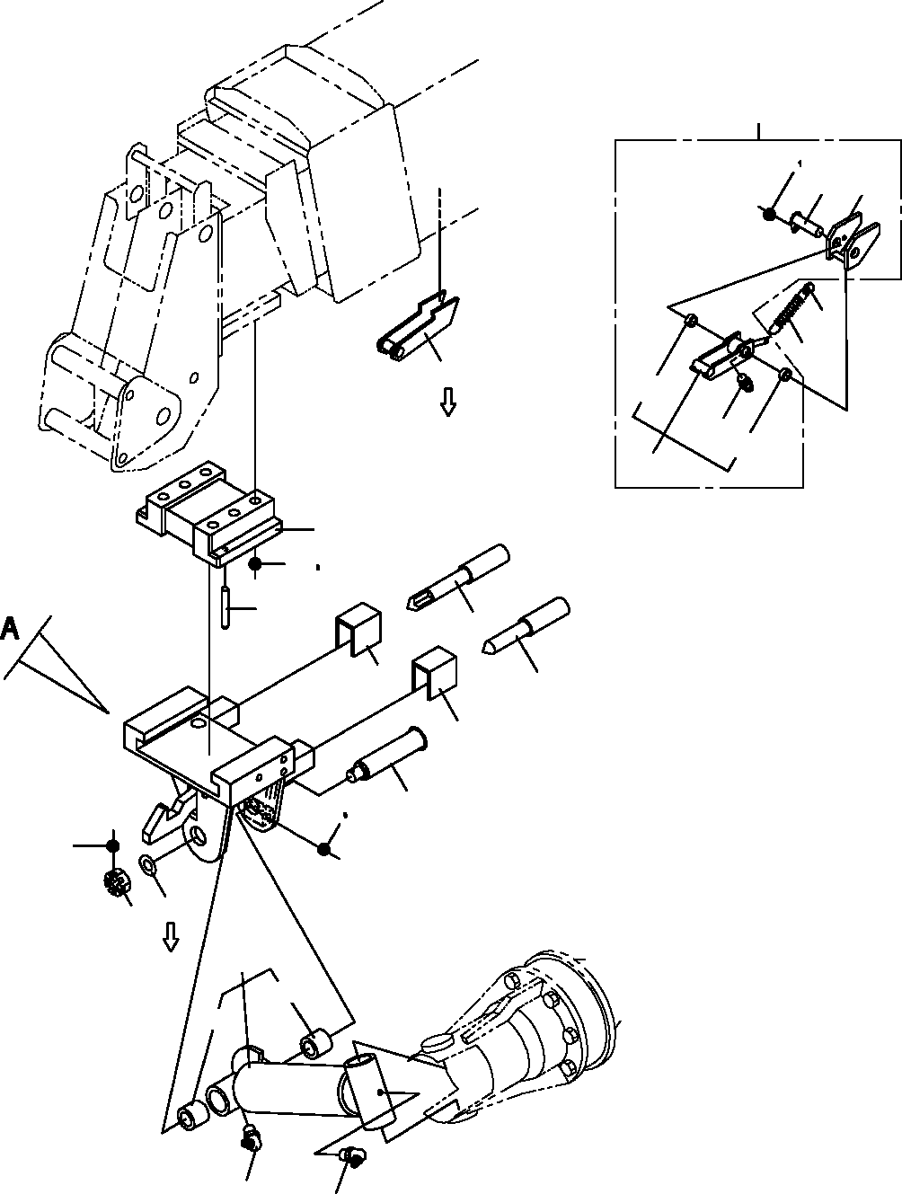
DT-600-2-00001 UPPER PP2050012-06 MOUNT,AUGER
21
36 84
83
82
23
22
8
96
21
34
96
81
4
17
16
12
7
6
5
6
11
19 20
15
13
14
2
63
61
61
3
3

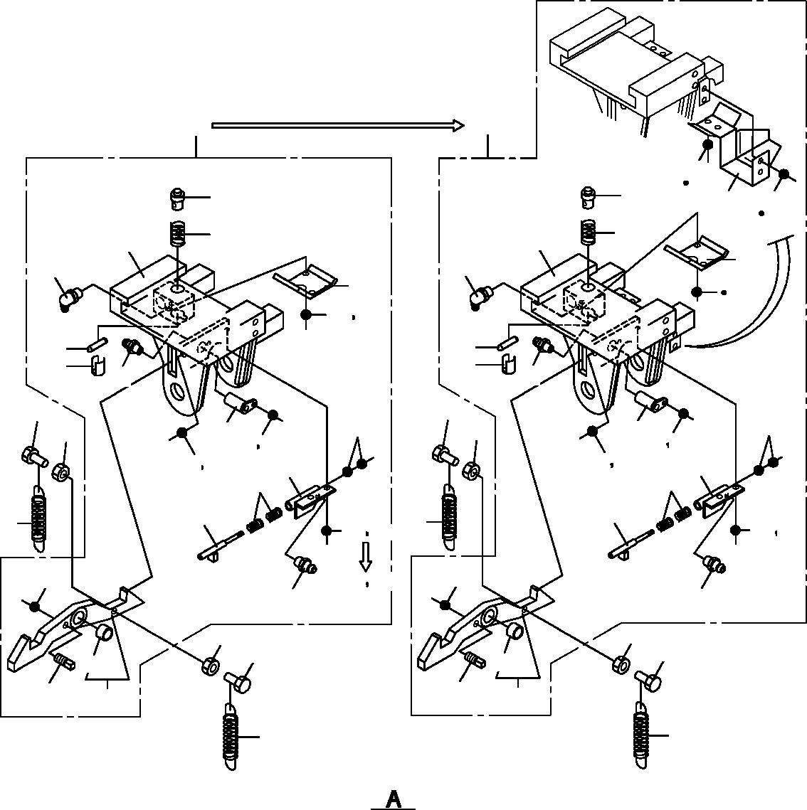
DT-600-2-00001 UPPER PP2050012-06 MOUNT,AUGER
1
101
135
137
39
39
56
134
135
120
40
111
31
44
43
43
36
52
44
36 52
41
42
41
42
34
34
9
9
51
51
10
10
33
33
35 36
45
49
35 36
45
49
46 47
46 47
50
50
18
18
36 53
35
36
38
38
36
53
34
34
10
10
9
9
73
73
37
37
32
32
18
18

DT-600-2-00001 UPPER
000093
Pos No.

Parts No
Parts Name
Qty
Unit
Technical Data
Serial No (Start)
Serial No (End)
Rema

1
2
3
4
5
6
7
8

9
10
11
12
13
14
15
16

17
18
19
20
21
22
23
31
32
33
34

35
36

37
38
39
40
41
42
43
44
45
46
47
49
50
51
52
53
56
61
63
73
81
82
83
84
96
101
111
120
134
135
137

32490300010
32490300020
82459103000
32490300030
32490300040
32490300050
32490300060
32490530010
32490530020
90101508020
90201200800
37000128360
80737160090
37000524100
90236202401
80136350045
90133916075
90172316075
90303501601
19114411000
90101508055
90302040801
32490531000
53620233000
37000504620
32490302000
32490302010
32490302020
82455106000
82455106000
82455106000
90101208016
90302040801
90302040801
90302040801
90781212400
90266201200
32490302040
37001201110
80747100056
32490302050
82459103000
32490302100
32490302070
90102506025
90203200600
37001201020
32490302080
90203200800
90180208016
90131508014
32472870202
37000401810
90303502701
80804025020
32490530200
32490530100
37000119920
90101208012
80804020010
32490530031
32490532000
37001202190
90101210020
90302041001
90180210020
SUPPORT ASSY ARM NIPPLE,GREASE SUPPORT
PIN SUPPORT PIN STOPPER STOPPER BOLT NUT
PIN PIN PLATE
NUT,CASTLE PIN,SPLIT
BOLT,HEXAGON SOCKET BOLT,HEXAGON SOCKET WASHER,PLAIN
SPRING BOLT
WASHER,SPRING STOPPER ASSY SPRING
PLATE SUPPORT STOPPER PIN
NIPPLE,GREASE NIPPLE,GREASE NIPPLE,GREASE BOLT WASHER,SPRING WASHER,SPRING WASHER,SPRING SCREW,SET
NUT PIN SPRING PIN (B)
SPACER NIPPLE,GREASE COVER
HOLDER BOLT NUT SPRING SHAFT NUT
BOLT,BUTTON BOLT,HEXAGON SOCKET SUPPORT BEARING,PLAIN WASHER,PLAIN <27) BEARING,PLAIN STOPPER
SUPPORT PIN
BOLT BEARING,PLAIN SUPPORT ASSY SUPPORT ASSY SPRING
BOLT WASHER,SPRING BOLT,BUTTON
1
1
2
1
1
2
1
1
1
2
2
1
2
1
1
1
6
6
6
2
1
1
1
1
1
1
1
1
2
1
2
1
5
1
5
1
1
1
1
1
1
1
1
1
1
1
2
1
2
2
2
1
4
1
1
1
1
1
1
2
1
1
1
2
4
2

C-PT1/8

M8X20 M8

16X90 T=6 M24 5X45 M16X75 M16X75 16

M8X55 8

A-M6F FE A-M6F FE A-M6F FE M8X16
8
8
8
M12X40 M12

10X56 C-PT1/8

M6X24 M6

M8 M8X16 M8X14

M8X12

M10X20 10 M10X20

275216

275470

275364
275364
275364

275364
275712
275712

275364
275712

275712

275712

275712
275712
275712

275376

275364
275364
275364
275364
275364
275712
275712
275712
275712
275712
275712
275711

275215
275363

275375

275469

275711

275711

275711

275711

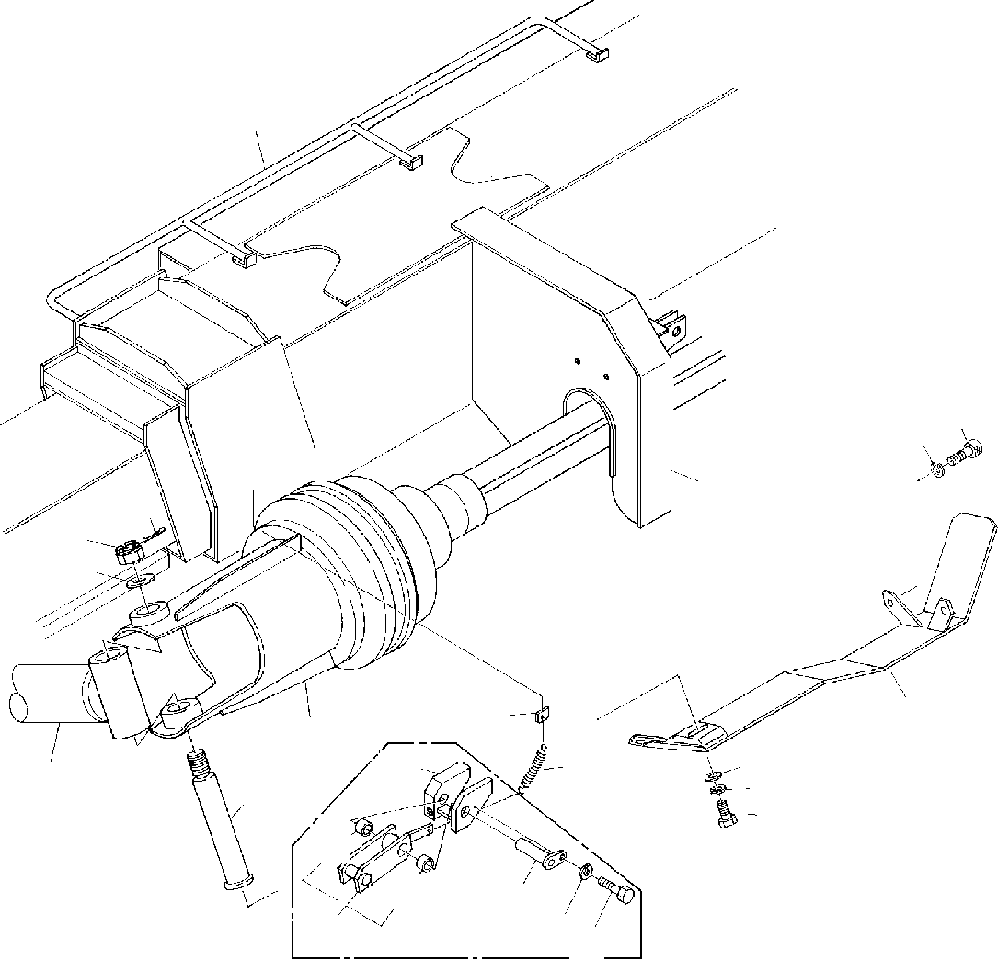
DT-600-2-00001 UPPER PP2050013-00 MOUNT,AUGER
1
11 10
4
14
13
12
6
30
2
102
29
9
22
5
8
7
132
132
103
48104
28
101

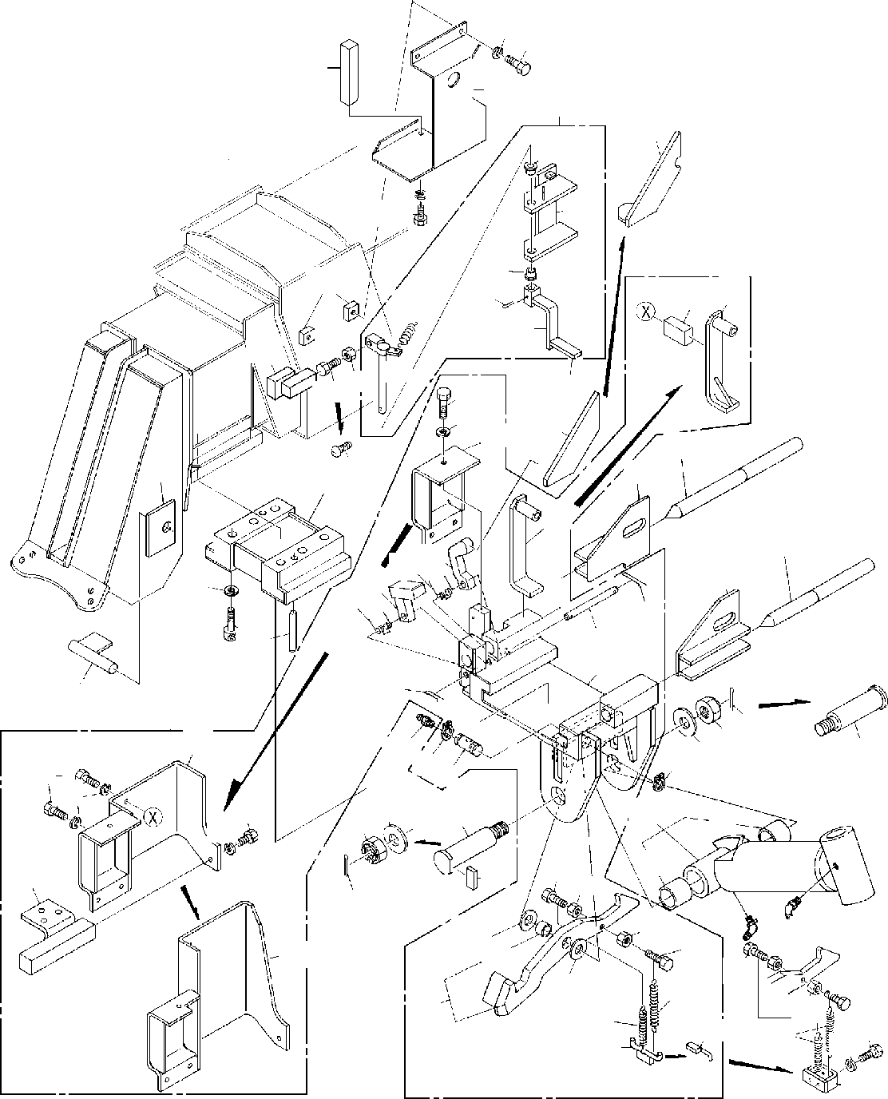
DT-600-2-00001 UPPER PP2050013-00 MOUNT,AUGER
48
149
144
143
141
162
42
48
149
164
162
165
166
146
74
81
29
145
163
14745
77
78
73
142
42
27
24
147
43
38
74
25
70 72
26
71
40
39
70
76
75
61
41
76
36
21
73
35
34
37
31
79 33
7963
31
77
48
33
22
77
91
34
48
91
68
32
80
67
35
67
23
65
45
68
82
124
44
44
65
46
62
45
46
46
69
47
69
48
49

DT-600-2-00001 UPPER
000094
Pos No.

Parts No
Parts Name
Qty
Unit
Technical Data
Serial No (Start)
Serial No (End)
Rema

1
2
4
5
6
7
8
9
10
11
12
13
14
21
22
23
24
25
26
27
28
29

30
31
33
34
35
36
37
38
39
40
41
43
44
45

46
47
48

49
61
62
63
65
70
71
74
75
76
77
79
80
81
82
91
101
102
103
104
124
132
141
142
143
144
145

(***********) (***********) (***********) 37000126040
32490230010
90101210025
90302041001
90303071001
90131512040
90302041201
37000524100
90236202400
80136350045
32490110010
32490110020
82458202000
32490110030
32490110040
32490110050
32490110060
32490110070
53620233000
53620233000
37000504620
37000128360
37000524100
90236202401
80136350045
32490110080
82456201000
32490110090
90133916075
90303501601
80737160090
32490110110
90101508020
90201200800
90201200800
19114411000
90101508040
90302040801
90302040801
32490110120
32490112000
32490119510
37000126120
37000524640
37001400150
32490112020
32490112050
37000126050
80136332020
90171108016
80601110220
32490262030
32490112420
32490262000
37000401810
32490112100
32490112110
37000119920
90101208012
80804022015
80804020010
32490112300
37000532930
32490112310
32490112320
32490112330
PIPING,AUGER AUGER MOUNT,AUGER PIN
COVER BOLT
WASHER,SPRING WASHER,PLAIN BOLT,HEXAGON SOCKET WASHER,SPRING
PLATE NUT,CASTLE PIN,SPLIT SUPPORT ASSY SUPPORT NIPPLE,GREASE COVER SUPPORT SUPPORT SUPPORT STOPPER ASSY SPRING
SPRING PLATE PIN PLATE
NUT,CASTLE PIN,SPLIT STOPPER NIPPLE,GREASE SUPPORT
BOLT,HEXAGON SOCKET WASHER,PLAIN
PIN SUPPORT BOLT NUT
NUT SPRING BOLT
WASHER,SPRING WASHER,SPRING STOPPER SUPPORT STOPPER ASSY PIN
PLATE SPRING STOPPER SUPPORT PIN PIN,SPLIT BOLT
RING,RITAINING SUPPORT SUPPORT COVER BEARING,PLAIN STOPPER SUPPORT
PIN BOLT
BEARING,PLAIN BEARING,PLAIN STOPPER ASSY PLATE
COVER SUPPORT SUPPORT
1
1
1
1
1
1
1
1
2
2
1
1
1
1
1
2
1
1
1
1
1
1
1
1
1
1
1
1
1
1
1
6
6
2
1
2
2
1
2
2
3
9
1
1
1
1
2
1
1
1
1
2
6
2
1
1
1
4
1
1
1
1
1
2
1
1
1
1
1

M10X25 10
10
M12X40 12
T=6 M24 5X45

B-TYPE PT1/8

T=6 M24 5X45
A-TYPE PT1/8 M16X75
16
16X90

M8X20 M8
M8

M8X40 8
8

3.2X20 M8X16 S22

M8X12

275018

275125
275125
275125

275018

275018

275018

275018

275104
275018
275104

275018
275018
275018
275018
275018

DT-600-2-00001 UPPER
000094
Pos No.

Parts No
Parts Name
Qty
Unit
Technical Data
Serial No (Start)
Serial No (End)
Rema

146
147
149
162
163
164
165
166

37000502190
80182308035
90101208014
37000401050
32490113000
32490113010
80720104028
32490113020
PLATE SCREW,MACHINE BOLT BEARING,PLAIN SHAFT
SUPPORT PIN,SPRING LEVER
2
1
3
2
1
1
1
1

M8X35 M8X14

4X28

275018
275032
275018
275018
275018
275018
275018
275018

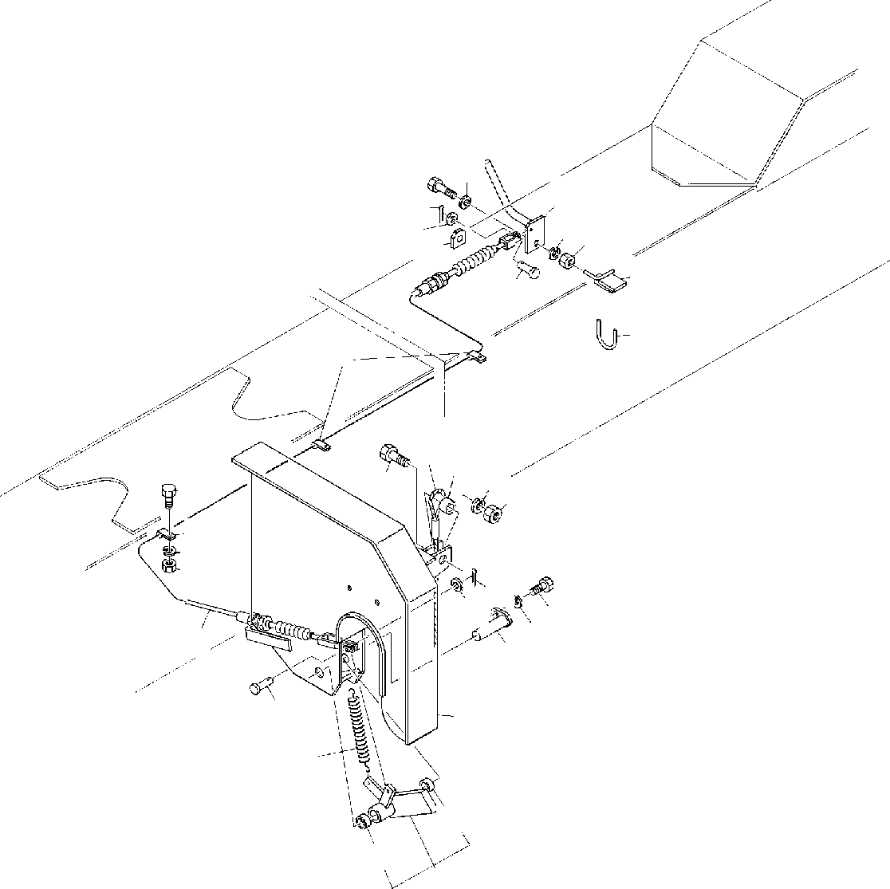
DT-600-2-00001 UPPER PP2050014-00 MOUNT,AUGER
2223
24
23
14
13
21
26
20
12
25
345 6
1915 18
17
4
3
6
5
16
14
13
10
11
9
7
12
2
1
42
42
8

DT-600-2-00001 UPPER
000095
Pos No.

Parts No
Parts Name
Qty
Unit
Technical Data
Serial No (Start)
Serial No (End)
Remarks
Pa

1
2
3
4
5
6
7
8
9
10
11
12
13
14
15
16
17
18
19
20
21
22
23
24
25
26
42

59240004001
32490130010
82100002006
90101206014
90201200600
90302040601
37001702800
32490130020
37000119940
90101208012
90302040801
37000109680
90303070601
80136316012
37000302260
90101216050
90201201600
90302041601
37001901130
32490130030
90201201200
90101212030
90303071201
32490130040
37000530940
32200232090
80804020010
SPRING SUPPORT CLAMP BOLT NUT
WASHER,SPRING CABLE,CONTROL LEVER
PIN BOLT
WASHER,SPRING PIN WASHER,PLAIN PIN,SPLIT SPACER
BOLT NUT
WASHER,SPRING ROPE,WIRE SUPPORT
NUT BOLT
WASHER,PLAIN LEVER SUPPORT SUPPORT BEARING,PLAIN
1
1
4
4
4
4
1
1
1
1
1
2
2
2
1
1
1
1
1
1
1
1
2
1
1
1
2

WR10 M6X14 M6
6
L=2950

M8X12 8

6
1.6X12 L=15 M16X50 M16
16

M12 M12X30 12

275200

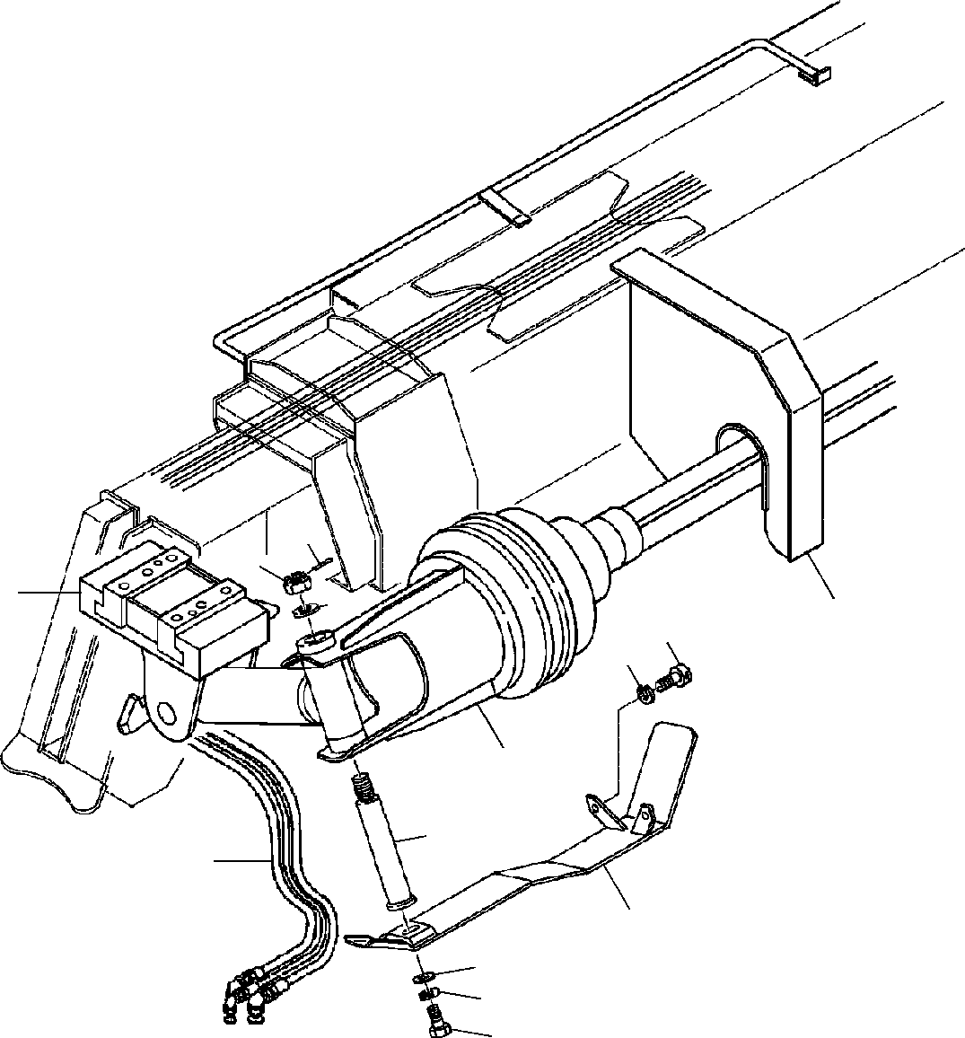
DT-600-2-00001 UPPER PP2050015-01 MOUNT,AUGER
14
13
3
12
4
10
11
2
5
1
6
9
8
7

DT-600-2-00001 UPPER
000096
Pos No.

Parts No
Parts Name
Qty
Unit
Technical Data
Serial No (Start)
Serial No (End)
Rema

1
2
3
4
5
6
7
8
9
10
11
12
13
14

(***********) (***********) (***********) (***********) 37000126040
32490230010
90101210025
90302041001
90303071001
90131512040
90302041201
37000524100
90236202400
80136350045
PIPING,AUGER AUGER MOUNT,AUGER MOUNT,AUGER PIN
COVER BOLT
WASHER,SPRING WASHER,PLAIN BOLT,HEXAGON SOCKET WASHER,SPRING
PLATE NUT,CASTLE PIN,SPLIT
1
1
1
1
1
1
1
1
1
2
2
1
1
1

M10X25 10
10
M12X40 12
T=6 M24 5X45

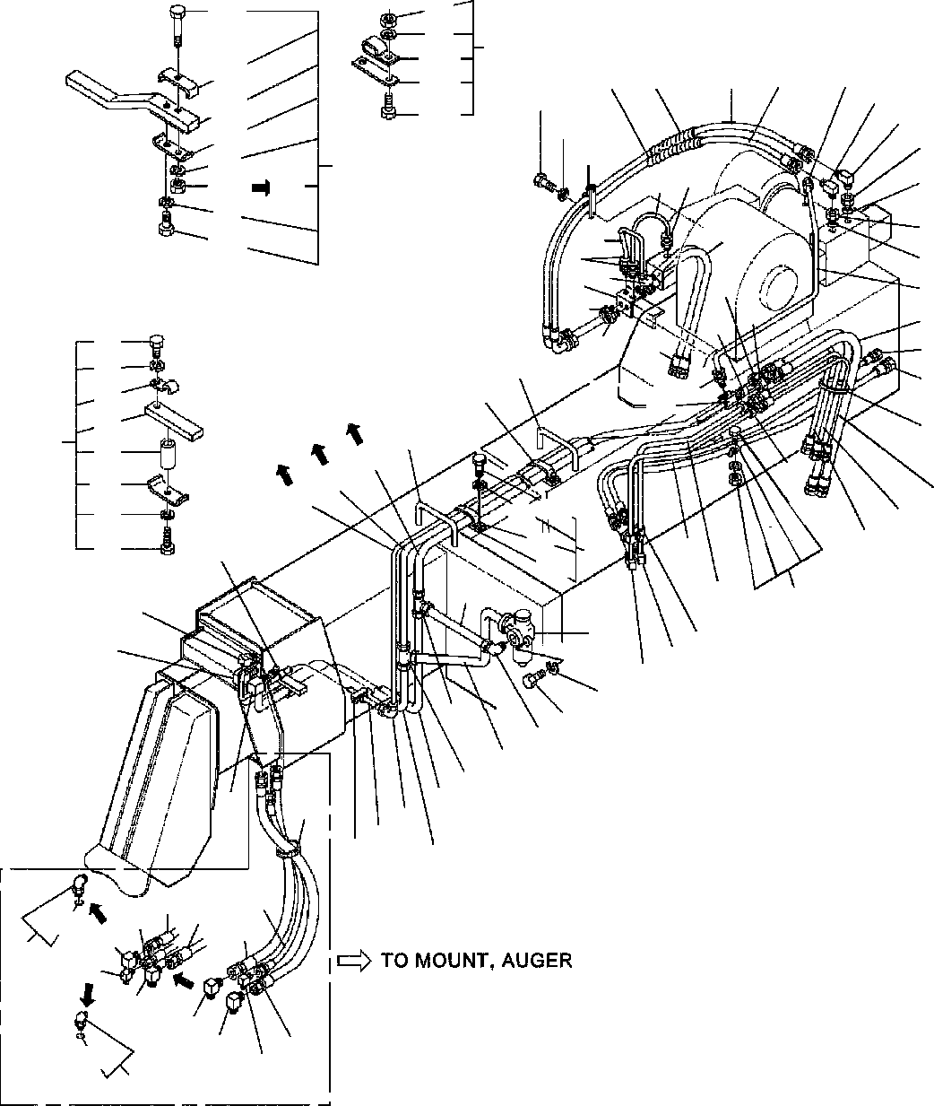
DT-600-2-00001 UPPER PP2100002-09 PIPING,AUGER
93
74
101
61
112
111
113
106
58
58
57
57
32
59
60
107
105
74
102
74
104
59
22
33
34
61
44
5
8
93
33
34
35
53
42
41
7
31
5
4
30
6
51
51
50
73
74
30
31
56
48
27
72
71
77
75
74
76
49
62
63
43
56
3
64
24
52
25
54
26
83
74
47
81
82
46
3
27
36
17
37
40
2
20
1
38
2
39
22
19
21
18
23
19
43
13
1
16
14
55
15
11
12
12
12
11
191
10
10
9
10
10
10
12
181
9
9

DT-600-2-00001 UPPER
000097
Pos No.

Parts No
Parts Name
Qty
Unit
Technical Data
Serial No (Start)
Serial No (End)
Remark

1
2
3
4
5
6
7
8
9

10

11

12
13
14
15
16
17
18
19
20
21
22
23
24
25
26
27
30
31

32
33
34
35
36
37
38
39
40
41

42

43

44
46
47

48
49
50
51
52
53
54

55
56
57

58
59
60
61
62

37000906830
37000906810
32340190010
32340190020
80302010100
80303030100
81408000130
81408000130
80430450650
80430620600
80430451250
80430621200
37002417820
37002413360
37002417790
81408000290
81408000160
81408000290
80303010100
81408000290
80303030280
80305010200
36620710000
90101210060
90302041001
81408000290
81408000290
81408000290
81408000160
32340110060
80430410650
37002417770
37002426520
80303030160
37000912460
91002802400
81408000160
81408000160
81408000160
37000708100
37000908570
32340110040
37002419210
37002415070
37002403320
37002426530
91810132530
91810132530
32340190030
37002419200
37002419220
37002426540
80302010140
32340190040
37000900110
37000900130
37000910110
37002413410
37002419190
37002426550
37000705960
32340190050
37002420680
37002426560
32340194150
37000911550
90101210025
32340190060
81408000290
JOINT JOINT
CLAMP ASSY JOINT FITTING
FITTING,ELBOW PIPE,STEEL PIPE,STEEL JOINT
JOINT (WITH O-RING) JOINT
JOINT HOSE HOSE HOSE PIPE,STEEL PIPE,STEEL PIPE,STEEL
FITTING,ELBOW PIPE,STEEL FITTING,ELBOW FITTING,TEE VALVE,CHECK BOLT WASHER,SPRING PIPE,STEEL PIPE,STEEL PIPE,STEEL PIPE,STEEL CLAMP ASSY JOINT
HOSE HOSE
FITTING,ELBOW JOINT
O-RING PIPE,STEEL PIPE,STEEL PIPE,STEEL CLAMP ASSY JOINT CLAMP ASSY HOSE
HOSE HOSE HOSE FASTENER FASTENER
CLAMP ASSY HOSE
HOSE HOSE FITTING JOINT JOINT JOINT JOINT HOSE HOSE HOSE
CLAMP ASSY GUARD HOSE
HOSE TUBE,SPIRAL JOINT
BOLT
CLAMP ASSY PIPE,STEEL
2
2
1
1
3
1
1
1
1
1
2
2
1
1
2
2
2
2
1
1
2
2
1
2
3
1
4
4
4
2
2
2
2
1
2
2
2
2
2
1
1
2
1
1
1
1
1
2
1
1
1
1
1
1
1
2
1
2
1
1
1
3
2
2
2
2
1
1
4

M M

M M M

M

M M M M

M M M

M

M
L,3/4-22

KCT10-020N KLN10-020N 10X1.8T
10X1.8T L,G3/8-G3/8

L=800 L=900 L=850 22X2.5T
12X1.4T
22X2.5T KLA12-000N 22X2.5T KLN22 KTA220-000N

M10X60 10
22X2.5T
22X2.5T
22X2.5T
12X1.4T

L=710 L=710 KLN12-030N

1B P24
12X1.4T
12X1.4T
12X1.4T
12X2

21X2 L=1320 L=1320 L=1400 L=1400

L=670 L=670 L=670
C717KCT12-020N

L=710 L=670 L=670 12

L=950 L=950

M10X25 22X2.5T

275203

275203

275082

275041

275041

275041

275032

275041

275041

275041

275241

275202
275212
275202
275212
275081
275212
275212

275240
275240
275240

275040

275040

275040

275031

275040

275040

275040

DT-600-2-00001 UPPER
000097
Pos No.

Parts No
Parts Name
Qty
Unit
Technical Data
Serial No (Start)
Serial No (End)
Remark

63
64
71
72
73
74
75
76
77
81
82
83
93

101

102
104

105
106
107
111
112
113
181
191

81408000290
81408000160
37000528330
37000600660
90101208012
90302040801
37000602560
90101208035
32340190070
32340112020
37000519310
90101508015
90201200800
90201200800
90101508075
90101208075
90201400800
90101508030
90101208030
37000602540
37000602230
32340192010
32340192100
82100002041
90101208016
91002801400
91002802400
PIPE,STEEL PIPE,STEEL PLATE CLAMP BOLT
WASHER,SPRING SUPPORT
BOLT SPACER SUPPORT PLATE BOLT NUT
NUT BOLT BOLT NUT BOLT BOLT SUPPORT SUPPORT SUPPORT PLATE CLAMP BOLT
O-RING O-RING
4
4
1
1
1
9
1
1
1
2
2
4
1
1
1
1
1
1
1
1
1
1
1
1
1
1
2
M M

22X2.5T
12X1.4T

R=6 M8X12 8

M8X35 L=20

M8X15 M8
M8 M8X75 M8X75 M8 M8X30 M8X30

M8X16 1B P14
1B P24
275241
275241

275352

275799

275799

275799

275203
275203

275863

275863

275798

275798
275798

275212
275212

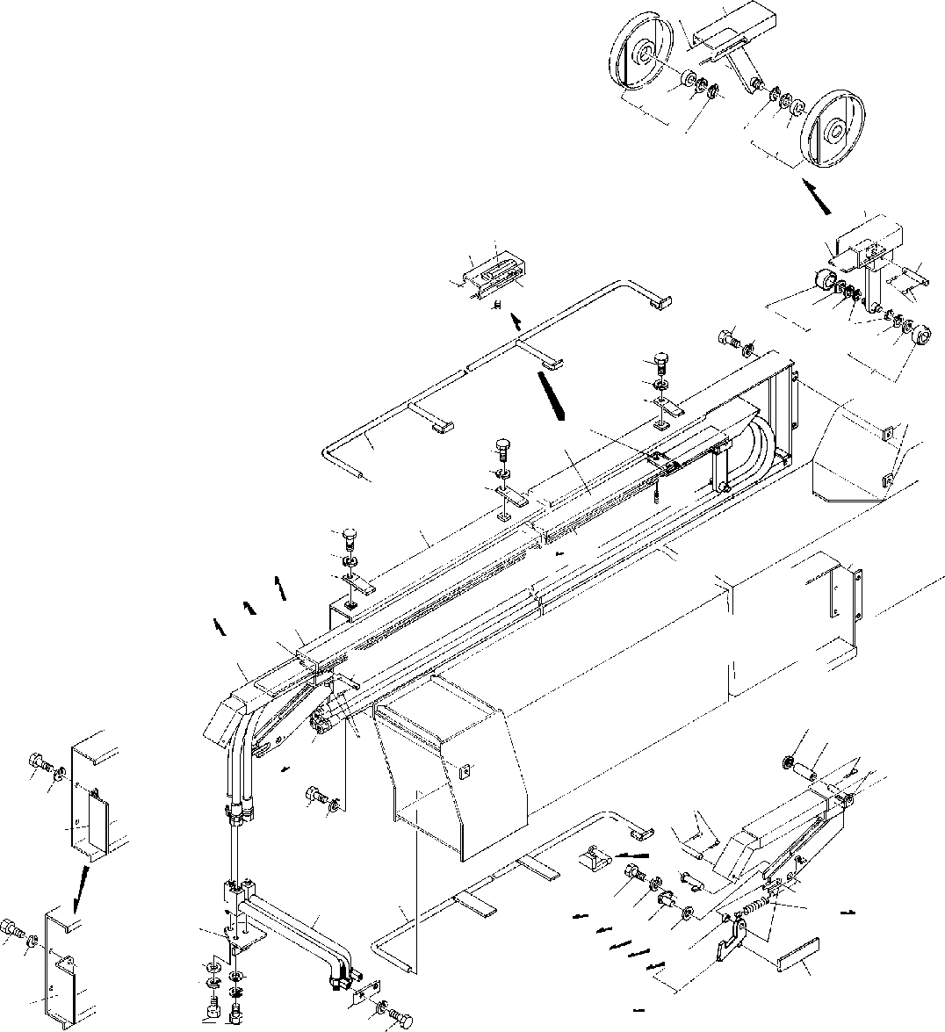
DT-600-2-00001 UPPER PP2100009-00 PIPING,AUGER
61
62
64
65
66
63
65
64
66
63
2
8385
21
15
84
86
5 6
1819
16
87
2019
17
5
6
4
18
17
7
9
8
5
6
11
41
10
1
5
6
4
21
1
61
52
62
83
21 2
3
15
40
30
3129
16
12
82
5 6
7
5
31
6
13
34
37
37
42
26
5
32
68
69
6
27
44
43
28
3635
70
717273
45 6
13
39
44
43
33
38
67
2543
28

DT-600-2-00001 UPPER
000098
Pos No.

Parts No
Parts Name
Qty
Unit
Technical Data
Serial No (Start)
Serial No (End)
Remarks

1
2
3
4
5

6

7
8
9
10
11
12
13

15
16
17
18
19
20
21
25
26
27
28
29
30
31
32
33
34
35
36
37

38
39
40
41
42
43
44
45
61
62
63
64
65
66
67
68
69
70
71
72
73

82
83
84
85
86
87
98
99

32490150010
32490150020
32490150030
32490090040
90101208012
90101208012
90302040801
90302040801
37000502190
32490150050
32490090060
90710006120
32490090070
37002419250
32490150060
32490150061
37000126090
80136325016
32490099510
80516006002
80602110320
80601110150
32490150090
37000530320
32490150100
32490150110
90101210020
32490150170
37001103150
80136332020
19114411000
37000527790
37000126060
90303071601
37000126100
32490090130
32490090190
32490099520
80804016015
90303071201
32490150150
32490150160
90302041001
90303071001
90101208010
32490150021
32490150091
32490099530
80516006004
80602110420
80601110200
32490099520
19114411000
90101208012
90302040801
37000126100
90303071601
80804016015
80804016015
80804016015
80804016015
37002419250
32490150031
32490152000
32490092020
32490091100
90710006080
80516006002
80602110320
COVER COVER COVER SUPPORT BOLT BOLT
WASHER,SPRING WASHER,SPRING PLATE
COVER PLATE SCREW,SET SUPPORT HOSE,TRIPLE COVER COVER
PIN PIN,SPLIT
ROLLER ASSY BEARING,BALL RING,RITAINING RING,RITAINING COVER
PLATE JOINT SUPPORT BOLT SUPPORT ROLLER PIN,SPLIT SPRING PLATE PIN
WASHER,PLAIN PIN
SUPPORT SUPPORT STOPPER ASSY BEARING,PLAIN WASHER,PLAIN GUARD
GUARD WASHER,SPRING WASHER,PLAIN BOLT
COVER COVER ROLLER ASSY
BEARING,BALL RING,RITAINING RING,RITAINING STOPPER ASSY SPRING
BOLT WASHER,SPRING PIN WASHER,PLAIN BEARING,PLAIN BEARING,PLAIN BEARING,PLAIN BEARING,PLAIN HOSE,TRIPLE COVER
COVER CUSHION PLATE SCREW,SET BEARING,BALL RING,RITAINING
1
1
1
4
16
13
16
15
8
1
4
8
1
1
1
1
2
4
2
2
2
2
1
1
1
1
5
1
1
3
1
1
1
2
1
1
1
1
1
1
1
1
5
3
2
1
1
2
4
4
2
1
1
1
1
1
2
1
1
1
1
1
1
1
1
1
4
2
2

M8X12 M8X12 8
8

M6X12 L=8730&8715&8695

2.5X16

R32 15

M10X20

3.2X20

16

12

10
10
M8X10

R42 S20

M8X12 8

16

L=8730&8715&8695

M6X8 R32

275104

275104

275104

275032

275104
275104
275104
275104
275104
275104
275104
275104
275104
275104
275104
275104
275104

275104
275104
275104
275104
275104
275104
275104
275104

275103
275103

275103

275103

275103
275103
275103

275103
275103

275103
275103
275103
275103
275103
275103
275103

275017

275103

275103
275103
275031

275103
275103

275103
275103

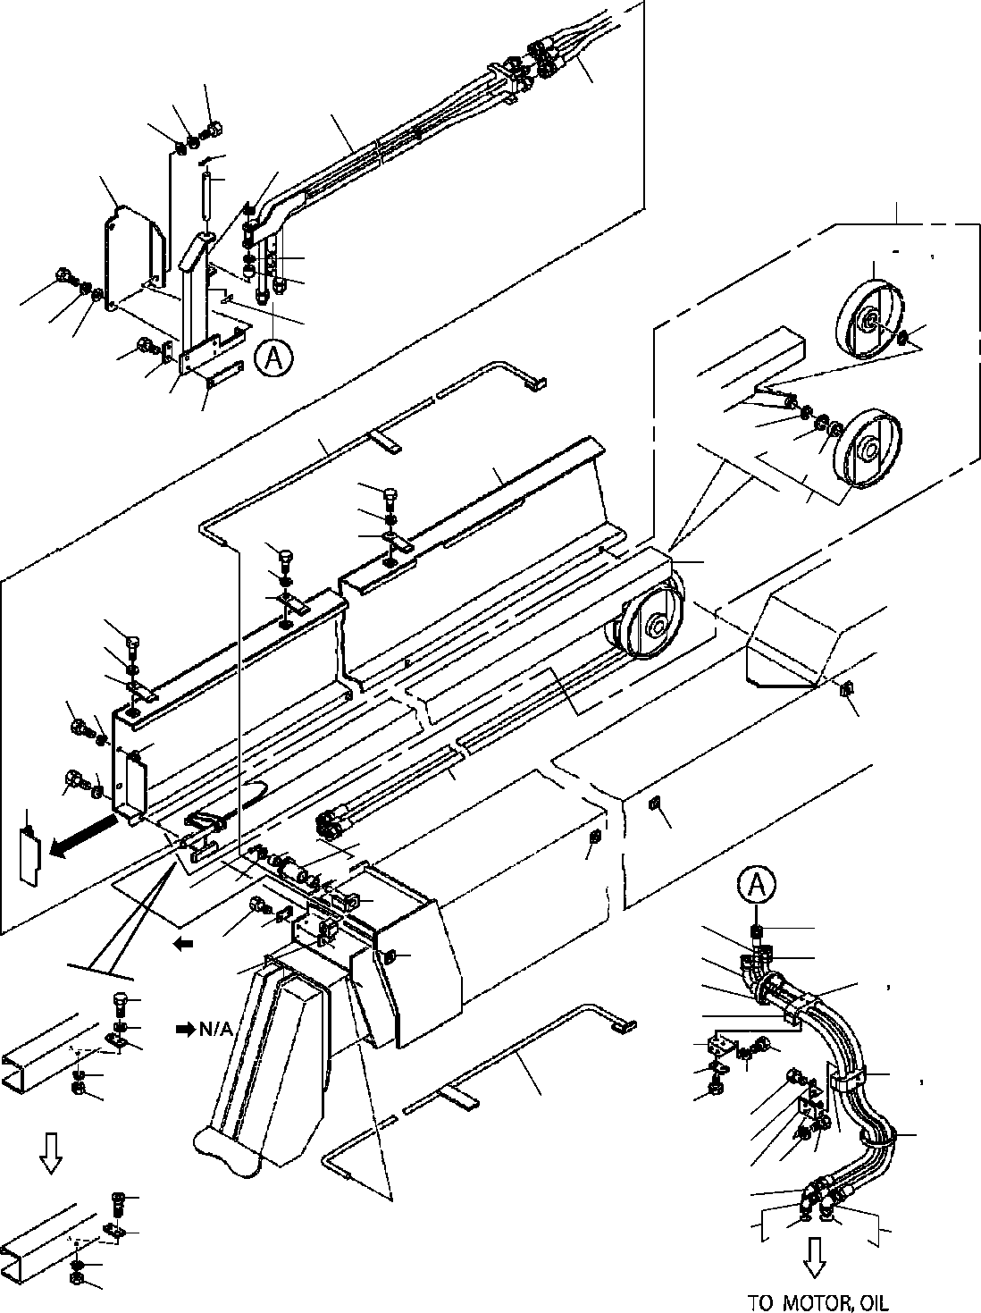
DT-600-2-00001 UPPER PP2100010-05 PIPING,AUGER
20
21
11
1
22
25
23
24
19
2
62
63 64
24
47
20
65
25
21
22
18
17
16
48
5
65
64
3
63
9
10
6
62
9
10
7
61
9
10
6
10
9
41
8
10
11
8
9
13
41
73
73
41
14
15
12
40
27
39
30
28
27
17
50
18
26
41
29
49
43
44
42
32
35
45
46
33
34
29 49
10
34
33
31
37
36
4
38
30
35
10
43
42
91
37
81
45
46

DT-600-2-00001 UPPER
000099
Pos No.

Parts No
Parts Name
Qty
Unit
Technical Data
Serial No (Start)
Serial No (End)
Remarks
1

2
3
4
5
6
7
8
9
10
11
12
13
14
15
16
17
18

19
20
21
22
23
24
25
26
27
28
29
30
31
32
33
34
35
36
37
38
39
40
41
42

43

44
45
46
47
48
49
50
61
62
63
64
65
73
81
91

32490510010
32490610050
32490510100
32490610030
32490510020
32490400040
32490090040
32490090070
32490500020
90101208012
90302040801
37002442480
32490400060
32490400070
90303072001
80136350032
32490640030
37000543030
90101512022
90101512025
32490290030
90101210016
90302041001
90303071001
37000157210
90303071601
80136340030
32490510050
37002442490
37002442500
32490510060
32490510070
32490510080
32490510090
37000551590
90101508040
90101508014
80430620600
80430621200
91810130270
91810130240
82100001411
37000502190
37002006780
37002018560
90101206016
90181006015
90303070601
90302040601
90201200600
37000308320
37000560190
32490610010
90171112022
32490510120
32490099530
80516006004
80602110420
80601110200
80804020020
91002801400
91002802400
JOINT JOINT
CASE ASSY (2ND) COVER
GUARD GUARD SUPPORT SUPPORT COVER BOLT
WASHER,SPRING HOSE,TRIPLE SUPPORT ROLLER WASHER,PLAIN PIN,SPLIT SUPPORT
PLATE BOLT BOLT COVER BOLT
WASHER,SPRING WASHER,PLAIN PIN WASHER,PLAIN PIN,SPLIT SUPPORT
HOSE HOSE SUPPORT SUPPORT SUPPORT SUPPORT PLATE BOLT BOLT
JOINT (WITH O-RING) JOINT
FASTENER FASTENER TUBE,SPIRAL PLATE PLATE,SLIDE PLATE,SLIDE BOLT
BOLT WASHER,PLAIN WASHER,SPRING NUT
SPACER PLATE PLATE BOLT CASE
ROLLER ASSY BEARING,BALL RING,RITAINING RING,RITAINING BEARING,PLAIN O-RING
O-RING
1
1
1
1
1
1
4
1
1
13
17
1
1
1
1
1
1
3
6
4
1
3
3
3
1
5
2
1
2
1
2
2
1
1
2
4
4
1
2
1
1
1
5
1
1
2
2
2
2
2
1
2
4
2
1
2
2
2
2
2
1
2

M

M8X12 8 L=4710

20
5X32

M12X22 M12X25

M10X16 10
10

16
4X30

L=1210 L=1400

M8X40 M8X14 L,G3/8-G3/8

SE-08BK

M6X16 M6X15 6
6
M6

M12X22

R42 S20

1B P14
1B P24

275218

275254

275651

275651

275254
275583
275254

275217

275253

275650

275650

275650

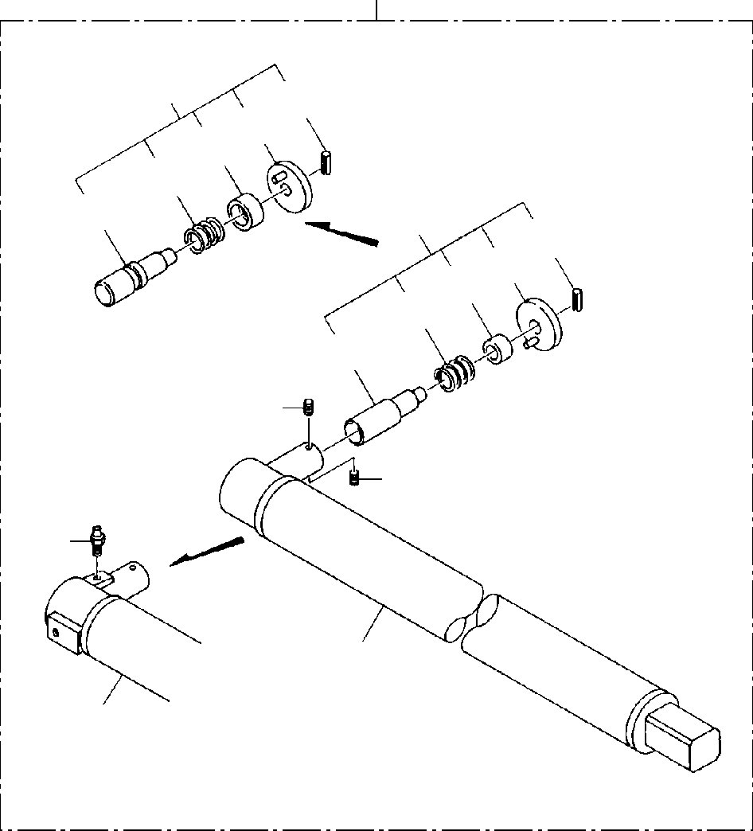
DT-600-2-00001 UPPER
PP2150008-02 SHAFT,AUGER (2M,OPTION)
100
3
35
33 34
32
31
3
25
23 24
22
21
2
2
4
1
1

DT-600-2-00001 UPPER
000100
Pos No.

Parts No
Parts Name
Qty
Unit
Technical Data
Serial No (Start)
Serial No (End)
Re

1

2
3

4
21
22
23
24
25
31
32
33
34
35
100

32470600010
32470600020
90710006080
32490020070
32490023000
82456106000
32490022030
37001200470
32490022060
32490022050
80720105018
32490023010
37001200720
32490253510
32490253520
80720105028
32470600000
SHAFT SHAFT SCREW,SET PIN ASSY PIN ASSY
NIPPLE,GREASE PIN
SPRING GUIDE GRIP PIN,SPRING PIN
SPRING GUIDE GRIP PIN,SPRING
SHAFT,AUGER (2M,OPTION)
1
1
2
1
1
1
1
1
1
1
1
1
1
1
1
1
1

M6X8

1/4-28UNF

5X18

5X28

275094

275094
275094

275094
275094
275094
275094
275094

275093

275093

275093
275093
275093
275093
275093

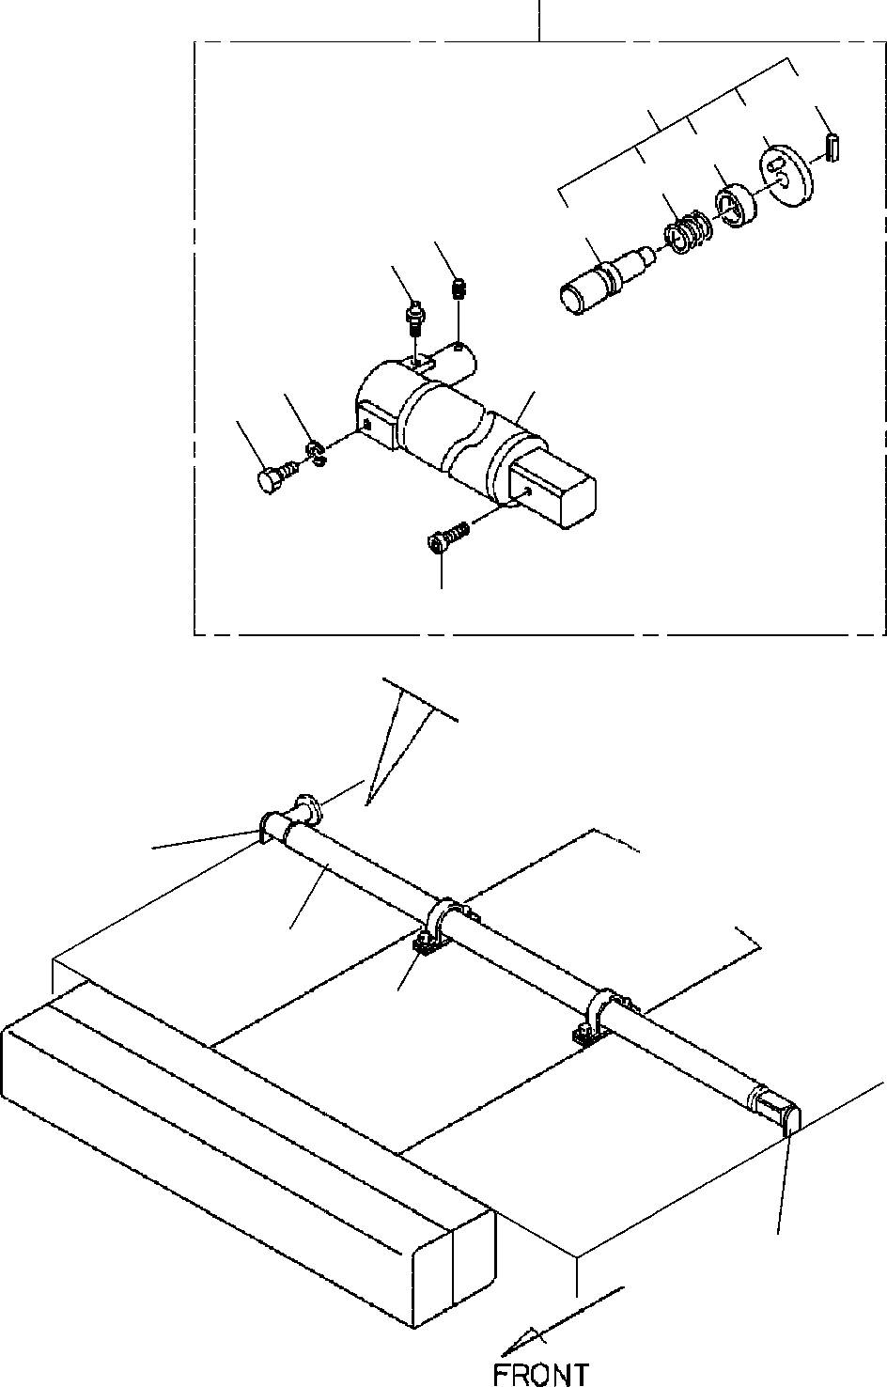
DT-600-2-00001 UPPER
PP2150012-02 SHAFT,AUGER (1.7M,OPTION)
2
43
35
34
33
32
42
31
44
46
41
45
47
3
2
1
3

DT-600-2-00001 UPPER
000101
Pos No.

Parts No
Parts Name
Qty
Unit
Technical Data
Serial No (Start)
Serial No (End)
Remarks
Pag

1
2
3
31

32

33

34

35

41

42
43

44

32470190010
32470190030
32470190040
32490022030
32490023010
37001200470
37001200720
32490022060
32490253510
32490022050
32490253520
80720105018
80720105028
32470192040
32470192050
90710006080
32490020070
32490023000
82456106000
CLAMP ASSY SHAFT ASSY PLATE
PIN PIN
SPRING SPRING GUIDE GUIDE GRIP GRIP
PIN,SPRING PIN,SPRING SHAFT SHAFT SCREW,SET PIN ASSY PIN ASSY
NIPPLE,GREASE
2
1
2
1
1
1
1
1
1
1
1
1
1
1
1
2
1
1
1

5X18
5X28

M6X8

1/4-28UNF

275566

275094

275094

275094

275094

275094

275094

275094
275094

275093

275093

275093

275093

275093

275093

275093

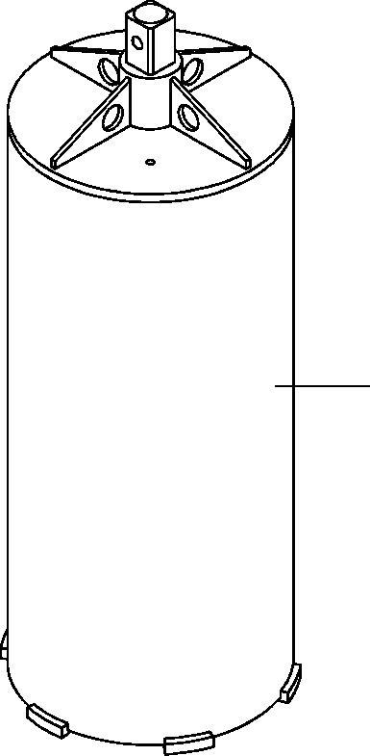
DT-600-2-00001 UPPER
PP2170000-00 HEAD,AUGER (450.DW) (OPTION)
1

DT-600-2-00001 UPPER
000102
Pos No.

Parts No
Parts Name
Qty
Unit
Technical Data
Serial No (Start)
Serial No (End)

1

32470650000
HEAD,AUGER (450.DW) (OPTION)
1

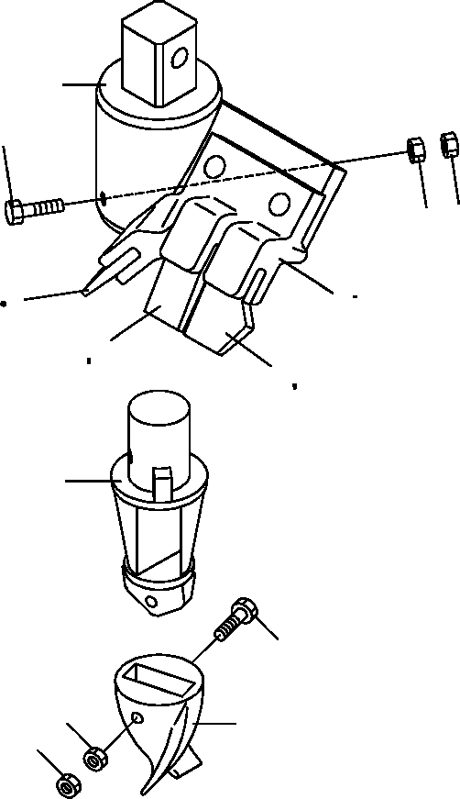
DT-600-2-00001 UPPER
PP2170001-02 HEAD,AUGER (PENGO,450.PH)
1
5
6
6
10
12
2 31
10 12
11
12
3
8
9
4
9

DT-600-2-00001 UPPER
000103
Pos No.

Parts No
Parts Name
Qty
Unit
Technical Data
Serial No (Start)
Serial No (End)
Re

1
2
3
4
5
6
8

9

10
11
12
31

32470720010
32470720100
32470720300
32470720400
90101512150
90201401200
90101510045
90101510050
90201401000
90203401000
32470730200
32470730100
32470720500
32470720200
SUPPORT
HOLDER (WITH BOLT&NUT) ADAPTER
BIT,PILOT (PENGO.FH205) BOLT
NUT BOLT BOLT NUT NUT
TOOTH (PEBGO.1656) TOOTH (PENGO.1658) CUSHION
BOLT ASSY
1
1
1
1
1
2
1
1
2
2
2
1
3
2

M12X150 M12 M10X45 M10X50 M10
M10

275094

275094

275093

275093

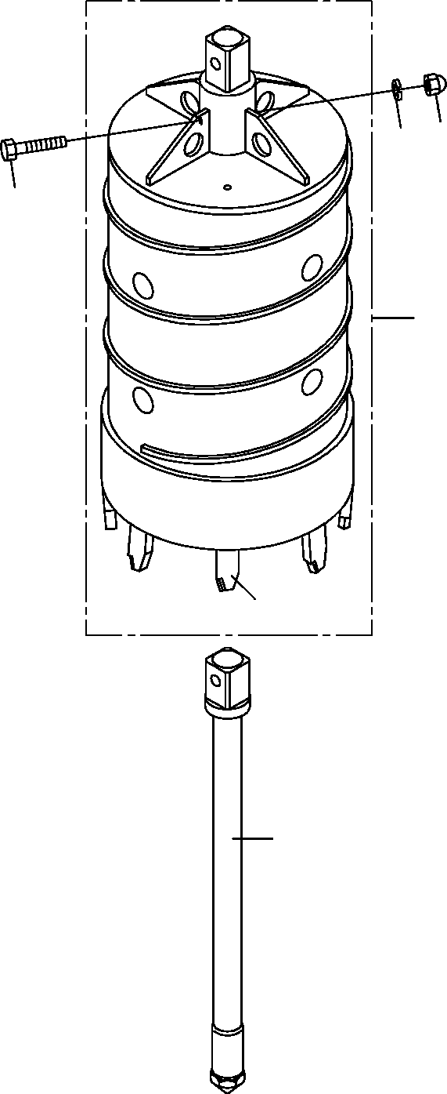
DT-600-2-00001 UPPER
PP2170002-01 HEAD,AUGER (450.D)
4
5
3
1
17
2

DT-600-2-00001 UPPER
000104
Pos No.

Parts No
Parts Name
Qty
Unit
Technical Data
Serial No (Start)
Serial No (End)
Remarks
Pa

1
2
3
4
5
17

32470761000
32470760020
90101218110
90240201800
90302041801
32470760010
HEAD,AUGER BIT,CENTER BOLT NUT,CAP
WASHER,SPRING BIT,CUTTER
1
1
1
1
1
8

18

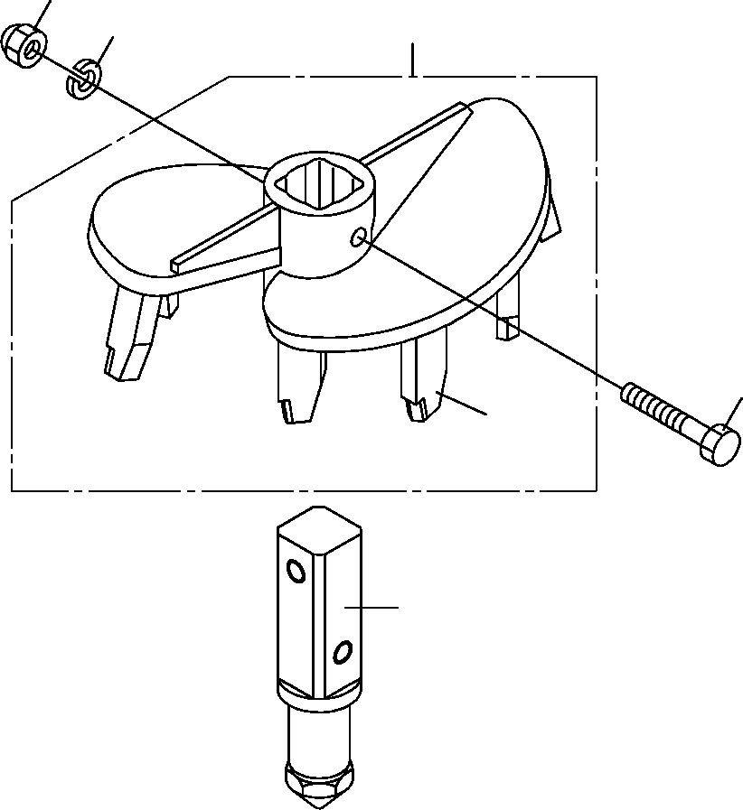
DT-600-2-00001 UPPER
PP2170003-01 HEAD,AUGER (450.F/OPTION)
4
5
1
3
15
2

DT-600-2-00001 UPPER
000105
Pos No.

Parts No
Parts Name
Qty
Unit
Technical Data
Serial No (Start)
Serial No (End)
Remarks
Pa

1
2
3
4
5
15

32470771000
32470660020
90101218110
90240201800
90302041801
32470770010
HEAD,AUGER BIT,CENTER BOLT NUT,CAP
WASHER,SPRING BIT,CUTTER
1
1
1
1
1
7

18

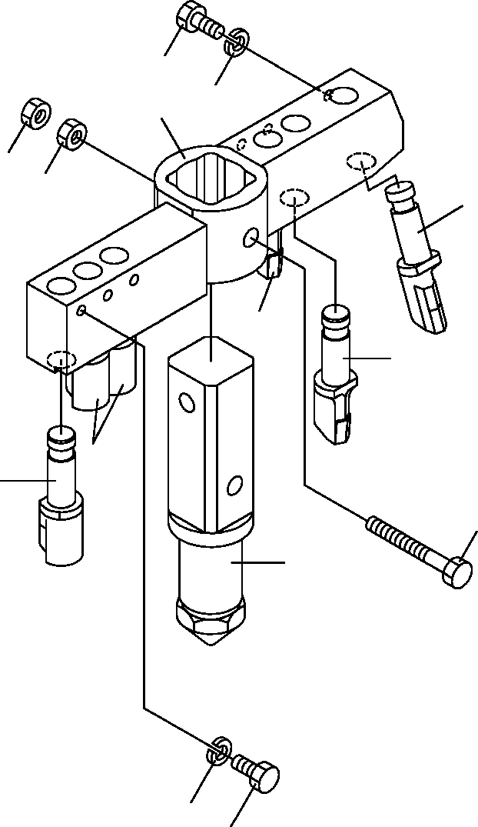
DT-600-2-00001 UPPER
PP2170004-02 HEAD,AUGER (550.R6/OPTION)
1
9
8
5
5
3
7
7
7
7
4
6
9
1

DT-600-2-00001 UPPER
000106
Pos No.

Parts No
Parts Name
Qty
Unit
Technical Data
Serial No (Start)
Serial No (End)
Remarks
Pa

1
3
4
5
6
7
8
9

90171110018
32470560040
37001502750
90201401800
32470560020
32470560010
32471130010
90302041001
BOLT BIT,CUTTER BOLT
NUT BIT,CENTER BIT,CUTTER SUPPORT
WASHER,SPRING
6
1
1
2
1
5
1
6

M10X18

M18X132 M18

10

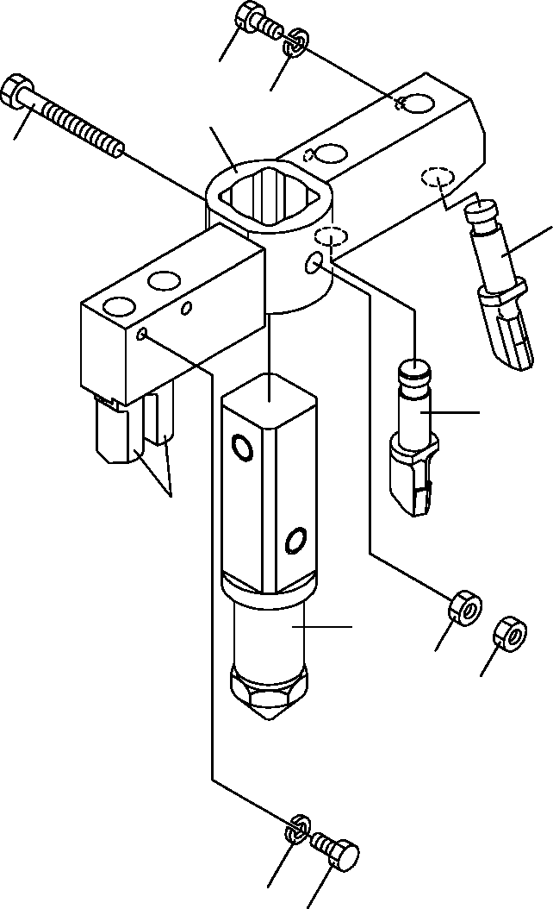
DT-600-2-00001 UPPER
PP2170005-02 HEAD,AUGER (R4/OPTION)
1
9
8
4
3
7
7
6
5
5
9
1

DT-600-2-00001 UPPER
000107
Pos No.

Parts No
Parts Name
Qty
Unit
Technical Data
Serial No (Start)
Serial No (End)
Remarks
Pa

1
3
4
5
6
7
8
9

90171110018
32470560040
37001502750
90201401800
32470560020
32470560010
32471230010
90302041001
BOLT BIT,CUTTER BOLT
NUT BIT,CENTER BIT,CUTTER SUPPORT
WASHER,SPRING
4
1
1
2
1
3
1
4

M10X18

M18X132 M18

10

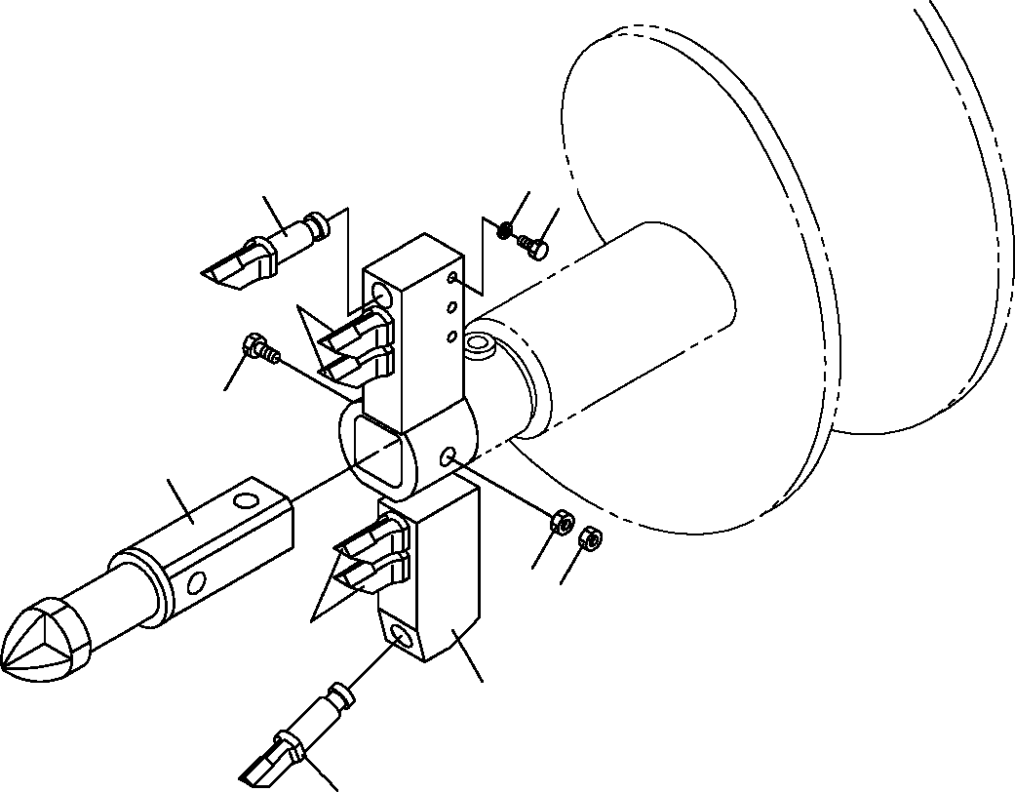
DT-600-2-00001 UPPER
PP2170006-01 HEAD,AUGER (400.R6)
9
7
1
7
4
6
5
5
7
8
3

DT-600-2-00001 UPPER
000108
Pos No.

Parts No
Parts Name
Qty
Unit
Technical Data
Serial No (Start)
Serial No (End)
Remarks
Pa

1
3
4
5
6
7
8
9

90171110018
32470560040
37001502750
90201401800
32470560020
32470560010
32471460010
90302041001
BOLT BIT,CUTTER BOLT
NUT BIT,CENTER BIT,CUTTER SUPPORT
WASHER,SPRING
6
1
1
2
1
5
1
6

M10X18

M18X132 M18

10

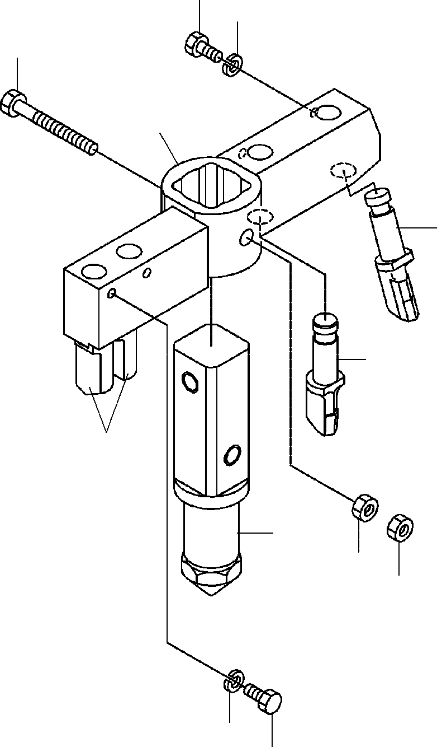
DT-600-2-00001 UPPER
PP2170008-01 HEAD,AUGER (300.R4)
1
9
4
8
3
7
7
6
5
5
9
1

DT-600-2-00001 UPPER
000109
Pos No.

Parts No
Parts Name
Qty
Unit
Technical Data
Serial No (Start)
Serial No (End)
Remarks
Pa

1
3
4
5
6
7
8
9

90171110018
32470560040
37001502750
90201401800
32470560020
32470560010
32471340010
90302041001
BOLT BIT,CUTTER BOLT
NUT BIT,CENTER BIT,CUTTER SUPPORT
WASHER,SPRING
4
1
1
2
1
3
1
4

M10X18

M18X132 M18

10

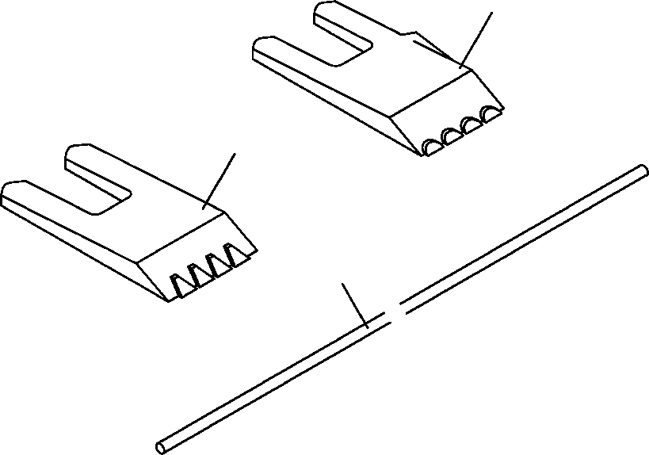
DT-600-2-00001 UPPER
PP2180000-01 TOOTH (PENGO.PH/OPTION)
1
2
3

DT-600-2-00001 UPPER
000110
Pos No.

Parts No
Parts Name
Qty
Unit
Technical Data
Serial No (Start)
Serial No (End)
Remarks

1
2
3

32470730100
32470730200
32470720800
TOOTH (PENGO.1658) TOOTH (PEBGO.1656) CUSHION
1
2
1

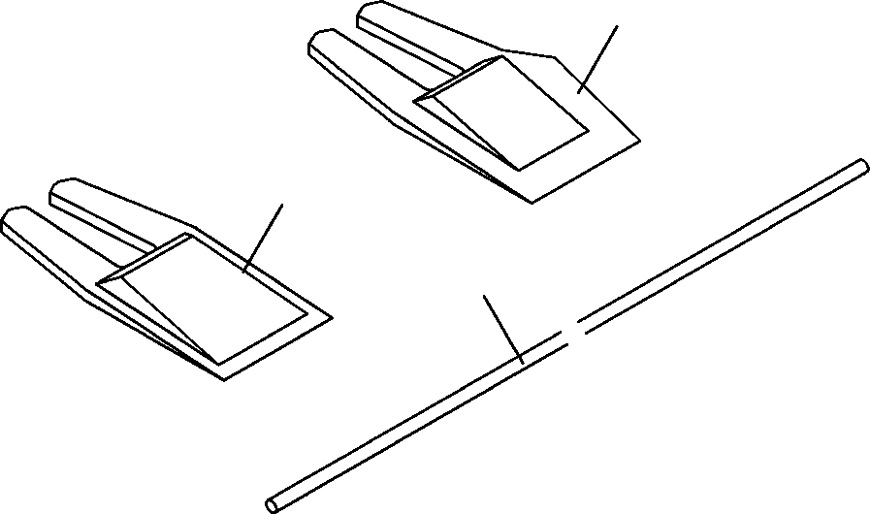
DT-600-2-00001 UPPER
PP2180001-01 TOOTH (PENGO,STD.P)/OPTION)
1
2
3

DT-600-2-00001 UPPER
000111
Pos No.

Parts No
Parts Name
Qty
Unit
Technical Data
Serial No (Start)
Serial No (End)
Remarks

1
2
3

32470720600
32470720700
32470720800
TOOTH (PENGO.1652) TOOTH (PENGO.1650) CUSHION
1
2
1

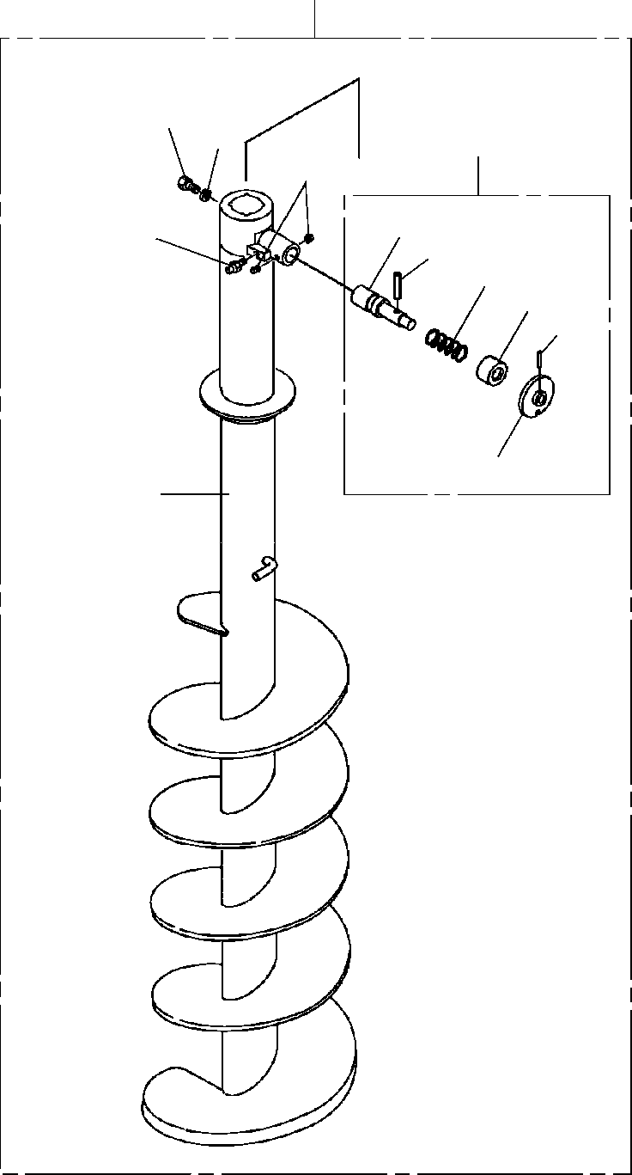
DT-600-2-00001 UPPER PS5040008-00 SCREW ASSY
100
12
13
3
6
31
14
34
32
33
36
35
16

DT-600-2-00001 UPPER
000112
Pos No.

Parts No
Parts Name
Qty
Unit
Technical Data
Serial No (Start)
Serial No (End)
Remarks
Pa

3
6
12
13
14
16
31
32
33
34
35
36
100

32490026000
90710006080
37001504060
90302041801
82456106000
32490022001
32490026100
37001200720
32490253510
80720106045
32490251200
80720105028
32490028031
PIN ASSY SCREW,SET BOLT WASHER,SPRING NIPPLE,GREASE SCREW
PIN SPRING GUIDE
PIN,SPRING GRIP PIN,SPRING SCREW ASSY
1
2
1
1
1
1
1
1
1
1
1
1
1

M6X8 18
1/4-28UNF

5X28

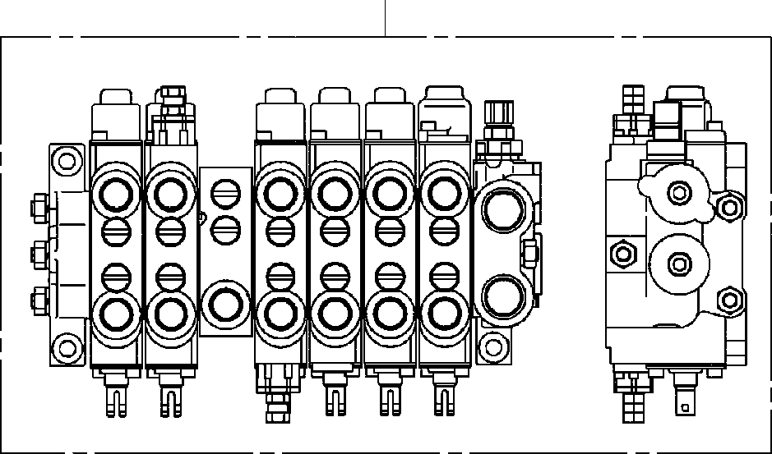
DT-600-2-00001 UPPER
PV5180003-00 VALVE ASSY,SELECTOR (MANUAL CONT.)
100

DT-600-2-00001 UPPER
000113
Pos No.

Parts No
Parts Name
Qty
Unit
Technical Data
Serial No (Start)
Serial

100

36638740000
VALVE ASSY,SELECTOR (MANUAL CONT.)
1

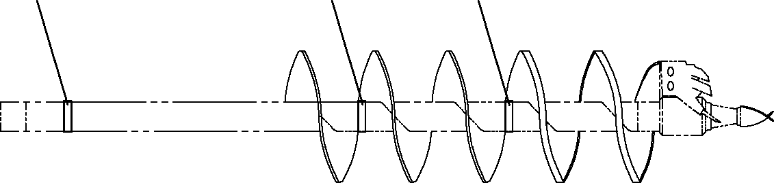
DT-600-2-00001 UPPER PX1940020-00 MOUNT (MARK)
1
1
1

DT-600-2-00001 UPPER
000114
Pos No.

Parts No
Parts Name
Qty
Unit
Technical Data
Serial No (Start)
Serial No (End)
Remarks
Pages
1

32472070100
SUPPORT
3

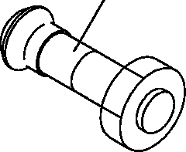
DT-600-2-00001 UPPER PX1940248-01 BOLT ASSY
1

DT-600-2-00001 UPPER
000115
Pos No.

Parts No
Parts Name
Qty
Unit
Technical Data
Serial No (Start)
Serial No (End)
Remarks
Pages
1

32470720200
32470720200
32470720200
BOLT ASSY BOLT ASSY BOLT ASSY
1
1
1

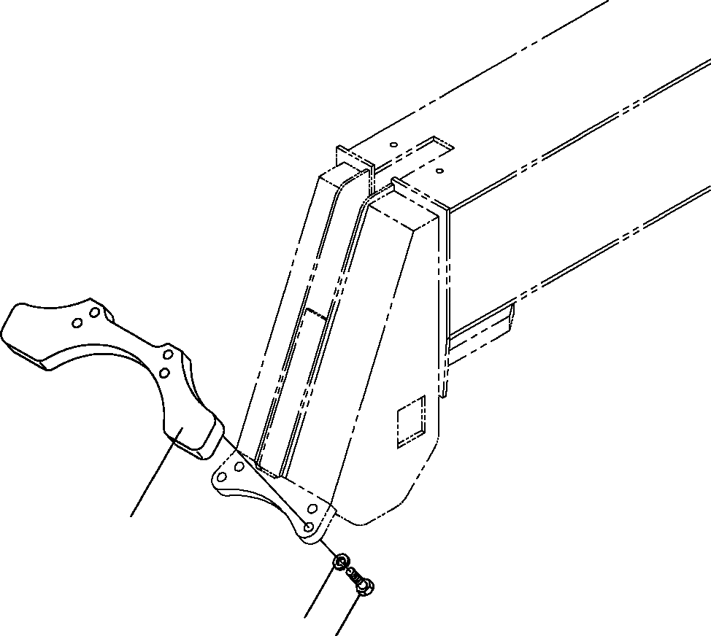
DT-600-2-00001 UPPER PY1040002-00 SUPPORT,POLE
1
4
3

DT-600-2-00001 UPPER
000116
Pos No.

Parts No
Parts Name
Qty
Unit
Technical Data
Serial No (Start)
Serial No (End)
Remarks
Pa

1
3
4

32470200010
90101514040
90302041401
SUPPORT BOLT
WASHER,SPRING
1
4
4

M14X40 14

