**DT-600-2-00001 UPPER**

PB1000102-02 HYDRAULIC PRESSURE GENERATING SYSTEM PD1000101-01 SWING SYSTEM

PE1000095-01 ELEVATING SYSTEM PF1000088-02 WINCH SYSTEM PG1000096-01 TELESCOPING SYSTEM PH1000095-00 SAFETY DEVICES PK1000103-01 FRAME

PL1000099-00 CONTROL DEVICES PN1000096-01 ELECTRIC EQUIPMENT PO1000123-00 INDICATION PLATES PP2000002-02 AUGER SYSTEM PY1000244-06 OPTIONS

ASSEMBLY

**000000**

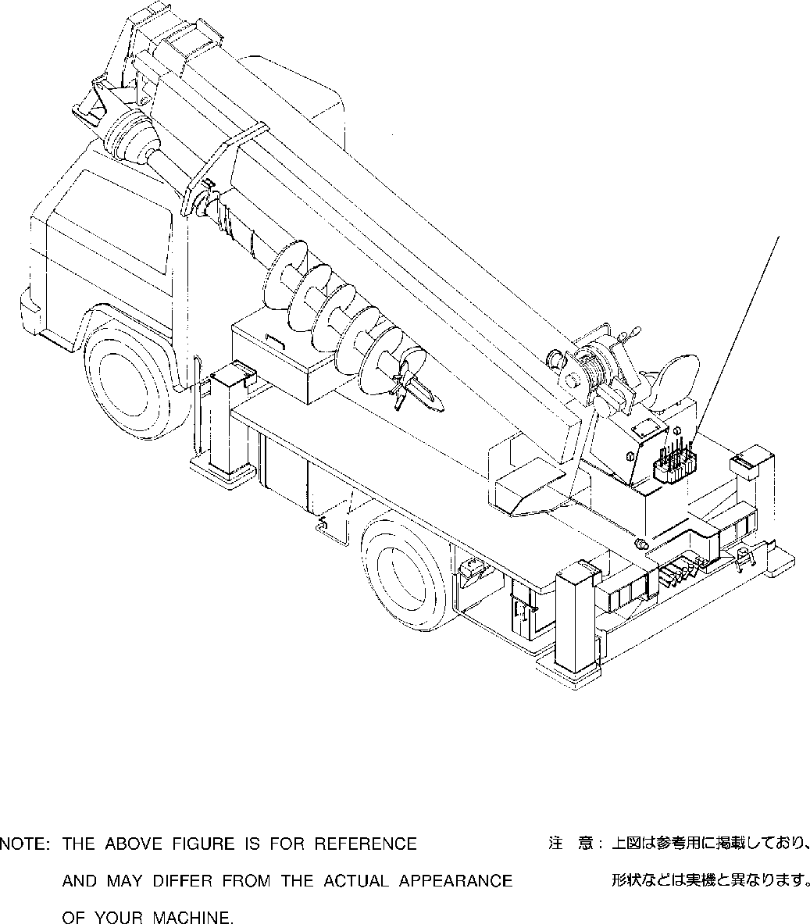

**DT-600-2-00001 UPPER**

**PB1000102-02 HYDRAULIC PRESSURE GENERATING SYSTEM**

**1**

**DT-600-2-00001 UPPER**

**000001**

Pos No.

Parts No

Parts Name

Qty

Unit

Technical Data

Serial No (Start)

Serial No (End)

Remar

1

(***********)

PIPING,HYDRAULIC UPPER

1

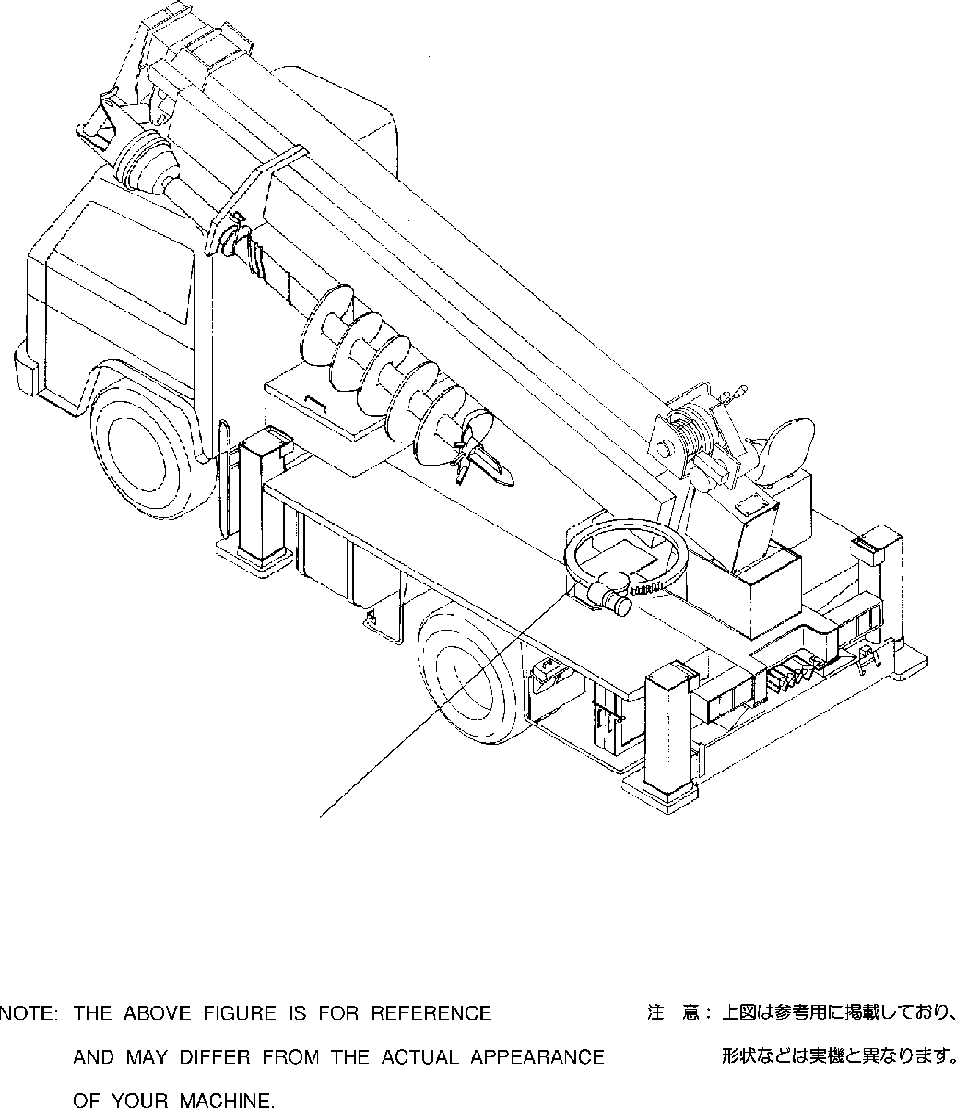

**DT-600-2-00001 UPPER PD1000101-01 SWING SYSTEM**

**1**

**DT-600-2-00001 UPPER**

**000002**

Pos No.

Parts No

Parts Name

Qty

Unit

Technical Data

Serial No (Start)

Serial No (End)

Remarks

1

(***********) (***********)

REDUCER,SWING SPEED REDUCER,SWING SPEED

1

1

275194

275193

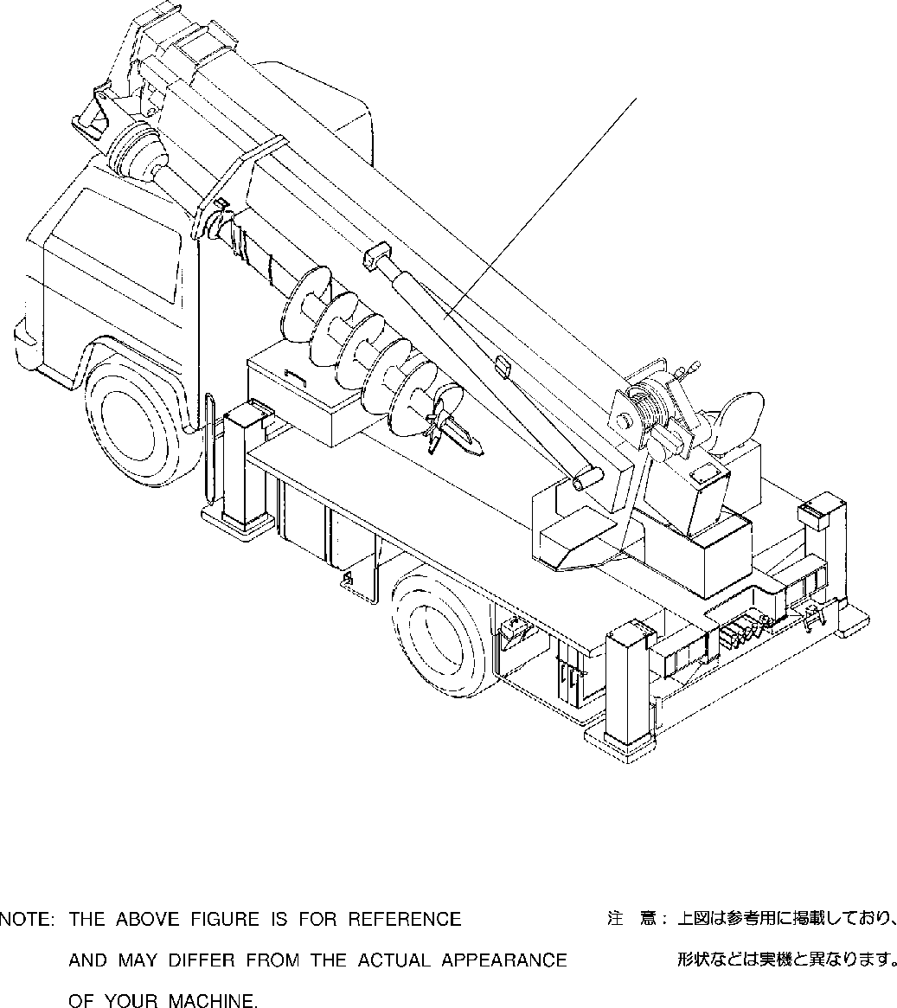

**DT-600-2-00001 UPPER**

**PE1000095-01 ELEVATING SYSTEM**

**1**

**DT-600-2-00001 UPPER**

**000003**

Pos No.

Parts No

Parts Name

Qty

Unit

Technical Data

Serial No (Start)

Serial No (End)

Remarks

1

(***********)

CYLINDER,ELEVATING

1

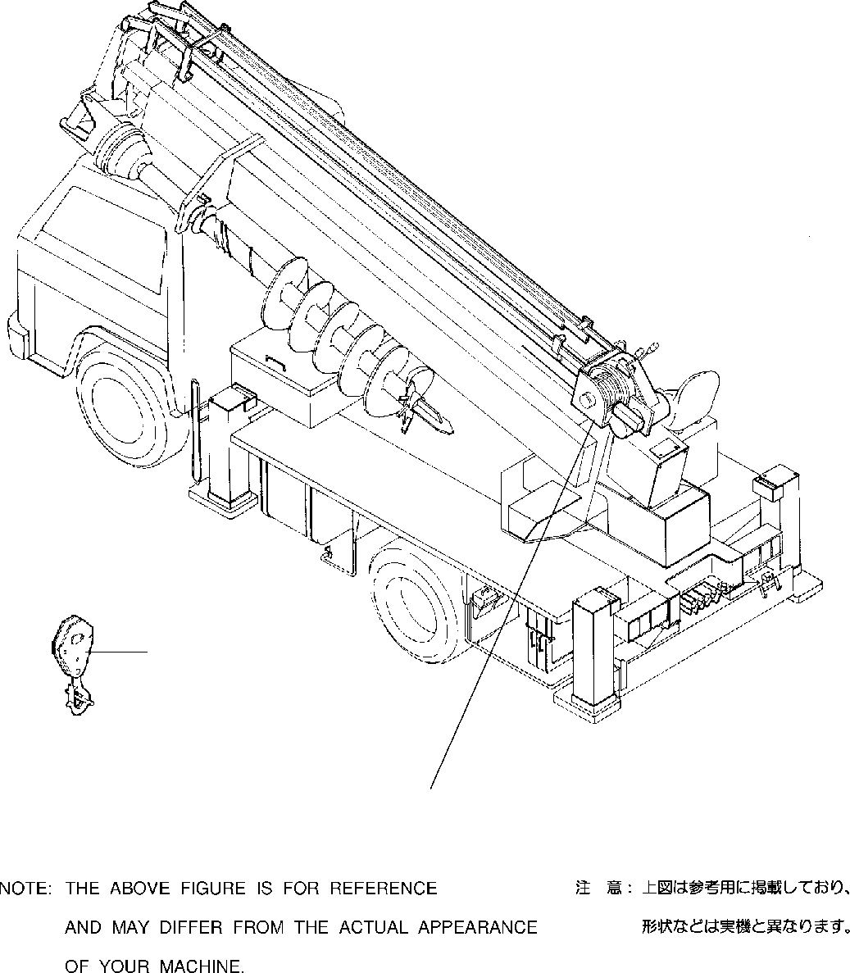

**DT-600-2-00001 UPPER PF1000088-02 WINCH SYSTEM**

**1**

**2**

**DT-600-2-00001 UPPER**

**000004**

Pos No.

Parts No

Parts Name

Qty

Unit

Technical Data

Serial No (Start)

Serial No (End)

Remarks

Page 00002

00002

00002

00003

1

2

(***********) 32290040000

(***********) (***********)

HOOK HOOK HOOK

MOUNT,WINCH

1

1

1

1

275088

275213

275087

275212

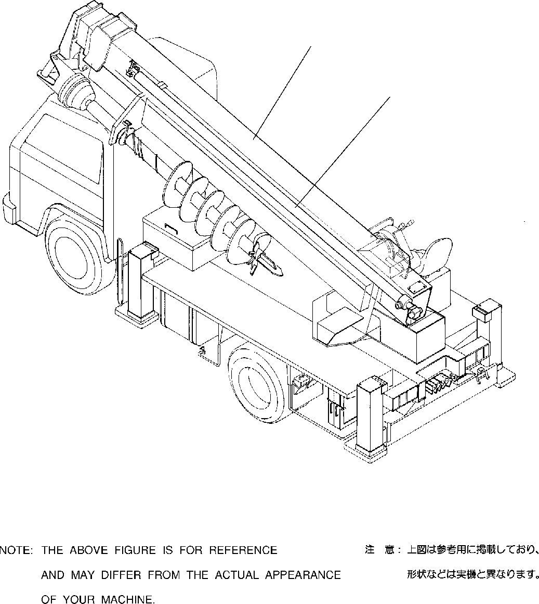

**DT-600-2-00001 UPPER**

**PG1000096-01 TELESCOPING SYSTEM**

**1**

**2**

**DT-600-2-00001 UPPER**

**000005**

Pos No.

Parts No

Parts Name

Qty

Unit

Technical Data

Serial No (Start)

Serial No (End)

R

1

2

(***********) (***********) (***********)

BOOM BOOM

CYLINDER ASSY,TELESCOPING

1

1

1

275213

275212

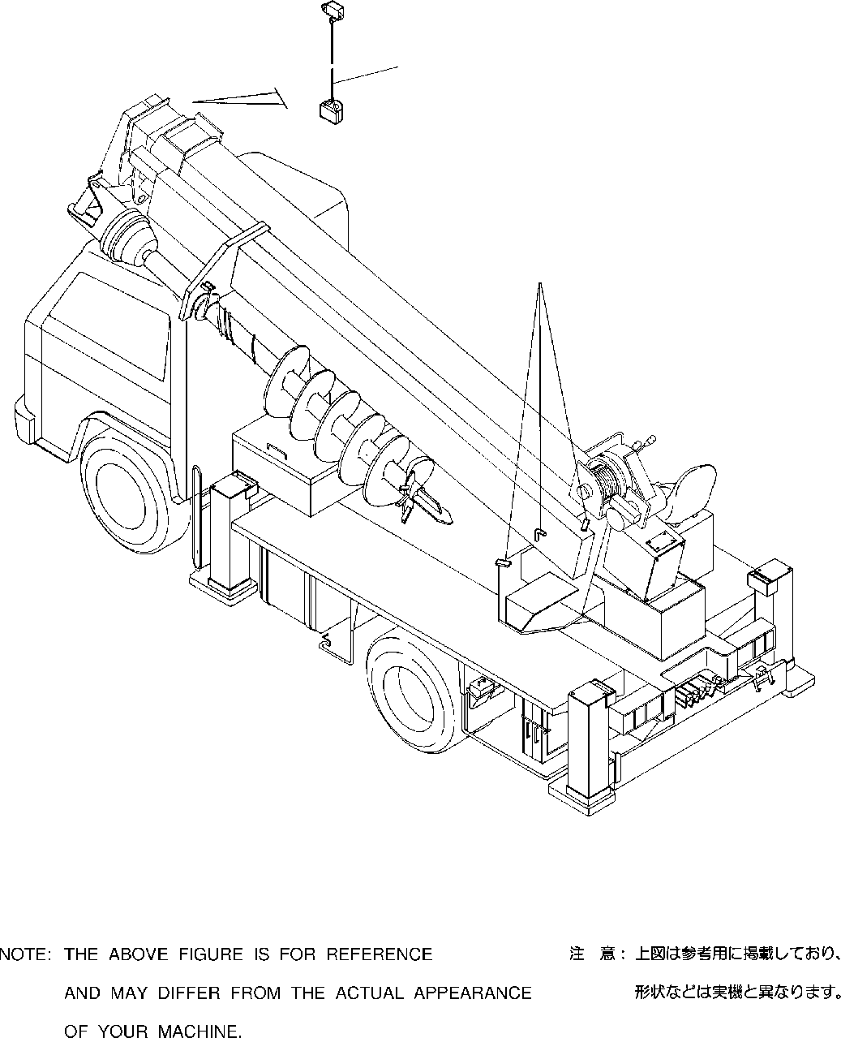

**DT-600-2-00001 UPPER PH1000095-00 SAFETY DEVICES**

**1**

**2**

**DT-600-2-00001 UPPER**

**000006**

Pos No.

Parts No

Parts Name

Qty

Unit

Technical Data

Serial No (Start)

Serial No (End)

R

1

2

(***********) (***********) (***********) (***********)

DETECTOR,OVER WINDING INDICATOR ASSY,OVERWIND DETECTOR,OVER FRONT AREA DETECTOR,OVER FRONT AREA

1

1

1

1

275054

275194

275053

275193

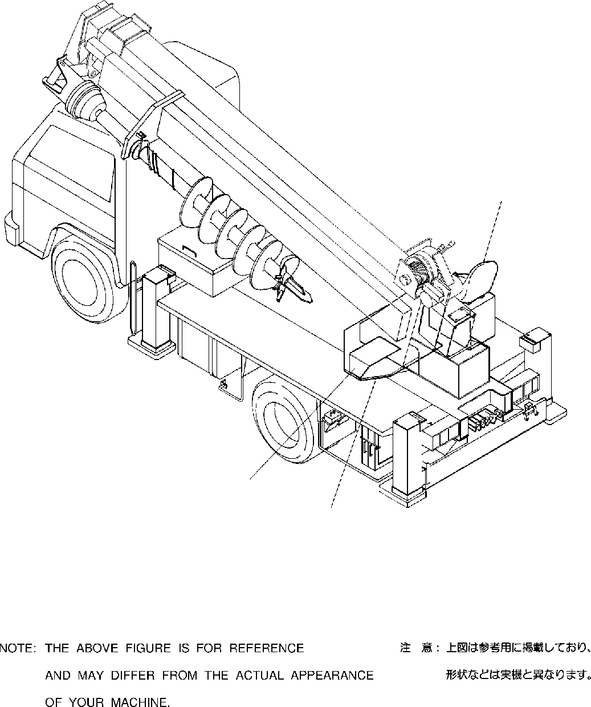

**DT-600-2-00001 UPPER PK1000103-01 FRAME**

**2**

**3**

**1**

**DT-600-2-00001 UPPER**

**000007**

Pos No.

Parts No

Parts Name

Qty

Unit

Technical Data

Serial No (Start)

Serial No (End)

Remarks

1

2

3

(***********) (***********) (***********) (***********)

SWING FRAME SWING FRAME SWING TABLE

COVER,SWING FRAME

1

1

1

1

275194

275193

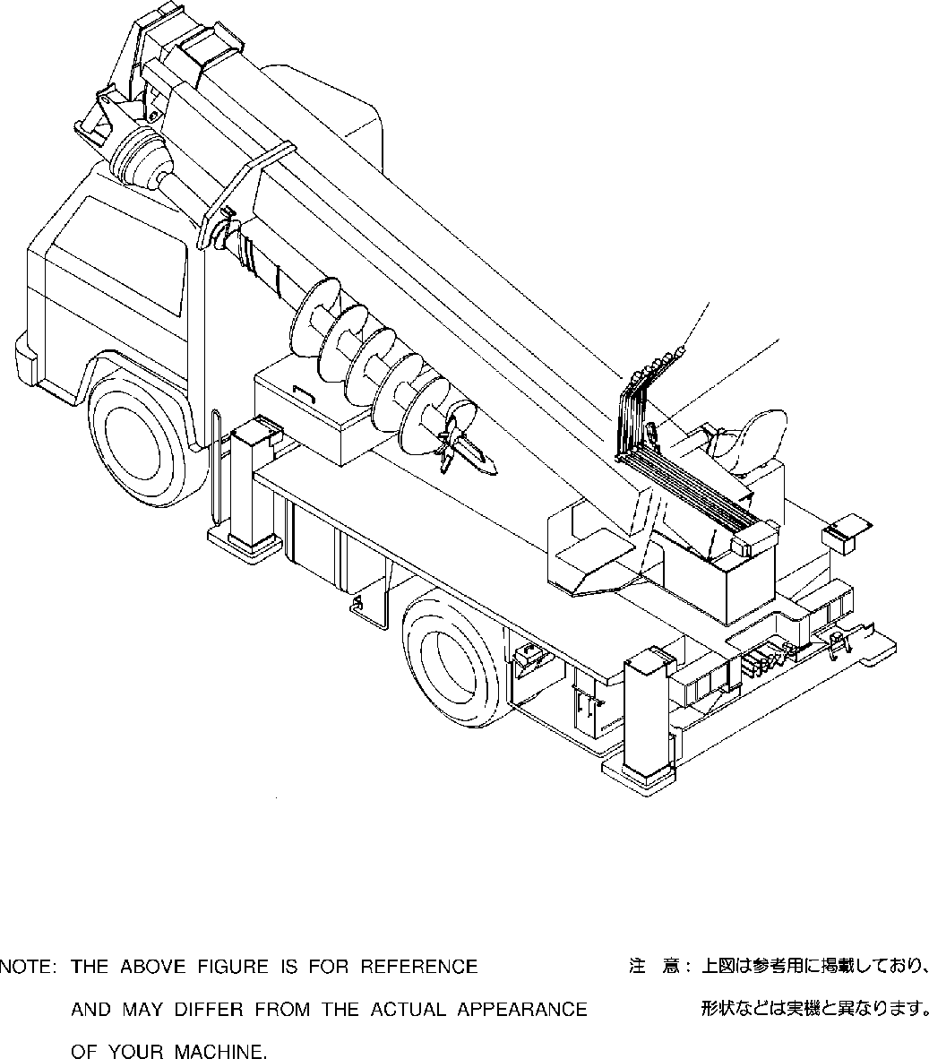

**DT-600-2-00001 UPPER PL1000099-00 CONTROL DEVICES**

**1**

**2**

**DT-600-2-00001 UPPER**

**000008**

Pos No.

Parts No

Parts Name

Qty

Unit

Technical Data

Serial No (Start)

Serial No (

1

2

(***********) (***********)

OPERATION SYSTEM, CONTROL VALVE OPERATION SYSTEM, ACCELERATOR

1

1

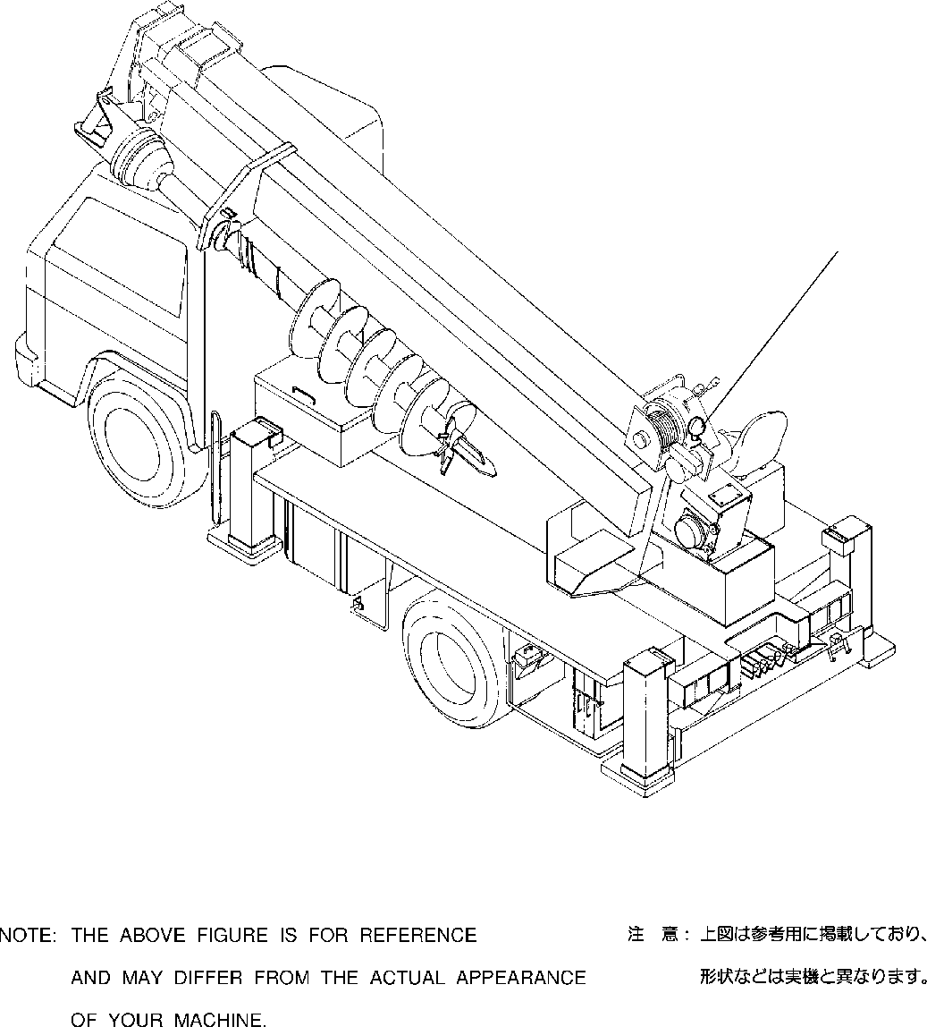

**DT-600-2-00001 UPPER**

**PN1000096-01 ELECTRIC EQUIPMENT**

**1**

**DT-600-2-00001 UPPER**

**000009**

Pos No.

Parts No

Parts Name

Qty

Unit

Technical Data

Serial No (Start)

Serial No (End)

Rema

1

(***********)

ELECTRICAL ACCESSORIES

1

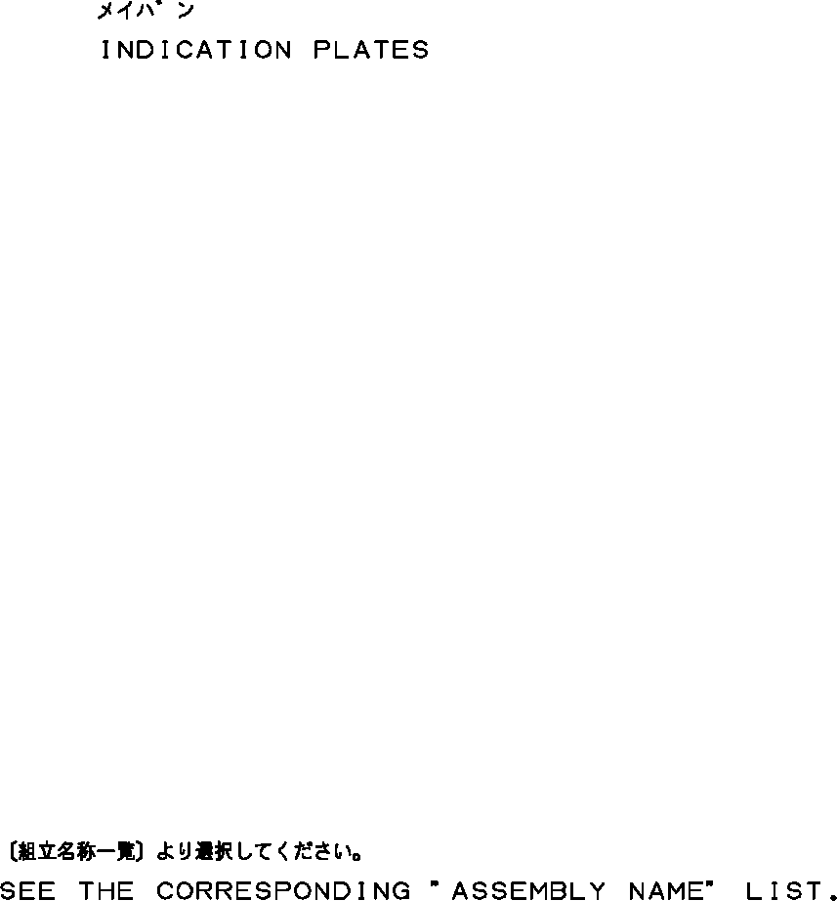

**DT-600-2-00001 UPPER**

**PO1000123-00 INDICATION PLATES**

**DT-600-2-00001 UPPER**

**000010**

Pos No.

Parts No

Parts Name

Qty

Unit

Technical Data

Serial No (Start)

Serial No (End)

Remarks

1

2

(***********) (***********)

PLATE,INDICATION PLATE ASSY,NAME (OIL)

1

1

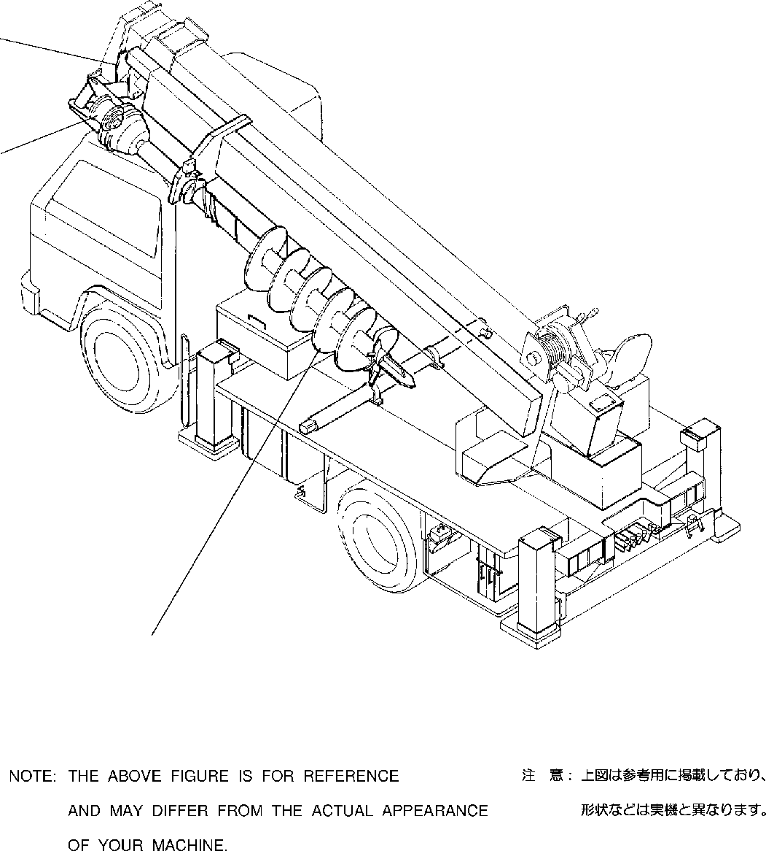

**DT-600-2-00001 UPPER PP2000002-02 AUGER SYSTEM**

**3**

**2**

**1**

**DT-600-2-00001 UPPER**

**000011**

Pos No.

Parts No

Parts Name

Qty

Unit

Technical Data

Serial No (Start)

Serial No (End)

Remarks

Pa 00

00

00

00

00

00

00

00

00

00

00

00

00

1

2

3

(***********) (***********) (***********) (***********) (***********) (***********) (***********) (***********) (***********) (***********) (***********) (***********) (***********)

AUGER (450,P) AUGER (300.PENGO) AUGER (250.PENGO) AUGER (350.PENGO) AUGER (400.PENGO) AUGER (200)

AUGER (300)

AUGER (450)

AUGER (450) MOUNT,AUGER MOUNT,AUGER MOUNT,AUGER PIPING,AUGER

1

1

1

1

1

1

1

1

1

1

1

1

1

275203

275203

275203

275203

275203

275687

275697

275700

275203

275213

275696

275696

275696

275696

275696

275696

275699

275202

275212

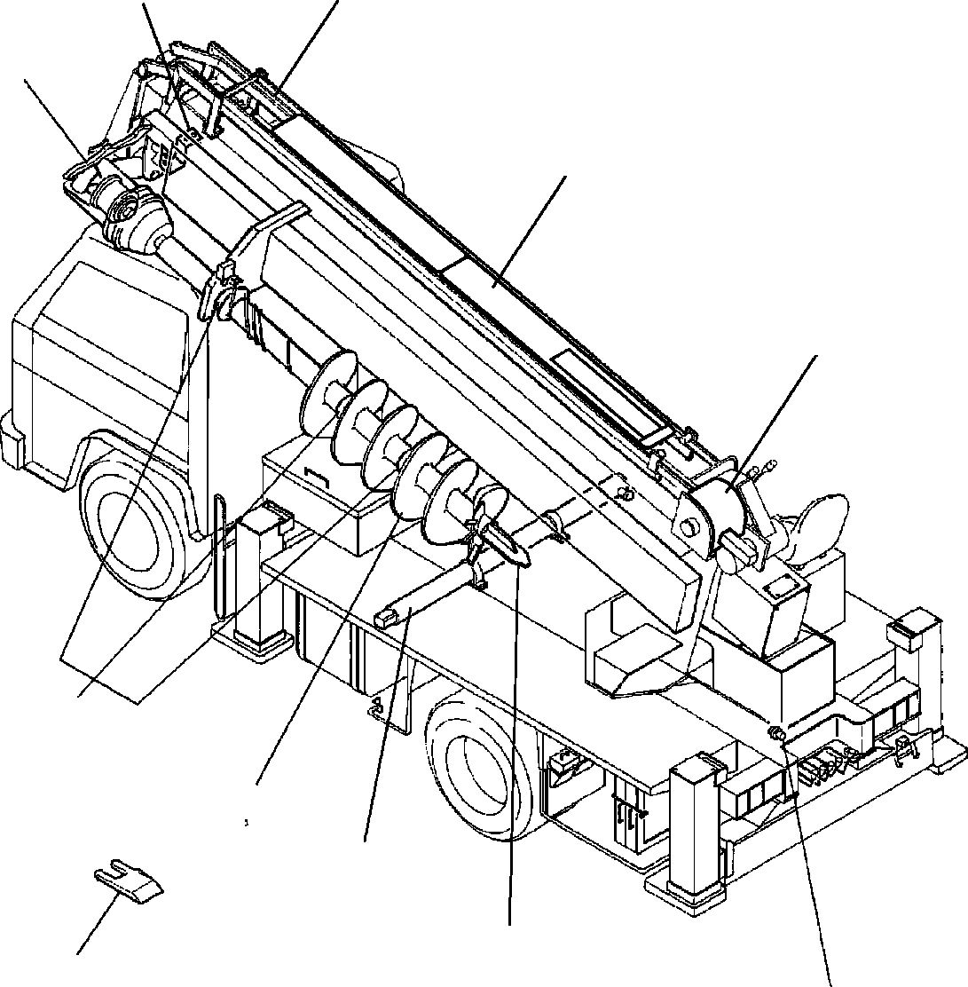

**DT-600-2-00001 UPPER PY1000244-06 OPTIONS**

**8**

**13**

**6**

**10**

**9**

**21**

**1 2**

**3**

**4**

**5**

**7**

**DT-600-2-00001 UPPER**

**000012**

Pos No.

Parts No

Parts Name

Qty

Unit

Technical Data

Serial No (Start)

Seria

1

2

3

4

5

6

7

8

9

10

13

21

(***********) (***********) (***********) (***********) (***********) 32471060000

(***********) (***********) (***********) (***********) (***********) (***********) 32490020100

(***********) (***********) (***********) (***********) (***********) (***********) (***********) (***********) (***********) 32470650000

(***********) (***********) (***********) (***********) (***********) (***********) (***********) (***********) (***********) (***********) (***********) (***********) (***********) (***********) (***********) (***********)

AUGER (300.PENGO) AUGER (600.OPTION) AUGER (400.R6,OPTION) AUGER (250.PENGO) AUGER (450,OPTION)

AUGER (650.S-TYPE,OPTION) AUGER (200)

AUGER (400.PENGO) AUGER (350.PENGO)

DRILL,AUGER (OPTION.450 R6) DRILL,AUGER (OPTION.450 R4) DRILL,AUGER (OPTION.450 R7) DRILL,AUGER (450 S) DRILL,AUGER (OPTION) DRILL,AUGER (OPTION.200 R2) DRILL,AUGER (OPTION) DRILL,AUGER (OPTION.450 R7) DRILL,AUGER (OPTION) SHAFT,AUGER (1.7M,OPTION) SHAFT,AUGER (2M,OPTION) HEAD,AUGER (450.D) HEAD,AUGER (R4/OPTION) HEAD,AUGER (450.DW) (OPTION) HEAD,AUGER (PENGO,450.PH) HEAD,AUGER (450.F/OPTION) HEAD,AUGER (550.R6/OPTION) HEAD,AUGER (400.R6) HEAD,AUGER (300.R4)

TOOTH (PENGO.PH/OPTION) TOOTH (PENGO,STD.P)/OPTION) SUPPORT,POLE

VALVE,MANUAL CONTROL (RELIEF VALVE) GUARD,WIRE (OPTION)

GUARD,WIRE (OPTION) GUARD,WIRE (OPTION) COVER (WINCH)

COVER (WIRE GUARD:2 PCS) GUARD ASSY

MOUNT (MARK)

1

1

1

1

1

1

1

1

1

1

1

1

1

1

1

1

1

1

1

1

1

1

1

1

1

1

1

1

1

1

1

1

1

1

1

1

1

1

1

275417

**DT-600-2-00001 UPPER**

PB1320073-01 VALVE,MANUAL CONTROL

PB1320168-00 VALVE,MANUAL CONTROL (RELIEF VALVE) PB1400045-02 PIPING,HYDRAULIC UPPER

PC5680001-00 COUPLING (AUGER/SHAFT) PD1010016-00 REDUCER,SWING SPEED PD1010084-00 REDUCER,SWING SPEED PD1010149-00 REDUCER,SWING SPEED PE1010041-03 CYLINDER,ELEVATING PF1010020-00 WINCH

PF1050040-01 HOOK PF1050042-00 HOOK PF1050042-00 HOOK PF1050059-00 HOOK

PF1050101-00 HOOK (SHEAVE 1 PC) PF1050201-01 HOOK

PF1070005-00 ROPE,WIRE PF1070005-00 ROPE,WIRE PF1400040-01 MOUNT,WINCH

PF1420001-00 GUARD,WIRE (OPTION) PF1420007-00 GUARD,WIRE (OPTION) PF1420008-00 GUARD,WIRE (OPTION) PG1010090-02 BOOM

PG1010383-05 BOOM

PG1050042-05 CYLINDER ASSY,TELESCOPING PG5200002-01 GUARD ASSY

PH1060036-02 DETECTOR,OVER WINDING PH1100006-00 DETECTOR,OVER FRONT AREA PH1100039-00 DETECTOR,OVER FRONT AREA PI1010011-01 MOTOR,HYDRAULIC (SWING) PI1010145-00 MOTOR,HYDRAULIC

PI1060001-00 CYLINDER,BRAKE PI1100006-01 VALVE,RELIEF PI1100008-01 VALVE,RELIEF PI1120034-01 VALVE,SOLENOID PI1140010-00 VALVE,CHECK

PI1250035-00 VALVE,COUNTERBALANCE PI1250063-00 VALVE,COUNTERBALANCE PI1250105-01 VALVE,COUNTERBALANCE PI1440007-00 METER,LOAD

PI5070003-00 INDICATOR ASSY,OVERWIND PK1100046-00 SWING FRAME

PK1100191-01 SWING FRAME PK1120052-03 SWING TABLE PK1200137-00 COVER,SWING FRAME PK1330253-00 COVER (WINCH)

PK1330414-00 COVER (WIRE GUARD:2 PCS) PL1010079-02 OPERATION SYSTEM, CONTROL VALVE PL1030067-02 OPERATION SYSTEM, ACCELERATOR PN1010184-03 ELECTRICAL ACCESSORIES PN1350070-02 REEL,CORD

PO1010166-02 PLATE,INDICATION PO1012579-01 PLATE ASSY,NAME (OIL) PP2010000-02 AUGER

PP2010002-02 AUGER (450,OPTION) PP2010009-03 AUGER (250.PENGO) PP2010010-01 AUGER (650.S-TYPE,OPTION) PP2010011-03 AUGER (300.PENGO) PP2010012-02 AUGER (400.PENGO) PP2010013-02 AUGER (350.PENGO) PP2010014-01 AUGER (200)

PP2010015-01 AUGER (600.OPTION) PP2010016-03 AUGER (450,P) PP2010017-00 AUGER

PP2010020-01 AUGER (400.R6,OPTION) PP2010027-02 AUGER (450)

PP2010030-00 AUGER (300)

PP2010031-00 AUGER (450) PP2020000-00 DRILL,AUGER (OPTION) PP2020001-00 DRILL,AUGER (OPTION)

PP2020005-02 DRILL,AUGER (OPTION.450 R6)

**000013**

**DT-600-2-00001 UPPER**

PP2020006-01 DRILL,AUGER (OPTION.450 R4) PP2020007-01 DRILL,AUGER (OPTION.200 R2) PP2020008-02 DRILL,AUGER (OPTION.450 R7) PP2020008-02 DRILL,AUGER (OPTION.450 R7) PP2020009-00 DRILL,AUGER (450 S) PP2020011-00 DRILL,AUGER (OPTION) PP2030000-01 DRIVING UNIT,AUGER PP2030002-02 DRIVING UNIT,AUGER PP2050002-01 MOUNT,AUGER

PP2050012-06 MOUNT,AUGER PP2050013-00 MOUNT,AUGER PP2050014-00 MOUNT,AUGER PP2050015-01 MOUNT,AUGER PP2100002-09 PIPING,AUGER PP2100009-00 PIPING,AUGER PP2100010-05 PIPING,AUGER

PP2150008-02 SHAFT,AUGER (2M,OPTION) PP2150012-02 SHAFT,AUGER (1.7M,OPTION) PP2170000-00 HEAD,AUGER (450.DW) (OPTION) PP2170001-02 HEAD,AUGER (PENGO,450.PH) PP2170002-01 HEAD,AUGER (450.D)

PP2170003-01 HEAD,AUGER (450.F/OPTION) PP2170004-02 HEAD,AUGER (550.R6/OPTION) PP2170005-02 HEAD,AUGER (R4/OPTION) PP2170006-01 HEAD,AUGER (400.R6) PP2170008-01 HEAD,AUGER (300.R4) PP2180000-01 TOOTH (PENGO.PH/OPTION) PP2180001-01 TOOTH (PENGO,STD.P)/OPTION) PS5040008-00 SCREW ASSY

PV5180003-00 VALVE ASSY,SELECTOR (MANUAL CONT.) PX1940020-00 MOUNT (MARK)

PX1940248-01 BOLT ASSY PY1040002-00 SUPPORT,POLE

**000013**

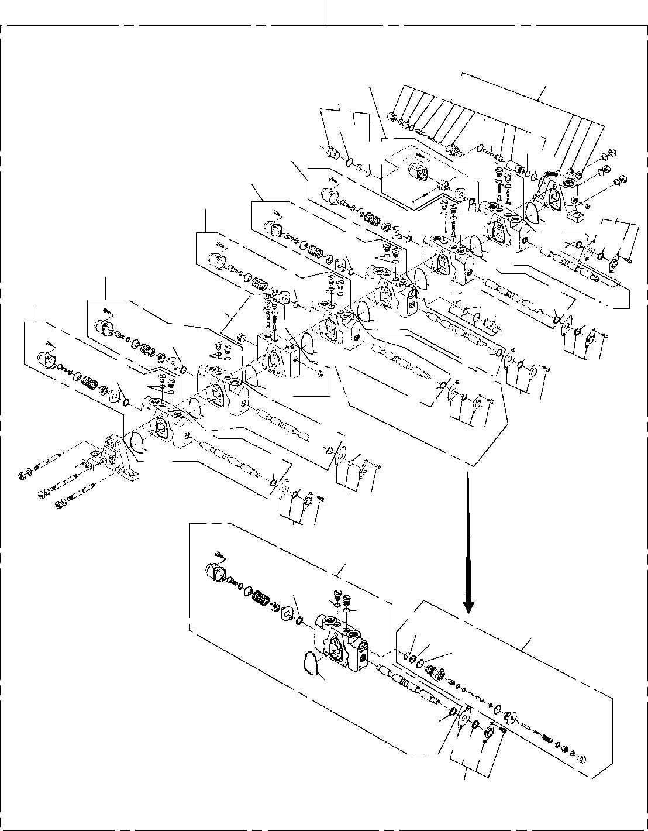

**DT-600-2-00001 UPPER**

**PB1320073-01 VALVE,MANUAL CONTROL**

**200**

**101**

**102**

**116**

**43**

**121**

**43**

**22**

**44**

**45**

**48**

**47**

**103**

**104**

**105**

**109**

**13**

**1522**

**21**

**15**

**15**

**1522**

**21**

**107**

**15**

**21**

**22**

**108**

**4544**

**15**

**106**

**13**

**43**

**21**

**22**

**116**

**13**

**15**

**22**

**21**

**15**

**13**

**15**

**109**

**22**

**21**

**15**

**109**

**21**

**15**

**13**

**109**

**109**

**13**

**21**

**15**

**109**

**104**

**15 22**

**22**

**45**

**110**

**4443**

**21**

**15**

**13**

**109**

**DT-600-2-00001 UPPER**

**000014**

Pos No.

Parts No

Parts Name

Qty

Unit

Technical Data

Serial No (Start)

Serial No (End

275087

275087

275087

275087

275087

3

13

15

21

22

43

44

45

47

48

101

102

103

104

105

106

107

108

109

110

116

121

200

36631065100

36631065110

36631065120

36631065120

36631065120

91001205500

91001205500

91001205500

91002801200

91002801200

91002801200

91001102100

91001102100

36631065130

36631065130

36631065140

36631065140

91001101600

91412001600

36631065010

36632045010

36631065030

36632285010

36632285010

36632045020

36631065060

36631065070

36631065150

36631065160

36631065090

36632285020

36631065080

36632280000

COVER,END SCRAPER RING,SEAL RING,SEAL RING,SEAL O-RING

O-RING O-RING O-RING O-RING O-RING O-RING O-RING

RING,BACKUP RING,BACKUP O-RING

O-RING O-RING

RING,BACKUP COVER ASSY (INLET)

VALVE,CONTROL (ATTACHMENT) VALVE,CONTROL (SWING) VALVE,CONTROL (ELEVATING) VALVE,CONTROL (ELEVATING) VALVE,CONTROL (TELESCOPE) VALVE,CHECK

VALVE,CONTROL (WINCH) VALVE,CONTROL (AUGER) CASE ASSY (SEAL) VALVE,RELIEF (175KG/CM2) PLUG ASSY

VALVE,RELIEF VALVE,MANUAL CONTROL

1

6

4

8

4

6

2

2

4

10

4

3

1

2

1

2

1

1

1

1

1

1

1

2

1

1

1

1

6

1

2

1

1

1A G55

1A G55

1A G55

1B P12

1B P12

1B P12

1A P21

1A P21

1A P16

275088

275088

275088

275088

275088

275088

275088

275088

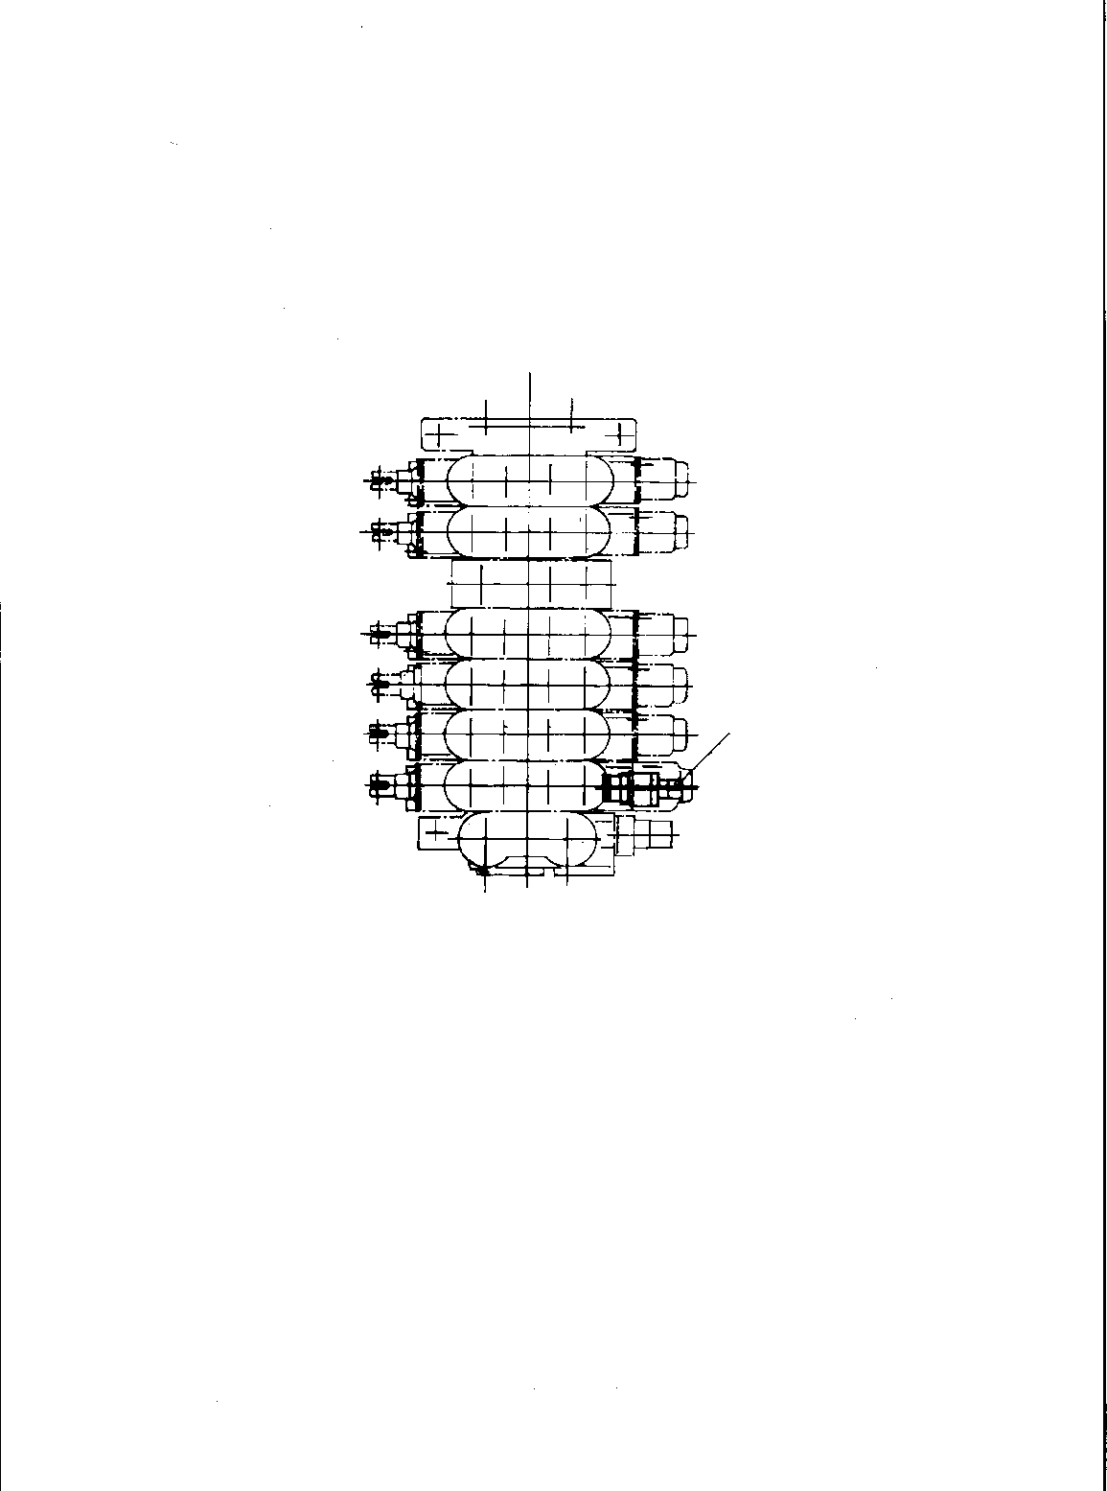

**DT-600-2-00001 UPPER**

**PB1320168-00 VALVE,MANUAL CONTROL (RELIEF VALVE)**

**1**

**DT-600-2-00001 UPPER**

**000015**

Pos No.

Parts No

Parts Name

Qty

Unit

Technical Data

Serial No (Start)

Serial No (End)

Remarks

Pages 00004

1

36601760000

VALVE,RELIEF

1

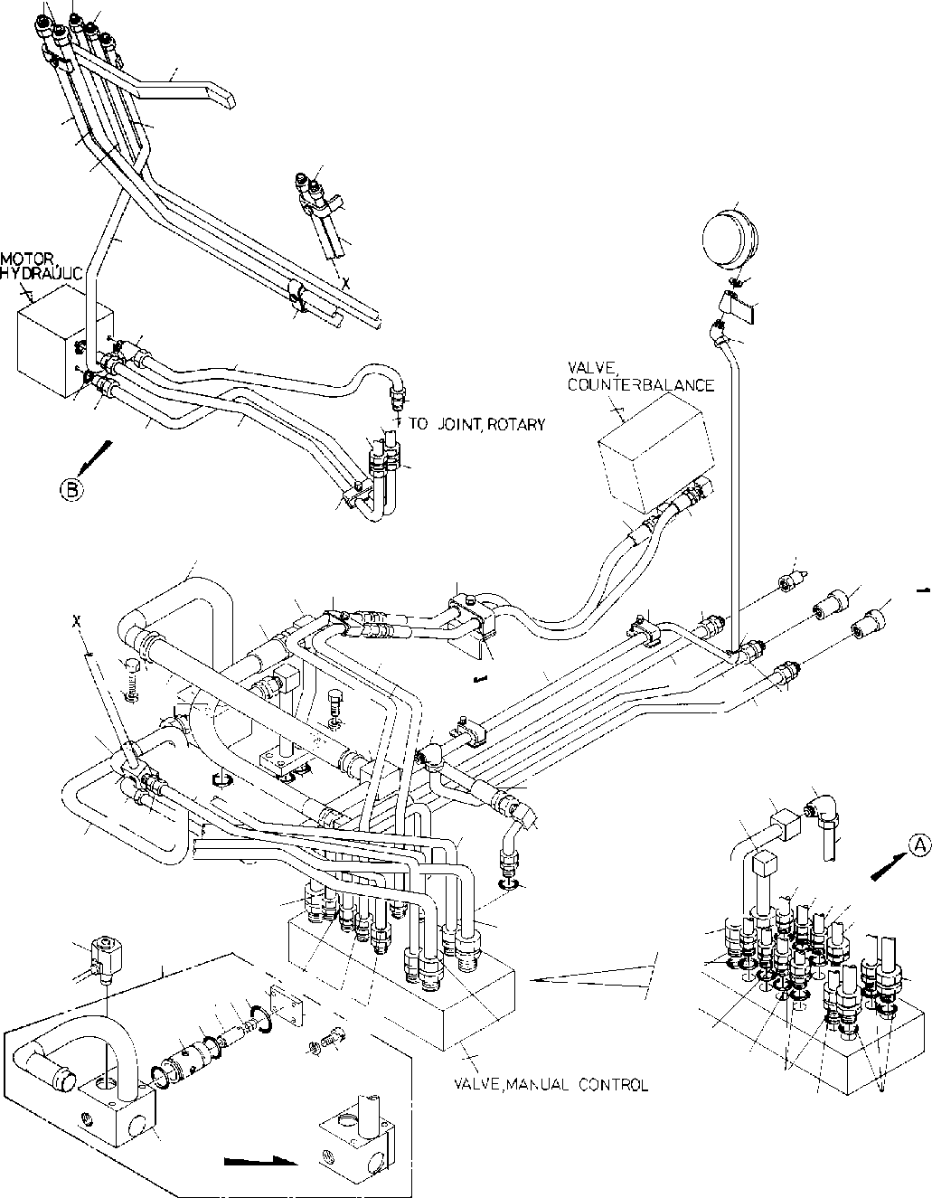

**DT-600-2-00001 UPPER**

**PB1400045-02 PIPING,HYDRAULIC UPPER**

**2**

**41**

**1**

**40**

**53**

**52**

**58**

**59**

**1**

**66**

**47**

**50**

**42**

**68**

**67**

**48**

**4**

**39**

**6**

**16**

**4443**

**11**

**10**

**3**

**5**

**45**

**21**

**62**

**22**

**18**

**23**

**38**

**17 17**

**63**

**29**

**71**

**64 16**

**32**

**69**

**25**

**13**

**12**

**20**

**70**

**19**

**26 2827**

**7**

**81**

**34**

**15**

**31**

**16**

**14**

**26**

**9**

**33**

**34**

**51**

**33**

**30**

**35**

**46**

**4849**

**24**

**37**

**50**

**14**

**36**

**56**

**55**

**8**

**1511**

**132**

**59**

**19**

**52**

**60**

**61**

**92**

**23**

**95969798**

**10**

**54**

**12**

**939493**

**58**

**53**

**1**

**10099**

**57**

**55**

**56**

**55**

**91**

**91**

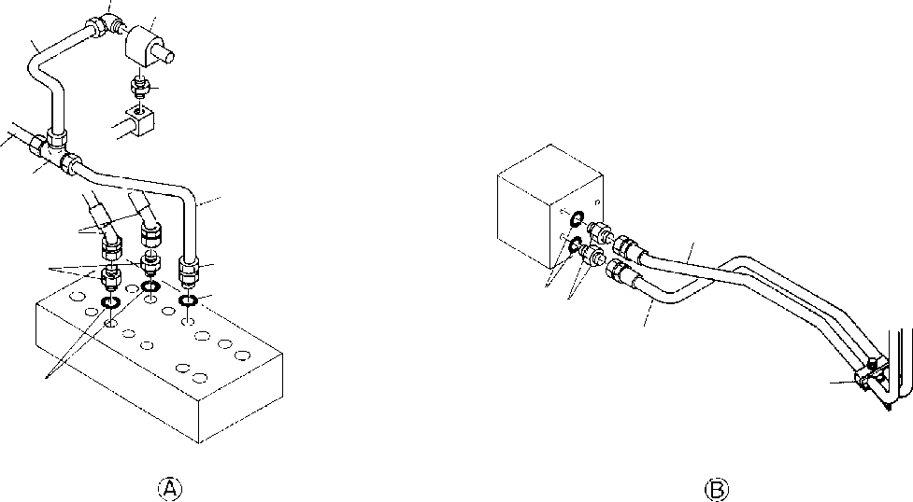

**DT-600-2-00001 UPPER**

**PB1400045-02 PIPING,HYDRAULIC UPPER**

**34**

**72**

**74**

**73**

**33**

**77**

**75**

**76**

**3**

**3**

**57**

**55**

**8078**

**4443**

**3**

**7962**

**55**

**DT-600-2-00001 UPPER**

**000016**

Pos No.

Parts No

Parts Name

Qty

Unit

Technical Data

Serial No (Start)

Serial No (End)

Rema

1

2

3

4

5

6

7

8

9

10

11

12

13

14

15

16

17

18

19

20

21

22

23

24

25

26

27

28

29

30

31

32

33

34

35

36

37

38

39

40

41

42

43

44

45

46

47

48

49

50

51

52

53

54

55

56

57

58

59

60

37000900110

37000910110

81408000160

37002428710

80305050100

81408000160

81408000160

80302010240

81408000241

80303030240

81408000160

81408000160

81408000160

81408000160

81408000160

81408000160

80302010160

80456010610

80456020610

81408000160

81408000130

37002417340

37002426570

37002417730

37002426580

32340188010

91001203500

90101510090

90302041001

37002502940

91801300480

32340180020

91002902500

90101510040

37002409350

37002425610

32340180030

80303030160

80303030160

80303030160

37002415480

37002404910

32340100050

32340180040

37000708060

37000708050

32340180050

37000900130

81408000160

80302090161

80400160129

91002801400

80301010100

32340180060

37000708040

80303030100

80302010200

81408000160

81408000210

81408000290

81408000290

80302090271

91002801800

80302090201

80302090151

80302090151

81408000160

81408000160

80302090281

JOINT JOINT PIPE,STEEL HOSE FITTING,TEE PIPE,STEEL PIPE,STEEL FITTING PIPE,STEEL

FITTING,ELBOW PIPE,STEEL PIPE,STEEL PIPE,STEEL PIPE,STEEL PIPE,STEEL PIPE,STEEL FITTING

JOINT,SELF SEALING JOINT,SELF SEALING PIPE,STEEL PIPE,STEEL

HOSE HOSE HOSE HOSE

VALVE ASSY O-RING BOLT

WASHER,SPRING HOSE

CLIP JOINT O-RING BOLT HOSE HOSE JOINT

FITTING,ELBOW FITTING,ELBOW FITTING,ELBOW HOSE

HOSE JOINT JOINT

CLAMP ASSY CLAMP ASSY CLAMP ASSY JOINT PIPE,STEEL FITTING JOINT

O-RING FITTING JOINT CLAMP ASSY

FITTING,ELBOW FITTING PIPE,STEEL PIPE,STEEL PIPE,STEEL PIPE,STEEL FITTING

O-RING FITTING FITTING FITTING PIPE,STEEL PIPE,STEEL FITTING

4

2

1

2

1

1

1

1

1

1

1

1

1

1

1

1

4

2

1

2

2

1

1

1

1

1

1

2

6

1

4

1

2

4

1

1

1

1

2

1

1

1

1

1

1

1

1

2

1

2

2

2

2

1

1

2

1

1

1

2

2

2

13

2

9

7

2

2

2

M

M M

M

M M M M M M

M M

M

M M M M

M M

12X1.4T L=1450 KTK12-030N 12X1.4T

12X1.4T

18X1.9T

12X1.4T

12X1.4T

12X1.4T

12X1.4T

12X1.4T

12X1.4T KCT12-030N

12X1.4T

10X1.8T L=750 L=750 L=825 L=825

1A G35 M10X90 10 L=450 D=43-48

1B G25 M10X40 L=530 L=530

KLN12-030N KLN12-030N KLN12-030N L=600 L=600

12X1.4T KCO12-030N

1B P14 KUA12-000N

KLN10-020N KCT15-040N 12X1.4T

15X2.0T

22X2.5T

22X2.5T KCO22-040N 1B P18 KCO15-040N KCO12-040N KCO12-040N 12X1.4T

12X1.4T KCO22-060N

275088

275041

275041

275034

275066

275088

275034

275088

275088

275087

275087

275087

275087

275040

275040

275033

275065

275087

275033

275087

275087

275087

275065

**DT-600-2-00001 UPPER**

**000016**

Pos No.

Parts No

Parts Name

Qty

Unit

Technical Data

Serial No (Start)

Serial No (End)

Rema

61

62

63

64

66

67

68

69

70

72

73

74

75

76

77

78

80

81

91

92

93

94

95

96

97

98

99

100

91002802400

37000708030

37000711090

37000714040

37000703420

37000700100

36681030000

32340180070

14115209000

91810130240

37000300740

36601080000

80306030040

81408000160

80305010100

81408000160

81408000160

80400160130

91810130250

37000300740

32340182000

36641460000

91001102600

32340182010

32340182020

59155306000

91001103600

32340182030

90131508025

90302040801

O-RING CLAMP ASSY CLAMP ASSY CLAMP ASSY CLAMP ASSY CLAMP ASSY METER,LOAD JOINT PACKING FASTENER SLEEVE VALVE,RELIEF JOINT,NIPPLE PIPE,STEEL FITTING,TEE PIPE,STEEL PIPE,STEEL JOINT FASTENER SLEEVE JOINT

VALVE,SOLENOID O-RING

SLEEVE VALVE SPRING O-RING COVER

BOLT,HEXAGON SOCKET WASHER,SPRING

2

1

1

1

1

2

1

1

3

1

1

1

1

1

1

1

1

2

2

1

1

1

2

1

1

1

1

1

4

4

1B P24

18X2

18X2

18-12

3/8

12X1.4T KTA12-000N 12X1.4T

12X1.4T S,G1/2-G3/8

18-12

1A P26

1A P36

M8X25 8

275088

275382

275066

275066

275066

275066

275066

275066

275088

275088

275294

275087

275381

275040

275087

275087

275087

275087

275087

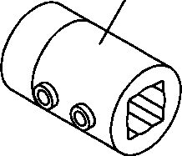

**DT-600-2-00001 UPPER**

**PC5680001-00 COUPLING (AUGER/SHAFT)**

**1**

**DT-600-2-00001 UPPER**

Rem

**000017**

Pos No.

Parts No

Parts Name

Qty

Unit

Technical Data

Serial No (Start)

Serial No (End)

1

32490520020

COUPLING (AUGER/SHAFT)

1

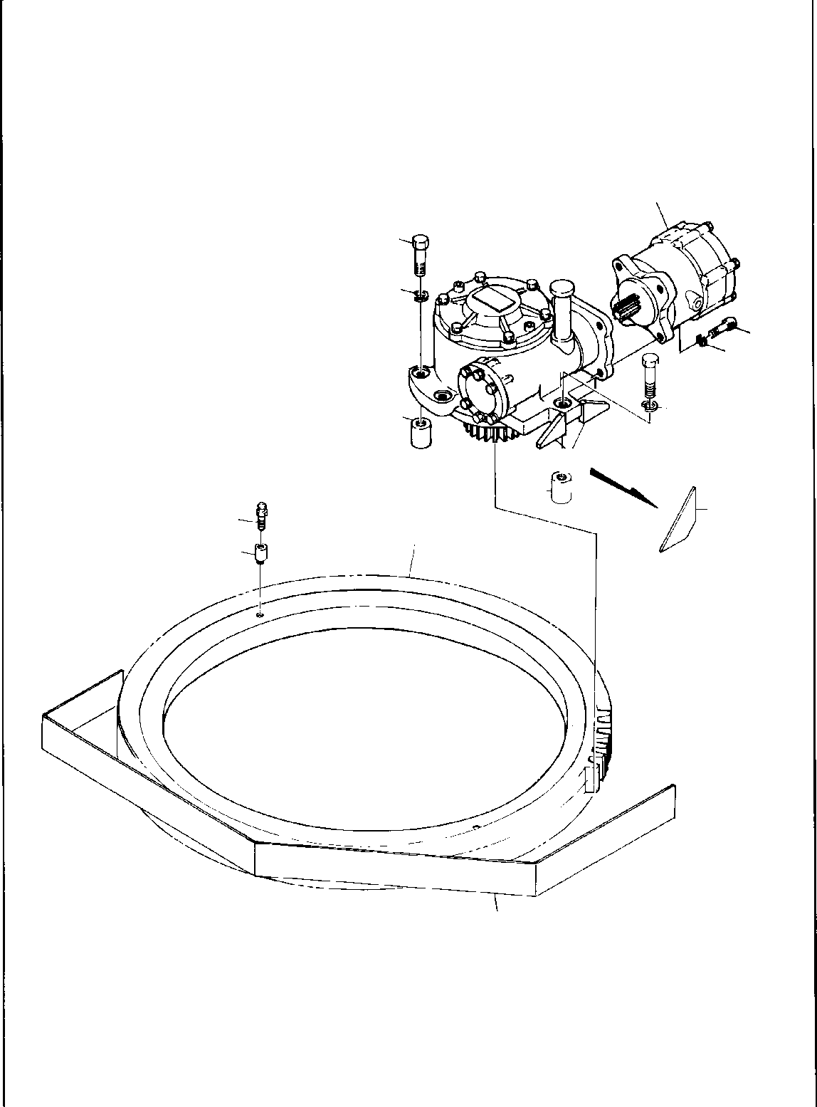

**DT-600-2-00001 UPPER**

**PD1010016-00 REDUCER,SWING SPEED**

**1**

**4**

**5**

**2**

**9**

**3**

**4**

**5**

**7**

**6**

**7**

**6**

**11**

**12**

**8**

**10**

**DT-600-2-00001 UPPER**

**000018**

Pos No.

Parts No

Parts Name

Qty

Unit

Technical Data

Serial No (Start)

Serial No (End)

Re

1

2

3

4

5

6

7

8

9

10

11

12

36660510000

90131512030

90302041201

90101514055

90302041401

32300000010

32300050030

32300050010

37002301350

36080250000

32300050020

82456101000

37000912420

MOTOR,HYDRAULIC (SWING) BOLT,HEXAGON SOCKET WASHER,SPRING

BOLT WASHER,SPRING PLATE

PLATE BOSS

BEARING,SWING REDUCER,SWING SPEED COVER

NIPPLE,GREASE JOINT

1

4

4

5

5

2

2

5

1

1

1

2

2

M12X30 12 M14X55 14

A-PT1/8

275023

275022

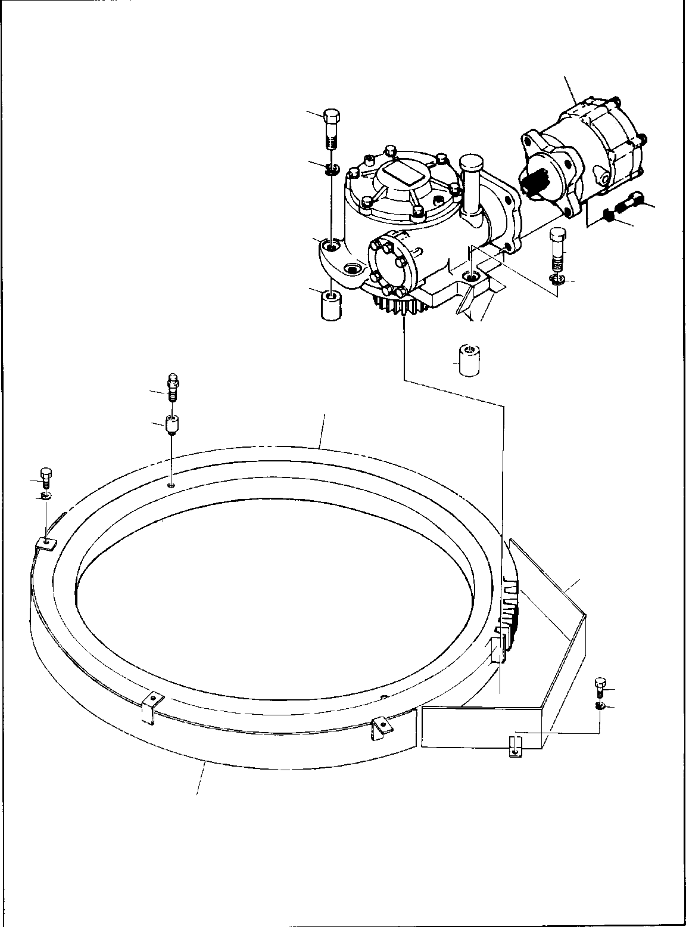

**DT-600-2-00001 UPPER**

**PD1010084-00 REDUCER,SWING SPEED**

**1**

**4**

**5**

**2**

**9**

**3**

**4**

**5**

**7**

**6**

**7**

**11**

**12**

**8**

**15**

**14**

**10**

**15**

**14**

**16**

**DT-600-2-00001 UPPER**

**000019**

Pos No.

Parts No

Parts Name

Qty

Unit

Technical Data

Serial No (Start)

Serial No (End)

Re

1

2

3

4

5

6

7

8

9

10

11

12

15

16

36660510000

90131512030

90302041201

90101514055

90302041401

32300050030

32300050010

37002302630

36080250000

32300190010

82456101000

37000912420

90302041001

32300190030

MOTOR,HYDRAULIC (SWING) BOLT,HEXAGON SOCKET WASHER,SPRING

BOLT WASHER,SPRING PLATE

BOSS BEARING,SWING

REDUCER,SWING SPEED COVER

NIPPLE,GREASE JOINT WASHER,SPRING COVER

1

4

4

5

5

2

5

1

1

1

2

2

5

1

M12X30 12 M14X55 14

A-PT1/8 10

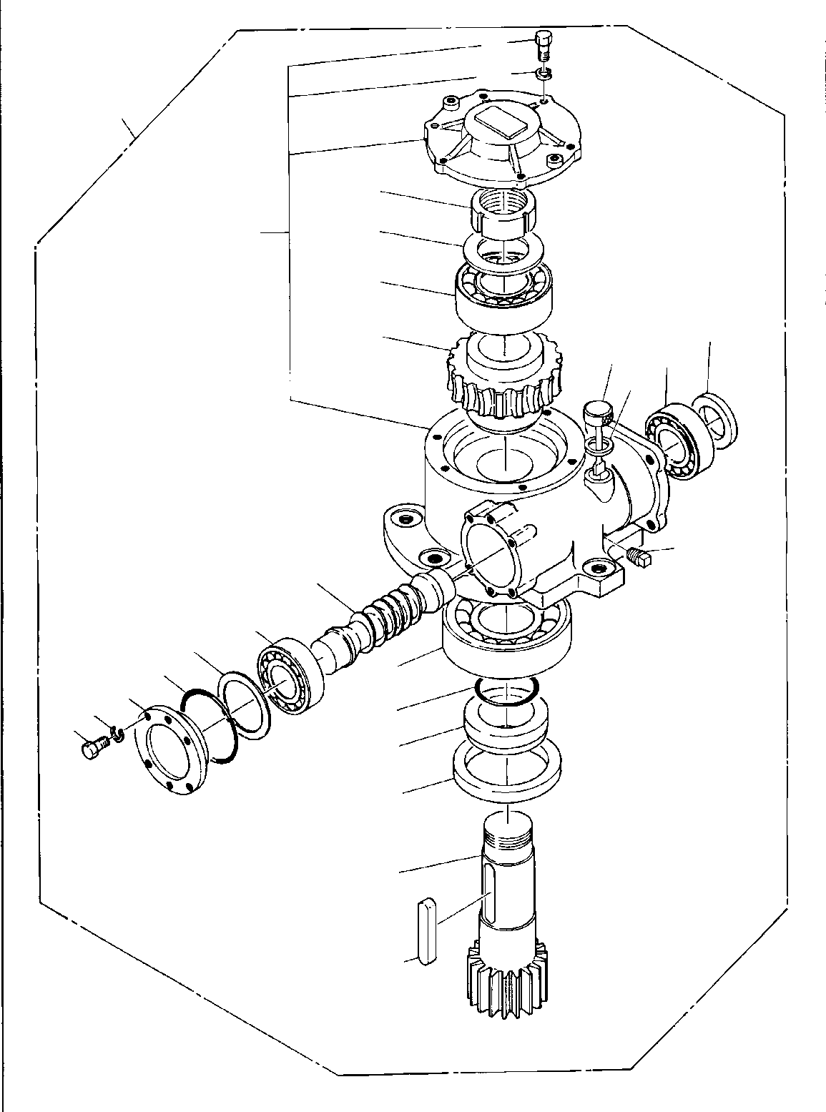

**DT-600-2-00001 UPPER**

**PD1010149-00 REDUCER,SWING SPEED**

**31**

**32**

**100**

**34**

**33**

**51**

**29**

**45**

**27**

**48**

**49**

**42**

**44**

**43**

**41**

**42**

**40**

**39**

**38**

**25**

**23**

**22**

**37**

**32**

**31**

**24**

**21**

**28**

**DT-600-2-00001 UPPER**

**000020**

Pos No.

Parts No

Parts Name

Qty

Unit

Technical Data

Serial No (Start)

Serial No (End)

Remar

21

22

23

24

25

27

28

29

31

32

33

34

37

38

39

40

41

42

43

44

45

48

49

51

100

36080205010

36080095020

91001207000

91216105001

80515006314

36080095040

36080095050

36080095130

90101510025

90302041001

80562100120

80561100120

12643302100

91001208500

12643302120

12643302130

12643302140

36080095120

36080095090

80205000200

36080095110

36080095072

36080235080

36080095150

36080250000

GEAR RING,SEAL O-RING SEAL,OIL

BEARING,BALL WHEEL,WORM KEY BEARING,BALL BOLT WASHER,SPRING WASHER,PLAIN NUT

RETAINER O-RING SHIM (T=0.1) SHIM (T=0.2) SHIM (T=0.3)

BEARING,ROLLER WORM

PLUG SEAL,OIL GAUGE,OIL WASHER,SEAL CASE ASSY

REDUCER,SWING SPEED

1

1

1

1

1

1

1

1

6

6

1

1

1

1

N N N 2

1

1

1

1

1

1

1

1A G70

M10X25 10 AW12 AN12

1A G85

PT1/4

M16

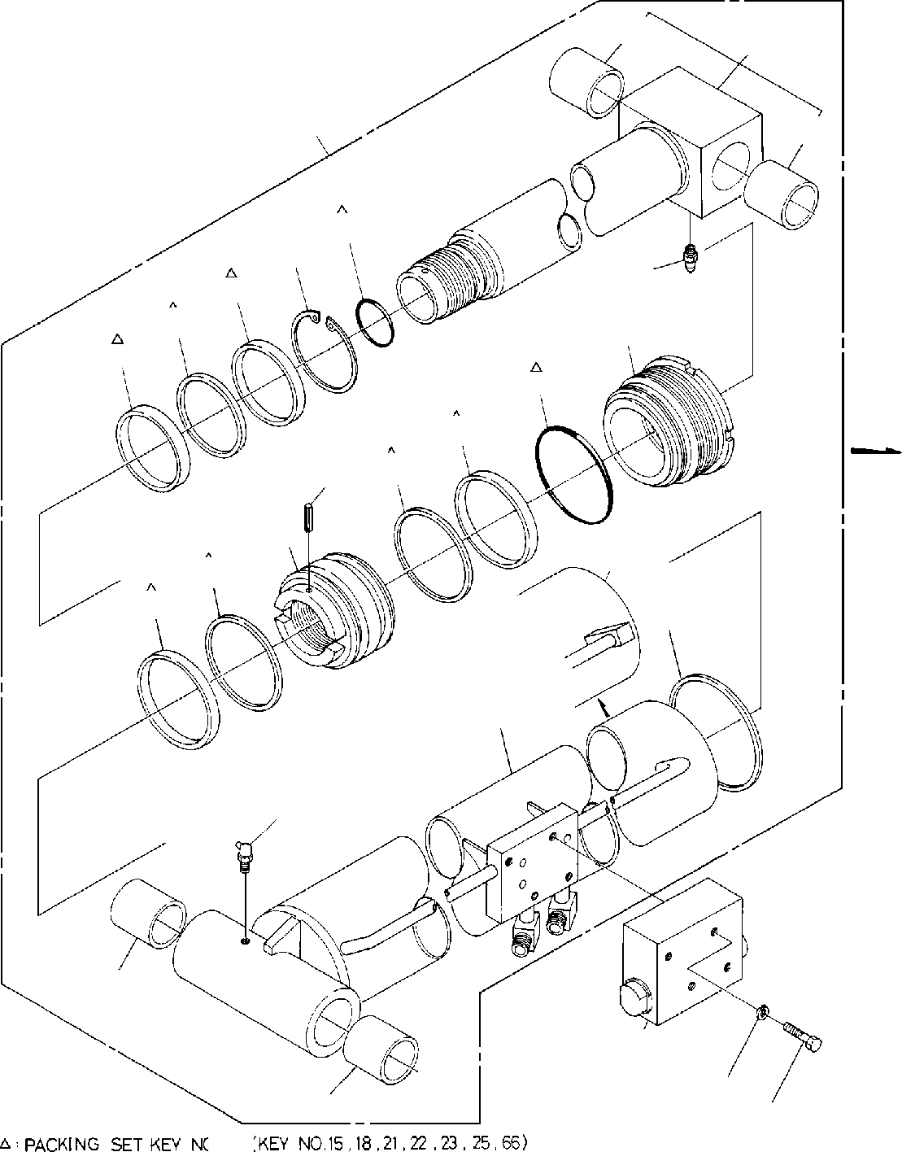

**DT-600-2-00001 UPPER**

**PE1010041-03 CYLINDER,ELEVATING**

**11**

**69**

**1**

**11**

**18**

**26**

**27**

**25**

**23**

**20**

**22**

**21**

**15**

**66**

**14**

**17**

**12**

**66**

**15**

**24**

**12**

**13**

**11**

**2**

**3**

**11**

**4**

**100**

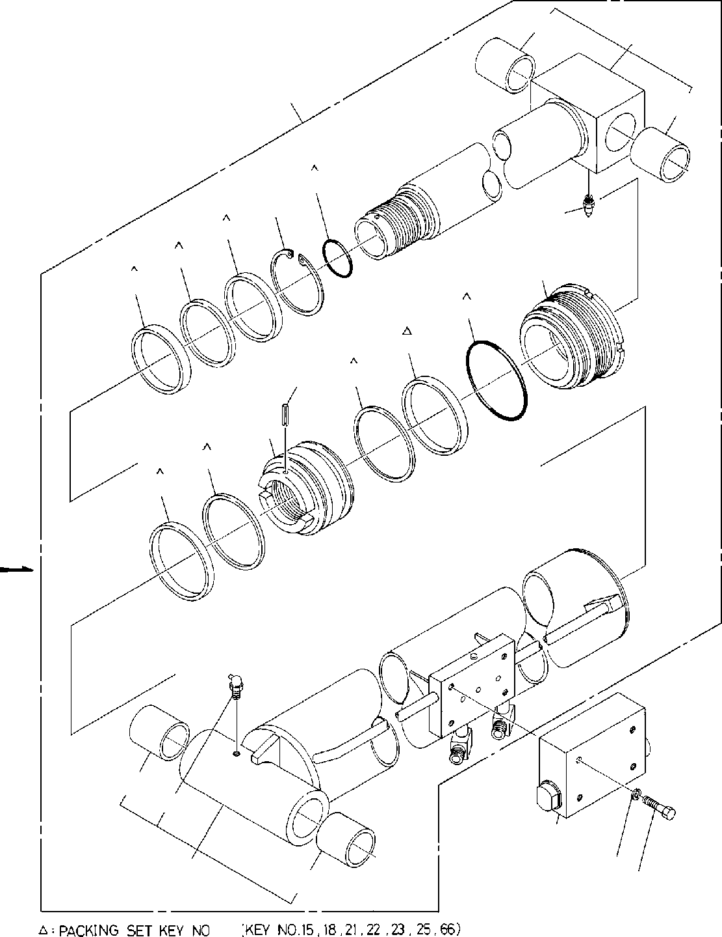

**DT-600-2-00001 UPPER**

**PE1010041-03 CYLINDER,ELEVATING**

**11**

**69**

**1**

**11**

**18**

**26**

**27**

**25**

**23**

**20**

**22**

**21**

**15**

**66**

**14**

**17**

**66**

**15**

**11**

**13**

**2**

**3**

**62**

**11**

**4**

**100**

**DT-600-2-00001 UPPER**

**000021**

Pos No.

Parts No

Parts Name

Qty

Unit

Technical Data

Serial No (Start)

Serial No (End)

Rem

1

2

3

4

11

12

13

14

15

17

18

20

21

22

23

24

25

26

27

62

66

69

100

36021670000

36023440000

36601030000

36603110000

90101208065

90101208070

90302040801

37000401400

37000401400

37000401400

37000403660

36021670010

36021670011

82458102000

80720105025

91684011500

36021670020

91002906000

36021670040

91002911000

91694008001

91410208001

36021670050

91660008000

80622000800

82456101000

36023449510

91411210001

36023719520

36021670030

36023449900

CYLINDER ASSY CYLINDER ASSY,DERRICK VALVE,COUNTERBALANCE VALVE,COUNTERBALANCE BOLT

BOLT WASHER,SPRING BEARING,PLAIN BEARING,PLAIN BEARING,PLAIN BEARING,PLAIN CYLINDER CYLINDER NIPPLE,GREASE PIN,SPRING PACKING PISTON

O-RING COVER,ROD O-RING PACKING RING,BACKUP WASHER SEAL,DUST

RING,RITAINING NIPPLE,GREASE CYLINDER ASSY RING,BACKUP ROD

ROD ASSY PACKING SET

1

1

1

1

4

4

4

2

2

2

4

1

1

1

1

2

1

1

1

1

1

1

1

1

1

1

1

2

1

1

1

M8X65 M8X70 8

B-PT1/8 5X25

1B G60

1B G110

SP80

A-PT1/8

100X160

275136

275136

275136

275136

275482

275104

275136

275482

275135

275135

275135

275481

275135

275481

275103

275135

275135

275481

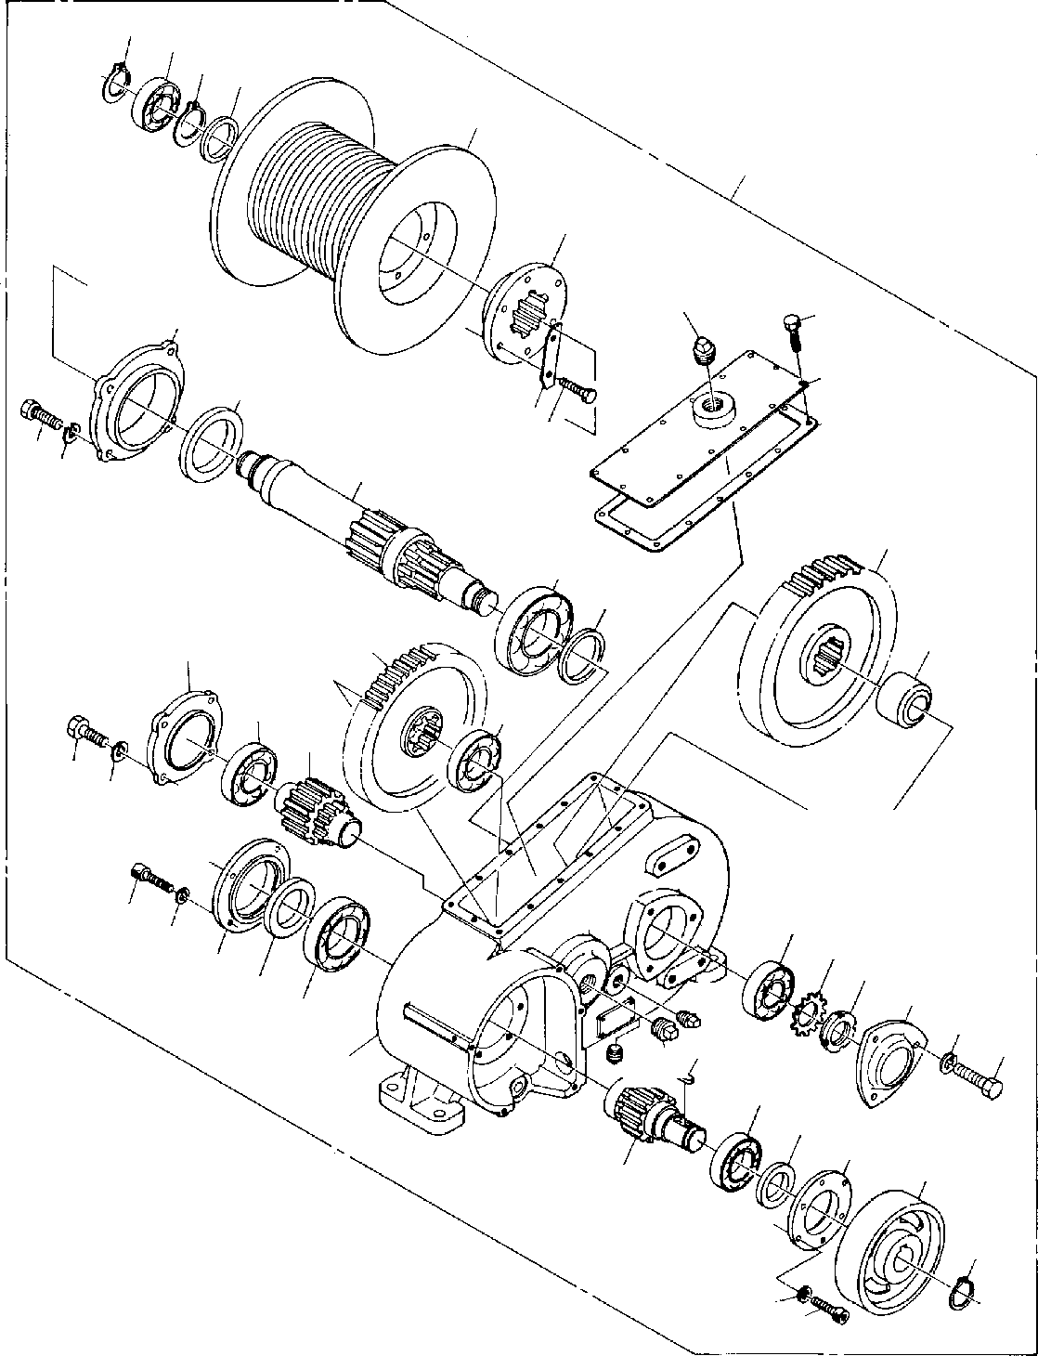

**DT-600-2-00001 UPPER PF1010020-00 WINCH**

**9**

**43**

**4241**

**40**

**50**

**39**

**15**

**35**

**14**

**12**

**13**

**36**

**3837**

**28**

**24**

**29**

**20**

**21**

**22**

**11**

**30**

**34**

**17**

**17**

**19**

**2829**

**27**

**26**

**3**

**4**

**25**

**33 31**

**23**

**16**

**32**

**29**

**28**

**1618 8**

**1**

**10**

**6**

**5**

**2**

**7**

**9**

**4**

**3**

**DT-600-2-00001 UPPER**

**000022**

Pos No.

Parts No

Parts Name

Qty

Unit

Technical Data

Serial No (Start)

Serial No (End)

Rema

1

2

3

4

5

6

7

8

9

10

11

12

13

14

15

16

17

18

19

20

21

22

23

24

25

26

27

28

29

30

31

32

33

34

35

36

37

38

39

40

41

42

43

46

50

36070945010

36070945011

36070565020

90131706018

90131706018

90302040601

90302040601

36070565030

91216040003

36070565040

36070565050

80601110350

80500006009

36070565060

36070945020

36070565080

36070565090

36070565100

80205000300

80500006208

80205000600

36070565110

36070565120

80500006212

36070305090

36070305091

36070565130

36070565140

36070565141

80561100070

80562100070

80500006207

90102210025

90302041001

36070565150

91216055002

80500006011

36070305020

36071435020

36070305040

36070305140

91216070002

90102512035

36070565160

36070565170

36070565180

36070565190

80601110450

80516006307

80303080080

36070940000

CASE,GEAR CASE,GEAR WHEEL,BRAKE

BOLT,HEXAGON SOCKET BOLT,HEXAGON SOCKET WASHER,SPRING WASHER,SPRING RETAINER (C)

SEAL,OIL GEAR,SPUR KEY RING,RITAINING BEARING,BALL GEAR,SPUR COVER PACKING

BOLT PLUG PLUG

BEARING,BALL PLUG GEAR,SPUR GEAR,SPUR BEARING,BALL SPACER SPACER RETAINER (B) DRUM,SHAFT DRUM,SHAFT NUT WASHER,PLAIN BEARING,BALL BOLT WASHER,SPRING SPACER (A) SEAL,OIL BEARING,BALL RETAINER (F) RETAINER (F) RETAINER (D) RETAINER (A) SEAL,OIL

BOLT PLATE

BOSS (DRUM) DRUM SPACER (B)

RING,RITAINING BEARING,BALL ELBOW

WINCH

1

1

1

10

12

10

12

1

1

1

1

2

1

1

1

1

14

1

2

2

1

1

1

1

1

1

1

1

1

1

1

1

11

11

1

1

1

1

1

1

1

1

6

3

1

1

1

1

1

1

1

M6X18 M6X18 6

6

S35

M6X12 PT3/4 PT3/8

PT3/4

AN07 AW07

M10X25 10

M12X35

S45

275099

275099

275099

275038

275038

275099

275017

275098

275098

275098

275037

275037

275098

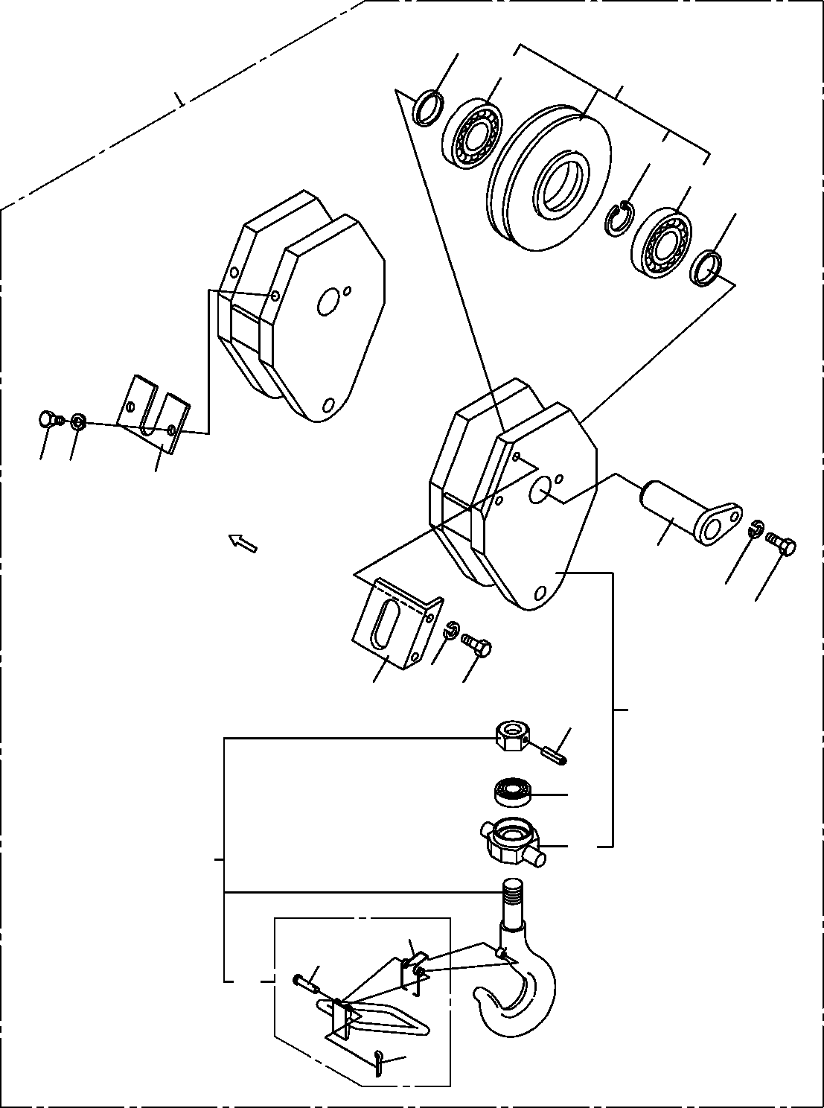

**DT-600-2-00001 UPPER PF1050040-01 HOOK**

**2**

**23**

**4**

**30**

**22**

**23**

**2**

**16**

**17**

**6**

**3**

**8**

**7**

**8**

**6**

**7**

**1**

**9**

**14**

**25**

**20**

**12**

**10**

**13**

**11**

**DT-600-2-00001 UPPER**

**000023**

Pos No.

Parts No

Parts Name

Qty

Unit

Technical Data

Serial No (Start)

Serial No (End)

Remarks

Pa

1

2

3

4

6

7

8

9

10

11

12

13

14

20

22

23

25

30

36091200010

37000303080

37000115430

37001003050

36091200020

90101210020

90302041001

80720105040

37000105180

80136316012

37001400020

36091209510

80500051205

36091209520

80602110800

80515006208

36091202000

36091200000

BODY SPACER PIN

SHEAVE ASSY SUPPORT BOLT

WASHER,SPRING PIN,SPRING

PIN PIN,SPLIT SPRING

STOPPER ASSY BEARING,BALL HOOK ASSY RING,RITAINING BEARING,BALL TRUNNION HOOK

1

2

1

1

1

3

3

1

1

1

1

1

1

1

1

2

1

1

L=7.5

M10X20 10

5X40

1.6X12

R80

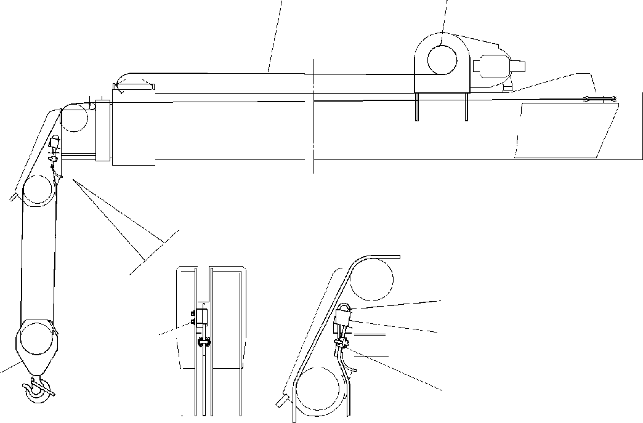

**DT-600-2-00001 UPPER PF1050042-00 HOOK**

**2**

**1**

**7**

**6**

**459**

**3**

**8**

**DT-600-2-00001 UPPER**

**000024**

Pos No.

Parts No

Parts Name

Qty

Unit

Technical Data

Serial No (Start)

Serial No (End)

Rema

1

2

3

4

5

6

7

8

9

13643002000

37001801490

36091200000

90131512028

90302041201

32290040010

14117602001

83151411000

90303071201

WEDGE ROPE,WIRE HOOK

BOLT,HEXAGON SOCKET WASHER,SPRING SOCKET

WEDGE CLIP

WASHER,PLAIN

1

1

1

2

2

1

1

1

2

M12X28 12

12



**DT-600-2-00001 UPPER PF1050042-00 HOOK**

**2**

**1**

**7**

**6**

**459**

**3**

**8**

**DT-600-2-00001 UPPER**

**000025**

Pos No.

Parts No

Parts Name

Qty

Unit

Technical Data

Serial No (Start)

Serial No (End)

Rema

1

2

3

4

5

6

7

8

9

13643002000

37001801700

36091840000

90131512028

90302041201

32290040010

14117602001

83151411000

90303071201

WEDGE ROPE,WIRE HOOK

BOLT,HEXAGON SOCKET WASHER,SPRING SOCKET

WEDGE CLIP

WASHER,PLAIN

1

1

1

2

2

1

1

1

2

M12X28 12

12

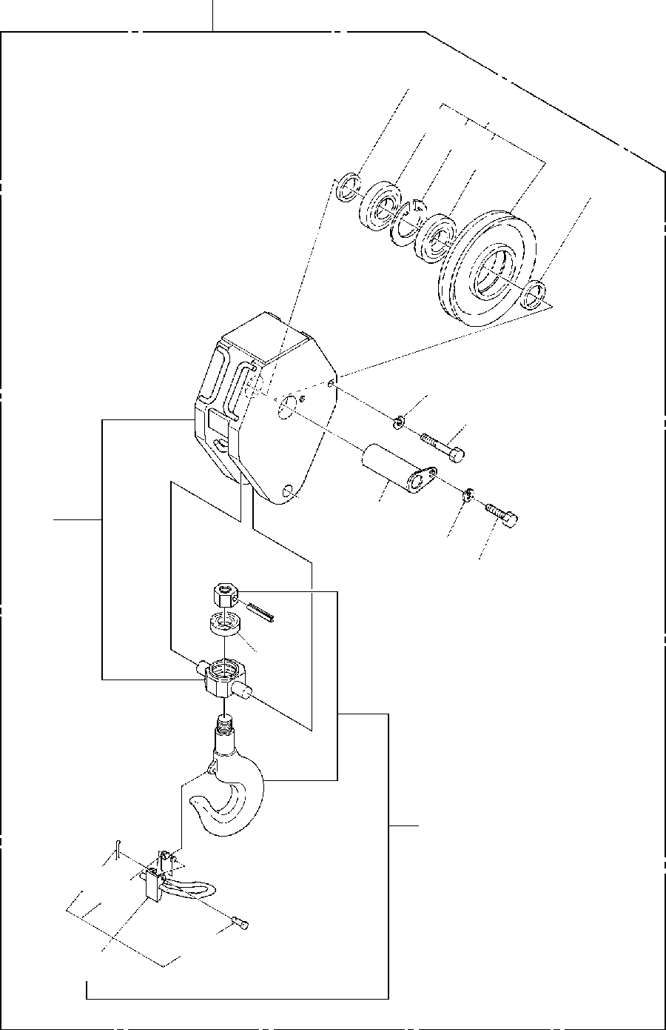

**DT-600-2-00001 UPPER PF1050059-00 HOOK**

**40**

**2**

**4**

**33**

**32**

**33**

**2**

**16**

**6**

**3**

**1**

**8**

**7**

**9**

**14**

**30**

**1112**

**10**

**13**

**DT-600-2-00001 UPPER**

**000026**

Pos No.

Parts No

Parts Name

Qty

Unit

Technical Data

Serial No (Start)

Serial No (End)

Remarks

Pa

1

2

3

4

6

7

8

9

10

11

12

13

14

16

30

32

33

40

36091840010

37000303080

37000115430

37001003050

90101208100

90101210020

90302041001

80720105040

37000105180

80136316012

37001400020

36091849510

80500051205

90302040801

36091849520

80602110800

80515006208

36091840000

BODY SPACER PIN

SHEAVE ASSY BOLT

BOLT WASHER,SPRING PIN,SPRING

PIN PIN,SPLIT SPRING

STOPPER ASSY BEARING,BALL WASHER,SPRING HOOK ASSY RING,RITAINING BEARING,BALL HOOK

1

2

1

1

1

1

1

1

1

1

1

1

1

1

1

1

2

1

L=7.5

M8X100 M10X20 10

5X40

1.6X12

8

R80

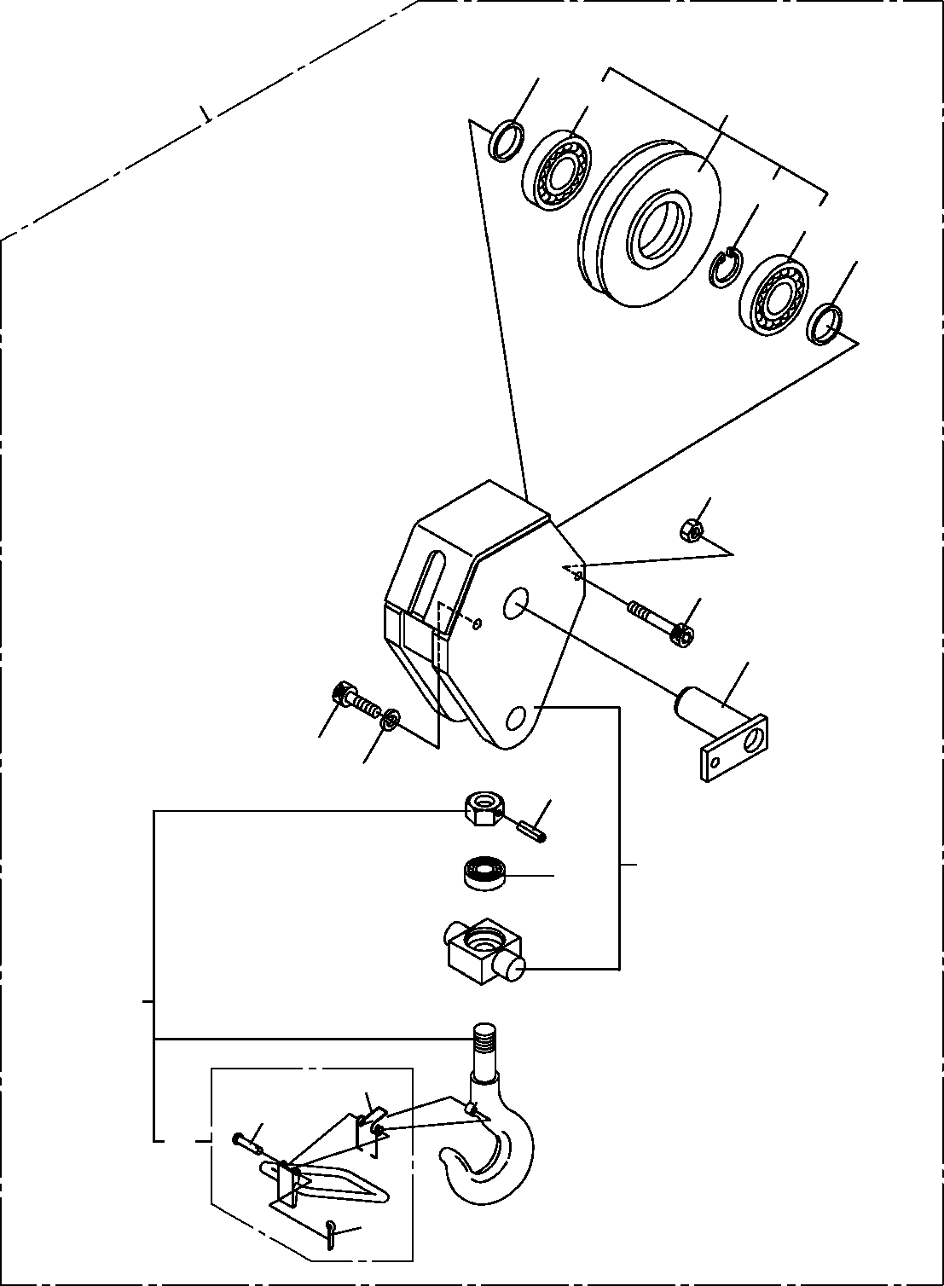

**DT-600-2-00001 UPPER**

**PF1050101-00 HOOK (SHEAVE 1 PC)**

**2**

**50**

**43**

**4**

**42**

**43**

**2**

**16**

**15**

**3**

**10**

**11**

**5**

**1**

**7**

**30**

**14**

**12**

**31**

**13**

**DT-600-2-00001 UPPER**

**000027**

Pos No.

Parts No

Parts Name

Qty

Unit

Technical Data

Serial No (Start)

Serial No (End)

Rema

1

2

3

4

5

7

10

11

12

13

14

15

16

30

31

42

43

50

36092390010

37000303080

36092390020

37001003050

80720105040

80720105045

80500051205

90131510035

90172110035

90302041001

37000105180

80136316012

37001400020

90131508085

90172108085

90201200800

36091209520

36091209510

80602110800

80515006208

36092390000

BODY SPACER PIN

SHEAVE ASSY PIN,SPRING PIN,SPRING BEARING,BALL

BOLT,HEXAGON SOCKET BOLT,HEXAGON SOCKET WASHER,SPRING

PIN PIN,SPLIT SPRING

BOLT,HEXAGON SOCKET BOLT,HEXAGON SOCKET NUT

HOOK ASSY STOPPER ASSY RING,RITAINING BEARING,BALL HOOK (SHEAVE 1 PC)

1

2

1

1

1

1

1

1

1

1

1

1

1

1

1

1

1

1

1

2

1

L=7.5

5X40

5X45

M10X35 M10X35 10

1.6X12

M8X85 M8X85 M8

R80

275291

275832

275832

275290

275831

275831

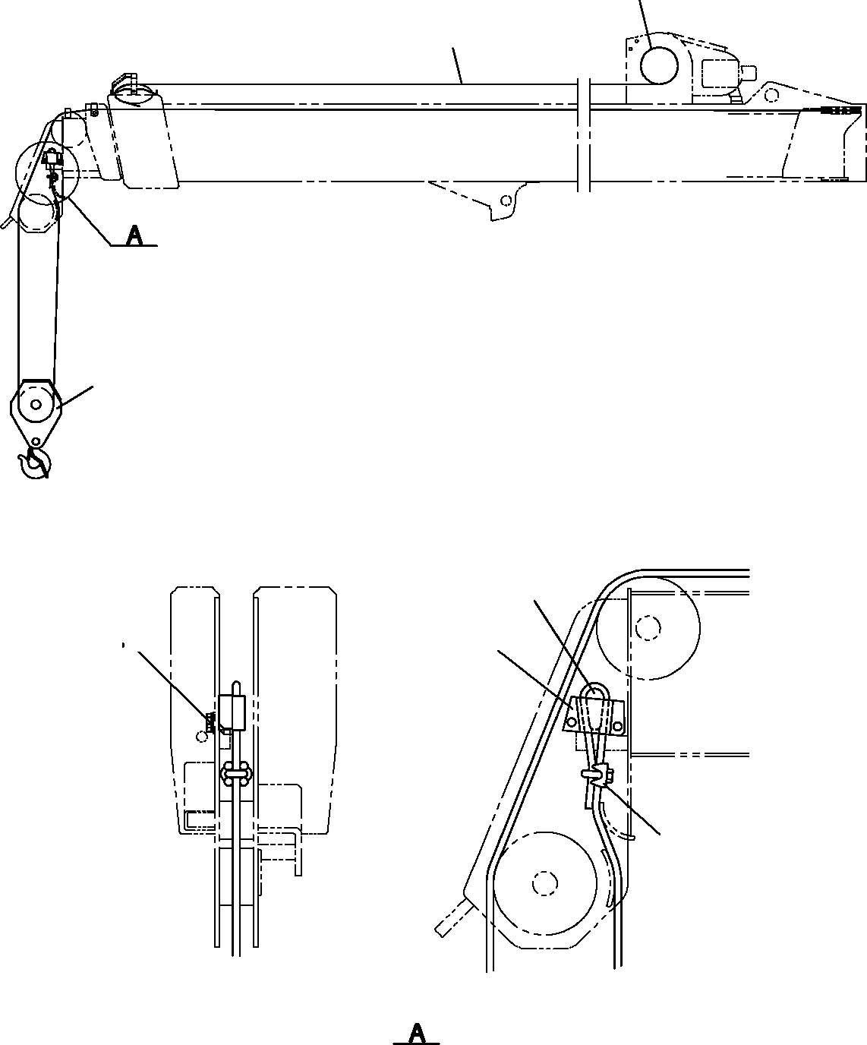

**DT-600-2-00001 UPPER PF1050201-01 HOOK**

**1**

**2**

**3**

**5**

**7**

**8 9**

**4**

**6**

**DT-600-2-00001 UPPER**

**000028**

Pos No.

Parts No

Parts Name

Qty

Unit

Technical Data

Serial No (Start)

Serial No (End)

Remarks

1

2

3

4

5

6

7

8

9

13643002000

37001801700

36092390000

32290260010

14117602001

83151411000

90101512030

90302041201

90303071201

WEDGE ROPE,WIRE

HOOK (SHEAVE 1 PC) SOCKET

WEDGE CLIP BOLT

WASHER,SPRING WASHER,PLAIN

1

1

1

1

1

1

2

2

2

M12X30 12

12

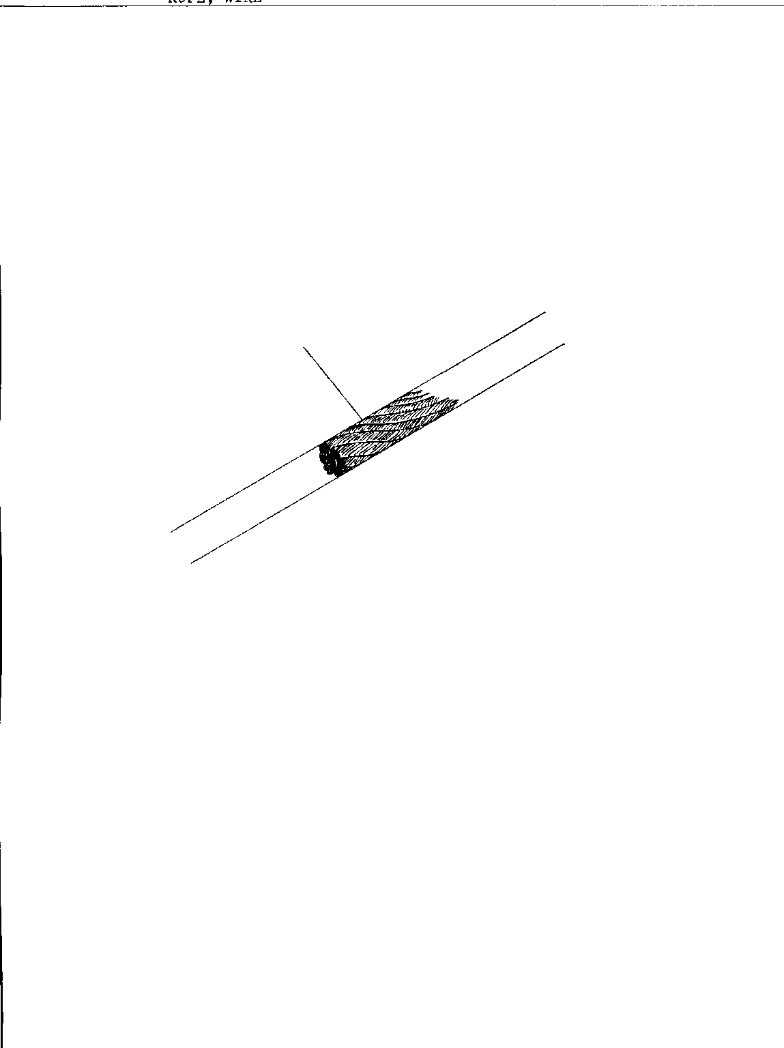

**DT-600-2-00001 UPPER PF1070005-00 ROPE,WIRE**

**1**

**DT-600-2-00001 UPPER**

**000029**

Pos No.

Parts No

Parts Name

Qty

Unit

Technical Data

Serial No (Start)

Serial No (End)

Remarks

Pages

1

37001801490

ROPE,WIRE

1



**DT-600-2-00001 UPPER PF1070005-00 ROPE,WIRE**

**1**

**DT-600-2-00001 UPPER**

**000030**

Pos No.

Parts No

Parts Name

Qty

Unit

Technical Data

Serial No (Start)

Serial No (End)

Remarks

Pages

1

37001801700

37001801700

ROPE,WIRE ROPE,WIRE

1

1

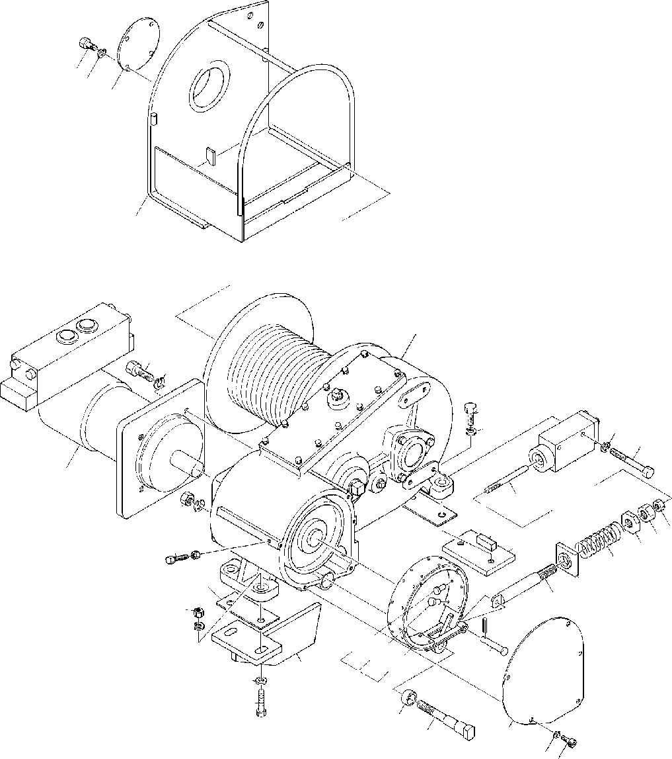

**DT-600-2-00001 UPPER PF1400040-01 MOUNT,WINCH**

**3031**

**32**

**71**

**1**

**33**

**10**

**26**

**10**

**24**

**23**

**25**

**29**

**22**

**27**

**3637**

**28**

**72**

**2021**

**5**

**27**

**4**

**19**

**18**

**16**

**17**

**9**

**10**

**15**

**14**

**5657**

**55**

**12**

**11**

**8**

**13**

**35**

**34**

**3**

**7 6**

**DT-600-2-00001 UPPER**

**000031**

Pos No.

Parts No

Parts Name

Qty

Unit

Technical Data

Serial No (Start)

Serial No (End)

Rema

1

3

4

5

6

7

8

9

10

11

12

13

14

15

16

17

18

19

20

21

22

23

24

25

26

27

28

29

30

31

32

33

34

35

36

37

55

56

57

71

72

36070940000

32310030030

90102206035

90201200600

90131506012

90302040601

90101512050

90201401200

90302041201

90303071201

32310040020

32310030020

37000115190

80720103020

32310010040

32310010100

37001200450

32310010030

90203252000

90203201200

32310010020

90101510070

90302041001

36060500000

90101512035

32310030050

37000507550

36660820000

90101208012

90302040801

32310030010

90101512040

37001501460

37000302160

90201201400

90302041401

32310034050

32310034060

32310034070

32310042010

32310032010

WINCH COVER BOLT NUT

BOLT,HEXAGON SOCKET WASHER,SPRING

BOLT NUT

WASHER,SPRING WASHER,PLAIN SUPPORT

BAND PIN

PIN,SPRING SUPPORT ROD SPRING SUPPORT NUT

NUT ROD BOLT

WASHER,SPRING CYLINDER,BRAKE BOLT

PLATE PLATE

MOTOR,HYDRAULIC BOLT WASHER,SPRING COVER

BOLT BOLT SPACER NUT

WASHER,SPRING LINING

RIVET RIVET SUPPORT PLATE

1

1

3

3

5

5

2

2

6

2

1

1

1

1

1

1

1

1

1

1

1

2

2

1

2

2

1

1

4

4

1

2

1

1

1

1

4

20

4

1

1

M6X35 M6 M6X12 6 M12X50 M12

12

12

3X20

M12

M10X70 10

M12X35

M8X12 8

M12X40

M14 14

3.9X9

3.9X11

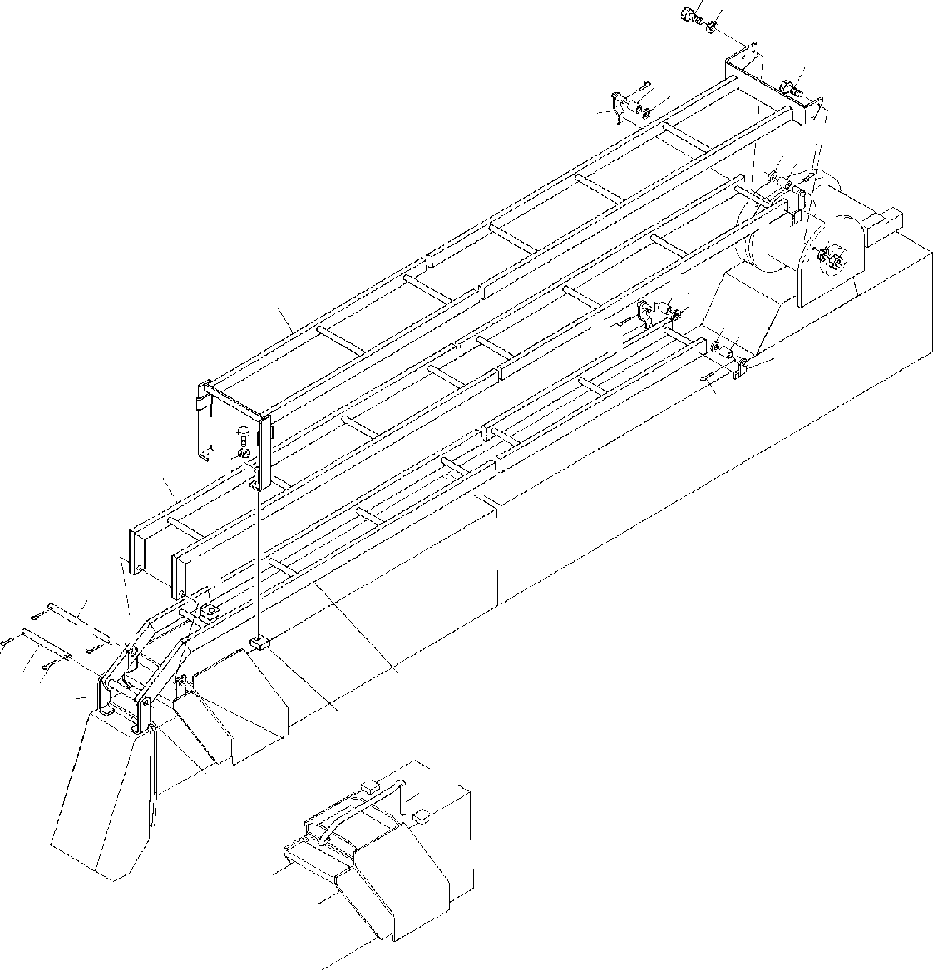

**DT-600-2-00001 UPPER**

**PF1420001-00 GUARD,WIRE (OPTION)**

**1718**

**17**

**16**

**1415**

**12**

**15 16**

**14**

**1819**

**12**

**1415**

**1**

**1514**

**1613**

**13**

**16**

**20**

**21**

**2**

**10**

**6**

**7**

**5**

**7**

**7**

**8 7**

**3**

**9**

**10**

**5**

**11**

**4**

**DT-600-2-00001 UPPER**

**000032**

Pos No.

Parts No

Parts Name

Qty

Unit

Technical Data

Serial No (Start)

Serial No (End)

Remarks

Pa

1

2

3

4

5

6

7

8

9

10

11

12

13

14

15

16

17

18

19

20

21

32470180010

32470180020

32470180030

32470180040

37000530000

37000127820

80136350032

37000127160

32470180050

32470122010

32470120080

32470120090

32470120100

37001103020

37000524650

80136340020

90101210025

90302041001

90201201000

90101212022

90302041201

GUARD GUARD GUARD SUPPORT PLATE PIN PIN,SPLIT PIN SUPPORT PLATE GUARD SUPPORT SUPPORT ROLLER PLATE PIN,SPLIT BOLT

WASHER,SPRING NUT

BOLT WASHER,SPRING

1

1

1

1

2

1

4

1

1

2

1

2

2

4

4

4

4

4

2

2

2

5X32

T=2.3 TO 2.5 4X20 M10X25

10

M10 M12X22 12

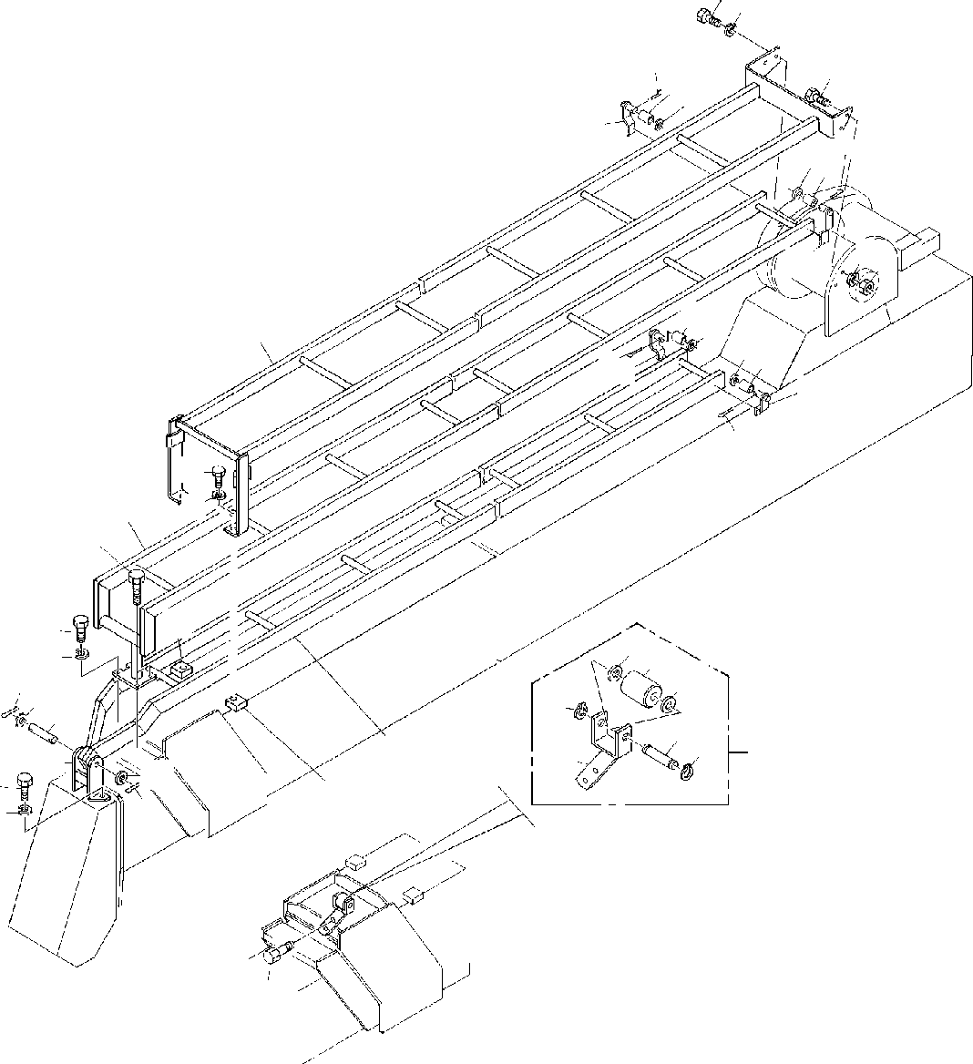

**DT-600-2-00001 UPPER**

**PF1420007-00 GUARD,WIRE (OPTION)**

**1718**

**16**

**1415**

**17**

**12**

**16**

**1514**

**1819**

**12**

**1415**

**1**

**1514**

**1613**

**13**

**16**

**20**

**21**

**2**

**5**

**10**

**17**

**18**

**32**

**31**

**32**

**722**

**4**

**34**

**8**

**33**

**34**

**11**

**3**

**35**

**22**

**7**

**17**

**18**

**10**

**9**

**DT-600-2-00001 UPPER**

**000033**

Pos No.

Parts No

Parts Name

Qty

Unit

Technical Data

Serial No (Start)

Serial No (End)

Remarks

Pa

1

2

3

4

5

7

8

9

10

11

12

13

14

15

16

17

18

19

20

21

31

32

33

34

35

32470180010

32471370020

32471370030

32471330020

90101210040

80136350032

37000126070

90101508030

32470122010

32470450050

32470120090

32470120100

37001103020

37000524650

80136340020

90101210025

90302041001

90201201000

90101212022

90302041201

37001104840

90303071401

37000136210

80601110150

32470452000

GUARD GUARD GUARD SUPPORT BOLT PIN,SPLIT PIN

BOLT PLATE

ROLLER ASSY SUPPORT SUPPORT ROLLER PLATE PIN,SPLIT BOLT

WASHER,SPRING NUT

BOLT WASHER,SPRING ROLLER WASHER,PLAIN PIN RING,RITAINING SUPPORT

1

1

1

1

2

2

1

2

2

1

2

2

4

4

4

8

8

2

2

2

1

2

1

2

1

M10X40 5X32

M8X30

T=2.3 TO 2.5 4X20 M10X25

10

M10 M12X22 12

14

15

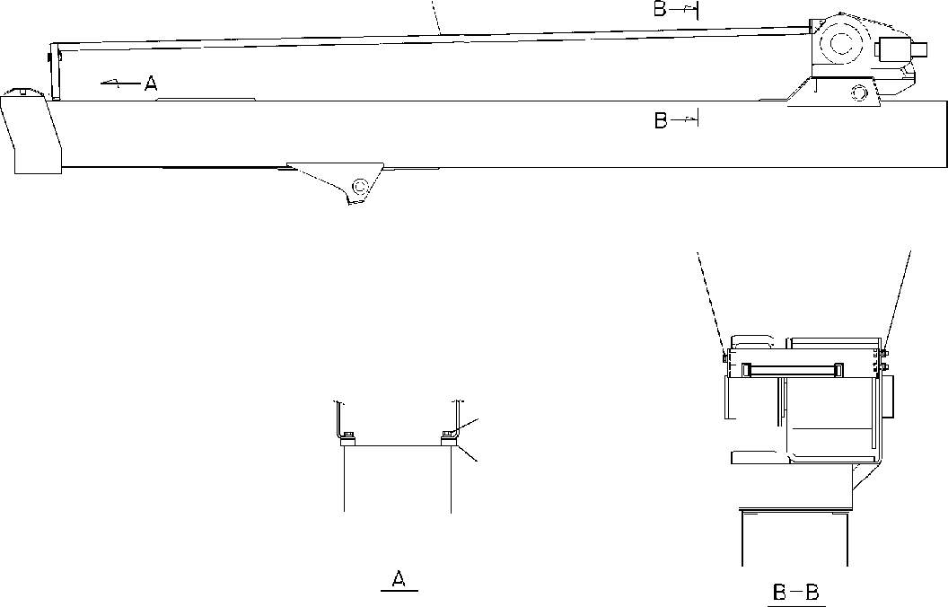

**DT-600-2-00001 UPPER**

**PF1420008-00 GUARD,WIRE (OPTION)**

**1**

**1718**

**171819**

**4 3**

**2**

**DT-600-2-00001 UPPER**

**000034**

Pos No.

Parts No

Parts Name

Qty

Unit

Technical Data

Serial No (Start)

Serial No (End)

Remarks

Pa

1

2

3

4

17

18

19

32470180010

32470122010

90101212022

90302041201

90101210025

90302041001

90201201000

GUARD PLATE BOLT

WASHER,SPRING BOLT WASHER,SPRING NUT

1

2

2

2

4

4

2

M12X22 12 M10X25 10

M10

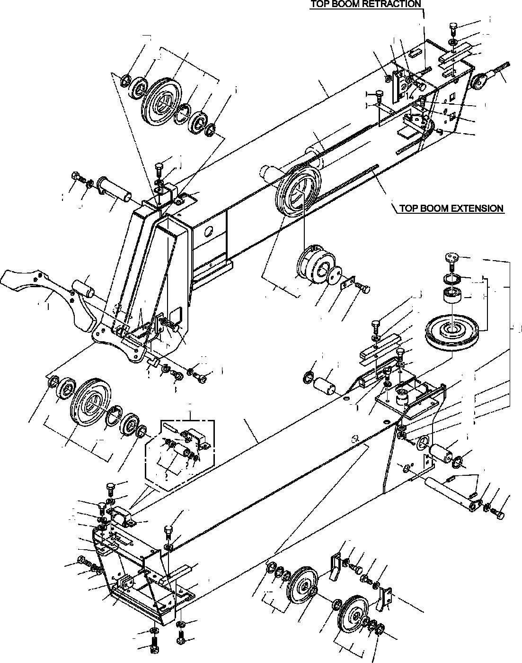

**DT-600-2-00001 UPPER PG1010090-02 BOOM**

**36**

**15**

**55**

**56**

**45**

**11**

**25**

**53**

**52**

**4**

**93**

**1**

**92**

**45**

**93**

**25**

**49**

**50**

**49**

**12**

**51**

**44**

**14**

**11**

**24**

**22**

**44**

**8**

**26**

**181**

**10**

**192**

**122**

**182**

**123**

**36**

**15**

**46**

**193**

**87**

**151**

**47**

**48**

**58**

**59**

**74**

**8**

**22**

**73**

**11**

**80**

**14**

**75**

**11**

**76**

**88**

**152**

**186**

**154**

**153**

**183**

**184**

**185**

**76**

**75**

**9**

**93**

**89**

**2**

**8**

**27**

**92**

**93**

**4**

**171**

**202**

**202**

**79**

**171**

**27**

**172**

**13**

**22**

**8**

**8**

**7**

**31**

**8**

**34**

**30**

**29**

**36**

**9**

**15**

**70**

**11 14**

**14**

**11**

**35**

**81**

**11**

**15**

**18**

**20**

**112**

**113**

**78**

**17**

**16**

**71**

**77**

**8**

**78**

**8**

**21**

**22**

**78**

**113**

**112**

**77**

**78**

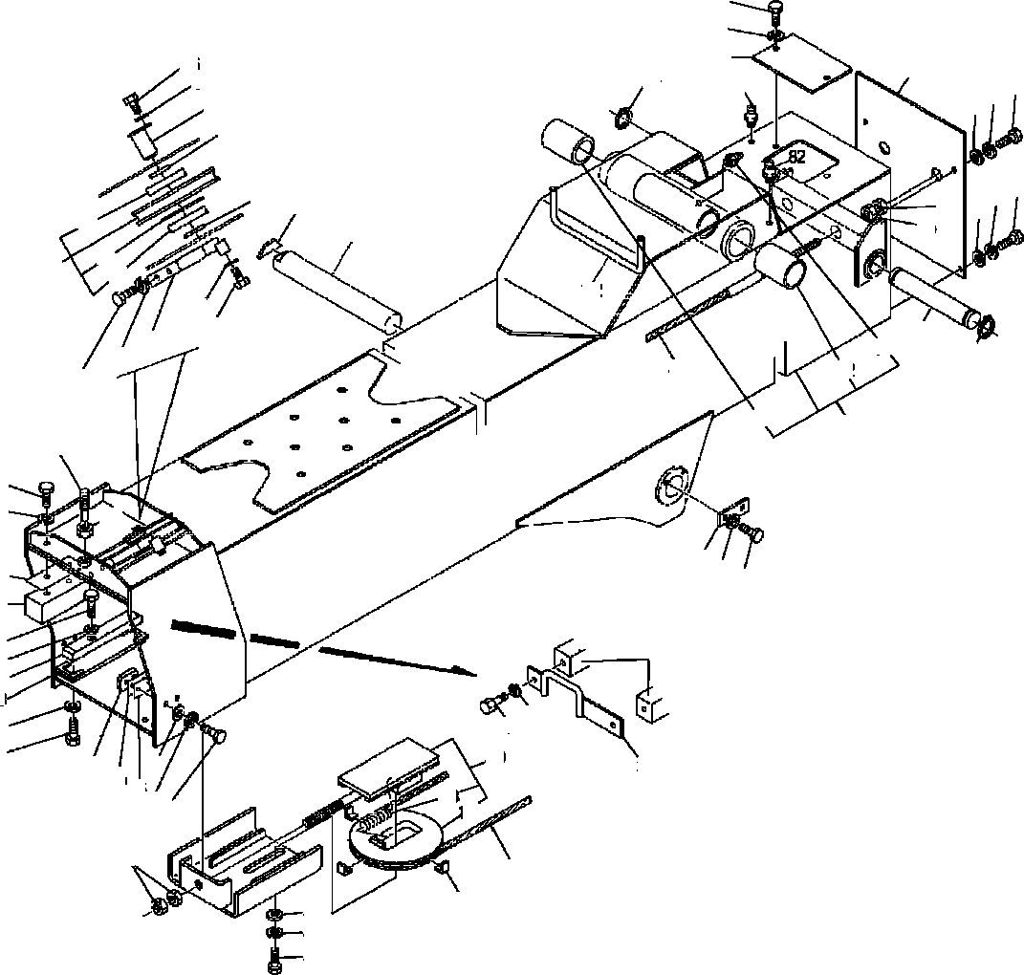

**DT-600-2-00001 UPPER PG1010090-02 BOOM**

**61**

**11**

**60**

**82**

**86**

**8**

**67**

**64**

**14**

**1511**

**6**

**5**

**11 14**

**5**

**63**

**66**

**15**

**93**

**54**

**69**

**92**

**93**

**4**

**142**

**11**

**14**

**65**

**19**

**57**

**64**

**11**

**44**

**62**

**14**

**62**

**3**

**37**

**22**

**8**

**72**

**68**

**8**

**33**

**32**

**22**

**36**

**15**

**38**

**23**

**32**

**8**

**7**

**8**

**7**

**40**

**15**

**83**

**37**

**84**

**85**

**133**

**132**

**1114**

**39**

**45**

**28**

**43**

**42**

**41**

**DT-600-2-00001 UPPER**

**000035**

Pos No.

Parts No

Parts Name

Qty

Unit

Technical Data

Serial No (Start)

Serial No (End)

Rema

1

2

3

4

5

6

7

8

9

10

11

12

13

14

15

16

17

18

19

20

21

22

23

24

25

26

27

28

29

30

31

32

33

34

35

36

37

38

39

40

41

42

43

44

45

46

47

48

49

50

51

52

53

54

55

56

57

58

59

60

61

32200090010

32200090020

32200099510

37001003470

37000303950

37000126160

90101210016

90101210016

90302041001

90302041001

32200090040

37000128790

90302040801

90302040801

37000529980

37000126140

90101508016

90303070801

37002000660

37002000660

31200090700

31200090700

31200090750

31200090750

32200080040

32200080050

90131510022

90101210022

32200080060

32200090050

37000303960

37000126180

37000304020

36010780050

37000529820

37000529800

90101210035

37000529810

32200140060

37000529790

90303071001

37002002290

90101506012

32200080080

32200140070

37002003150

90201201600

32200080090

90101212020

90302041201

90303071201

37001912150

37001902410

37001003880

37000527870

37000527860

90101510030

37000529990

32200080100

90303072001

32200090060

90203251800

37002002300

37000512150

82456101000

37002002270

37000512120

32200090070

90101208010

BOOM,TOP BOOM,2ND BOOM,BASE SHEAVE ASSY SPACER

PIN BOLT BOLT

WASHER,SPRING WASHER,SPRING ROLLER ASSY PIN WASHER,SPRING WASHER,SPRING PLATE

PIN BOLT

WASHER,PLAIN PLATE,SLIDE PLATE,SLIDE SHIM

SHIM SHIM SHIM GUARD RETAINER

BOLT,HEXAGON SOCKET BOLT

RETAINER GUARD SPACER PIN SPACER PLATE

PLATE,SLIDE PLATE

BOLT PLATE,SLIDE PLATE,SLIDE PLATE WASHER,PLAIN PLATE,SLIDE BOLT

BOLT COVER PLATE,SLIDE NUT

SHEAVE ASSY BOLT WASHER,SPRING WASHER,PLAIN ROPE,WIRE (TESAC) ROPE,WIRE SHEAVE ASSY PLATE

PLATE BOLT PLATE SUPPORT

WASHER,PLAIN PIN

NUT PLATE,SLIDE PLATE NIPPLE,GREASE PLATE,SLIDE PLATE

PLATE BOLT

1

1

1

3

2

1

9

11

33

35

1

1

29

33

1

1

23

28

4

2

4

2

4

2

1

1

2

15

2

1

2

1

2

3

2

2

4

2

2

2

4

2

8

1

1

2

2

1

1

1

1

1

1

2

2

2

4

1

1

2

2

2

2

4

1

2

4

1

2

L=3.5

M10X16 M10X16 10

10

8

8

M8X16 8

T=1 T=1 T=0.5 T=0.5

M10X22 M10X22

L=13.5 L=6

T=1.0 M10X35

T=1.0 10

M6X12

M16

M12X20 12

12

8

M10X30 T=1.6

20

T=1.0

A-PT1/8 T=1.0

M8X10

275088

275088

275032

275028

275028

275028

275088

275088

275087

275087

275031

275027

275027

275027

275087

275087

**DT-600-2-00001 UPPER**

**000035**

Pos No.

Parts No

Parts Name

Qty

Unit

Technical Data

Serial No (Start)

Serial No (End)

Rema

62

63

64

65

66

67

68

69

70

71

72

73

74

75

76

77

78

79

80

81

82

83

84

85

86

87

88

89

92

93

112

113

122

123

132

133

142

151

152

153

154

171

172

181

182

183

184

185

186

192

193

202

37000400950

90201251800

80601110350

37000111690

32200090120

32200090080

37000507400

37000127720

32200090090

32200090100

90201201400

32200090130

90191510025

80602110400

37000127780

37001003700

37000303980

80720105040

37000531030

90101508020

82458202000

37002003440

32200080180

32200080190

90101210014

32200120120

90131508016

90180208016

90131510025

80602110720

80515006207

80602110620

80516006206

80602111100

80516006310

32200082030

37001200550

32440050020

32470200010

32470200020

90101514040

90302041401

37000303970

37001103540

32200082080

37001004440

90303071201

90236201201

80136332025

32200092050

80604110720

80520314910

80516006001

BEARING,PLAIN NUT RING,RITAINING PIN

PLATE PLATE PLATE PIN GUARD GUARD NUT

SHEAVE ASSY BOLT RING,RITAINING PIN

SHEAVE ASSY SPACER PIN,SPRING PLATE

BOLT NIPPLE,GREASE PLATE,SLIDE SHIM

SHIM BOLT PLATE

BOLT,HEXAGON SOCKET BOLT,BUTTON BOLT,HEXAGON SOCKET RING,RITAINING BEARING,BALL RING,RITAINING BEARING,BALL RING,RETAINING BEARING,BALL

SHEAVE SPRING SUPPORT SUPPORT PLATE BOLT

WASHER,SPRING SPACER

ROLLER ASSY BOLT

SHEAVE ASSY WASHER,PLAIN NUT,CASTLE PIN,SPLIT SUPPORT RING,RETAINING BEARING,ROLLER BEARING,BALL

2

2

2

1

1

1

1

1

1

1

1

1

2

2

2

2

4

2

1

4

4

2

2

2

1

2

4

4

4

3

6

2

2

2

2

1

1

1

1

2

4

4

2

1

1

1

1

1

1

1

1

1

2

M18 S35

M14

M10X25 R40

L=7 5X40

M8X20

B-TYPE PT1/8

T=1 T=0.5 M10X14

M8X16 M8X16 M10X25 R72

R62 110

M14X40 14 L=2.5

12

M12 3.2X25

275028

275028

275028

275032

275032

275082

275087

275081

275055

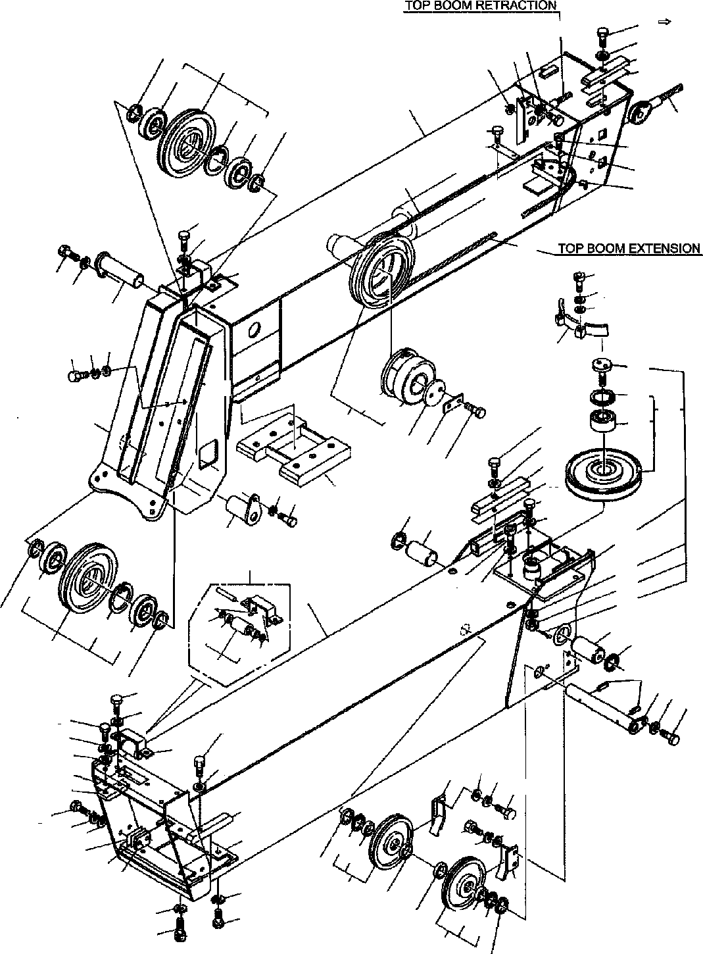

**DT-600-2-00001 UPPER PG1010383-05 BOOM**

93

36

15

55

56

45

53 11

25

103

52

4

1

102

103

45

25

49

50

14

49

12

51

44

14

11

44

24

92

8

34

22

8

26

11 15

91

27

141

80

162

163

132

142

133

36

15

58

59

74

8

46

47

48

22

73

8

87

86

75

76

6

146

9

143

144

145

76

75

89 8

103

2

5

102

111

172

103

4

172111

112

79

5

13 8

22

8

7

31

8

34

30

29

36

9

15

15 11

70

14

35

81

15

11

20

15

18

14

152

153

11

78

17

16

71

77

8

22

78

8

21

78

153

152

77

78

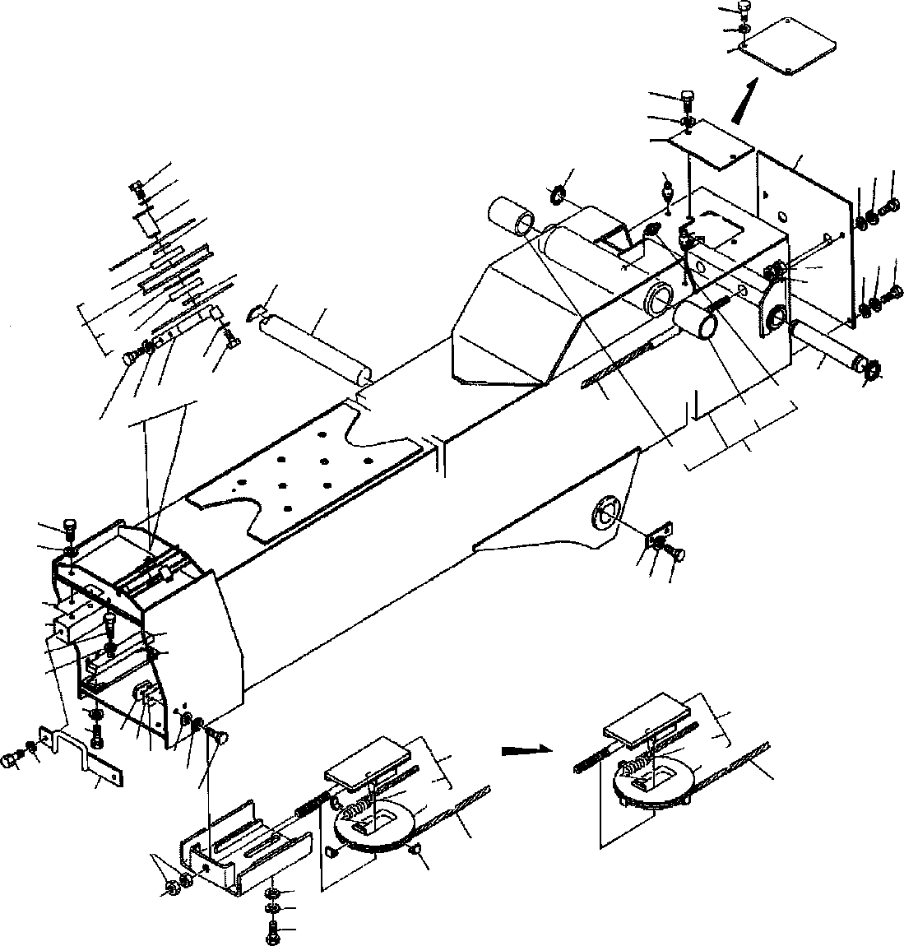

**DT-600-2-00001 UPPER PG1010383-05 BOOM**

61

11

60

61

11

60

82

67

86

8

64

1114

15

6

5

82

11 14

63

54

5

15

66

103

69

102

103

4

11

14

65

19

57

64

11

44

62

14

62

3

22

8

68 8

22

33

32

36

15

38

23

8

7

110

83

123

182

84

40

85 15

11

14

8

7

123

45

37

122

39

45

28

43

42

41

**DT-600-2-00001 UPPER**

**000036**

Pos No.

Parts No

Parts Name

Qty

Unit

Technical Data

Serial No (Start)

Serial No (End)

Rema

1

2

3

4

5

6

7

8

9

11

12

13

14

15

16

17

18

19

20

21

22

23

24

25

26

27

28

29

30

31

32

33

34

35

36

37

38

39

40

41

42

43

44

45

46

47

48

49

50

51

52

53

54

55

56

57

32200090200

32200090020

32200099510

37001003470

37000303950

37000126160

90101210016

90302041001

32200090040

90302040801

37000529980

37000126140

90101508016

90171108016

90303070801

90303070801

37002000660

31200090700

31200090750

32200080040

32200080050

90131510022

90172110022

90101210022

32200080060

32200090050

37000303960

37000126180

90101208012

36010780050

37000529820

37000572300

37000529800

90101210035

90101210032

90171110032

32200140060

37000529790

37000529790

90303071001

37002002290

90101506012

90171106012

90171106012

32200140070

37002003150

90201201600

32200080090

90101212020

90302041201

90303071201

37001912150

37001910780

37001902410

37001920870

37001920860

37001003880

37000527870

37000527860

90101510030

90171110030

37000529990

32200080100

90303072001

32200090060

90203251800

37002002300

37000512150

82456101000

BOOM,TOP BOOM,2ND BOOM,BASE SHEAVE ASSY SPACER

PIN BOLT

WASHER,SPRING ROLLER ASSY WASHER,SPRING PLATE

PIN BOLT BOLT

WASHER,PLAIN WASHER,PLAIN PLATE,SLIDE SHIM

SHIM GUARD RETAINER

BOLT,HEXAGON SOCKET BOLT,HEXAGON SOCKET BOLT

RETAINER GUARD SPACER PIN

BOLT PLATE

PLATE,SLIDE PLATE,SLIDE PLATE

BOLT BOLT BOLT

PLATE,SLIDE PLATE PLATE

WASHER,PLAIN PLATE,SLIDE BOLT

BOLT BOLT COVER

PLATE,SLIDE NUT

SHEAVE ASSY BOLT WASHER,SPRING WASHER,PLAIN ROPE,WIRE (TESAC)

ROPE,WIRE (KOKOKU) ROPE,WIRE ROPE,WIRE (TESAC) ROPE,WIRE (KOKOKU) SHEAVE ASSY

PLATE PLATE BOLT BOLT PLATE SUPPORT

WASHER,PLAIN PIN

NUT PLATE,SLIDE PLATE NIPPLE,GREASE

1

1

1

3

4

2

11

38

1

33

1

1

22

22

30

34

2

2

2

1

1

2

2

15

2

1

2

1

2

3

2

2

2

4

4

4

2

2

8

6

2

8

8

6

1

2

2

1

1

1

1

1

1

1

1

1

2

2

2

4

4

1

1

2

2

2

2

4

1

L=3.5

M10X16 10

8

M8X16 M8X16 8

8

T=1 T=0.5

M10X22 M10X22 M10X22

L=13.5 M8X12

T=1.0 M10X35 M10X32 M10X32

T=1.0 T=1.0 10

M6X12 M6X12 M6X12

M16

M12X20 12

12

8

M10X30 M10X30 T=1.6

20

T=1.0

A-PT1/8

275213

275213

275301

275301

275301

275449

275449

275557

275301

275213

275301

275763

275343

275557

275557

275301

275300

275300

275300

275778

275448

275448

275556

275300

275300

275762

275778

275556

275300

**DT-600-2-00001 UPPER**

**000036**

Pos No.

Parts No

Parts Name

Qty

Unit

Technical Data

Serial No (Start)

Serial No (End)

Rema

58

59

60

61

62

63

64

65

66

67

68

69

70

71

73

74

75

76

77

78

79

80

81

82

83

84

85

86

87

89

91

92

93

102

103

110

111

112

122

123

132

133

141

142

143

144

145

146

152

153

162

163

172

182

37002002270

37000512120

32200080120

90101208010

37000400950

90201251800

80601110350

37000111690

32200090120

32200090080

37000507400

37000127720

32200090090

32200090140

32200090100

32200090150

32200090130

90191510025

90171110025

80602110400

37000127780

37001003700

37000303980

80720105040

32200310050

90101508020

90171108020

90171108018

82458202000

37002003440

32200080180

32200080190

90101210014

32200238110

90131510025

90172110025

32200080240

90131510040

90172110040

90171106016

80602110720

80515006207

32200080091

37000303970

37001103540

32200082030

37001200550

80602111100

80516006310

32200082080

37001004440

90303071201

90236201201

80136332025

32200092050

80602110620

80516006206

80604110720

80520314910

80516006001

32200082031

PLATE,SLIDE PLATE COVER BOLT

BEARING,PLAIN NUT RING,RITAINING PIN

PLATE PLATE PLATE PIN GUARD GUARD GUARD GUARD

SHEAVE ASSY BOLT

BOLT RING,RITAINING PIN

SHEAVE ASSY SPACER PIN,SPRING PLATE

BOLT BOLT BOLT

NIPPLE,GREASE PLATE,SLIDE SHIM

SHIM BOLT

SUPPORT ASSY BOLT,HEXAGON SOCKET BOLT,HEXAGON SOCKET GUARD

BOLT,HEXAGON SOCKET BOLT,HEXAGON SOCKET BOLT

RING,RITAINING BEARING,BALL SHEAVE ASSY SPACER ROLLER ASSY SHEAVE SPRING

RING,RETAINING BEARING,BALL BOLT

SHEAVE ASSY WASHER,PLAIN NUT,CASTLE PIN,SPLIT SUPPORT RING,RITAINING BEARING,BALL RING,RETAINING BEARING,ROLLER BEARING,BALL SHEAVE

2

4

1

4

2

2

2

1

1

1

1

1

1

1

1

1

1

2

2

2

2

2

4

2

1

4

4

4

4

2

2

2

2

1

4

4

1

2

2

2

3

6

1

2

1

1

1

2

2

1

1

1

1

1

1

2

2

1

1

2

1

T=1.0 M8X10

M18 S35

M10X25 M10X25 R40

L=7 5X40

M8X20 M8X20 M8X18

B-TYPE PT1/8

T=1 T=0.5 M10X14

M10X25 M10X25

M10X40 M10X40 M6X16 R72

L=2.5

110

12

M12 3.2X25

R62

275213

275213

275557

275557

275301

275301

275635

275301

275213

275213

275301

275763

275779

275779

275556

275556

275300

275300

275634

275300

275300

275778

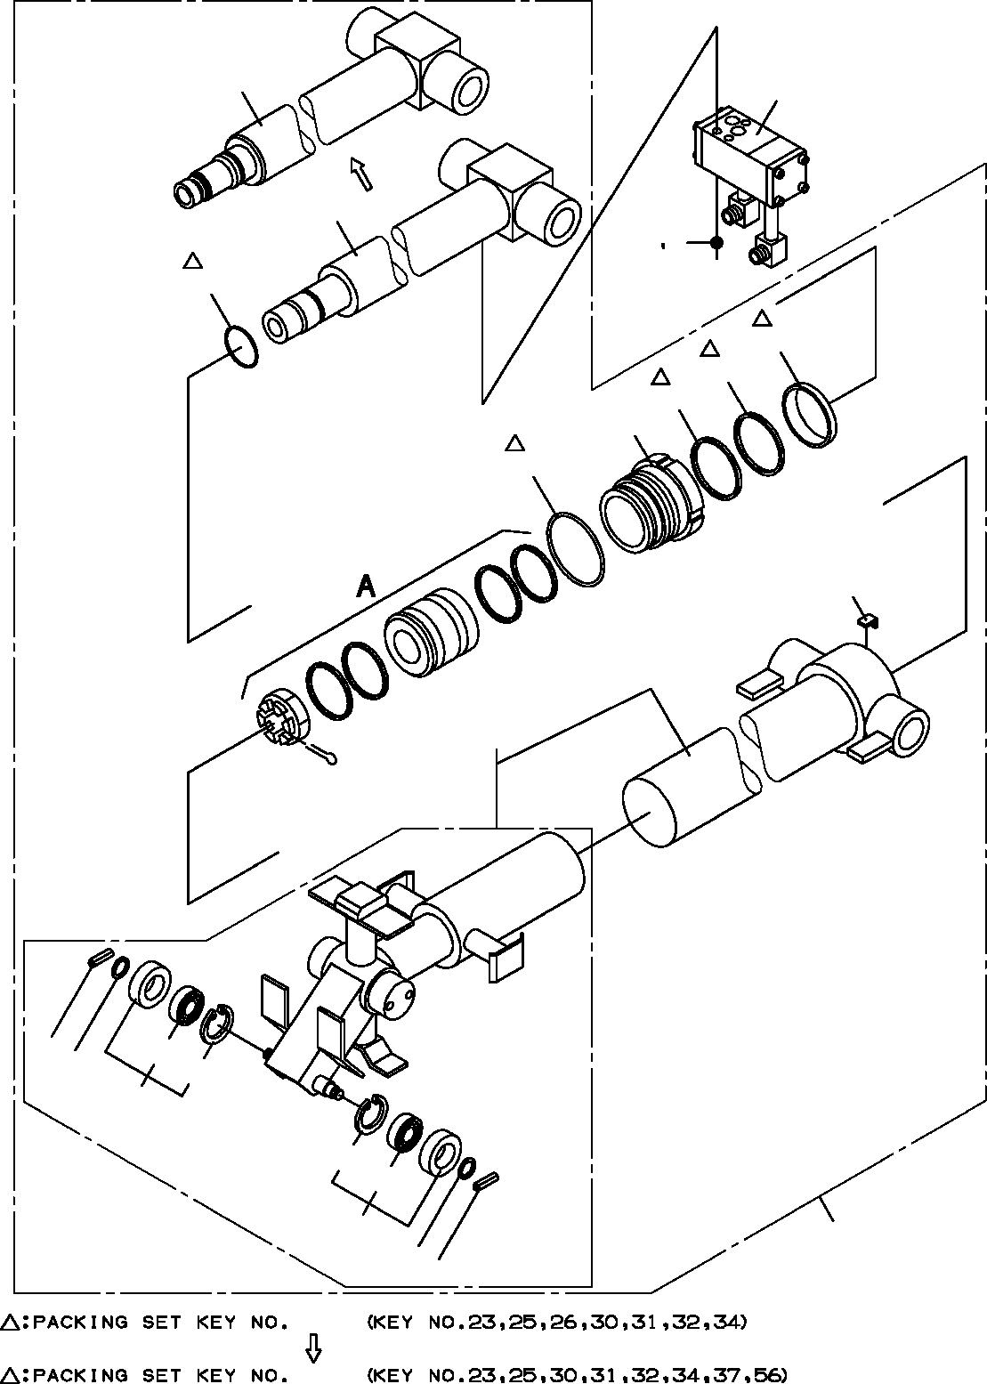

**DT-600-2-00001 UPPER**

**PG1050042-05 CYLINDER ASSY,TELESCOPING**

58

3

28

4 5

23

34

32

31

29

30

33

60

14

13

41

42

12

42

41

12

40

13

14

100

101

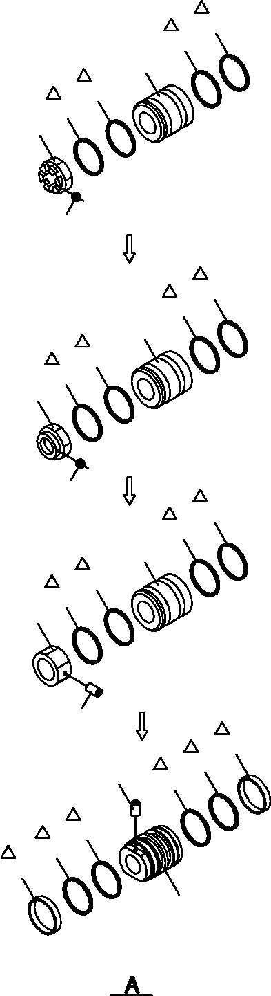

**DT-600-2-00001 UPPER**

**PG1050042-05 CYLINDER ASSY,TELESCOPING**

**25**

**26**

**24**

**26**

**25**

**22**

**21**

**25**

**26**

**24**

**26**

**25**

**52**

**51**

**25**

**26**

**24**

**26**

**25**

**36**

**35**

**37**

**25**

**55**

**56**

**56**

**25**

**37**

**54**

**DT-600-2-00001 UPPER**

**000037**

Pos No.

Parts No

Parts Name

Qty

Unit

Technical Data

Serial No (Start)

Serial No (End)

3

4

5

12

13

14

21

22

23

24

25

26

28

29

30

31

32

33

34

35

36

37

40

41

42

51

52

54

55

56

58

60

100

101

36601770000

90131508065

90302040801

37001102380

90303071201

80720103018

80136363071

37001600000

91002803600

36011840010

91684008001

91411206502

36011840030

36011840040

91002907500

91694106500

91410206503

36011840050

91660006501

90190000010

37001602590

91302208000

32210058010

80516006002

80602110320

80136363065

37001601100

36011840070

90730008140

91431206502

36011840100

36011849520

36011849900

36011849901

VALVE,COUNTERBALANCE BOLT,HEXAGON SOCKET WASHER,SPRING

ROLLER ASSY WASHER,PLAIN PIN,SPRING PIN,SPLIT NUT,CASTLE

O-RING PISTON PACKING RING,BACKUP ROD COVER,ROD O-RING PACKING RING,BACKUP PLATE SEAL,DUST SCREW,SET NUT

BEARING,PLAIN

CYLINDER ASSY,TELESCOPING BEARING,BALL RING,RITAINING

PIN,SPLIT NUT PISTON SCREW,SET

RING,BACKUP ROD

CYLINDER ASSY PACKING SET PACKING SET

1

3

3

2

2

2

1

1

1

1

2

2

1

1

1

1

1

1

1

1

1

2

1

2

2

1

1

1

1

2

1

1

1

1

M8X65 8

12

3X18

6.3X71 M36 1B P36

1B G75

M8X10

R32 6.3X65 M36X2

M8X14

65X80

65X80

275404

275404

275725

275088

275088

275725

275725

275725

275725

275725

275087

275087

275724

275724

275724

275724

275724

275403

275403

275724

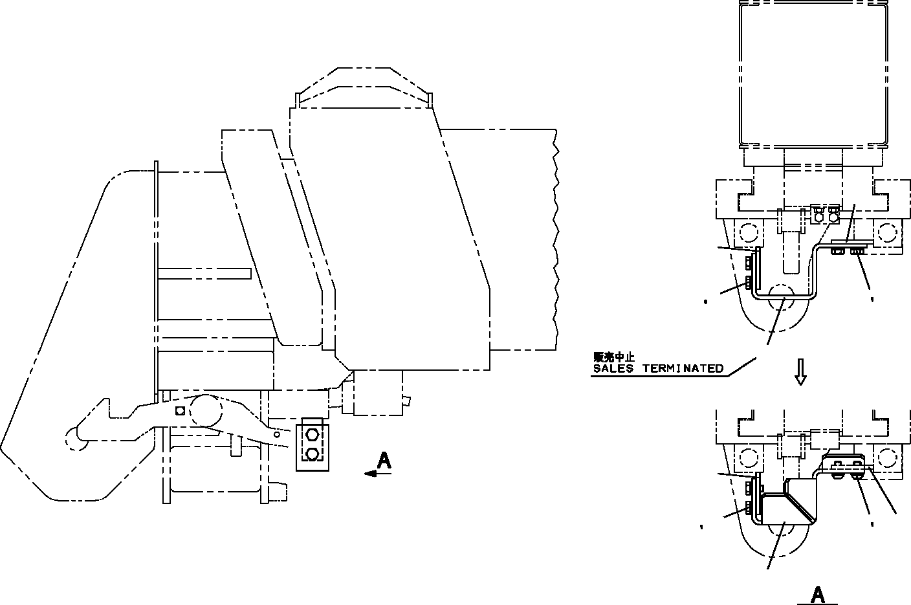

**DT-600-2-00001 UPPER PG5200002-01 GUARD ASSY**

**3**

**3**

**1 2**

**1 2**

**4**

**3**

**2 5 3**

**2**

**11**

**14**

**DT-600-2-00001 UPPER**

**000038**

Pos No.

Parts No

Parts Name

Qty

Unit

Technical Data

Serial No (Start)

Serial No (End)

Remarks

Pa

1

2

3

4

5

11

14

90101210020

90302041001

32472870100

32472870200

90180210020

90101210020

32472870201

BOLT WASHER,SPRING PLATE

SUPPORT BOLT,BUTTON BOLT SUPPORT

4

4

2

1

2

2

1

M10X20 10

M10X20 M10X20

275442

275442

275442

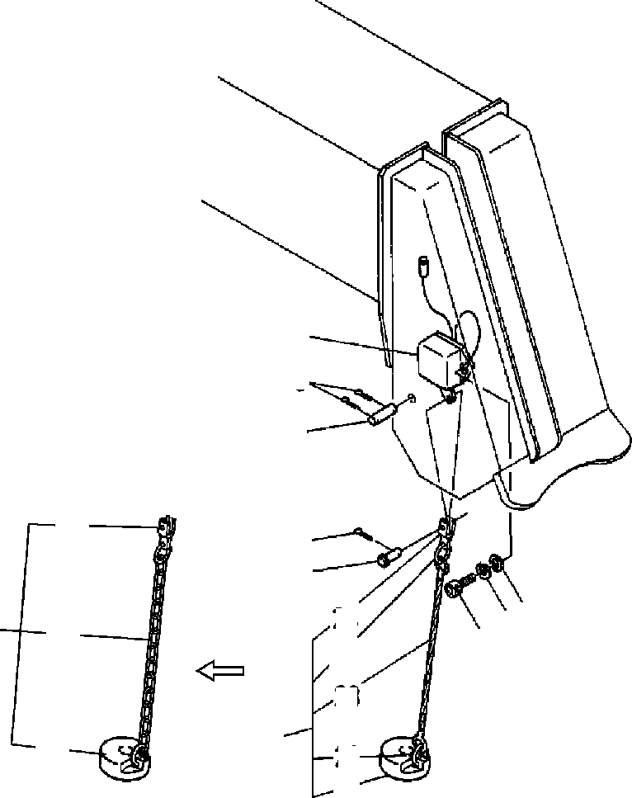

**DT-600-2-00001 UPPER**

**PH1060036-02 DETECTOR,OVER WINDING**

**7**

**5**

**4**

**24**

**9**

**8**

**3 2**

**24**

**22**

**23**

**10**

**33**

**1**

**10**

**21**

**22**

**21**

**DT-600-2-00001 UPPER**

**000039**

Pos No.

Parts No

Parts Name

Qty

Unit

Technical Data

Serial No (Start)

Serial No (End)

Rema

1

2

3

4

5

7

8

9

10

21

22

23

24

90131506016

90303070601

90302040601

37000128780

80136340018

31370000010

37000120180

90000000090

80136332014

32370070010

32370072010

14128208000

37001902460

32370020060

BOLT,HEXAGON SOCKET WASHER,PLAIN WASHER,SPRING

PIN PIN,SPLIT SWITCH PIN

RING PIN,SPLIT WEIGHT ASSY WEIGHT

RING ROPE,WIRE END

2

2

2

1

2

1

1

1

1

1

1

2

1

1

M6X16 6

6

4X18

3.2X14

275031

275030

275702

275300

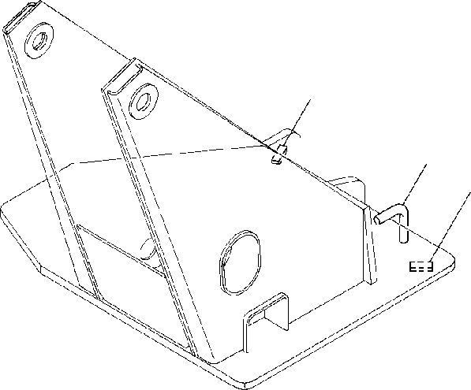

**DT-600-2-00001 UPPER**

**PH1100006-00 DETECTOR,OVER FRONT AREA**

**1**

**2**

**1**

**DT-600-2-00001 UPPER**

**000040**

Pos No.

Parts No

Parts Name

Qty

Unit

Technical Data

Serial No (Start)

Serial No (End)

Remarks

Pages

1

2

37000530330

32950030010

PLATE BAR

2

1

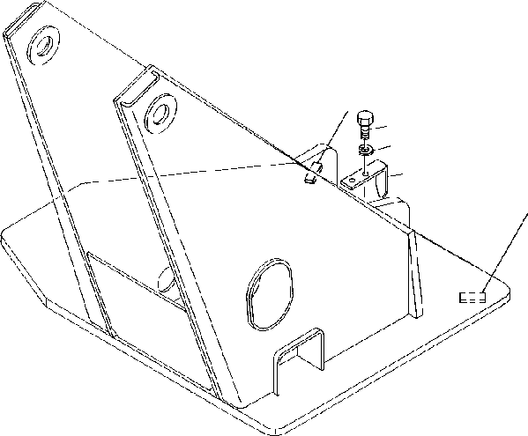

**DT-600-2-00001 UPPER**

**PH1100039-00 DETECTOR,OVER FRONT AREA**

**1**

**3**

**4**

**2**

**1**

**DT-600-2-00001 UPPER**

**000041**

Pos No.

Parts No

Parts Name

Qty

Unit

Technical Data

Serial No (Start)

Serial No (End)

Remarks

Pa

1

2

3

4

37000530330

32950070010

90101210016

90302041001

PLATE INDICATOR BOLT

WASHER,SPRING

2

1

2

2

M10X16 10

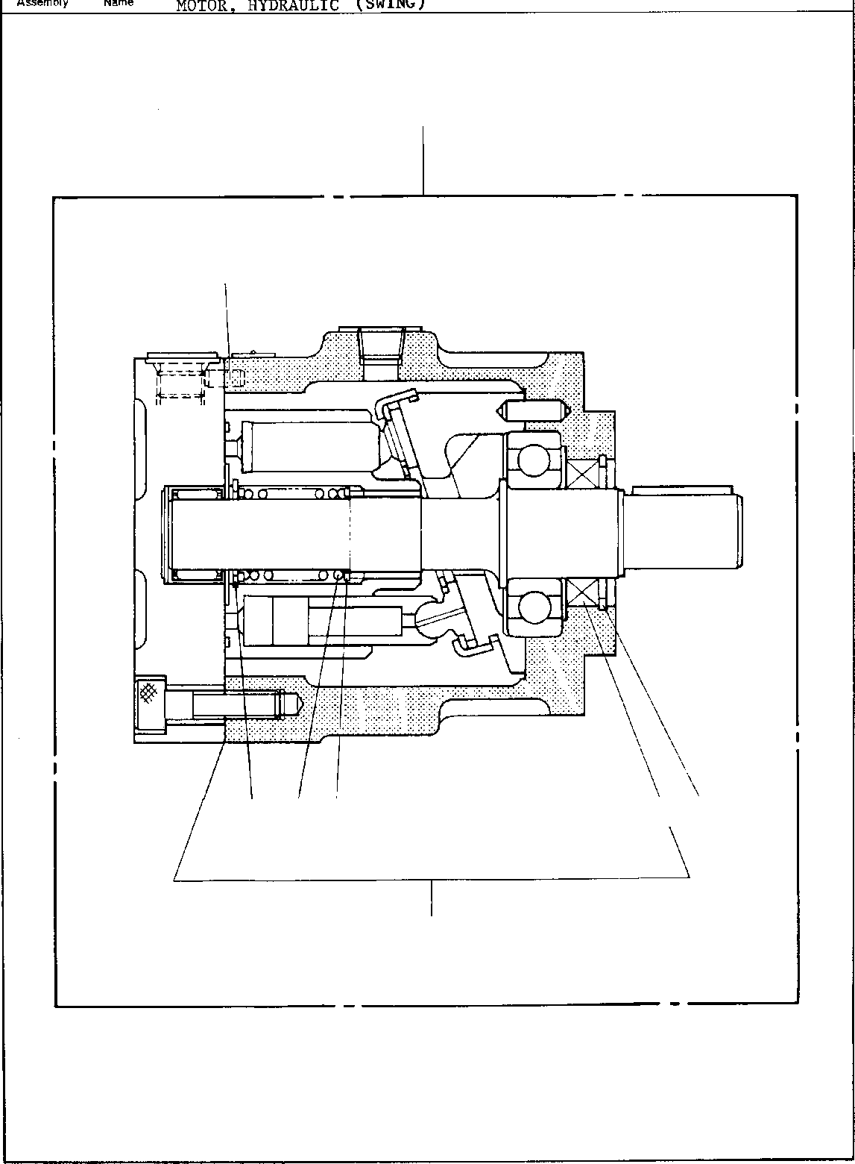

**DT-600-2-00001 UPPER**

**PI1010011-01 MOTOR,HYDRAULIC (SWING)**

**50**

**14**

**17**

**15**

**16**

**10**

**9**

**30**

**DT-600-2-00001 UPPER**

**000042**

Pos No.

Parts No

Parts Name

Qty

Unit

Technical Data

Serial No (Start)

Serial No (End)

Re

9

10

14

15

16

17

30

50

36660515010

36660515020

80730060012

36660515030

36660515040

36660515050

36660515060

36660510000

WASHER SPRING PIN

RING,RETAINING RING,RETAINING SEAL,OIL

SEAL KIT (REPAIR KIT) MOTOR,HYDRAULIC (SWING)

2

1

2

1

1

1

1

1

6X12

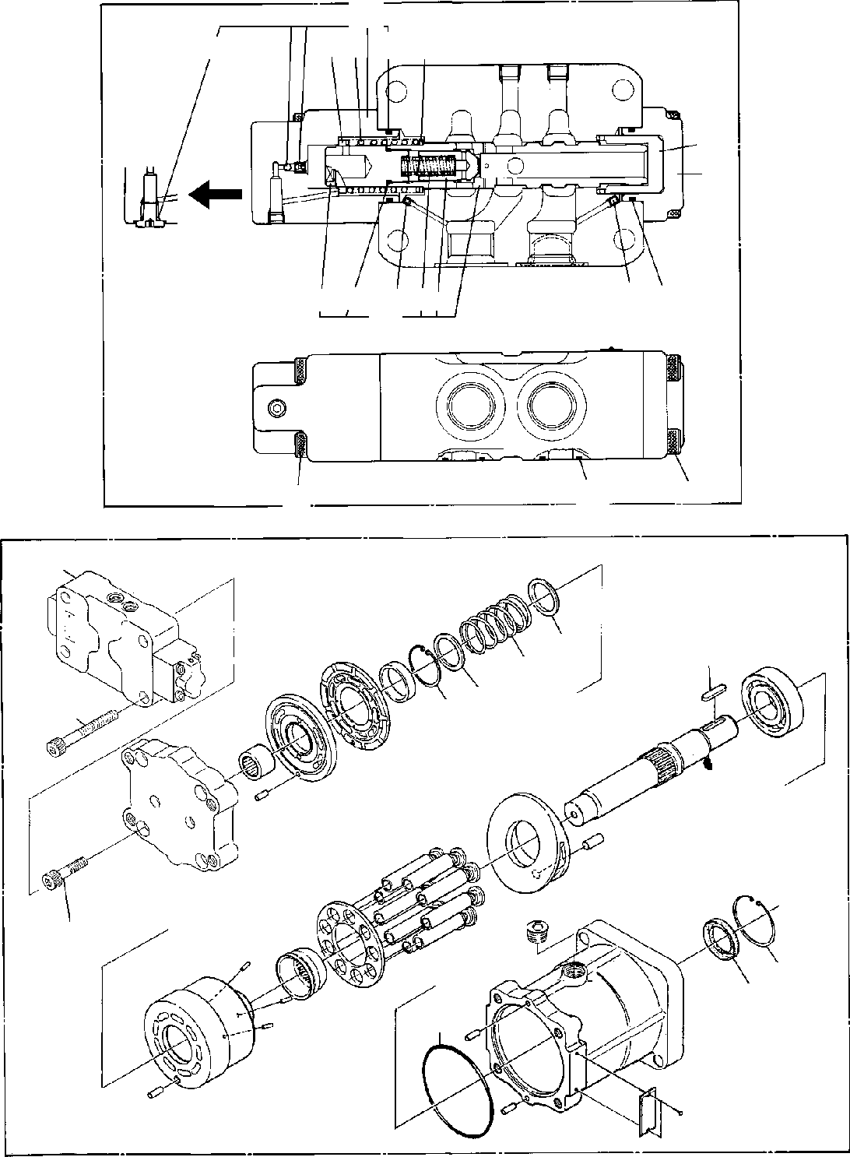

**DT-600-2-00001 UPPER**

**PI1010145-00 MOTOR,HYDRAULIC**

**35**

**46**

**4543 53**

**44**

**76**

**48**

**47**

**58 53**

**64 65 57 63**

**42**

**54**

**50**

**49**

**100**

**35**

**12**

**32**

**18**

**19 13**

**36**

**31**

**20**

**29**

**23**

**DT-600-2-00001 UPPER**

**000043**

Pos No.

Parts No

Parts Name

Qty

Unit

Technical Data

Serial No (Start)

Serial No (End)

Rem

12

13

18

19

20

23

29

31

32

35

36

42

43

44

45

46

47

48

49

50

53

54

57

58

63

64

65

76

100

36660825010

36660825020

36660825030

36660825040

36660825050

91001211500

36660825060

90131712040

36660825070

36660825080

90131712070

36660825090

36660825120

36660825190

36660825130

36660825140

36660825200

36660825150

36660825210

36660825160

36600755030

90131710060

90131710030

91002904000

91002802200

36660825170

36660825180

36660825100

36660825110

91002801800

91002800800

36660820000

GUIDE,SPRING GUIDE,SPRING SPRING RING,RETAINING RING,RETAINING O-RING SEAL,OIL

BOLT,HEXAGON SOCKET KEY VALVE,COUNTERBALANCE BOLT,HEXAGON SOCKET PLUNGER ASSY

SPRING SPRING SEAT,SPRING SEAT,SPRING SEAT,SPRING CAP ASSY CAP ASSY CAP

CAP

BOLT,HEXAGON SOCKET BOLT,HEXAGON SOCKET O-RING

O-RING ORIFICE ORIFICE <0.6. SPRING PLUG

O-RING O-RING

MOTOR,HYDRAULIC

1

1

1

1

1

1

1

4

1

1

4

1

1

1

1

1

1

1

1

1

1

4

4

2

2

1

1

1

1

1

1

1

1A G115 M12X40

M12X70

M10X60 M10X30 1B G40

1B P22

1.2

1B P18

1B P8

275041

275041

275387

275387

275040

275040

275386

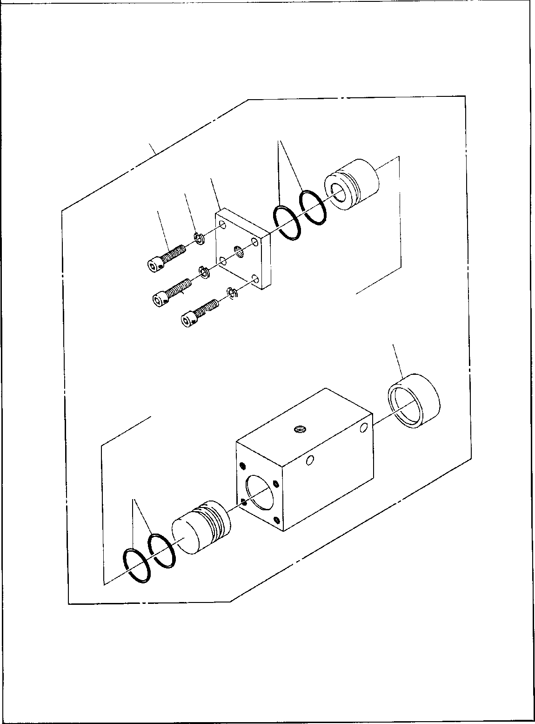

**DT-600-2-00001 UPPER PI1060001-00 CYLINDER,BRAKE**

**4**

**10**

**5**

**6**

**7**

**6**

**7**

**6**

**7**

**8**

**4**

**DT-600-2-00001 UPPER**

**000044**

Pos No.

Parts No

Parts Name

Qty

Unit

Technical Data

Serial No (Start)

Serial No (End)

Rema

4

5

6

7

8

10

91002803000

36060505010

90302040801

90131508025

36060505020

36060500000

O-RING COVER

WASHER,SPRING BOLT,HEXAGON SOCKET BOOT

CYLINDER,BRAKE

4

1

4

4

1

1

1B P30

8

M8X25

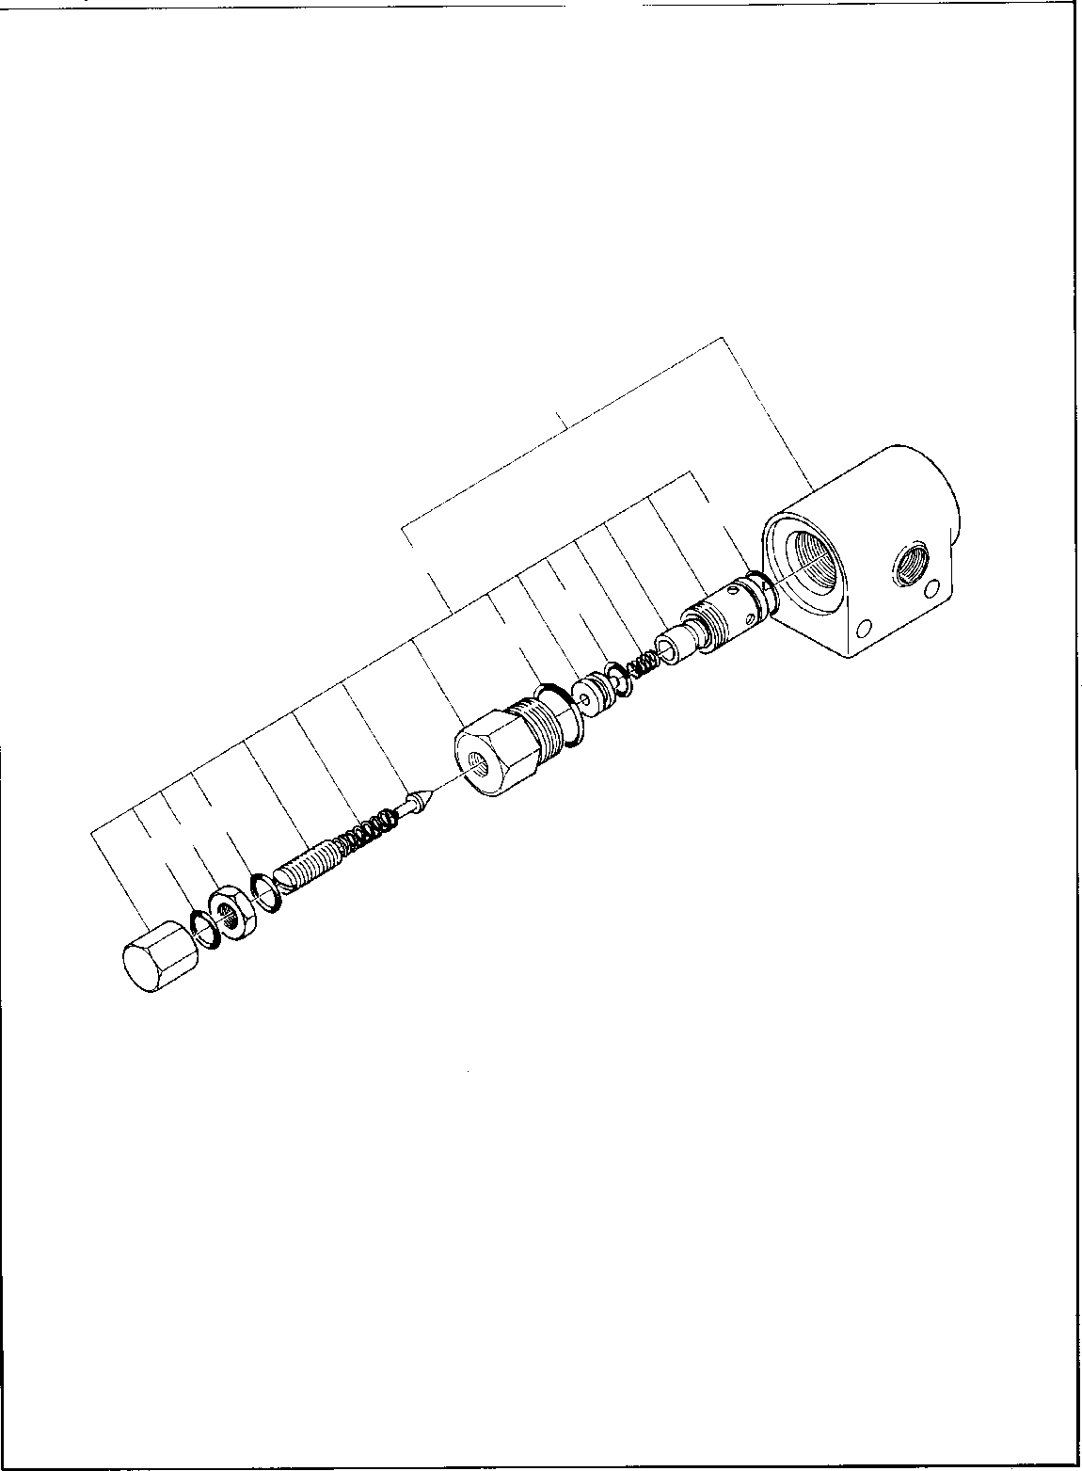

**DT-600-2-00001 UPPER PI1100006-01 VALVE,RELIEF**

**30**

**4**

**20**

**6**

**5**

**14**

**14**

**DT-600-2-00001 UPPER**

**000045**

Pos No.

Parts No

Parts Name

Qty

Unit

Technical Data

Serial No (Start)

Serial No (End)

Remarks

Pages

4

5

6

14

20

30

91000501500

91002802200

91002801001

91001001600

58355102000

36601080000

O-RING O-RING O-RING O-RING

VALVE,RELIEF VALVE,RELIEF

1

1

1

2

1

1

AS568-015 1B P22

1B P10A

1A S16

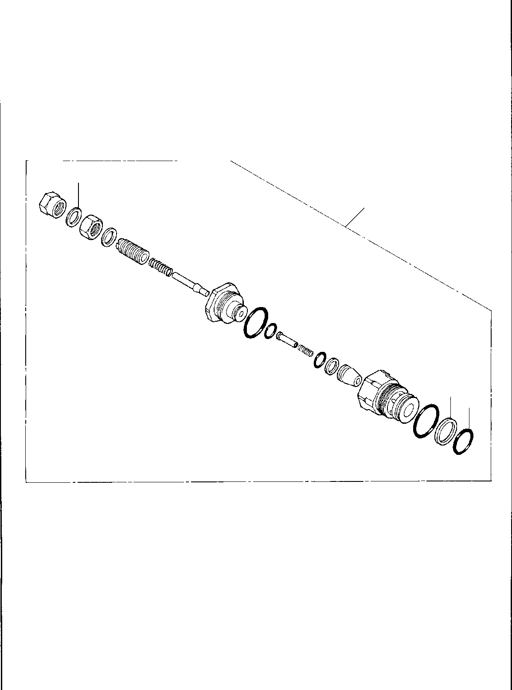

**DT-600-2-00001 UPPER PI1100008-01 VALVE,RELIEF**

**14**

**14**

**20**

**9**

**2**

**1**

**DT-600-2-00001 UPPER**

**000046**

Pos No.

Parts No

Parts Name

Qty

Unit

Technical Data

Serial No (Start)

Serial No (End)

Remarks

Pages

1

2

9

14

20

36631065140

36631065130

91001102100

36601765010

36601760000

O-RING RING,BACKUP O-RING GASKET VALVE,RELIEF

1

1

1

1

1

1A P21

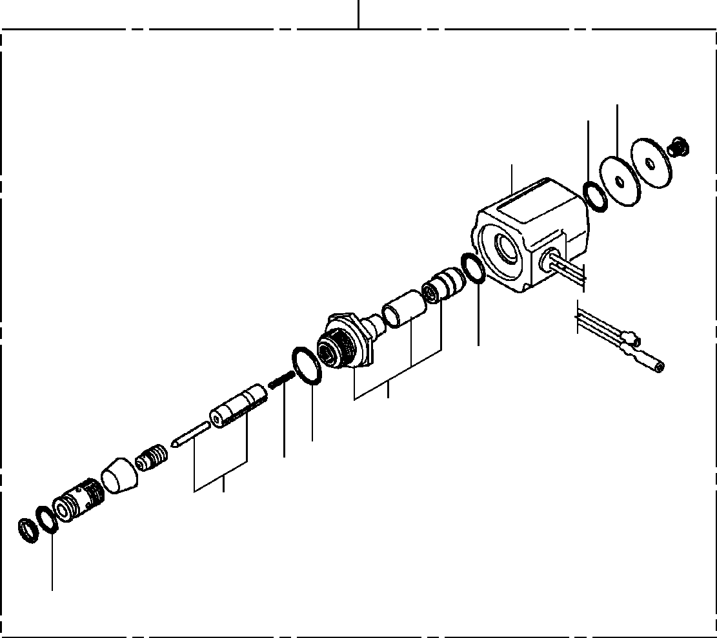

**DT-600-2-00001 UPPER PI1120034-01 VALVE,SOLENOID**

**30**

**14**

**12**

**13**

**12**

**22**

**8**

**7**

**21**

**2**

**DT-600-2-00001 UPPER**

**000047**

Pos No.

Parts No

Parts Name

Qty

Unit

Technical Data

Serial No (Start)

Serial No (End)

Remarks

Pa

2

7

8

12

13

14

21

22

30

36641465020

36641465040

36641465050

91001101120

36641465060

36641465070

36641465080

36641465090

36641460000

O-RING SPRING O-RING O-RING

SOLENOID PLATE PLUNGER ASSY BODY ASSY

VALVE,SOLENOID

1

1

1

2

1

1

1

1

1

1A P11.2

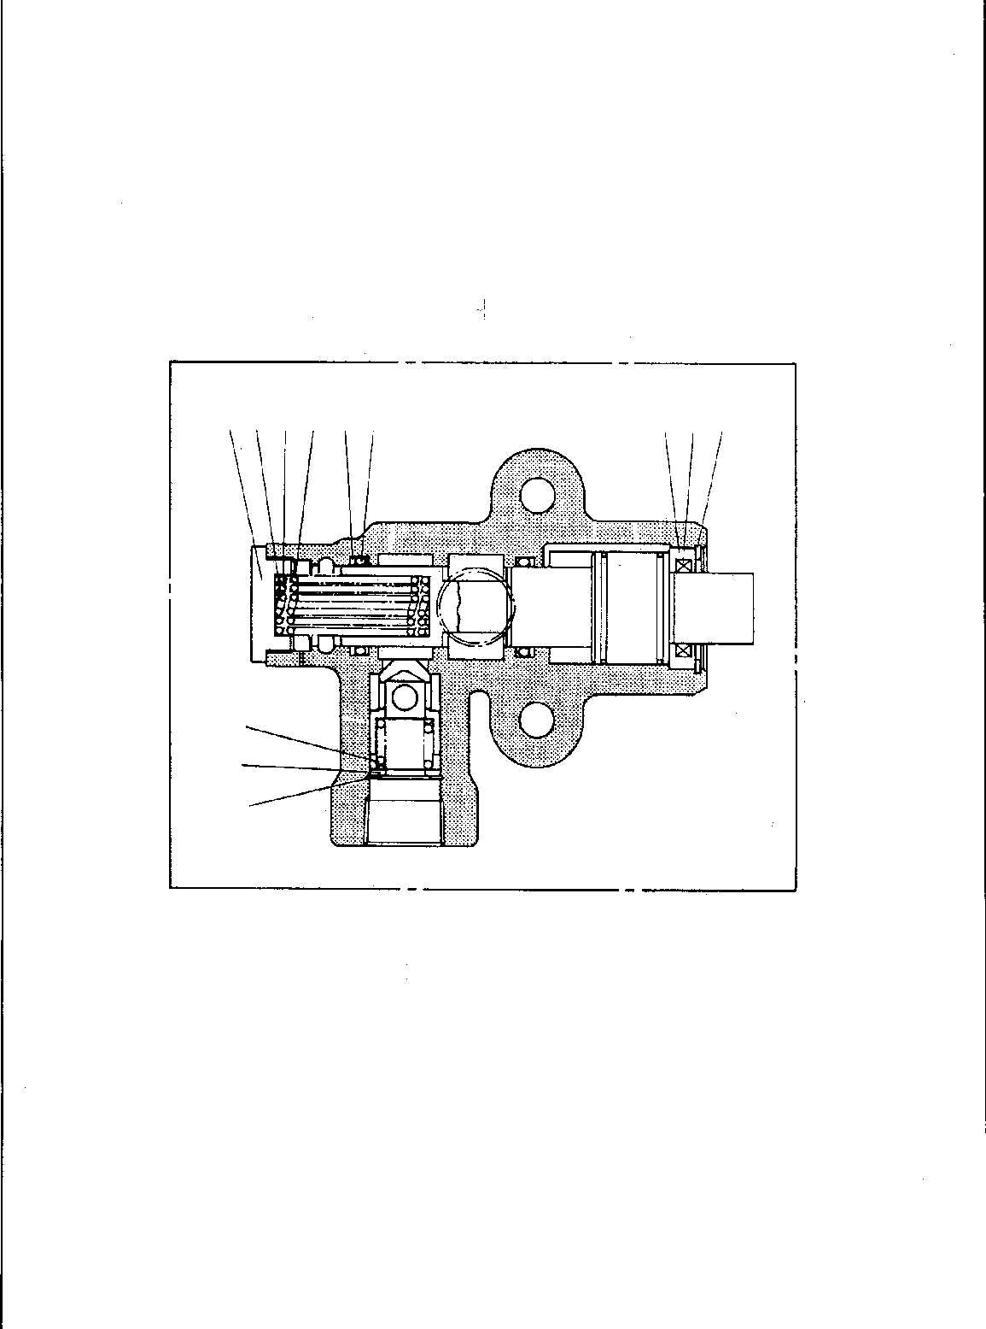

**DT-600-2-00001 UPPER PI1140010-00 VALVE,CHECK**

**50**

**4 1615 81112**

**6 9 14**

**10**

**7**

**13**

**DT-600-2-00001 UPPER**

**000048**

Pos No.

Parts No

Parts Name

Qty

Unit

Technical Data

Serial No (Start)

Serial No (End)

Remarks

Page

4

6

7

8

9

10

11

12

13

14

15

16

50

36620715010

36620715020

36620715030

36620715040

36620715050

36620715060

91411002500

91001102500

80602110220

80602110380

36620715070

36620715080

36620710000

CAP COVER SEAT SPRING (A) SEAL,DUST SPRING

RING,BACKUP O-RING RING,RITAINING RING,RITAINING SPRING (C) SPRING (D) VALVE,CHECK

1

1

1

1

1

1

2

2

1

1

1

1

1

P25

1A P25 R22 R38

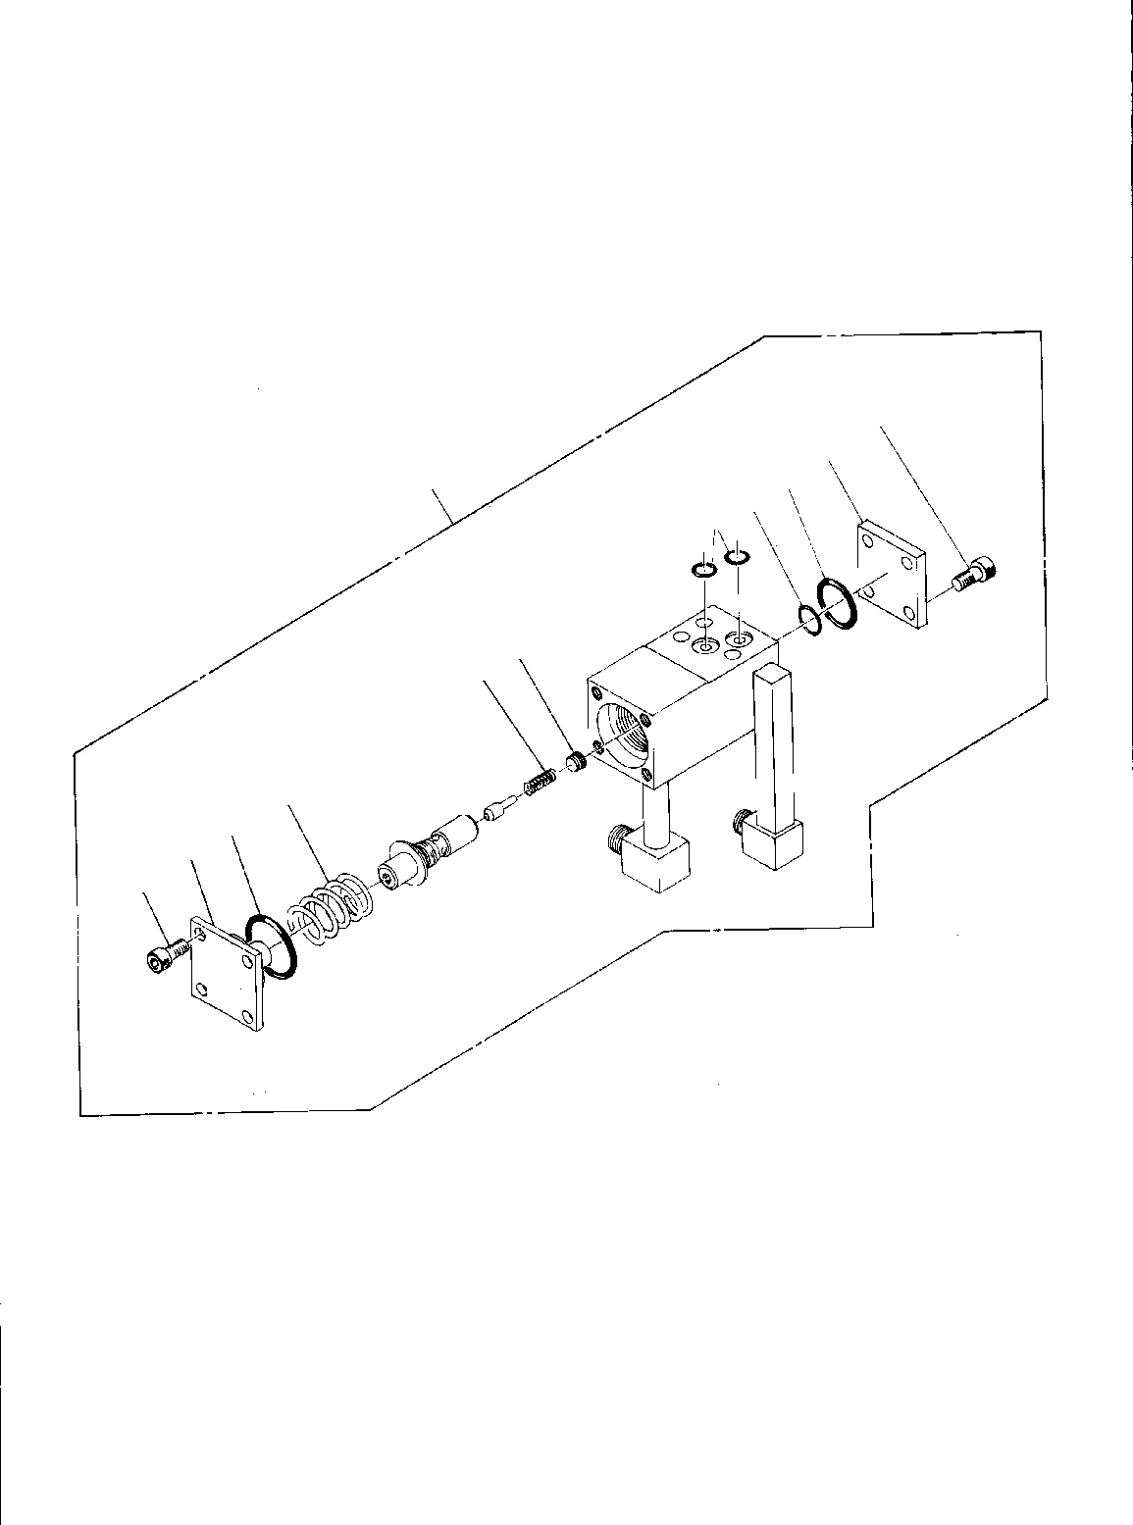

**DT-600-2-00001 UPPER**

**PI1250035-00 VALVE,COUNTERBALANCE**

**1**

**12**

**10**

**8**

**20**

**13**

**9 11**

**4**

**3**

**2**

**1**

**DT-600-2-00001 UPPER**

**000049**

Pos No.

Parts No

Parts Name

Qty

Unit

Technical Data

Serial No (Start)

Serial No (End)

Rem

1

2

3

4

8

9

10

11

12

13

20

90131708018

36600160010

91002803800

36600070020

91002801600

36600070070

91002802800

80316030020

36600870030

91002801500

36601770000

BOLT,HEXAGON SOCKET COVER

O-RING SPRING O-RING SPRING O-RING PLUG COVER O-RING

VALVE,COUNTERBALANCE

8

1

1

1

1

1

1

1

1

2

1

M8X18 1B P38

1B P16

1B P28 PT1/8

1B P15

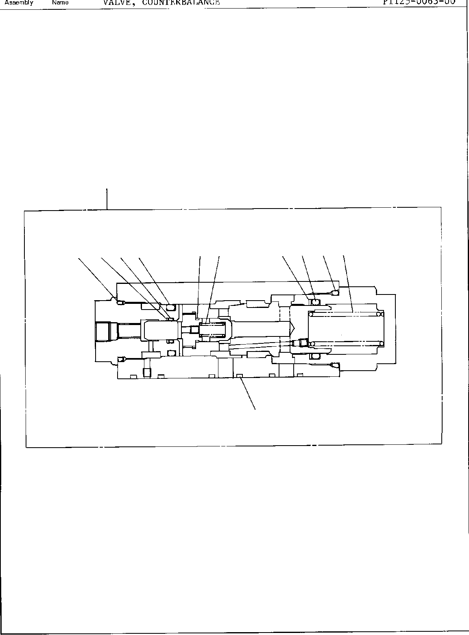

**DT-600-2-00001 UPPER**

**PI1250063-00 VALVE,COUNTERBALANCE**

**50**

**15 14 13 11**

**10 7**

**18 21 20 19**

**3**

**DT-600-2-00001 UPPER**

**000050**

Pos No.

Parts No

Parts Name

Qty

Unit

Technical Data

Serial No (Start)

Serial No (End)

Rem

3

7

10

11

13

14

15

18

19

20

21

50

91002801400

36601665020

91001001600

36601665030

91002803400

36601665050

91410002500

91002802600

91001301600

91002801000

91410001000

36603110000

O-RING SPRING O-RING SPRING O-RING O-RING

RING,BACKUP O-RING

O-RING O-RING

RING,BACKUP VALVE,COUNTERBALANCE

3

1

1

1

1

1

1

1

1

1

1

1

1B P14

1A S16

1B P34 P25 P25

1B P26 WP16 1B P10 P10

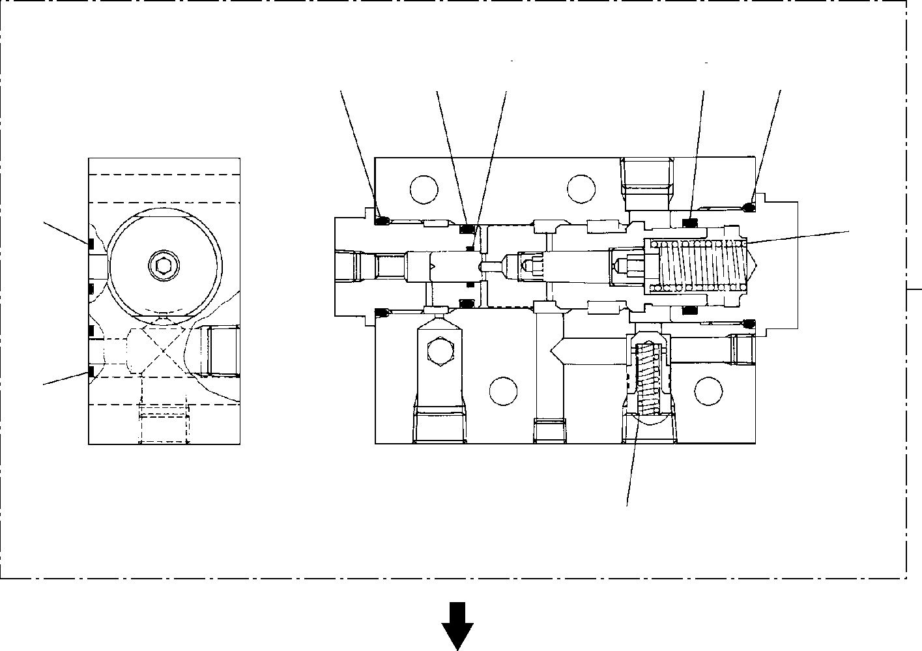

**DT-600-2-00001 UPPER**

**PI1250105-01 VALVE,COUNTERBALANCE**

**21**

**11**

**20**

**8**

**13**

**12**

**9**

**18**

**6**

**50**

**18**

**15**

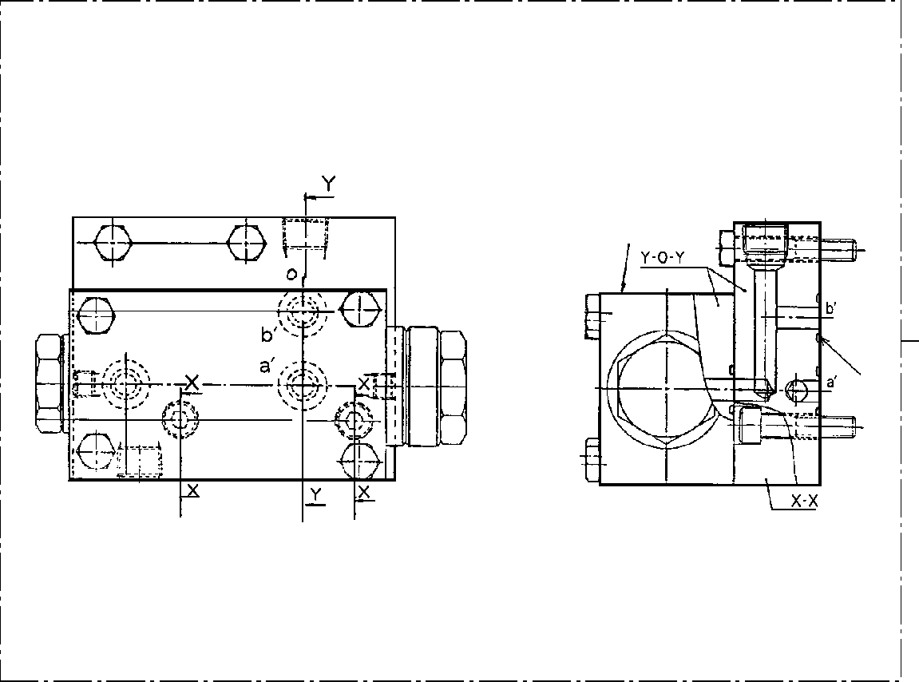

**DT-600-2-00001 UPPER**

**PI1250105-01 VALVE,COUNTERBALANCE**

**34**

**50**

**18**

**DT-600-2-00001 UPPER**

**000051**

Pos No.

Parts No

Parts Name

Qty

Unit

Technical Data

Serial No (Start)

Serial No (End)

Rem

6

8

9

11

12

13

15

18

20

21

50

36601665010

91002802500

91002803400

91002801000

91001301600

91002802800

36601035070

91002801400

91410002500

91410001000

36601030000

SPRING (A) O-RING

O-RING O-RING O-RING O-RING

SPRING (B) O-RING

RING,BACKUP RING,BACKUP VALVE,COUNTERBALANCE

1

1

1

1

1

1

1

3

1

1

1

1B P25

1B P34

1B P10 WP16 1B P28

1B P14 P25 P10

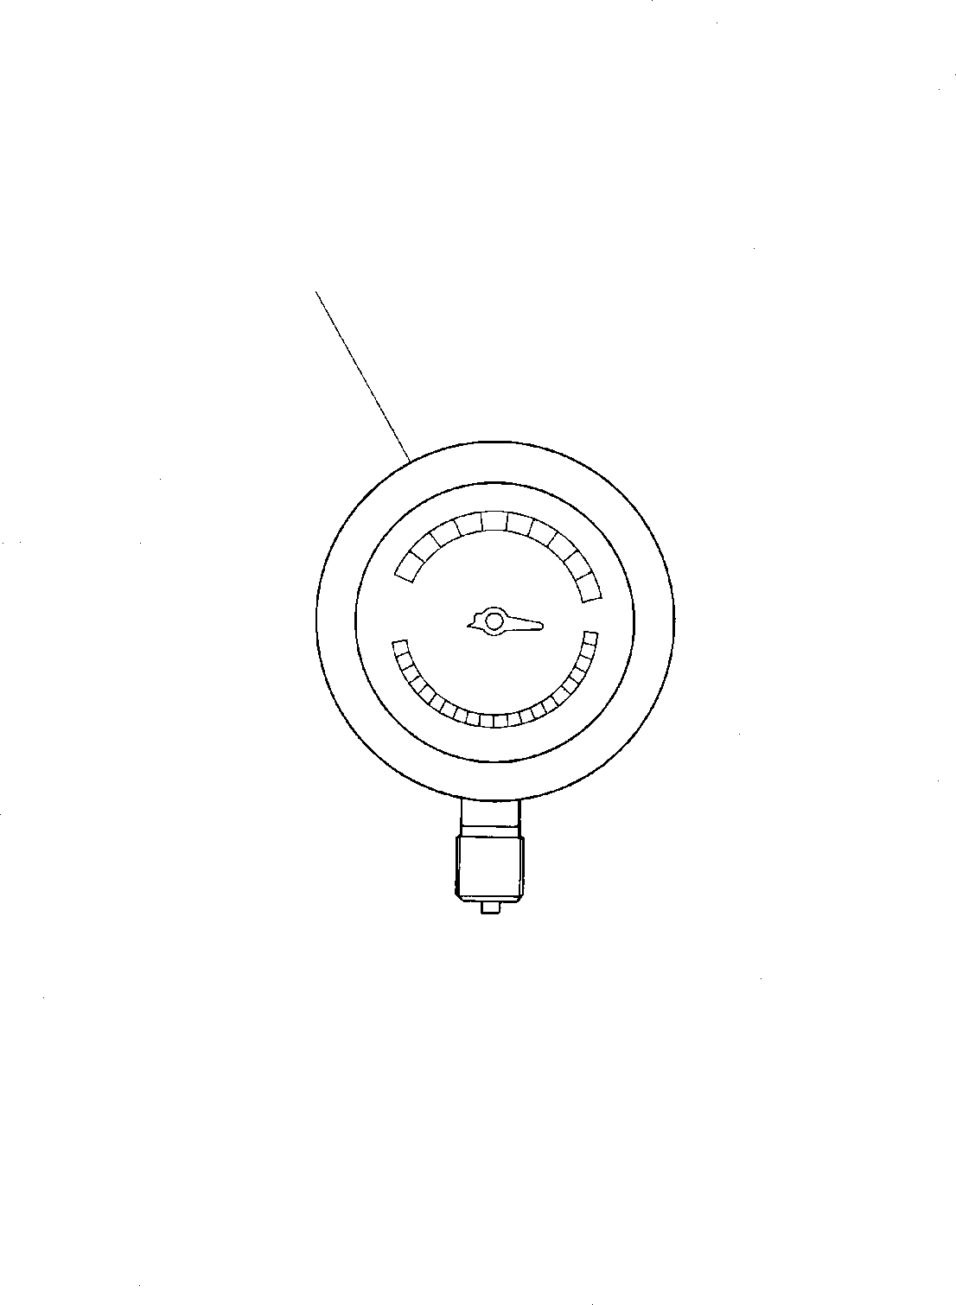

**DT-600-2-00001 UPPER PI1440007-00 METER,LOAD**

**1**

**DT-600-2-00001 UPPER**

**000052**

Pos No.

Parts No

Parts Name

Qty

Unit

Technical Data

Serial No (Start)

Serial No (End)

Remarks

Pages

1

36681030000

METER,LOAD

1

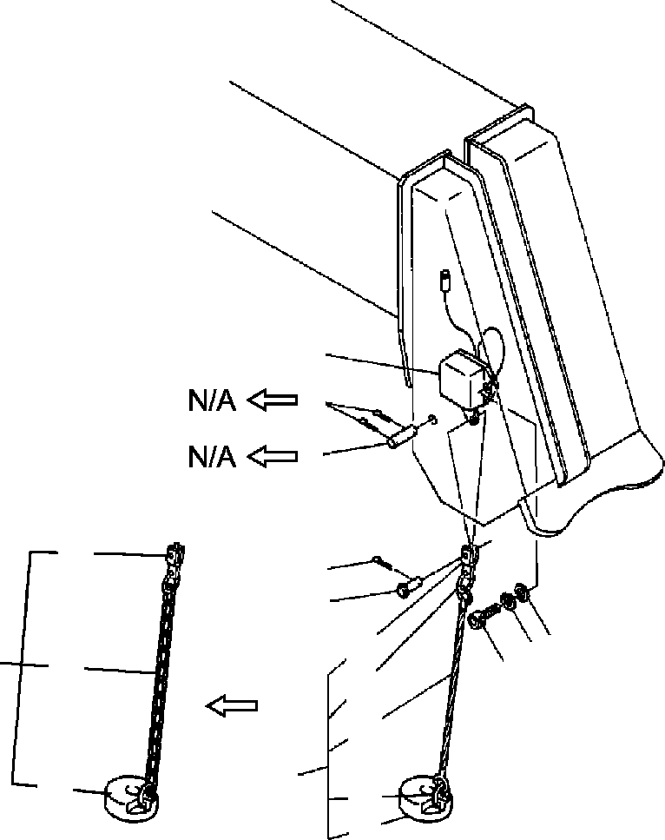

**DT-600-2-00001 UPPER**

**PI5070003-00 INDICATOR ASSY,OVERWIND**

**7**

**5**

**4**

**24**

**9**

**8**

**32**

**24**

**22**

**23**

**10**

**33**

**1**

**10**

**21**

**22**

**21**

**DT-600-2-00001 UPPER**

**000053**

Pos No.

Parts No

Parts Name

Qty

Unit

Technical Data

Serial No (Start)

Serial No (End)

See a

1

2

3

4

5

7

8

9

10

21

22

23

24

33

*

90131506016

90303070601

90302040601

37000128780

80136340018

32370081000

37000120180

90000000090

32370070010

32370080100

32370072010

31371923000

14128208000

37001902460

37001905070

32370020060

32472090200

32370080200

BOLT,HEXAGON SOCKET WASHER,PLAIN WASHER,SPRING

PIN PIN,SPLIT

SWITCH ASSY PIN

RING

WEIGHT ASSY WEIGHT ASSY WEIGHT WEIGHT

RING ROPE,WIRE ROPE,WIRE END

CHAIN ASSY CHAIN ASSY

2

2

2

1

2

1

1

1

1

1

1

1

2

1

1

1

1

1

M6X16 6

6

4X18

3X0.375M

275712

275712

275301

275703

275712

275713

275713

275711

275711

275702

275300

275702

275711

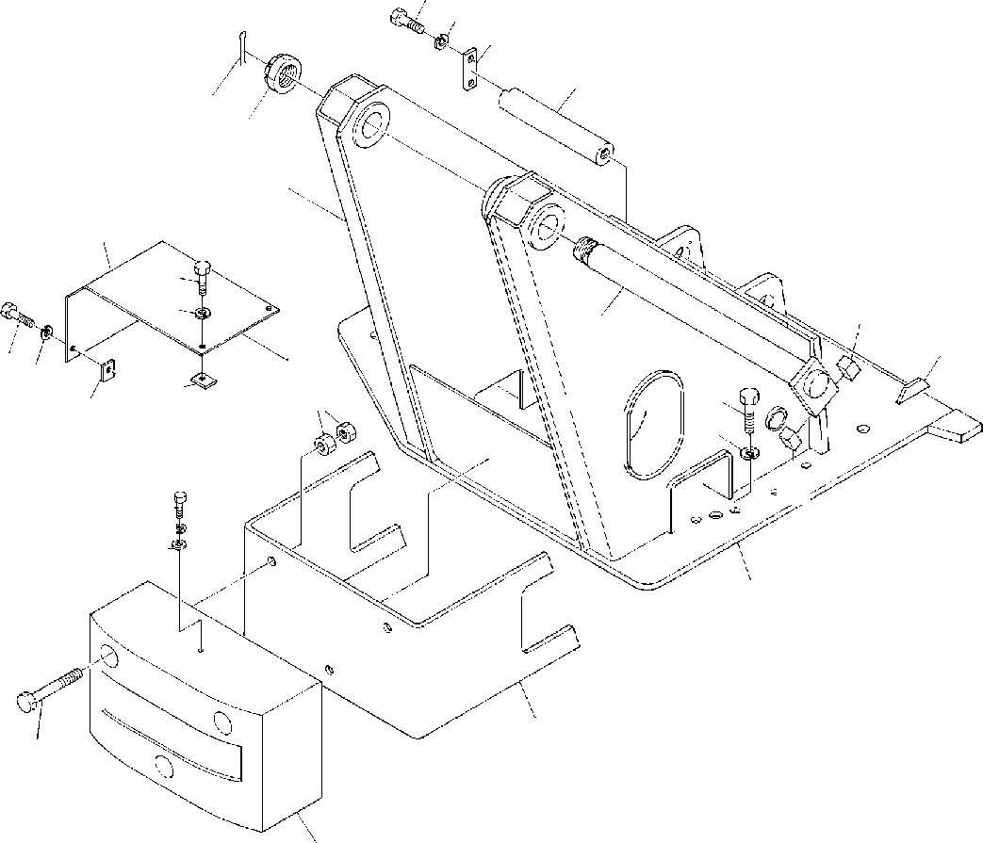

**DT-600-2-00001 UPPER PK1100046-00 SWING FRAME**

**6**

**7**

**5**

**8**

**3**

**2**

**21**

**23**

**24**

**15**

**1**

**16**

**2324**

**22**

**11**

**12**

**10**

**22**

**15**

**6**

**7**

**17**

**4**

**14**

**9**

**13**

**DT-600-2-00001 UPPER**

**000054**

Pos No.

Parts No

Parts Name

Qty

Unit

Technical Data

Serial No (Start)

Serial No (End)

Remarks

Pa

1

2

3

4

5

6

7

8

9

10

11

12

13

14

15

16

17

21

22

23

24

37000127630

37001600330

80136380071

32230070010

37000507400

90101210022

90302041001

37000114710

90101216140

90101216160

90201201600

37001501320

90302041601

90303501601

32230070020

32230070040

32230070030

32230070050

37000525160

32230010020

90303071001

32270040010

37000508890

90101208012

90302040801

PIN NUT,CASTLE PIN,SPLIT

TABLE,SLEWING PLATE

BOLT WASHER,SPRING PIN

BOLT BOLT NUT BOLT

WASHER,SPRING WASHER,PLAIN WEIGHT

WEIGHT SUPPORT SUPPORT BAR PLATE

WASHER,PLAIN COVER

PLATE BOLT

WASHER,SPRING

1

1

1

1

1

3

3

1

3

3

6

26

26

26

1

1

1

1

2

1

1

1

4

4

4

8X71

M10X22 10

M16X140 M16X160 M16 M16X60 16

16

10

M8X12 8

275134

275122

275134

275134

275133

275121

275133

275133

275133

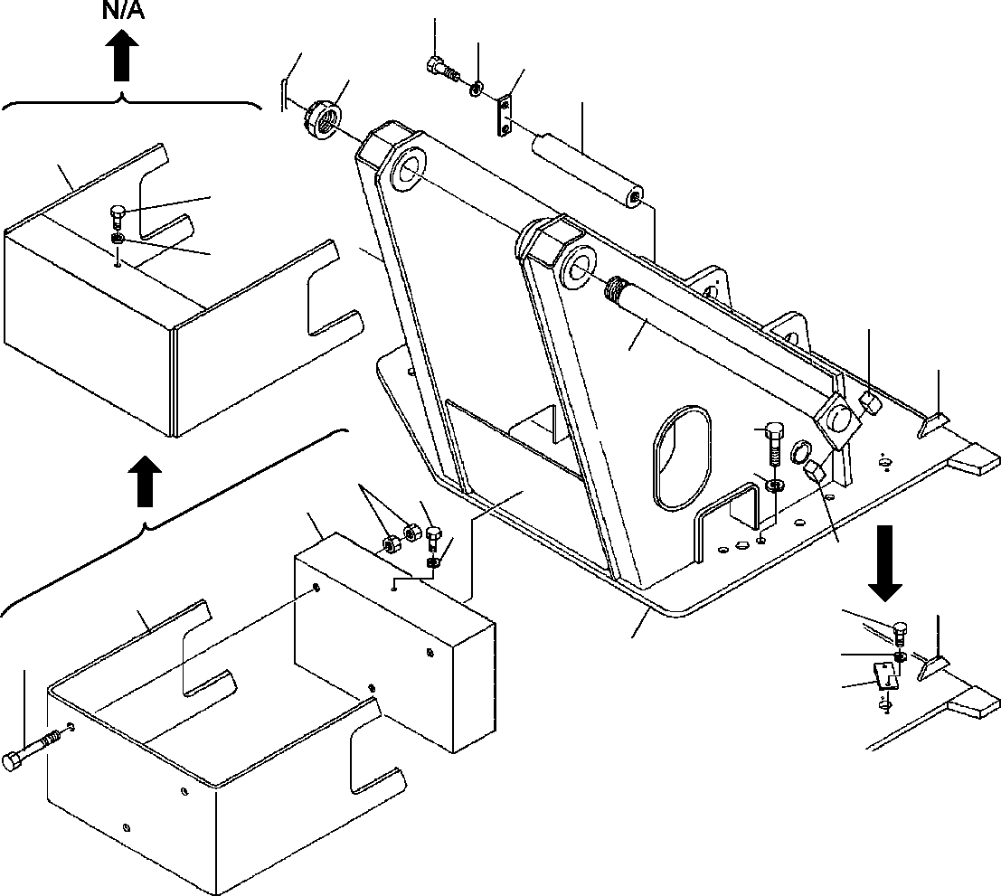

**DT-600-2-00001 UPPER PK1100191-01 SWING FRAME**

**6**

**7**

**3**

**5**

**2**

**8**

**34**

**6**

**7**

**15**

**16**

**1**

**11**

**12**

**10**

**6**

**13**

**7**

**15**

**14**

**16**

**18**

**7**

**17**

**9**

**4**

**DT-600-2-00001 UPPER**

**000055**

Pos No.

Parts No

Parts Name

Qty

Unit

Technical Data

Serial No (Start)

Serial No (End)

Remarks

Pa

1

2

3

4

5

6

7

8

9

10

11

12

13

14

15

16

17

18

34

37000152000

37001600330

80136380071

32230328010

37000507400

90101210022

90101210022

90302041001

90302041001

90302041001

37000152950

90101216160

90201201600

37001505940

90303501805

32230070040

32230070050

37000525160

32230010020

37000518610

90101210016

32230070060

PIN NUT,CASTLE PIN,SPLIT

TABLE,SLEWING PLATE

BOLT BOLT

WASHER,SPRING WASHER,SPRING WASHER,SPRING PIN

BOLT NUT BOLT

WASHER,PLAIN WEIGHT SUPPORT

BAR PLATE PLATE BOLT SUPPORT

1

1

1

1

1

3

2

3

5

4

1

3

6

29

29

1

1

2

1

1

2

1

8X71

M10X22 M10X22 10

10

10

M16X160 M16 M18X60 18

M10X16

275309

275236

275309

275236

275236

275213

275308

275235

275308

275212

275212

275212

275212

275308

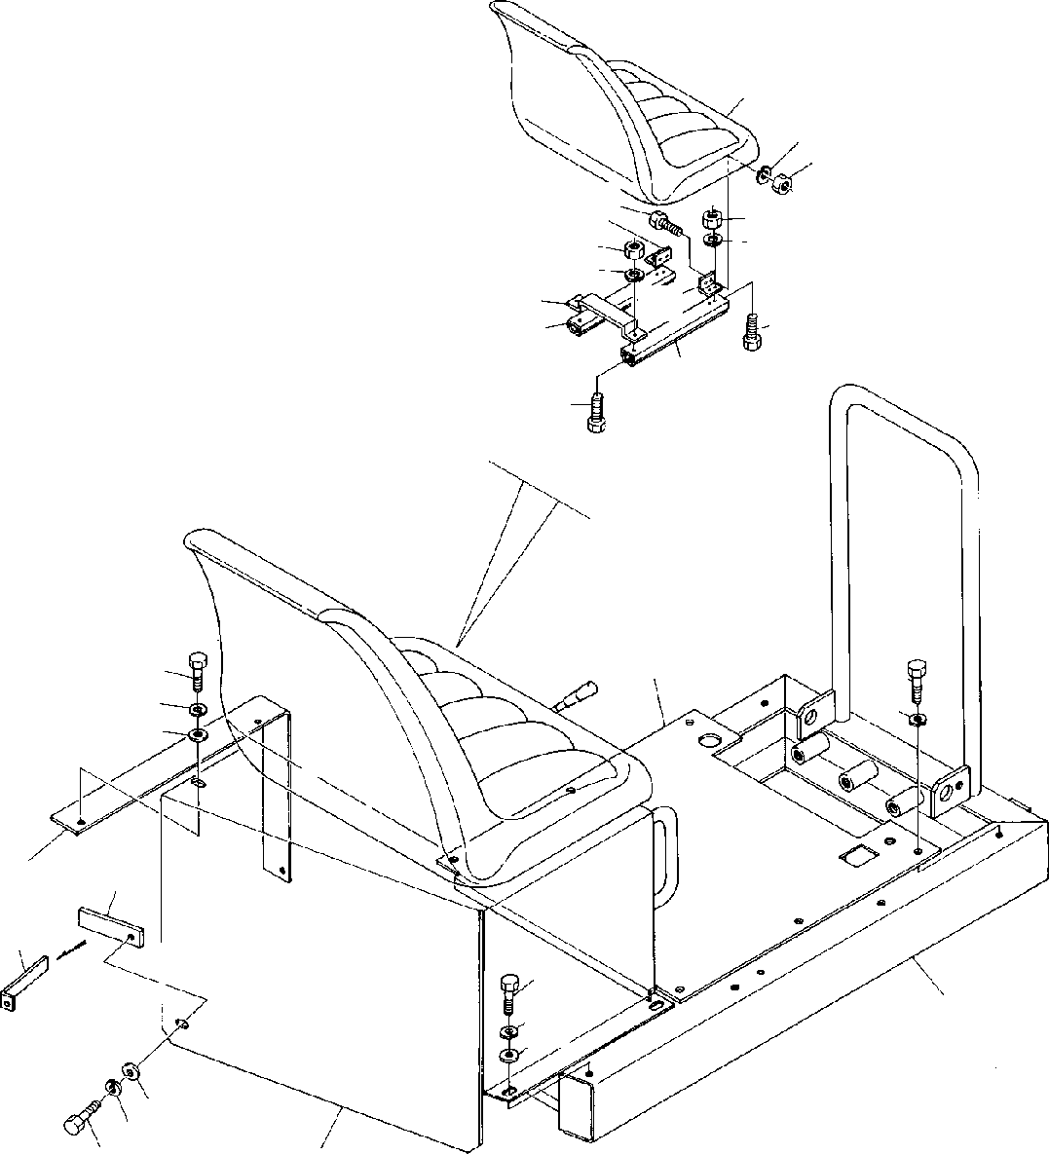

**DT-600-2-00001 UPPER PK1120052-03 SWING TABLE**

**21**

**28**

**27**

**26**

**27**

**28**

**29**

**27**

**28**

**25**

**24**

**22**

**26**

**23**

**26**

**6**

**1**

**2**

**8**

**1**

**2**

**3**

**9**

**9**

**1**

**2**

**8**

**7**

**8**

**2**

**1**

**4**

**DT-600-2-00001 UPPER**

**000056**

Pos No.

Parts No

Parts Name

Qty

Unit

Technical Data

Serial No (Start)

Serial No (End)

Rema

1

2

3

4

6

7

8

9

21

22

23

24

25

26

27

28

29

90101208016

90302040801

32250050010

32250050020

32250050050

32250050030

32250050040

90303070801

37000521820

32250050100

32250041100

32250043010

32250041300

32250041200

32250043020

90131508018

90131508016

90201200800

90302040801

32250043030

BOLT WASHER,SPRING SUPPORT COVER

COVER COVER FRAME

WASHER,PLAIN PLATE SUPPORT SEAT SUPPORT ADJUSTER ADJUSTER SUPPORT

BOLT,HEXAGON SOCKET BOLT,HEXAGON SOCKET NUT

WASHER,SPRING SUPPORT

12

12

1

1

1

1

1

6

1

1

1

1

1

1

1

10

10

10

10

1

M8X16 8

8

M8X18 M8X16 M8

8

275090

275309

275274

275089

275308

275273

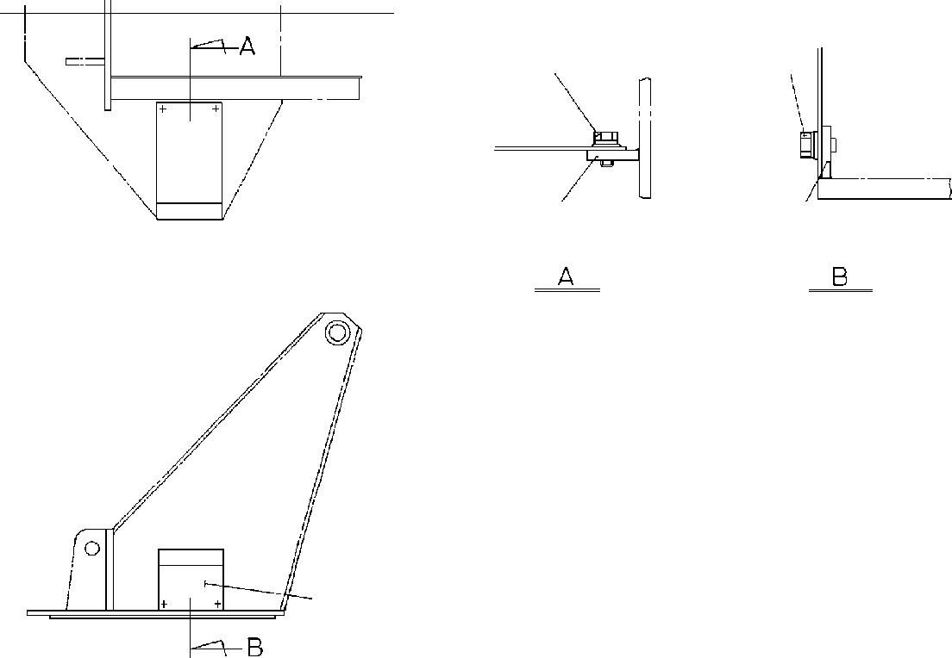

**DT-600-2-00001 UPPER**

**PK1200137-00 COVER,SWING FRAME**

**3 4**

**3 4**

**2**

**2**

**1**

**DT-600-2-00001 UPPER**

**000057**

Pos No.

Parts No

Parts Name

Qty

Unit

Technical Data

Serial No (Start)

Serial No (End)

Remarks

Pa

1

2

3

4

32270040010

37000508890

90101208012

90302040801

COVER PLATE BOLT

WASHER,SPRING

1

4

4

4

M8X12 8

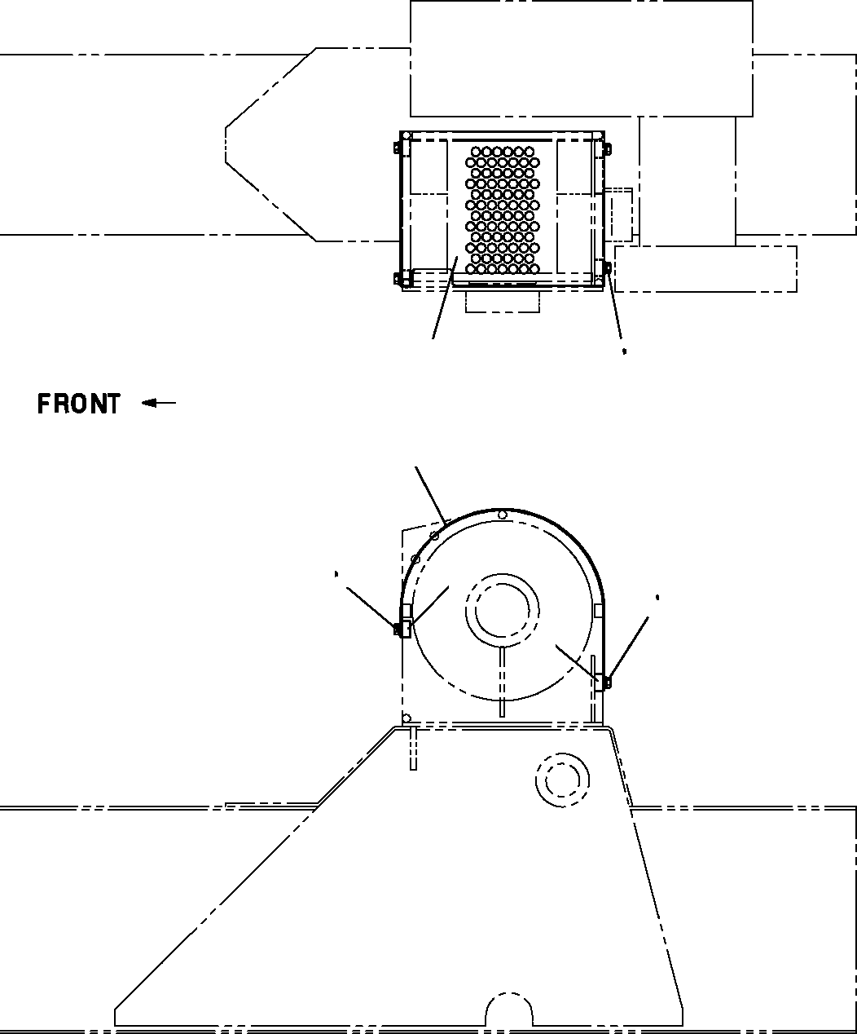

**DT-600-2-00001 UPPER PK1330253-00 COVER (WINCH)**

**1**

**3 4**

**5**

**1**

**3 4**

**5**

**2**

**3 4**

**5**

**2**

**DT-600-2-00001 UPPER**

**000058**

Pos No.

Parts No

Parts Name

Qty

Unit

Technical Data

Serial No (Start)

Serial No (End)

Remarks

Pa

1

2

3

4

5

32472600100

32472602000

37000541030

90101208012

90302040801

90303070801

COVER COVER PLATE BOLT

WASHER,SPRING WASHER,PLAIN

1

1

4

4

4

4

M8X12 8

8

275454

275453

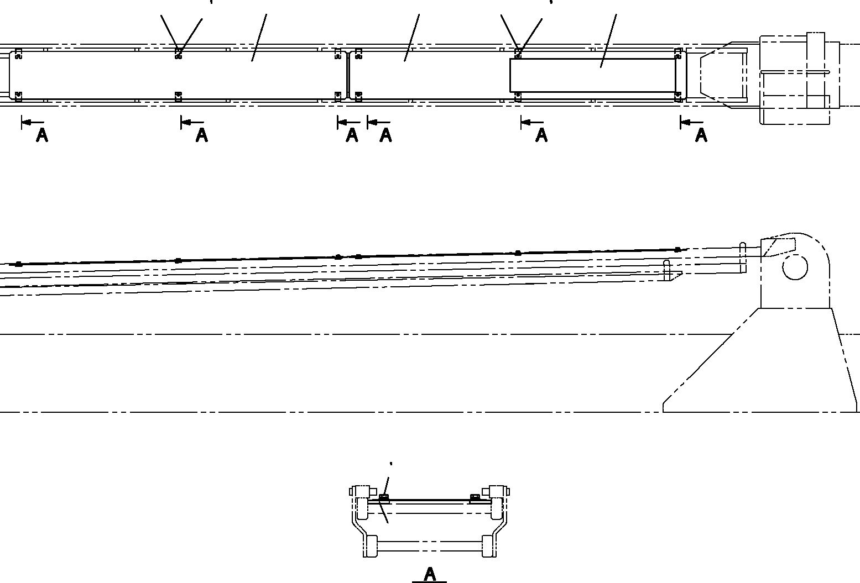

**DT-600-2-00001 UPPER**

**PK1330414-00 COVER (WIRE GUARD:2 PCS)**

**2 3**

**4**

**2 3**

**4**

**6**

**1**

**1**

**6**

**5**

**2 3**

**4**

**6**

**DT-600-2-00001 UPPER**

**000059**

Pos No.

Parts No

Parts Name

Qty

Unit

Technical Data

Serial No (Start)

Serial No (End)

Remarks

Pa

1

2

3

4

5

6

32472830100

90101208014

90302040801

90303070801

32472830200

37000555360

COVER BOLT

WASHER,SPRING WASHER,PLAIN PLATE,NAME PLATE

2

12

12

12

1

12

M8X14 8

8

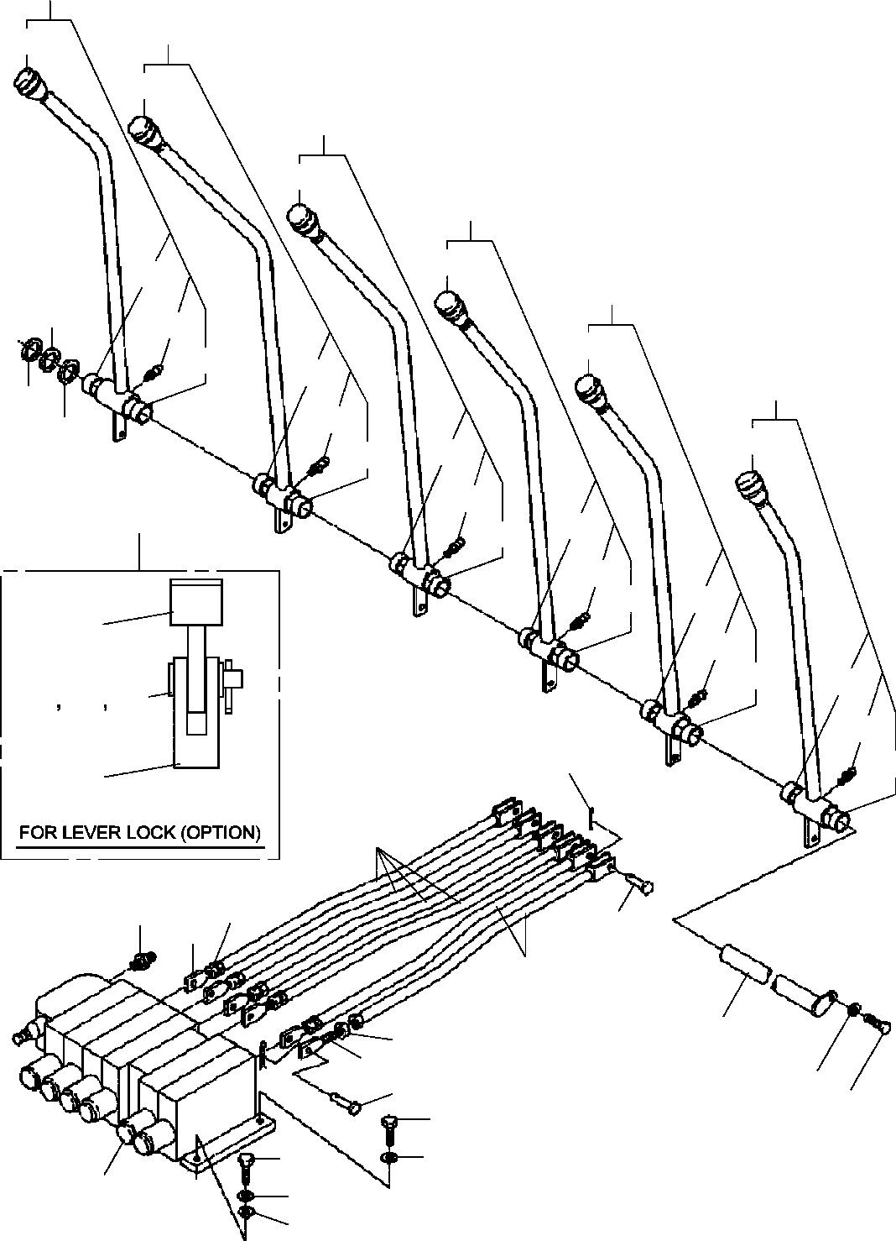

**DT-600-2-00001 UPPER**

**PL1010079-02 OPERATION SYSTEM, CONTROL VALVE**

**20**

**19**

**31**

**31**

**18**

**31**

**17**

**31**

**36**

**16**

**14**

**33**

**31**

**36**

**36**

**15**

**14**

**33**

**14**

**31**

**36**

**36**

**33**

**101**

**36**

**36**

**33**

**36**

**36**

**51**

**33**

**36**

**36**

**52**

**53**

**54**

**33**

**10**

**36**

**55**

**7**

**6**

**21**

**8**

**5**

**7**

**12**

**6**

**5**

**3**

**8**

**13**

**2**

**3**

**2**

**3**

**4**

**1**

**DT-600-2-00001 UPPER**

**000060**

Pos No.

Parts No

Parts Name

Qty

Unit

Technical Data

Serial No (Start)

Serial 27573

27508

27508

27569

1

2

3

4

5

6

7

8

10

12

13

14

15

16

17

18

19

20

21

31

33

36

51

53

54

55

101

36632280000

36638740000

90101210030

90302041001

90303071001

31320020071

90203200800

32320060010

37000120030

37000129200

80136320010

37000115680

37000135360

90101210018

37000518780

32320060020

32320060030

32320060040

32320060050

32320060060

32320060070

80456950401

31320020010

31320020020

82456106000

82456106000

82455106000

80804022010

33320001200

90303070601

80136320014

33320001210

33320001040

VALVE,MANUAL CONTROL

VALVE ASSY,SELECTOR (MANUAL CONT.) BOLT

WASHER,SPRING WASHER,PLAIN ADJUSTER

NUT ROD PIN PIN

PIN,SPLIT PIN

PIN BOLT PLATE

LEVER ASSY LEVER ASSY LEVER ASSY LEVER ASSY LEVER ASSY LEVER ASSY

JOINT,SELF SEALING (COUPLER) KNOB (BLACK)

KNOB (RED) NIPPLE,GREASE NIPPLE,GREASE NIPPLE,GREASE BEARING,PLAIN LEVER WASHER,PLAIN PIN,SPLIT SUPPORT LEVER ASSY

1

1

4

5

1

6

6

6

12

12

12

1

1

1

3

1

1

1

1

1

1

1

5

1

1

5

5

12

1

1

1

1

1

M10X30 10

10

M8

2X10

M10X18

1/4-28UNF

1/4-28UNF A-M6F FE

6

2X14

275731

275082

275082

275397

275700

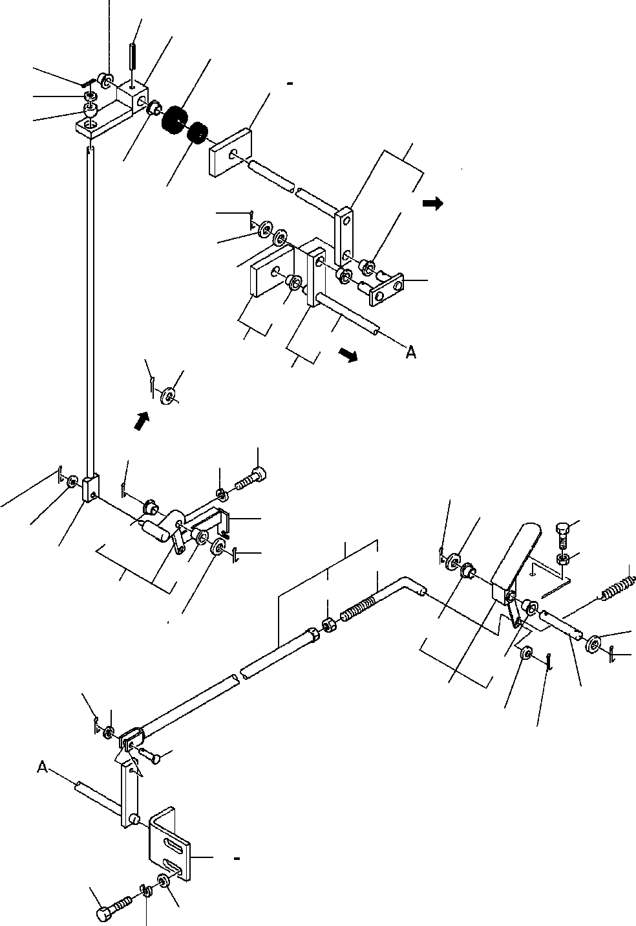

**DT-600-2-00001 UPPER**

**PL1030067-02 OPERATION SYSTEM, ACCELERATOR**

**21**

**23**

**22**

**25**

**11**

**10**

**9**

**27**

**52**

**24**

**21**

**26**

**52**

**62**

**15**

**14**

**34**

**28**

**52**

**52**

**15**

**29**

**14**

**62**

**1**

**32**

**15**

**33**

**15**

**14**

**8**

**31**

**16**

**6**

**10**

**52**

**17**

**15**

**19**

**20**

**41**

**52**

**42**

**30**

**14**

**52**

**14**

**15**

**52**

**8**

**12**

**7**

**13**

**7**

**8**

**18**

**2**

**52**

**3**

**5**

**4**

**DT-600-2-00001 UPPER**

**000061**

Pos No.

Parts No

Parts Name

Qty

Unit

Technical Data

Serial No (Start)

Serial No (End)

Remarks

Pa

1

2

3

4

5

6

7

8

9

10

11

12

13

14

15

16

17

18

19

20

21

22

23

24

25

26

27

28

29

30

31

32

33

34

41

42

52

62

32330050010

32330022010

90101210020

90302041001

90303071001

32330030020

90303070801

80136320016

32330020120

90303070601

80720102012

32330050020

37000104920

90303071201

90303071201

80136332025

90102210035

90203201000

37000105730

16314010000

32330030030

32330050060

37000400510

32330020110

80720104032

32330050030

82400000075

82400000215

32330020070

32330050040

32330050050

32330030050

32330030060

32330050070

90101208015

90302040801

42823500200

32330022130

90201200800

37000400510

37000400510

80824001208

LEVER SUPPORT BOLT

WASHER,SPRING WASHER,PLAIN ROD ASSY WASHER,PLAIN PIN,SPLIT

END WASHER,PLAIN PIN,SPRING PEDAL

PIN WASHER,PLAIN WASHER,PLAIN PIN,SPLIT BOLT

NUT PIN SPRING ROD ROD

BEARING,PLAIN LEVER PIN,SPRING SHAFT GROMMET GROMMET SUPPORT

ROD SUPPORT LEVER SUPPORT SUPPORT BOLT

WASHER,SPRING PLATE

ROD NUT

BEARING,PLAIN BEARING,PLAIN BEARING,PLAIN

1

1

2

2

2

1

2

3

1

2

1

1

1

5

6

5

1

1

1

1

1

1

2

1

1

1

1

1

1

1

1

1

1

1

2

2

2

1

1

7

2

2

M10X20 10

10

8

2X16

6

2X12

12

12

3.2X25 M10X35 M10

4X32

M8X15 8

M8

275018

275018

275018

275830

275474

275017

275017

275017

275473

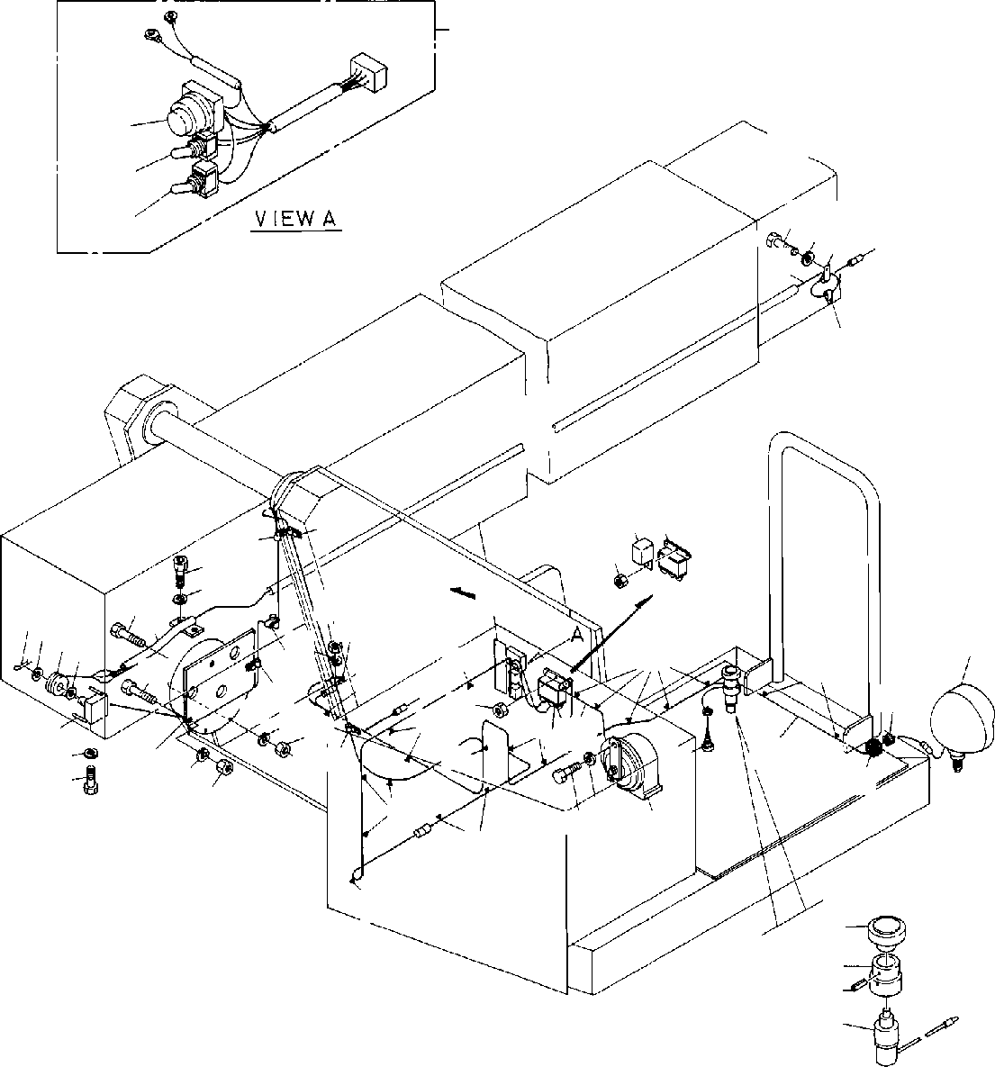

**DT-600-2-00001 UPPER**

**PN1010184-03 ELECTRICAL ACCESSORIES**

**25**

**4647**

**4344**

**4445**

**121314**

**9**

**121314**

**31**

**24**

**23**

**22**

**22**

**17**

**1**

**32**

**12**

**16**

**26**

**15**

**24**

**3 4 5**

**18**

**18**

**13**

**22**

**1140**

**4**

**18**

**18**

**18**

**28**

**20**

**24**

**21**

**1324**

**22**

**18**

**18**

**7**

**6**

**1**

**2**

**23**

**19**

**18**

**27**

**29**

**13**

**24**

**10**

**2 1**

**18**

**8**

**18**

**18**

**51**

**52**

**53**

**54**

**DT-600-2-00001 UPPER**

**000062**

Pos No.

Parts No

Parts Name

Qty

Unit

Technical Data

Serial No (Start)

Serial No (

275202

275053

275375

275053

275053

275053

275426

1

2

3

4

5

6

7

8

9

10

11

12

13

14

15

16

17

18

19

20

21

22

23

24

25

26

27

28

29

31

32

40

43

44

45

46

47

51

52

53

54

90302040801

90101208016

80136332020

90303071201

37001102460

32430080010

32430080020

82100000001

82100002600

32430030010

82400000216

82100001354

90101206012

90302040601

90302040601

82100002052

32430080030

32430080040

90131508012

82100001173

32430080050

32430100020

91810130240

31370250010

37000705910

82100000734

90201200600

90201200600

32430080060

32430100030

90101206016

32430030030

82100002002

90441340060

59481504000

82100002851

32430080030

82100000044

82100000897

82100000665

82100000895

82100001658

82100001694

42430130410

42430130450

80720103025

82100000081

WASHER,SPRING BOLT

PIN,SPLIT WASHER,PLAIN ROLLER SUPPORT HARNESS HORN

HORN (HIGH PITCH) HARNESS GROMMET

LAMP BOLT

WASHER,SPRING WASHER,SPRING CLAMP PLATE,NAME SUPPORT

BOLT,HEXAGON SOCKET <M8X12. CLAMP ASSY

HARNESS HARNESS FASTENER REEL,CORD CLAMP ASSY RELAY

NUT NUT

SWITCH ASSY

SWITCH ASSY (WITH HARNESS,3 SW) BOLT

PLATE CLAMP

SCREW,TAPPING RELAY

RELAY PLATE,NAME

BULB,LAMP (24V 60/60W> SWITCH,TOGGLE

CAP (BLACK) SWITCH,TOGGLE SWITCH,PUSH

COVER (RUBBER/BLACK) ROD

SUPPORT PIN,SPRING SWITCH,LIMIT

5

3

1

2

1

1

1

1

1

1

1

1

2

5

6

1

1

1

2

20

1

1

1

1

4

1

5

6

1

1

3

1

1

1

1

1

1

1

1

2

1

1

1

1

1

1

1

8

M8X16 3.2X20

12

L=450

L=5100 C30NG79-H 24V 60W M6X12

6

6

L=65

D=8

M6 M6

M6X16

WR6 M4X6

3X25

275203

275054

275054

275054

275054

275054

275427

275376

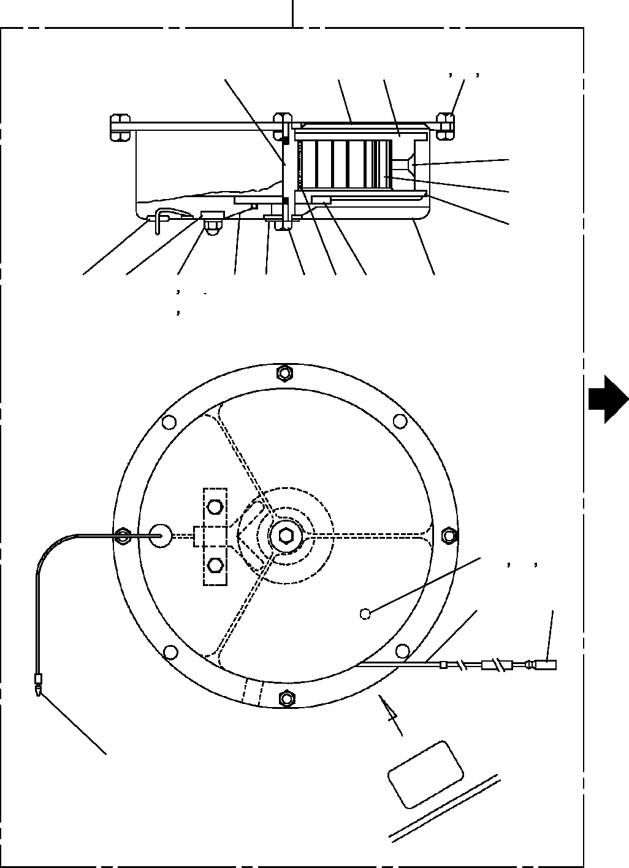

**DT-600-2-00001 UPPER PN1350070-02 REEL,CORD**

**500**

**8**

**1**

**3**

**24**

**25**

**26**

**6**

**7**

**4**

**19**

**11**

**13**

**12**

**14**

**9**

**17**

**18**

**5**

**15**

**2**

**10**

**21**

**22**

**23**

**16**

**30**

**27**

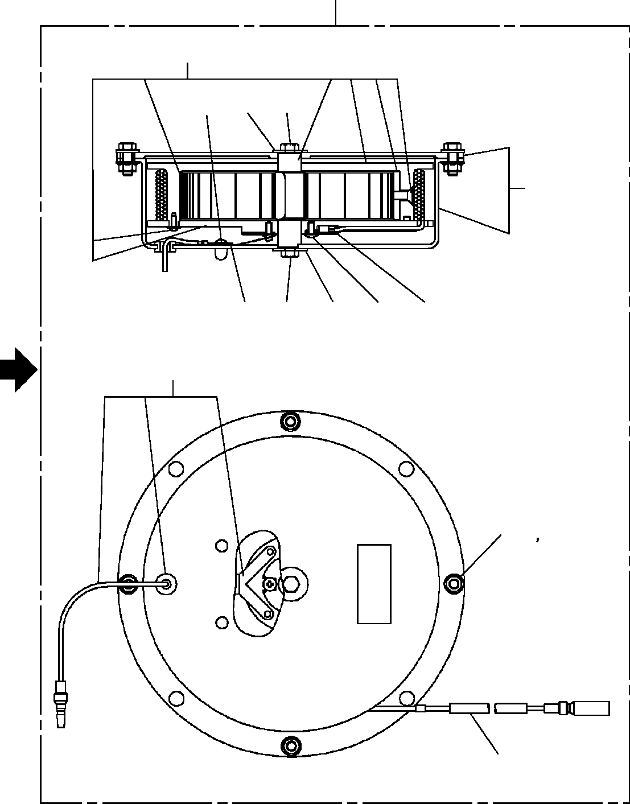

**DT-600-2-00001 UPPER PN1350070-02 REEL,CORD**

**500**

**152**

**111**

**114**

**115**

**151**

**110**

**115**

**114**

**111**

**112**

**153**

**119 120**

**113**

**DT-600-2-00001 UPPER**

**000063**

Pos No.

Parts No

Parts Name

Qty

Unit

Technical Data

Serial No (Start)

Serial No (End)

Remarks

P

1

2

3

4

5

6

7

8

9

10

11

12

13

14

15

16

17

18

19

21

22

23

24

25

26

27

30

110

111

112

113

114

115

119

120

151

152

153

500

31370255010

31370255020

31370255030

31370255040

31370255050

80175105012

31370255060

31370255070

31370255080

31370255090

80175104012

90240200400

90303100401

90302040401

31370255100

82100000080

31370255110

90102205008

31370255120

90441230010

90302040301

90303100301

90102205012

90201200500

90303100501

82100000192

82100000191

31370257510

31370257520

31370257530

31370257540

31370257550

90102205008

31370257560

31370257570

31370257580

31370257590

31370257600

31370250010

PLATE CASE DRUM

PLATE (DRUM) SPRING SCREW,MACHINE NUT

SHAFT BRUSH PLATE

SCREW,MACHINE NUT,CAP WASHER,PLAIN WASHER,SPRING RING,SLIP

CORD (1-LINE) WASHER BOLT GROMMET

SCREW,MACHINE WASHER,SPRING WASHER,PLAIN BOLT

NUT WASHER,PLAIN TERMINAL TERMINAL PLATE SCREW,MACHINE RING,SLIP

CORD ASSY (MAIN) WASHER

BOLT

BOLT (WITH W) NUT

CASE ASSY SPRING ASSY CORD ASSY (SUB) REEL,CORD

1

1

1

1

1

1

1

1

1

1

2

2

2

2

1

9

2

2

1

4

4

4

4

4

8

1

1

1

4

1

1

2

2

4

4

1

1

1

1

M

M5X12

M4X12 M4

4

4

M5X8

M3X10 3

3

M5X12 M5

5

M3X6 L=8.6M

M5X8 M5X12

275442

275442

275442

275442

275442

275442

275442

275442

275442

275442

275442

275441

275441

275441

275441

275441

275441

275441

275441

275441

275441

275441

275441

275441

275441

275441

275441

275441

275441

275441

275441

275441

275441

275441

275441

275441

275441

275441

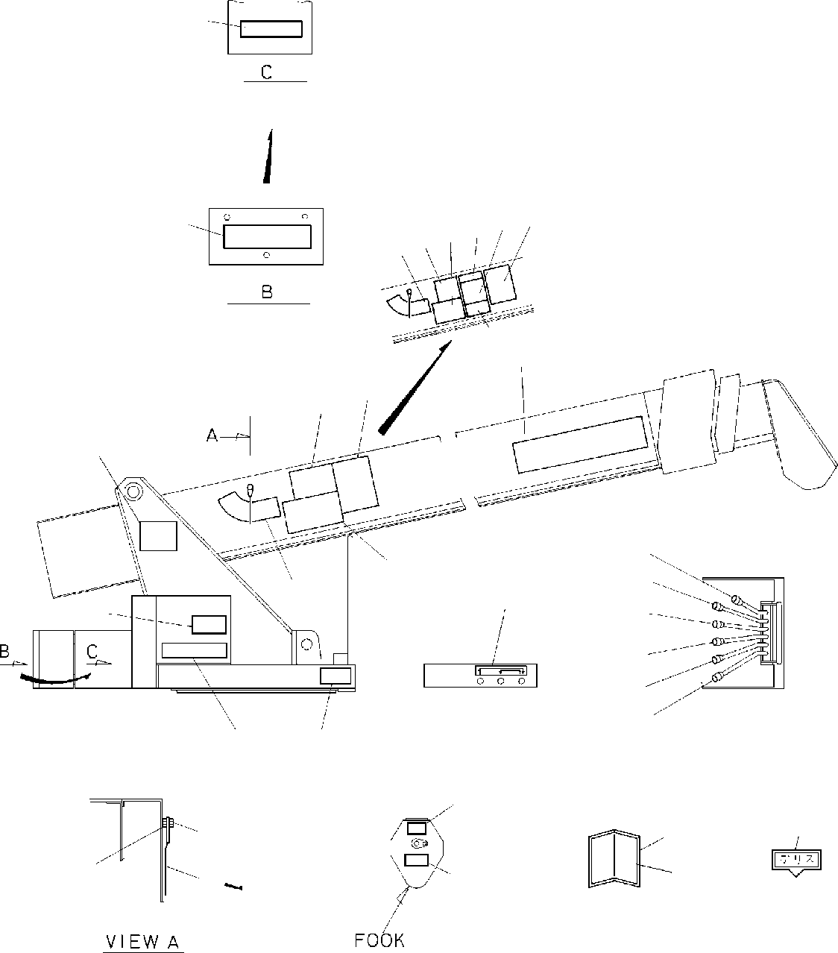

**DT-600-2-00001 UPPER PO1010166-02 PLATE,INDICATION**

**26**

**8 28 9 291110**

**26**

**30 2**

**10**

**9**

**7**

**16**

**17**

**18**

**19**

**20**

**21**

**11**

**8**

**15**

**27**

**1**

**1314**

**3**

**25**

**5**

**6**

**23**

**22**

**24**

**4**

**31**

**DT-600-2-00001 UPPER**

**000064**

Pos No.

Parts No

Parts Name

Qty

Unit

Technical Data

Serial No (Start)

Serial No (End)

Re

1

2

3

4

5

6

7

8

9

10

11

14

15

16

17

18

19

20

21

22

23

24

25

26

28

29

30

31

32390140010

12647115000

37002209510

13117014000

37002200180

32390140070

18617081000

32390140020

32390140030

32390050060

32390140040

32390140050

32390050100

32390140080

80147310420

32390050110

32390050120

37002203620

37002202000

37002202010

42390010050

37002203630

90201201000

90101210016

90101210018

11627023001

31391150120

12117140000

37002209550

32940720020

32390140090

32940720050

32940720030

31390040010

PLATE,NAME (DT-600) PLATE,NAME (TADANO) PLATE,NAME (TADANO) PLATE,NAME (2.9TON) PLATE,NAME (2.9TON) PLATE,NAME (11.66M-370KG) CASE

PLATE,NAME PLATE,NAME PLATE,NAME PLATE,NAME PLATE,NAME PLATE,CAUTION PLATE,NAME RIVET PLATE,NAME PLATE,NAME PLATE,NAME PLATE,NAME PLATE,NAME PLATE,NAME PLATE,NAME NUT

BOLT BOLT INDICATOR INDICATOR

PLATE,NAME (GREASE) PLATE,NAME (TADANO) PLATE,CAUTION PLATE,CAUTION PLATE,CAUTION PLATE,CAUTION INDICATOR

2

2

2

2

2

1

1

1

1

1

1

1

1

1

4

1

1

1

1

1

1

1

1

1

1

1

1

12

1

1

1

1

1

1

3.2X6

M10 M10X16 M10X18

275134

275397

275331

275228

275225

275134

275331

275376

275331

275331

275331

275133

275396

275330

275227

275224

275330

275375

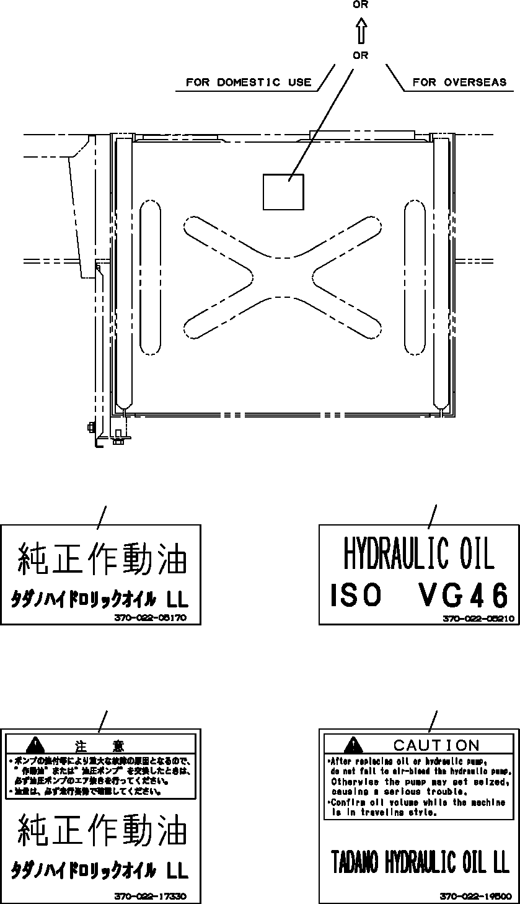

**DT-600-2-00001 UPPER**

**PO1012579-01 PLATE ASSY,NAME (OIL)**

**11**

**12**

**1**

**2**

**1**

**2**

**11**

**12**

**DT-600-2-00001 UPPER**

**000065**

Pos No.

Parts No

Parts Name

Qty

Unit

Technical Data

Serial No (Start)

Serial N 275429

275429

1

2

11

12

37002205170

37002205210

37002217330

37002219500

PLATE,NAME (HYDRAULIC OIL LL) PLATE,NAME (OIL ISO VG46 ,EXP) PLATE,CAUTION (TADANO HYDRAULIC) PLATE,CAUTION (OIL/FOR EXP.)

1

1

1

1

275430

275430

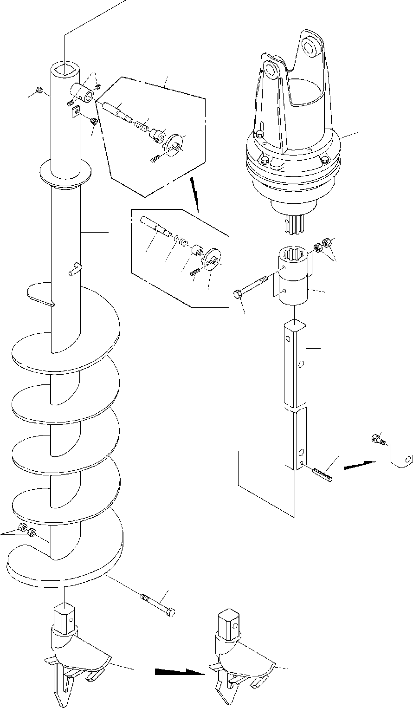

**DT-600-2-00001 UPPER PP2010000-02 AUGER**

**6**

**3**

**21**

**4**

**22**

**23**

**24**

**1**

**4**

**25**

**7**

**21 22**

**11**

**2**

**2325**

**24**

**3**

**12**

**5**

**13**

**5**

**9**

**11**

**12**

**8**

**8**

**DT-600-2-00001 UPPER**

**000066**

Pos No.

Parts No

Parts Name

Qty

Unit

Technical Data

Serial No (Start)

Serial No (End)

Rema

1

2

3

4

5

6

7

8

9

11

12

13

21

22

23

24

25

36340050000

32490020010

32490020060

32490020070

80316030060

32490020030

32490020110

90710006080

32490020040

32490020051

32490020100

80720110080

90201401800

90101718140

90131510020

32490022030

37001200470

32490022040

32490022060

32490022050

80720105018

DRIVING UNIT,AUGER COUPLING

PIN ASSY PIN ASSY PLUG SHAFT SHAFT SCREW,SET SCREW DRILL

DRILL,AUGER (450 S) PIN,SPRING

NUT BOLT

BOLT,HEXAGON SOCKET PIN

SPRING GUIDE GUIDE GRIP PIN,SPRING

1

1

1

1

2

1

1

2

1

1

1

1

6

3

1

1

1

1

1

1

1

PT3/8

M6X8 450

M18 M18X140 M10X20

5X18

275023

275094

275023

275094

275023

275022

275093

275022

275093

275022

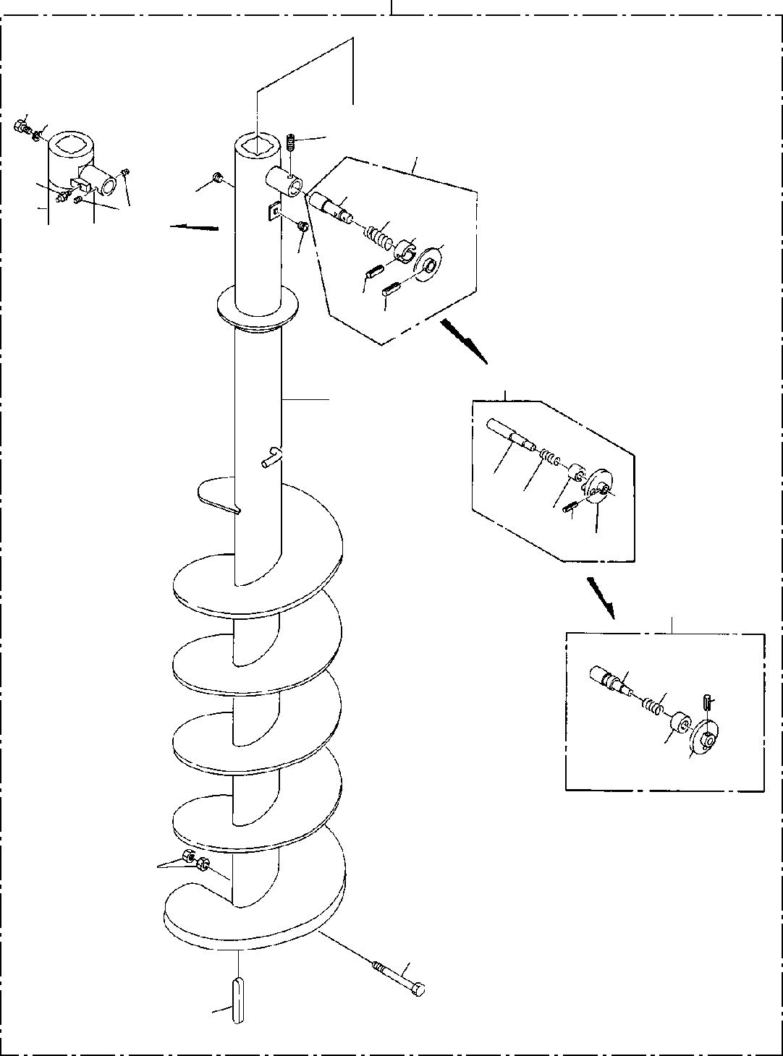

**DT-600-2-00001 UPPER**

**PP2010002-02 AUGER (450,OPTION)**

**100**

**9 10**

**6**

**3**

**8**

**7**

**21**

**4**

**2223**

**6**

**25**

**4**

**24**

**26**

**3**

**5**

**3122**

**3326**

**34**

**3**

**41**

**42**

**24**

**4344**

**2**

**1**

**7**

**DT-600-2-00001 UPPER**

**000067**

Pos No.

Parts No

Parts Name

Qty

Unit

Technical Data

Serial No (Start)

Serial No (End)

Remarks

Pa

1

2

3

4

5

6

7

8

9

10

21

22

23

24

25

26

31

33

34

41

42

43

44

100

90101916150

90201401600

32490020020

32490020070

32490023000

80316030060

32470220010

32470220030

90710006080

90710006080

32470220020

82456106000

37001504060

90302041801

37000115560

37001200470

32490022010

80720105028

80720105028

32490022020

80720105018

32490022030

32490022060

32490022050

32490023010

37001200720

32490253510

32490253520

32470220000

BOLT NUT

PIN ASSY PIN ASSY PIN ASSY PLUG SCREW SCREW SCREW,SET SCREW,SET KEY

NIPPLE,GREASE BOLT WASHER,SPRING PIN

SPRING GUIDE PIN,SPRING PIN,SPRING GRIP PIN,SPRING PIN

GUIDE GRIP PIN SPRING GUIDE GRIP

AUGER (450)

1

2

1

1

1

2

1

1

1

2

2

1

1

1

1

1

1

1

1

1

1

1

1

1

1

1

1

1

1

M16X150 M16

PT3/8

M6X8 M6X8

1/4-28UNF

18

5X28

5X28

5X18

275028

275094

275094

275028

275094

275094

275094

275094

275028

275028

275028

275094

275094

275094

275094

275027

275093

275093

275093

275027

275027

275093

275027

275027

275027

275093

275093

275093

275093

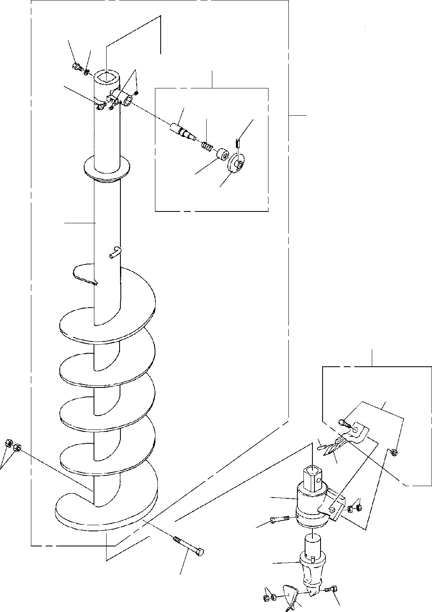

**DT-600-2-00001 UPPER**

**PP2010009-03 AUGER (250.PENGO)**

**1**

**2**

**4**

**3**

**5**

**21**

**22**

**25**

**100**

**23**

**24**

**8**

**32**

**51**

**42**

**41**

**7**

**36**

**31**

**35**

**33**

**39**

**6**

**34**

**38**

**DT-600-2-00001 UPPER**

**000068**

Pos No.

Parts No

Parts Name

Qty

Unit

Technical Data

Serial No (Start)

Serial No (End)

Rema

1

2

3

4

5

6

7

8

21

22

23

24

25

31

32

33

34

35

36

38

39

41

42

51

100

37001504060

37001504060

90302041801

90302041801

32490023000

32490023000

90710006080

90710006080

82456106000

82456106000

90101918140

90101918140

90201401800

90201401800

32471020010

32471020010

32490023010

32490023010

37001200720

37001200720

32490253510

32490253510

32490253520

32490253520

80720105028

80720105028

32471012000

32471012000

32471012100

32471012100

32470720300

32470720300

32470720400

32470720400

90101512150

90101512150

90201401200

90201401200

90101510050

90101510050

90203401000

90203401000

32470720600

32470720600

32470720500

32470720500

32470720200

32470720200

32471028010

32471028010

BOLT BOLT

WASHER,SPRING WASHER,SPRING PIN ASSY

PIN ASSY SCREW,SET SCREW,SET NIPPLE,GREASE NIPPLE,GREASE BOLT

BOLT NUT NUT SCREW SCREW PIN

PIN SPRING SPRING GUIDE GUIDE GRIP GRIP

PIN,SPRING PIN,SPRING SUPPORT SUPPORT HOLDER HOLDER ADAPTER ADAPTER

BIT,PILOT (PENGO.FH205) BIT,PILOT (PENGO.FH205) BOLT

BOLT NUT NUT BOLT BOLT NUT NUT

TOOTH (PENGO.1652) TOOTH (PENGO.1652) CUSHION

CUSHION BOLT ASSY BOLT ASSY SCREW ASSY SCREW ASSY

1

1

1

1

1

1

2

2

1

1

1

1

2

2

1

1

1

1

1

1

1

1

1

1

1

1

1

1

1

1

1

1

1

1

1

1

2

2

1

1

2

2

1

1

1

1

1

1

1

1

18

18

M6X8 M6X8

1/4-28UNF

1/4-28UNF M18X140 M18X140 M18

M18

5X28

5X28

M12X150 M12X150 M12

M12 M10X50 M10X50 M10 M10

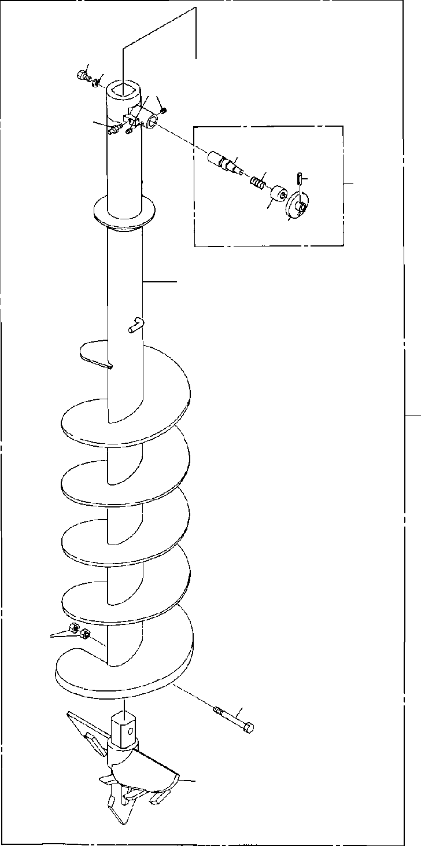

**DT-600-2-00001 UPPER**

**PP2010010-01 AUGER (650.S-TYPE,OPTION)**

**1 2**

**4**

**5**

**21**

**22**

**25**

**3**

**2324**

**8**

**100**

**7**

**6**

**9**

**DT-600-2-00001 UPPER**

**000069**

Pos No.

Parts No

Parts Name

Qty

Unit

Technical Data

Serial No (Start)

Serial No (End)

Re

1

2

3

4

5

6

7

8

9

21

22

23

24

25

100

37001504060

90302041801

32490023000

90710006080

82456106000

90101918140

90201401800

32471060010

32471060020

32490023010

37001200720

32490253510

32490253520

80720105028

32471060000

BOLT WASHER,SPRING PIN ASSY SCREW,SET NIPPLE,GREASE BOLT

NUT SCREW

HEAD,AUGER PIN

SPRING GUIDE GRIP PIN,SPRING

AUGER (650.S-TYPE,OPTION)

1

1

1

2

1

1

2

1

1

1

1

1

1

1

1

18

M6X8

1/4-28UNF M18X140 M18

5X28

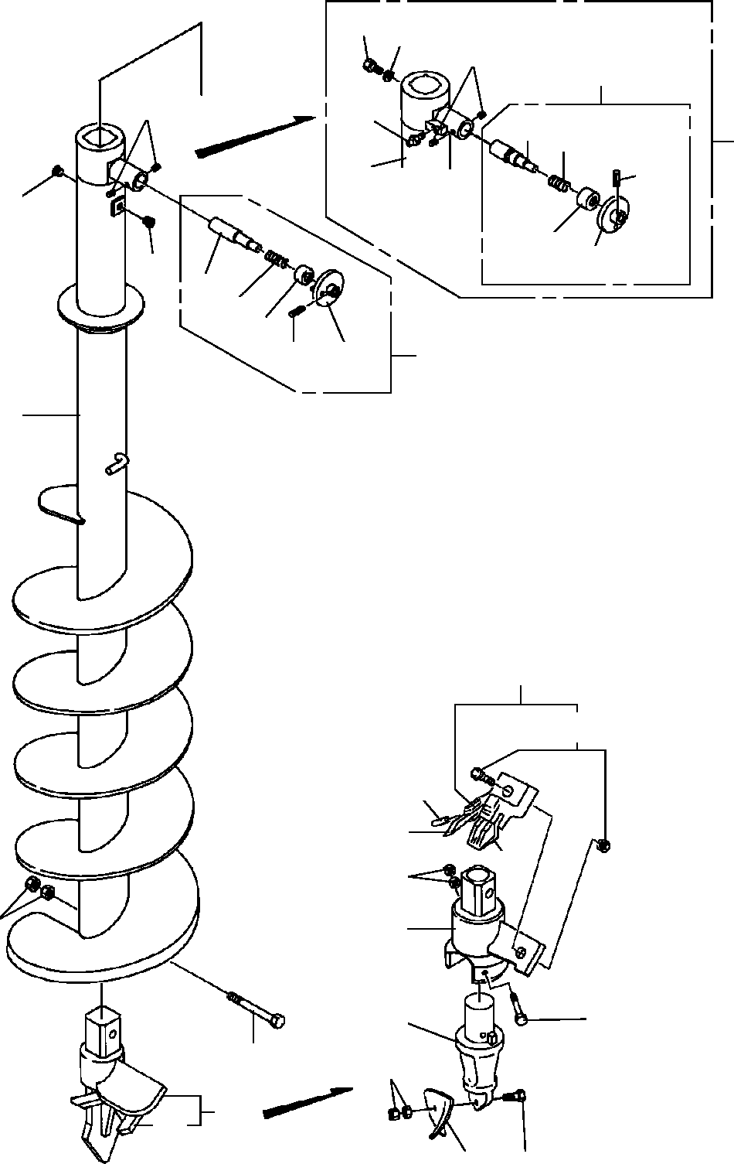

**DT-600-2-00001 UPPER**

**PP2010011-03 AUGER (300.PENGO)**

**12 13**

**6**

**3**

**6**

**14**

**7**

**31 32**

**100**

**35**

**4**

**33 34**

**4**

**21**

**22**

**23**

**3**

**25**

**24**

**7**

**52**

**71**

**62**

**60**

**56**

**51**

**61**

**11**

**55**

**53**

**59**

**10**

**8**

**45**

**54**

**58**

**DT-600-2-00001 UPPER**

**000070**

Pos No.

Parts No

Parts Name

Qty

Unit

Technical Data

Serial No (Start)

Serial No (End)

Remarks

Pa

3

4

6

7

8

10

11

12

13

14

21

22

23

24

25

31

32

33

34

35

45

100

32490020070

32490023000

32490023000

80316030060

90710006080

90710006080

32470350010

32470350020

32470350020

32470340020

32470340020

90101918140

90101918140

90201401800

90201401800

37001504060

37001504060

90302041801

90302041801

82456106000

82456106000

32490022030

37001200470

32490022060

32490022050

80720105018

32490023010

32490023010

37001200720

37001200720

32490253510

32490253510

32490253520

32490253520

80720105028

80720105028

32470590000

32470590000

32470358010

32470358010

PIN ASSY PIN ASSY PIN ASSY PLUG SCREW,SET SCREW,SET SCREW SCREW SCREW DRILL DRILL

BOLT BOLT NUT NUT BOLT BOLT

WASHER,SPRING WASHER,SPRING NIPPLE,GREASE NIPPLE,GREASE PIN

SPRING GUIDE GRIP PIN,SPRING PIN

PIN SPRING SPRING GUIDE GUIDE GRIP GRIP

PIN,SPRING PIN,SPRING BIT,CUTTER BIT,CUTTER SCREW ASSY SCREW ASSY

1

1

1

2

2

2

1

1

1

1

1

1

1

2

2

1

1

1

1

1

1

1

1

1

1

1

1

1

1

1

1

1

1

1

1

1

2

2

1

1

PT3/8 M6X8 M6X8

300

300

M18X140 M18X140 M18

M18

18

18

1/4-28UNF

1/4-28UNF

5X18

5X28

5X28

275094

275094

275094

275094

275094

275094

275094

275094

275094

275094

275094

275094

275094

275094

275094

275094

275094

275094

275094

275094

275094

275094

275094

275094

275093

275093

275093

275093

275093

275093

275093

275093

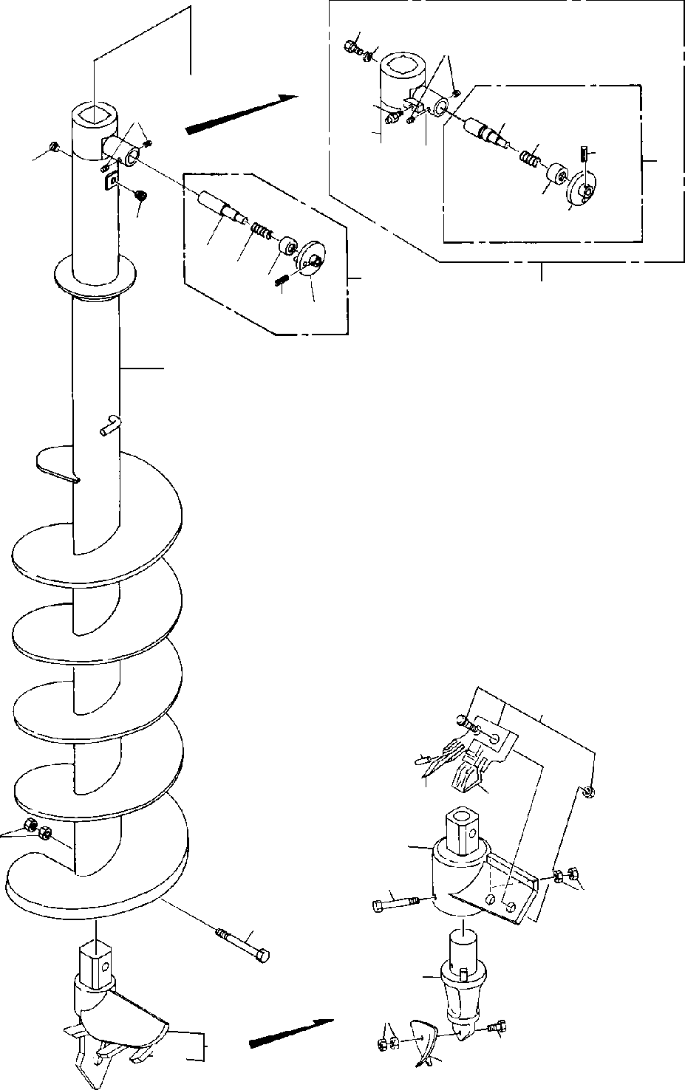

**DT-600-2-00001 UPPER**

**PP2010012-02 AUGER (400.PENGO)**

**1213**

**6**

**14**

**7**

**6**

**31**

**32**

**35**

**3**

**4**

**33**

**34**

**4**

**21**

**2223**

**2524**

**3**

**100**

**7**

**52**

**62**

**60**

**61**

**11**

**51**

**55**

**56**

**10**

**53**

**59**

**8**

**58**

**45**

**54**

**DT-600-2-00001 UPPER**

**000071**

Pos No.

Parts No

Parts Name

Qty

Unit

Technical Data

Serial No (Start)

Serial No (End)

Remarks

Pa

3

4

6

7

8

10

11

12

13

14

21

22

23

24

25

31

32

33

34

35

45

100

32490020070

32490023000

32490023000

80316030060

90710006080

90710006080

32470360010

32470360020

32470360020

32470260020

32470260020

90101918140

90101918140

90201401800

90201401800

37001504060

37001504060

90302041801

90302041801

82456106000

82456106000

32490022030

37001200470

32490022060

32490022050

80720105018

32490023010

32490023010

37001200720

37001200720

32490253510

32490253510

32490253520

32490253520

80720105028

80720105028

32470590000

32470590000

32470368010

32470368010

PIN ASSY PIN ASSY PIN ASSY PLUG SCREW,SET SCREW,SET SCREW SCREW SCREW DRILL DRILL

BOLT BOLT NUT NUT BOLT BOLT

WASHER,SPRING WASHER,SPRING NIPPLE,GREASE NIPPLE,GREASE PIN

SPRING GUIDE GRIP PIN,SPRING PIN

PIN SPRING SPRING GUIDE GUIDE GRIP GRIP

PIN,SPRING PIN,SPRING BIT,CUTTER BIT,CUTTER SCREW ASSY SCREW ASSY

1

1

1

2

2

2

1

1

1

1

1

1

1

2

2

1

1

1

1

1

1

1

1

1

1

1

1

1

1

1

1

1

1

1

1

1

3

3

1

1

PT3/8 M6X8 M6X8

400

400

M18X140 M18X140 M18

M18

18

18

1/4-28UNF

1/4-28UNF

5X18

5X28

5X28

275097

275097

275097

275097

275097

275097

275097

275097

275097

275097

275097

275097

275097

275097

275097

275097

275097

275097

275097

275097

275097

275097

275097

275097

275096

275096

275096

275096

275096

275096

275096

275096

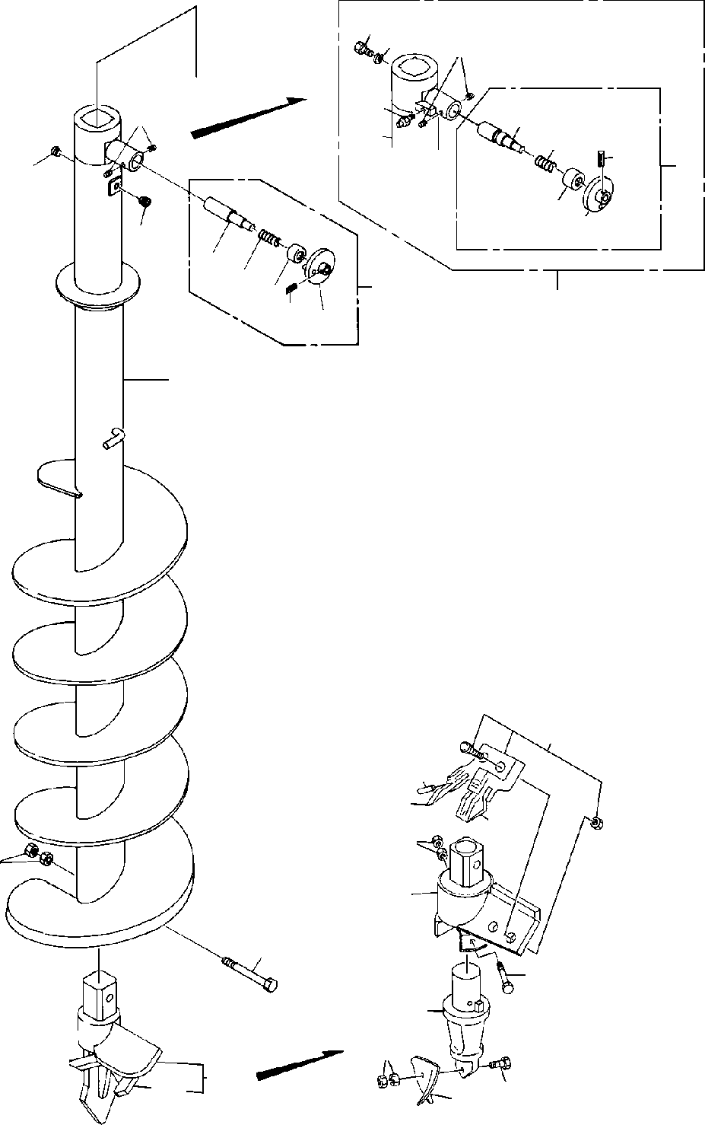

**DT-600-2-00001 UPPER**

**PP2010013-02 AUGER (350.PENGO)**

**1213**

**6**

**14**

**7**

**6**

**31**

**32**

**35**

**3**

**4**

**33**

**34**

**4**

**21**

**2223**

**3**

**100**

**2524**

**7**

**52**

**62**

**60**

**56**

**51**

**61**

**11**

**10**

**55**

**53**

**59**

**8**

**45**

**58**

**54**

**DT-600-2-00001 UPPER**

**000072**

Pos No.

Parts No

Parts Name

Qty

Unit

Technical Data

Serial No (Start)

Serial No (End)

Remarks

Pa

3

4

6

7

8

10

11

12

13

14

21

22

23

24

25

31

32

33

34

35

45

100

32490020070

32490023000

32490023000

80316030060

90710006100

90710006080

90710006080

32470390010

32470390020

32470390020

32470400020

32470400020

90101918140

90101918140

90201401800

90201401800

37001504060

37001504060

90302041801

90302041801

82456106000

82456106000

32490022030

37001200470

32490022060

32490022050

80720105018

32490023010

32490023010

37001200720

37001200720

32490253510

32490253510

32490253520

32490253520

80720105028

80720105028

32470590000

32470590000

32470398010

32470398010

PIN ASSY PIN ASSY PIN ASSY PLUG SCREW,SET SCREW,SET SCREW,SET SCREW SCREW SCREW DRILL DRILL

BOLT BOLT NUT NUT BOLT BOLT

WASHER,SPRING WASHER,SPRING NIPPLE,GREASE NIPPLE,GREASE PIN

SPRING GUIDE GRIP PIN,SPRING PIN

PIN SPRING SPRING GUIDE GUIDE GRIP GRIP

PIN,SPRING PIN,SPRING BIT,CUTTER BIT,CUTTER SCREW ASSY SCREW ASSY

1

1

1

2

2

1

1

1

1

1

1

1

1

1

2

2

1

1

1

1

1

1

1

1

1

1

1

1

1

1

1

1

1

1

1

1

1

2

2

1

1

PT3/8 M6X10 M6X8 M6X8

350

350

M18X140 M18X140 M18

M18

18

18

1/4-28UNF

1/4-28UNF

5X18

5X28

5X28

275094

275094

275094

275094

275094

275094

275094

275094

275094

275094

275094

275094

275094

275094

275094

275094

275094

275094

275094

275094

275094

275094

275094

275094

275093

275093

275093

275093

275093

275093

275093

275093

275093

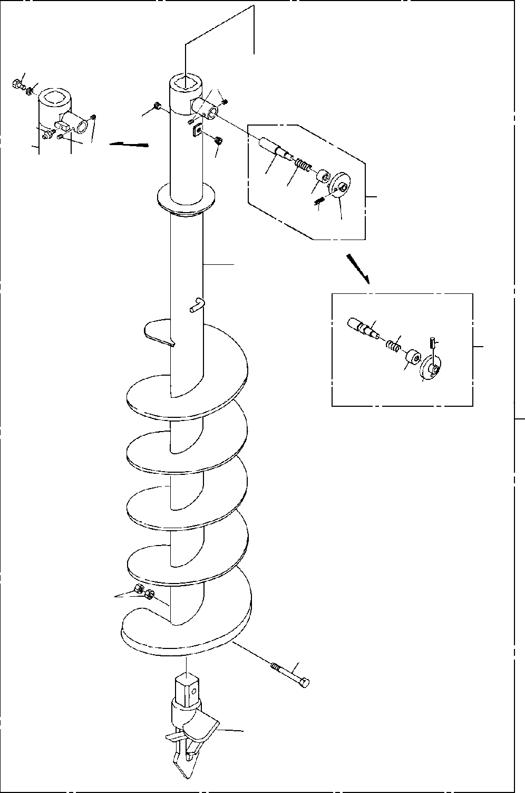

**DT-600-2-00001 UPPER PP2010014-01 AUGER (200)**

**1213**

**6**

**14**

**7**

**4**

**6**

**4**

**2122 23**

**25 24**

**3**

**7**

**31**

**32**

**35**

**3**

**3334**

**100**

**11**

**10**

**8**

**DT-600-2-00001 UPPER**

**000073**

Pos No.

Parts No

Parts Name

Qty

Unit

Technical Data

Serial No (Start)

Serial No (End)

Remarks

Pa

3

4

6

7

8

10

11

12

13

14

21

22

23

24

25

31

32

33

34

35

100

32490020070

32490023000

32490023000

80316030060

90710006100

90710006080

90710006080

32470430010

32470430030

32470430030

32470430020

32470430020

90171118160

90101918140

90101918140

90201401800

90201401800

37001504060

37001504060

90302041801

90302041801

82456106000

82456106000

32490022030

37001200470

32490022060

32490022050

80720105018

32490023010

32490023010

37001200720

37001200720

32490253510

32490253510

32490253520

32490253520

80720105028

80720105028

32470430000

32470430000

PIN ASSY PIN ASSY PIN ASSY PLUG SCREW,SET SCREW,SET SCREW,SET SCREW SCREW SCREW DRILL DRILL

BOLT BOLT BOLT NUT NUT BOLT BOLT

WASHER,SPRING WASHER,SPRING NIPPLE,GREASE NIPPLE,GREASE PIN

SPRING GUIDE GRIP PIN,SPRING PIN

PIN SPRING SPRING GUIDE GUIDE GRIP GRIP

PIN,SPRING PIN,SPRING AUGER (200)

AUGER (200)

1

1

1

2

2

2

2

1

1

1

1

1

1

1

1

2

2

1

1

1

1

1

1

1

1

1

1

1

1

1

1

1

1

1

1

1

1

1

1

1

PT3/8 M6X10 M6X8 M6X8

M18X160 M18X140 M18X140 M18

M18

18

18

1/4-28UNF

1/4-28UNF

5X18

5X28

5X28

275094

275094

275094

275094

275094

275094

275094

275094

275094

275094

275094

275094

275094

275094

275094

275094

275094

275094

275094

275094

275094

275094

275094

275094

275093

275093

275093

275093

275093

275093

275093

275093

275093

275093

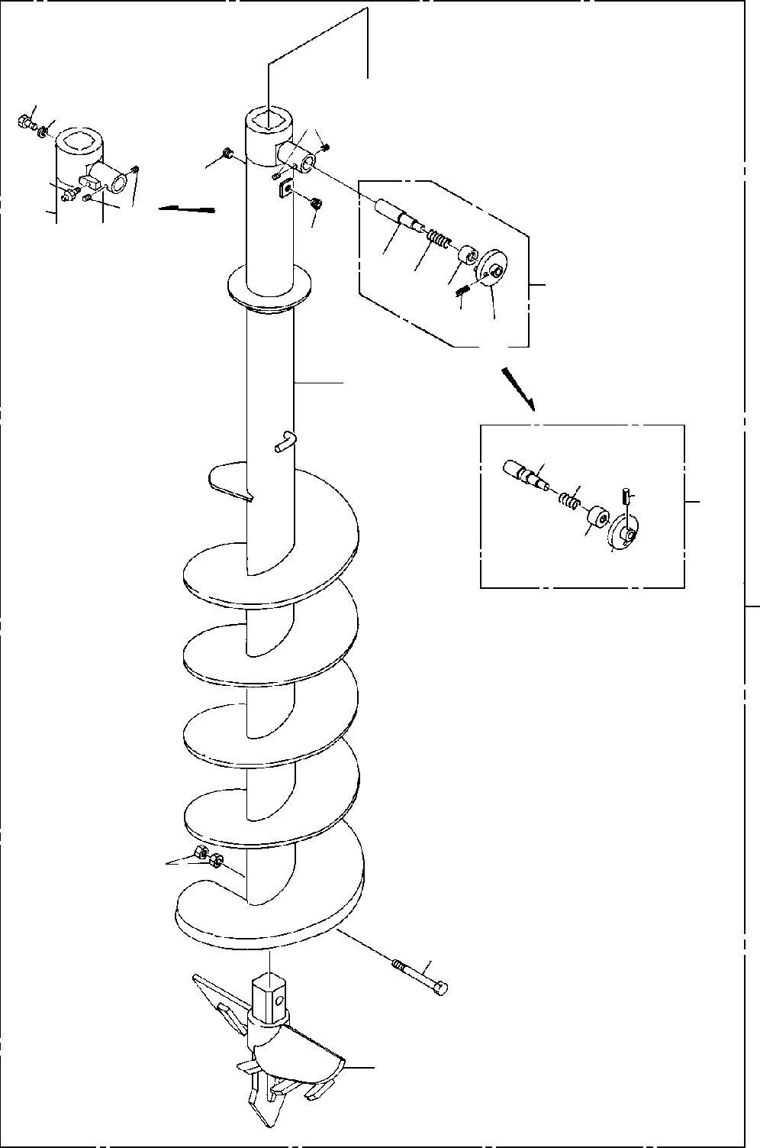

**DT-600-2-00001 UPPER**

**PP2010015-01 AUGER (600.OPTION)**

**1213**

**6**

**14**

**7**

**4**

**6**

**4**

**2122**

**3**

**23**

**25 24**

**7**

**31**

**32**

**35**

**3**

**3334**

**100**

**11**

**10**

**8**

**DT-600-2-00001 UPPER**

**000074**

Pos No.

Parts No

Parts Name

Qty

Unit

Technical Data

Serial No (Start)

Serial No (End)

Remarks

3

4

6

7

8

10

11

12

13

14

21

22

23

24

25

31

32

33

34

35

100

32490020070

32490023000

80316030060

90710006080

32470540010

32470540030

32470540020

90101918140

90201401800

37001504060

90302041801

82456106000

32490022030

37001200470

32490022060

32490022050

80720105018

32490023010

37001200720

32490253510

32490253520

80720105028

32470540000

PIN ASSY PIN ASSY PLUG SCREW,SET SCREW SCREW DRILL

BOLT NUT BOLT

WASHER,SPRING NIPPLE,GREASE PIN

SPRING GUIDE GRIP PIN,SPRING PIN

SPRING GUIDE GRIP PIN,SPRING

AUGER (600.OPTION)

1

1

2

2

1

1

1

1

2

1

1

1

1

1

1

1

1

1

1

1

1

1

1

PT3/8 M6X8

M18X140 M18

18

1/4-28UNF

5X18

5X28

275094

275094

275094

275094

275094

275094

275094

275094

275094

275094

275093

275093

275093

275093

275093

275093

275093

275093

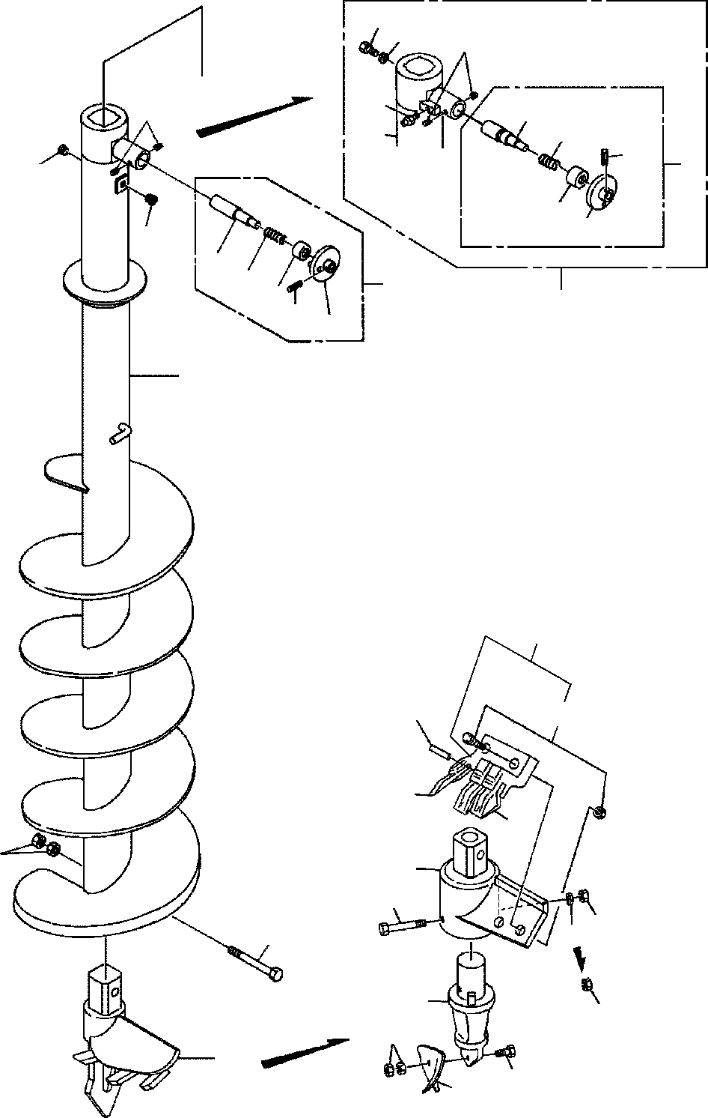

**DT-600-2-00001 UPPER PP2010016-03 AUGER (450,P)**

**12**

**13**

**6**

**14**

**7**

**6**

**31**

**32**

**35**

**3**

**4**

**33**

**34**

**4**

**21**

**22**

**3**

**23**

**100**

**25**

**24**

**7**

**42**

**52**

**61**

**50**

**51**

**11**

**41**

**45**

**47 46**

**10**

**43**

**46**

**49**

**8**

**48**

**44**

**DT-600-2-00001 UPPER**

**000075**

Pos No.

Parts No

Parts Name

Qty

Unit

Technical Data

Serial No (Start)

Serial No (End)

Re

3

4

6

7

8

10

11

12

13

14

21

22

23

24

25

31

32

33

34

35

41

42

43

44

45

46

47

48

49

50

51

52

61

100

32490023000

32490020070

80316030060

90710006080

32490020040

32490022000

32490020100

90101918140

90201401800

37001504060

90302041801

82456106000

32490022030

37001200470

32490022060

32490022050

80720105018

32490023010

37001200720

32490253510

32490253520

80720105028

32470720010

32470720100

32470720300

32470720400

90101512140

90101512150

90201401200

90201401200

90302041201

90101510050

90203401000

32470720700

32470720600

32470720500

32470720200

32490028030

PIN ASSY PIN ASSY PLUG SCREW,SET SCREW SCREW

DRILL,AUGER (450 S) BOLT

NUT BOLT

WASHER,SPRING NIPPLE,GREASE PIN

SPRING GUIDE GRIP PIN,SPRING PIN

SPRING GUIDE GRIP PIN,SPRING SUPPORT

HOLDER (WITH BOLT&NUT) ADAPTER

BIT,PILOT (PENGO.FH205) BOLT

BOLT NUT NUT

WASHER,SPRING BOLT

NUT

TOOTH (PENGO.1650) TOOTH (PENGO.1652) CUSHION

BOLT ASSY SCREW ASSY

1

1

2

2

1

1

1

1

2

1

1

1

1

1

1

1

1

1

1

1

1

1

1

1

1

1

1

1

1

2

1

1

2

2

1

3

2

1

PT3/8 M6X8

M18X140 M18

18

1/4-28UNF

5X18

5X28

M12X150 M12

M12 12

M10X50 M10

275094

275094

275094

275094

275094

275434

275094

275434

275094

275094

275094

275094

275094

275094

275094

275093

275093

275093

275093

275093

275093

275093

275093

275093

275433

275433

275433

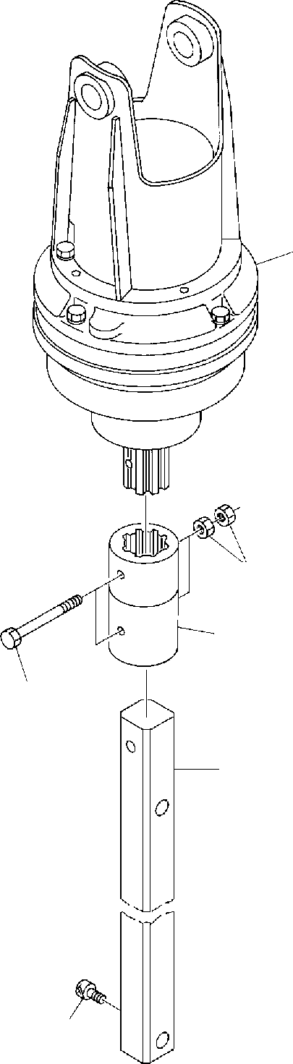

**DT-600-2-00001 UPPER PP2010017-00 AUGER**

**1**

**7**

**2**

**6**

**3**

**5**

**DT-600-2-00001 UPPER**

Rem

**000076**

Pos No.

Parts No

Parts Name

Qty

Unit

Technical Data

Serial No (Start)

Serial No (End)

1

2

3

5

6

7

36340260000

32490520010

32490025000

32490520020

32490020110

32490023500

90131510020

90101718140

90171118160

90201401800

DRIVING UNIT,AUGER COUPLING COUPLING (LONG)

COUPLING (AUGER/SHAFT) SHAFT

SHAFT

BOLT,HEXAGON SOCKET BOLT

BOLT NUT

1

1

1

1

1

1

1

2

2

4

M10X20 M18X140 M18X160 M18

275251

275251

275250

275250

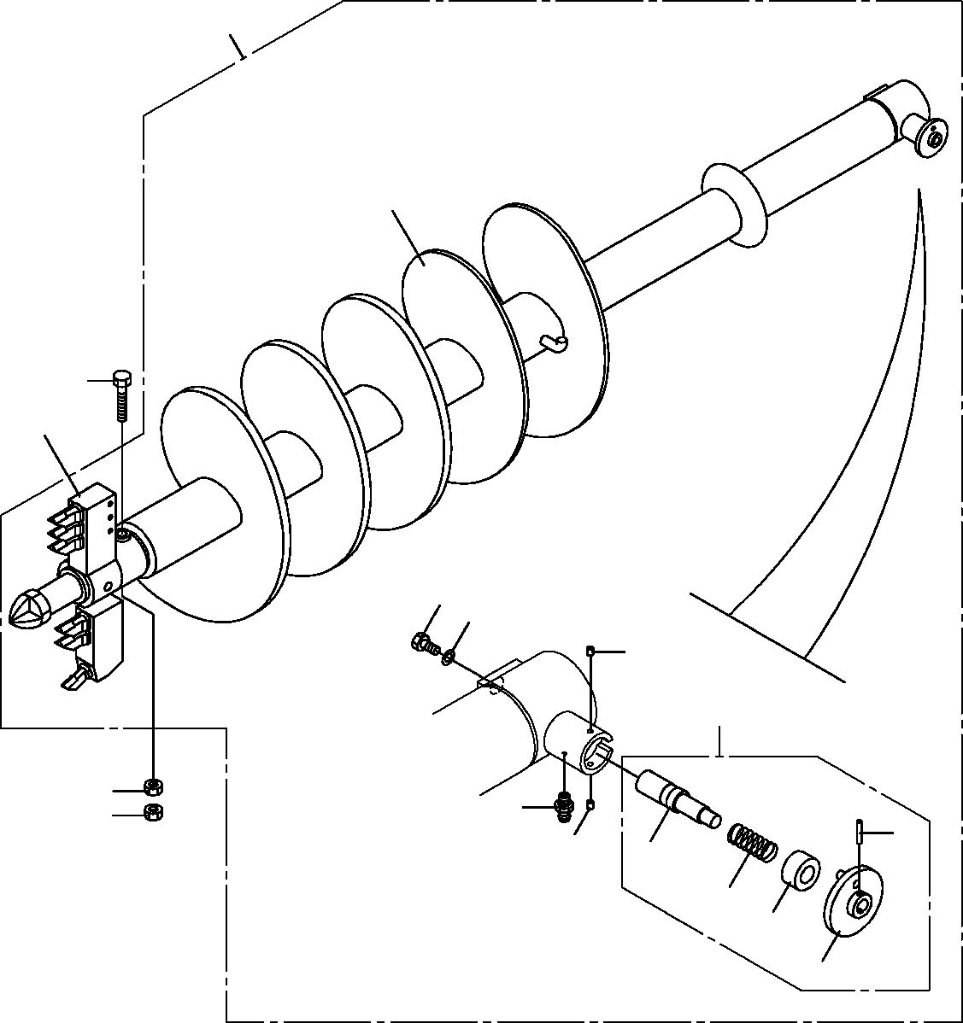

**DT-600-2-00001 UPPER**

**PP2010020-01 AUGER (400.R6,OPTION)**

**100**

**4**

**5**

**9**

**1**

**2**

**7**

**3**

**6**

**6**

**8**

**25**

**7**

**21**

**22**

**23**

**24**

**DT-600-2-00001 UPPER**

**000077**

Pos No.

Parts No

Parts Name

Qty

Unit

Technical Data

Serial No (Start)

Serial No (End)

Remarks

1

2

3

4

5

6

7

8

9

21

22

23

24

25

100

37001504060

90302041801

32490023000

32470360020

90101918140

90201401800

90710006080

82456106000

(***********) 32490023010

37001200720

32490253510

32490253520

80720105028

32470368010

BOLT WASHER,SPRING PIN ASSY SCREW

BOLT NUT

SCREW,SET NIPPLE,GREASE HEAD,AUGER (400.R6) PIN

SPRING GUIDE GRIP PIN,SPRING

SCREW ASSY

1

1

1

1

1

2

2

1

1

1

1

1

1

1

1

18

M18X140 M18 M6X8

1/4-28UNF

5X28

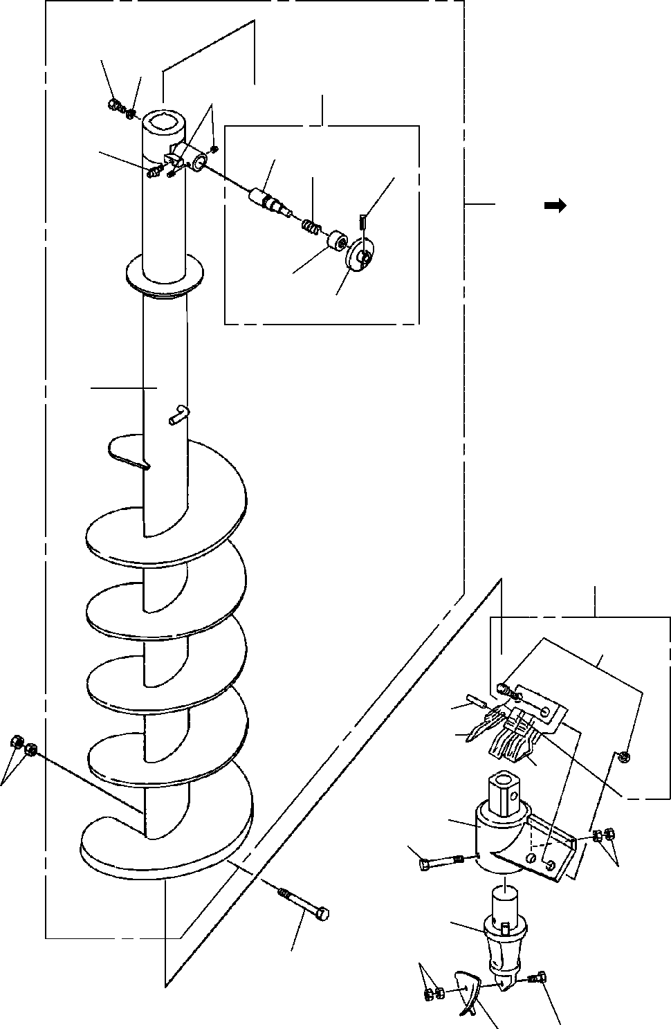

**DT-600-2-00001 UPPER PP2010027-02 AUGER (450)**

**12**

**13**

**3**

**6**

**31**

**14**

**32**

**35**

**100**

**101**

**33**

**34**

**7**

**42**

**61**

**52**

**50**

**51**

**11**

**41**

**45**

**46**

**43**

**49**

**10**

**44**

**48**

**DT-600-2-00001 UPPER**

**000078**

Pos No.

Parts No

Parts Name

Qty

Unit

Technical Data

Serial No (Start)

Serial No (End)

Re

10

11

41

42

43

44

45

46

48

49

50

51

52

61

101

90101918140

90201401800

32470720010

32470720100

32470720300

32470720400

90101512150

90201401200

90101510050

90203401000

32470720700

32470720600

32470720500

32470720200

32490028031

BOLT NUT SUPPORT

HOLDER (WITH BOLT&NUT) ADAPTER

BIT,PILOT (PENGO.FH205) BOLT

NUT BOLT NUT

TOOTH (PENGO.1650) TOOTH (PENGO.1652) CUSHION

BOLT ASSY SCREW ASSY

1

2

1

1

1

1

1

2

1

2

2

1

3

2

1

M18X140 M18

M12X150 M12 M10X50 M10

275434

275434

275094

275094

275697

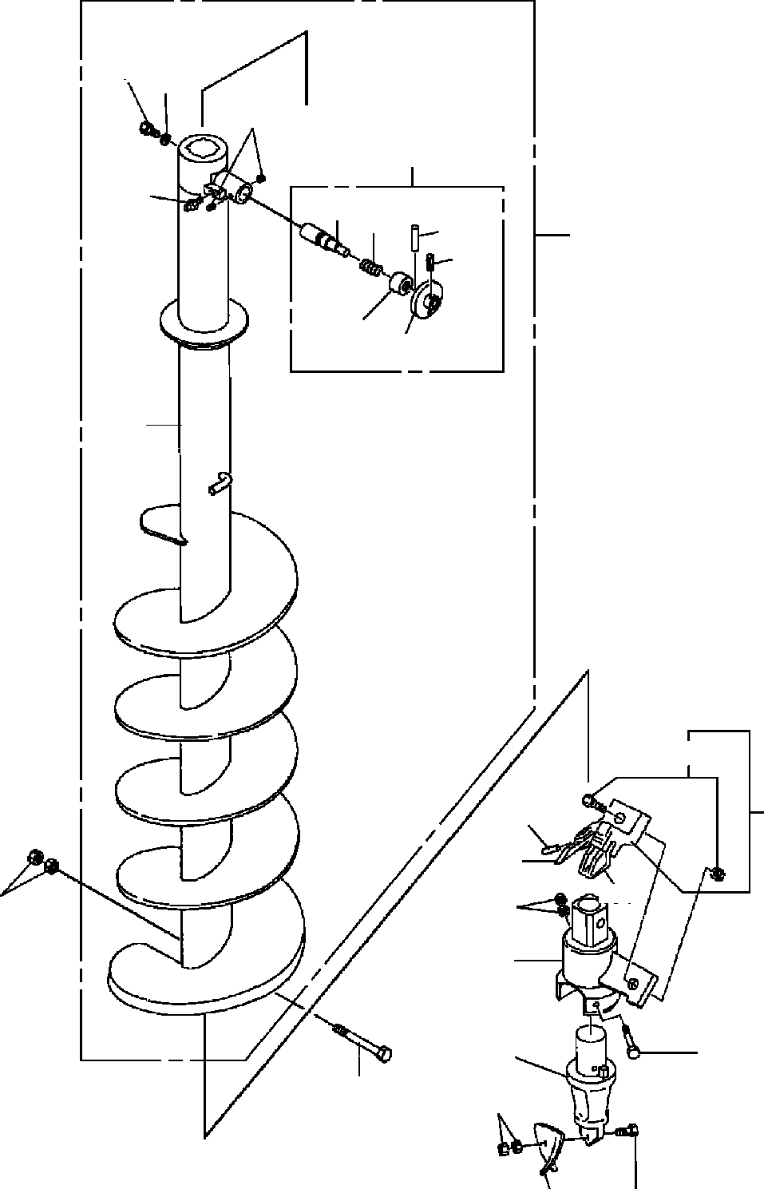

**DT-600-2-00001 UPPER PP2010030-00 AUGER (300)**

**4**

**5**

**53**

**51**

**52**

**61**

**62**

**64**

**66**

**100**

**63**

**65**

**2**

**41**

**32**

**22**

**30**

**31**

**7**

**26**

**21**

**23**

**25**

**6**

**29**

**24**

**28**

**DT-600-2-00001 UPPER**

**000079**

Pos No.

Parts No

Parts Name

Qty

Unit

Technical Data

Serial No (Start)

Serial No (End)

Rema

2

4

5

6

7

21

22

23

24

25

26

28

29

30

31

32

41

51

52

53

61

62

63

64

65

66

100

32470350021

37001504060

90302041801

90171118140

90201401800

32470342000

32470342100

32470720300

32470720400

90101512150

90201401200

90101510050

90203401000

32470720700

32470720600

32470720500

32470720200

32490026000

82455106000

90710006080

32490026100

37001200720

32490253510

80720106045

32490251200

80720105028

32470358030

SCREW BOLT

WASHER,SPRING BOLT

NUT SUPPORT HOLDER ADAPTER

BIT,PILOT (PENGO.FH205) BOLT

NUT BOLT NUT

TOOTH (PENGO.1650) TOOTH (PENGO.1652) CUSHION

BOLT ASSY PIN ASSY

NIPPLE,GREASE SCREW,SET

PIN SPRING GUIDE

PIN,SPRING GRIP PIN,SPRING SCREW ASSY

1

1

1

1

2

1

1

1

1

1

2

1

2

1

1

2

1

1

1

2

1

1

1

1

1

1

1

18

M18X140 M18

M12X150 M12 M10X50 M10

A-M6F FE M6X8

5X28

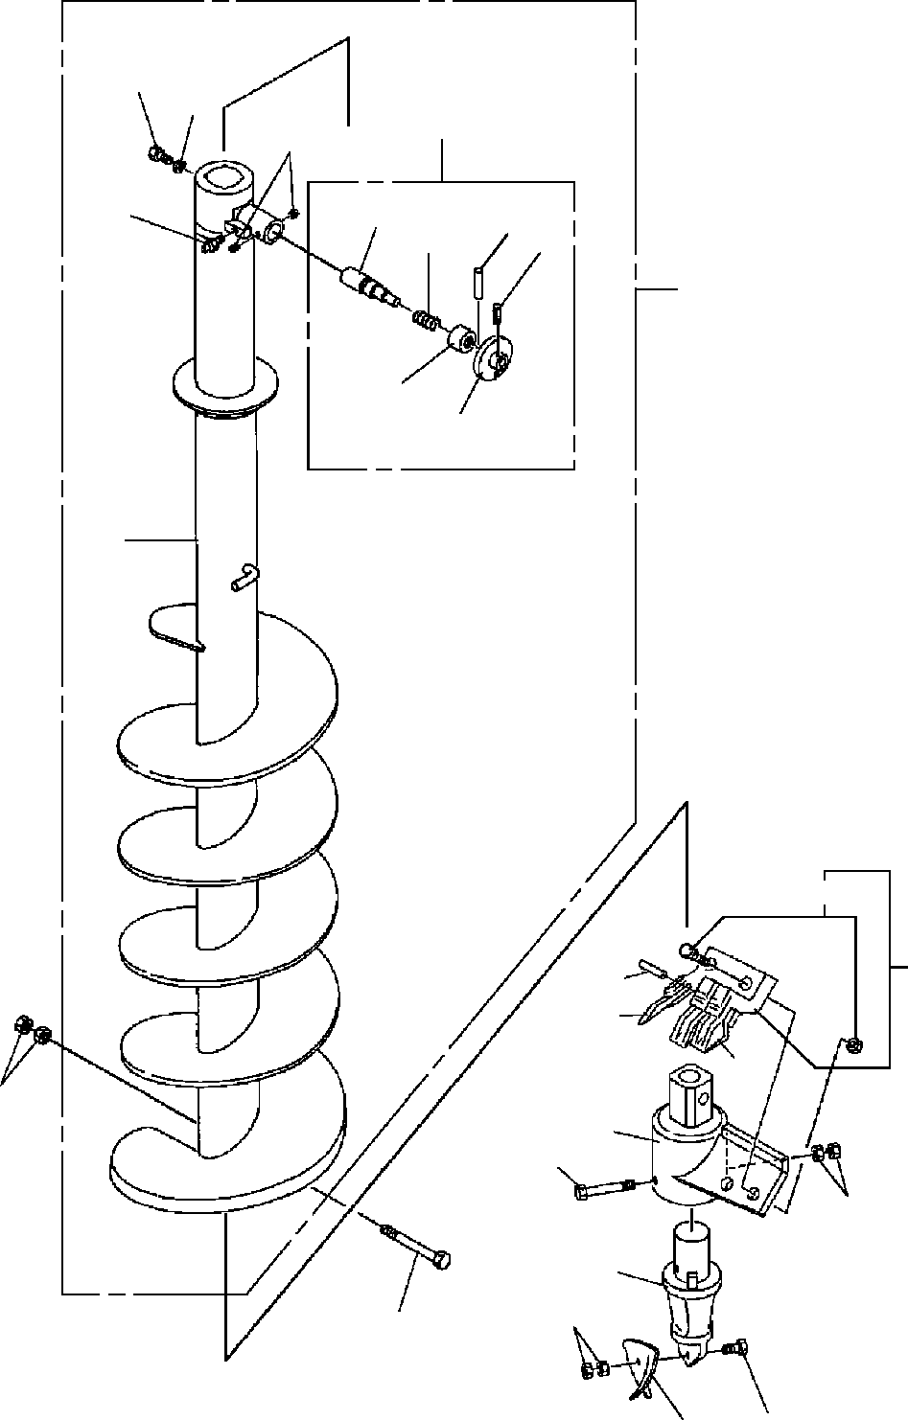

**DT-600-2-00001 UPPER PP2010031-00 AUGER (450)**

**4**

**5**

**51**

**53**

**52**

**61**

**64**

**66**

**62**

**100**

**63**

**65**

**2**

**41**

**22**

**32**

**30**

**31**

**7**

**21**

**25**

**26**

**23**

**29**

**6**

**28**

**24**

**DT-600-2-00001 UPPER**

**000080**

Pos No.

Parts No

Parts Name

Qty

Unit

Technical Data

Serial No (Start)

Serial No (End)

Re

2

4

5

6

7

21

22

23

24

25

26

28

29

30

31

32

41

51

52

53

61

62

63

64

65

66

100

32490022002

37001504060

90302041801

90171118140

90201401800

32470720010

32470720100

32470720300

32470720400

90101512150

90201401200

90101510050

90203401000

32470720700

32470720600

32470720500

32470720200

32490026000

82455106000

90710006080

32490026100

37001200720

32490253510

80720106045

32490251200

80720105028

32490708020

SCREW BOLT

WASHER,SPRING BOLT

NUT SUPPORT

HOLDER (WITH BOLT&NUT) ADAPTER

BIT,PILOT (PENGO.FH205) BOLT

NUT BOLT NUT

TOOTH (PENGO.1650) TOOTH (PENGO.1652) CUSHION

BOLT ASSY PIN ASSY

NIPPLE,GREASE SCREW,SET

PIN SPRING GUIDE

PIN,SPRING GRIP PIN,SPRING SCREW ASSY

1

1

1

1

2

1

1

1

1

1

2

1

2

2

1

3

2

1

1

2

1

1

1

1

1

1

1

18

M18X140 M18

M12X150 M12 M10X50 M10

A-M6F FE M6X8

5X28

275434

275434

275094

275094

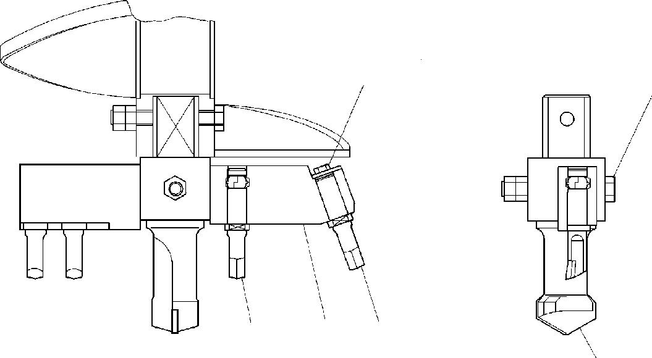

**DT-600-2-00001 UPPER**

**PP2020000-00 DRILL,AUGER (OPTION)**

**129**

**45**

**7**

**8**

**3**

**6**

**DT-600-2-00001 UPPER**

**000081**

Pos No.

Parts No

Parts Name

Qty

Unit

Technical Data

Serial No (Start)

Serial No (End)

Remarks

Pa

1

2

3

4

5

6

7

8

9

90171110020

37000517380

32470090040

37001502750

90201401800

32470090030

32470090020

32470090010

90302041001

BOLT PLATE BIT,CUTTER BOLT

NUT BIT,CENTER BIT,CUTTER SUPPORT

WASHER,SPRING

1

1

1

1

2

1

3

1

1

M10X20 T=2.3 TO 3.2

M18X132 M18

10

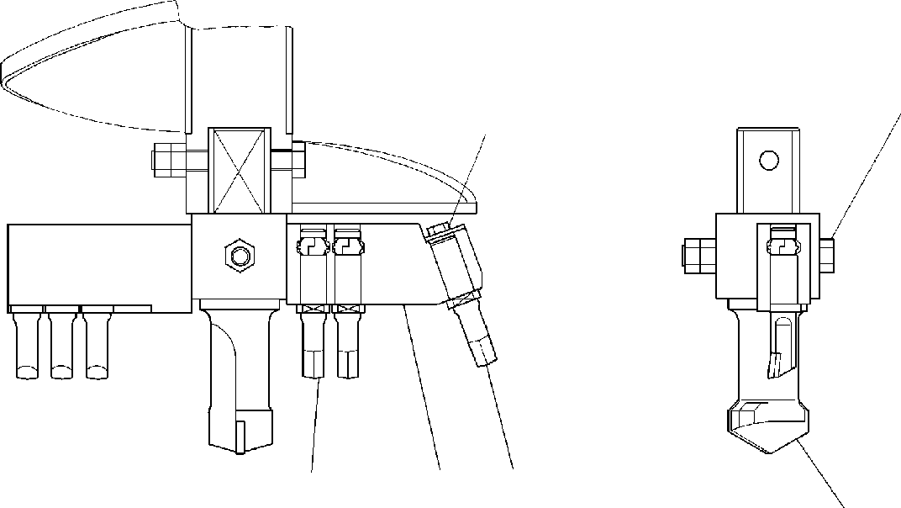

**DT-600-2-00001 UPPER**

**PP2020001-00 DRILL,AUGER (OPTION)**

**45**

**129**

**8**

**3**

**7**

**6**

**DT-600-2-00001 UPPER**

**000082**

Pos No.

Parts No

Parts Name

Qty

Unit

Technical Data

Serial No (Start)

Serial No (End)

Remarks

Pa

1

2

3

4

5

6

7

8

9

90171110020

37000517380

32470090040

37001502750

90201401800

32470090030

32470090020

32470100010

90302041001

BOLT PLATE BIT,CUTTER BOLT

NUT BIT,CENTER BIT,CUTTER SUPPORT

WASHER,SPRING

1

1

1

1

2

1

5

1

1

M10X20 T=2.3 TO 3.2

M18X132 M18

10

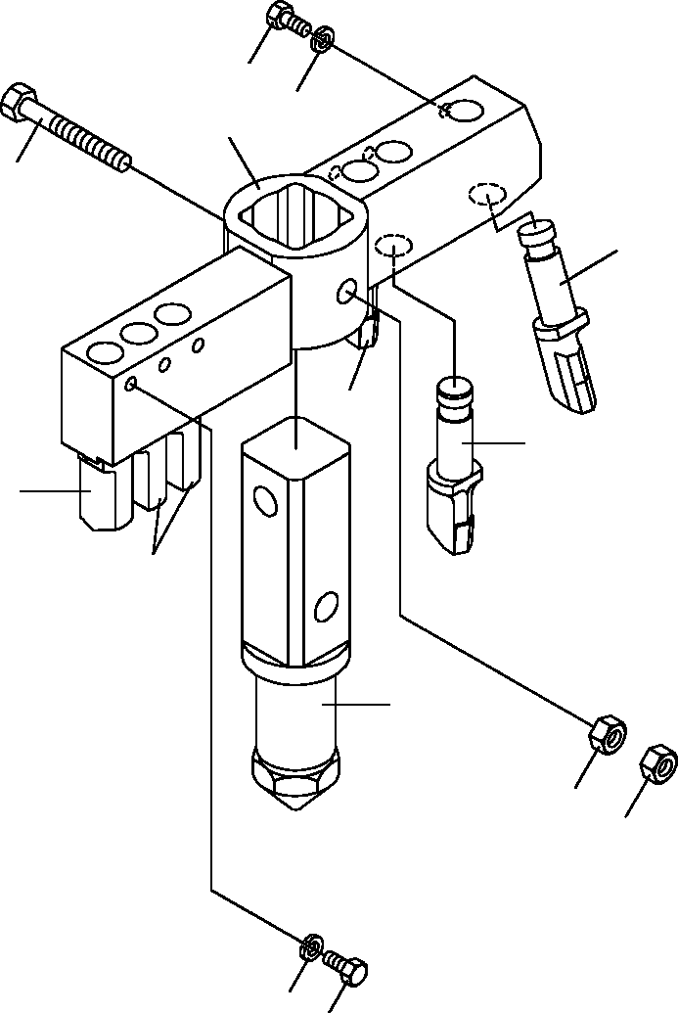

**DT-600-2-00001 UPPER**

**PP2020005-02 DRILL,AUGER (OPTION.450 R6)**

**1**

**9**

**8**

**4**

**3**

**7**

**7**

**7**

**7**

**6**

**5**

**5**

**9**

**1**

**DT-600-2-00001 UPPER**

**000083**

Pos No.

Parts No

Parts Name

Qty

Unit

Technical Data

Serial No (Start)

Serial No (End)

Remarks

Pa

1

3

4

5

6

7

8

9

90171110018

32470560040

37001502750

90201401800

32470560020

32470560010

32470560030

90302041001

BOLT BIT,CUTTER BOLT

NUT BIT,CENTER BIT,CUTTER SUPPORT

WASHER,SPRING

6

1

1

2

1

5

1

6

M10X18

M18X132 M18

10

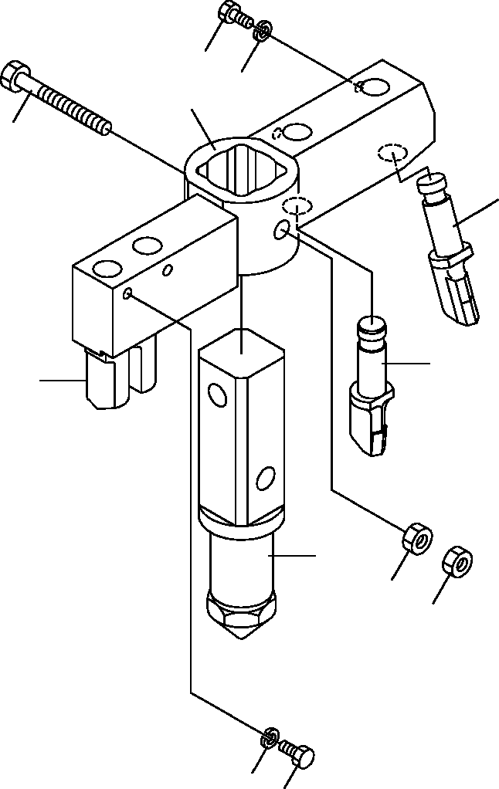

**DT-600-2-00001 UPPER**

**PP2020006-01 DRILL,AUGER (OPTION.450 R4)**

**1**

**9**

**8**

**4**

**3**

**7**

**7**

**6**

**5**

**5**

**9**

**1**

**DT-600-2-00001 UPPER**

**000084**

Pos No.

Parts No

Parts Name

Qty

Unit

Technical Data

Serial No (Start)

Serial No (End)

Remarks

Pa

1

3

4

5

6

7

8

9

90171110018

32470560040

37001502750

90201401800

32470560020

32470560010

32470570010

90302041001

BOLT BIT,CUTTER BOLT

NUT BIT,CENTER BIT,CUTTER SUPPORT

WASHER,SPRING

4

1

1

2

1

3

1

4

M10X18

M18X132 M18

10

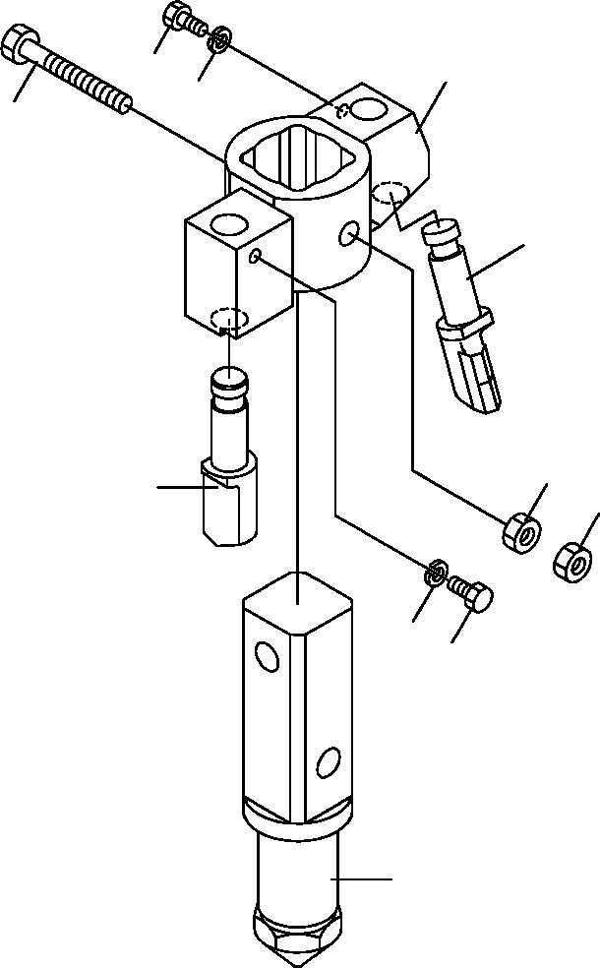

**DT-600-2-00001 UPPER**

**PP2020007-01 DRILL,AUGER (OPTION.200 R2)**

**1**

**8**

**9**

**4**

**3**

**5**

**7**

**5**

**9**

**1**

**6**

**DT-600-2-00001 UPPER**

**000085**

Pos No.

Parts No

Parts Name

Qty

Unit

Technical Data

Serial No (Start)

Serial No (End)

Remarks

Pa

1

3

4

5

6

7

8

9

90171110018

32470560040

37001502750

90201401800

32470560020

32470560010

32470580010

90302041001

BOLT BIT,CUTTER BOLT

NUT BIT,CENTER BIT,CUTTER SUPPORT

WASHER,SPRING

2

1

1

2

1

1

1

2

M10X18

M18X132 M18

10

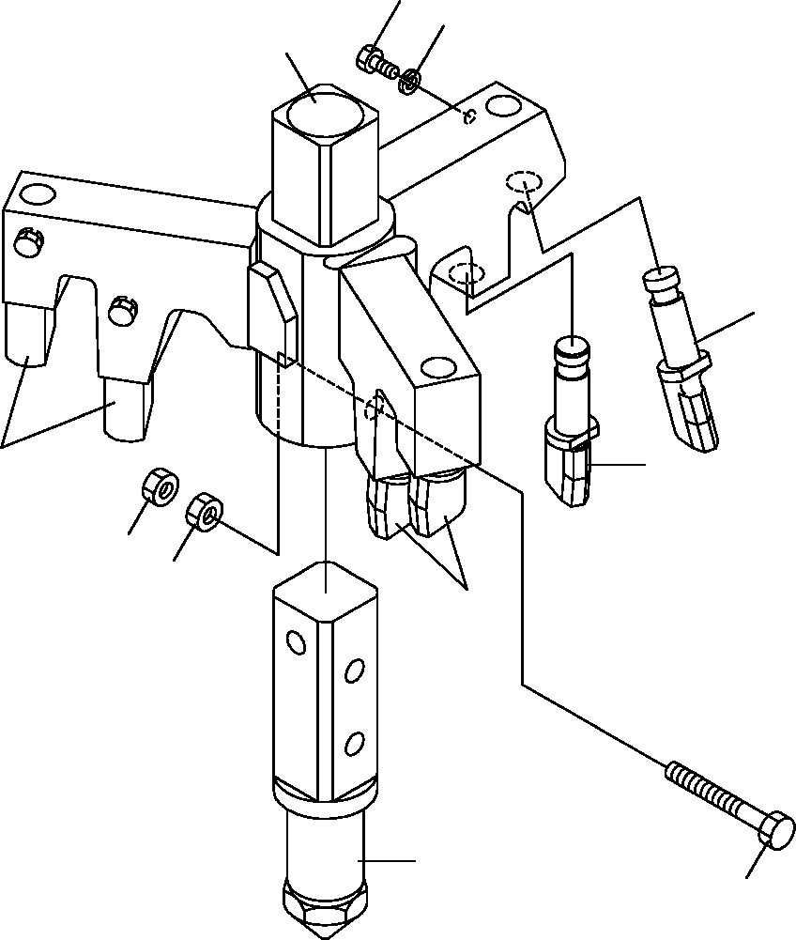

**DT-600-2-00001 UPPER**

**PP2020008-02 DRILL,AUGER (OPTION.450 R7)**

**6**

**7**

**1**

**2**

**2**

**2**

**5**

**5**

**2**

**3**

**4**

**DT-600-2-00001 UPPER**

**000086**

Pos No.

Parts No

Parts Name

Qty

Unit

Technical Data

Serial No (Start)

Serial No (End)

Remarks

Pa

1

2

3

4

5

6

7

32470660010

32470560040

32470660020

90171118160

90201401800

90171110018

90302041001

SUPPORT BIT,CUTTER BIT,CENTER BOLT

NUT BOLT

WASHER,SPRING

1

7

1

1

2

7

7

M18X160 M18 M10X18 10



**DT-600-2-00001 UPPER**

**PP2020008-02 DRILL,AUGER (OPTION.450 R7)**

**6**

**7**

**1**

**2**

**2**

**2**

**5**

**5**

**2**

**3**

**4**

**DT-600-2-00001 UPPER**

**000087**

Pos No.

Parts No

Parts Name

Qty

Unit

Technical Data

Serial No (Start)

Serial No (End)

Remarks

Pa

1

2

3

4

5

6

7

32470661000

32470560040

32471170010

90101918140

90201401800

90171110018

90302041001

SUPPORT BIT,CUTTER BIT,CENTER BOLT

NUT BOLT

WASHER,SPRING

1

7

1

1

2

7

7

M18X140 M18 M10X18 10

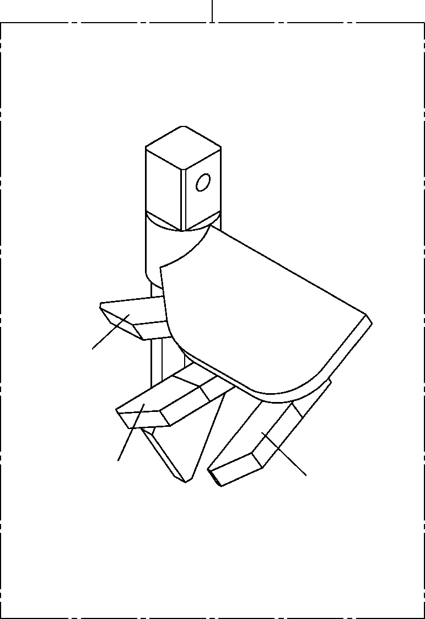

**DT-600-2-00001 UPPER**

**PP2020009-00 DRILL,AUGER (450 S)**

**20**

**5**

**5**

**5**

**DT-600-2-00001 UPPER**

**000088**

Pos No.

Parts No

Parts Name

Qty

Unit

Technical Data

Serial No (Start)

Serial No (End)

Remarks

5

20

32470590000

32470590000

32490020100

32490020100

BIT,CUTTER BIT,CUTTER DRILL,AUGER (450 S)

DRILL,AUGER (450 S)

3

3

1

1

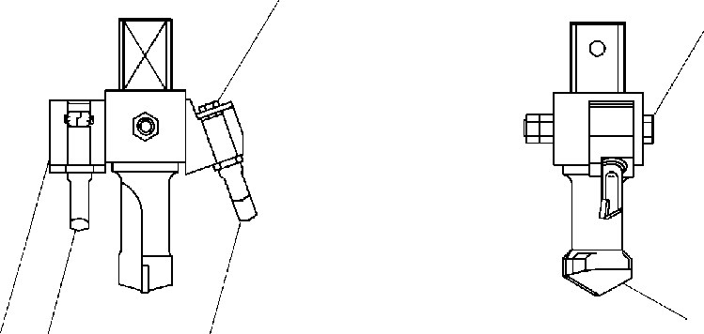

**DT-600-2-00001 UPPER**

**PP2020011-00 DRILL,AUGER (OPTION)**

**12 9**

**4 5**

**6**

**8**

**7**

**3**

**DT-600-2-00001 UPPER**

**000089**

Pos No.

Parts No

Parts Name

Qty

Unit

Technical Data

Serial No (Start)

Serial No (End)

Remarks

Pa

1

2

3

4

5

6

7

8

9

90171110020

37000517380

32470090040

37001502750

90201401800

32470090030

32470090020

32470490010

90302041001

BOLT PLATE BIT,CUTTER BOLT

NUT BIT,CENTER BIT,CUTTER SUPPORT

WASHER,SPRING

1

1

1

1

2

1

1

1

1

M10X20 T=2.3 TO 3.2

M18X132 M18

10

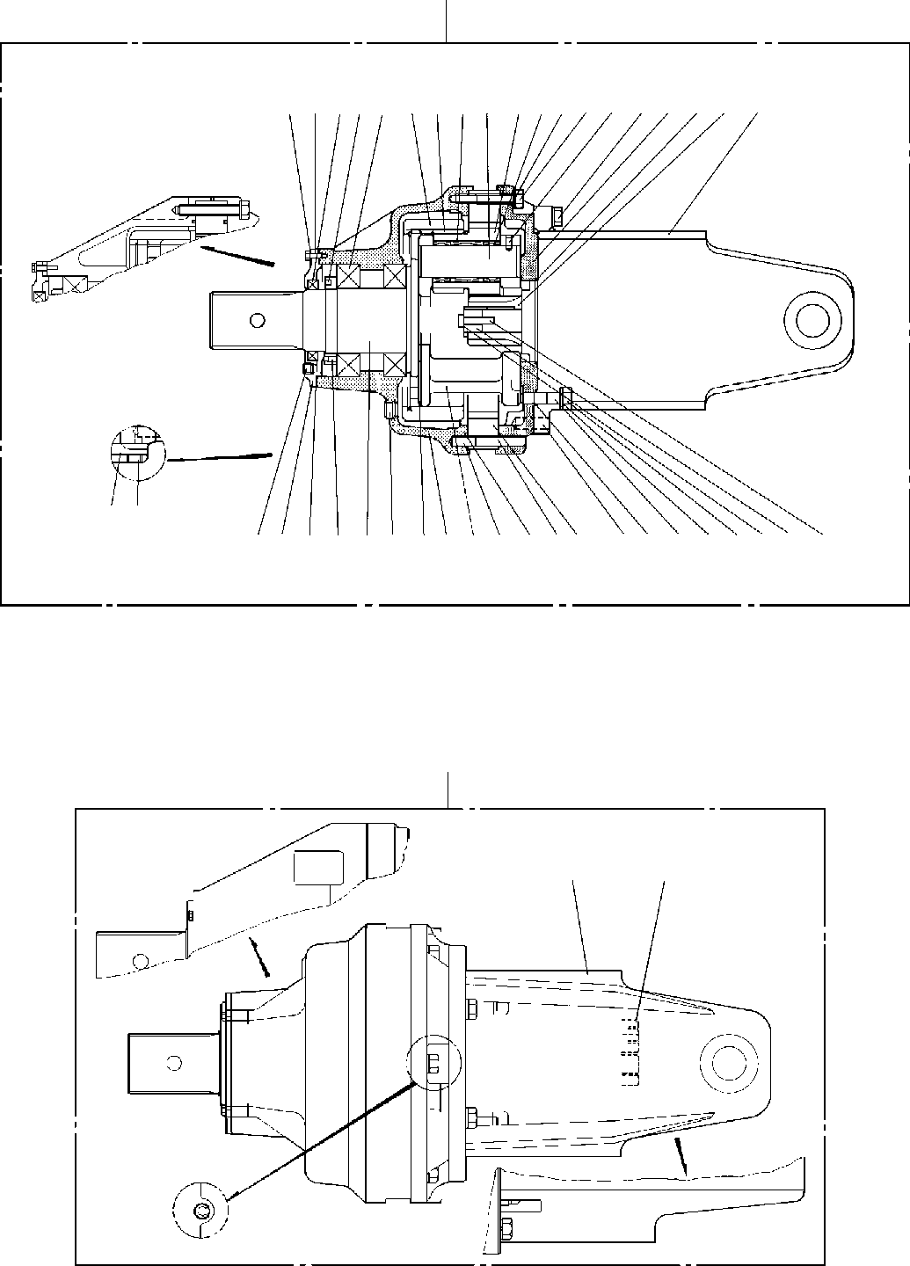

**DT-600-2-00001 UPPER**

**PP2030000-01 DRIVING UNIT,AUGER**

**100**

**29309 7 4 51516141317623182721322425**

**3122**

**1110 3 8 2224011220333119 2836342635383739**

**120**

**100**

**110**

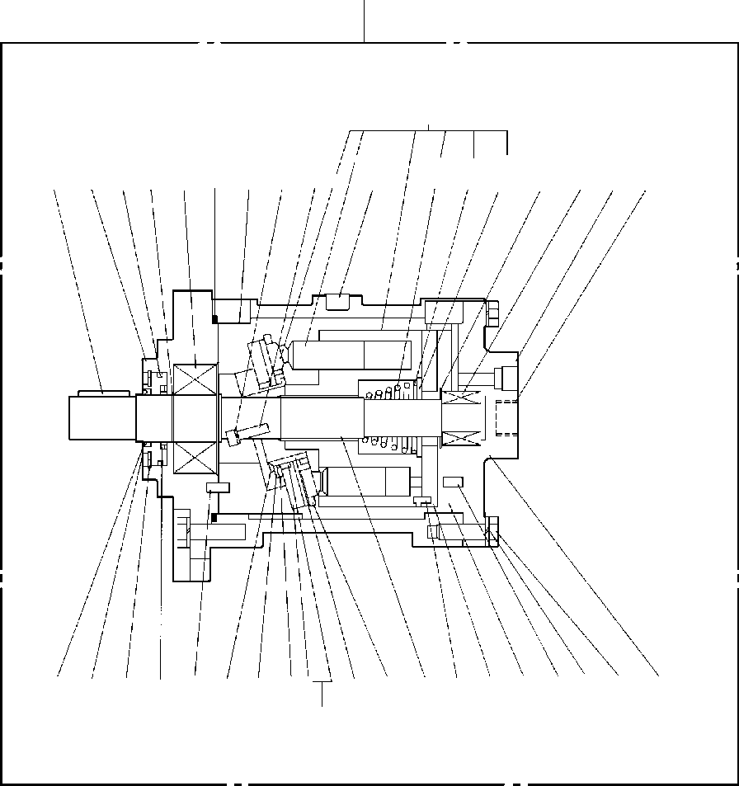

**DT-600-2-00001 UPPER**

**PP2030000-01 DRIVING UNIT,AUGER**

**110**

**55**

**838584 65 627574**

**694447434256452949**

**64**

**51544173726061585963**

**6848704671665052**

**53**

**DT-600-2-00001 UPPER**

**000090**

Pos No.

Parts No

Parts Name

Qty

Unit

Technical Data

Serial No (Start)

Serial No (End)

Re

1

2

3

4

5

6

7

8

9

10

11

12

13

14

15

17

18

19

20

21

22

23

24

25

26

27

28

29

30

31

32

33

34

35

36

37

38

39

40

41

42

43

44

45

46

47

48

49

50

51

52

53

54

55

56

58

59

60

61

62

63

64

65

36340055031

36340136010

36340055040

36340136020

91001214000

36340055050

36340055060

90302041201

36340055070

36340136030

36340055080

36340136040

36660005020

36340055431

36340136050

36340055090

36340055100

36340055110

36340055120

36340055130

36340055150

36340055160

36340175080

36340055171

36340055180

36340055191

36340055200

90101512075

36340055210

36340055221

90302041401

90101514045

36340055230

90302040601

90101506020

36340055240

91001210000

36340055250

36340055260

90201201400

91001101400

36340055271

36340055280

90101508040

36340055290

36340055300

36340055310

80601110300

36340055320

36340055330

36340055340

36340055350

36340055360

90131506020

13115101180

13115101050

13115101150

13115195050

13115101060

36340055370

91001212000

90302041001

90191010035

13615101190

80720106014

36340055380

36340055390

80316030060

13615101290

HOUSING (GEAR) HOUSING (GEAR) SHAFT (R) SHAFT (R)

O-RING BEARING GEAR (R2)

WASHER,SPRING NUT

NUT (AN16) SCREW,SET WASHER SEAL,OIL

COVER (OIL SEAL) COVER (OIL SEAL) PLUG

SPIDER GEAR (P) PIN,KING

BEARING,THRUST BEARING,NEEDLE SCREW,SET SCREW,SET GEAR (R1)

PIN COVER,END PLUG

BOLT GEAR (S1) SUPPORT

WASHER,SPRING BOLT

PIN WASHER,SPRING BOLT

PIN

O-RING O-RING

BOLT,STUD NUT

O-RING WASHER WASHER,TOOTH BOLT RING,RETAINING SHAFT

BEARING RING,RITAINING FLANGE

PLATE (CAM) SEAL,OIL

O-RING

COVER (OIL SEAL) BOLT,HEXAGON SOCKET PLATE,THRUST RETAINER

BEARING PLATE,THRUST HOLDER,PLUNGER BARREL,CYLINDER O-RING WASHER,SPRING BOLT

PLATE (VALVE) PIN,SPRING BEARING

COVER (BOTTOM) PLUG RING,RETAINING

1

1

1

1

1

2

1

6

1

1

1

1

1

1

1

2

1

3

3

6

12

3

3

1

4

1

1

6

1

1

8

4

4

6

4

4

1

2

4

4

4

1

1

1

3

1

1

2

1

1

1

1

1

2

1

1

1

1

1

1

2

16

16

1

1

1

1

1

1

1A G140

12

M8X10

PT1/4

M8X12 M8X16

13X30

PT1/2 M12X75

14

M14X45 14X40

6

M6X20 13X60

1A G100

M14 1A P14

M8X40

S30

M6X20

1A G120

10

M10X35 6X14

PT3/8

275099

275099

275099

275099

275099

275099

275098

275098

275098

275098

275098

275098

**DT-600-2-00001 UPPER**

**000090**

Pos No.

Parts No

Parts Name

Qty

Unit

Technical Data

Serial No (Start)

Serial No (End)

Re

66

68

69

70

71

72

73

83

84

85

100

110

120

80601110500

36340055400

36340055410

80602110600

80720110020

36340055420

80730060014

13115101070

80602110450

13615101100

36340055011

36340136000

36340055020

36340050000

RING,RITAINING SEAL,OIL

KEY RING,RITAINING PIN,SPRING

PLATE (CYLINDER BARREL) PIN

SPRING (CENTER) RING,RITAINING SEAT,SPRING REDUCER ASSY REDUCER ASSY MOTOR ASSY DRIVING UNIT,AUGER

1

1

1

1

1

1

2

1

1

1

1

1

1

1

S50

R60 10X20

6X14 R45

275099

275098

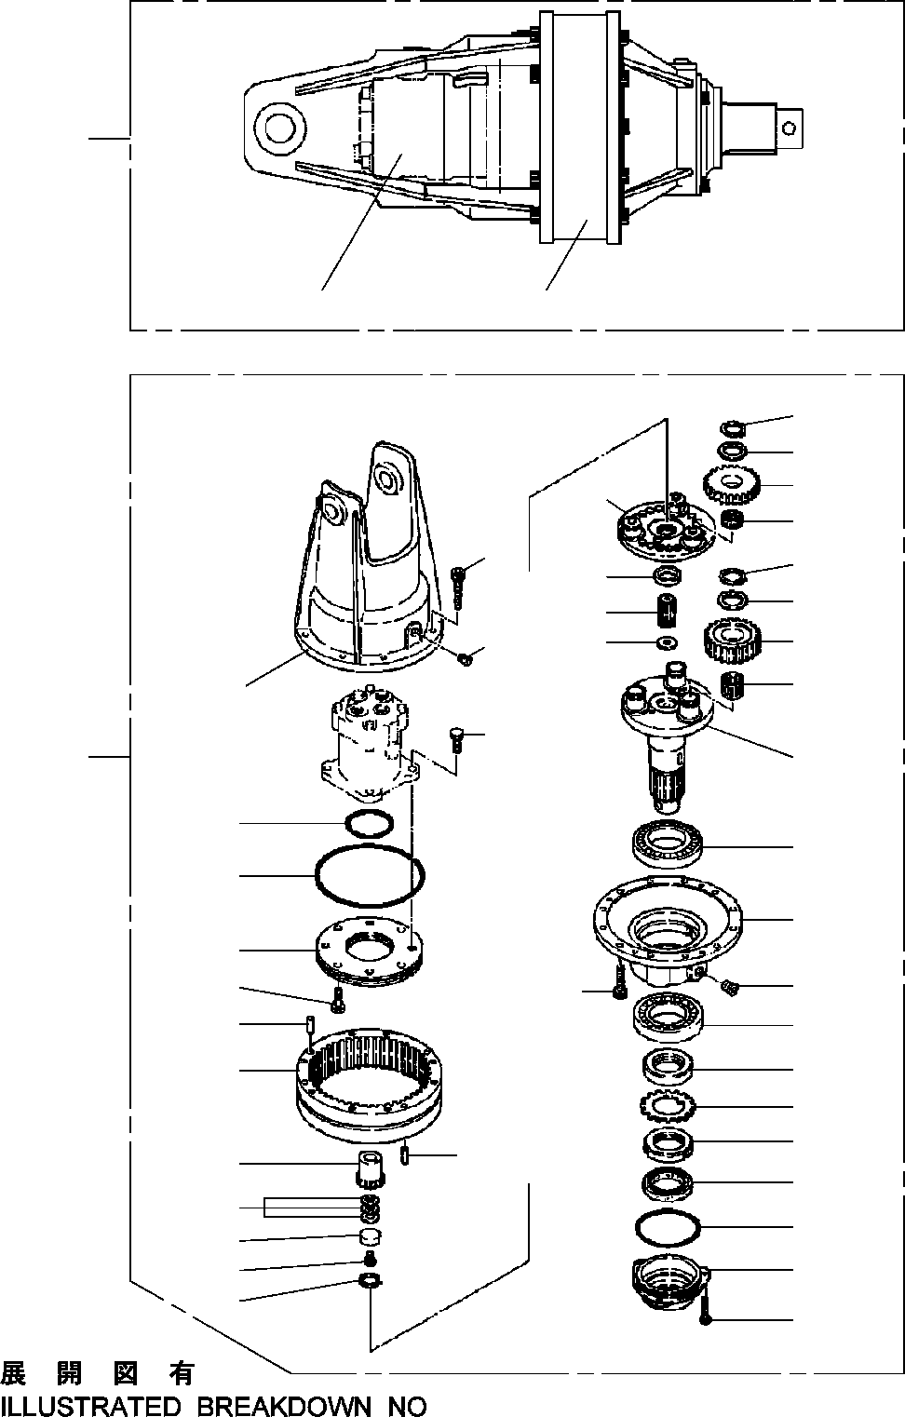

**DT-600-2-00001 UPPER**

**PP2030002-02 DRIVING UNIT,AUGER**

**100**

**2**

**1**

**25**

**24**

**28**

**27**

**25**

**24**

**23**

**22**

**26**

**48**

**35**

**34**

**33**

**18**

**49**

**45**

**1**

**21**

**44**

**17**

**43**

**20**

**42**

**45**

**41**

**32**

**18**

**17**

**15**

**16**

**15**

**14**

**13**

**12**

**19**

**31**

**40**

**39**

**38**

**37**

**36**

**11**

**2**

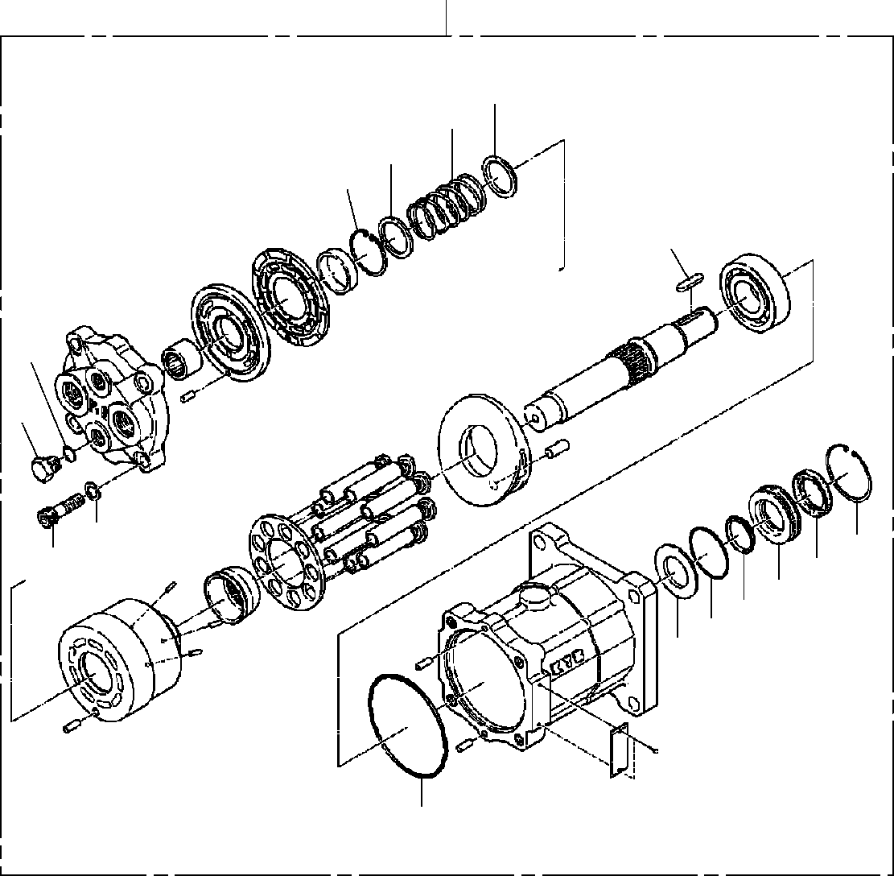

**DT-600-2-00001 UPPER**

**PP2030002-02 DRIVING UNIT,AUGER**

**2**

**52**

**58**

**53**

**59**

**75**

**61**

**70**

**72**

**60**

**71**

**69**

**51**

**65**

**62**

**57**

**63**

**DT-600-2-00001 UPPER**

**000091**

Pos No.

Parts No

Parts Name

Qty

Unit

Technical Data

Serial No (Start)

Serial No (End)

Rema

1

2

11

12

13

14

15

16

17

18

19

20

21

22

23

24

25

26

27

28

31

32

33

34

35

36

37

38

39

40

41

42

43

44

45

48

49

51

52

53

57

58

59

60

61

62

63

65

69

70

71

72

75

100

36340200000

36661930000

90131510025

36340205010

36340205020

36340205030

36340205040

36340205050

36340205060

80316030080

90131512030

36340205080

36340205090

36340205100

36340205110

36340205120

80601110400

36340205130

36340205140

36340205150

80730100026

36340205160

36340205170

36340205180

36340205190

80601110340

90131508020

36340205200

36340205210

36340205220

36340205230

36340205240

36340205250

36340205260

90101514040

90131514040

36340205280

36661315010

36660825010

36660825020

36661315020

36660825030

36660825040

36661315030

91002801400

91001205500

91001211500

36661315040

36661315050

36661315060

90131712040

90302041201

36661315070

36340260000

REDUCER ASSY MOTOR,HYDRAULIC BOLT,HEXAGON SOCKET CARRIER

O-RING SEAL,OIL NUT,LOCK WASHER (LOCK)

BEARING,ROLLER PLUG

BOLT,HEXAGON SOCKET HOUSING

CARRIER ASSY (N2) BEARING,NEEDLE GEAR,PLANETARY RETAINER (THRUST) RING,RITAINING CARRIER ASSY (N1) BEARING,NEEDLE GEAR,PLANETARY PIN

GEAR,RING RETAINER (THRUST) GEAR,SUN (N2) RETAINER (THRUST) RING,RITAINING

BOLT,HEXAGON SOCKET RETAINER

SHIM SET GEAR,SUN (N1) PIN (KNOCK) PLATE (RETAINER) O-RING

O-RING BOLT

BOLT,HEXAGON SOCKET SUPPORT

CASE (OIL SEAL) GUIDE,SPRING GUIDE,SPRING PLATE

SPRING RING,RETAINING RING,RETAINING O-RING

O-RING O-RING

SEAL,CAP SEAL,OIL PLUG

BOLT,HEXAGON SOCKET WASHER,SPRING

KEY

DRIVING UNIT,AUGER

1

1

3

1

1

1

2

1

2

2

12

1

1

3

3

6

6

1

3

3

2

1

1

1

1

1

1

1

1

1

4

1

1

1

8

8

1

1

1

1

1

1

1

1

1

1

1

1

1

1

4

4

1

1

M10X25

PT1/2 M12X30

S40

10X26

S34 M8X20

M14X40 M14X40

1B P14

1A G55

1A G115

M12X40 12

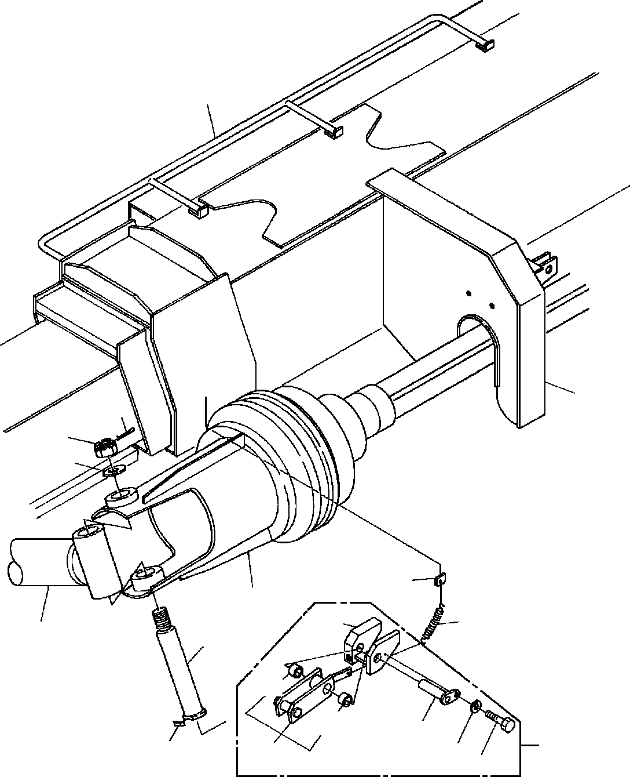

**DT-600-2-00001 UPPER PP2050002-01 MOUNT,AUGER**

**1**

**4**

**14**

**13**

**12**

**30**

**2**

**29**

**102**

**22**

**15**

**132**

**132**

**103**

**28**

**16**

**101**

**48**

**104**

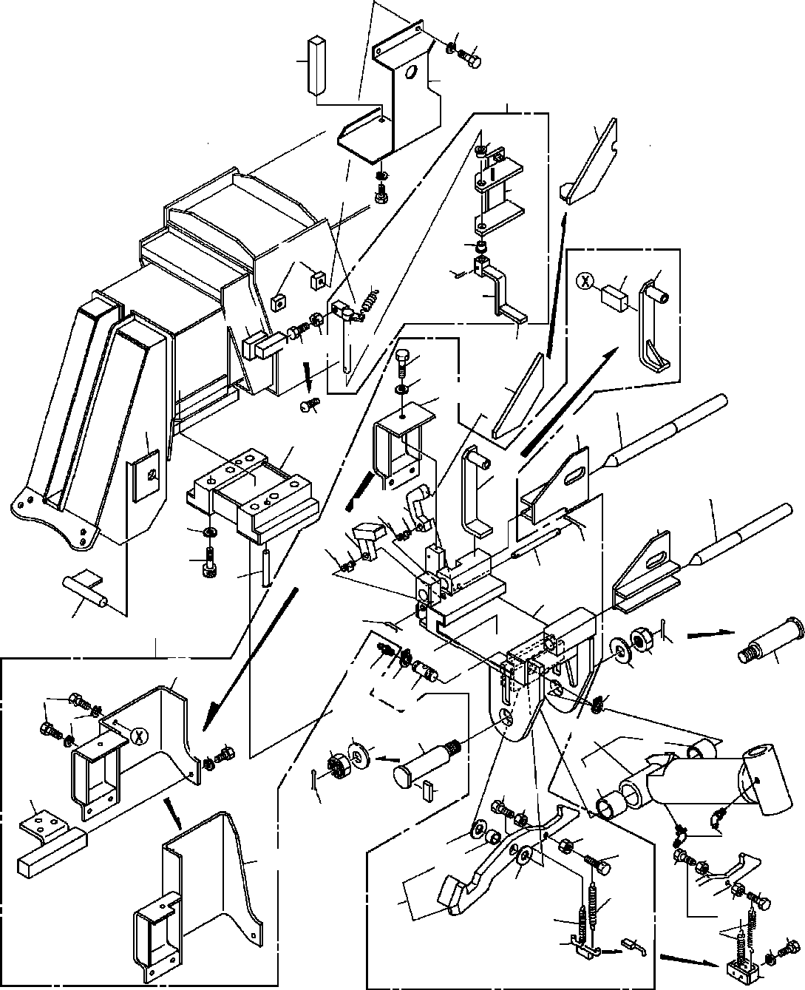

**DT-600-2-00001 UPPER PP2050002-01 MOUNT,AUGER**

**48**

**149**

**144**

**143**

**141**

**162**

**42**

**48**

**149**

**164**

**162**

**165**

**166**

**146**

**74**

**81**

**29**

**145**

**163**

**14745**

**142**

**42**

**77**

**78**

**73**

**27**

**24**

**147**

**43**

**38**

**74**

**25**

**70 72**

**26**

**40**

**71**

**70**

**76**

**39**

**75**

**61**

**41**

**76**

**36**

**21**

**35**

**34**

**73**

**37**

**31**

**79 33**

**79**

**77**

**63**

**31**

**48**

**34 33**

**22**

**4877**

**91**

**91**

**68**

**32**

**80**

**67**

**35**

**67**

**45 23**

**65**

**68**

**82**

**124**

**44**

**44**

**65**

**46**

**62**

**45**

**46**

**69**

**69**

**47**

**46**

**48**

**49**

**DT-600-2-00001 UPPER**

**000092**

Pos No.

Parts No

Parts Name

Qty

Unit

Technical Data

Serial No (Start)

Serial No (En

275124

275124

275124

275017

275017

275017

275017

275017

275103

275017

275103

1

2

4

12

13

14

15

16

21

22

23

24

25

26

27

28

29

30

31

33

34

35

36

37

38

39

40

41

42

43

44

45

46

47

48

49

61

62

63

65

70

71

72

73

74

75

76

77

79

80

81

82

91

101

102

103

104

124

(***********) (***********) (***********) 37000524100

90236202400

80136350045

37000126040

37000527800

32490110010

32490110020

82458202000

32490110030

32490110040

32490110050

32490110060

32490110070

53620233000

53620233000

37000504620

37000128360

37000524100

90236202401

80136350045

32490110080

82456201000

32490110090

90131516075

90133916075

90302041601

90303501601

80747130090

80737160090

32490110130

32490110110

90101508020

90201200800

90201200800

19114411000

90101508040

90302040801

90302040801

90302040801

32490110120

32490112000

32490119510

37000126120

37000524640

37001400150

37001400150

32490112020

32490112030

32490112040

32490112400

32490112050

37000126050

80136332020

90171108016

90171108016

80601110220

32490112410

32490262030

32490112420

32490262000

37000401810

32490112100

32490112110

37000119920

90101208012

80804022015

PIPING,AUGER AUGER MOUNT,AUGER PLATE NUT,CASTLE PIN,SPLIT

PIN BAR

SUPPORT ASSY SUPPORT NIPPLE,GREASE COVER SUPPORT SUPPORT SUPPORT STOPPER ASSY SPRING

SPRING PLATE PIN PLATE

NUT,CASTLE PIN,SPLIT STOPPER NIPPLE,GREASE SUPPORT

BOLT,HEXAGON SOCKET <M16X75. BOLT,HEXAGON SOCKET WASHER,SPRING

WASHER,PLAIN PIN

PIN CAM

SUPPORT BOLT NUT

NUT SPRING BOLT

WASHER,SPRING WASHER,SPRING WASHER,SPRING STOPPER SUPPORT STOPPER ASSY PIN

PLATE SPRING SPRING STOPPER STOPPER COVER COVER SUPPORT PIN PIN,SPLIT BOLT BOLT

RING,RITAINING SUPPORT SUPPORT SUPPORT COVER BEARING,PLAIN STOPPER SUPPORT

PIN BOLT

BEARING,PLAIN

1

1

1

1

1

1

1

1

1

1

2

1

1

1

1

1

1

1

1

1

1

1

1

1

1

1

6

6

6

6

2

2

1

1

2

2

1

2

2

3

4

9

1

1

1

1

2

2

1

1

1

1

1

1

1

2

4

6

2

1

1

1

1

4

1

1

1

1

1

T=6 M24 5X45

B-TYPE PT1/8

T=6 M24 5X45

A-TYPE PT1/8

M16X75 16

16

13X90

16X90

M8X20 M8

M8

M8X40 8

8

8

3.2X20 M8X16 M8X16 S22

M8X12

275018

275125

275125

275125

275018

275018

275018

275018

275018

275018

275104

275018

275104

**DT-600-2-00001 UPPER**

**000092**

Pos No.

Parts No

Parts Name

Qty

Unit

Technical Data

Serial No (Start)

Serial No (En

275031

132

141

142

143

144

145

146

147

149

162

163

164

165

166

80804020010

32490112300

37000532930

32490112310

32490112320

32490112330

37000502190

90101208030

80182308035

90101208014

37000401050

32490113000

32490113010

80720104028

32490113020

BEARING,PLAIN STOPPER ASSY PLATE

COVER SUPPORT SUPPORT PLATE BOLT

SCREW,MACHINE BOLT BEARING,PLAIN SHAFT

SUPPORT PIN,SPRING LEVER

2

1

1

1

1

1

2

1

1

3

2

1

1

1

1

M8X30 M8X35 M8X14

4X28

275018

275018

275018

275018

275018

275018

275018

275032

275018

275018

275018

275018

275018

275018

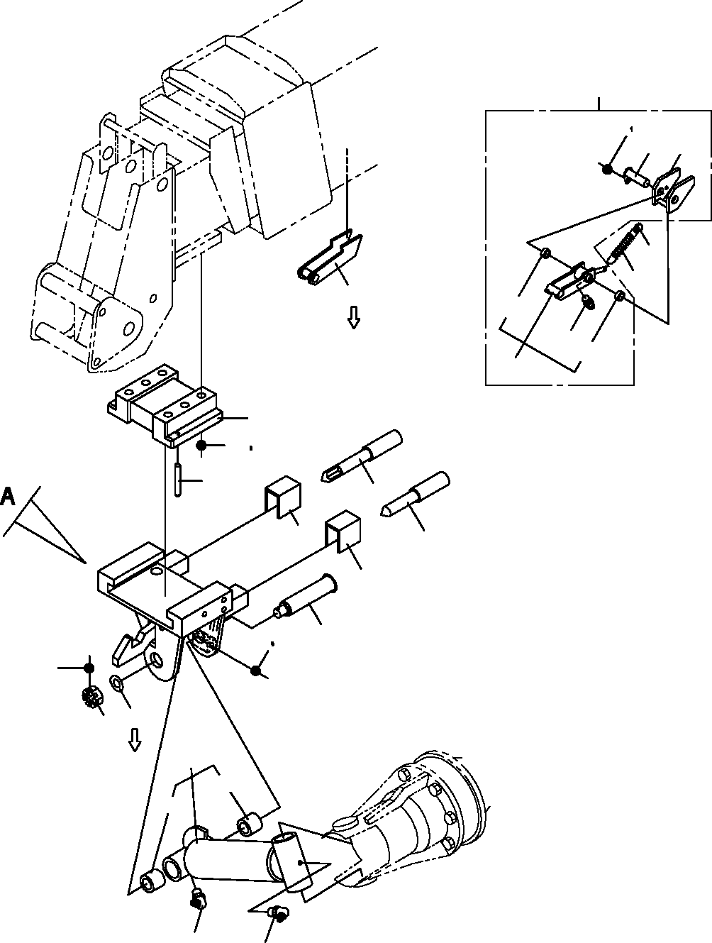

**DT-600-2-00001 UPPER PP2050012-06 MOUNT,AUGER**

**21**

**36 84**

**83**

**82**

**23**

**22**

**8**

**96**

**21**

**34**

**96**

**81**

**4**

**17**

**16**

**12**

**7**

**6**

**5**

**6**

**11**

**19 20**

**15**

**13**

**14**

**2**

**63**

**61**

**61**

**3**

**3**

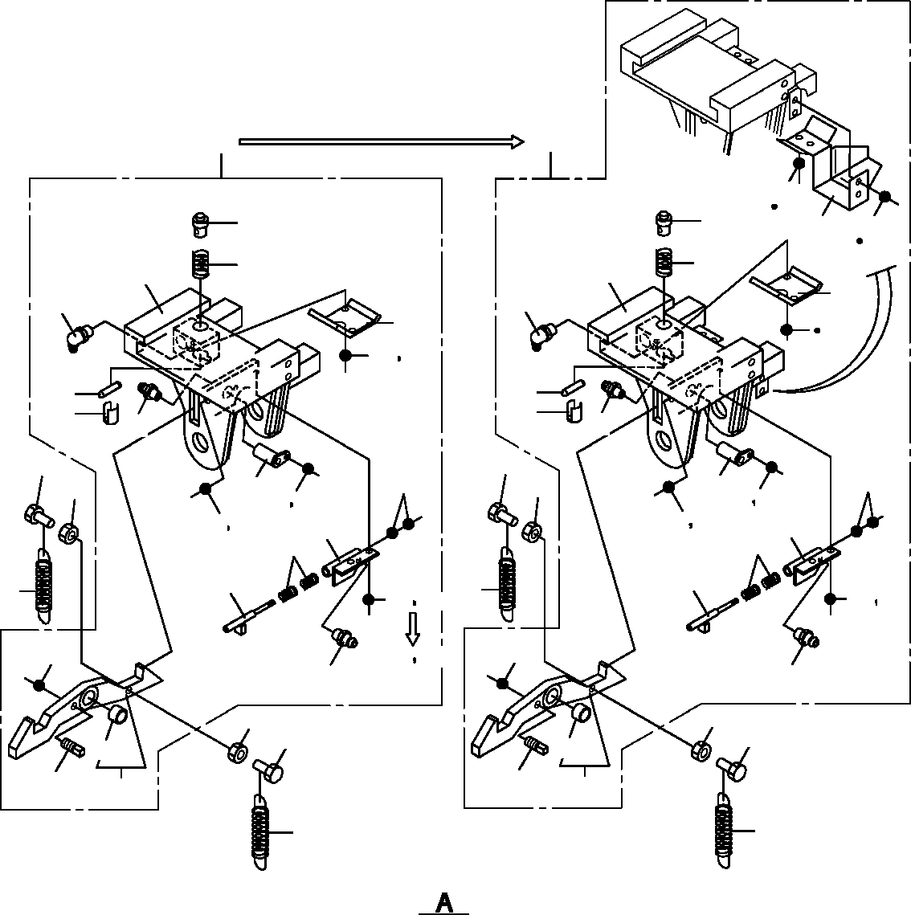

**DT-600-2-00001 UPPER PP2050012-06 MOUNT,AUGER**

**1**

**101**

**135**

**137**

**39**

**39**

**56**

**134**

**135**

**120**

**40**

**111**

**31**

**44**

**43**

**43**

**36**

**52**

**44**

**36 52**

**41**

**42**

**41**

**42**

**34**

**34**

**9**

**9**

**51**

**51**

**10**

**10**

**33**

**33**

**35 36**

**45**

**49**

**35 36**

**45**

**49**

**46 47**

**46 47**

**50**

**50**

**18**

**18**

**36 53**

**35**

**36**

**38**

**38**

**36**

**53**

**34**

**34**

**10**

**10**

**9**

**9**

**73**

**73**

**37**

**37**

**32**

**32**

**18**

**18**

**DT-600-2-00001 UPPER**

**000093**

Pos No.

Parts No

Parts Name

Qty

Unit

Technical Data

Serial No (Start)

Serial No (End)

Rema

1

2

3

4

5

6

7

8

9

10

11

12

13

14

15

16

17

18

19

20

21

22

23

31

32

33

34

35

36

37

38

39

40

41

42

43

44

45

46

47

49

50

51

52

53

56

61

63

73

81

82

83

84

96

101

111

120

134

135

137

32490300010

32490300020

82459103000

32490300030

32490300040

32490300050

32490300060

32490530010

32490530020

90101508020

90201200800

37000128360

80737160090

37000524100

90236202401

80136350045

90133916075

90172316075

90303501601

19114411000

90101508055

90302040801

32490531000

53620233000

37000504620

32490302000

32490302010

32490302020

82455106000

82455106000

82455106000

90101208016

90302040801

90302040801

90302040801

90781212400

90266201200

32490302040

37001201110

80747100056

32490302050

82459103000

32490302100

32490302070

90102506025

90203200600

37001201020

32490302080

90203200800

90180208016

90131508014

32472870202

37000401810

90303502701

80804025020

32490530200

32490530100

37000119920

90101208012

80804020010

32490530031

32490532000

37001202190

90101210020

90302041001

90180210020

SUPPORT ASSY ARM NIPPLE,GREASE SUPPORT

PIN SUPPORT PIN STOPPER STOPPER BOLT NUT

PIN PIN PLATE

NUT,CASTLE PIN,SPLIT

BOLT,HEXAGON SOCKET BOLT,HEXAGON SOCKET WASHER,PLAIN

SPRING BOLT

WASHER,SPRING STOPPER ASSY SPRING

PLATE SUPPORT STOPPER PIN

NIPPLE,GREASE NIPPLE,GREASE NIPPLE,GREASE BOLT WASHER,SPRING WASHER,SPRING WASHER,SPRING SCREW,SET

NUT PIN SPRING PIN (B)

SPACER NIPPLE,GREASE COVER

HOLDER BOLT NUT SPRING SHAFT NUT

BOLT,BUTTON BOLT,HEXAGON SOCKET SUPPORT BEARING,PLAIN WASHER,PLAIN <27) BEARING,PLAIN STOPPER

SUPPORT PIN

BOLT BEARING,PLAIN SUPPORT ASSY SUPPORT ASSY SPRING

BOLT WASHER,SPRING BOLT,BUTTON

1

1

2

1

1

2

1

1

1

2

2

1

2

1

1

1

6

6

6

2

1

1

1

1

1

1

1

1

2

1

2

1

5

1

5

1

1

1

1

1

1

1

1

1

1

1

2

1

2

2

2

1

4

1

1

1

1

1

1

2

1

1

1

2

4

2

C-PT1/8

M8X20 M8

16X90 T=6 M24 5X45 M16X75 M16X75 16

M8X55 8

A-M6F FE A-M6F FE A-M6F FE M8X16

8

8

8

M12X40 M12

10X56 C-PT1/8

M6X24 M6

M8 M8X16 M8X14

M8X12

M10X20 10 M10X20

275216

275470

275364

275364

275364

275364

275712

275712

275364

275712

275712

275712

275712

275712

275712

275376

275364

275364

275364

275364

275364

275712

275712

275712

275712

275712

275712

275711

275215

275363

275375

275469

275711

275711

275711

275711

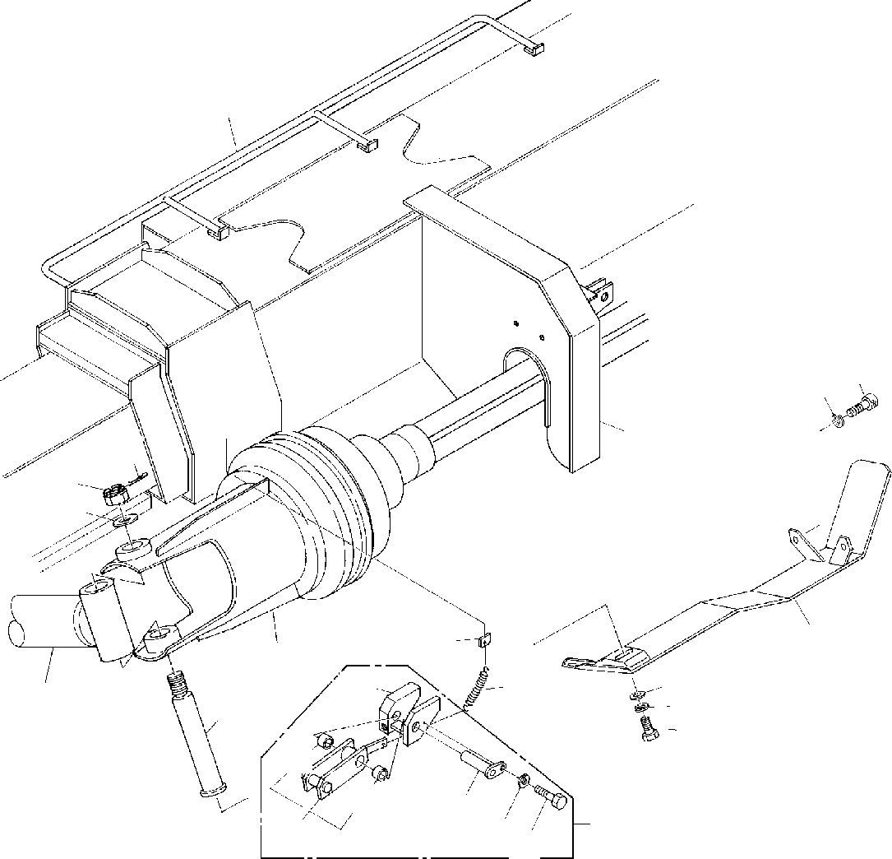

**DT-600-2-00001 UPPER PP2050013-00 MOUNT,AUGER**

**1**

**11 10**

**4**

**14**

**13**

**12**

**6**

**30**

**2**

**102**

**29**

**9**

**22**

**5**

**8**

**7**

**132**

**132**

**103**

**48104**

**28**

**101**

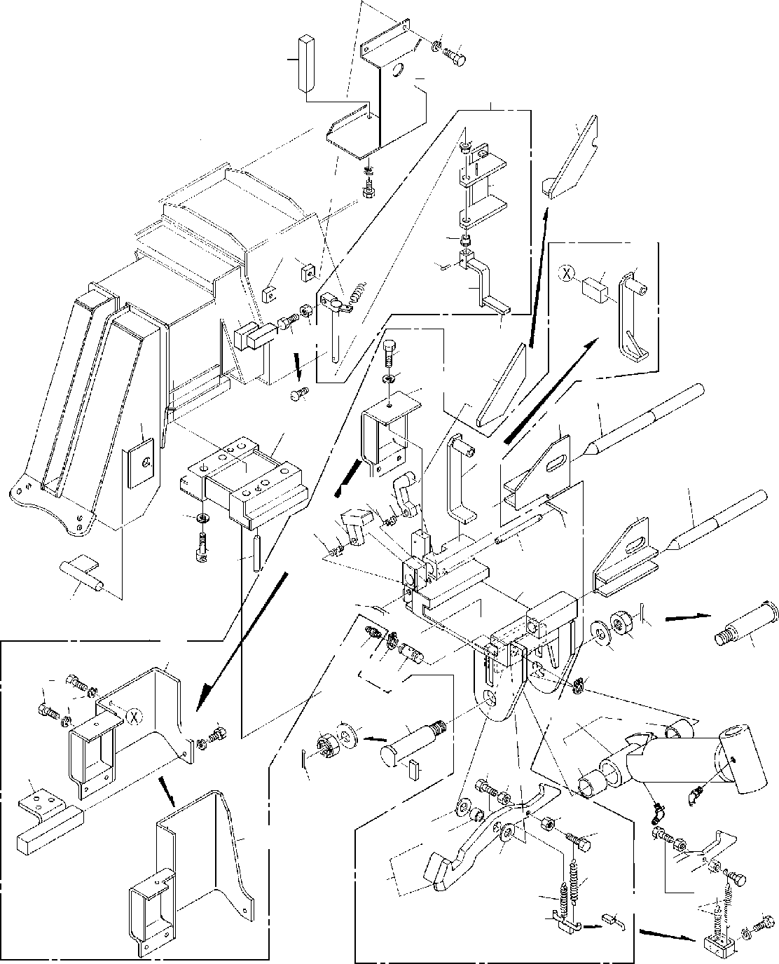

**DT-600-2-00001 UPPER PP2050013-00 MOUNT,AUGER**

**48**

**149**

**144**

**143**

**141**

**162**

**42**

**48**

**149**

**164**

**162**

**165**

**166**

**146**

**74**

**81**

**29**

**145**

**163**

**14745**

**77**

**78**

**73**

**142**

**42**

**27**

**24**

**147**

**43**

**38**

**74**

**25**

**70 72**

**26**

**71**

**40**

**39**

**70**

**76**

**75**

**61**

**41**

**76**

**36**

**21**

**73**

**35**

**34**

**37**

**31**

**79 33**

**7963**

**31**

**77**

**48**

**33**

**22**

**77**

**91**

**34**

**48**

**91**

**68**

**32**

**80**

**67**

**35**

**67**

**23**

**65**

**45**

**68**

**82**

**124**

**44**

**44**

**65**

**46**

**62**

**45**

**46**

**46**

**69**

**47**

**69**

**48**

**49**

**DT-600-2-00001 UPPER**

**000094**

Pos No.

Parts No

Parts Name

Qty

Unit

Technical Data

Serial No (Start)

Serial No (End)

Rema

1

2

4

5

6

7

8

9

10

11

12

13

14

21

22

23

24

25

26

27

28

29

30

31

33

34

35

36

37

38

39

40

41

43

44

45

46

47

48

49

61

62

63

65

70

71

74

75

76

77

79

80

81

82

91

101

102

103

104

124

132

141

142

143

144

145

(***********) (***********) (***********) 37000126040

32490230010

90101210025

90302041001

90303071001

90131512040

90302041201

37000524100

90236202400

80136350045

32490110010

32490110020

82458202000

32490110030

32490110040

32490110050

32490110060

32490110070

53620233000

53620233000

37000504620

37000128360

37000524100

90236202401

80136350045

32490110080

82456201000

32490110090

90133916075

90303501601

80737160090

32490110110

90101508020

90201200800

90201200800

19114411000

90101508040

90302040801

90302040801

32490110120

32490112000

32490119510

37000126120

37000524640

37001400150

32490112020

32490112050

37000126050

80136332020

90171108016

80601110220

32490262030

32490112420

32490262000

37000401810

32490112100

32490112110

37000119920

90101208012

80804022015

80804020010

32490112300

37000532930

32490112310

32490112320

32490112330

PIPING,AUGER AUGER MOUNT,AUGER PIN

COVER BOLT

WASHER,SPRING WASHER,PLAIN BOLT,HEXAGON SOCKET WASHER,SPRING

PLATE NUT,CASTLE PIN,SPLIT SUPPORT ASSY SUPPORT NIPPLE,GREASE COVER SUPPORT SUPPORT SUPPORT STOPPER ASSY SPRING

SPRING PLATE PIN PLATE

NUT,CASTLE PIN,SPLIT STOPPER NIPPLE,GREASE SUPPORT

BOLT,HEXAGON SOCKET WASHER,PLAIN

PIN SUPPORT BOLT NUT

NUT SPRING BOLT

WASHER,SPRING WASHER,SPRING STOPPER SUPPORT STOPPER ASSY PIN

PLATE SPRING STOPPER SUPPORT PIN PIN,SPLIT BOLT

RING,RITAINING SUPPORT SUPPORT COVER BEARING,PLAIN STOPPER SUPPORT

PIN BOLT

BEARING,PLAIN BEARING,PLAIN STOPPER ASSY PLATE

COVER SUPPORT SUPPORT

1

1

1

1

1

1

1

1

2

2

1

1

1

1

1

2

1

1

1

1

1

1

1

1

1

1

1

1

1

1

1

6

6

2

1

2

2

1

2

2

3

9

1

1

1

1

2

1

1

1

1

2

6

2

1

1

1

4

1

1

1

1

1

2

1

1

1

1

1

M10X25 10

10

M12X40 12

T=6 M24 5X45

B-TYPE PT1/8

T=6 M24 5X45

A-TYPE PT1/8 M16X75

16

16X90

M8X20 M8

M8

M8X40 8

8

3.2X20 M8X16 S22

M8X12

275018

275125

275125

275125

275018

275018

275018

275018

275104

275018

275104

275018

275018

275018

275018

275018

**DT-600-2-00001 UPPER**

**000094**

Pos No.

Parts No

Parts Name

Qty

Unit

Technical Data

Serial No (Start)

Serial No (End)

Rema

146

147

149

162

163

164

165

166

37000502190

80182308035

90101208014

37000401050

32490113000

32490113010

80720104028

32490113020

PLATE SCREW,MACHINE BOLT BEARING,PLAIN SHAFT

SUPPORT PIN,SPRING LEVER

2

1

3

2

1

1

1

1

M8X35 M8X14

4X28

275018

275032

275018

275018

275018

275018

275018

275018

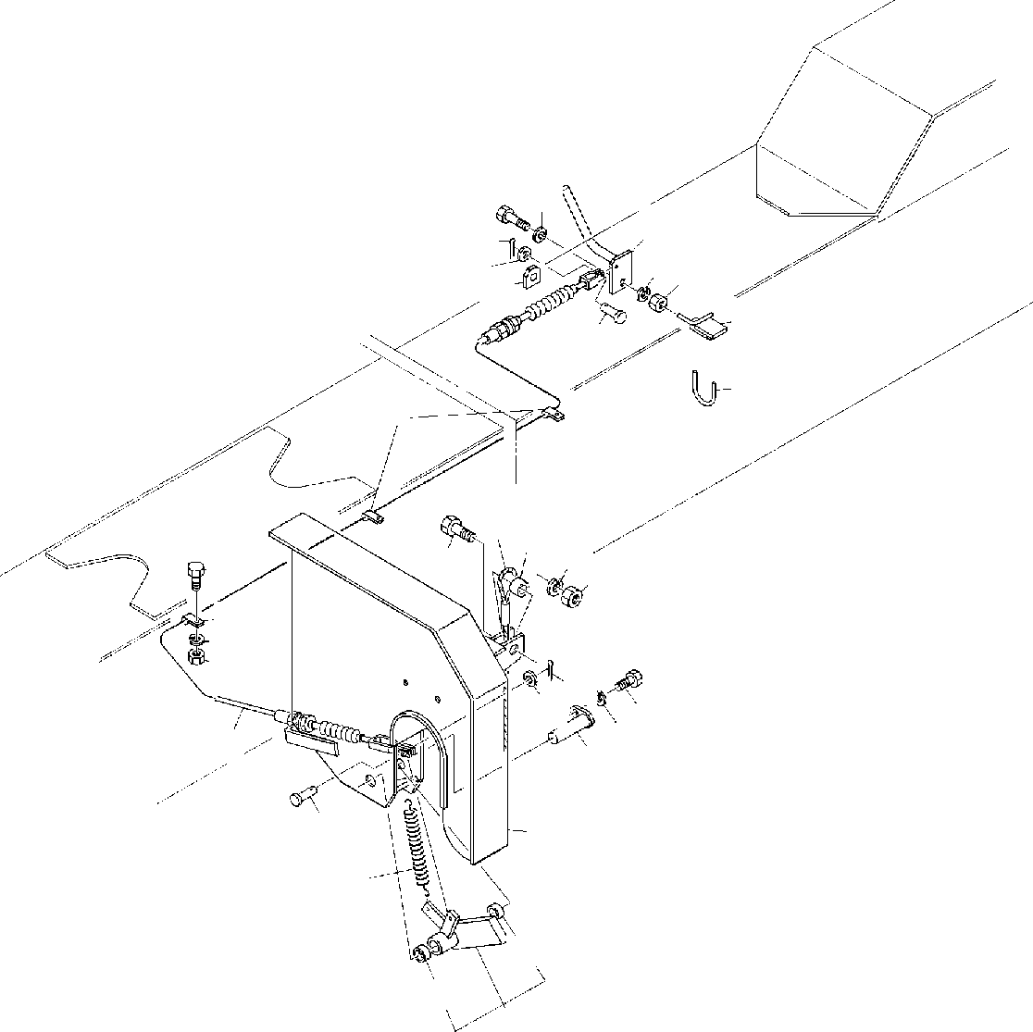

**DT-600-2-00001 UPPER PP2050014-00 MOUNT,AUGER**

**2223**

**24**

**23**

**14**

**13**

**21**

**26**

**20**

**12**

**25**

**345 6**

**1915 18**

**17**

**4**

**3**

**6**

**5**

**16**

**14**

**13**

**10**

**11**

**9**

**7**

**12**

**2**

**1**

**42**

**42**

**8**

**DT-600-2-00001 UPPER**

**000095**

Pos No.

Parts No

Parts Name

Qty

Unit

Technical Data

Serial No (Start)

Serial No (End)

Remarks

Pa

1

2

3

4

5

6

7

8

9

10

11

12

13

14

15

16

17

18

19

20

21

22

23

24

25

26

42

59240004001

32490130010

82100002006

90101206014

90201200600

90302040601

37001702800

32490130020

37000119940

90101208012

90302040801

37000109680

90303070601

80136316012

37000302260

90101216050

90201201600

90302041601

37001901130

32490130030

90201201200

90101212030

90303071201

32490130040

37000530940

32200232090

80804020010

SPRING SUPPORT CLAMP BOLT NUT

WASHER,SPRING CABLE,CONTROL LEVER

PIN BOLT

WASHER,SPRING PIN WASHER,PLAIN PIN,SPLIT SPACER

BOLT NUT

WASHER,SPRING ROPE,WIRE SUPPORT

NUT BOLT

WASHER,PLAIN LEVER SUPPORT SUPPORT BEARING,PLAIN

1

1

4

4

4

4

1

1

1

1

1

2

2

2

1

1

1

1

1

1

1

1

2

1

1

1

2

WR10 M6X14 M6

6

L=2950

M8X12 8

6

1.6X12 L=15 M16X50 M16

16

M12 M12X30 12

275200

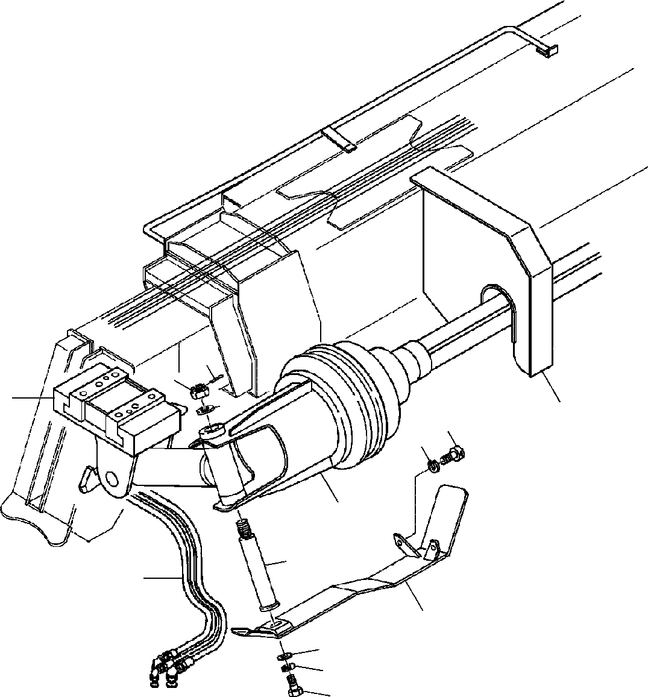

**DT-600-2-00001 UPPER PP2050015-01 MOUNT,AUGER**

**14**

**13**

**3**

**12**

**4**

**10**

**11**

**2**

**5**

**1**

**6**

**9**

**8**

**7**

**DT-600-2-00001 UPPER**

**000096**

Pos No.

Parts No

Parts Name

Qty

Unit

Technical Data

Serial No (Start)

Serial No (End)

Rema

1

2

3

4

5

6

7

8

9

10

11

12

13

14

(***********) (***********) (***********) (***********) 37000126040

32490230010

90101210025

90302041001

90303071001

90131512040

90302041201

37000524100

90236202400

80136350045

PIPING,AUGER AUGER MOUNT,AUGER MOUNT,AUGER PIN

COVER BOLT

WASHER,SPRING WASHER,PLAIN BOLT,HEXAGON SOCKET WASHER,SPRING

PLATE NUT,CASTLE PIN,SPLIT

1

1

1

1

1

1

1

1

1

2

2

1

1

1

M10X25 10

10

M12X40 12

T=6 M24 5X45

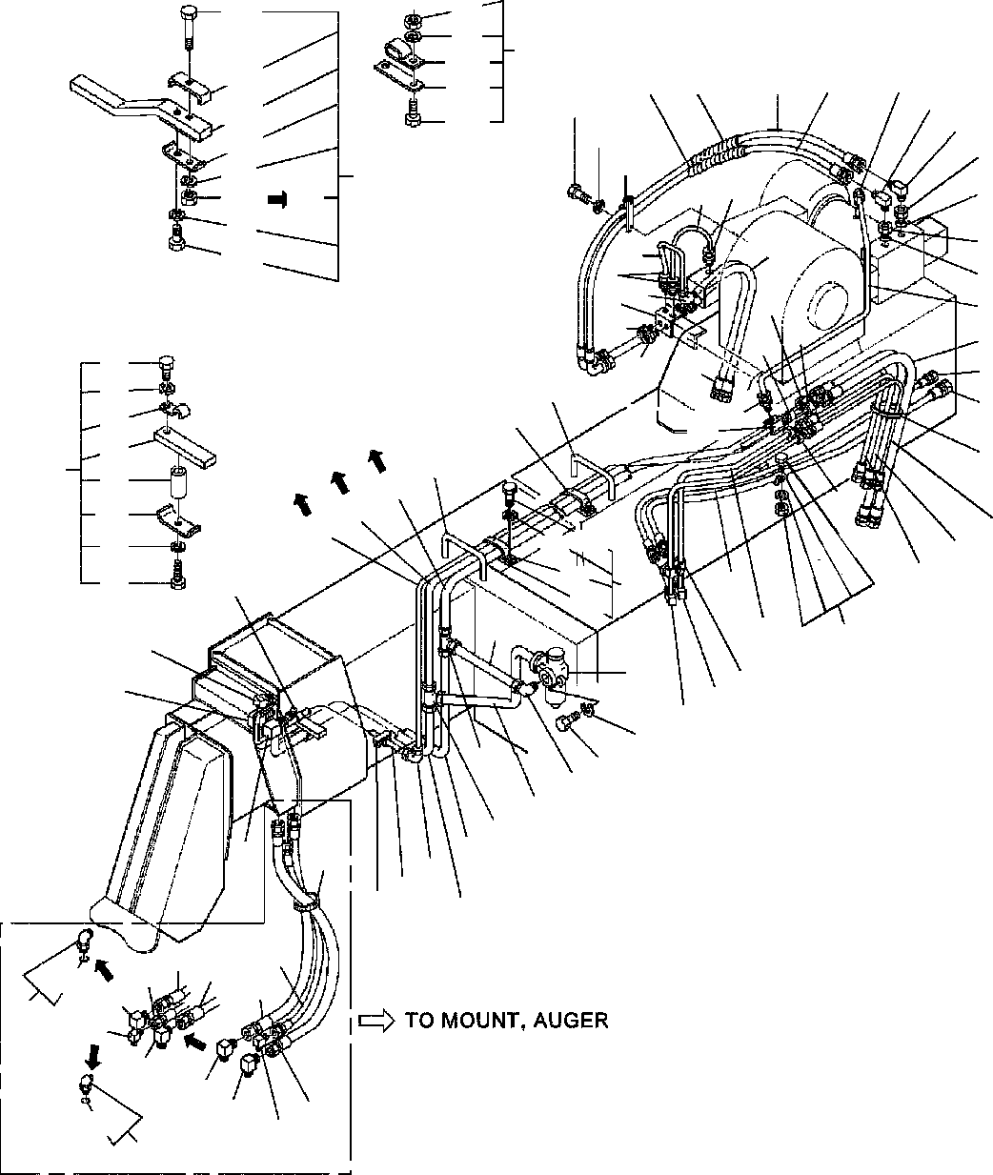

**DT-600-2-00001 UPPER PP2100002-09 PIPING,AUGER**

**93**

**74**

**101**

**61**

**112**

**111**

**113**

**106**

**58**

**58**

**57**

**57**

**32**

**59**

**60**

**107**

**105**

**74**

**102**

**74**

**104**

**59**

**22**

**33**

**34**

**61**

**44**

**5**

**8**

**93**

**33**

**34**

**35**

**53**

**42**

**41**

**7**

**31**

**5**

**4**

**30**

**6**

**51**

**51**

**50**

**73**

**74**

**30**

**31**

**56**

**48**

**27**

**72**

**71**

**77**

**75**

**74**

**76**

**49**

**62**

**63**

**43**

**56**

**3**

**64**

**24**

**52**

**25**

**54**

**26**

**83**

**74**

**47**

**81**

**82**

**46**

**3**

**27**

**36**

**17**

**37**

**40**

**2**

**20**

**1**

**38**

**2**

**39**

**22**

**19**

**21**

**18**

**23**

**19**

**43**

**13**

**1**

**16**

**14**

**55**

**15**

**11**

**12**

**12**

**12**

**11**

**191**

**10**

**10**

**9**

**10**

**10**

**10**

**12**

**181**

**9**

**9**

**DT-600-2-00001 UPPER**

**000097**

Pos No.

Parts No

Parts Name

Qty

Unit

Technical Data

Serial No (Start)

Serial No (End)

Remark

1

2

3

4

5

6

7

8

9

10

11

12

13

14

15

16

17

18

19

20

21

22

23

24

25

26

27

30

31

32

33

34

35

36

37

38

39

40

41

42

43

44

46

47

48

49

50

51

52

53

54

55

56

57

58

59

60

61

62

37000906830

37000906810

32340190010

32340190020

80302010100

80303030100

81408000130

81408000130

80430450650

80430620600

80430451250

80430621200

37002417820

37002413360

37002417790

81408000290

81408000160

81408000290

80303010100

81408000290

80303030280

80305010200

36620710000

90101210060

90302041001

81408000290

81408000290

81408000290

81408000160

32340110060

80430410650

37002417770

37002426520

80303030160

37000912460

91002802400

81408000160

81408000160

81408000160

37000708100

37000908570

32340110040

37002419210

37002415070

37002403320

37002426530

91810132530

91810132530

32340190030

37002419200

37002419220

37002426540

80302010140

32340190040

37000900110

37000900130

37000910110

37002413410

37002419190

37002426550

37000705960

32340190050

37002420680

37002426560

32340194150

37000911550

90101210025

32340190060

81408000290

JOINT JOINT

CLAMP ASSY JOINT FITTING

FITTING,ELBOW PIPE,STEEL PIPE,STEEL JOINT

JOINT (WITH O-RING) JOINT

JOINT HOSE HOSE HOSE PIPE,STEEL PIPE,STEEL PIPE,STEEL

FITTING,ELBOW PIPE,STEEL FITTING,ELBOW FITTING,TEE VALVE,CHECK BOLT WASHER,SPRING PIPE,STEEL PIPE,STEEL PIPE,STEEL PIPE,STEEL CLAMP ASSY JOINT

HOSE HOSE

FITTING,ELBOW JOINT

O-RING PIPE,STEEL PIPE,STEEL PIPE,STEEL CLAMP ASSY JOINT CLAMP ASSY HOSE

HOSE HOSE HOSE FASTENER FASTENER

CLAMP ASSY HOSE

HOSE HOSE FITTING JOINT JOINT JOINT JOINT HOSE HOSE HOSE

CLAMP ASSY GUARD HOSE

HOSE TUBE,SPIRAL JOINT

BOLT

CLAMP ASSY PIPE,STEEL

2

2

1

1

3

1

1

1

1

1

2

2

1

1

2

2

2

2

1

1

2

2

1

2

3

1

4

4

4

2

2

2

2

1

2

2

2

2

2

1

1

2

1

1

1

1

1

2

1

1

1

1

1

1

1

2

1

2

1

1

1

3

2

2

2

2

1

1

4

M M

M M M

M

M M M M

M M M

M

M

L,3/4-22

KCT10-020N KLN10-020N 10X1.8T

10X1.8T L,G3/8-G3/8

L=800 L=900 L=850 22X2.5T

12X1.4T

22X2.5T KLA12-000N 22X2.5T KLN22 KTA220-000N

M10X60 10

22X2.5T

22X2.5T

22X2.5T

12X1.4T

L=710 L=710 KLN12-030N

1B P24

12X1.4T

12X1.4T

12X1.4T

12X2

21X2 L=1320 L=1320 L=1400 L=1400

L=670 L=670 L=670

C717KCT12-020N

L=710 L=670 L=670 12

L=950 L=950

M10X25 22X2.5T

275203

275203

275082

275041

275041

275041

275032

275041

275041

275041

275241

275202

275212

275202

275212

275081

275212

275212

275240

275240

275240

275040

275040

275040

275031

275040

275040

275040

**DT-600-2-00001 UPPER**

**000097**

Pos No.

Parts No

Parts Name

Qty

Unit

Technical Data

Serial No (Start)

Serial No (End)

Remark

63

64

71

72

73

74

75

76

77

81

82

83

93

101

102

104

105

106

107

111

112

113

181

191

81408000290

81408000160

37000528330

37000600660

90101208012

90302040801

37000602560

90101208035

32340190070

32340112020

37000519310

90101508015

90201200800

90201200800

90101508075

90101208075

90201400800

90101508030

90101208030

37000602540

37000602230

32340192010

32340192100

82100002041

90101208016

91002801400

91002802400

PIPE,STEEL PIPE,STEEL PLATE CLAMP BOLT

WASHER,SPRING SUPPORT

BOLT SPACER SUPPORT PLATE BOLT NUT

NUT BOLT BOLT NUT BOLT BOLT SUPPORT SUPPORT SUPPORT PLATE CLAMP BOLT

O-RING O-RING

4

4

1

1

1

9

1

1

1

2

2

4

1

1

1

1

1

1

1

1

1

1

1

1

1

1

2

M M

22X2.5T

12X1.4T

R=6 M8X12 8

M8X35 L=20

M8X15 M8

M8 M8X75 M8X75 M8 M8X30 M8X30

M8X16 1B P14

1B P24

275241

275241

275352

275799

275799

275799

275203

275203

275863

275863

275798

275798

275798

275212

275212

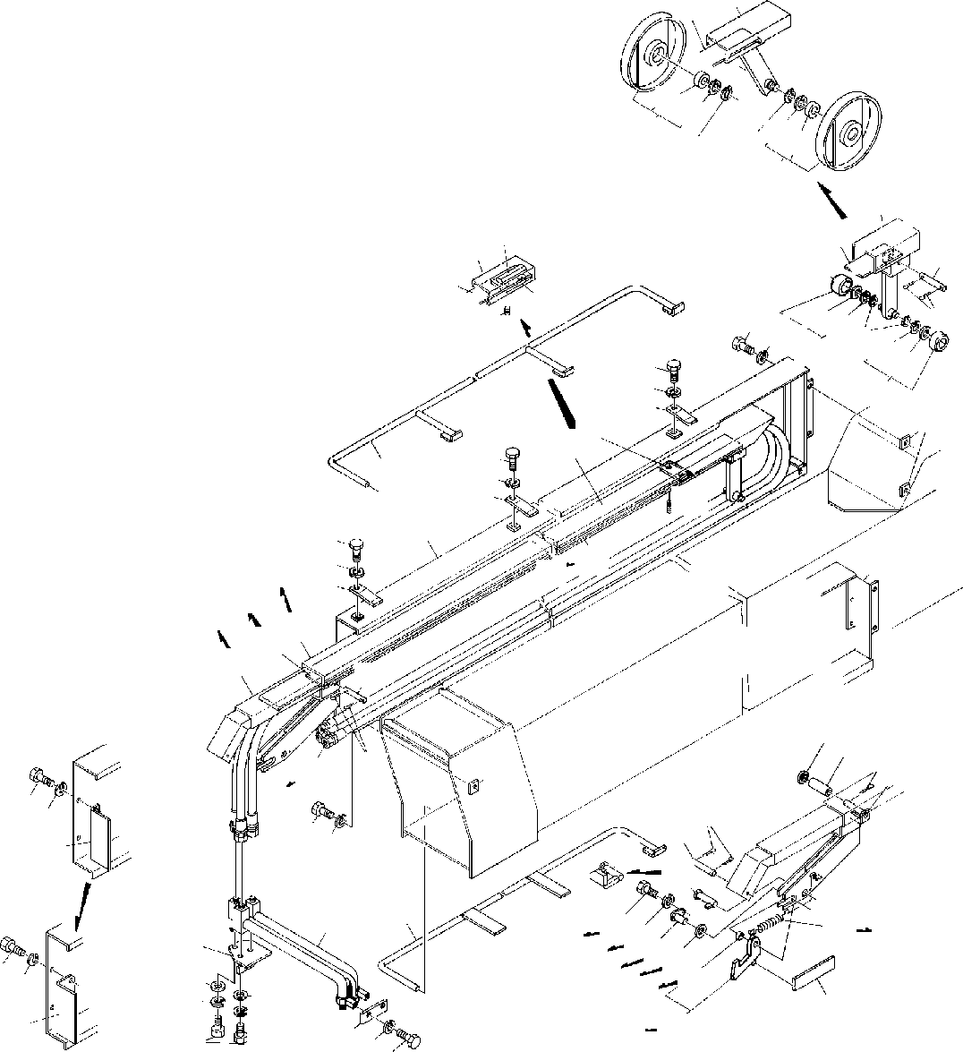

**DT-600-2-00001 UPPER PP2100009-00 PIPING,AUGER**

**61**

**62**

**64**

**65**

**66**

**63**

**65**

**64**

**66**

**63**

**2**

**8385**

**21**

**15**

**84**

**86**

**5 6**

**1819**

**16**

**87**

**2019**

**17**

**5**

**6**

**4**

**18**

**17**

**7**

**9**

**8**

**5**

**6**

**11**

**41**

**10**

**1**

**5**

**6**

**4**

**21**

**1**

**61**

**52**

**62**

**83**

**21 2**

**3**

**15**

**40**

**30**

**3129**

**16**

**12**

**82**

**5 6**

**7**

**5**

**31**

**6**

**13**

**34**

**37**

**37**

**42**

**26**

**5**

**32**

**68**

**69**

**6**

**27**

**44**

**43**

**28**

**3635**

**70**

**717273**

**45 6**

**13**

**39**

**44**

**43**

**33**

**38**

**67**

**2543**

**28**

**DT-600-2-00001 UPPER**

**000098**

Pos No.

Parts No

Parts Name

Qty

Unit

Technical Data

Serial No (Start)

Serial No (End)

Remarks

1

2

3

4

5

6

7

8

9

10

11

12

13

15

16

17

18

19

20

21

25

26

27

28

29

30

31

32

33

34

35

36

37

38

39

40

41

42

43

44

45

61

62

63

64

65

66

67

68

69

70

71

72

73

82

83

84

85

86

87

98

99

32490150010

32490150020

32490150030

32490090040

90101208012

90101208012

90302040801

90302040801

37000502190

32490150050

32490090060

90710006120

32490090070

37002419250

32490150060

32490150061

37000126090

80136325016

32490099510

80516006002

80602110320

80601110150

32490150090

37000530320

32490150100

32490150110

90101210020

32490150170

37001103150

80136332020

19114411000

37000527790

37000126060

90303071601

37000126100

32490090130

32490090190

32490099520

80804016015

90303071201

32490150150

32490150160

90302041001

90303071001

90101208010

32490150021

32490150091

32490099530

80516006004

80602110420

80601110200

32490099520

19114411000

90101208012

90302040801

37000126100

90303071601

80804016015

80804016015

80804016015

80804016015

37002419250

32490150031

32490152000

32490092020

32490091100

90710006080

80516006002

80602110320

COVER COVER COVER SUPPORT BOLT BOLT

WASHER,SPRING WASHER,SPRING PLATE

COVER PLATE SCREW,SET SUPPORT HOSE,TRIPLE COVER COVER

PIN PIN,SPLIT

ROLLER ASSY BEARING,BALL RING,RITAINING RING,RITAINING COVER

PLATE JOINT SUPPORT BOLT SUPPORT ROLLER PIN,SPLIT SPRING PLATE PIN

WASHER,PLAIN PIN

SUPPORT SUPPORT STOPPER ASSY BEARING,PLAIN WASHER,PLAIN GUARD

GUARD WASHER,SPRING WASHER,PLAIN BOLT

COVER COVER ROLLER ASSY

BEARING,BALL RING,RITAINING RING,RITAINING STOPPER ASSY SPRING

BOLT WASHER,SPRING PIN WASHER,PLAIN BEARING,PLAIN BEARING,PLAIN BEARING,PLAIN BEARING,PLAIN HOSE,TRIPLE COVER

COVER CUSHION PLATE SCREW,SET BEARING,BALL RING,RITAINING

1

1

1

4

16

13

16

15

8

1

4

8

1

1

1

1

2

4

2

2

2

2

1

1

1

1

5

1

1

3

1

1

1

2

1

1

1

1

1

1

1

1

5

3

2

1

1

2

4

4

2

1

1

1

1

1

2

1

1

1

1

1

1

1

1

1

4

2

2

M8X12 M8X12 8

8

M6X12 L=8730&8715&8695

2.5X16

R32 15

M10X20

3.2X20

16

12

10

10

M8X10

R42 S20

M8X12 8

16

L=8730&8715&8695

M6X8 R32

275104

275104

275104

275032

275104

275104

275104

275104

275104

275104

275104

275104

275104

275104

275104

275104

275104

275104

275104

275104

275104

275104

275104

275104

275104

275103

275103

275103

275103

275103

275103

275103

275103

275103

275103

275103

275103

275103

275103

275103

275103

275017

275103

275103

275103

275031

275103

275103

275103

275103

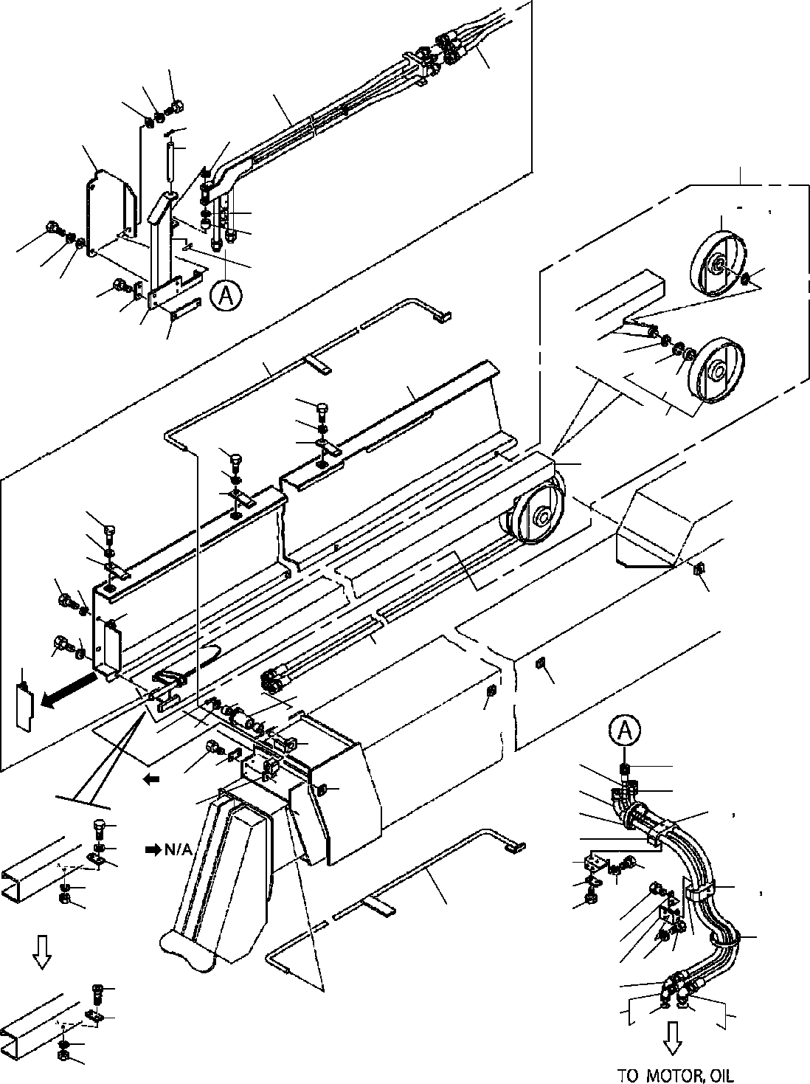

**DT-600-2-00001 UPPER PP2100010-05 PIPING,AUGER**

**20**

**21**

**11**

**1**

**22**

**25**

**23**

**24**

**19**

**2**

**62**

**63 64**

**24**

**47**

**20**

**65**

**25**

**21**

**22**

**18**

**17**

**16**

**48**

**5**

**65**

**64**

**3**

**63**

**9**

**10**

**6**

**62**

**9**

**10**

**7**

**61**

**9**

**10**

**6**

**10**

**9**

**41**

**8**

**10**

**11**

**8**

**9**

**13**

**41**

**73**

**73**

**41**

**14**

**15**

**12**

**40**

**27**

**39**

**30**

**28**

**27**

**17**

**50**

**18**

**26**

**41**

**29**

**49**

**43**

**44**

**42**

**32**

**35**

**45**

**46**

**33**

**34**

**29 49**

**10**

**34**

**33**

**31**

**37**

**36**

**4**

**38**

**30**

**35**

**10**

**43**

**42**

**91**

**37**

**81**

**45**

**46**

**DT-600-2-00001 UPPER**

**000099**

Pos No.

Parts No

Parts Name

Qty

Unit

Technical Data

Serial No (Start)

Serial No (End)

Remarks

1

2

3

4

5

6

7

8

9

10

11

12

13

14

15

16

17

18

19

20

21

22

23

24

25

26

27

28

29

30

31

32

33

34

35

36

37

38

39

40

41

42

43

44

45

46

47

48

49

50

61

62

63

64

65

73

81

91

32490510010

32490610050

32490510100

32490610030

32490510020

32490400040

32490090040

32490090070

32490500020

90101208012

90302040801

37002442480

32490400060

32490400070

90303072001

80136350032

32490640030

37000543030

90101512022

90101512025

32490290030

90101210016

90302041001

90303071001

37000157210

90303071601

80136340030

32490510050

37002442490

37002442500

32490510060

32490510070

32490510080

32490510090

37000551590

90101508040

90101508014

80430620600

80430621200

91810130270

91810130240

82100001411

37000502190

37002006780

37002018560

90101206016

90181006015

90303070601

90302040601

90201200600

37000308320

37000560190

32490610010

90171112022

32490510120

32490099530

80516006004

80602110420

80601110200

80804020020

91002801400

91002802400

JOINT JOINT

CASE ASSY (2ND) COVER

GUARD GUARD SUPPORT SUPPORT COVER BOLT

WASHER,SPRING HOSE,TRIPLE SUPPORT ROLLER WASHER,PLAIN PIN,SPLIT SUPPORT

PLATE BOLT BOLT COVER BOLT

WASHER,SPRING WASHER,PLAIN PIN WASHER,PLAIN PIN,SPLIT SUPPORT

HOSE HOSE SUPPORT SUPPORT SUPPORT SUPPORT PLATE BOLT BOLT

JOINT (WITH O-RING) JOINT

FASTENER FASTENER TUBE,SPIRAL PLATE PLATE,SLIDE PLATE,SLIDE BOLT

BOLT WASHER,PLAIN WASHER,SPRING NUT

SPACER PLATE PLATE BOLT CASE

ROLLER ASSY BEARING,BALL RING,RITAINING RING,RITAINING BEARING,PLAIN O-RING

O-RING

1

1

1

1

1

1

4

1

1

13

17

1

1

1

1

1

1

3

6

4

1

3

3

3

1

5

2

1

2

1

2

2

1

1

2

4

4

1

2

1

1

1

5

1

1

2

2

2

2

2

1

2

4

2

1

2

2

2

2

2

1

2

M

M8X12 8 L=4710

20

5X32

M12X22 M12X25

M10X16 10

10

16

4X30

L=1210 L=1400

M8X40 M8X14 L,G3/8-G3/8

SE-08BK

M6X16 M6X15 6

6

M6

M12X22

R42 S20

1B P14

1B P24

275218

275254

275651

275651

275254

275583

275254

275217

275253

275650

275650

275650

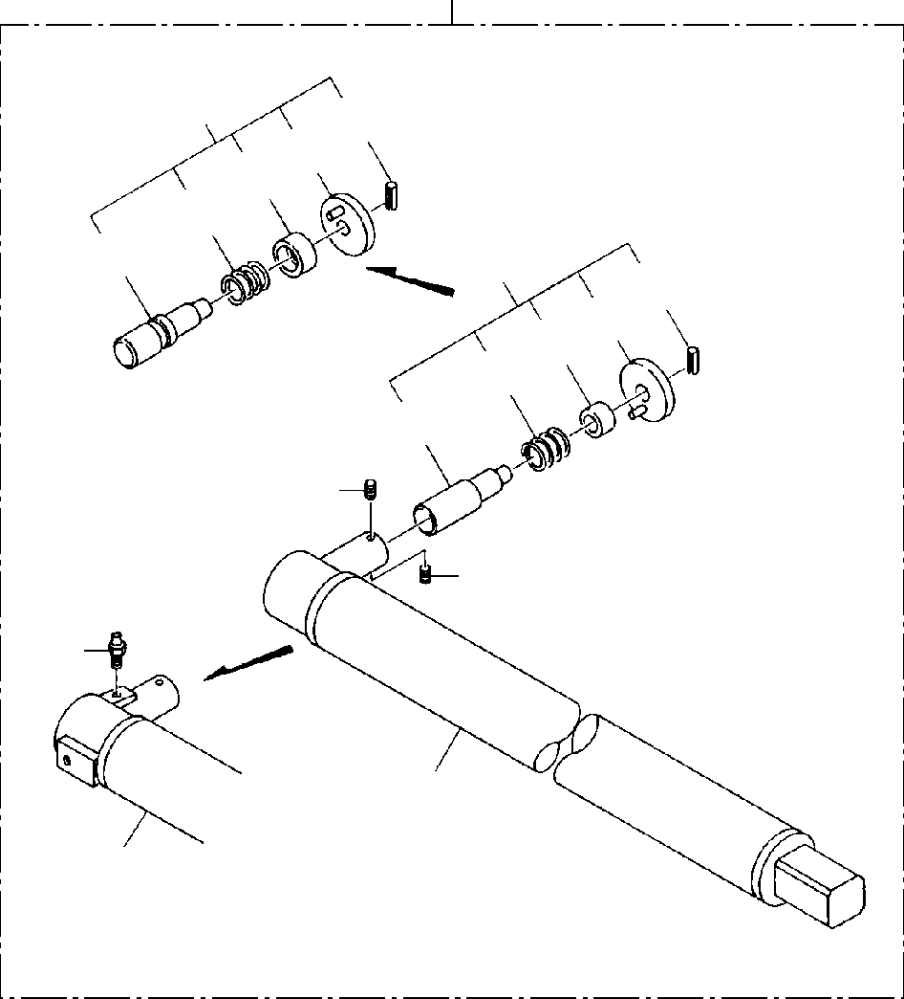

**DT-600-2-00001 UPPER**

**PP2150008-02 SHAFT,AUGER (2M,OPTION)**

**100**

**3**

**35**

**33 34**

**32**

**31**

**3**

**25**

**23 24**

**22**

**21**

**2**

**2**

**4**

**1**

**1**

**DT-600-2-00001 UPPER**

**000100**

Pos No.

Parts No

Parts Name

Qty

Unit

Technical Data

Serial No (Start)

Serial No (End)

Re

1

2

3

4

21

22

23

24

25

31

32

33

34

35

100

32470600010

32470600020

90710006080

32490020070

32490023000

82456106000

32490022030

37001200470

32490022060

32490022050

80720105018

32490023010

37001200720

32490253510

32490253520

80720105028

32470600000

SHAFT SHAFT SCREW,SET PIN ASSY PIN ASSY

NIPPLE,GREASE PIN

SPRING GUIDE GRIP PIN,SPRING PIN

SPRING GUIDE GRIP PIN,SPRING

SHAFT,AUGER (2M,OPTION)

1

1

2

1

1

1

1

1

1

1

1

1

1

1

1

1

1

M6X8

1/4-28UNF

5X18

5X28

275094

275094

275094

275094

275094

275094

275094

275094

275093

275093

275093

275093

275093

275093

275093

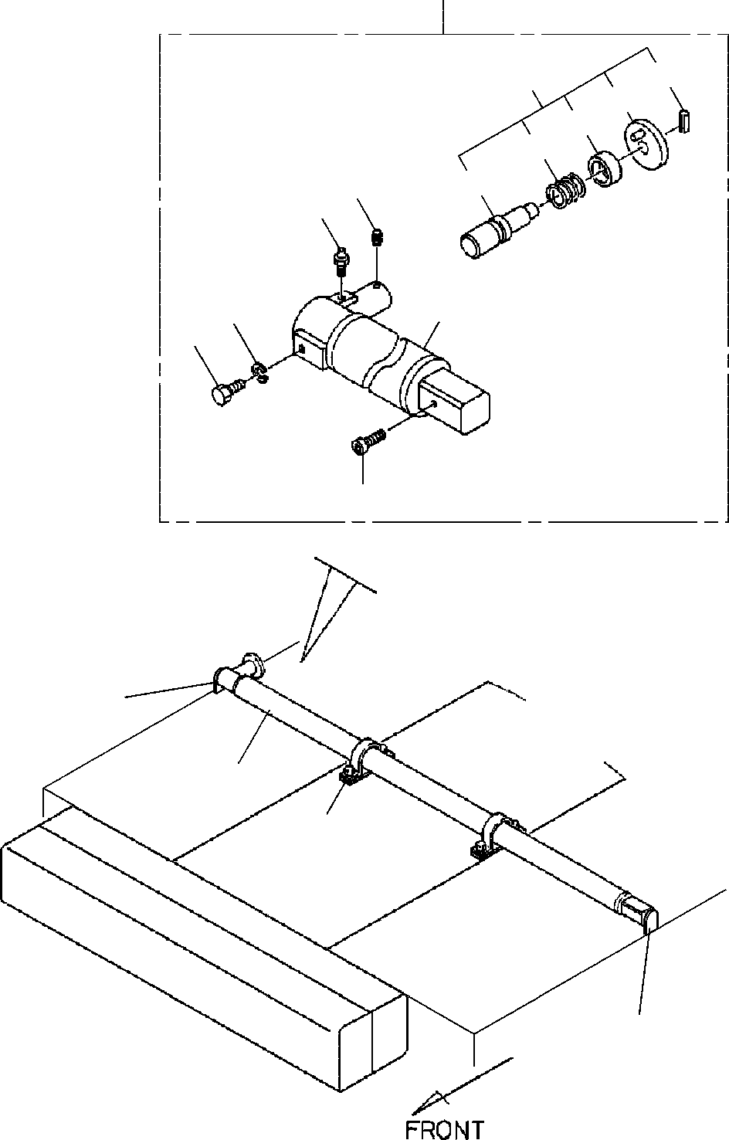

**DT-600-2-00001 UPPER**

**PP2150012-02 SHAFT,AUGER (1.7M,OPTION)**

**2**

**43**

**35**

**34**

**33**

**32**

**42**

**31**

**44**

**46**

**41**

**45**

**47**

**3**

**2**

**1**

**3**

**DT-600-2-00001 UPPER**

**000101**

Pos No.

Parts No

Parts Name

Qty

Unit

Technical Data

Serial No (Start)

Serial No (End)

Remarks

Pag

1

2

3

31

32

33

34

35

41

42

43

44

32470190010

32470190030

32470190040

32490022030

32490023010

37001200470

37001200720

32490022060

32490253510

32490022050

32490253520

80720105018

80720105028

32470192040

32470192050

90710006080

32490020070

32490023000

82456106000

CLAMP ASSY SHAFT ASSY PLATE

PIN PIN

SPRING SPRING GUIDE GUIDE GRIP GRIP

PIN,SPRING PIN,SPRING SHAFT SHAFT SCREW,SET PIN ASSY PIN ASSY

NIPPLE,GREASE

2

1

2

1

1

1

1

1

1

1

1

1

1

1

1

2

1

1

1

5X18

5X28

M6X8

1/4-28UNF

275566

275094

275094

275094

275094

275094

275094

275094

275094

275093

275093

275093

275093

275093

275093

275093

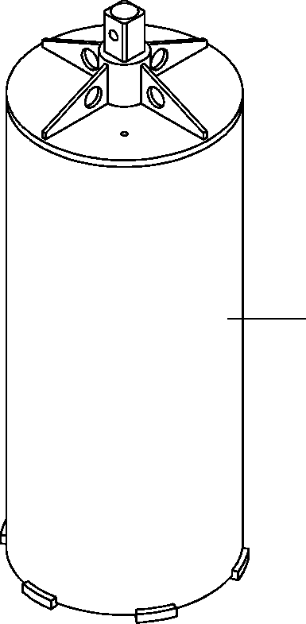

**DT-600-2-00001 UPPER**

**PP2170000-00 HEAD,AUGER (450.DW) (OPTION)**

**1**

**DT-600-2-00001 UPPER**

**000102**

Pos No.

Parts No

Parts Name

Qty

Unit

Technical Data

Serial No (Start)

Serial No (End)

1

32470650000

HEAD,AUGER (450.DW) (OPTION)

1

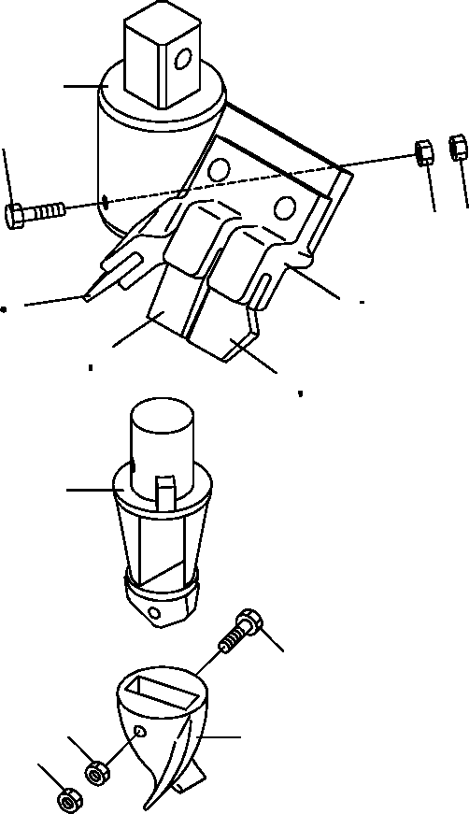

**DT-600-2-00001 UPPER**

**PP2170001-02 HEAD,AUGER (PENGO,450.PH)**

**1**

**5**

**6**

**6**

**10**

**12**

**2 31**

**10 12**

**11**

**12**

**3**

**8**

**9**

**4**

**9**

**DT-600-2-00001 UPPER**

**000103**

Pos No.

Parts No

Parts Name

Qty

Unit

Technical Data

Serial No (Start)

Serial No (End)

Re

1

2

3

4

5

6

8

9

10

11

12

31

32470720010

32470720100

32470720300

32470720400

90101512150

90201401200

90101510045

90101510050

90201401000

90203401000

32470730200

32470730100

32470720500

32470720200

SUPPORT

HOLDER (WITH BOLT&NUT) ADAPTER

BIT,PILOT (PENGO.FH205) BOLT

NUT BOLT BOLT NUT NUT

TOOTH (PEBGO.1656) TOOTH (PENGO.1658) CUSHION

BOLT ASSY

1

1

1

1

1

2

1

1

2

2

2

1

3

2

M12X150 M12 M10X45 M10X50 M10

M10

275094

275094

275093

275093

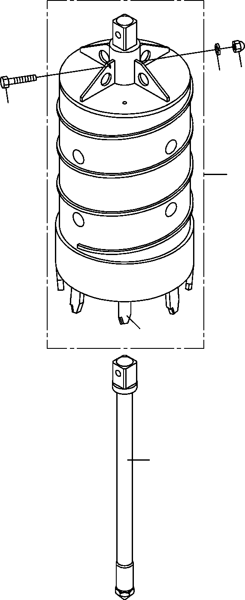

**DT-600-2-00001 UPPER**

**PP2170002-01 HEAD,AUGER (450.D)**

4

5

3

1

17

2

**DT-600-2-00001 UPPER**

**000104**

Pos No.

Parts No

Parts Name

Qty

Unit

Technical Data

Serial No (Start)

Serial No (End)

Remarks

Pa

1

2

3

4

5

17

32470761000

32470760020

90101218110

90240201800

90302041801

32470760010

HEAD,AUGER BIT,CENTER BOLT NUT,CAP

WASHER,SPRING BIT,CUTTER

1

1

1

1

1

8

18

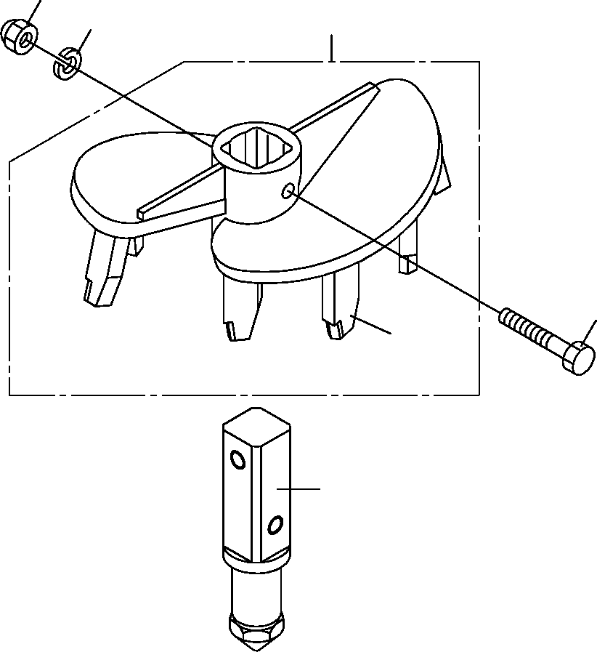

**DT-600-2-00001 UPPER**

**PP2170003-01 HEAD,AUGER (450.F/OPTION)**

**4**

**5**

**1**

**3**

**15**

**2**

**DT-600-2-00001 UPPER**

**000105**

Pos No.

Parts No

Parts Name

Qty

Unit

Technical Data

Serial No (Start)

Serial No (End)

Remarks

Pa

1

2

3

4

5

15

32470771000

32470660020

90101218110

90240201800

90302041801

32470770010

HEAD,AUGER BIT,CENTER BOLT NUT,CAP

WASHER,SPRING BIT,CUTTER

1

1

1

1

1

7

18

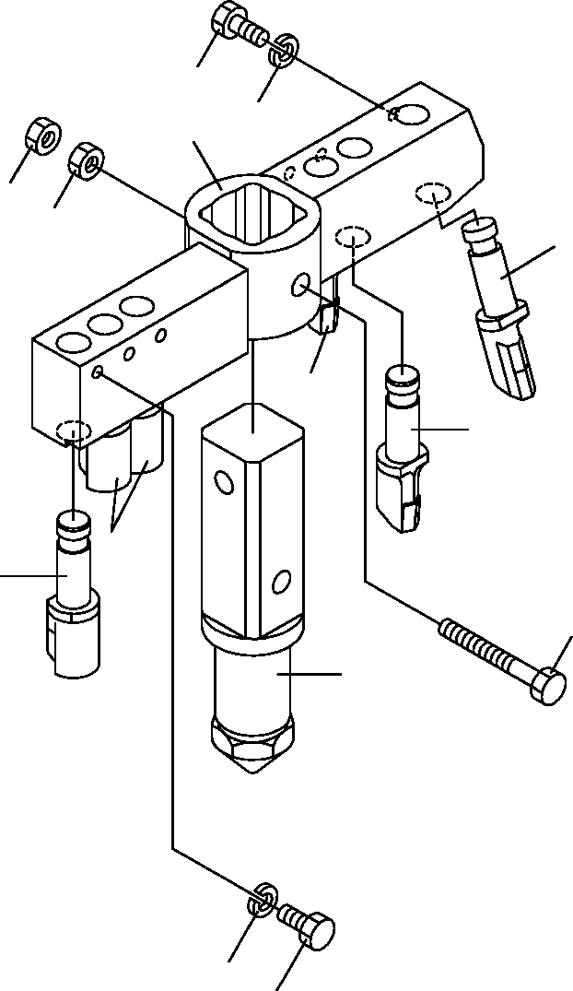

**DT-600-2-00001 UPPER**

**PP2170004-02 HEAD,AUGER (550.R6/OPTION)**

**1**

**9**

**8**

**5**

**5**

**3**

**7**

**7**

**7**

**7**

**4**

**6**

**9**

**1**

**DT-600-2-00001 UPPER**

**000106**

Pos No.

Parts No

Parts Name

Qty

Unit

Technical Data

Serial No (Start)

Serial No (End)

Remarks

Pa

1

3

4

5

6

7

8

9

90171110018

32470560040

37001502750

90201401800

32470560020

32470560010

32471130010

90302041001

BOLT BIT,CUTTER BOLT

NUT BIT,CENTER BIT,CUTTER SUPPORT

WASHER,SPRING

6

1

1

2

1

5

1

6

M10X18

M18X132 M18

10

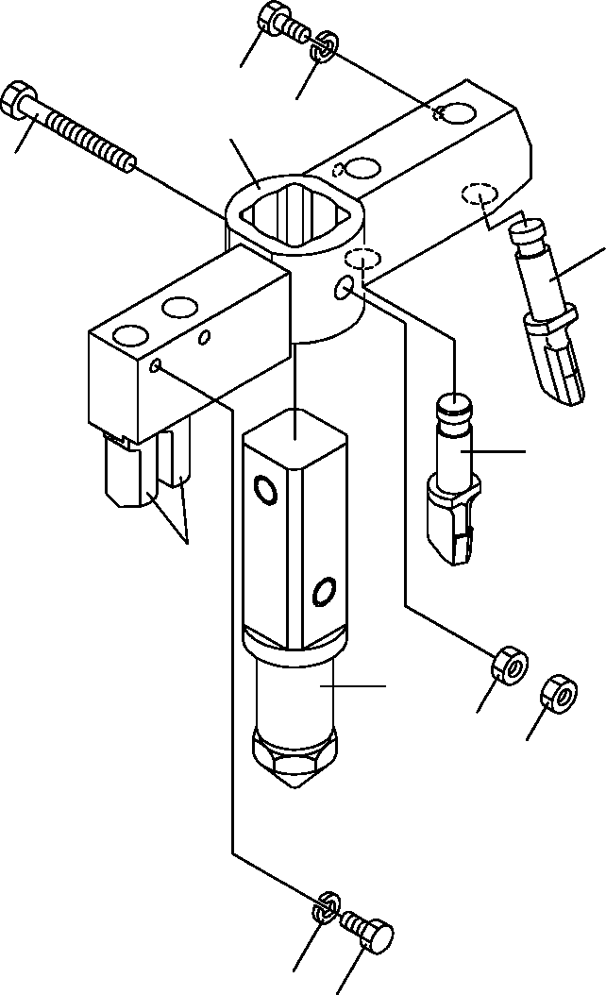

**DT-600-2-00001 UPPER**

**PP2170005-02 HEAD,AUGER (R4/OPTION)**

**1**

**9**

**8**

**4**

**3**

**7**

**7**

**6**

**5**

**5**

**9**

**1**

**DT-600-2-00001 UPPER**

**000107**

Pos No.

Parts No

Parts Name

Qty

Unit

Technical Data

Serial No (Start)

Serial No (End)

Remarks

Pa

1

3

4

5

6

7

8

9

90171110018

32470560040

37001502750

90201401800

32470560020

32470560010

32471230010

90302041001

BOLT BIT,CUTTER BOLT

NUT BIT,CENTER BIT,CUTTER SUPPORT

WASHER,SPRING

4

1

1

2

1

3

1

4

M10X18

M18X132 M18

10

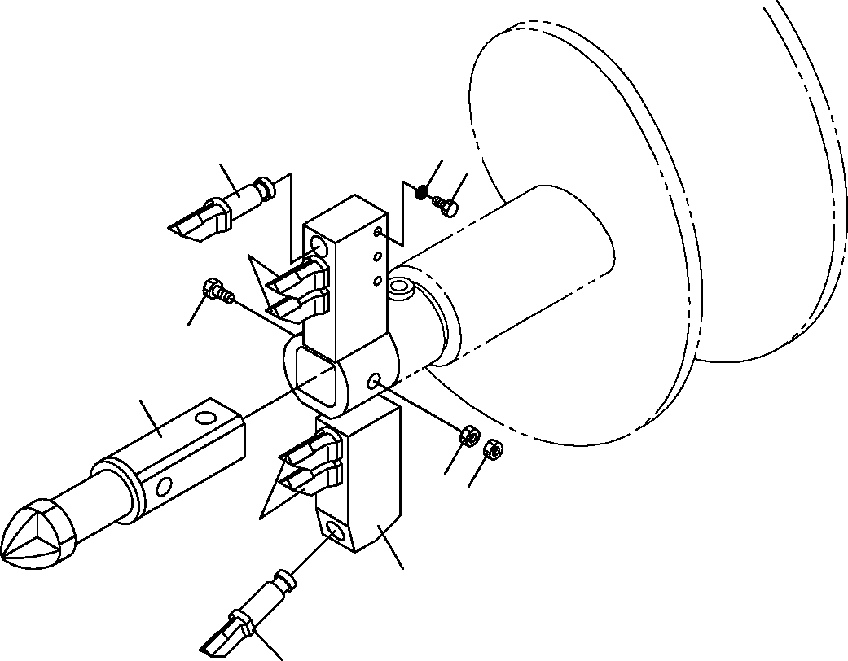

**DT-600-2-00001 UPPER**

**PP2170006-01 HEAD,AUGER (400.R6)**

**9**

**7**

**1**

**7**

**4**

**6**

**5**

**5**

**7**

**8**

**3**

**DT-600-2-00001 UPPER**

**000108**

Pos No.

Parts No

Parts Name

Qty

Unit

Technical Data

Serial No (Start)

Serial No (End)

Remarks

Pa

1

3

4

5

6

7

8

9

90171110018

32470560040

37001502750

90201401800

32470560020

32470560010

32471460010

90302041001

BOLT BIT,CUTTER BOLT

NUT BIT,CENTER BIT,CUTTER SUPPORT

WASHER,SPRING

6

1

1

2

1

5

1

6

M10X18

M18X132 M18

10

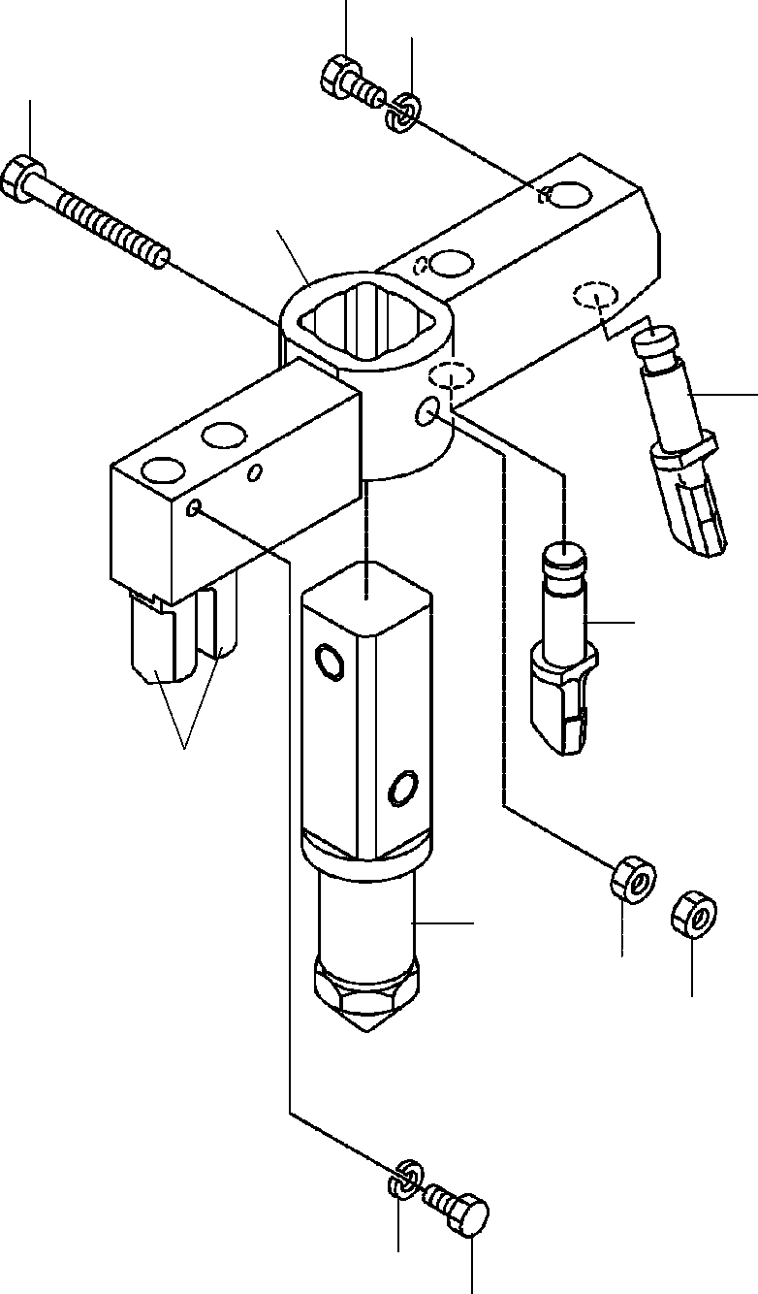

**DT-600-2-00001 UPPER**

**PP2170008-01 HEAD,AUGER (300.R4)**

**1**

**9**

**4**

**8**

**3**

**7**

**7**

**6**

**5**

**5**

**9**

**1**

**DT-600-2-00001 UPPER**

**000109**

Pos No.

Parts No

Parts Name

Qty

Unit

Technical Data

Serial No (Start)

Serial No (End)

Remarks

Pa

1

3

4

5

6

7

8

9

90171110018

32470560040

37001502750

90201401800

32470560020

32470560010

32471340010

90302041001

BOLT BIT,CUTTER BOLT

NUT BIT,CENTER BIT,CUTTER SUPPORT

WASHER,SPRING

4

1

1

2

1

3

1

4

M10X18

M18X132 M18

10

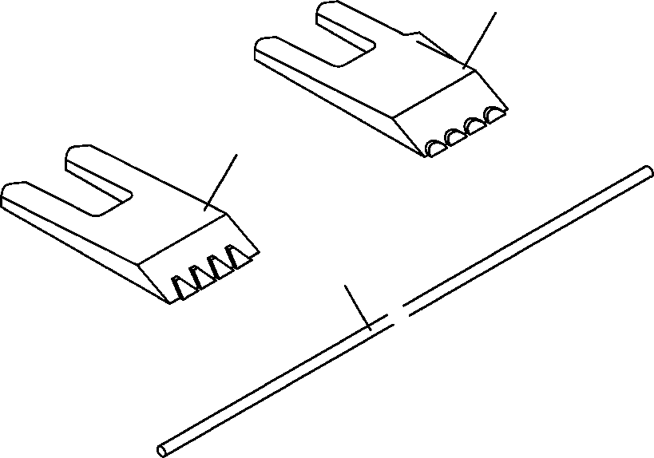

**DT-600-2-00001 UPPER**

**PP2180000-01 TOOTH (PENGO.PH/OPTION)**

1

2

3

**DT-600-2-00001 UPPER**

**000110**

Pos No.

Parts No

Parts Name

Qty

Unit

Technical Data

Serial No (Start)

Serial No (End)

Remarks

1

2

3

32470730100

32470730200

32470720800

TOOTH (PENGO.1658) TOOTH (PEBGO.1656) CUSHION

1

2

1

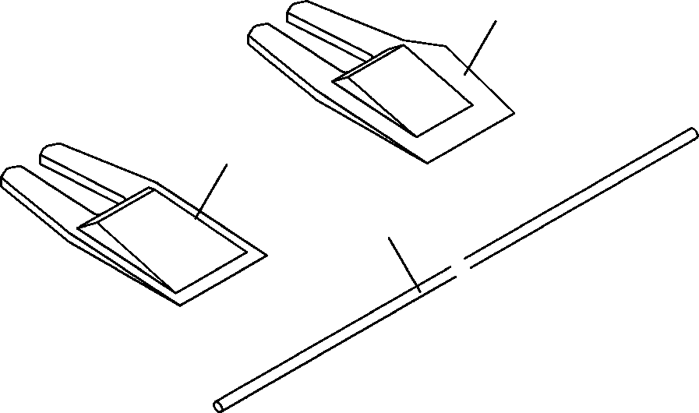

**DT-600-2-00001 UPPER**

**PP2180001-01 TOOTH (PENGO,STD.P)/OPTION)**

**1**

**2**

**3**

**DT-600-2-00001 UPPER**

**000111**

Pos No.

Parts No

Parts Name

Qty

Unit

Technical Data

Serial No (Start)

Serial No (End)

Remarks

1

2

3

32470720600

32470720700

32470720800

TOOTH (PENGO.1652) TOOTH (PENGO.1650) CUSHION

1

2

1

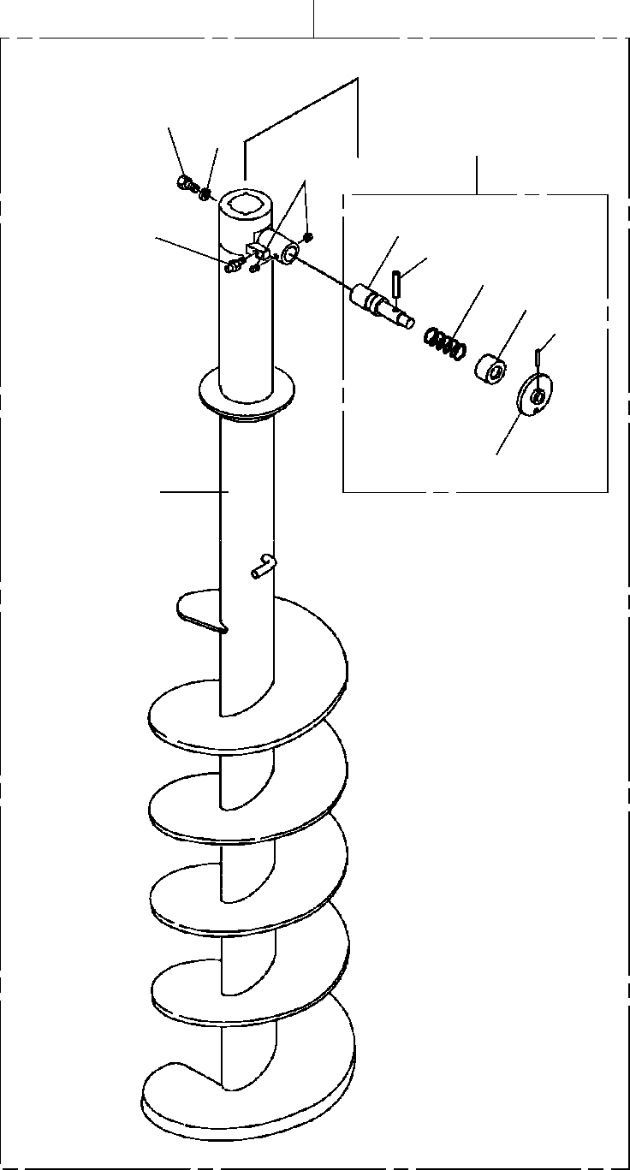

**DT-600-2-00001 UPPER PS5040008-00 SCREW ASSY**

**100**

**12**

**13**

**3**

**6**

**31**

**14**

**34**

**32**

**33**

**36**

**35**

**16**

**DT-600-2-00001 UPPER**

**000112**

Pos No.

Parts No

Parts Name

Qty

Unit

Technical Data

Serial No (Start)

Serial No (End)

Remarks

Pa

3

6

12

13

14

16

31

32

33

34

35

36

100

32490026000

90710006080

37001504060

90302041801

82456106000

32490022001

32490026100

37001200720

32490253510

80720106045

32490251200

80720105028

32490028031

PIN ASSY SCREW,SET BOLT WASHER,SPRING NIPPLE,GREASE SCREW

PIN SPRING GUIDE

PIN,SPRING GRIP PIN,SPRING SCREW ASSY

1

2

1

1

1

1

1

1

1

1

1

1

1

M6X8 18

1/4-28UNF

5X28

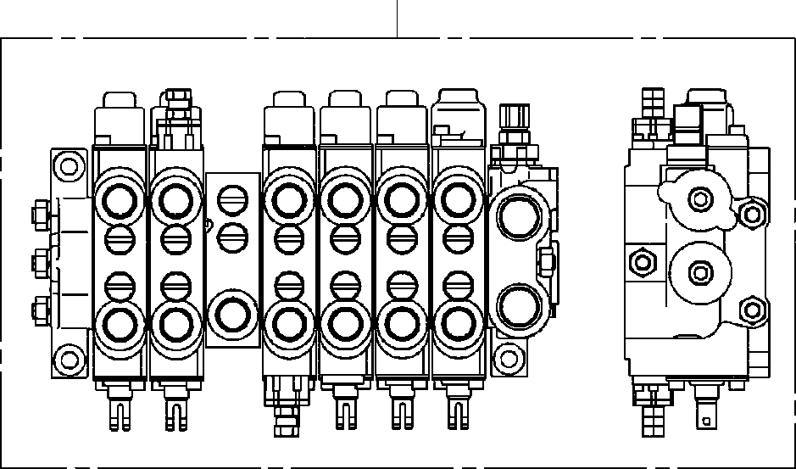

**DT-600-2-00001 UPPER**

**PV5180003-00 VALVE ASSY,SELECTOR (MANUAL CONT.)**

**100**

**DT-600-2-00001 UPPER**

**000113**

Pos No.

Parts No

Parts Name

Qty

Unit

Technical Data

Serial No (Start)

Serial

100

36638740000

VALVE ASSY,SELECTOR (MANUAL CONT.)

1

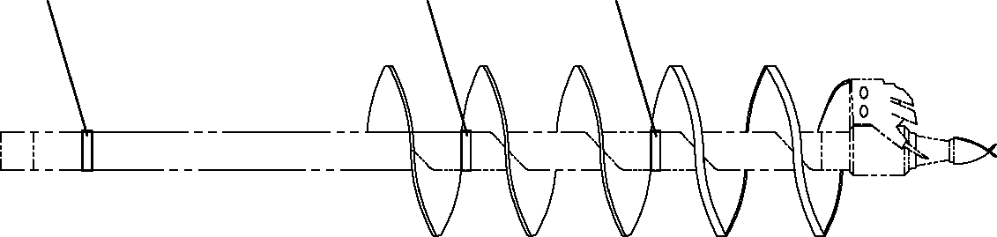

**DT-600-2-00001 UPPER PX1940020-00 MOUNT (MARK)**

**1**

**1**

**1**

**DT-600-2-00001 UPPER**

**000114**

Pos No.

Parts No

Parts Name

Qty

Unit

Technical Data

Serial No (Start)

Serial No (End)

Remarks

Pages

1

32472070100

SUPPORT

3

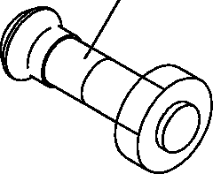

**DT-600-2-00001 UPPER PX1940248-01 BOLT ASSY**

**1**

**DT-600-2-00001 UPPER**

**000115**

Pos No.

Parts No

Parts Name

Qty

Unit

Technical Data

Serial No (Start)

Serial No (End)

Remarks

Pages

1

32470720200

32470720200

32470720200

BOLT ASSY BOLT ASSY BOLT ASSY

1

1

1

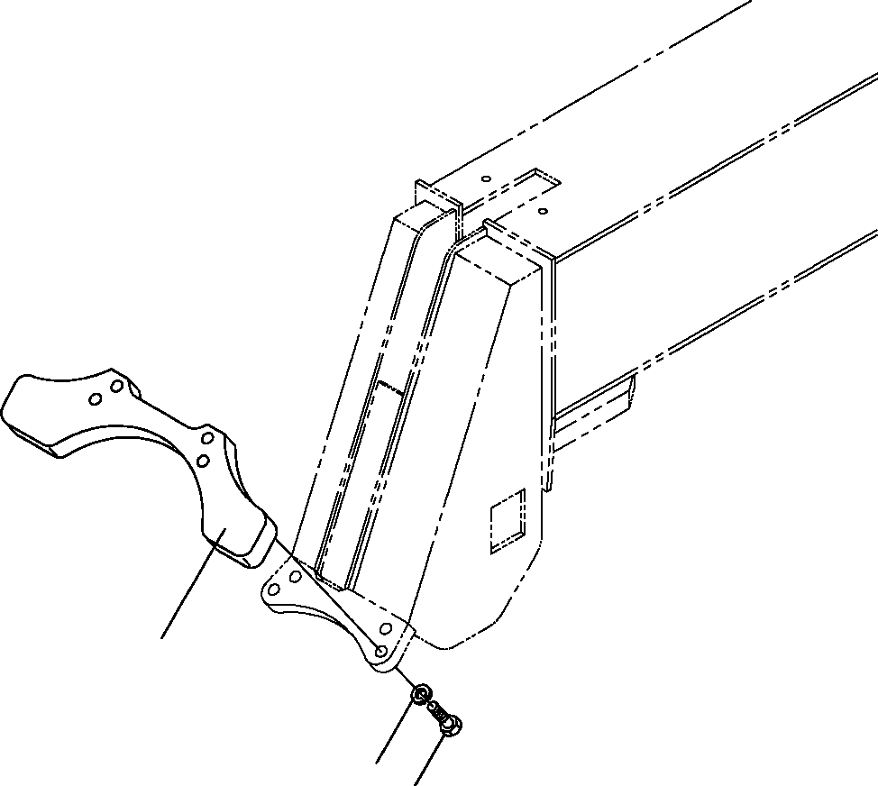

**DT-600-2-00001 UPPER PY1040002-00 SUPPORT,POLE**

**1**

**4**

**3**

**DT-600-2-00001 UPPER**

**000116**

Pos No.

Parts No

Parts Name

Qty

Unit

Technical Data

Serial No (Start)

Serial No (End)

Remarks

Pa

1

3

4

32470200010

90101514040

90302041401

SUPPORT BOLT

WASHER,SPRING

1

4

4

M14X40 14